1. Goto <https://control.akamai.com/qos/SecMonServlet?analyzerId=100605&newView=true&viewId=5336>

This URL will show the traffic for /us/en/GCBalanceCmd

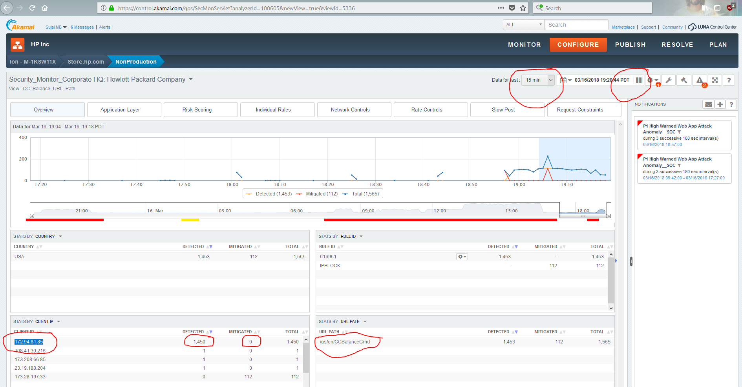

1. If we see any IP which is hitting more than 50+ times in the left side Client IP Pane, copy that IP
2. Goto <https://control.akamai.com/apps/pulsar-networklists-ui/#/?tab=CONFIGURE&type=context>
3. Click on IP_Blacklist
4. In the Add Items, paste the IP and hit Enter 🡪 That will add the IP to the list

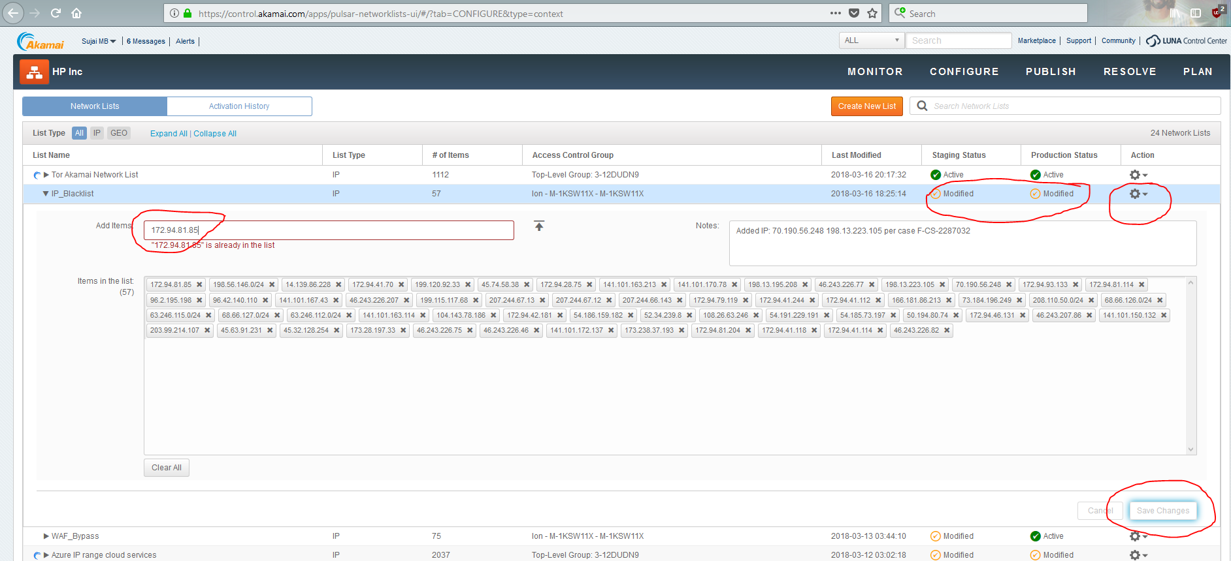

1. Click Save changes
2. Click on Settings icon in the right corner against IP_Blacklist
3. Activate 🡪 Select Production 🡪 Activate List (Staging is optional for now for activation)
4. This will 10 – 15 mins to propagate

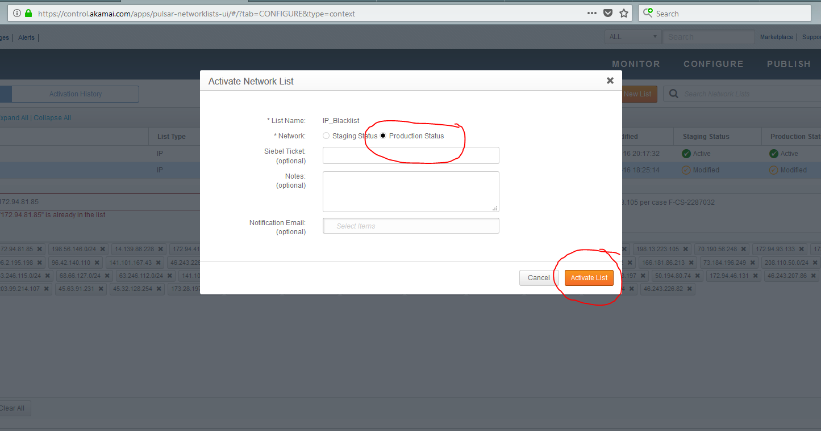

1. Then go back to <https://control.akamai.com/qos/SecMonServlet?analyzerId=100605&newView=true&viewId=5336>
2. And monitor the status
3. Now we can see that IP’s requests will be in mitigated count and gone from the list in sometime
4. The attacker will change the IP again
5. Repeat the steps again if you see any such IPs hitting again.