Chaining Process using Jenkins:

Build Trigger:

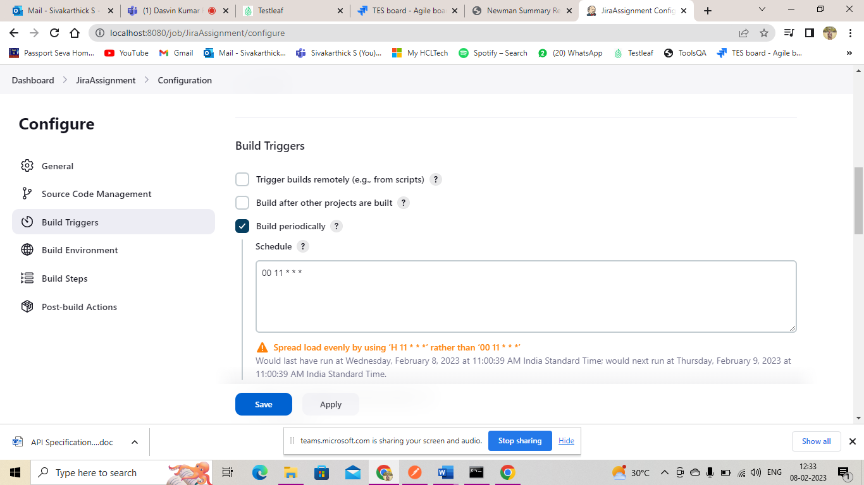

Build Environment:

Build Steps:

Console Output:

