Set 5
Q1. Generate Python code for the Fibonacci sequence with Cursor AI. Refine your
prompts to handle only positive integers and record the changes and outcomes.
(Each question carries 5 marks)

Promt:

Generate a Python function to calculate non negative number of the nth number in the Fibonacci sequence, give user inputs, and display the whole Fibonacci series.

Code:

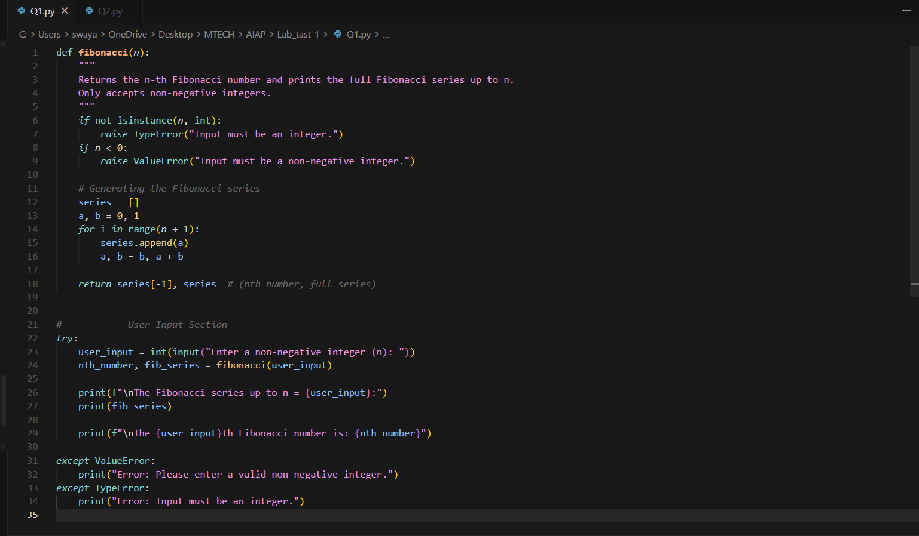

Output:

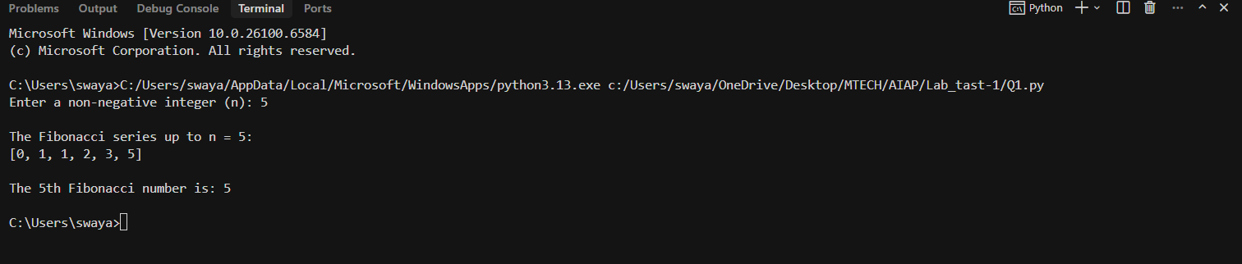

Q2. Write a Python queue class (`enqueue`, `dequeue`, `peek`). Use an AI assistant and test the class with multiple scenarios. Describe how AI-generated code manages edge cases and how you improved it.
(Each question carries 5 marks)

Promt:

Write a python code to create a function enqueue, dequeue, peek and generate test cases with multiple scenarios.

Code:

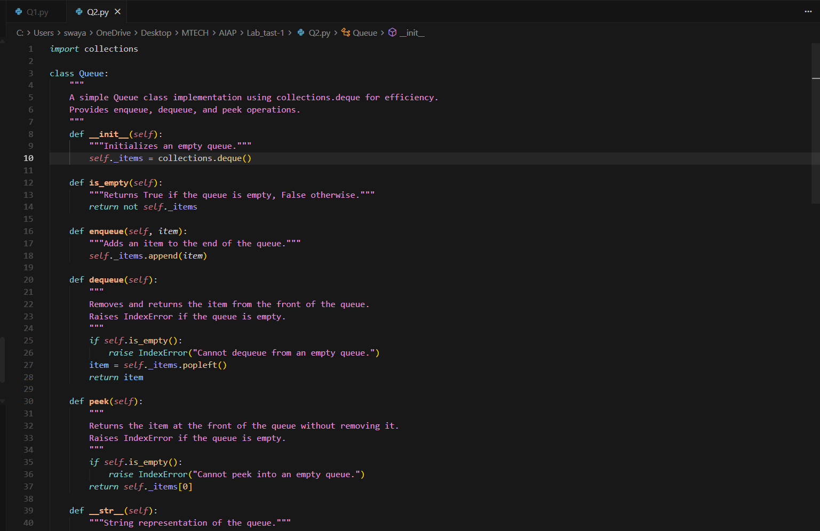

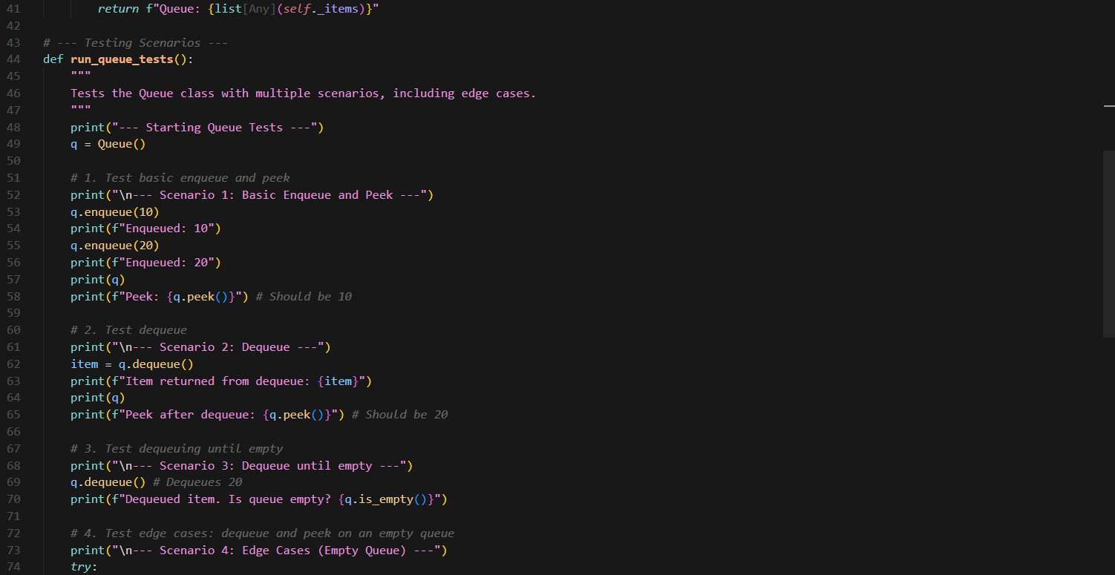

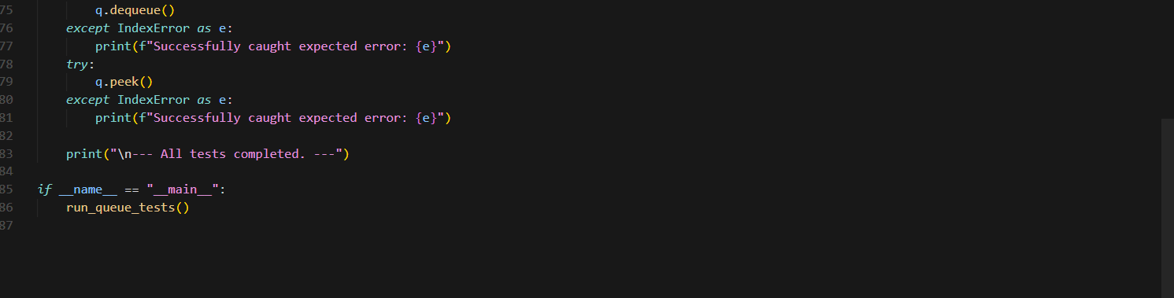

Output:

