Task 1
Description: Install and configure GitHub Copilot in VS Code. Take screenshots of each step.
Expected Output: Install and configure GitHub Copilot in VS Code. Take screenshots of each step.

Prerequisites: Latest version of VS Code is installed, GitHub Account, Internet Connection
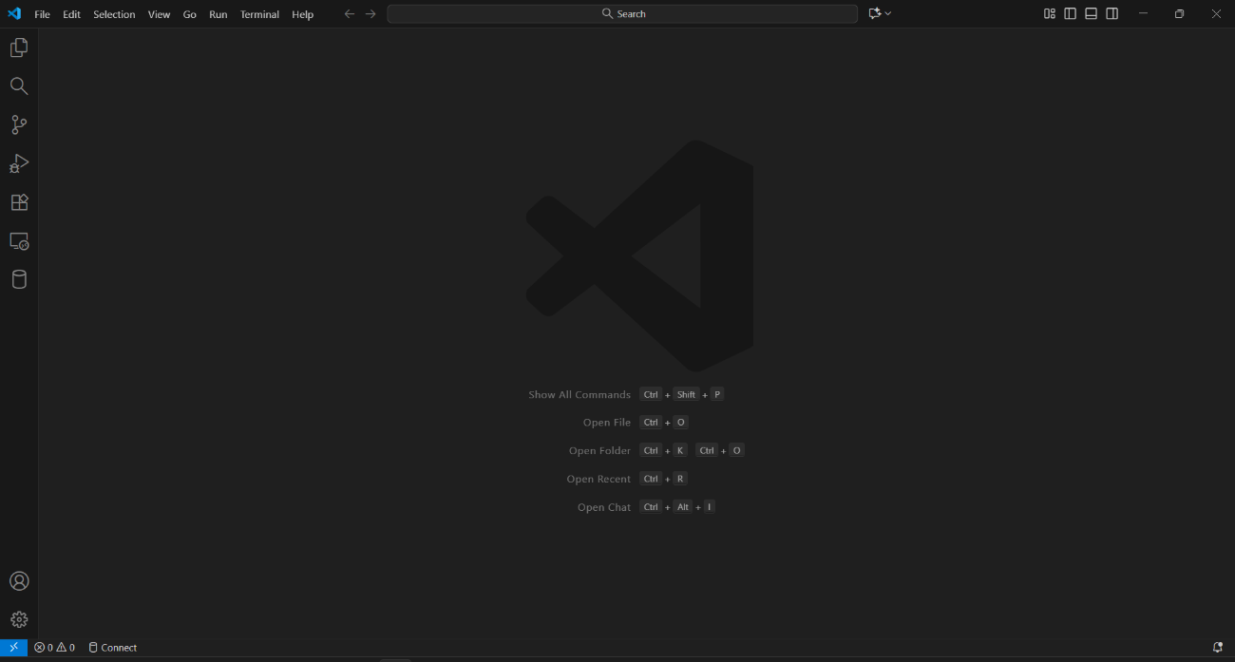
Step 1: Open VS Code

Step 2: Open the Extensions Tab
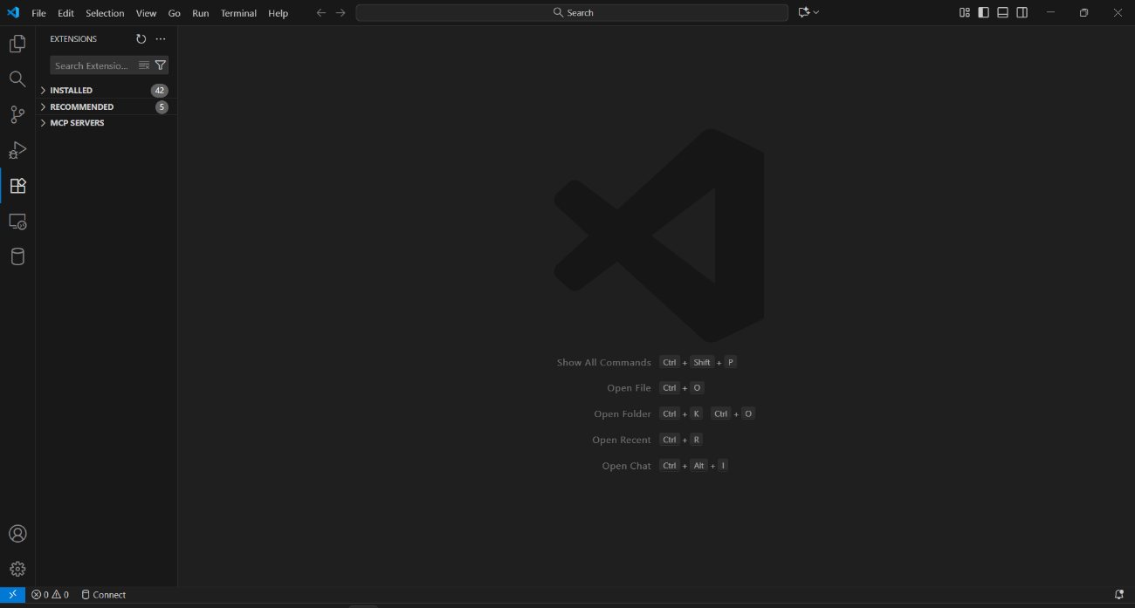

Step 3: Search for “GitHub Copilot”
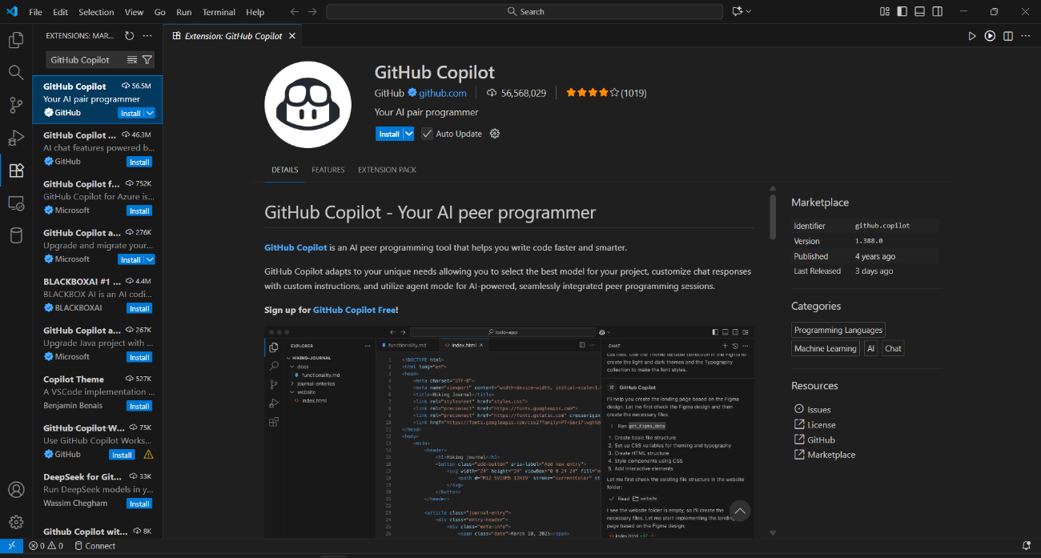
Step 4: Click on “Install” and wait for VS Code to install the GitHub Copilot Extension
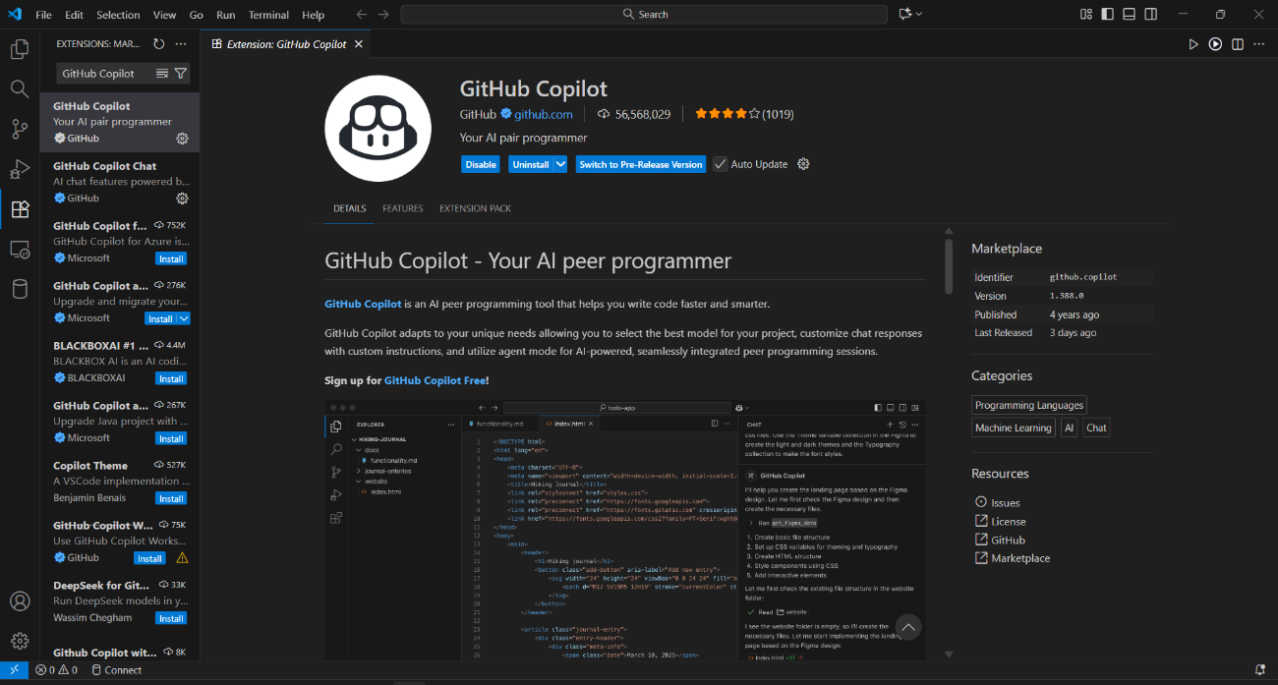

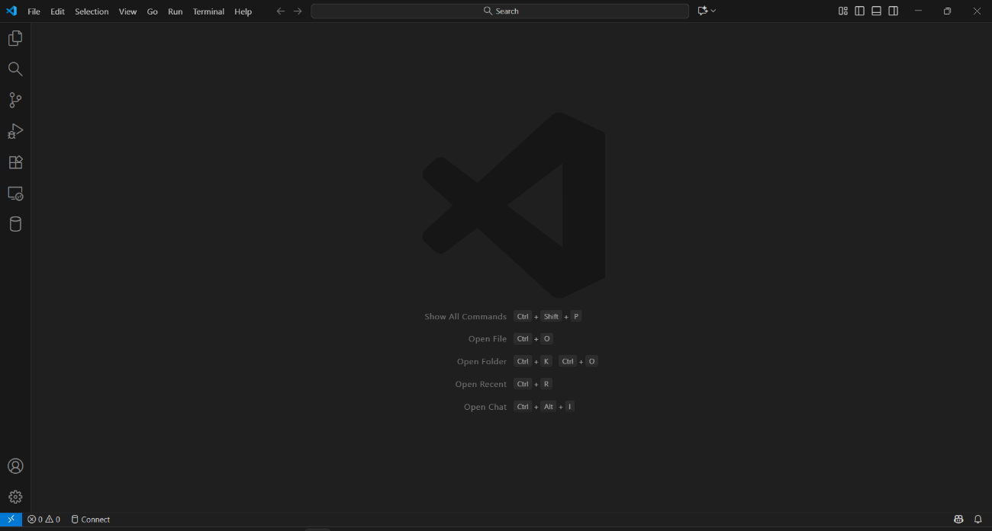
Step 5: Close and Reopen VS Code

Step 6: Sign-in and Authorize GitHub Copilot using the GitHub account


Step 7: GitHub Copilot is now Ready!


Task 2
Description: Use Copilot to generate a is_prime() Python function.
Expected Output: Function to check primality with correct logic.

Prerequisites: Latest version of VS Code is installed, GitHub Copilot in VS Code, Internet Connection
Prompt: write code for the function named is_prime(), that takes a number as an argument and checks whether the number is a prime number or not
Co-Pilot (AI) Generated Code:
def is_prime(number):
# Check if number is less than 2 (not prime)
if number < 2:
print(f"{number} is not a prime number")
return False

# Check for divisibility from 2 to square root of number
for i in range(2, int(number ** 0.5) + 1):
if number % i == 0:
print(f"{number} is not a prime number")
return False

print(f"{number} is a prime number")
return True

# Example usage:
is_prime(29)
is_prime(15)

Output:
29 is a prime number
15 is not a prime number

Task 3
Description: Write a comment like # Function to reverse a string and use Copilot to generate the function.
Expected Output: Auto-completed reverse function

Prerequisites: Latest version of VS Code is installed, GitHub Copilot in VS Code, Internet Connection
Prompt: Function to reverse a string
Co-Pilot (AI) Generated Code:
# Function to reverse a string
def reverse_string(s):
return s[::-1]
# Example usage
input_string = "Hello, World!"
reversed_string = reverse_string(input_string)
print("Reversed String:", reversed_string)
# Output: !dlroW ,olleH

Output:
Reversed String: !dlroW ,olleH

Task 4
Description: Generate both recursive and iterative versions of a factorial function using comments.
Expected Output: Two working factorial implementations

Prerequisites: Latest version of VS Code is installed, GitHub Copilot in VS Code, Internet Connection
Prompt: Iterative and recursive function for factorial
Co-Pilot (AI) Generated Code:
# Iterative and recursive function for factorial
def factorial_iterative(n):
result = 1
for i in range(2, n + 1):
result *= i
return result
def factorial_recursive(n):
if n == 0 or n == 1:
return 1
else:
return n * factorial_recursive(n - 1)

# Example usage
if __name__ == "__main__":
number = 5
print(f"Iterative Factorial of {number}: {factorial_iterative(number)}")
print(f"Recursive Factorial of {number}: {factorial_recursive(number)}")

Output:
Iterative Factorial of 5: 120
Recursive Factorial of 5: 120
Task 5
Description: Use Copilot to find the largest number in a list. Assess code quality and efficiency.
Expected Output: A valid function with your review

Prerequisites: Latest version of VS Code is installed, GitHub Copilot in VS Code, Internet Connection
Prompt: Function to find the largest number in a list
Co-Pilot (AI) Generated Code:
# Function to find the largest number in a list
def find_largest_number(numbers):
if not numbers:
return None # Return None if the list is empty
largest = numbers[0]
for number in numbers:
if number > largest:
largest = number
return largest
# Example usage
numbers = [3, 5, 2, 8, 1]
largest_number = find_largest_number(numbers)
print(f"The largest number in the list is: {largest_number}")

Output:
The largest number in the list is: 8

Code review: The AI-generated code defines a function named find_largest_number() that identifies the largest number in a given list. The function first checks whether the list is empty; if it is, the function returns None. If the list contains elements, it initializes the first element as the variable largest. It then iterates through each number in the list, comparing it to largest. If a number is greater than largest, the function updates largest with that number. After completing the iteration, the function returns the final value of largest, which represents the largest number in the list.

