**Name: Panja, Kumara Satya Gopal**

**Class ID: 32**

**Lab 4**

**1 Objective:**

To write a spark program for image classification.

**2 Technologies Used:**

Scala, Intellij, Git

**3 Description:**

Image classification is an approach of classification based on information in images. Main goal of this classification is classifying the images. Here I took my own data set. My data set contains 9 categories. They are accordion, airplanes, anchor, ant, barrel, bass, beaver, binocular, bonsai. I divided the data into train data and test data. First we need to identify key discriptors. After that I used k-means, Decision tree techniques for image classification

**4 Screenshots:**

**4.1 Data set:**

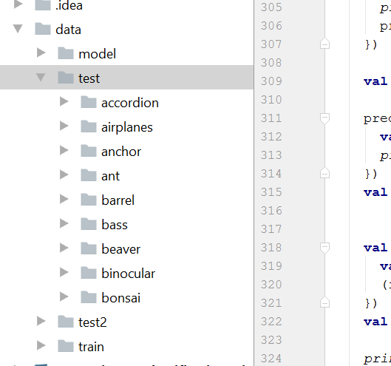

**4.2 Sample Key Descriptors:**

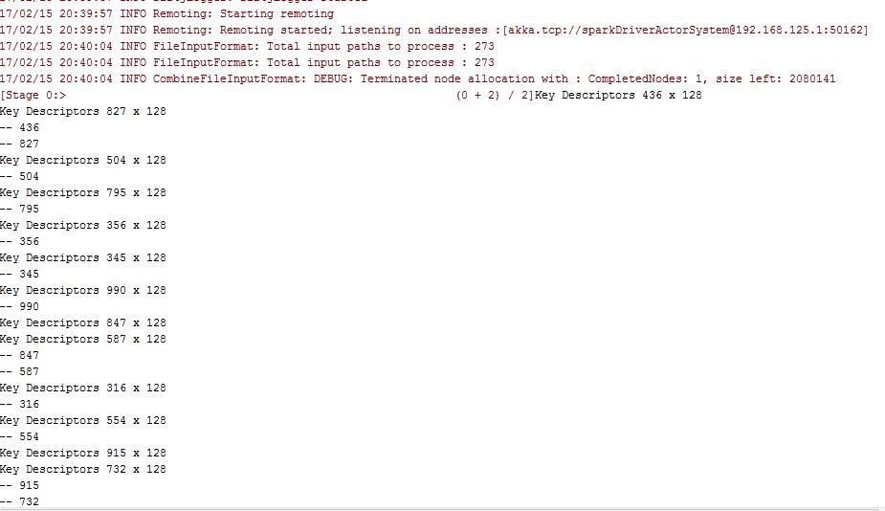

4.3 Sample Histograms:

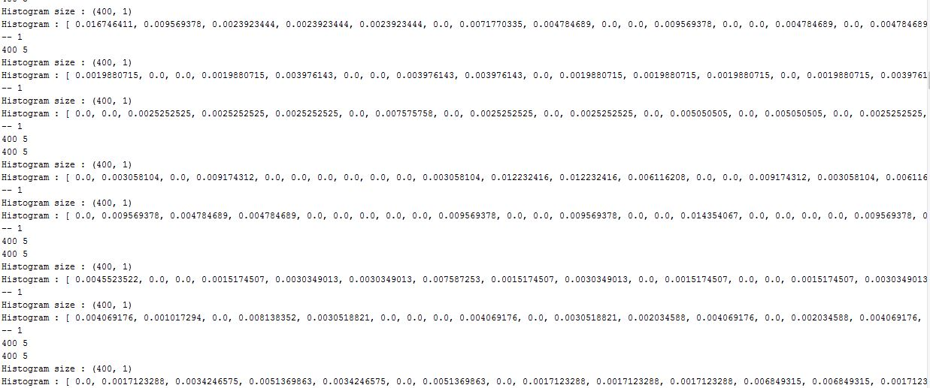

**4.4 Sample Decision Tree:**

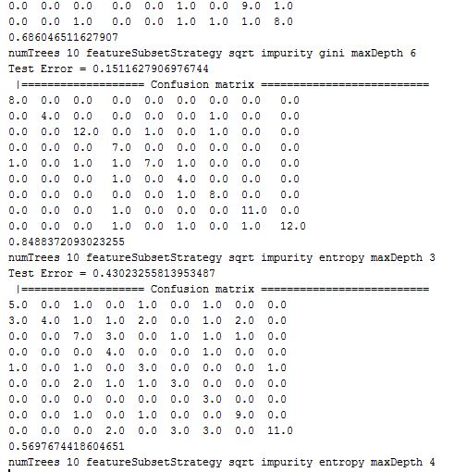

**4.5 Sample output:**

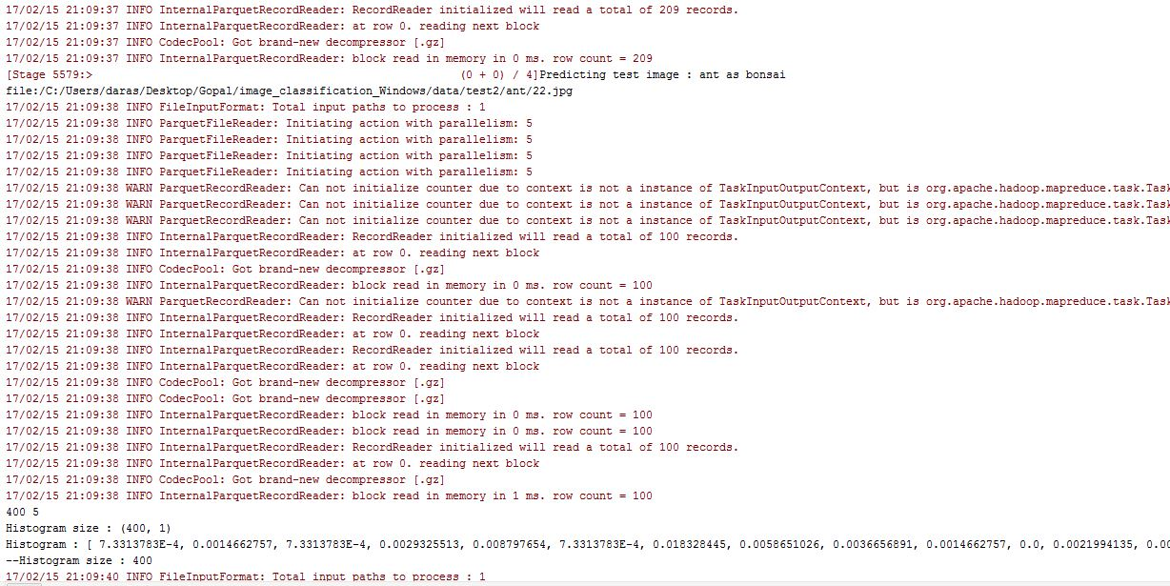

**4.6 Confusion Matrix:**

