1. Generate Timesheet

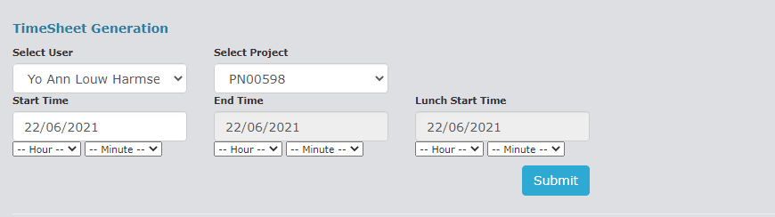

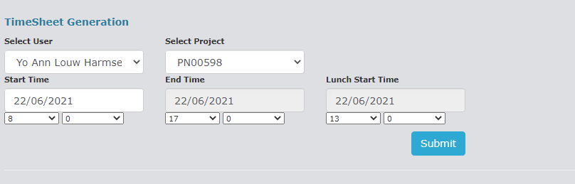

1. View Timesheet

