

Siva Prasanna S,

Associate Software Developer,

[sivaprasanna.s@heptagon.in](mailto:sivaprasanna.s@heptagon.in)

WORKFLOW

1. INTRODUCTION:

A WorkFlow is the process of how you get stuff done. It’s a system that makes work more efficient while keeping you on the same page. Workflow management is all about building and tracking these processes. WorkFlow is like a home base for all your workflows: use it as a tool to create workflows and track your own work.

2. SYSTEM REQUIRMENTS:

|  |  |
| --- | --- |
| Front – End Development | Angular |
| Back -End Development | MySQL, Spring boot |
| Internet | High Speed Internet |

3. SYSTEM DESIGN:

Software design serves as a foundation for all the software engineering steps that follow. Without a strong design we risk building an unstable system that will be difficult to test, one whose quality cannot be assessed until the last stage. Design is the first step in the development phase for any engineered product or system. The designer’s goal is to produce a model or representation of an entity that will later be built. Design is the place where quality is fostered in software development. Design provides us with representations of software that can assess the quality. Design is the only way that we can accurately translate a customer’s view into a finished software product or system.

4. SYSTEM MODULES:

The various system modules are:

1. Home
2. Task
3. Profile
4. Login
5. Register

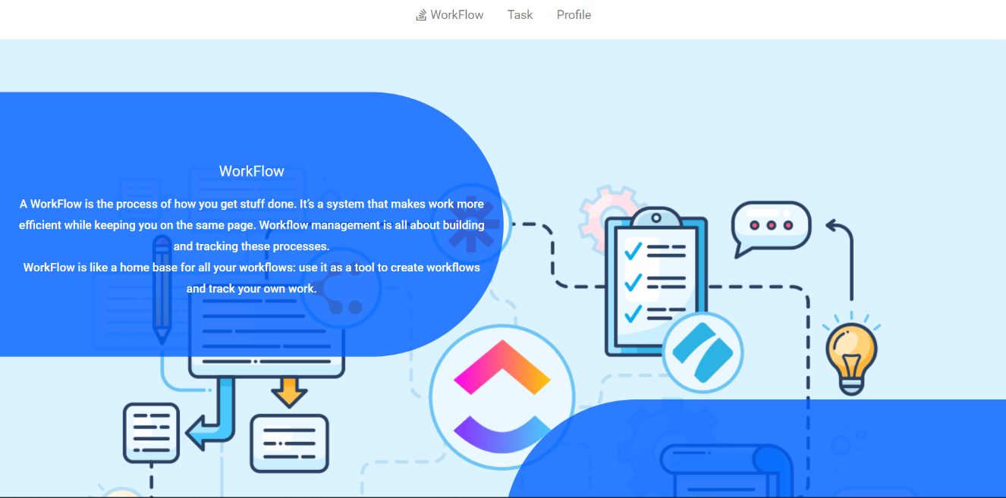 4.1. HOME

4.2. TASK

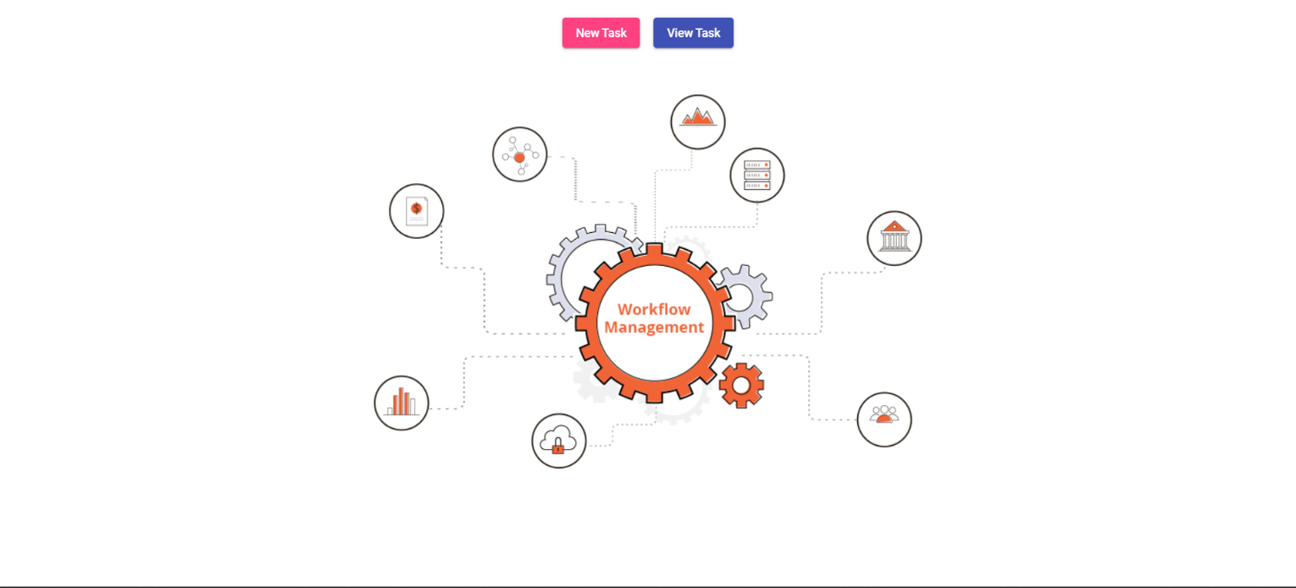

4.3. NEW TASK

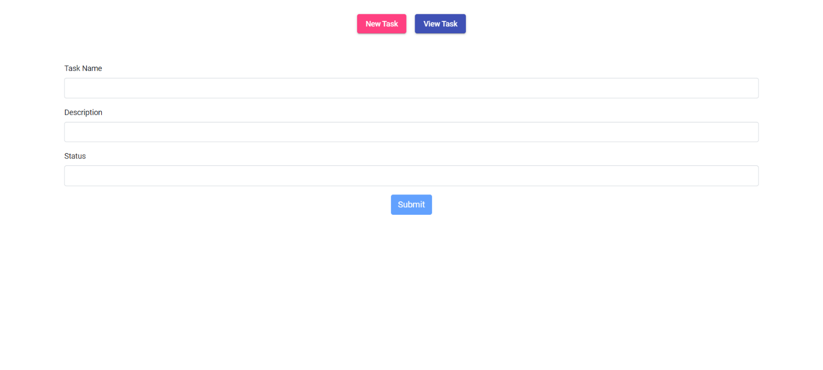

4.4. VIEW TASK

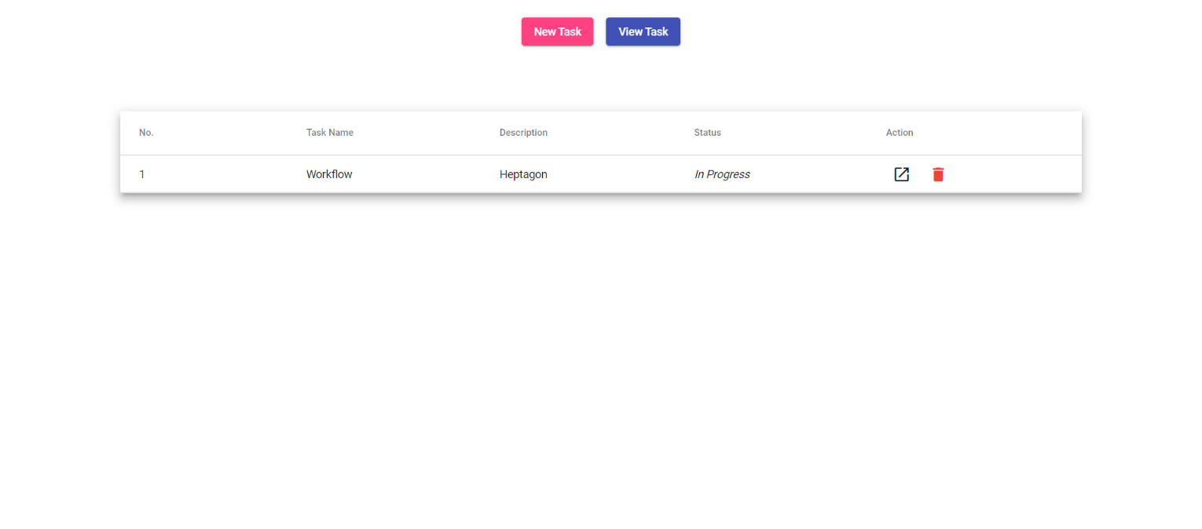

4.5. PROFILE

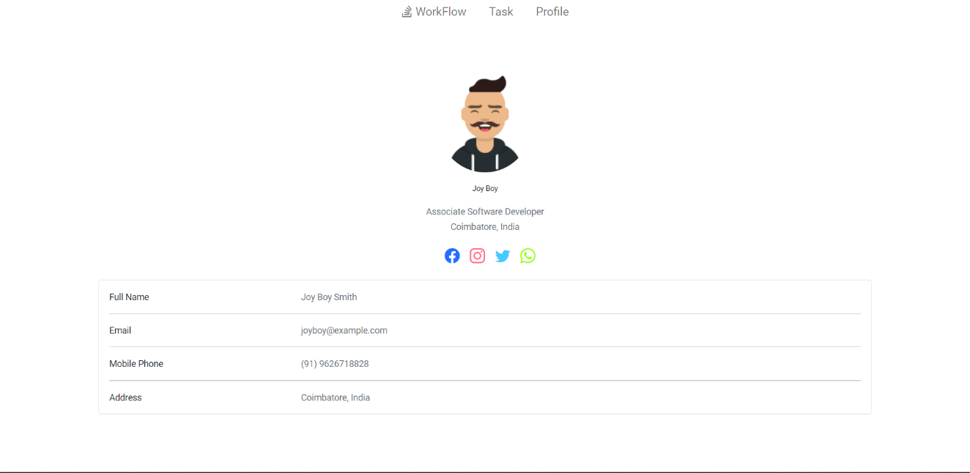

 4.6. LOGIN

4.7. REGISTER

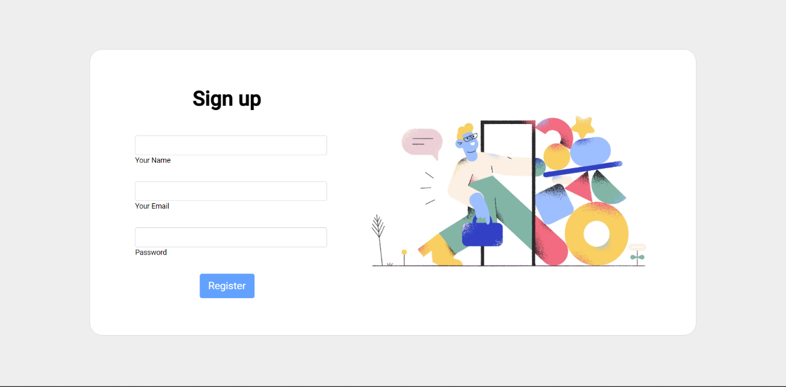

5. WORKFLOW:

START

UPDATE TASK

DELETE TASK

VIEW TASK

ADD TASK

OPERATION

TASK

LOG OUT

PROFILE

TASK

HOME

REGISTER

LOGIN

6. CONCLUSION:

WorkFlow system will be very useful to segregate and maintain your task.