TASK-5(II)

Cognizance

Sivaananth

CSE-B

21165

* Write a bash script to echo your name 25 times

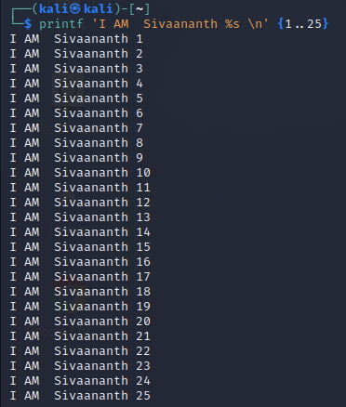

* What command should I use to display the **first** 30 entries of syslog file?

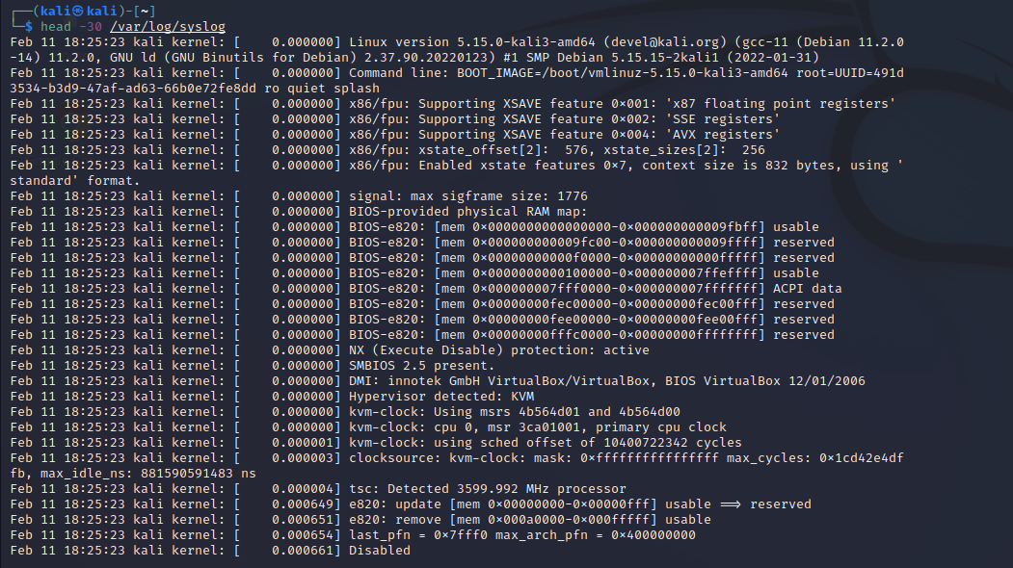

* What command should I use to display the **last** 30 entries of syslog file?

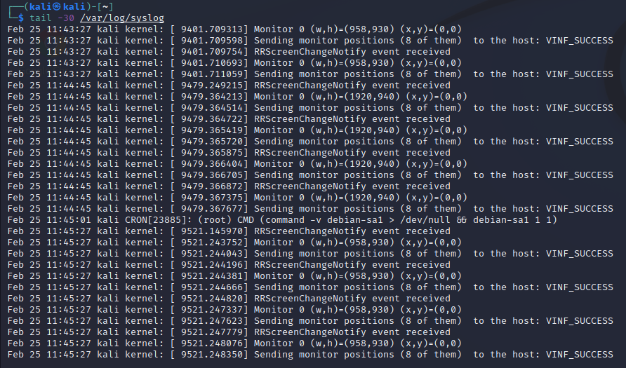

What command should I use to arrange the entries of a file

* Alphabetically

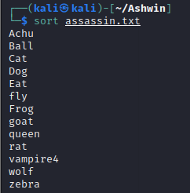

* Reverse order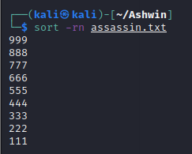
* Numerical order

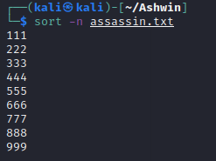

* Copee is a hard-working cop. He found a case and almost at the verge of cracking it. It could be his best breakthrough. He has the list of criminals but lots of duplicates are there. He needs to find the only one that is **different.** He sought your help. How will you sort this issue?

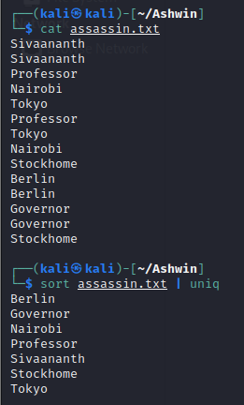

The four parts of file’s permission are:-

* Read(r) – Allowed to read the file
* Write(w) – Allowed to change the contents of file
* Execute – Allowed to use the file as a command