**Hands on AWS Lab**

**Lab 1: Create And Connect To Windows EC2 Machine**

**Objective:**

Setting up and securely connecting to a Windows EC2 instance on AWS.

**Architectural Diagram:**

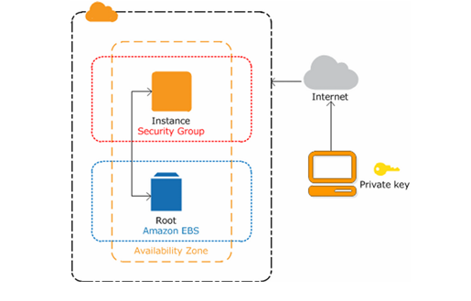

**Steps:**

* Launching the Windows Instance
* Connecting to the Windows Instance
* Resetting Password for Windows Instance

**Step-by-Step Instructions:**

**Step 1: Log In to AWS Management Console**

1. Open [AWS Management Console](https://aws.amazon.com/console/).
2. Log in with your AWS credentials.

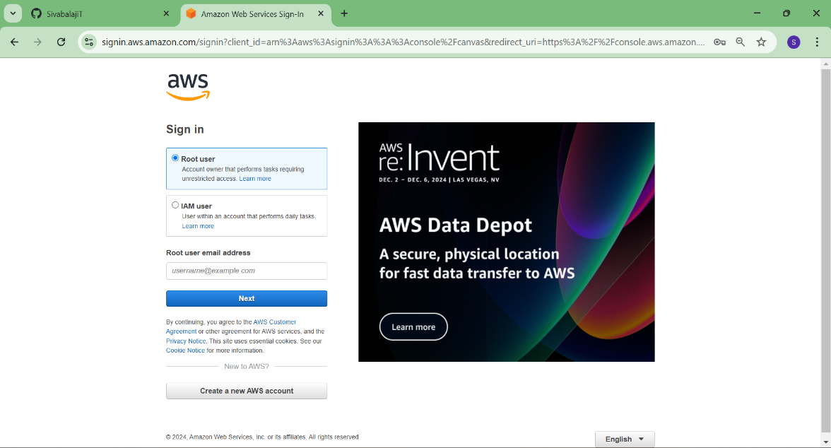

**Step 2: Launch an EC2 Instance**

1. Navigate to **EC2 Dashboard**:

* Type "EC2" in the AWS search bar and select **EC2**.

1. Click **Launch Instances**:

* Under the "Instances" section, click **Launch Instances**.

3.Wait for the instance to initialize:

* Return to the **Instances** page, and wait until the instance state shows as "Running."

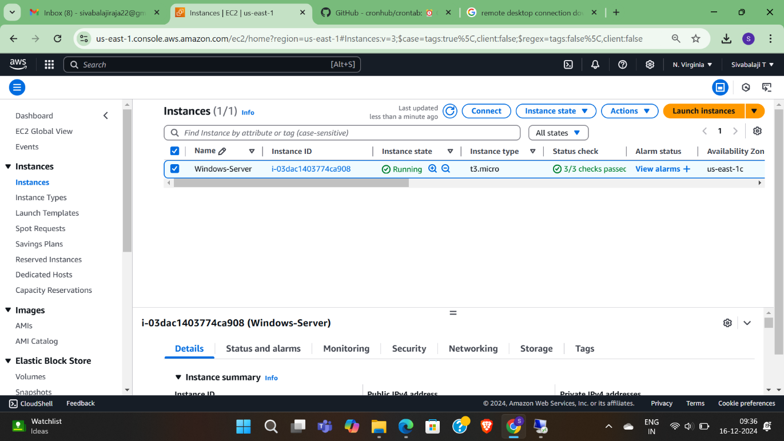

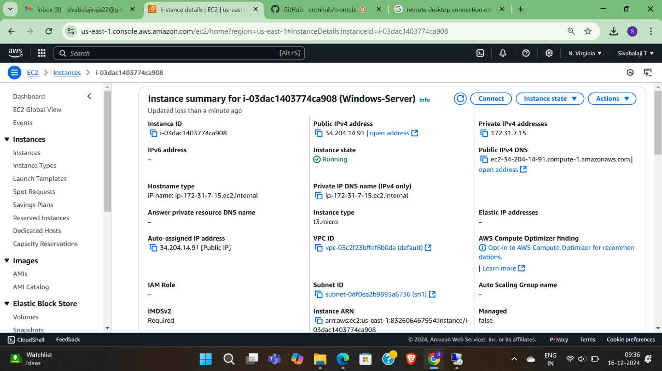

**Step 3: Connect to the Windows EC2 Instance**

1. **Retrieve the Password**:

* Select your instance > click **Connect**.
* Under "RDP client," click **Get Password**.
* Upload the key pair file (.pem), and click **Decrypt Password**.
* Copy the decrypted password.

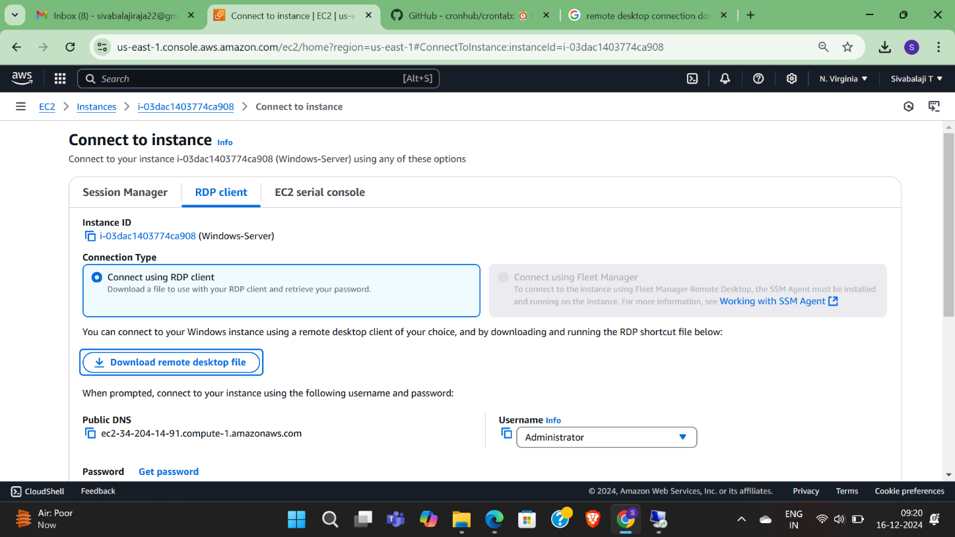

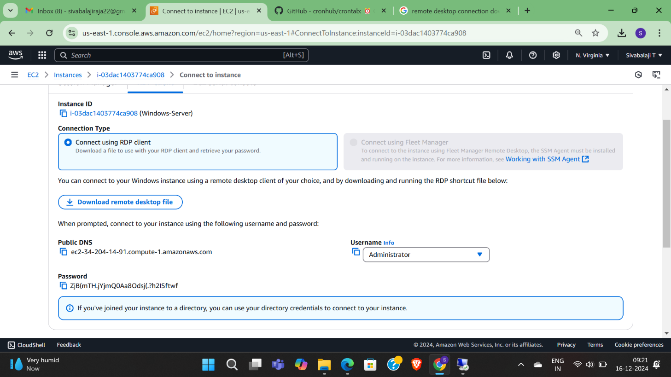

**2.Connect via Remote Desktop**:

* Download and install a Remote Desktop client (if not already installed).
* Use the public IP of the instance:
* Open the Remote Desktop client.
* Enter the public IP address.
* Enter the username (Administrator) and the decrypted password.
* Click **Connect** to access your Windows EC2 instance.

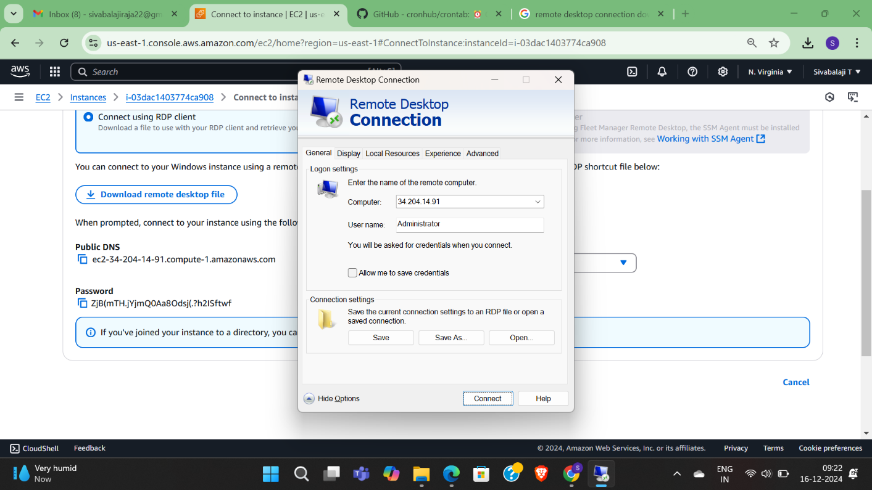

**Step 4: Post-Connection Tasks**

1. **Verify Connectivity**:
   * Ensure the Windows server desktop is accessible.
   * Check internet access and any required configurations.
2. **Security Best Practices**:
   * Change the password for the Administrator account.
   * Limit the RDP access in the security group by restricting allowed IP ranges.

