Educational Organization

**Using ServiceNow**

**Team Members:**

|  |  |
| --- | --- |
| **Sivabalan G** | **820422205075** |
| **Sriram R** | **820422205078** |
| **Nivash M** | **820422205049** |
| **Senthamizharasu D** | **820422205071** |

# Abstract

The project titled **“Educational Organization”** focuses on the digital transformation of educational service management through the implementation of **ServiceNow**, a leading cloud-based **IT Service Management (ITSM)** and workflow automation platform. In most educational institutions, administrative and technical services—such as maintenance requests, student support queries, and IT incident handling—are managed through manual processes involving paper-based forms, emails, or verbal communication. These traditional methods often result in inefficiencies, delays in response times, lack of transparency, and difficulty in tracking the status of requests or responsibilities.

To address these challenges, the proposed system leverages **ServiceNow** to design and implement an **automated workflow-driven solution** that simplifies and centralizes the management of academic and administrative services within the organization. The platform’s powerful features such as the **Service Catalog**, **Incident Management**, **Workflow Editor**, and **Custom Application Development** are utilized to build a system that enables students, faculty, and staff to submit service requests or report issues through a single, unified portal.

The project’s core objective is to replace time-consuming manual procedures with a digital platform that offers **real-time visibility**, **automated task assignments**, and **role-based access control**. This ensures that every request is properly logged, prioritized, routed to the appropriate department, and tracked until completion. Automated notifications and approval workflows improve collaboration between departments and reduce administrative overhead.

From a design perspective, the system emphasizes a **user-friendly interface (UI)** and an intuitive **user experience (UX)**, ensuring that even non-technical users can easily navigate and use the system. The project also incorporates elements such as dynamic forms, validation scripts, and automated email alerts to enhance interactivity and reliability.

The successful implementation of this system demonstrates how **ServiceNow** can be customized beyond traditional IT environments to support the operations of an educational institution. By introducing **automation, transparency, and accountability**, the project significantly improves service quality, reduces operational bottlenecks, and enhances user satisfaction. Furthermore, this digital initiative aligns with the broader vision of creating **smart campuses**, where technology-driven solutions streamline daily activities, optimize resources, and foster an environment of innovation and collaboration.

The project validates the adaptability of the **ServiceNow platform** to diverse domains outside corporate IT, particularly in academia where administrative and student support systems often struggle with inefficiencies. Through the integration of modules such as **Incident Management**, **Service Catalog**, and **Workflow Automation**, the system simplifies complex service processes, minimizes delays, and provides measurable performance improvements.

In addition, the platform enables educational administrators to gain **real-time insights** into institutional operations through analytical reports and dashboards. These tools allow management to identify recurring issues, monitor departmental workloads, and evaluate the responsiveness of support teams. The data-driven insights obtained through ServiceNow contribute to informed decision-making, better policy formulation, and continuous process optimization.

From a long-term perspective, this project lays a strong foundation for **digital transformation in educational governance**. It opens the door for future integrations with **Learning Management Systems (LMS)**, **Student Information Systems (SIS)**, and other academic platforms, enabling a unified digital ecosystem across the institution

# Introduction

**Background of the Project**

In the modern era, educational institutions are expanding rapidly in both scale and complexity. They are no longer limited to traditional teaching and learning functions but have evolved into multifaceted organizations that manage a wide range of academic, administrative, and technical operations. These operations include handling student and faculty requests, resolving technical issues, maintaining campus facilities, and ensuring smooth coordination between various departments such as IT, administration, maintenance, and academics.

However, most institutions still rely on **manual, paper-based processes** or scattered communication methods like email and phone calls to handle internal requests and issue reporting. This manual approach often leads to inefficiencies such as delayed responses, loss of information, duplication of work, and lack of visibility into request progress. When service requests or incidents are handled manually, there is no standardized process to ensure accountability, prioritization, or timely resolution.

The absence of a centralized system results in **ineffective communication**, **inefficient workflows**, and **poor tracking mechanisms**. For example, if a faculty member reports a malfunctioning projector or a student raises an IT issue, the request might be passed through several intermediaries before reaching the right technician. Without a tracking system, it becomes difficult to monitor whether the request was resolved, when it was completed, and who was responsible.

With increasing student populations and expanding infrastructure, these inefficiencies become even more prominent. As institutions aim to provide high-quality services and seamless user experiences, there is a growing need for **automation, digitization, and transparency** in their internal management processes.

This project, titled **“Educational Organization,”** addresses this very challenge by leveraging **ServiceNow**, a powerful cloud-based IT Service Management (ITSM) and workflow automation platform. The system developed in this project aims to automate the processes of service request management, incident reporting, and approval workflows for educational environments. By transforming traditional manual systems into digital workflows, this project contributes to building a **“smart campus” ecosystem** — one that integrates technology into daily academic and administrative activities to improve overall efficiency and satisfaction.

## Why ServiceNow Was Chosen

The selection of **ServiceNow** for this project was driven by its versatility, scalability, and capability to design customized enterprise-level solutions with minimal coding effort. ServiceNow is one of the most trusted and widely adopted platforms for workflow automation across various industries, including education, healthcare, and IT services.

Several factors influenced the decision to use ServiceNow as the core platform for this project:

## Low-Code / No-Code Development Environment:

ServiceNow’s intuitive tools like **ServiceNow Studio**, **Flow Designer**, and **Workflow Editor** allow developers to design complex applications and workflows without deep programming knowledge. This makes it suitable for academic and student-led projects.

## Centralized Service Management:

ServiceNow provides a unified platform to manage all types of requests — IT issues, maintenance needs, administrative queries, and more — within a single system. This centralized structure ensures standardization and improves visibility.

## Automation and Efficiency:

Manual tasks such as request routing, approval, and notifications can be automated using business rules and flow designer tools. This drastically reduces human intervention and minimizes errors.

## Scalability and Integration:

The platform can easily scale to accommodate more departments or features, and it supports integration with other systems like Student Information Systems (SIS) and HR databases, which can be added in future enhancements.

## Real-Time Tracking and Analytics:

One of ServiceNow’s key strengths is its ability to track requests in real-time and generate reports on service performance. These analytics can help educational administrators make informed decisions.

## Free Developer Instance:

ServiceNow offers a **personal developer instance** that can be used by students and developers to practice and build custom applications. This makes it accessible and cost-effective for educational projects.

Given these advantages, ServiceNow was the ideal choice for developing an automated service management system tailored for educational institutions. Its flexibility enables the creation of custom applications like **Service Request Portals**, **Incident Tracking Systems**, and **Knowledge Bases**, all of which can enhance institutional service quality.

## Objectives of the Project

The primary objective of this project is to design and implement a **ServiceNow-based automated system** for managing service requests and incidents within an educational organization. The system aims to create a more efficient, transparent, and user-friendly environment for students, faculty, and administrative staff.

The detailed objectives include:

## To Automate Manual Processes:

Replace traditional paper-based service request and approval systems with an automated digital workflow on the ServiceNow platform.

## To Centralize Service Management:

Develop a unified portal that allows users to submit, track, and manage requests in real time from anywhere within the institution.

## To Improve Communication and Visibility:

Ensure that all stakeholders (students, staff, and administrators) have access to transparent status updates and communication regarding their requests or incidents.

## To Enable Efficient Workflow and Approvals:

Implement approval chains, task assignments, and escalation mechanisms to reduce delays and improve accountability.

## To Enhance User Experience:

Design an intuitive and responsive user interface (UI) that simplifies form submissions, reduces input errors, and provides quick access to services.

## To Reduce Turnaround Time:

Utilize automation and notifications to ensure faster acknowledgment, assignment, and resolution of requests.

## To Provide Reporting and Analytics:

Enable administrators to generate reports and track performance metrics such as number of requests, average resolution time, and departmental efficiency.

## To Build a Scalable and Sustainable System:

Design the system architecture to be adaptable for future enhancements such as mobile integration, chatbot support, and analytics dashboards.

The project titled **“Educational Organization”** aims to modernize and automate the internal service management processes within educational institutions through the use of **ServiceNow**, a leading cloud- based IT Service Management (ITSM) platform. In traditional educational settings, administrative and academic service requests—such as facility maintenance, IT support, staff approvals, and student inquiries—are often handled manually through emails, phone calls, or paper-based systems. These methods are time-consuming, prone to delays, and lack transparency in tracking progress or accountability. With the increasing need for efficiency and digital transformation, educational institutions are now seeking smarter solutions o manage internal operations seamlessly and improve user experience for both staff and students.

**ServiceNow** was chosen as the foundation for this project due to its flexibility, scalability, and powerful automation capabilities. It provides a unified platform where institutions can build custom workflows, automate repetitive tasks, and centralize service requests in one intuitive interface. The main objectives of this project are to enhance communication between departments, streamline service delivery, and reduce manual intervention. By implementing modules such as **Service Catalog**, **Incident Management**, and **Workflow Editor**, the system aims to create a transparent and efficient process for handling academic and administrative needs. Ultimately, the project seeks to demonstrate how ServiceNow can transform traditional educational processes into a **smart, automated, and data- driven service ecosystem**.

Additionally, this project emphasizes how technology can bridge the gap between administrative efficiency and user satisfaction within an educational ecosystem. By adopting ServiceNow, the institution gains a structured, automated environment that eliminates redundancies and promotes accountability. The platform’s cloud-based nature ensures accessibility from anywhere, enabling students, faculty, and administrators to raise and track requests in real time. Moreover, the system provides valuable analytics and reporting capabilities, allowing decision-makers to monitor performance, identify bottlenecks, and implement continuous improvements.

# Problem Statement:

In many educational institutions, administrative and academic operations are often managed through manual processes that rely heavily on paperwork, emails, and in-person communication. This traditional approach leads to several inefficiencies, including delays in service delivery, miscommunication between departments, and difficulty in tracking requests or maintaining accountability. For instance, when students or staff members face issues such as requesting IT support, reporting facility maintenance problems, or seeking approvals for academic activities, these requests are often handled manually through phone calls or physical forms. This results in lost information, inconsistent updates, and a lack of visibility into the status of each request. Moreover, administrators often struggle to prioritize tasks or measure performance due to the absence of centralized data and real-time reporting. As the number of students and staff increases, these challenges multiply, causing unnecessary workload and frustration across all levels of the institution.

Another major concern is the absence of an integrated system to connect various departments such as IT, administration, academics, and facilities management. Each department often maintains its own processes and tools, leading to silos of information and limited collaboration. Without a unified service management platform, communication gaps frequently occur, making it difficult to ensure timely responses or monitor service quality. Additionally, the lack of automation results in repetitive manual tasks, such as re-entering the same data across multiple systems or sending constant reminders for pending approvals. This not only reduces productivity but also increases the risk of human error. The absence of a proper escalation mechanism further aggravates the issue, as unresolved requests can go unnoticed for long periods. Furthermore, the management has limited ability to generate insights or analytics regarding service performance, resource allocation, or user satisfaction, since data is scattered and unstructured.

In today’s fast-paced, technology-driven environment, such manual and disconnected systems hinder the growth and modernization of educational organizations. Institutions are expected to operate with the same level of efficiency and service quality as modern enterprises, providing seamless experiences to their users. However, the lack of digital infrastructure prevents them from meeting these expectations. This project, therefore, addresses the critical need for a centralized, automated, and transparent service management system that can replace manual workflows and fragmented communication channels. By leveraging ServiceNow’s capabilities, the goal is to transform traditional processes into an intelligent, user-friendly digital ecosystem that enhances visibility, accountability, and overall operational performance. The problem statement thus revolves around eliminating inefficiencies, improving coordination between departments, and ensuring that service requests—from IT support to administrative approvals—are managed systematically, tracked efficiently, and resolved promptly within the educational environment.

Furthermore, the absence of a structured digital platform in educational institutions has resulted in poor visibility into ongoing operations and service performance, making it challenging for management to make informed decisions. Without real-time tracking and reporting, administrators lack the ability to monitor workloads, identify recurring issues, or measure departmental efficiency. This lack of insight often leads to delays in addressing critical problems, such as unresolved maintenance requests or IT failures that disrupt learning activities. Additionally, the absence of transparency creates frustration among users—students and staff have no clear way to check the status of their requests or know who is responsible for resolving them. Over time, this weakens trust in the institution’s administrative system and lowers overall satisfaction levels. Therefore, implementing an automated platform like ServiceNow becomes essential not only to streamline processes but also to introduce transparency, accountability, and data-driven management.

# Methodology/System Design:

The methodology and system design of the **“Educational Organization”** project revolve around leveraging **ServiceNow’s cloud-based capabilities** to create an integrated, automated, and user- friendly service management platform tailored for educational institutions. The approach follows a structured development process, starting from requirement analysis and design planning to implementation and testing. Initially, the existing challenges in the manual system—such as lack of transparency, delayed responses, and inefficient communication—were analyzed to define the scope and objectives of automation. Based on this analysis, the system was designed to handle common institutional needs such as service requests, incident management, maintenance reporting, and approval workflows. The **Agile methodology** was adopted to ensure flexibility in development, allowing iterative improvements and feedback at every stage. Each phase—requirement gathering, design, development, testing, and deployment—was carefully executed to ensure the system aligned with institutional goals and user expectations.

The **design approach** focused on creating a centralized platform that streamlines communication and automates service processes between students, staff, and administrators. ServiceNow’s built-in tools such as **Service Catalog**, **Incident Management**, and **Workflow Editor** were utilized to model the institution’s workflows digitally. Custom tables and forms were developed to capture specific academic and administrative requirements, such as classroom maintenance requests, IT support tickets, and leave approvals. The workflows were designed to ensure that once a request is raised, it automatically routes to the appropriate department or authority for action, reducing manual intervention. Notifications and escalations were configured to ensure that no request remains unattended. Additionally, role-based access control was implemented to maintain data privacy and ensure that users only view information relevant to their roles—students can raise requests, staff can approve or resolve them, and administrators can oversee operations.

The **system architecture** of the project integrates multiple ServiceNow modules to function cohesively as one digital ecosystem. The architecture is layered, with the **user interface (UI)** at the top, where users interact through the Service Portal. The **application logic layer** handles workflow automation, approvals, and notifications, while the **database layer** manages the storage of all service requests, user details, and activity logs. This modular architecture ensures scalability, enabling the institution to add new services or departments in the future without major redesign. Furthermore, the platform’s **integration capability** allows for potential connections with student information systems, HR modules, or external communication tools like email and messaging platforms to enhance collaboration.

The **User Interface (UI) and User Experience (UX)** design focused on simplicity, clarity, and accessibility. The Service Portal was customized with institutional branding, intuitive navigation, and clear categories for different types of requests. Forms were designed with minimal input fields and pre- filled user data to reduce effort and errors. The portal also provides users with real-time tracking of their requests, along with automatic email or notification updates. Administrators have access to dashboards that display live analytics, including the number of active requests, average resolution time, and departmental performance. This ensures that users at all levels experience a seamless, efficient, and transparent workflow process.

Overall, the methodology and system design highlight the adaptability of ServiceNow in creating an educational service management system that goes beyond traditional IT support. The combination of structured workflows, automated notifications, user-friendly interfaces, and robust reporting capabilities ensures that the institution operates efficiently, transparently, and in alignment with its digital transformation goals.

# Design Approach:

The **design approach** of the project **“Educational Organization”** is centered around creating a seamless, efficient, and user-oriented digital environment that automates and simplifies the internal service management processes within an educational institution. The design philosophy is built on three core principles: **automation, accessibility, and accountability**. The goal is to replace time-consuming manual operations with automated workflows, provide a unified portal accessible to all users, and ensure every service request or issue is transparently tracked until resolution. To achieve this, the system is designed using the modular capabilities of the **ServiceNow platform**, which offers powerful tools for creating custom applications, managing workflows, and delivering intuitive user experiences. The focus is not only on digitizing existing processes but also on improving them through intelligent routing, notifications, and data-driven insights.

The system utilizes several **key ServiceNow features and modules** that together form the backbone of the solution. The **Service Catalog** module is used to create a centralized catalog of services, such as IT support, classroom maintenance, equipment requests, and administrative approvals. Each service is defined with its own request form, workflow, and approval chain, allowing users to easily submit and track requests. The **Incident Management** module is employed to handle and monitor issues raised by students or staff—such as technical problems or facility malfunctions—ensuring they are categorized, prioritized, and resolved efficiently. To manage and customize these workflows, **ServiceNow Studio** is used as the development environment, where custom tables, fields, and forms are designed according to the specific needs of the institution. The **Workflow Editor** plays a crucial role in automating the flow of tasks, such as routing requests to the appropriate departments, sending notifications to responsible users, and triggering escalations for overdue tasks.

Additionally, the design includes the use of **UI Policies, Business Rules, and Client Scripts** to enhance the user experience and system behavior. For instance, UI Policies dynamically adjust form fields based on user input, ensuring that only relevant information is displayed, while Business Rules enforce data integrity and automate backend logic, such as updating request status or assigning tickets automatically. **Notifications and Service Level Agreements (SLAs)** are also configured to keep users informed of progress and to ensure timely service delivery within defined time frames. The portal’s **user interface (UI)** is designed with simplicity and clarity in mind, incorporating institutional branding, intuitive icons, and easy navigation for different user roles—students, staff, and administrators.

In summary, the design approach leverages the full potential of ServiceNow’s low-code development capabilities to build a solution that is both robust and flexible. By integrating modules like **Service Catalog, Incident Management, Workflow Editor, and ServiceNow Studio**, the project delivers a digital ecosystem that enhances collaboration, speeds up service resolution, and provides real-time visibility into operations. This thoughtful combination of functionality and design ensures that the educational organization moves closer to becoming a **smart, automated, and service-oriented institution**.

Furthermore, the design approach emphasizes scalability and customization to meet the evolving needs of the institution. Educational organizations often experience dynamic operational changes, such as new academic programs, shifting administrative structures, or expanding infrastructure, and the system is built to adapt seamlessly to such developments. The use of **modular design principles** allows new services or departments to be added effortlessly without disrupting existing workflows. In addition, the system incorporates **role-based access controls (RBAC)** to ensure data security and define user privileges clearly—students can submit requests, staff can approve or resolve them, and administrators can monitor overall performance. The design also integrates **reporting and analytics dashboards**, giving management real-time insights into request trends, response times, and departmental efficiency.

# System Architecture

The **system architecture** of the project **“Educational Organization”** is designed to provide a unified, scalable, and automated service management environment within the educational institution using the **ServiceNow platform**. The architecture follows a **multi-layered model** that integrates different modules, workflows, and user interfaces to deliver a seamless experience for students, staff, and administrators. Each layer of the system plays a specific role—ensuring that requests flow smoothly from submission to resolution while maintaining transparency, efficiency, and accountability throughout the process. The system architecture primarily consists of three key layers: the **presentation layer (User Interface)**, the **application logic layer (Workflow & Automation)**, and the **data layer (Database & Records Management)**. Together, these layers interact cohesively to form a reliable, cloud-based service management ecosystem.

At the **presentation layer**, users interact with the system through a customized **Service Portal**, which acts as the central access point for all services. The portal is designed with simplicity and clarity, allowing students and staff to log in, browse the **Service Catalog**, and submit requests or incidents based on their needs. For instance, a student can raise a request for repairing classroom equipment, or a staff member can submit an IT support ticket—all from one unified interface. The portal dynamically adjusts based on user roles, ensuring each user sees only the services relevant to them. The **UI Pages**, **Forms**, and **Catalog Items** within the ServiceNow platform are customized to capture institution- specific data fields and ensure user-friendly navigation. Additionally, real-time updates, notifications, and request-tracking dashboards enhance user engagement and transparency.

The **application logic layer** forms the core of the system and is responsible for managing workflows, automations, and business rules. This layer utilizes **Workflow Editor**, **Flow Designer**, and **Business Rules** to automate tasks such as routing requests to the appropriate departments, assigning tickets to specific staff, triggering approvals, and sending notifications at each stage. The logic layer also includes **UI Policies** and **Client Scripts** that dynamically control the behavior of forms and interfaces, ensuring data validation and improving user experience. The **Incident Management** and **Service Catalog** modules operate within this layer, handling the creation, assignment, and resolution of tickets. Additionally, **Service Level Agreements (SLAs)** are applied here to monitor response and resolution times, ensuring timely action and accountability. This centralized automation minimizes human intervention and ensures consistent service quality across departments.

The **data layer** handles the storage, retrieval, and management of all records within the system. ServiceNow’s built-in database structure is used to store essential information such as user profiles, service requests, incidents, and workflow logs. Custom tables are created for institution-specific needs, such as student requests, maintenance logs, or faculty approvals, providing flexibility while maintaining data integrity. The system also supports relational links between tables, allowing for easy access and reporting across various entities. Furthermore, data in this layer is secured through **role- based permissions**, ensuring that sensitive information is accessible only to authorized users.

In addition to the core architecture, the system design allows for **integration capabilities** that extend beyond the ServiceNow environment. The platform can be connected to external tools such as **email servers** for automated notifications, **student information systems (SIS)** for synchronized user data, and **analytics dashboards** for real-time performance monitoring. These integrations help in creating a connected ecosystem that supports both administrative and academic functions efficiently.

Overall, the system architecture ensures smooth interaction between users, workflows, and data while maintaining flexibility for future enhancements. By structuring the solution into well-defined layers and integrating automation at every level, the architecture supports the goal of creating a **smart, efficient, and technology-driven educational service management system** using ServiceNow.

# User Interface (UI) and User Experience (UX):

The **User Interface (UI)** and **User Experience (UX)** design of the project **“Educational Organization”** are centered around creating an intuitive, accessible, and visually appealing digital platform that ensures seamless interaction between users and the system. The goal of the design is to provide a **simple yet powerful interface** where students, staff, and administrators can easily navigate, raise requests, and track their progress without confusion or delay. Since the target users of the system include individuals with varying levels of technical expertise, the interface prioritizes

**clarity, consistency, and ease of use**. The design philosophy focuses on minimizing the number of steps required to complete any action while ensuring all critical information is visible and easily accessible.

The **Service Portal** serves as the primary entry point for users and is designed using ServiceNow’s customization options to reflect the branding of the educational institution—featuring the institution’s logo, color themes, and banners to give a professional and cohesive look. The homepage layout provides clearly categorized service sections such as **IT Support**, **Facility Maintenance**,

**Administrative Requests**, and **Academic Assistance**. Each category contains specific service catalog items represented by easily recognizable icons and short labels. Users can quickly search for the service they need through the search bar or browse through the categorized tiles. Once a user selects a service, a **custom-designed form** appears with relevant fields tailored for that request type. These forms are simplified and dynamic—using **UI Policies** and **Client Scripts** to display only necessary fields based on the user’s selection, reducing clutter and confusion. For example, if a user reports an IT issue, only device-related fields will appear, while facility requests will display location and maintenance-related options.

The **forms and layouts** are carefully structured to ensure smooth data entry and validation. Each form includes predefined dropdown lists, radio buttons, and auto-filled user information (like name, email, and department) fetched from the user profile to save time and prevent errors. Mandatory fields are clearly indicated, and validation rules prevent incomplete submissions. Once a request is submitted, users are immediately provided with a **confirmation message** and a unique request ID for tracking. The **request tracking interface** allows users to view the current status of their tickets—such as “Open,” “In Progress,” “Awaiting Approval,” or “Resolved”—along with timestamps and assigned personnel details. Automated **email and in-app notifications** ensure users stay informed about every stage of the process, from submission to resolution.

For staff and administrators, the UX design focuses on **efficiency and visibility**. Dashboards are created using ServiceNow’s reporting and performance analytics tools to provide a clear overview of active requests, pending tasks, and resolution timelines. Color-coded visual indicators highlight urgent or overdue tasks, helping staff prioritize effectively. Additionally, administrators have access to analytics dashboards that display key performance metrics such as average response time, most common request types, and department efficiency. These dashboards are designed to be interactive, allowing users to filter and drill down into specific details as needed.

Accessibility and responsiveness are also core aspects of the design. The portal is optimized for multiple devices—desktops, tablets, and smartphones—ensuring that users can raise or track requests from anywhere, at any time. The use of consistent color schemes, readable fonts, and appropriate contrast enhances readability and ensures compliance with accessibility standards. Animations and transitions are kept minimal to maintain speed while providing a modern, engaging experience.

# Implementation Details:

The **Implementation Details** of the project **“Educational Organization”** focus on the practical execution of the system—beginning from platform setup and configuration to development, customization, and workflow automation—within the **ServiceNow** environment. The implementation was carried out systematically to ensure that every component of the system worked cohesively to support the institution’s service management needs. The process began with setting up the ServiceNow instance, defining user roles, and creating the necessary database structures, followed by building customized forms, workflows, and automation scripts. Each phase was tested for accuracy, usability, and performance to ensure a reliable and efficient platform.

The first stage, **Platform Setup**, involved configuring the ServiceNow instance specifically for the educational institution. Administrative roles were defined to manage the platform, while user groups such as *students*, *faculty*, *technical staff*, and *administrators* were created to represent different access levels. Role-based access control (RBAC) ensured that each user could only view and interact with features relevant to their responsibilities. The initial configuration also included updating organizational details such as the institution name, logo, and departmental structure. This setup provided the foundation for assigning service requests, approvals, and incident management tasks to appropriate users or teams.

Next, the **Development and Customization** phase involved creating **custom tables**, **fields**, and **forms** that catered specifically to the operational needs of an educational institution. Using **ServiceNow Studio**, custom applications were developed to manage workflows like *Classroom Maintenance Requests*, *IT Support Tickets*, and *Administrative Approvals*. Each application contained its own set of database tables and user interfaces. The **Service Catalog** was configured with categorized service items, enabling users to submit various requests through an easy-to-navigate interface. Forms were designed with minimal but essential fields, using **UI Policies** and **Client Scripts** to make them dynamic and context-aware. For example, when a student selects a service type as “Facility Issue,” location and room number fields become visible automatically, ensuring only relevant data is captured.

The **Workflow Implementation** phase was the core of automation. Using ServiceNow’s **Workflow Editor** and **Flow Designer**, each service request was assigned a predefined lifecycle—from submission to approval and resolution. Workflows were configured to route requests automatically to the respective department, notify users about updates, and escalate cases if unresolved within a specified time frame. For instance, an IT issue raised by a student is automatically assigned to the IT team, which receives notifications until the issue is marked as resolved. **Business Rules** and **Notifications** were implemented to handle backend logic, such as updating request statuses, sending acknowledgment emails, and ensuring consistent service levels.

The **Testing and Validation** stage involved end-to-end testing of every module to verify that forms, workflows, and reports functioned as expected. Different user scenarios were simulated to ensure that the system correctly handled various request types, role permissions, and approval chains. Feedback from test users helped refine form layouts, notification content, and dashboard designs for better usability. The final deployment was followed by user training sessions to familiarize staff and students with the new system, ensuring a smooth transition from manual to automated operations.

Overall, the implementation of the “Educational Organization” project demonstrates how ServiceNow can be tailored beyond IT service management to address the specific operational needs of educational institutions. Through careful setup, customization, and workflow automation, the project successfully transformed traditional, paper-based processes into a **fully digital, efficient, and transparent service management system** that enhances productivity, accountability, and user satisfaction across the campus.

# Platform Setup:

The Platform Setup phase of the project “Educational Organization” marked the foundational step in implementing the ServiceNow-based system. It involved configuring the ServiceNow instance, defining user roles, creating groups, and setting up organizational data structures to ensure that the platform accurately reflected the operational hierarchy of an educational institution. The primary goal of this phase was to establish a secure and structured environment that supports automation, role-based access, and seamless communication among users. Careful planning and configuration during this stage ensured that subsequent development and workflow automation could proceed efficiently without conflicts or access-related issues.

The setup began with provisioning a ServiceNow Developer Instance, which served as the working environment for building and testing the project. The instance was initialized with the institution’s details, including the organization name, logo, and branding elements, to give the system a professional and institution-specific identity. The system administrator configured the basic instance settings, such as time zone, language preferences, and email notifications, ensuring that all communications and workflow timings aligned with the institution’s operations. The navigation menus were customized to include key modules like *Service Catalog, Incident Management, Workflow Editor,* and *Reports*, which would later host the main functionality of the system.

Next, the focus shifted to user and group creation, which plays a crucial role in defining access levels and workflow responsibilities. In ServiceNow, users represent individual members of the institution— such as students, faculty, non-teaching staff, and administrators—while groups represent departments or teams responsible for specific types of requests. To establish this structure, four main user groups were created: Student Group, Faculty Group, IT Support Group, and Administration Group. Each group was assigned appropriate roles and permissions according to their function. For instance, the *Student Group* could submit and track requests but not modify workflows; the *Faculty Group* could raise service requests and approve certain academic or administrative tasks; the *IT Support Group* could manage incident tickets and resolve technical issues; and the *Administration Group* had the highest privileges to monitor system-wide operations, approve escalations, and generate reports.

Individual user accounts were then created and mapped to their respective groups. Each user profile included details such as *Name, Email, Department, Designation, and Role*. This configuration ensured that when a user logged into the ServiceNow portal, they only saw the services, requests, and forms relevant to their assigned role—achieved through role-based access control (RBAC). For example, a student could only view academic and maintenance-related services, whereas an administrator could access dashboards, monitor SLAs, and oversee all active requests.

To enable smooth communication and notifications, the email server configuration was also completed during this stage. This setup allowed the platform to send automated acknowledgment emails, status updates, and resolution notifications to users. The administrator further defined notification templates for key events such as “Request Submitted,” “Request Approved,” “Request Assigned,” and “Request Resolved.”

In addition, the departmental structure of the institution was replicated within the ServiceNow environment. Departments such as *IT Department, Facilities Department, Academic Office, and Administration* were created as organizational entities, each linked to the respective user groups. This mapping ensured that any request raised by a student or staff member would automatically route to the appropriate department based on predefined workflow rules.

Finally, basic security configurations were applied to safeguard institutional data. Password policies, session timeouts, and data access restrictions were implemented to protect user information and maintain compliance with institutional privacy standards.

# Development and Customization:

The development and customization phase formed the core of the project’s implementation, focusing on tailoring the ServiceNow platform to meet the unique operational needs of the educational institution. Custom tables were designed to store structured data related to different service categories such as IT support, facility management, and student service requests. Each table was configured with relevant fields—such as request type, requester details, priority, status, and assigned technician—to ensure that all critical information was captured systematically. Relationships between tables were established using reference fields and database views to support data consistency and reporting across different modules.

To enhance functionality, client-side and server-side scripts were developed to automate actions and improve interactivity. Client scripts were used to dynamically control form behavior, such as automatically populating fields or hiding irrelevant sections based on user selections. Business rules were implemented to enforce backend logic, ensuring that workflows followed specific approval processes or triggered notifications at the right stages. Additionally, UI policies were configured to create a smooth and intuitive user experience—for example, setting mandatory fields, disabling certain inputs, or displaying contextual instructions based on user roles. These configurations reduced user errors and improved data accuracy.

Custom forms and UI pages were also developed within ServiceNow Studio to provide a more user- friendly interface. Catalog items were designed for common service requests, complete with approval workflows and email notifications. The scripting environment within ServiceNow allowed for deeper customization, integrating automation scripts that routed requests to the appropriate departments and generated performance metrics. Through careful configuration, scripting, and testing, the platform evolved into a robust and responsive system that reflected the institution’s workflow precisely, minimizing manual intervention and enhancing operational efficiency.

Further extending the customization process, additional modules and functionalities were developed to make the system more intelligent and aligned with the institution’s operational goals. Advanced scripting techniques such as GlideRecord queries and scheduled jobs were utilized to automate repetitive tasks like data cleanup, daily reports, and escalation management. For instance, the system was designed to automatically escalate high-priority issues to supervisors if they remained unresolved beyond a defined time frame. This automation reduced administrative burden and ensured that service quality remained consistent.

Moreover, UI Macros and UI Actions were incorporated to simplify navigation and improve accessibility across the platform. These enhancements allowed users to perform key actions such as updating records, attaching documents, or reassigning tasks directly from list views or record forms without unnecessary clicks. The development team also created custom dashboards using Performance Analytics to provide real-time visibility into service trends, response times, and user satisfaction levels. This empowered administrators and decision-makers to identify bottlenecks quickly and make data- driven improvements.

Integration capabilities were leveraged to connect ServiceNow with existing institutional systems such as student information and email management tools. Through REST APIs, automated data synchronization was achieved, ensuring that user and request details were always accurate and up to date. Additionally, custom notifications and email templates were developed to keep all stakeholders informed at each stage of the workflow. The consistent application of best practices in design, scripting, and testing throughout the development phase ensured that the customized ServiceNow platform not only met the project’s objectives but also provided a scalable foundation for future enhancements and feature integrations.

# Workflow Implementation:

The workflow implementation phase served as the backbone of the “Educational Organization” project, enabling automation, consistency, and control across various service processes. ServiceNow’s Flow Designer and Workflow Editor were utilized to design and manage workflows that govern the entire lifecycle of incidents, service requests, and change management processes within the institution. Each workflow was developed with the goal of minimizing manual intervention while ensuring that every request followed a predefined path based on its type, priority, and category.

For incident management, the workflow was designed to automatically assign incidents to the appropriate department based on predefined rules such as issue category or requester type (student, faculty, or staff). Once an incident was submitted through the portal, it was routed to the relevant support group, such as IT Support for technical issues or Maintenance for facility-related problems. Automated notifications were sent to both the requester and the assigned technician, ensuring transparency and communication throughout the process. Escalation rules were configured so that unresolved incidents beyond the defined service level agreement (SLA) timelines were automatically escalated to higher authorities. This approach helped reduce response delays and improved accountability among service teams.

For service requests, the workflows were developed using ServiceNow’s Service Catalog and Request Management modules. Each request item—such as a request for new equipment, ID card reissuance, or classroom maintenance—was linked to its own customized workflow. These workflows included multiple approval stages, typically starting with a departmental head’s authorization followed by administrative verification. Conditional logic was applied so that certain requests, like IT asset provisioning, triggered sub-flows to handle inventory checks and procurement approvals. Notifications and task assignments were automatically generated at each stage, ensuring a seamless experience for users and staff alike.

In the case of change management, workflows were created to manage modifications to institutional infrastructure, IT systems, or academic configurations. The process included stages such as submission, risk assessment, peer review, approval, implementation, and post-change evaluation. Each stage was automated through task creation and assignment, ensuring that changes were properly reviewed before deployment. The inclusion of rollback and testing tasks further enhanced system reliability and minimized disruption to ongoing operations.

To ensure maintainability and scalability, all workflows were thoroughly tested and version-controlled. Reusable components and subflows were created to handle recurring actions like email notifications, SLA tracking, and approvals. The use of visual workflow design tools in ServiceNow allowed administrators to easily modify or extend existing processes without the need for deep technical expertise. Overall, the workflow implementation not only streamlined institutional operations but also established a foundation for continuous improvement through automation, monitoring, and feedback- driven optimization.

To further enhance the workflow implementation process, several advanced configurations and optimizations were incorporated to ensure efficiency, scalability, and user satisfaction across the educational organization’s service management system. One key enhancement was the implementation of dynamic approval routing, where approval paths automatically adjusted based on the requester’s department, role, or request type. For example, a maintenance request from the Engineering Department would be routed to the Engineering Head, whereas a request from Administration would go to the Facilities Manager. This reduced administrative overhead and ensured that every request reached the correct approver without manual intervention.

# ScreenShot:

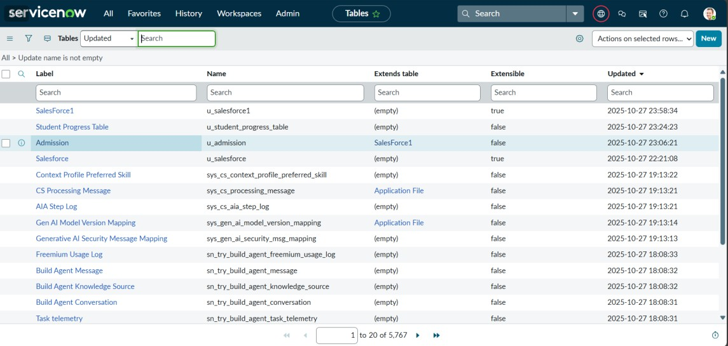

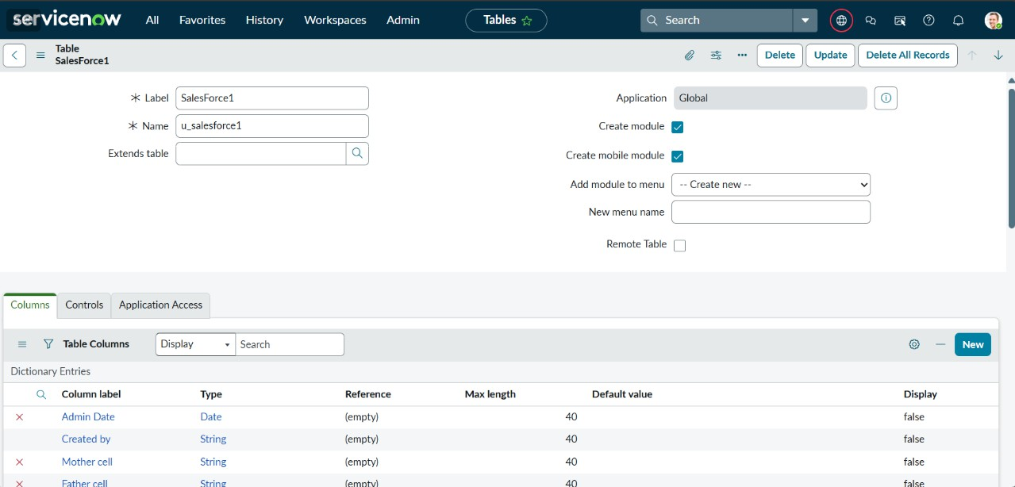

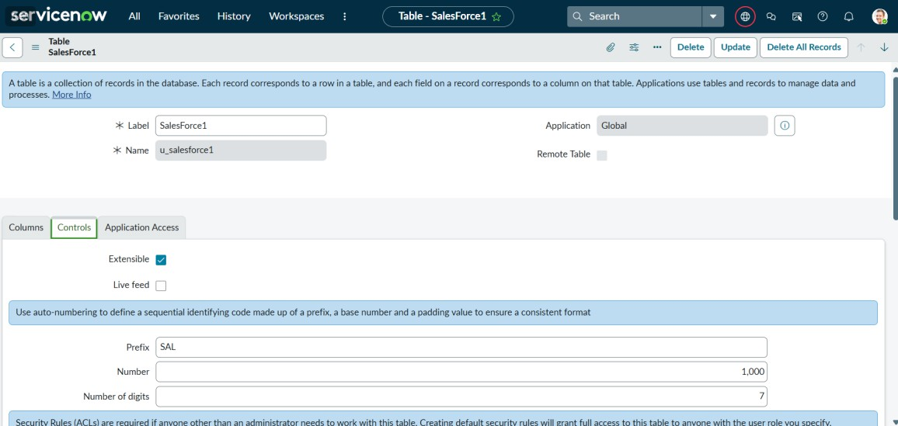

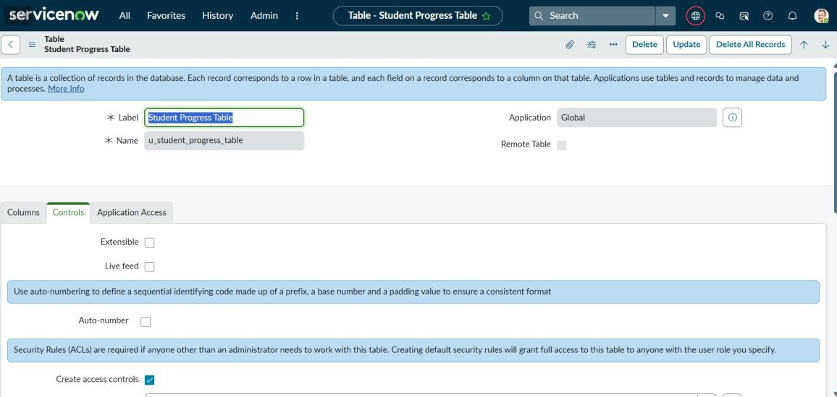

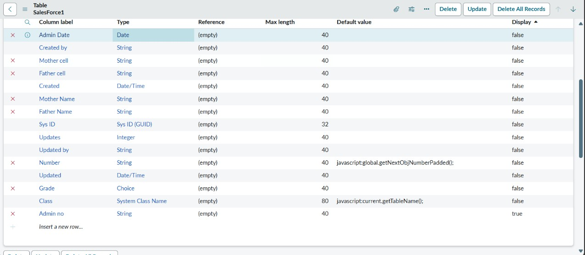

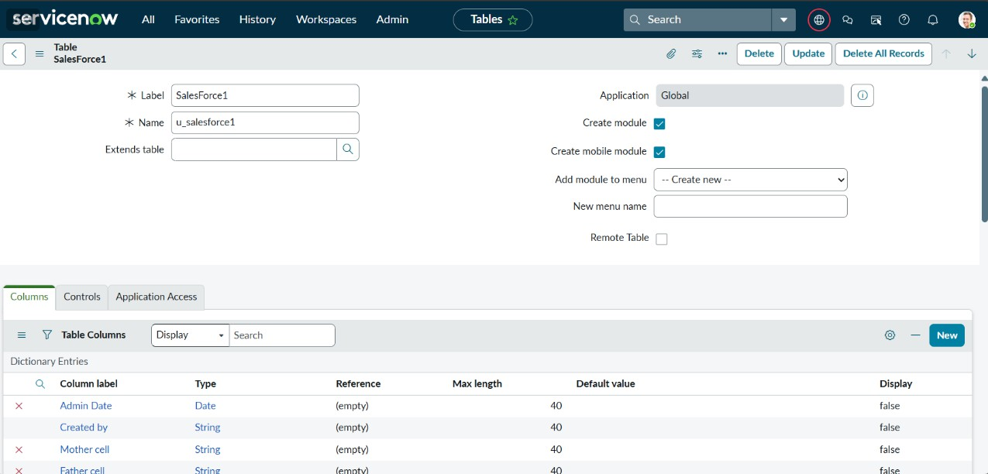

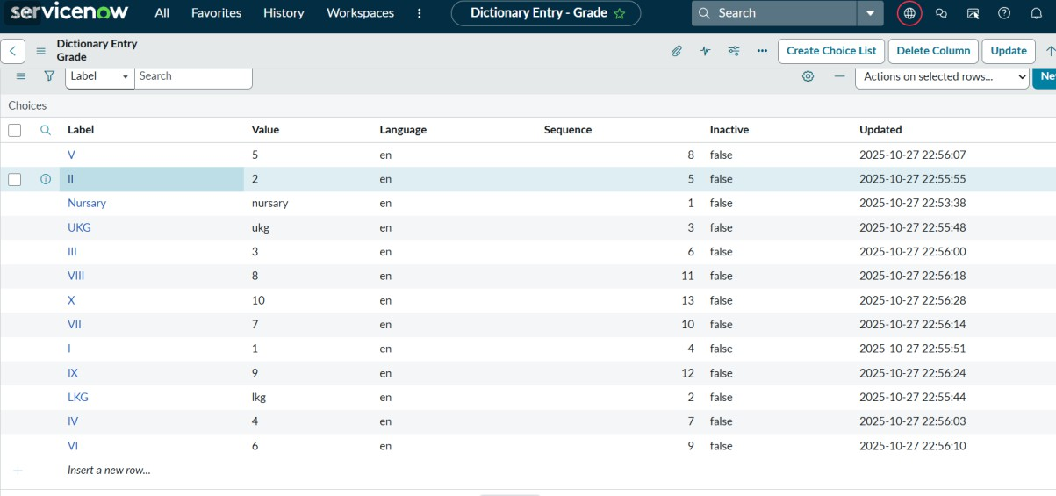

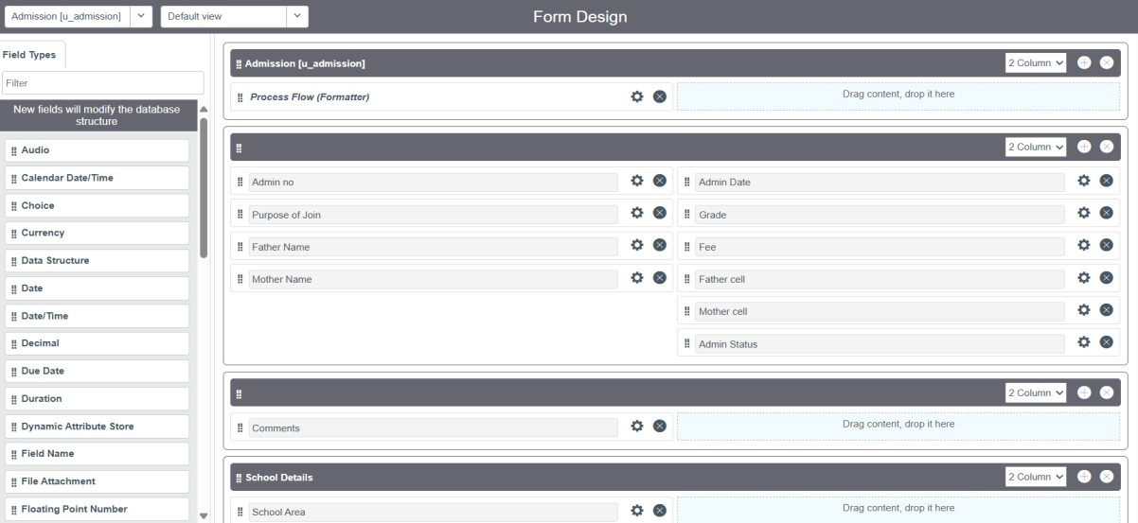

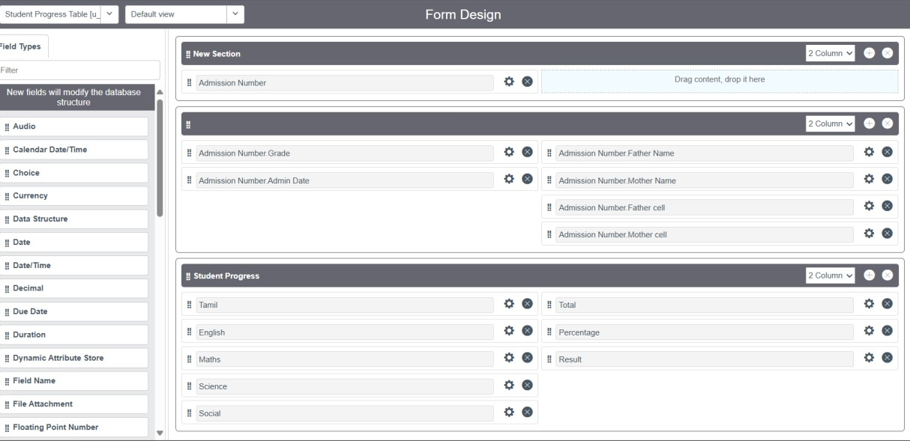

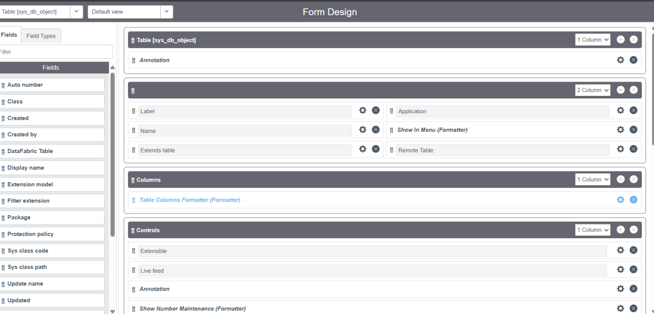

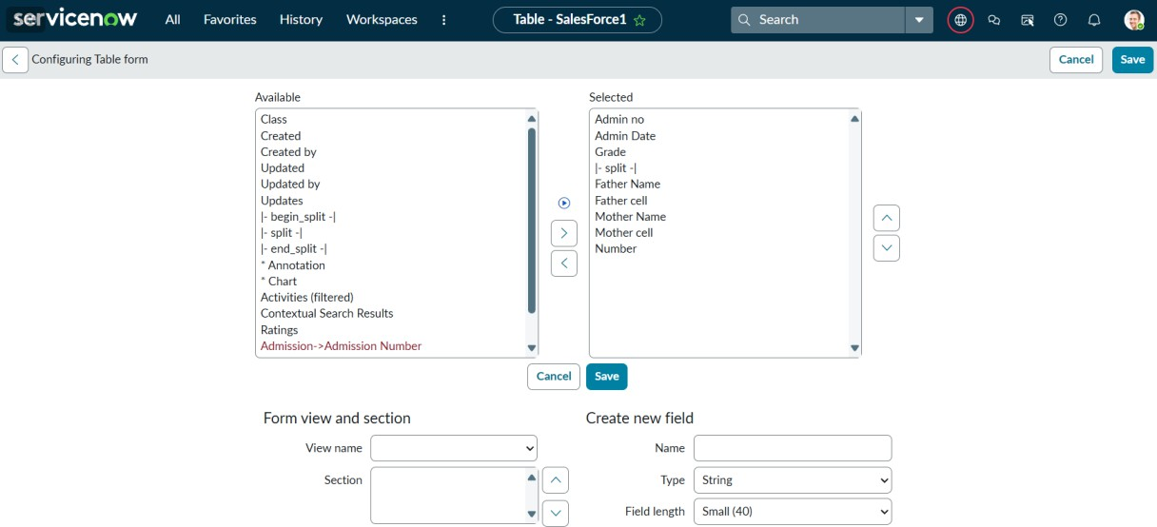

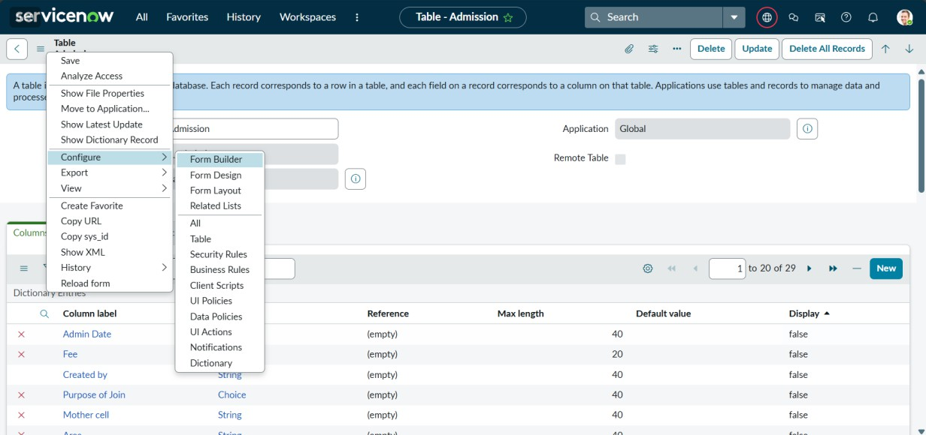

**Conclusion and Future Scope**

The implementation of the *“Educational Organization”* project using ServiceNow has successfully demonstrated how cloud-based automation can transform the administrative and service management processes of an educational institution. By replacing traditional manual and paper-based systems with an integrated digital platform, the project has significantly improved efficiency, transparency, and responsiveness in handling service requests, incidents, and approvals. The system provided a centralized hub where students, faculty, and staff could seamlessly interact, submit requests, and track progress, reducing dependency on human intermediaries and minimizing delays.

Through the use of key ServiceNow modules such as the **Service Catalog, Incident Management, Flow Designer, and Workflow Editor**, the project achieved a high level of process automation. It established well-defined workflows that ensured accountability, timely resolution, and effective communication among departments. The customization and configuration of the platform—including custom tables, fields, notifications, and reports—allowed the system to align perfectly with the unique requirements of an educational environment. Moreover, the introduction of dashboards and analytics enabled the management to make data-driven decisions, track performance, and continuously improve institutional operations.

The project also proved that ServiceNow’s flexibility extends far beyond traditional IT service management. Its adaptability to academic and administrative use cases demonstrates its potential as a comprehensive platform for educational transformation. The automated workflows not only reduced operational overhead but also empowered faculty and staff to focus on core academic goals instead of administrative bottlenecks. Additionally, the centralized digital platform enhanced the student experience by offering faster resolution times and consistent service quality.

Looking forward, the **future scope** of this project includes expanding its functionality through advanced integrations and AI-powered enhancements. ServiceNow can be integrated with **Student Information Systems (SIS), Learning Management Systems (LMS), and HR management tools** to create a unified digital ecosystem. Implementing **chatbots and virtual assistants** can further streamline user interactions by enabling instant query resolutions and 24/7 support. Additionally, incorporating **predictive analytics and machine learning** can help identify recurring issues, forecast resource needs, and optimize service delivery.

Another key future enhancement is the adoption of **mobile accessibility and multi-channel support**, allowing users to submit and manage requests through mobile apps, emails, or messaging platforms. The introduction of **role-based dashboards and advanced analytics** will also provide deeper insights into service performance, departmental workloads, and satisfaction trends.

In conclusion, this project serves as a foundational step toward building a smart, digitally empowered campus ecosystem. With continuous improvement and integration of emerging technologies, the ServiceNow-based system can evolve into a powerful platform that supports not just administrative efficiency but also academic innovation and strategic decision-making in the education sector.

The successful deployment of this system underscores the potential of **cloud-based platforms like ServiceNow** in revolutionizing how educational organizations function. What was once a time- consuming and fragmented service process is now an integrated, automated, and data-driven environment. The project not only enhanced operational efficiency but also contributed to **sustainability goals** by reducing paper usage and promoting a fully digital workflow. Furthermore, it empowered decision-makers with analytical insights that can guide strategic planning, optimize resource allocation, and improve student and staff satisfaction levels.