**BIG DATA ANALYSIS USING IBM CLOUD DATABASES**

**TEAM MEMBER:** SIVADHARSHINI S (822721106037)

**PHASE 4:**Development Part 2

**Problem Title:** Big Data Analysis

**Problem Statement:** Dive into the world of big data analysis with IBM Cloud Databases. Uncover hidden insights from vast datasets, from climate trends to social patterns. Visualize your findings and derive valuable business intelligence. Embark on data-driven adventures, exploring the endless possibilities of big data!

**DATA EXPLORATION:**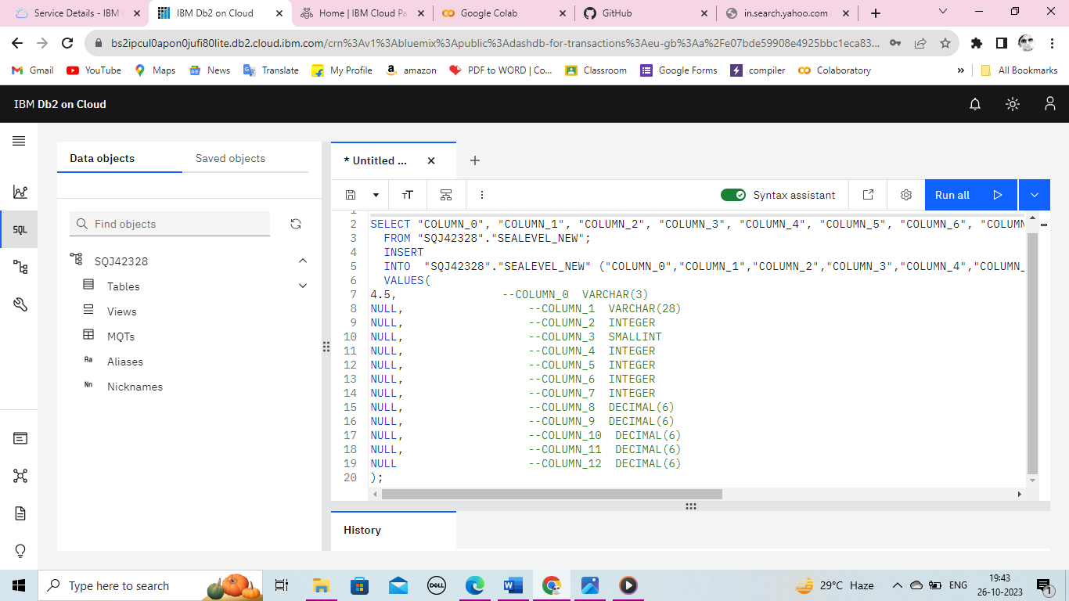

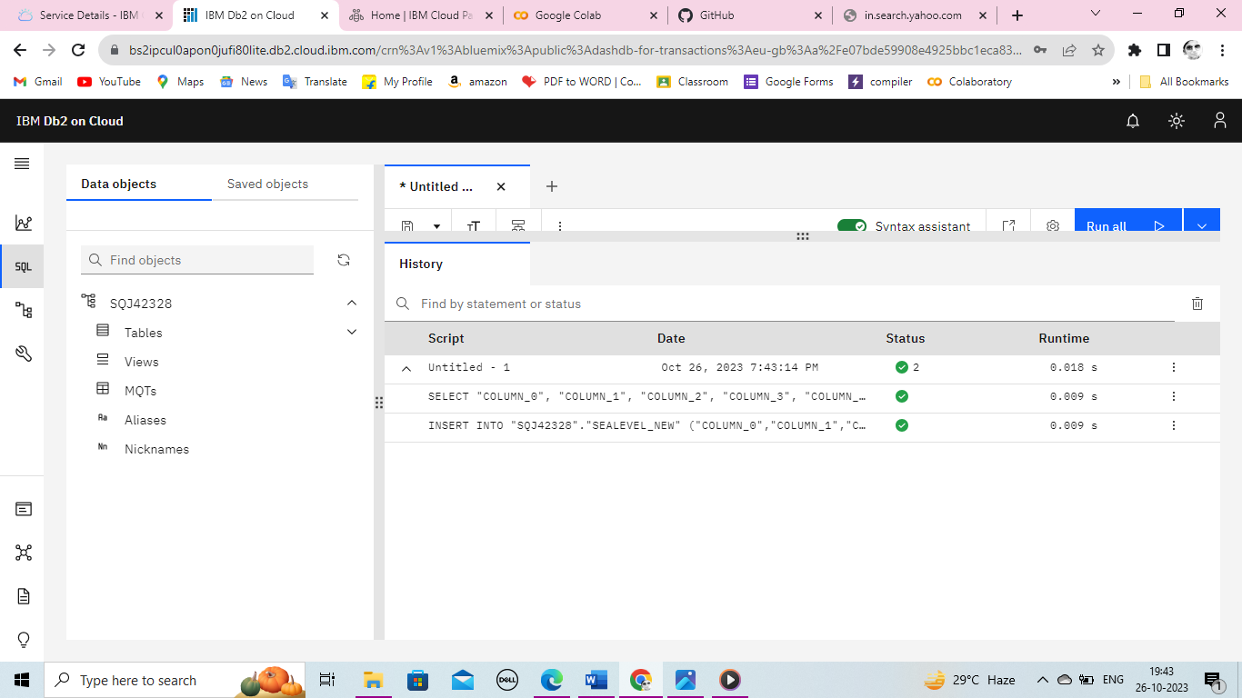

**ANALYSIS TECHNIQUES:**

Sentimental Analysis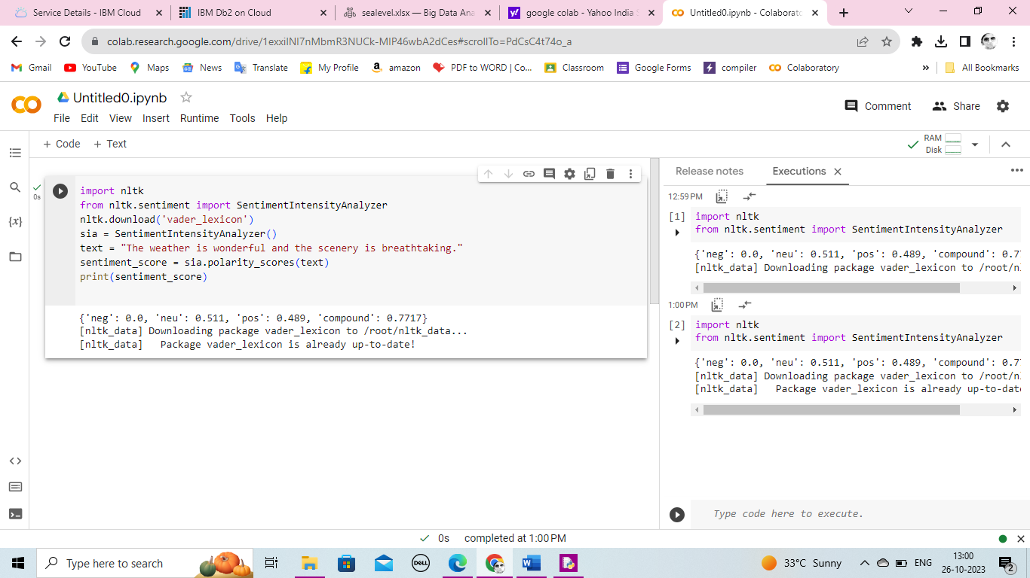

**VISUALIZATION:**

Visualized results between Country Name between Country Area(sq.km).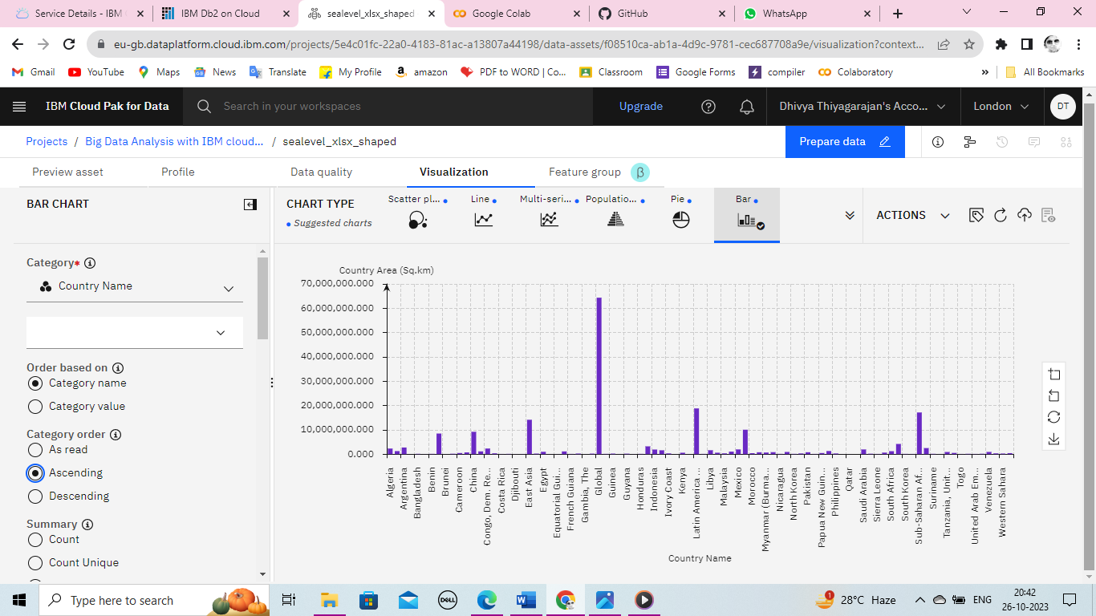

**IBM CLOUD PAK FOR DATA:**

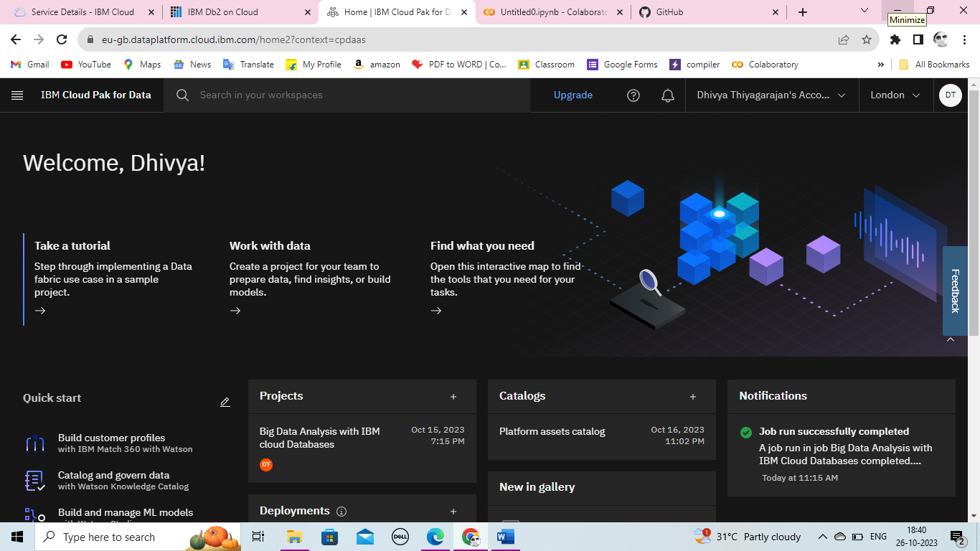

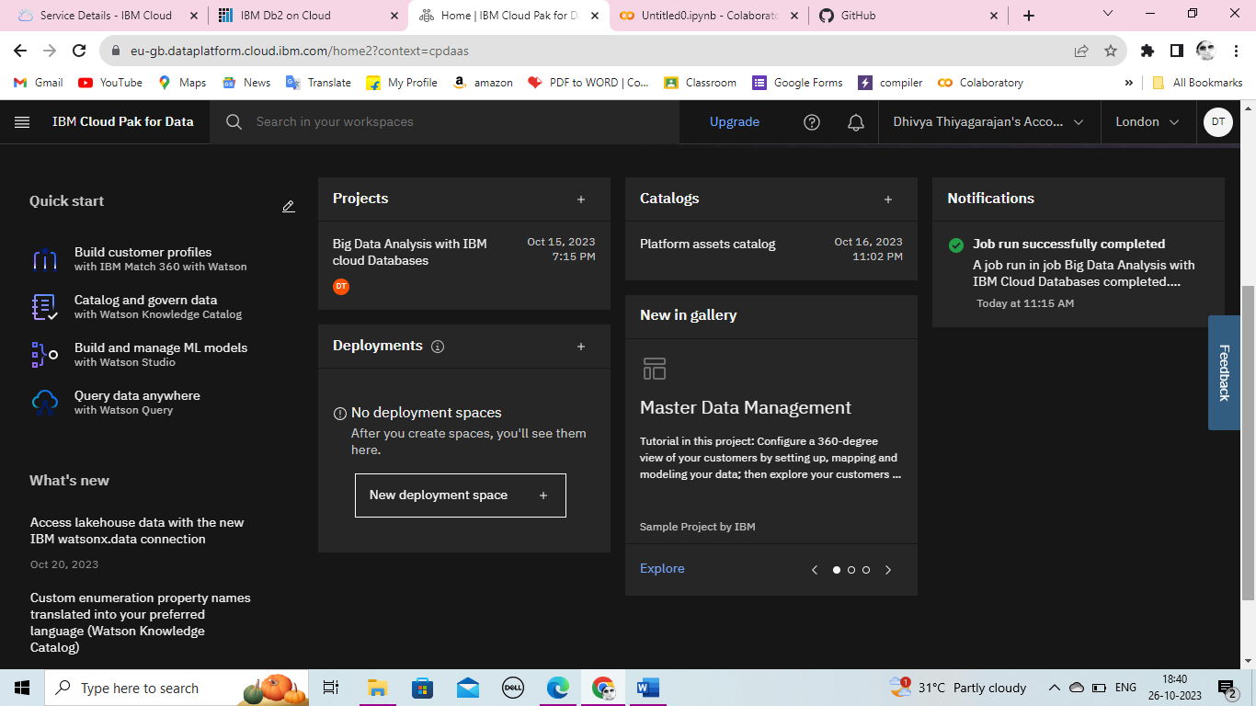

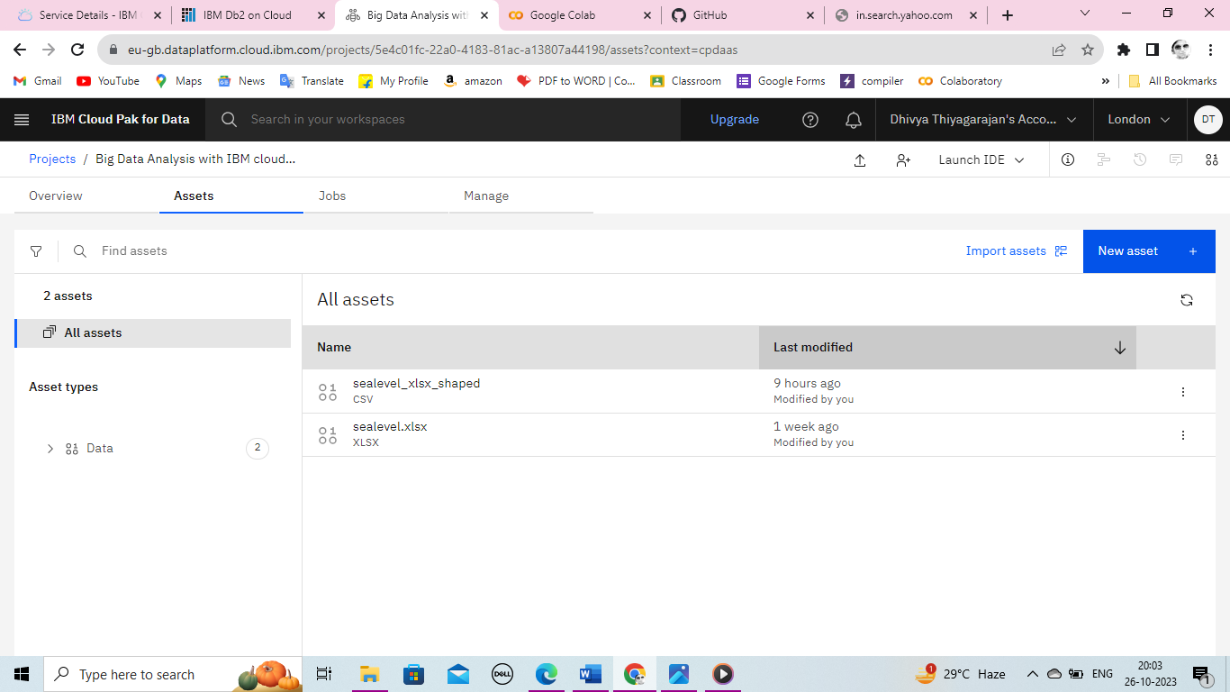

**Visualized result between 1meter(Impact), 2meter(Impact), 3meter(Impact), 1meter(Impact),**

**And 5meter(Impact):**