Financial Forecasting Report
Sample Superstore Dataset · Revenue Forecast for Jan–Jun 2019
15.6%  Validation MAPE | $47.9K  Avg Monthly Sales | +20.4%  2018 YoY Growth | $354.4K  Next 6-Mo Forecast

1. Objective
This report uses four years of historical monthly revenue (Jan 2015 – Dec 2018) to forecast expected revenue for the next six months. The goal is to give finance and operations teams a data-driven baseline for budgeting, cash-flow planning, and target-setting.
- Method: Holt-Winters Triple Exponential Smoothing (additive trend + additive seasonality, 12-month period)
- Validation: model trained on the first 42 months, tested against the final 6 actual months
- Tools used: Python (Statsmodels, Scikit-learn, Matplotlib)

2. Seasonal Decomposition
Breaking the monthly revenue series into trend, seasonal, and residual components confirms a steady upward trend across the four years, with a repeating annual seasonal pattern (a strong Q4 peak, a Q1 trough) and no major structural anomalies in the residuals.
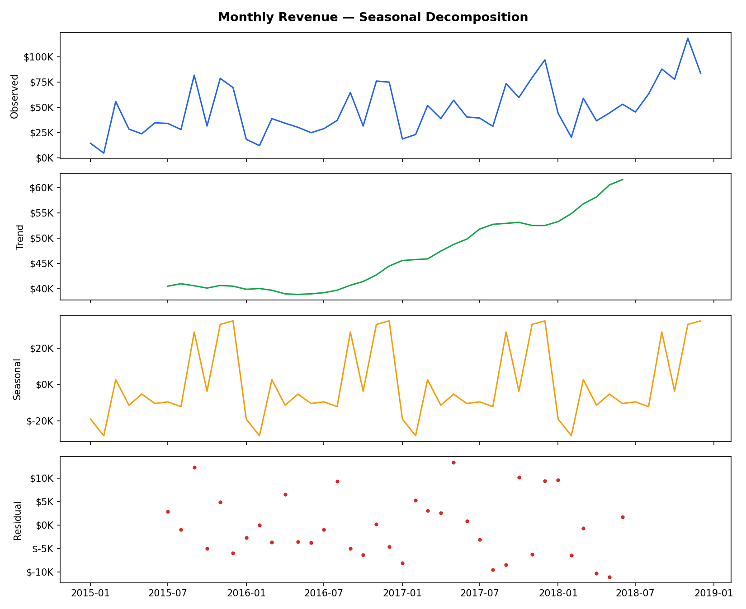
Figure 1: Additive decomposition of monthly revenue into trend, seasonal, and residual components.

3. Model Validation
Before forecasting the future, the model was tested on data it had not seen: trained on the first 3.5 years and evaluated against the actual final 6 months. The model achieved a Mean Absolute Percentage Error (MAPE) of 15.6%, correctly capturing the direction and rough magnitude of the year-end seasonal swing, which gives reasonable confidence in the forward-looking forecast.
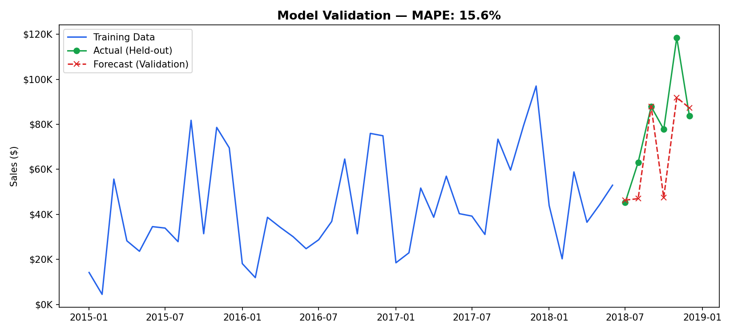
Figure 2: Validation forecast (red) vs. actual held-out revenue (green) for the last 6 known months.

4. Six-Month Revenue Forecast
Using the full four-year history, the model projects the following monthly revenue for the first half of 2019. Total projected revenue for the period is approximately $354,400, consistent with the seasonal low typically seen in Q1 followed by a build into spring.
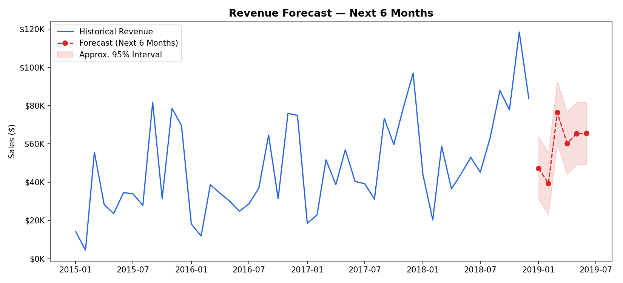
Figure 3: Historical revenue with 6-month forward forecast and an approximate 95% confidence band.
Month | Forecasted Revenue
Jan 2019 | $47,337
Feb 2019 | $39,353
Mar 2019 | $76,412
Apr 2019 | $60,367
May 2019 | $65,417
Jun 2019 | $65,518

5. Key Insights & Recommendations
- Expect a seasonal dip in January–February 2019, consistent with every prior year — plan cash reserves and discretionary spend accordingly rather than treating it as underperformance.
- March 2019 is forecast to rebound sharply (~$76K), so inventory and staffing should ramp ahead of quarter-end rather than reactively.
- 2018 closed with 20.4% YoY growth; if that momentum continues beyond this conservative baseline forecast, actual 2019 H1 revenue could outperform the model — treat these figures as a floor, not a ceiling, for target-setting.
- Re-run this model quarterly as new actuals arrive to narrow the confidence interval and catch any deviation from trend early.

