**KUBERNETES:**

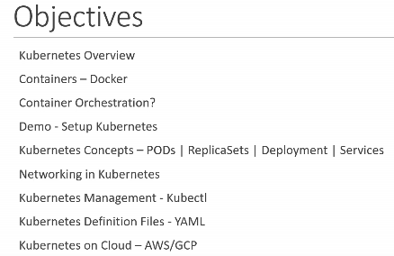

[**https://www.cncf.io/certification/ckad/**](https://www.cncf.io/certification/ckad/)

The online, proctored, performance-based test consists of a set of performance-based items (problems) to be solved in a command line and is expected to take approximately two (2) hours to complete.

This exam curriculum includes these general domains and their weights on the exam:

* 13% – Core Concepts
* 18% – Configuration
* 10% – Multi-Container Pods
* 18% – Observability
* 20% – Pod Design
* 13% – Services & Networking
* 8% – State Persistence

**Container:**

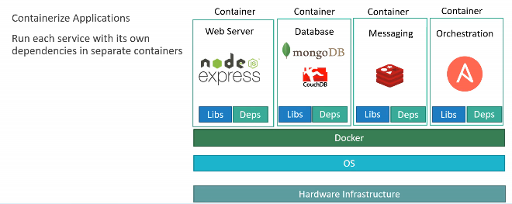

**Advantage of using contianers:**

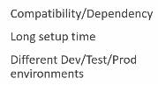

* Docker use LXC container

**LXC** (**Linux Containers**) is an [operating-system-level virtualization](https://en.wikipedia.org/wiki/Operating-system-level_virtualization) method for running multiple isolated [Linux](https://en.wikipedia.org/wiki/Linux) systems (containers) on a control host using a single Linux kernel.

The [Linux kernel](https://en.wikipedia.org/wiki/Linux_kernel) provides the [cgroups](https://en.wikipedia.org/wiki/Cgroups) functionality that allows limitation and prioritization of resources (CPU, memory, block I/O, network, etc.) without the need for starting any [virtual machines](https://en.wikipedia.org/wiki/Virtual_machine), and also [namespace isolation](https://en.wikipedia.org/wiki/Linux_namespaces) functionality that allows complete isolation of an application's view of the operating environment, including [process](https://en.wikipedia.org/wiki/Process_(computing)) trees, [networking](https://en.wikipedia.org/wiki/Computer_network), [user IDs](https://en.wikipedia.org/wiki/User_ID) and [mounted](https://en.wikipedia.org/wiki/Mount_(computing)) [file systems](https://en.wikipedia.org/wiki/File_system).[[3]](https://en.wikipedia.org/wiki/LXC#cite_note-3)

LXC combines the kernel's cgroups and support for isolated [namespaces](https://en.wikipedia.org/wiki/Namespace) to provide an isolated environment for applications. Early versions of [Docker](https://en.wikipedia.org/wiki/Docker_(software)) used LXC as the container execution driver, though LXC was made optional in v0.9 and support was dropped in Docker v1.10.

**Contianer vs virtualization:**

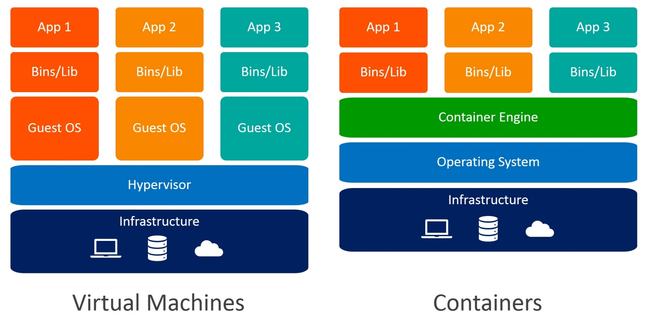

* **Docker image**
* **Docker file**

**Contianer orchestration:**

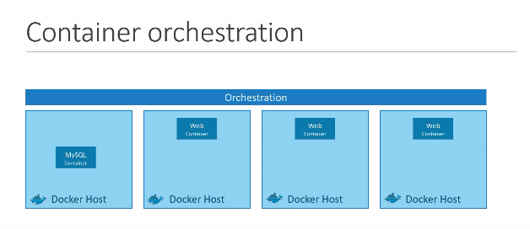

* **Common Platform has to manage the application, its connectivity and scalability is called container orchestration**
* **KUBERNETES is a Container orchestration technology**

1. **It is use Deployment and Management of container in cluster environment.**

**KUBERNETTES Architecture:**

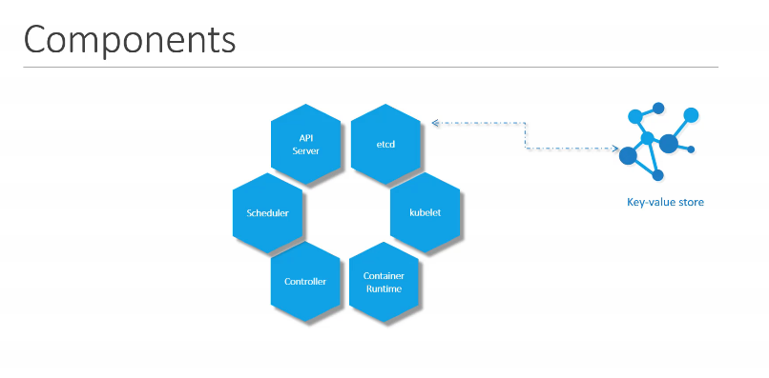

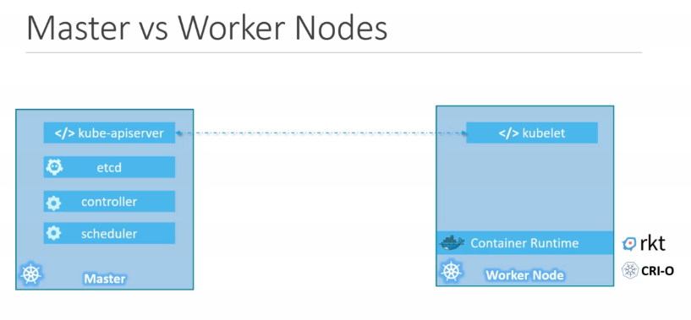

Basic command:

**Kubectl cluster-info**

**Kubectl get node**

**Kubectl run <application>**

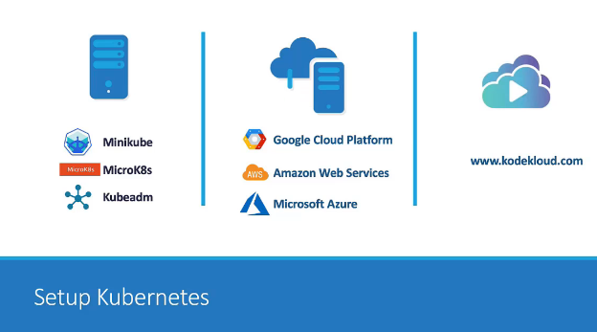

[**https://www.kodekloud.com/**](https://www.kodekloud.com/)

[**https://kodekloud.com/p/public-labs?scenario=kubernetes-for-beginners-basiccommands-test**](https://kodekloud.com/p/public-labs?scenario=kubernetes-for-beginners-basiccommands-test)

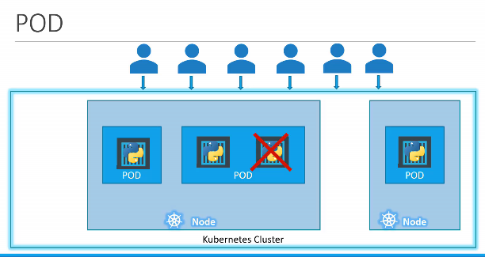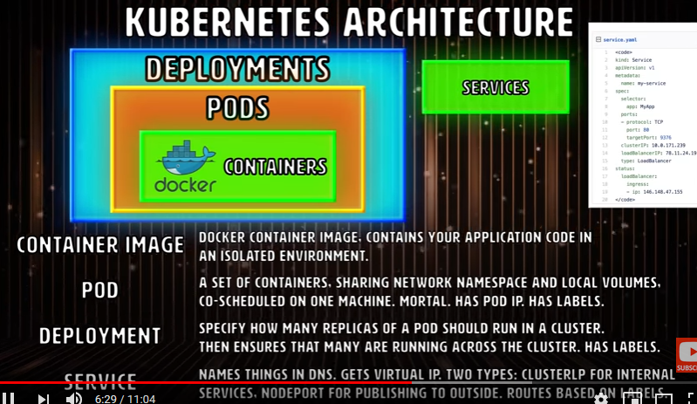

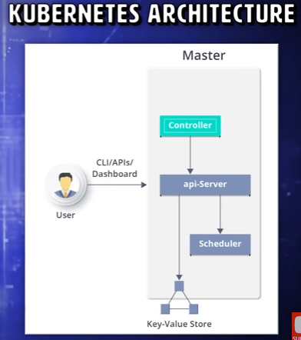

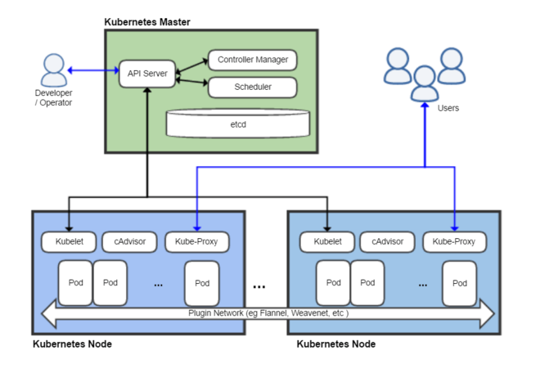

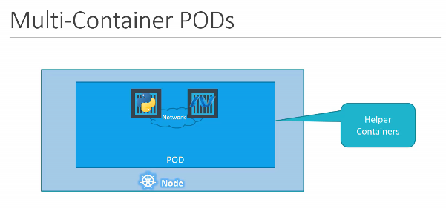

1. Worker machine in Kubernetes known as **NODE or minions.**
2. Multiple nodes are together to form a **cluster.**
3. **Etcd** is distributed reliable key-value store used by Kubernetes to store all data used to manage the cluster.
4. **Schedular** services is responsible for distributing work or containers across multiple nodes.
5. **Container runtime** is the underlying framework that is responsible for running application in containers like Docker.
6. **Kubectl** is the command line utility used to manage a Kubernetes cluster.
7. The smallest unit you can create in Kubernetes object model is **POD.**
8. **Minikube etc** is used to run Kubernetes in local environment.
9. **Google container engine** is an instant way of setting up a permanent kubernetes cluster on the cloud
10. **Kubeadm** is the solution is used for setting up a multi-node Kubernetes cluster in a local environment

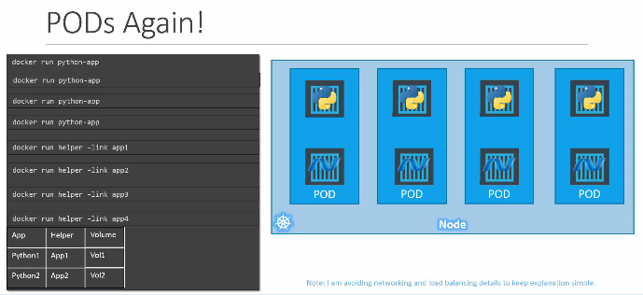

**YAML:**

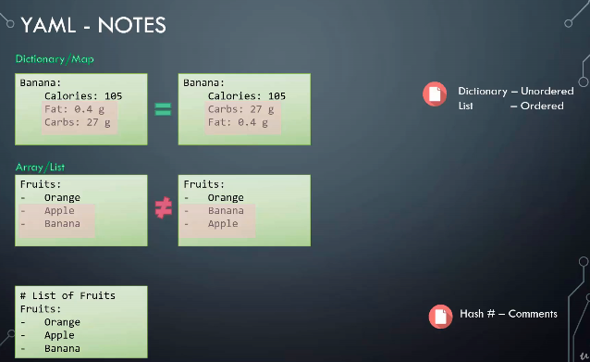

**List of Kubernetes model:**

* **Network**
* **POD**
* **Service**
* **Deployment**
* **Replica set**
* **Ingress**

**Network:**

* **Ip address is assigned to pod**
* **Kubernetes intial assign a private network**
* **Cluster networking**

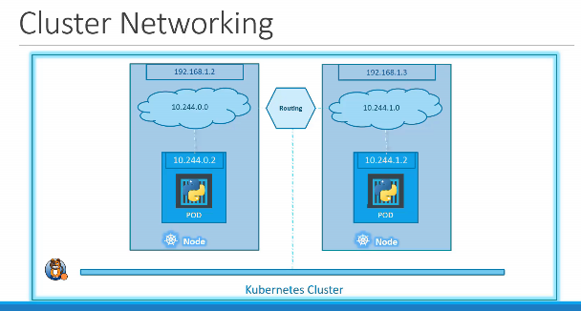

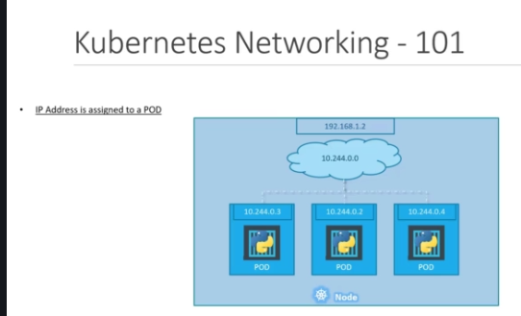

[**https://kubernetes.io/docs/tutorials/hello-minikube/**](https://kubernetes.io/docs/tutorials/hello-minikube/)

[**https://minikube.sigs.k8s.io/docs/start/**](https://minikube.sigs.k8s.io/docs/start/)

**Kubectl run redis –image=redis123 –dry-run=client –o yaml > pod.yaml**

**Kubectl edit pods <podname>**

**-----------------------------------------------------------------------------------------------------------------------------------------------------------**

* **Replication Controller:**

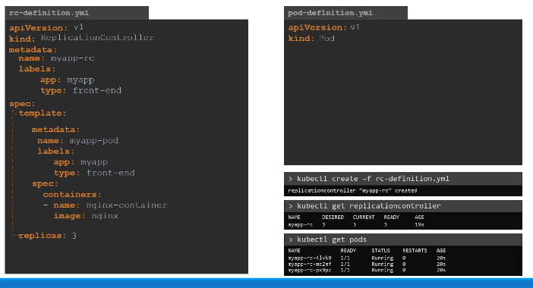

* **Replica set:**

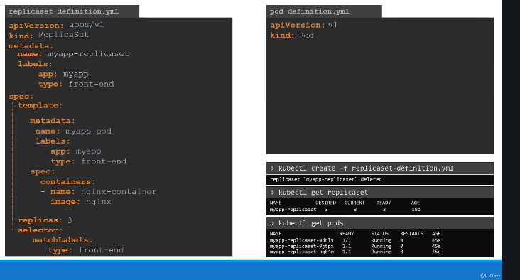

**Scale**

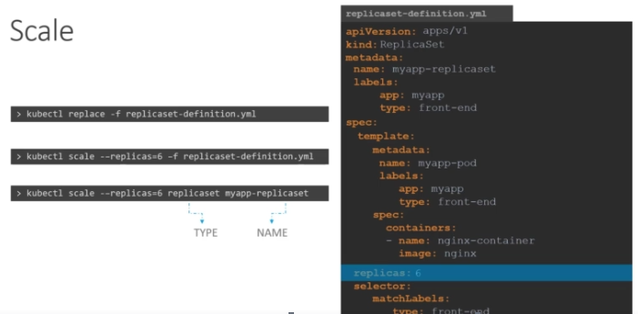

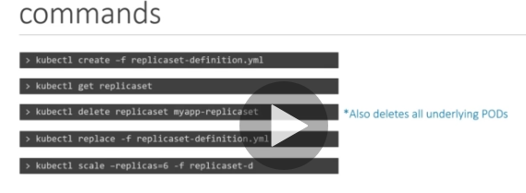

**Deployments:**

**Deployed**

**Upgrade**

**Rolling update**

**Rollback**

**Pause the application**

**Resume the application**

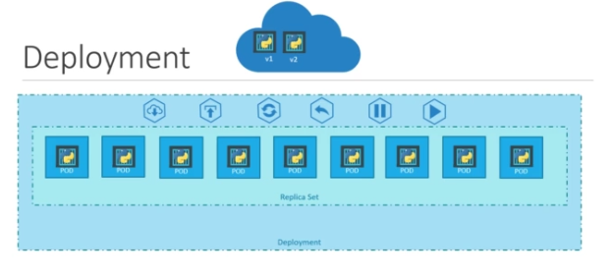

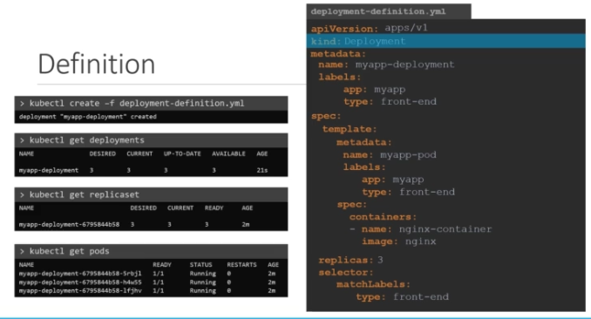

**Deployment update and rollout:**

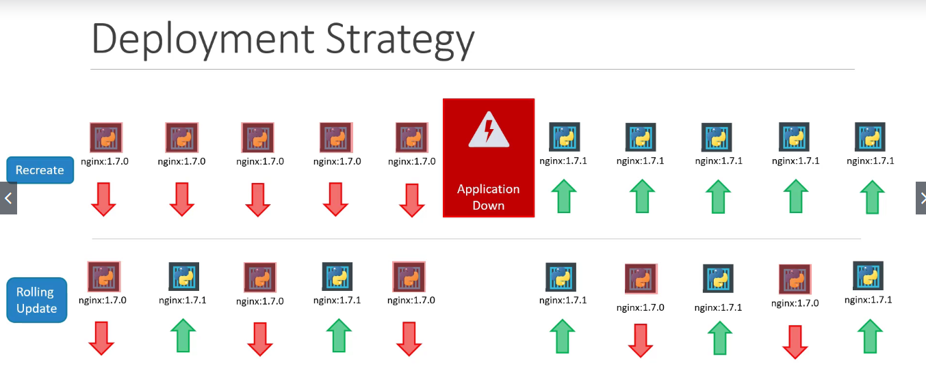

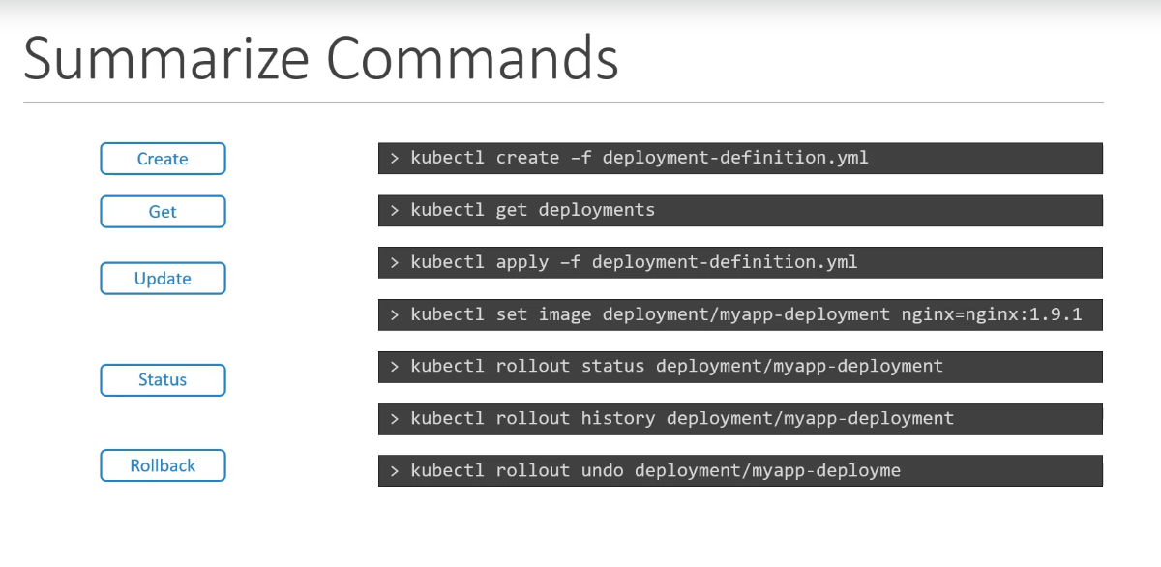

**Kubectl set image deployment <deployment-name> imagename=image –record**

**Services:**

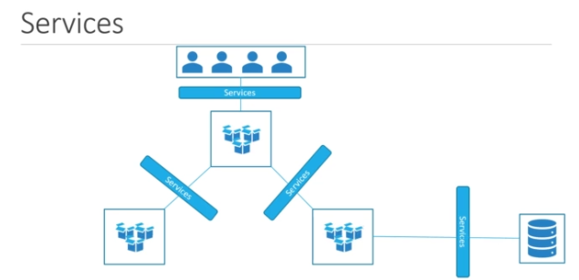

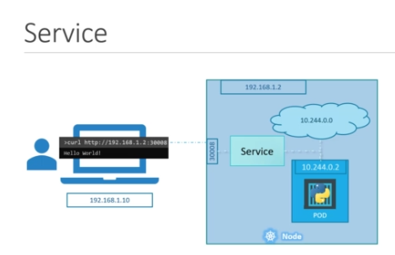

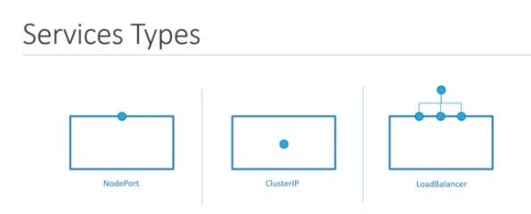

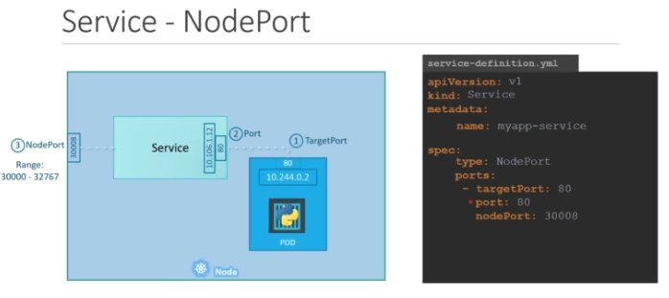

**To get the ipaddress of the node:**

* **Kubectl get node –o yaml**
* **Minikube ip**
* **minikube service <service-name> -- url**
* **Pod of the single node**
* **Multiple pod in single node**
* **Multiple pod in multiple node**

**Service will act upon in the stable manner**

**Load Balancer:**

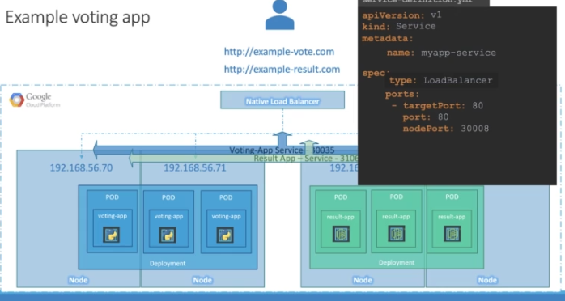

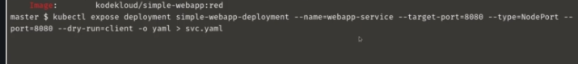

**Micro service Architecture:**

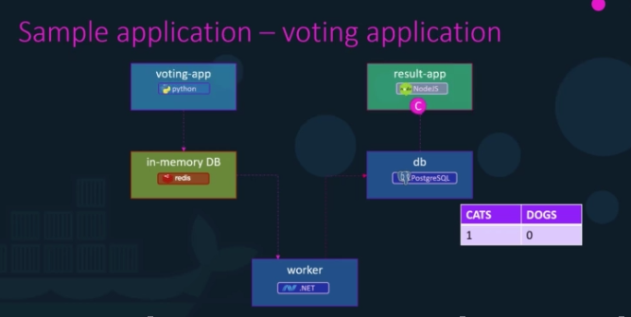

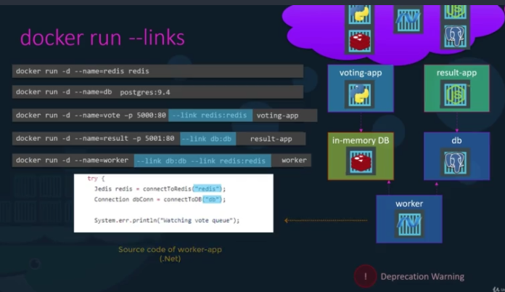

**GOAL:**

**1) Deploy application (PODs)**

**2) Enable connectivity**

**3) External Access**

