TRAFFIC MANAGEMENT

IOT_PHASE-2

SIVAHARI.S

**712521104309**

TRAFFIC MANAGEMENT:

**Introduction:**

The sustainability and smartness of the smart city concept rely on the [technologies](https://www.sciencedirect.com/topics/earth-and-planetary-sciences/science-and-technology) adopted to improve the people’s [quality of life](https://www.sciencedirect.com/topics/medicine-and-dentistry/quality-of-life). The smart city governance is one significant aspect of smart city initiatives, which will facilitate the planning techniques for better decision making . One of the key elements of the smart city governance framework is the public value generated out of the smart services provided .

The government has to work on different aspects of smart city solutions such as smart [health care](https://www.sciencedirect.com/topics/medicine-and-dentistry/health-care), [smart building](https://www.sciencedirect.com/topics/engineering/intelligent-buildings) management, smart traffic management, smart parking solutions, smart transportation, etc. to generate public value for the service they provided. The emergence of the [internet of things](https://www.sciencedirect.com/topics/engineering/internet-of-things) (IoT) has evolved the concept of smart cities. In a smart city environment, the physical infrastructures of the city are equipped with smart devices, which continuously produce multidimensional data in different spaces and these data are processed to achieve intelligence for the infrastructure . Ultimately, intelligence is applied to improve the socio-economic activities of the society.

The message units installed at important road intersections substitutes the smart devices and update drivers on the current traffic scenario.Appropriate to estimate traffic congestions on collector roads using road occupancy measure.

* Update residents on real-time traffic messages through roadside display units
* Monitor the road density of smart campuses especially during peak hours and help to improve mobility
* Assist authorities to broadcast important traffic incident messages

**2**. Related work:

This section first discusses the recent research developments in intelligent traffic management including system models for traffic updates, traffic congestion measures, emergency vehicle handling, and applications of [roadside](https://www.sciencedirect.com/topics/engineering/roadsides) units to deliver messages. Current advances in cost-effective and power-efficient [wireless sensor nodes](https://www.sciencedirect.com/topics/engineering/wireless-sensor-node) for [traffic monitoring](https://www.sciencedirect.com/topics/earth-and-planetary-sciences/traffic-monitoring) follow this. This section also includes specific [printed circuit boards](https://www.sciencedirect.com/topics/engineering/printed-circuit-board) based on [sensor nodes](https://www.sciencedirect.com/topics/engineering/sensor-node) to detect vehicles, estimate speed, and classify them. The discussion includes the features of these nodes, their pros, and cons.

**2.1. Real-time traffic updates**

Real-time traffic monitoring systems play a key role in the transition toward smart cities. A considerable amount of literature has been published on intelligent traffic management systems based on the [IoT](https://www.sciencedirect.com/topics/engineering/internet-of-things" \o "Learn more about IoT from ScienceDirect's AI-generated Topic Pages) paradigm];. Autonomous traffic sensing is at the heart of smart city infrastructures, wherein smart wireless sensors are used to measure traffic flow, predict congestion, and adaptively control traffic routes. Doing so effectively provides an awareness that enables more efficient use of resources and infrastructure.

Identifying and measuring congestion is the very first step in the traffic management process . The flow, occupancy, density is the widely used traffic congestion measures, which are mostly obtained from images or videos captured by vision systems initially Based on these measures, the traffic warning messages are broadcasted through smartphones, radio, televisions, light signals, dynamic variable message signs, or display units. Among them, the mobile-based web applications received much attention among researchers .

Most of the recent developments in delivering real-time traffic updates used the congestion estimates to dynamically control the traffic signal .An IoT based real-time traffic monitoring system is proposed for dynamic handling of traffic signals based on traffic density. The proposed system uses a set of [ultrasonic sensors](https://www.sciencedirect.com/topics/engineering/ultrasonic-sensor) and has two modules:

one for vehicle monitoring and other for priority management. The ultrasonic sensors are used to detect vehicles, and the density levels of a given road are sent to an LCD, and the data sent to the server for later usage.

**2.2. Wireless sensors for vehicle data collection**

This section presents the review of sensors that are used for vehicle detection and classification. The sensors used in intelligent traffic monitoring systems can be on-road sensors or in-vehicle sensors. The on-road traffic sensors can be again classified into two types: intrusive and non-intrusive. The intrusive sensors are paved on the road and are costly compared to non-intrusive sensors. The intrusive sensors provide accurate information; The non-intrusive sensors can be fixed on different parts of roads/roadsides. This includes magnetic sensors , ultrasonic sensors , infrared sensors , acoustic sensors , video cameras;

. Each sensor has its advantages and disadvantages. The ultrasonic sensors are prone to [environmental factors](https://www.sciencedirect.com/topics/medicine-and-dentistry/environmental-factor) . The video monitoring systems are comparatively costly than other sensors when considering the purchase, installation, and maintenance costs . However, the sensors are relatively less expensive in purchase costs.

Besides different types of sensors, a few research efforts have attempted to develop printed circuit boards (PCBs), which can be directly adapted for vehicle detection/speed estimation/classification such as PRS , LCTS , iVCCS , and CPIUS . shows the PCBs of PRS, LCTS, and iVCCS sensor nodes. The main objective of all these researches is to design and develop inexpensive and portable sensor nodes. On average, a single sensor node costs an average of $30 and operational for many years.

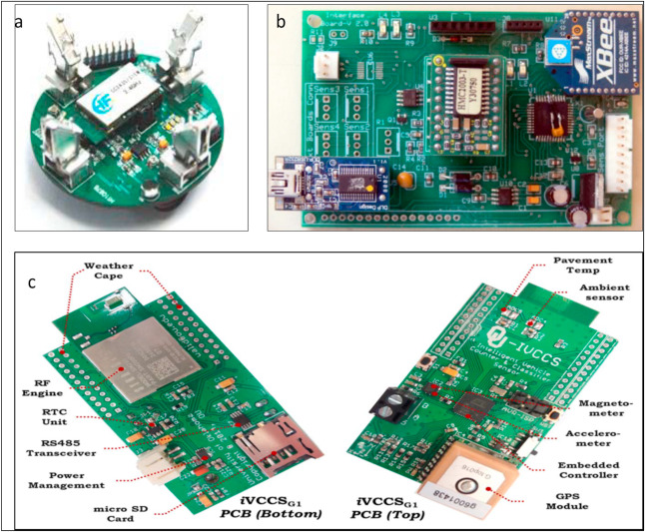

Fig. 1. (a) LCTS Sensor Node (b) PRS Physical Board ,and (c) iVCCS Physical Board.

PRS is a portable roadside sensor for vehicle detection, counting, classification, and speed estimation . PRS uses a magnetic sensor for vehicle detection. The single PCB board of PRS contains two magnetic sensors (HMC2003). This sensor uses the XBee module for [wireless communication](https://www.sciencedirect.com/topics/engineering/wireless-communication). PRS shows an accuracy of 99% in vehicle detection, and the maximum error rate of speed estimation is 2.5% (in a range of 5–27 m/s). Besides, the system also detects the right intersection. The vehicle length and height are estimated from the magnetic length.

LCTS is another low-speed congested traffic sensor node with a magnetic sensor specifically for a single lane road . The sensor node is designed using magnetic sensor HMC5883L. In addition to the magnetic sensor, the node also contains a sound sensor and four infrared sensors. However, the magnetic sensor alone performs vehicle detection and classification. The validation results show a detection accuracy of 99.05% and a [classification accuracy](https://www.sciencedirect.com/topics/engineering/classification-accuracy) of 93.66%.

The iVCCS is an [intelligent vehicle](https://www.sciencedirect.com/topics/engineering/intelligent-vehicle-highway-systems) counting and classification sensor; the node has different sensors and components such as [temperature sensor](https://www.sciencedirect.com/topics/engineering/thermal-sensor), [accelerometer](https://www.sciencedirect.com/topics/earth-and-planetary-sciences/accelerometer), magnetic sensor, [GPS](https://www.sciencedirect.com/topics/earth-and-planetary-sciences/global-positioning-system) module, real-time clock unit, memory unit, etc..

The iVCCS is a small battery-powered node with a 6-axis magnetic sensor and accelerometer FXOS8700. It uses a Zigbee wireless communication.

The iVCCS nodes are validated in different field trials and exhibit a 99.98% accuracy in vehicle detection, 97% accuracy in vehicle classification, and 97.11% in speed estimation. The consistency of the sensor’s output under different conditions is tested and showed high similarity

**3. The research methodology**

A robust research methodology is essential to achieve the research objectives. This research work is carried out in five main phases according to [design science research](https://www.sciencedirect.com/topics/engineering/design-science-research) methodology .The five phases are given:

(i) research background study, (ii) objective definition, (iii) design and development of artifacts, (iv) demonstration to show how the artifacts resolve the problems, and (iv) final evaluation.



Fig. 2. Research methodology.

A research background study is conducted as part of an objective definition. It has been observed that [wireless sensor networks](https://www.sciencedirect.com/topics/engineering/wireless-sensor-network) are widely applied in traffic management projects and have a significant role in detecting and reducing traffic congestion. Many kinds of sensors are used for real-time traffic monitoring. The selection criteria for sensors can be [power consumption](https://www.sciencedirect.com/topics/engineering/electric-power-utilization), cost, sensitivity, reliability, etc. In addition to the traditional traffic monitoring sensors such as magnetic/infrared/ultrasonic sensors, there are dedicated sensors for vehicle detection and classification as discussed in the related work section.

The road occupancy measure is accurate for both highways and collector roads. Collector roads mostly have small vehicles, which has relatively low length hence a length based road occupancy measure is considered in this research. The road space occupancy measure is a spatial measure calculated by considering the length of the vehicle, the safe distance between vehicles, and a buffer length.

The safe distance between the two vehicles is 2 m . When a vehicle enters a road segment, the road occupancy measure is increased by the length of the vehicle and decreased when the vehicle exits from that particular road segment. Based on the literature review, this research has decided to go ahead with magnetic sensors (or magnetic sensor-based PCB) for collecting traffic information as they show good accuracy in vehicle detection

**4. System design and development:**

This section discusses the proposed system model, different software and hardware components required, and algorithms to implement the proposed system. The proposed [system communication](https://www.sciencedirect.com/topics/engineering/communication-system) model is presented in , which has components installed at the roadside and a cloud-based central server. The roadside setup includes sensors and message boards. The sensors and boards will be installed between two road segment intersections. The central server includes data storage, cloud services, and interfaces. The components can communicate with each other using WiFi.

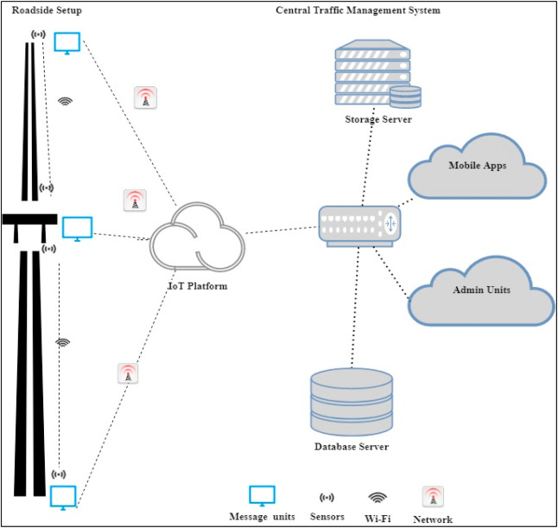

 model.

**4.1. System architecture:**

An IoT based system architecture mostly contains a sensing layer, network layer, service layer, and an application layer .The sensing layer acquires data from the things, the network layer transfers the collected data from devices to the service layer, the service layer controls the devices and analyzes the collected data, and finally, the application layer which indicates the user interface. The layered architecture is presented in .

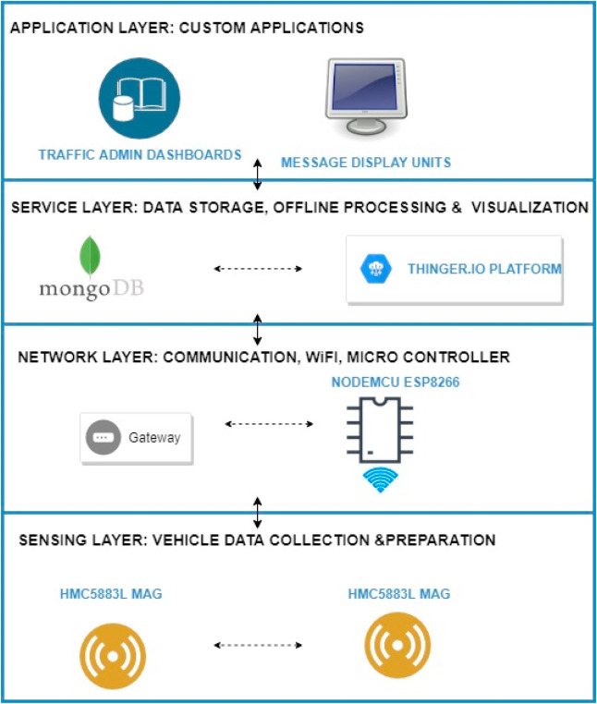

The four main system development activities are: (i) populate geographical map details for a given location, (ii) detect vehicle and estimate vehicle length, (iii) determine growing queue, and (iv) display traffic updates. The system components include (i) Geographical map, (ii) Sensors, (iii) Microcontroller, (iv) IoT platform, (v) Database, and (vi) Electronic display units. The activities, the software, and hardware components associated with each activity are given in.

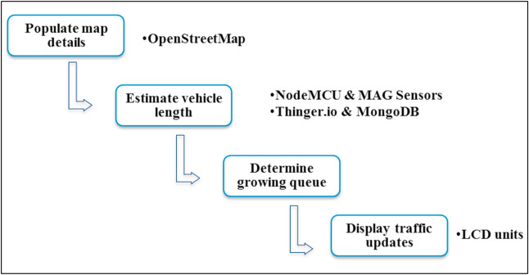

An extensive literature review has been conducted to select various system components and [technologies](https://www.sciencedirect.com/topics/earth-and-planetary-sciences/science-and-technology) [[58](https://www.sciencedirect.com/science/article/pii/S2589791820300207#bib58)]. The hardware and software components used for the system development are given below.

* •

**OpenStreetMap**: The OpenStreetMap (OSM) is one of the practical projects that provide map data [[24](https://www.sciencedirect.com/science/article/pii/S2589791820300207#bib24)]. The map data provided by OSM is free to use ([wiki.openstreetmap.org](http://wiki.openstreetmap.org/)). The individual users are contributed to the development of OSM, and the geographical information contributed by them is the core part of OSM. OSM provides editing, exporting, and uploading functionalities. The export functionality can be used to generate row map data or map images. The raw data can be processed by other systems that use geographical information. The OSM also provides a java interface to edit and work with maps, i.e., Java OpenStreetMap (JOSM) editor, similar to traditional geographic information system packages.

* •

**MongoDB:** MongoDB ([www.mongodb.com](http://www.mongodb.com/)) is a document database, and it stores the data from JSON like documents. MongoDB provides flexible access to data and supports nested objects as values. MongoDB has both community and enterprise versions [[42](https://www.sciencedirect.com/science/article/pii/S2589791820300207#bib42)]. The community version of MongoDB is used in this research. A record in MongoDB consists of field and value pairs and basically, it is a document. The documents in MongoDB are stored as collections, and similar to tables. The OpenStreetMap downloaded and converted to geojson format and stored in the MongoDB for experiments. We selected MongoDB due to its performance and rich [query language](https://www.sciencedirect.com/topics/earth-and-planetary-sciences/query-language).

* •

**Magnetic Sensors**: The magnetic sensor has the following advantages: (i) it can be easily installed on roadsides, (ii) reduces detection error, (iii) there is no climate influence (Q [[71](https://www.sciencedirect.com/science/article/pii/S2589791820300207#bib71)]. Honeywell HMC5883L is a tri-axial magnetic sensor used in many traffic monitoring research due to its high sensitivity (Q [[71](https://www.sciencedirect.com/science/article/pii/S2589791820300207#bib71)]. and cost-effectiveness. Hence, this research also used the HMC5883L magnetic sensor to collect vehicle data. It is worth to note that there exist many PCBs with all the necessary components for vehicle detection and classification as discussed in related work, section [2.2](https://www.sciencedirect.com/science/article/pii/S2589791820300207#sec2.2). These boards have individual physical sensors as well as the firmware. It is also a good idea to go ahead with these readymade nodes as they are cost-effective and the expected cost of a single node is less than $50.

* •

**NodeMCU:** NodeMCU is a firmware developed for ESP8266 WiFi [system on chip](https://www.sciencedirect.com/topics/engineering/system-on-chip) (SoC). It is also an open-source platform. NodeMCU helps to prototype IoT products [[33](https://www.sciencedirect.com/science/article/pii/S2589791820300207#bib33)]. ESP8266 has a general-purpose input/output interface [[19](https://www.sciencedirect.com/science/article/pii/S2589791820300207#bib19)], hence the sensors/devices can be integrated easily. NodeMCU board has WiFi capability, digital pins (D0-D8), analog pin (A0), and supports [serial communication](https://www.sciencedirect.com/topics/engineering/serial-communication) protocols (I2C, UART, etc.). ESP8266 chip is developed by Espressif Systems ([www.espressif.com](http://www.espressif.com/)). ESP8266 has 2.4 GHz WiFi, 64 KB boot ROM, 96 KB data [RAM](https://www.sciencedirect.com/topics/engineering/reliability-availability-and-maintainability-reliability-engineering), and 64 KB instruction RAM. ESP8266 module can be used for end to end IoT system developments.

* •

**Thinger. io:** Thinger. io is an open-source IoT platform that supports [sensor data collection](https://www.sciencedirect.com/topics/engineering/sensor-data-collection), management, analysis, and visualization [[13](https://www.sciencedirect.com/science/article/pii/S2589791820300207#bib13)]. Thinger. io ([www.thinger.io](http://www.thinger.io/)) supports the deployment of [data fusion](https://www.sciencedirect.com/topics/earth-and-planetary-sciences/multisensor-fusion) applications with the integration of cloud, IoT technologies, and big data. It supports the [remote sensing](https://www.sciencedirect.com/topics/earth-and-planetary-sciences/telemetry) and [actuation](https://www.sciencedirect.com/topics/engineering/actuation) of any sensor, and provide readymade services to connect devices. Thinger. io is unique in terms of transmission efficiency by providing an optimized encoding scheme, namely Protoson [[13](https://www.sciencedirect.com/science/article/pii/S2589791820300207#bib13)]. Thinger. io is highly interoperable and provides real-time bidirectional communications. The storage management mechanism of Thinger. io is called data buckets and supports document storages such as MongoDB. The Thinger. io platform offers an interface to configure devices, create data buckets, and model devices in this research.

* •

**LCD Unit:** The message board unit can be a WiFi-enabled character type LCD unit. However, to experiment, a 16 x 02 LCD unit was used that can display only 32 characters.

**4.3. System development activities:**

The proposed algorithms for system development activities presented in  are discussed in this section.

**4.3.1. Geographical map data processing:**

The geographical map provides the road segment information, intersections, and routes. The maps are processed to load the road information to the database as well as to extract the message board locations. The user-generated map can be used to find the message board location [[24](https://www.sciencedirect.com/science/article/pii/S2589791820300207#bib24)]. The road junctions that have more connected road segments are the best locations to display traffic-warning messages. The message board locations are selected based on its exposure to maximize message visibility. The message board selection is considered as a maximization problem because the objective is to maximize the visibility of the message. The idea of billboard advertising can be applied here to maximize the strength of message exposure (L [[70](https://www.sciencedirect.com/science/article/pii/S2589791820300207#bib70)]. Also, the major parking slots in a closed campus can be selected to reach the messages to the maximum. The number of connected roads is one parameter that decides the strength of message exposure. Besides, the earlier patterns of traffic density can also be selected while determining the message unit location.

The OSM map for a given location can be downloaded from the OpenStreetMap website. The OSM file follows XML format and there are three key elements: nodes, ways, and relations. There is a different tag to identify each type of road. The highway key can have different values such as a motorway, trunk, primary, residential, etc. Similarly, the link roads also can be identified. The junctions key can be used together with highways, and particular types of junctions are roundabouts, circular, filter, and jughandle. These keys help to extract the relevant information on a street. The flowchart to process the OSM file is presented in .

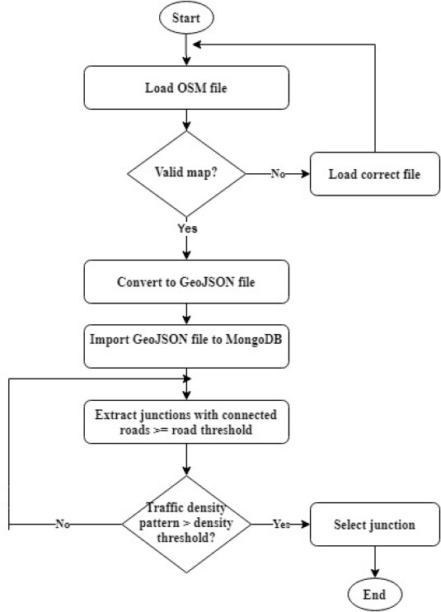

 Map processing.

The process begins with geographical map format conversion and database loading. The second step is to identify the message board locations based on previous traffic density at intersections and the number of connected roads.

**4.3.2. Vehicle detection and physical length estimation:**

The real-time vehicle data captured by magnetic sensors are used to detect vehicle and estimate the vehicle length. The predicted vehicle speed is a parameter that is mostly used to determine the length of the vehicle .

Magnetic sensors detect the disturbance in the earth’s magnetic field caused by moving vehicles and measured as vehicle magnetic length.

The vehicle magnetic length (VML) is used to estimate [vehicle physical](https://www.sciencedirect.com/topics/engineering/physical-vehicle) length the studies reported that a single magnetic sensor can be used for vehicle detection with 99% accuracy, one or two sensors for vehicle speed estimation, more than two magnetic sensors for vehicle classification.

Hence vehicle detection and length estimation algorithm is adopted in this research as it has 99% accuracy in speed estimation, 97.8% accuracy in vehicle classification. The vehicle detection occurs when the [magnetic field intensity](https://www.sciencedirect.com/topics/engineering/magnetic-field-intensity) is higher than the threshold. The magnetic field intensity of the signal and measured as

VML is estimated from vehicle speed and sensor occupancy time. VML is always greater than the actual length of the vehicle. The sensor occupancy time  is calculated

The vehicle physical length (VPL) can be calculated in different ways; however, there are challenges in estimating exact VPL . The physical length is estimated as a derivative of sensor signals , signal gradient ,and from the mean estimate of a set of sensors. One another way to estimate VPL is to subtract the length of the sensor detection zone from VML.

The microcontroller of sensor node B estimates the physical lengths from the given input. (a) presents the flowchart for vehicle length estimation. The given equations are used to estimate the speed, magnetic, length, length of the detection zone for vehicle. These values are used to estimate the physical length in the final step of the algorithm.

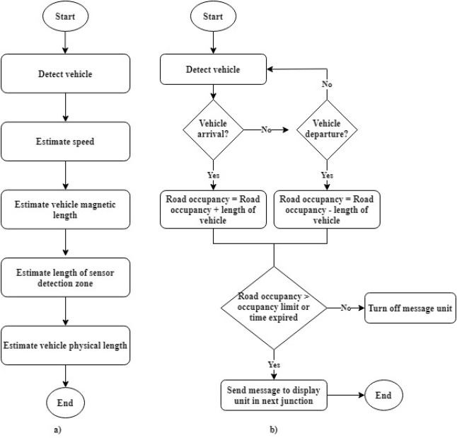

Fig. 7. (a) Vehicle length estimation, (b) Send traffic update on occupancy.

**4.3.3. Road occupancy and growing queues:**

The traffic congestion measures are mostly based on parameters such as speed, time and delay, reliability, service, space, etc. The road space occupancy is one such measure to determine the growing traffic queue and (b) shows the flowchart on how to determine the road congestion using occupancy measure.  illustrates how the road occupancy measure is calculated. When sensor C detects a vehicle, sensor node D will estimate the physical length and send it to sensor B. The microcontroller associated with sensor B holds the occupancy measure and sends real-time traffic updates.

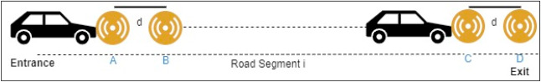

The road occupancy measure is estimated from vehicle physical length at the entrance and exit of the road segment. The algorithm (b) is implemented as firmware for the sensor node B*.* The sensor node D only estimates the physical length and sends it to node A, which acts as the server here and sends the message to the display unit as well as it will load the data to the IoT platform wirelessly.

4.3.4. Display warning messages

The traffic warning message can be of two types:

(i)real-time updates on traffic density,

(ii) messages on unusual road incidents by authorities. These updates can be accessed by drivers while driving through different modes such as smart mobile applications, radios, televisions, etc.

5. **Experiments and discussions:**

An experiment has been conducted to demonstrate the feasibility and applicability of the proposed system. A [proof of concept](https://www.sciencedirect.com/topics/engineering/proof-of-concept) system is developed. The experiment execution steps are (i) load geographical map details, (ii) conduct on the road test for vehicle detection, vehicle length estimation, and road occupancy measurement, and (iii) traffic dashboard creation from real-time data. The communication model of the prototype is given. The experiment used a single node for vehicle detection and a simulation scenario for road occupancy measurement.

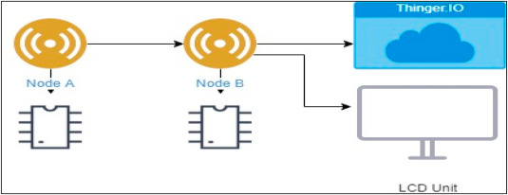

 Prototype communication model.

The hardware and software components used for the prototype implementation is discussed in detail under section 4.2. The hardware and software components required to set up the experiment are:

* HMC5883L, NodeMCU ESP8266, LCD unit, [Breadboard](https://www.sciencedirect.com/topics/engineering/breadboard), Jumper wires, USB cable
* Arduino IDE, Thinger. io, MongoDB, OSM file

The Arduino IDE is used for NodeMCU programming. The libraries required for thinger. io are imported to Arduino IDE using the import libraries feature. The sensors are registered to the Thinger. io interface.

(a) the empty road and junction, (b) vehicle are approaching the junction, (c) vehicles are exiting the junction. The message display unit at this junction will provide the traffic information of the next upcoming junctions, so the drivers can decide to choose another path to the exit gate.

6. **Evaluation:**

A step-by-step evaluation process has been executed to validate three main functionalities: (i) map processing and selection of message board location, (ii) vehicle data collection and processing, and (iii) dashboards.

**6.1. Selection of message board location:**

The map of the university is downloaded from the OpenStreetMap website. The OSM files are converted and loaded to MongoDB and the pictorial view is presented in . The original map is on the left and expected junctions are marked on the right.

* Precision % = (Number of relevant junctions retrieved/Number of junctions retrieved) ∗ 100%
* Recall %= (Number of relevant junctions retrieved/Number of relevant junctions in the map) ∗ 100%

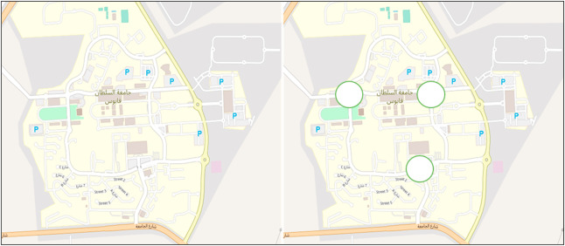

The script expects to retrieve the message board location according to the given threshold for the number of connected roads. The OSM map is manually compared with the image from another map tool Mapcarta .The results of the university map processed are given in [Table 1](https://www.sciencedirect.com/science/article/pii/S2589791820300207#tbl1).

. Map processing evaluation.

| **Maximum roads Threshold** | **Junctions Retrieved** | **Relevant Junctions** | **Precision** | **Recall** |
| --- | --- | --- | --- | --- |
| 4 | 3 | 3 | 100% | 100% |

The high precision and recall indicate the map processing script works as expected. Three intersections are identified as the locations for the message board location based on the exposure of message visibility.

**6.2. Vehicle detection and road occupancy estimation:**

The vehicle detection has been tested using a single roadside node.  shows the experiment setup and the magnetic field fluctuations of a Renault Duster car when the sensor is placed at a distance of 100 cm. The earth’s magnetic [field flux](https://www.sciencedirect.com/topics/engineering/field-flux) intensity *f*, the [geomagnetic field](https://www.sciencedirect.com/topics/earth-and-planetary-sciences/geomagnetism) components *x, y, z* when the sensor detects a vehicle is shown .

| **Road** | **Actual** | **Detected** | **Relative Error** |
| --- | --- | --- | --- |
| A | 12 | 12 | 0% |
| B | 8 | 8 | 0% |
| C | 10 | 10 | 0% |

Sensor node B estimates the vehicle speed, magnetic length, physical length, road occupancy, and sends the data to the Thinger. io platform. This study has not detailed the validation of speed/length estimation as they are already proven in . The road occupancy measure calculated from the physical length of the vehicle is given.

Table 3. Road occupancy evaluation.

| **Road** | **Road Length** | **Actual Occupancy** | **Estimated Occupancy** | **Relative Error** |
| --- | --- | --- | --- | --- |
| A | 300 M | 240 M | 254 M | 5.8% |
| B | 200 M | 170 M | 182 M | 7.5% |
| C | 400 M | 320 M | 338 M | 5.6% |
| Total | 900 M | 730 M | 774 M | Average = 6.35% |

The system shows an average relative error of 6.35%. These results are achieved for passenger cars. The medium, medium-long, or long vehicles are not considered, which is a limitation of this evaluation. As the length of the road increases, the error percentage also decreases. Hence, the system is expected to perform better in real road scenarios.

6.3. Dashboards

The communication between sensor node B and Thinger. io has been established to build the dashboard and store real-time traffic data for the future. A simple dashboard to find the occupancy of road A, B, and C at different timings is given in .

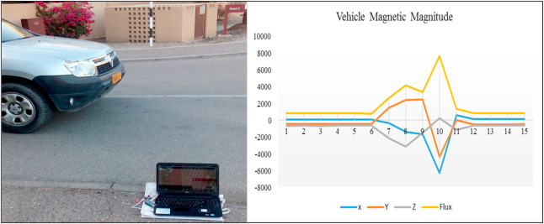

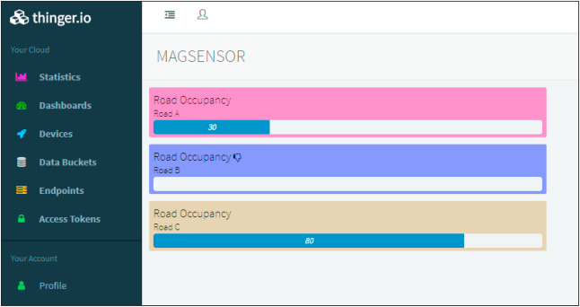

The dashboarding tools can be evaluated from different user perspectives, such as the consumers of information, administrators, and developers. In this section, the dashboard is evaluated from a user’s view according to the dashboard evaluation criteria defined .  presents the attributes, description, and compliance. The compliance value can be true or false based on the attribute is supported or not, compliance = {0,1}.

The Thinger. io dashboards comply with most of the dashboard evaluation attributes except the ability to subscribe, export, or toggle. These criteria are not too relevant in this context as the dashboards are created from the real-time data loaded to the IoT platform.

**6.4. System comparison:**

The proposed system model is compared with existing systems discussed in the related works section based on functional aspects. The functionality is evaluated with respect to research objectives. The real-time monitoring of traffic scenarios and reach out to the public through traffic updates is the main objective of the proposed system. Hence, the three parameters ‘real-time monitoring’, ‘real-time signal controlling’, ‘real-time public updates’ are defined as parameters to evaluate the functionality.

The ‘partially addressed’ parameter indicates that the study support only minimum functionality, whereas the ‘completely addressed’ parameter, indicates the support to different functional requirements. For eg, the functionality of real-time traffic update is only through traffic signals in studies 3, 4, and 5, whereas study 1 and 2 also provide the update on the intensity of traffic congestion.

Similarly, study 5 provides a few kinds of administrative reports through the application layer and the system design uses fixed surveillance cameras; however, it does not provide a real-time dashboard. Considering this, the ‘partially addressed’ score has been assigned to the system for administrator updates and system scalability parameters. The evaluation results are given in.

Table 5. Functionality evaluation.

| **System** | **Real-time monitoring** | **Real-time traffic updates** | **Real-time Signal control** | **Administrator updates** | **System scalability** | **Total (score/25)∗100** |
| --- | --- | --- | --- | --- | --- | --- |
| 1. Proposed System | 5 | 5 | 0 | 5 | 5 | 80% |
| 2 [[60](https://www.sciencedirect.com/science/article/pii/S2589791820300207#bib60)]. | 5 | 5 | 0 | 0 | 5 | 60% |
| 3 [[43](https://www.sciencedirect.com/science/article/pii/S2589791820300207#bib43)]. | 5 | 3 | 5 | 0 | 5 | 72% |
| 4 [[63](https://www.sciencedirect.com/science/article/pii/S2589791820300207#bib63)]. | 5 | 3 | 5 | 0 | 5 | 72% |
| 5 [[29](https://www.sciencedirect.com/science/article/pii/S2589791820300207#bib29)]. | 5 | 3 | 5 | 3 | 3 | 76% |

 shows that the proposed system achieves the objectives and outperforms the similar system models discussed in the related works section.

**7. Discussion:**

The study proposed a system model for real-time traffic updates in an IoT context to assist drivers. The system has three main functionalities: (i) map processing, (ii) traffic data collection, (iii) visualization, and storage. The system uses an existing free wiki map to collect the road information and extract the message unit location. The data collection layer is built on magnetic sensors to detect vehicles and estimate the length of the vehicle and road occupancy.

The system architecture establishes a WiFi-based communication model between sensors and the IoT platform. The roadside magnetic sensors and the micro-controller follows a client-server WiFi communication.

The sensor nodes A and C act as client and sensor nodes B and D as the server to estimate vehicle length at entry and exit points of the road segment. The sensor node B acts as a server and sensor node A acts as a client while estimating the road occupancy measure. The sensor node B sends the message to the roadside unit through WiFi and to the real-time data to the IoT platform. As part of the prototype, the Nodemcu microcontroller is used and a more powerful unit can be used in real-time. The central traffic management system can also connect to the IoT platform in the same way, which is beyond the scope of this work.

The road segments between 200 and 500 m are considered for evaluation. The test results indicate that the road length is inversely proportional to the error rate. Hence, the proposed system model is expected to perform well in real road scenarios.

**8. Limitations and future work:**

There are some limitations on the proposed model, which need to be enhanced further. The proposed system uses WiFi to communicate between devices; however, their energy consumptions and solutions to recharge them are not considered in this study. Alternate solutions such as solar charging or charging from street lights can be further looked at. Similarly, the proposed model is tested only in the context of the single-lane road as intended. However, it would be useful to test the system in a multi-lane scenario to identify the false detections.

For future directions, the proposed system could be further improved considering different aspects. The first dimension is suggesting an optimal route for the drivers based on real-time data.

**9. Conclusion:**

This research proposed an IoT based system model to collect, process, and store real-time traffic data. This research provided real-time traffic monitoring for traffic updates through roadside message units.

The proposed system uses magnetic sensor nodes to collect real-time vehicle information. The real-time data is processed by WiFi-enabled microcontrollers and sends to an IoT platform for further actions. Whereas, the proposed system does not expect any smart equipped devices with the driver of the car or within the car such as sensors, [GPS](https://www.sciencedirect.com/topics/earth-and-planetary-sciences/global-positioning-system), WiFi, etc. and which makes this model unique.

The proposed system is expected to be considered in any smart city initiatives such as a smart university campus or any closed smart premises. As a prototype was implemented to demonstrate the feasibility of the proposed model, the results of the prototype demonstration showed good accuracy in vehicle detection and a low relative error in road occupancy estimation. Thus, the proposed model can help citizens to save their time based on the early-warning messages displayed in the message unit, especially during peak hours.