**DELIVERABLE 2** SUNSHINE BOYS

**CROP MANAGEMENT SYSTEM**

MUHAMMAD QAMAR – N01344609 NOHA PHILIPS – N01351336

TANVIR PAHWA – N01245843

SIVAJAN MANIKAVASAGAR – N01240148



**TABLE OF CONTENTS**

1) Project Description………........................3

2) Team member names and signatures.......................................3

3) Github link........................................3

4) Stories and tasks......................................4

5) Business Model Canvas...............................6

6) Firebase.............................................7

7) Progress Made.......................................11

6. DESCRIPTION OF PROJECT

This project encapsulates the use of multiple sensors such as humidity, temperature, moisture, and level sensors to monitor and grow household plants. Our project will actively monitor plants to make sure they are growing optimally without manual intervention.

7/8. TABLE OF SIGNATURES

| Name | ID | Signature | Effort |
| --- | --- | --- | --- |
| Muhammad  Qamar | N01344609 |  | 100 |
| Noha Philips | N01351336 |  | 100 |
| Tanvir Pahwa | N01245843 |  | 100 |
| Sivajan  Manikavasagar | N01240148 |  | 100 |

9/10. GITHUB LINK

<https://github.com/SivajanManikavasagar0124/CropManagementSystem>

11. Hardware Prof Invite

Our prof refused to provide an e-mail for github. Prof. Ali Maki said that inviting him to the github was not necessary and any android app related matters could be discussed with our Software Project Professor instead.

14-16. Stories and Tasks

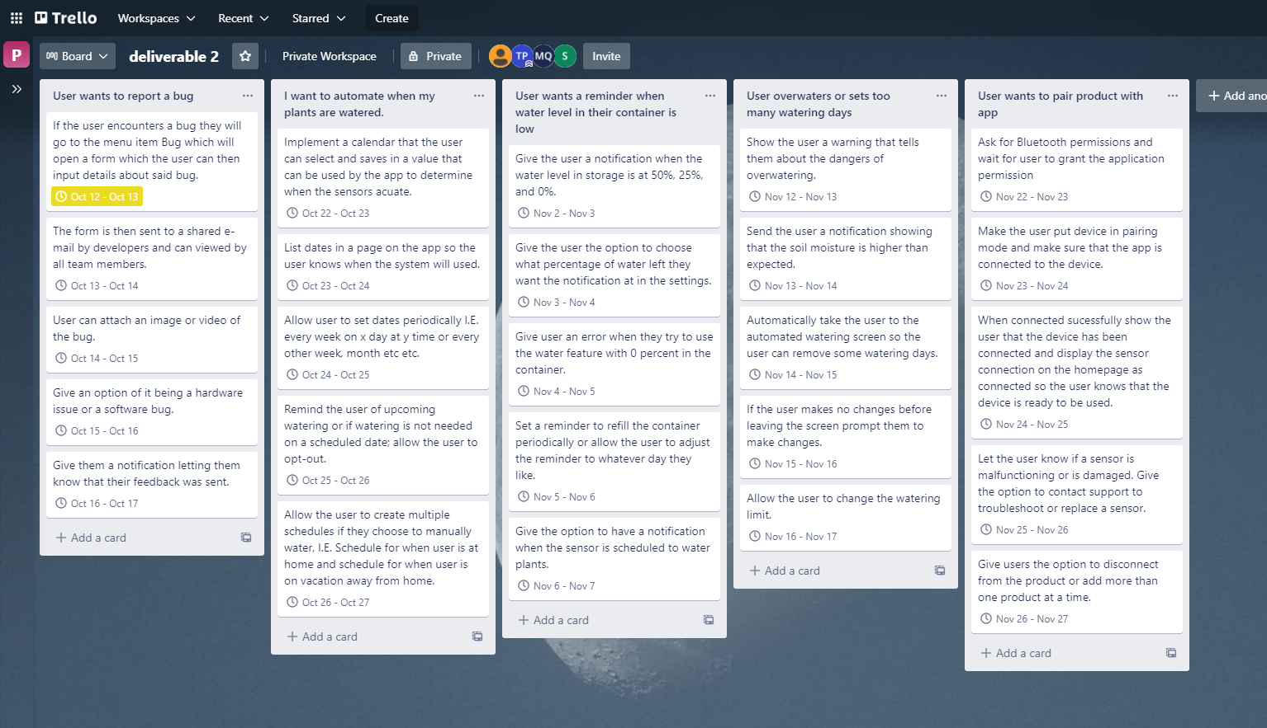

17. The DoD Criteria

* The Acceptance Criteria is met : All the requirements that are needed for deliverable 2 are met by all the group members equally.
* Coding Task is completed : The coding part for deliverable 2 is also completed, all the requirements are met like integrating the 5 different fragments into the app etc.
* Regression testing is up to date : The code and the functionality in the app has not caused any problems, it all works the way it should be working.
* Unit testing is done : All the functions, procedures and interfaces are tested for the app.
* Automated unit testing : The application meets the design and acts as it is intended.

18. Business Model Canvas

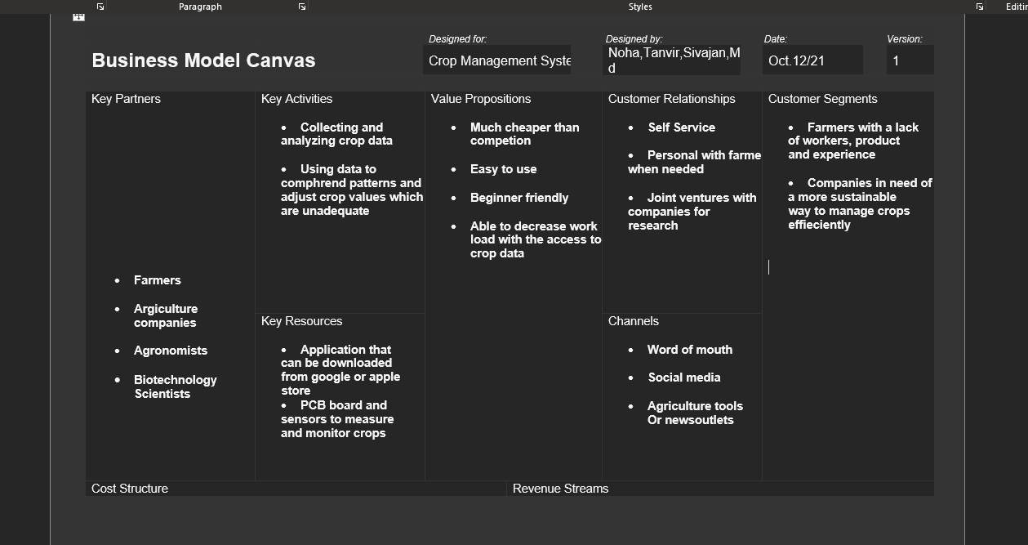

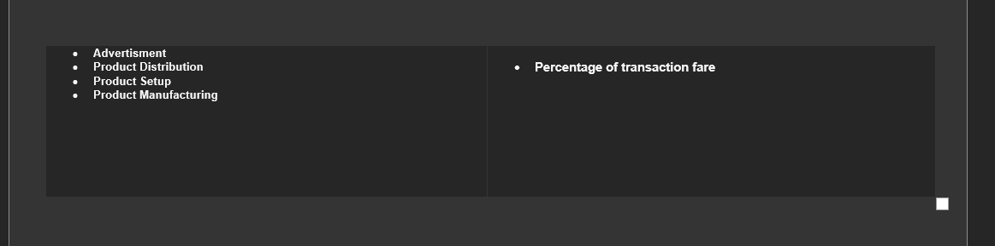

19. Firebase Database

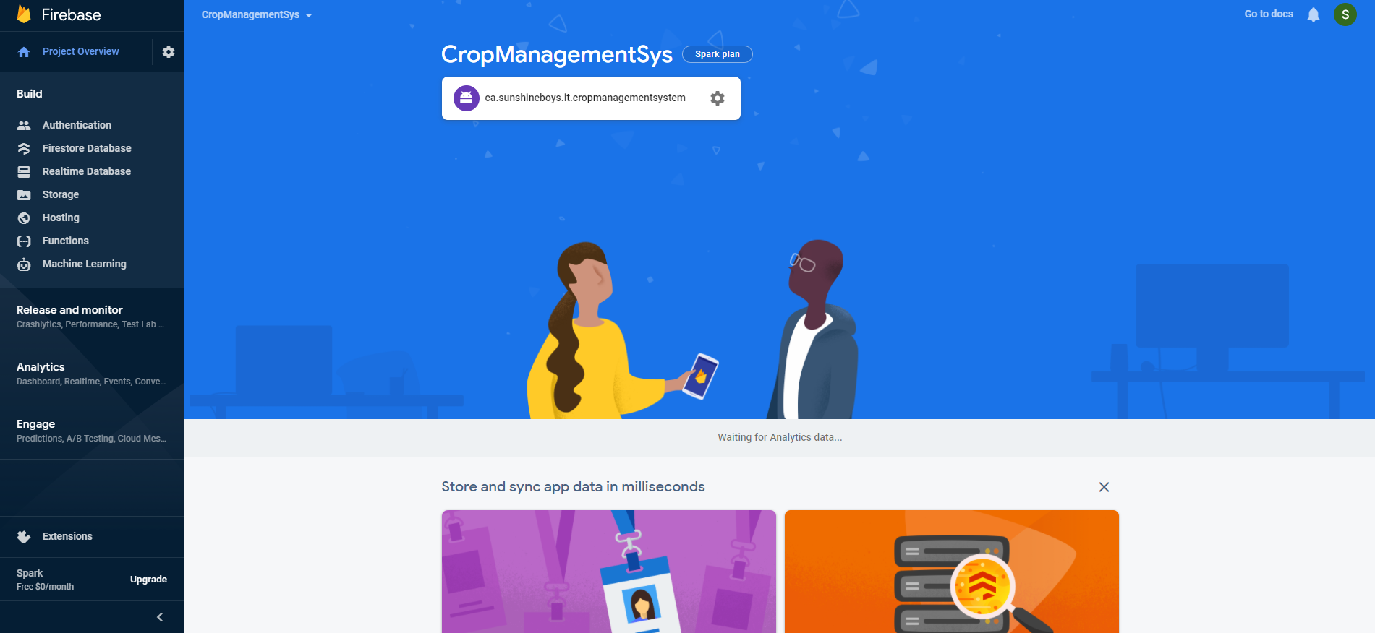

Our database uses analytics to deliver bugs and crashes to the developer to increase stability and optimisation. The Firebase database also allows us to use cloud messaging. The use of cloud messaging will help us implement real-time support for users who have trouble with the app. This will allow our business to implement customer service reps who can reply to the users experiencing issues.

20. Progress since deliverable 1

Since deliverable 1, we’ve added 2 new pages, adjusted the current pages to include our sensor information. A menu system with new options as well as a settings fragment that opens when clicked in the menu. A Splash screen was also implemented with a new logo and theme. We will follow the splash logo theme in upcoming deliverables so the main pages may change in colours, font, and overall style. We want to create an app that has a uniform style as that is what is considered good practice in UI/UX Design. Connect sensor implements the use of bluetooth permissions and will ask the user to enable permissions before attempting to connect to the sensors. We’ve also added icons for each navigation menu item as well as vector icons for the toolbar menu. Other cosmetic tweaks in preparation for functionality were implemented.

21. Daily Stand up activities