Table of Contents

1.1 Backup Nozomi Physical/Virtual Devices 7
1.2 Checklist for Update Prerequisites/Validation 8
1.3 Identify Nozomi Physical/Virtual Devices Version 9
1.4 Understanding the Nozomi Upgrade Path 10
1.5 VM ESXI v8.0 Compatibility Upgrade 11
1.6 Procedure for Upgrading Nozomi Devices 12
1.7 Updating Threat Intelligence and Asset Intelligence Definitions 14

Backup Nozomi Physical/Virtual Devices
    - Log into a device that can access the Nozomi web console
    - Log into Nozomi Web Console (Refer to Password Document – Nozomi)
    - Navigate Administration (Gear icon in the Top Right) -> System -> Backup and Restore
    - Under Generate Backup Archive, Select Download button
      - Select Include traces
      - Encryption Password: (Refer to Password Document – Nozomi)
      - Select Download
    - Repeat this process for all Nozomi Devices (Guardian and CMC)

Checklist for Update Prerequisites/Validation
Note: Ensure all devices (Guardian and CMC) are at the same version
    - Follow instructions in “Backup Nozomi Physical/Virtual Devices” to complete a full backup.
    - Check the Health Page
    - In the Nozomi Web UI, navigate to Gear Icon (Top left of page) -> System -> Health -> Preformance Tab
    - Ensure there are no warning messages and all Health/Services are OK
    - In the Nozomi Web UI, navigate to Gear Icon (Top left of page) -> System -> Health -> Health Log Tab
    - Ensure there are no recent alerts in the health log that could affect the upgrade
    - Failed migrations
    - System under high load
    - X% CPU usage
    - X% RAM used
    - X% disk space used
    - Check Disk for Errors
    - In vSphere, open a web console for Guardian and CMC or Log in using SSH
    - Enter command: zpool status
    - Verify SSH Access
    - Log into the Guardian and CMC using SSH or Putty
    - In a command prompt, enter ssh admin@<IP address for Guardian or CMC>
    - Log in using Nozomi credentials

Identify Nozomi Physical/Virtual Devices Version
- Log into a device that can access the Nozomi web console
- Log into Nozomi Web Console (Refer to Password Document – Nozomi)
- At the top of the page, a banner will have the version of the Nozomi Device
- Write down the hostname and version of each device
- Repeat this process for all Nozomi Devices (Guardian and CMC)

Understanding the Nozomi Upgrade Path
- Based on the version list created for current Nozomi Devices on the network,
- Nozomi Upgrade Path:
  - 23.4.0 -> 24.5.1 -> 25.5.0 -> 25.6.0 -> 26.2.0

Note: Upgrading from 24.5.1 -> 25.5.0 requires the VM to be updated to Host ESXI v8.0 and virtual hardware version 20+. (Refer to VM ESXI v8.0 Compatibility Upgrade Section in this document)
  - If you are lower than the version listed above, update to the next version
    - Ex. If you were at 24.2.0, you would want to upgrade to 24.5.1. Then, follow the rest of the upgrade path.
- If you have a CMC, all updates will be done through the CMC and will be propagated to all connected Guardians.
  - All devices must be in the same upgrade band (Ex. If all Nozomi Device versions are between 24.5.1 and 25.5.0, then that is the same upgrade band)
  - If not, Refer to Individual Nozomi Device Upgrade to get all devices in the same upgrade band before continuing.
- If you do not have a CMC, all Nozomi Devices will have to be individually updated.

VM ESXI v8.0 Compatibility Upgrade

Note: Skip this section if you do not have to upgrade from 24.5.1 -> 25.5.0

Note: Make sure the Backup Section is completed for each Virtual Nozomi Device that needs the ESXI v8.0 upgrade
- For virtual Guardian and CMC,
- Log into the ESXI/vCenter host
- Under Virtual Machines, Select Nozomi Device
- On the VM page, check to see if the compatibility is ESXI v7.x

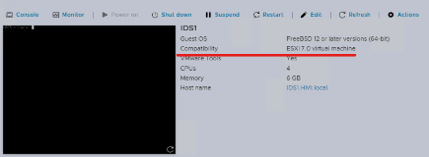
- Select Shut Down
- Select Actions or Right Click the VM name under Virtual Machines
- Select Upgrade VM compatibility
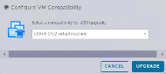

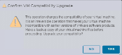
- Select ESXI 8.0 or ESXI 8.0 U2 virtual machine

- Select Yes
- Select Power on
- Repeat this process for all virtual Nozomi Devices (Guardian and CMC)

Procedure for Upgrading Nozomi Devices
- Before upgrade follow “Checklist for Update Prerequisites/Validation” section to ensure no errors in upgrade
- Log into the Nozomi CMC or Nozomi Guardian web console

Note: If the upgrade is performed through CMC, it will update all connected Guardians. If the upgrade is performed on the Guardian, the process will have to be repeated on each Guardian.
- Navigate to Administration -> System -> Operations
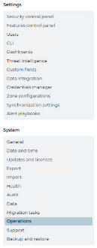

- Select the Software Update button

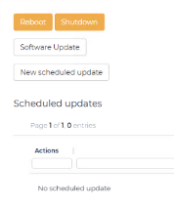
Note: May look different based on which version upgrading to, but it will have all the same buttons

- Select “Browse”, go to the Prerequisite folder in ISO and select <the corresponding update.bundle> (Ex. “2X.X.X-XXXXXXXX_XXXXX-advanced-update.bundle”.)
- Select Proceed button

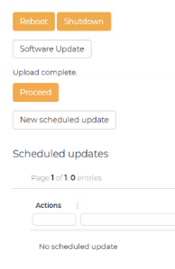
- The update may take several minutes to complete, and CMC/Guardian will reboot.
- When finished, Select Close

Note: If updating through CMC, the update may take 12-20 minutes to propagate the software update to connected Guardians. Then, it will take several minutes to complete, and the Guardian will reboot.
- After update finishes, review “Checklist for Update Prerequisites/Validation” section to ensure no errors in upgrade
Note: If updating from 24.5.1 -> 25.5.0, there may be an error in Web GUI or SSH access. If so, follow the instructions below to fix Web GUI or SSH access issue.
- Log into Guardian/CMC using vSphere web console for the machine that has a Web GUI or SSH access issue
- Enter command: enable-me
- Enter command: setup
- Navigate down using arrow keys to Option 4: Default Router/Gateway
- Navigate up to the empty box and Select Enter Key to Edit setting for Default Gateway
- Enter IP address of DC1
- Navigate down and Select Enter key on OK button
- Navigate up to the Option X: Exit and Select Enter Key
- Enter command: reboot.
- Verify Web GUI and SSH access
- Repeat instructions for Nozomi Guardian/CMC upgrade step till desired update or latest 26.2.0

Updating Threat Intelligence and Asset Intelligence Definitions

Note: Update Threat Intelligence and Asset Intelligence through CMC (if applicable). Otherwise follow instructions for updating through Guardian.

Note: All Nozomi Guardians connected to a CMC will update from the CMC’s Threat and Asset Intelligence version
- Log into the Nozomi CMC/Guardian web console
  - Navigate to System -> Updates & Licenses
  - Select the Update service configuration
    - Select the Manual contents upload
    - Browse for the update files or Drag and Drop them in

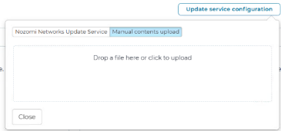
    - Wait for the “Verifying….” Message to complete, an “upload succeeded…” message will be displayed.
    - Select “Close”.
    - The version of the update will be displayed in the “Threat Intelligence” window.

Note: You may need to refresh the browser to see the version of the update.
  - Repeat for “Asset Intelligence” if applicable.

