

Batch: KSRVLSI01
Advanced Diploma in VLSI Design and Verification

PROJECT SYNOPSIS REPORT
ON

“<AXI4 FULL MASTER-SLAVE COMMUNICATION>”

by

S. Chaitra Sivaji Reddy CL20251226011329132
S. Moin CL20251226011328122
R. Bhargavi CL20251226011327819

Under the guidance of
Aashrithest H G
Cranes Varsity, Bangalore
Dec-Mar2026

ABSTRACT
The AXI4-FULL protocol, a part of the AMBA bus architecture developed by Arm Ltd., is widely used in high-performance System-on-Chip (SoC) designs for efficient and high-speed communication between processing units and memory or peripheral devices. This project focuses on the design and implementation of AXI4-FULL communication between a single master and a single slave using Verilog HDL.
The AXI4-FULL protocol supports separate read and write channels, burst-based data transfer, and high-throughput pipelined communication. In this work, the master module initiates read and write transactions, generates addresses, controls burst parameters, and manages data flow. The slave module responds to these transactions by storing or retrieving data from internal memory and providing appropriate response signals. The communication is implemented using five independent channels: write address, write data, write response, read address, and read data.
The design ensures proper handshaking using VALID and READY signals, supports burst transfers, and follows AXI4-FULL protocol requirements. Simulation and verification are carried out to validate correct data transfer between the master and slave. The results demonstrate reliable and efficient communication.
This implementation provides a strong foundation for understanding AXI-based SoC architectures and can be extended to multi-master and multi-slave systems.

INTRODUCTION
In modern digital systems, high-speed and reliable data communication is essential for efficient system performance. As System-on-Chip (SoC) designs become increasingly complex, multiple components such as processors, memory units, and peripheral devices must communicate with each other efficiently. To enable this communication, a well-defined bus architecture is required.
Traditional bus systems often suffer from limitations such as lower data transfer speed, limited scalability, and inefficient handling of multiple transactions. To address these challenges, advanced communication protocols have been developed. One of the most widely used bus architectures in SoC design is the AMBA (Advanced Microcontroller Bus Architecture), developed by Arm Ltd.. AMBA provides a standardized interface for high-performance communication between system components.
Among the AMBA protocols, AXI (Advanced extensible Interface) is widely adopted due to its high throughput, low latency, and support for burst-based and pipelined data transfers. AXI4-FULL, in particular, supports separate read and write channels, enabling simultaneous operations and improving overall system efficiency. It uses VALID and READY handshaking signals to ensure reliable and synchronized data transfer between master and slave devices.
The AXI4-FULL protocol consists of five independent channels: write address channel, write data channel, write response channel, read address channel, and read data channel. These channels operate independently, allowing multiple transactions to occur in parallel. Burst transfer capability further enhances performance by allowing multiple data transfers in a single transaction.
This project focuses on the design and implementation of AXI4-FULL communication between one master and one slave using Verilog HDL. The master module initiates read and write transactions by generating addresses and control signals, while the slave module responds to these requests and performs memory operations accordingly. The design supports burst transfers and follows the standard AXI4-FULL protocol timing requirements.
The implementation and simulation of this system provide a fundamental understanding of AXI-based communication and its role in high-performance SoC architectures. This work serves as a foundation for extending the design to more complex systems involving multiple masters and slaves.

OBJECTIVES
The main objectives of this project are as follows:
  - To study and understand the AXI4-FULL protocol, which is a part of the AMBA bus architecture developed by Arm Ltd.
  - To design and implement an AXI4-FULL master module capable of initiating read and write transactions.
  - To design an AXI4-FULL slave module that can respond to master requests and perform memory read and write operations.
  - To support burst-based data transfer for efficient and high-speed communication.
  - To implement separate read and write channels to enable parallel and pipelined data communication.
  - To ensure proper handshaking using VALID and READY signals for reliable data transfer.
  - To verify the functionality of the system through simulation using Verilog HDL.
  - To analyze the performance and correctness of communication between the master and slave.
  - To develop a scalable and modular design that can be extended to multi-master and multi-slave systems.
  - To gain practical knowledge of AXI-based communication used in modern SoC designs.

LITERACTURE SURVEY
The design of high-performance communication protocols is an important area in modern System-on-Chip (SoC) development. As digital systems grow in complexity, efficient data transfer between processors, memory, and peripherals has become essential. Various bus architectures have been developed to improve speed, scalability, and reliability in such systems.
Earlier communication protocols such as AHB and APB, which are part of the AMBA (Advanced Microcontroller Bus Architecture), provided basic communication between system components. However, these protocols had limitations in terms of throughput, scalability, and support for multiple outstanding transactions. To overcome these issues, advanced bus protocols were introduced by Arm.
The AXI (Advanced extensible Interface) protocol was developed to provide high-performance and flexible communication in modern SoC designs. AXI4-FULL supports burst-based data transfer, pipelined communication, and separate read and write channels. These features enable high throughput and low latency. The VALID-READY handshaking mechanism ensures reliable and synchronized communication between master and slave devices.
Several researchers have implemented AXI-based communication using hardware description languages such as Verilog and VHDL. Their work mainly focuses on improving performance, reducing latency, and designing efficient memory interfaces. Some studies also explore multi-master and multi-slave architectures to support complex SoC systems.
Recent research has emphasized the importance of burst transfers and pipelining in increasing system performance. These techniques allow multiple transactions to occur simultaneously, improving bandwidth utilization. AXI protocols are widely used in modern processors, graphics processing units, and embedded systems due to their flexibility and scalability.
In this project, an AXI4-FULL communication system between a single master and a single slave is designed and implemented using Verilog HDL. The work focuses on understanding the protocol, implementing burst transfers, and verifying the communication through simulation. This study provides a foundation for future work in advanced AXI-based SoC architectures.

HARDWARE AND SOFTWARE REQUIREMENT
Software Requirement – Xilinx Vivado

METHODOLOGY

BLOCK DIAGRAM
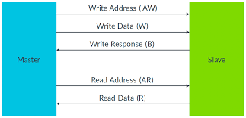

AXI Master Module

The AXI master is responsible for initiating all read and write transactions. It generates the address and control signals required for communication. During a write operation, the master sends the write address, burst information, and write data to the slave. During a read operation, the master sends the read address and receives data from the slave.
The master also manages burst parameters such as burst length, burst size, and burst type. It controls the VALID signals and monitors the READY signals from the slave to ensure proper handshaking. The master increments the address for each beat in incremental burst transactions. The master module also indicates the completion of transactions through a status signal.

AXI SLAVE MODULE

The AXI slave responds to the requests initiated by the master. It performs the actual memory read and write operations. During a write transaction, the slave receives the address and data from the master and stores the data in its internal memory. During a read transaction, the slave retrieves data from memory and sends it back to the master.
The slave generates response signals to indicate whether the transaction is successful. It also provides READY signals to control the flow of data and ensure synchronization between master and slave.

AXI CHANNEL DESCRIPTION

[1] Write Address Channel (AW)

This channel transfers the write address and control information from the master to the slave. It includes signals such as address, burst length, burst size, and burst type. The handshake is performed using AWVALID and AWREADY signals.

[2] Write Data Channel (W)

This channel transfers the actual write data from the master to the slave. It also includes the WLAST signal to indicate the last data beat in a burst transfer. The handshake is controlled by WVALID and WREADY.

[3] Write Response Channel (B)

After receiving and storing the write data, the slave sends a response to the master through this channel. The response indicates the status of the write transaction. It uses BVALID and BREADY signals.

[4] Read Address Channel (AR)

This channel transfers the read address and burst information from the master to the slave. The handshake is performed using ARVALID and ARREADY signals.

[5] Read Data Channel (R)

This channel transfers the read data and response from the slave to the master. The RLAST signal indicates the last beat of the read burst. The handshake is controlled by RVALID and RREADY signals.

Dependencies between channel handshake signals

Write transaction Dependencies
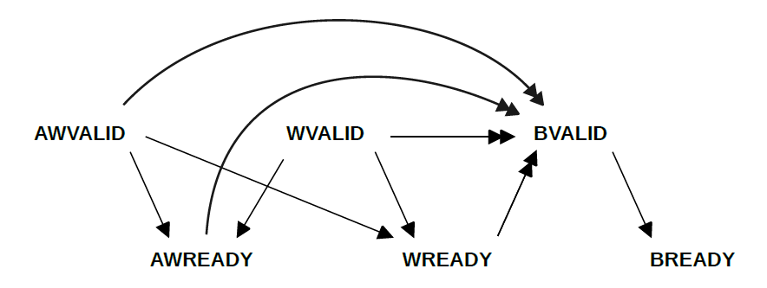

Read transaction Dependencies

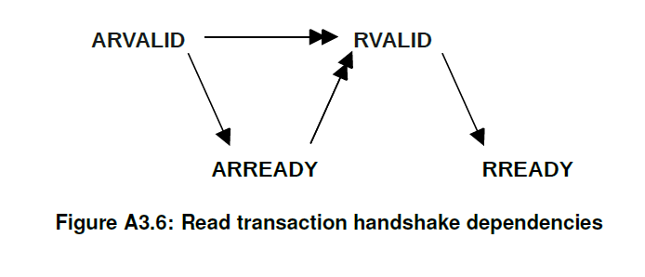

AXI SIGNALS

Global signals
clk → Provides clock to synchronize all AXI operations.
rst → Resets the system to a known initial state.

Control signals
start_write → Starts the AXI write transaction from the master.
start_read → Starts the AXI read transaction from the master.
done → Indicates completion of the AXI transaction.
error → Indicates an error occurred during read or write transfer.

Address and data inputs
base_write_addr → Specifies the starting memory address for write operation.
base_read_addr → Specifies the starting memory address for read operation.
write_data → Provides the initial data value for burst write transfer.

Burst control signals
burst_len → Defines the number of data beats in a burst transfer.
burst_size → Specifies the number of bytes transferred in each beat.
burst_type → Defines the burst mode such as FIXED, INCR, or WRAP.

Write Address channel
AWADDR → Sends the starting write address from master to slave.
AWLEN → Indicates the number of beats in the write burst.
AWSIZE → Specifies the size of each data transfer.
AWBURST → Defines the type of burst transfer.
AWVALID → Indicates the write address is valid.
AWREADY → Indicates the slave is ready to accept the address.

WRITE DATA CHANNEL (W)
WDATA → Transfers write data from master to slave.
WSTRB → Enables byte-wise write operation.
WVALID → Indicates valid write data is available.
WLAST → Indicates the last data beat of the burst.
WREADY → Indicates the slave is ready to accept data.

WRITE RESPONSE CHANNEL (B)
BRESP → Provides the write transaction status from slave.
BVALID → Indicates write response is valid.
BREADY → Indicates the master is ready to receive the response.

READ ADDRESS CHANNEL (AR)
ARADDR → Sends the starting read address to the slave.
ARLEN → Indicates number of beats in read burst.
ARSIZE → Specifies the size of each read transfer.
ARBURST → Defines the read burst type.
ARVALID → Indicates the read address is valid.
ARREADY → Indicates the slave is ready to accept the address

READ DATA CHANNEL (R)
RDATA → Transfers read data from slave to master.
RRESP → Provides the read transaction status.
RVALID → Indicates read data is valid.
RLAST → Indicates the last beat of read burst.
RREADY → Indicates the master is ready to receive data.

Burst attribute
The Burst attribute describes how the address increments between transfers in a transaction. There are three different Burst types:

FIXED

This Burst type is used for repeated accesses to the same location such as when loading or emptying a FIFO.
• The address is the same for every transfer in the burst.

INCR (incrementing)

With this Burst type, the address for each transfer is an increment of the address for the previous transfer. The increment value depends on the transaction Size. For example, for an aligned start address, the address for each transfer in a transaction with a Size of 4 bytes is the previous address plus 4. This Burst type is used for accesses to normal sequential memory.

WRAP (wrapping)

This Burst type is similar to INCR except that the address wraps around to a lower address if an upper address limit is reached.
The following restrictions apply:
• The start address must be aligned to the size of each transfer.
• The Length of the burst must be 2, 4, 8, or 16 transfers.

Algorithm
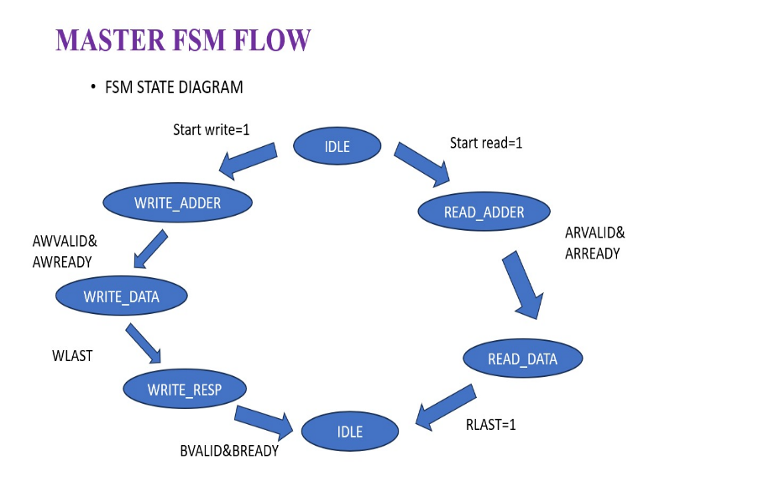

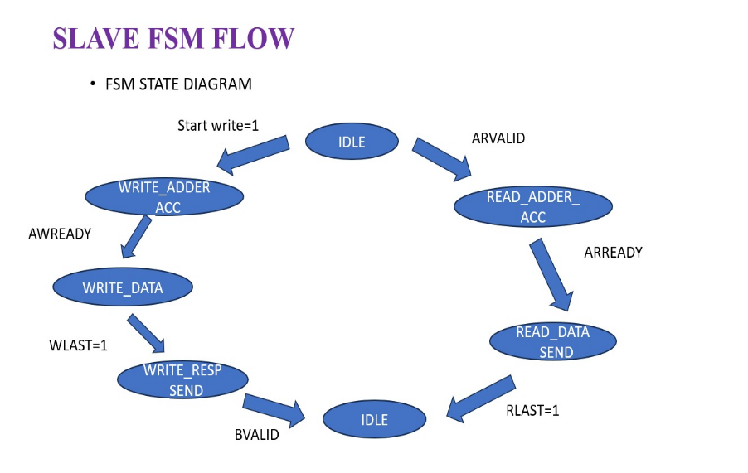

OUTCOMES
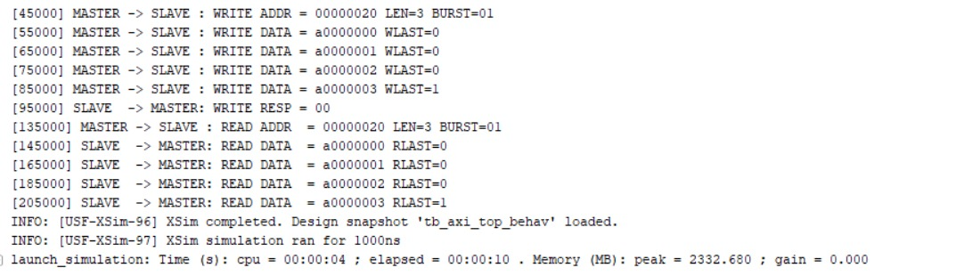

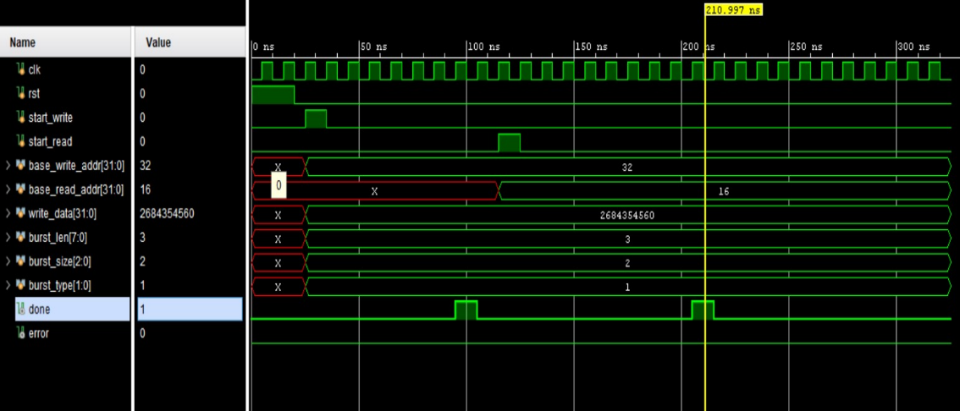

CONCLUSION
This project presents the design and implementation of the ARM AXI4 Full communication protocol between a single master and a single slave. The system enables smooth and structured data transfer by using separate channels for address, control, and data. Burst transfer and address increment features are implemented to allow continuous data movement in an organized manner.
The design ensures proper handshaking between master and slave, along with error checking to maintain correct communication. Simulation results verify that both read and write operations are performed successfully according to the protocol rules. This project demonstrates how AXI4 supports reliable and high-speed communication in modern digital systems. In future work, the design can be extended to support multiple masters and slaves to build more complex and scalable System-on-Chip architectures.

REFERENCES
[1] Arm Limited, AMBA® AXI and ACE Protocol Specification,
Document No. ARM IHI 0022, Issue J, Mar. 2023, Arm Ltd..

[2] Author(s), “Design, Analysis and Verification of AMBA AXI4.0,” in Proceedings of the International Conference on Visual Analytics and Data Visualization (ICVADV-2025), IEEE Xplore, Part No. CFP25VQ6-ART, ISBN: 979-8-3315-2139-4, 2025.
[3] Author(s), “Design and Simulation of AXI4 Stream Interconnect Using Verilog,” in Proceedings of the 2024 IEEE International Conference on Information Technology, Electronics and Intelligent Communication Systems (ICITEICS), Karnataka, India, Jun. 28–29, 2024.
[4] Arm Ltd., “AMBA AXI and ACE Protocol Specification,” [Online]. Available: https://www.arm.com/architecture/system-architectures/amba/amba-4. [Accessed: Feb. 20, 2026].
[5] Arm Ltd., “AMBA Specifications,” [Online]. Available: https://www.arm.com/architecture/system-architectures/amba/amba-specifications. [Accessed: Feb. 20, 2026].
[6] AMD, “AXI Overview,” [Online]. Available: https://www.amd.com/en/products/adaptive-socs-and-fpgas/intellectual-property/axi.html. [Accessed: Feb. 20, 2026].

