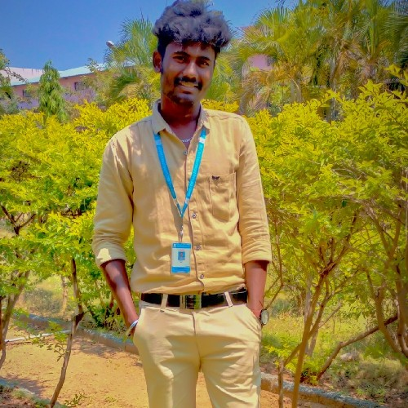

Siva R

Manamadurai, Sivaganga-630606

+91 8270657156 | [siv](mailto:siva432001@gmail.com)[a432001@gmail.com](mailto:a432001@gmail.com)

↑ https:/[/www.linkedin.com/in/siva-r-417a16222](http://www.linkedin.com/in/siva-r-417a16222)

Objective

I seek challenging opportunities where I can fully use my skills for the success of the organization.

Education



OVC Higher secondary school

10 th std

87%



OVC Higher secondary school

12 th std

75%



Christ the King engineering college -coimbatore

Bachelor of Engineering

7.6 CGPA

2016

2018

2022

Skills

Python programming language C programming language

Front end development (Html,CSS, JavaScript, jQuery, Bootstrap, Semantic UI,Node JS, React JS)



Achievements & Awards

Ethical hacking in using python Front end development

Interests

Gaming Creation Website designing

Activities

Farming activities

Watching documentaries and sports over the Weekends



Languages

English Tamil

Malayalam



Personal Details

Date of Birth : 04/03/2001 Marital Status : Single

Nationality : Indian