Result

Once the project is developed, go to project directory, and run the command “mvn clean install”.

Example:

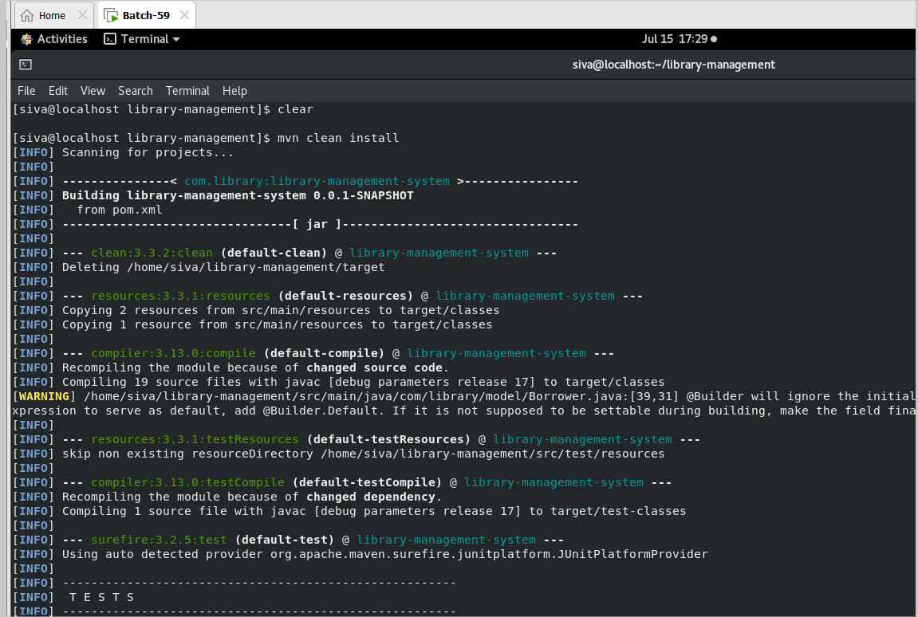

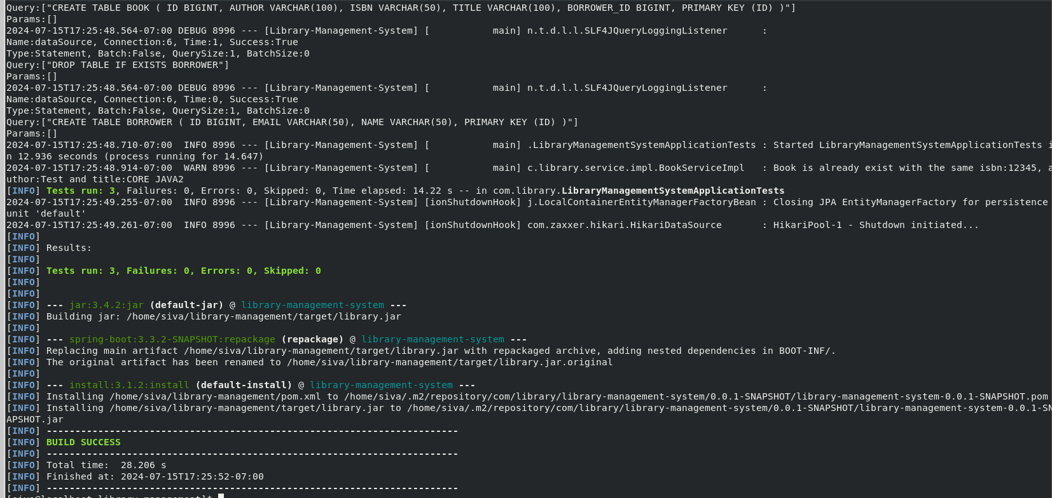

Test cases are working as expected.

Now run the 2nd command “docker build -t library-management-system .” to create the image in docker.

Example

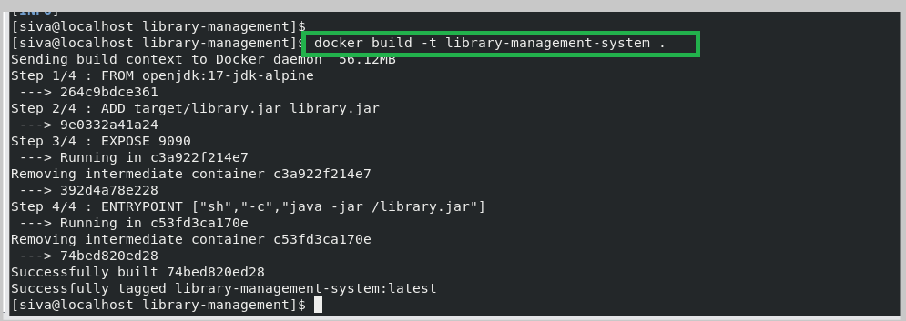

Image has successfully created with the tag latest

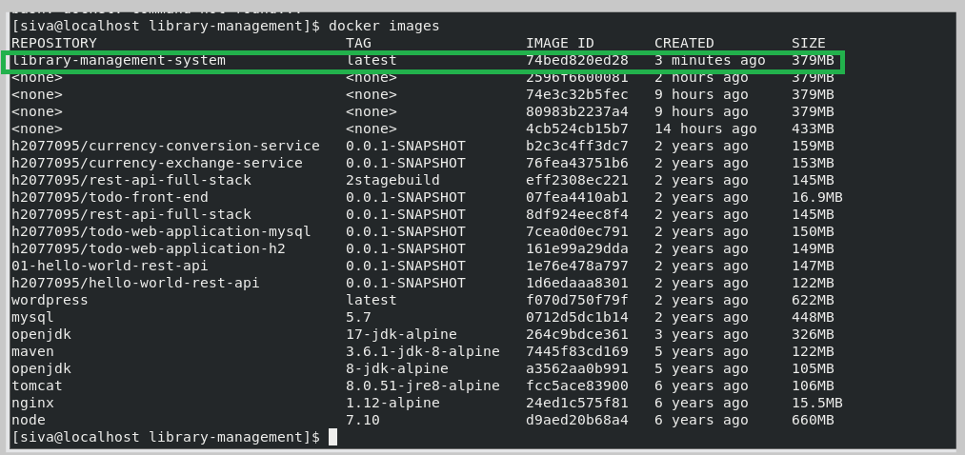

Now the run the docker image by using below command

docker run -p 9191:9090 library-management-system:latest

now docker image is running on port 9090.

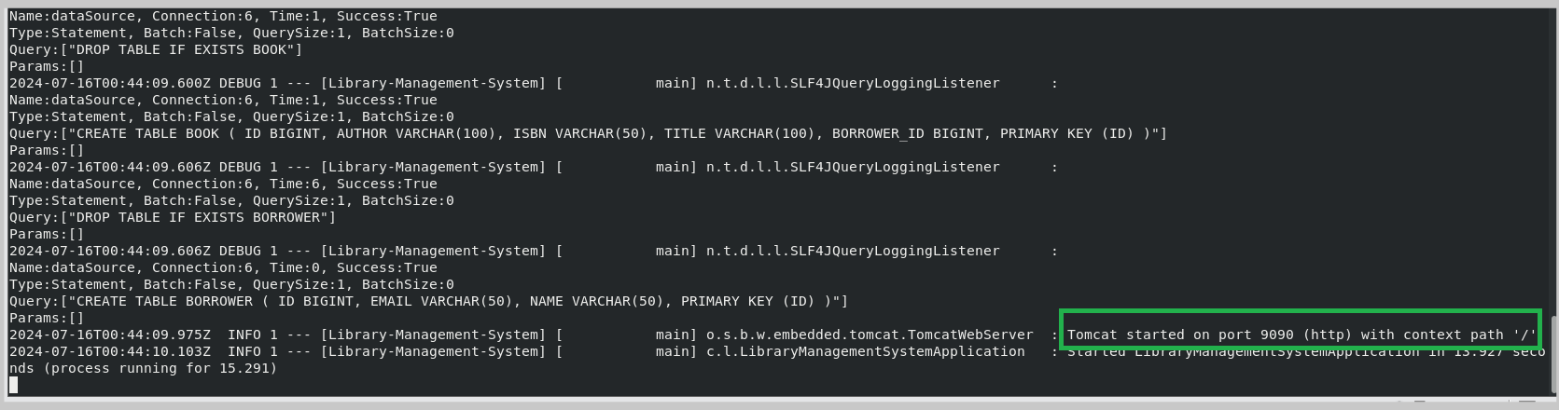

Now can access the H2 db and swagger using below URL’s

<http://192.168.25.128:9191/swagger-ui/index.html>

<http://192.168.25.128:9191/h2-console>

Example:

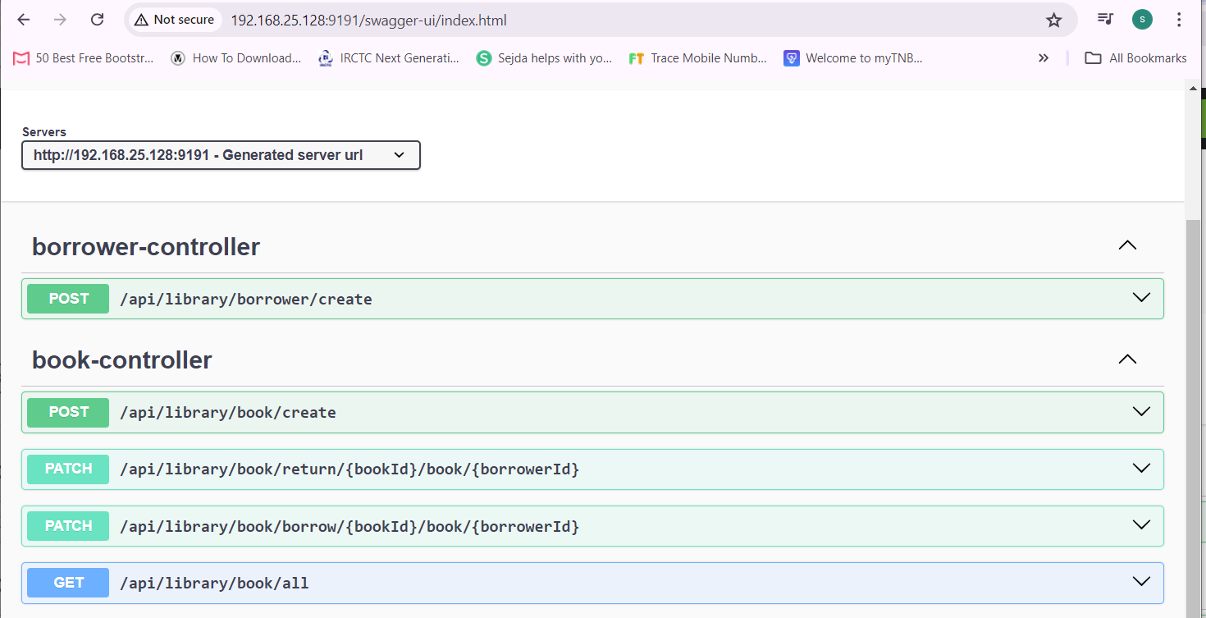

1. Creating books using swagger:

Example:

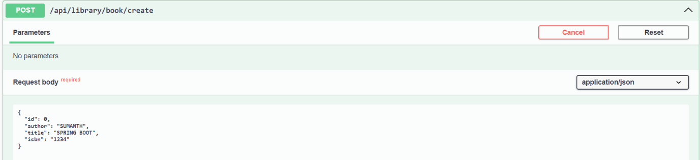

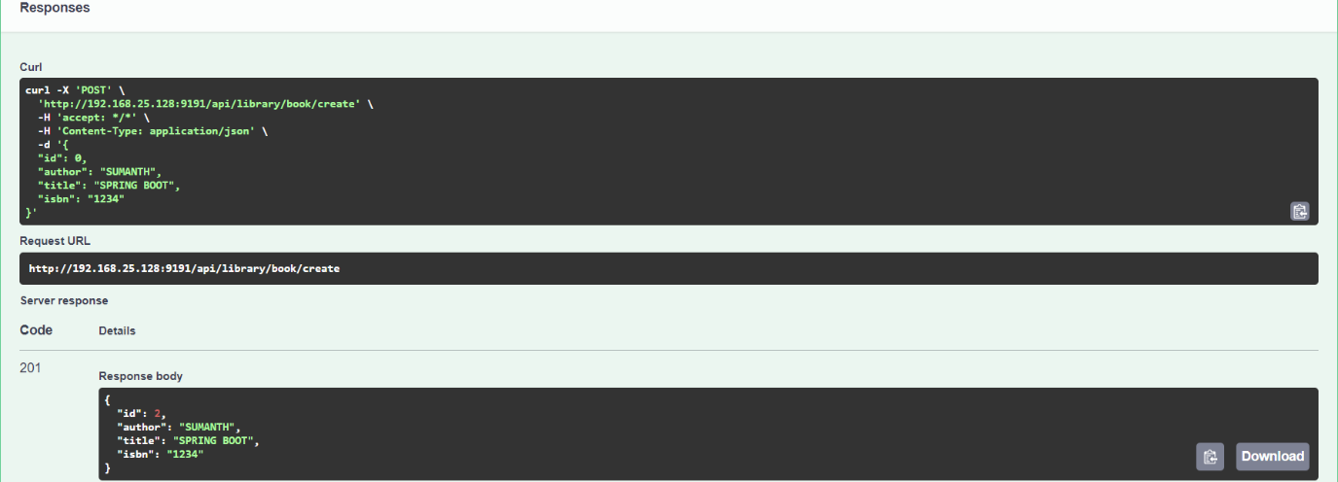

1. Check the books which are created:

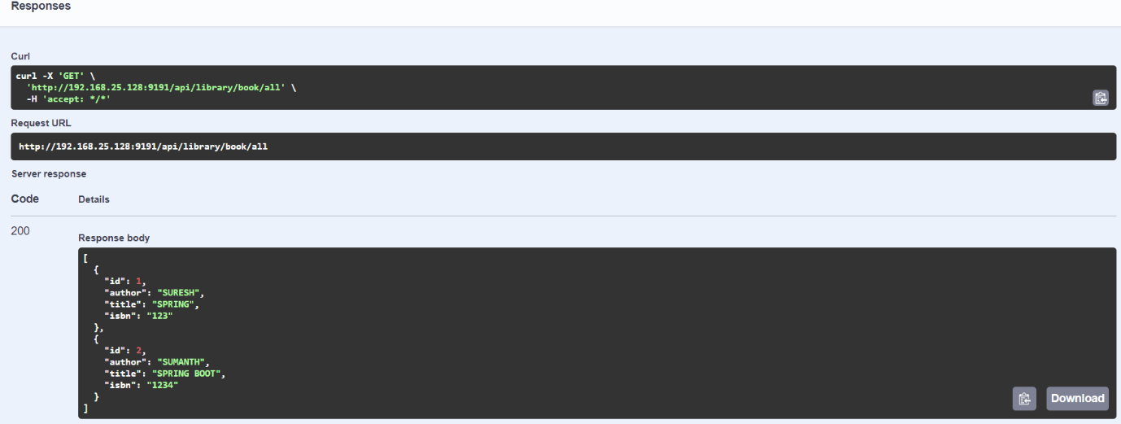

1. Create the borrowers:

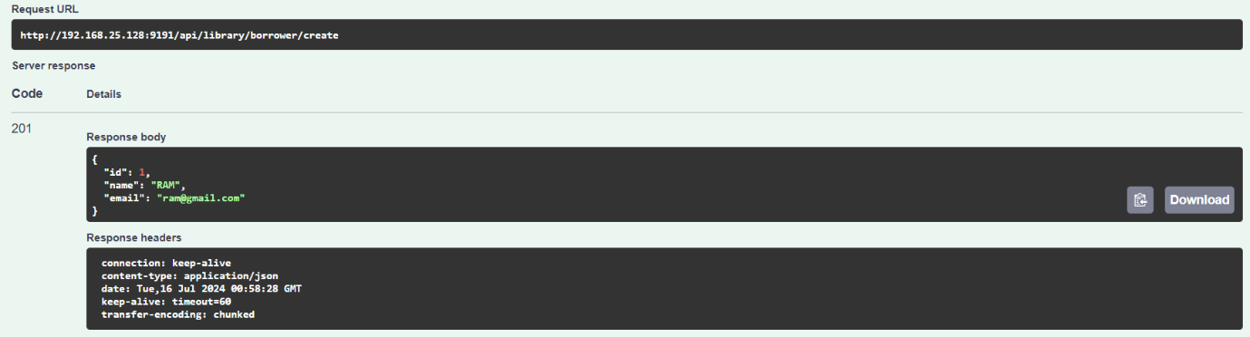

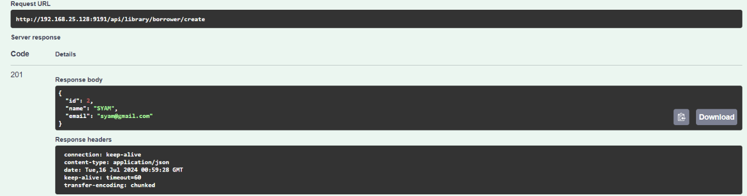

1. Borrow the book from Library:

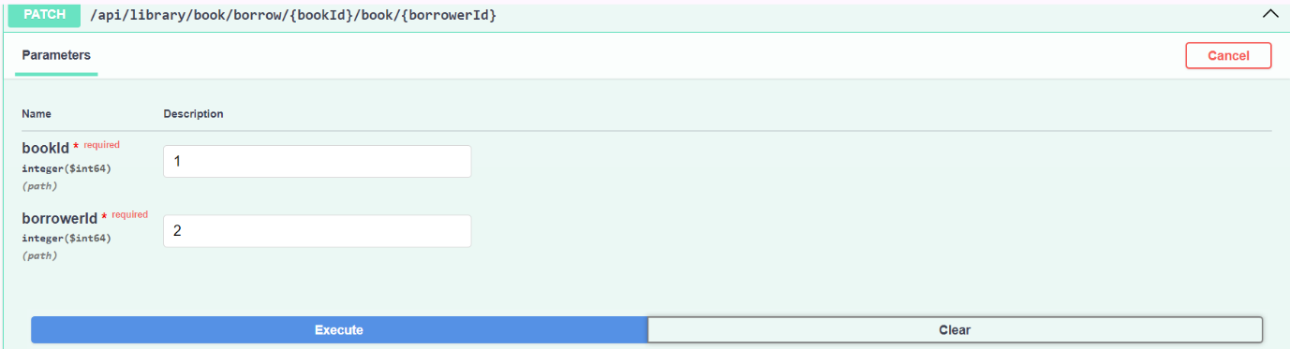

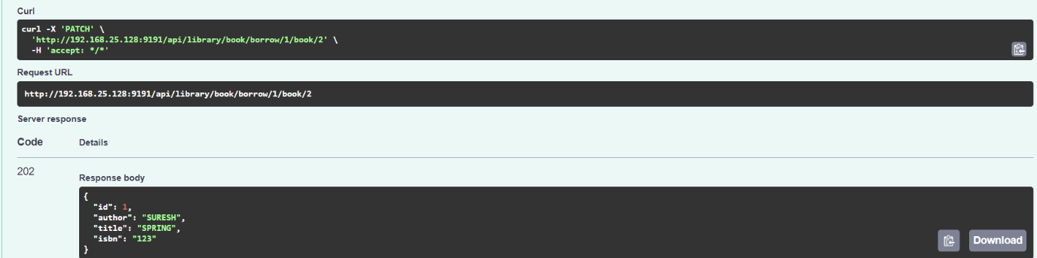

**In DB:**

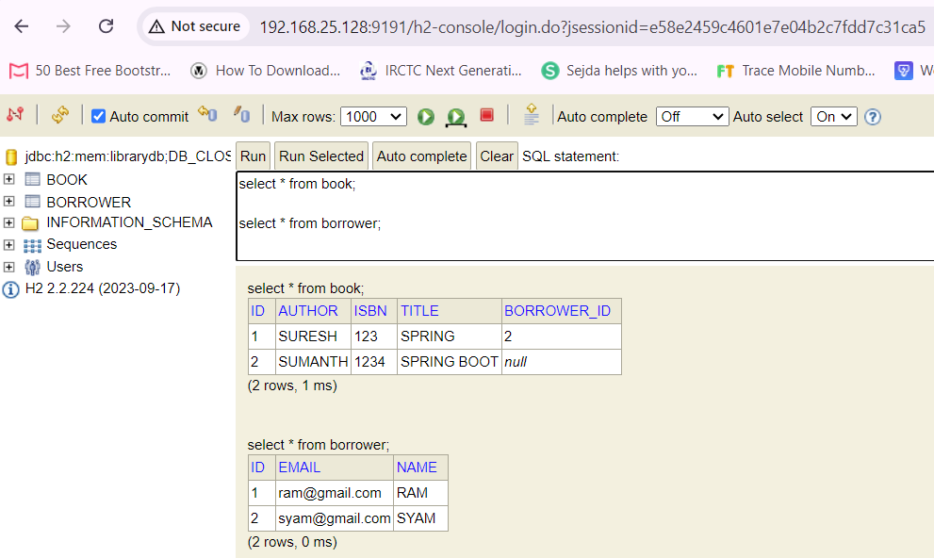

Giving another book to SYAM.

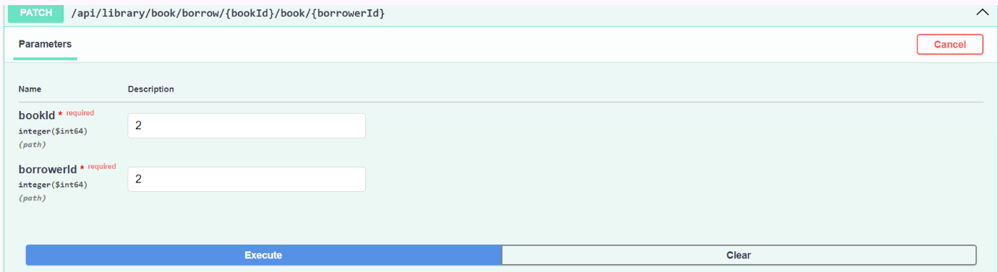

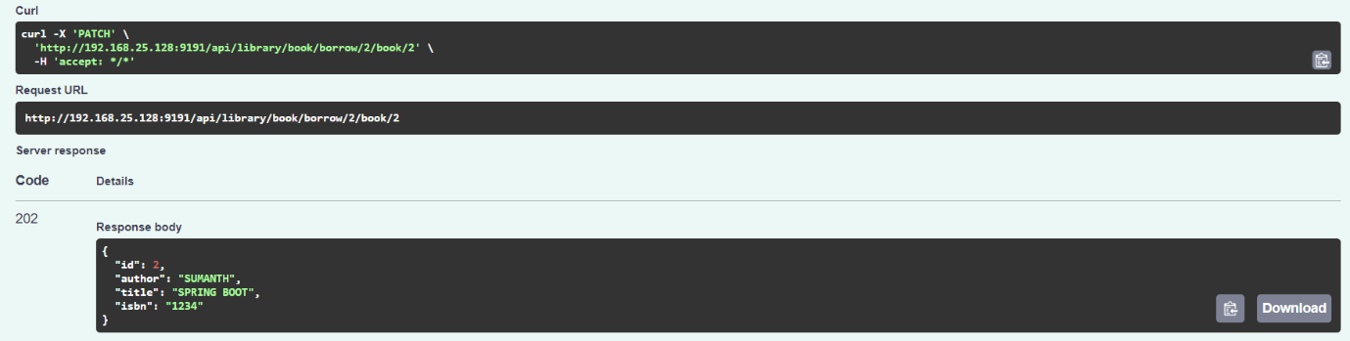

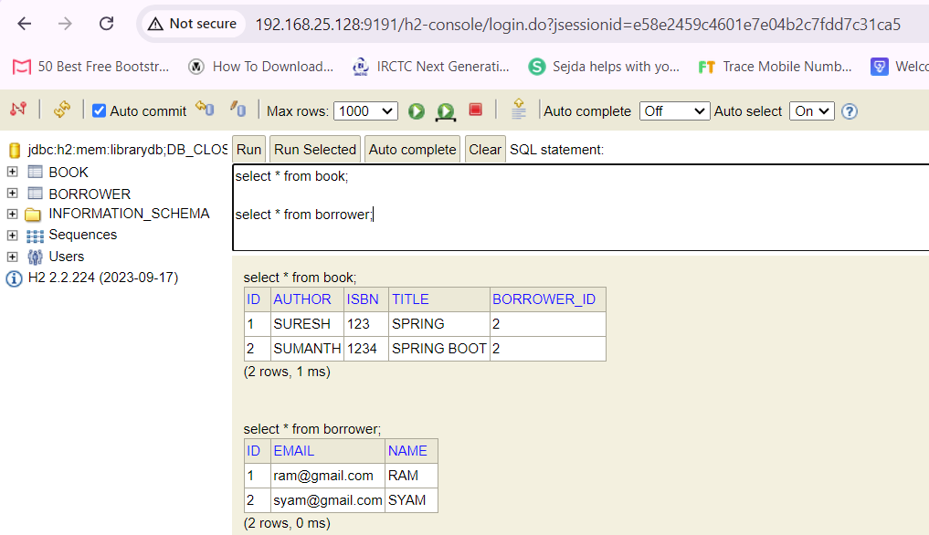

1. Return the book:

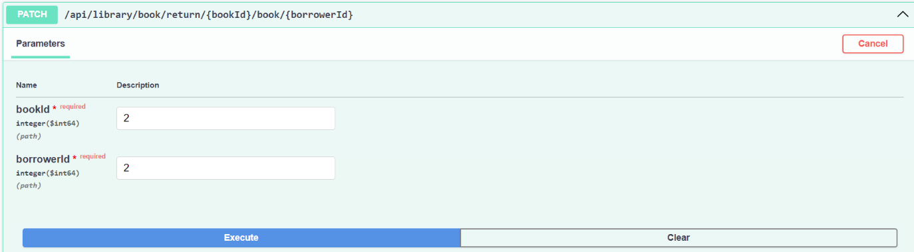

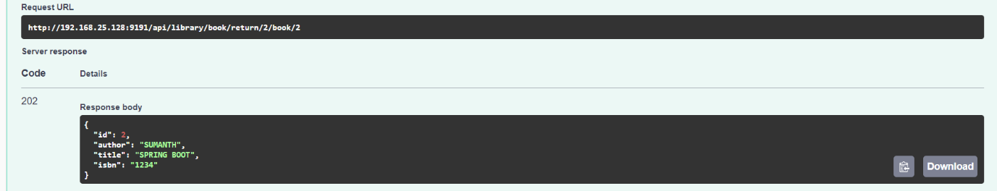

In DB

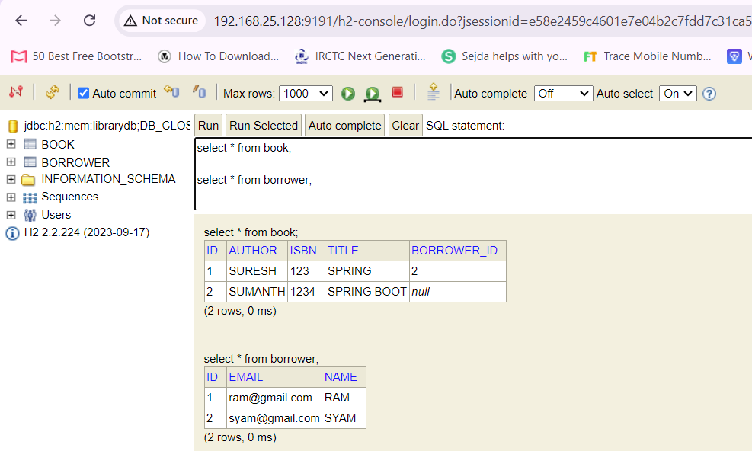

************************************ THANK YOU ***********************************