**LOCAL GOVERNMENT DIRECTORY MANAGEMENT SYSTEM**

Project report Submitted to

**Thanthai Periyar Government Arts and Science College**

**(Autonomous), Tiruchirappalli–620023**

(Affiliated to Bharathidasan University, Tiruchirappalli–24)

in partial fulfillment of the requirements for the award of the degree of

**MASTER OF SCIENCE IN COMPUTER SCIENCE**

**By**

**V. SIVAKUMAR**

**(Reg.No:22PCS15)**

Under the guidance of

**Dr. R. PARIMALA M.Sc., D.C.P.A., M.Phil., Ph.D.,**

Associate Professor of Computer Science



**P.G. & RESEARCH DEPARTMENT OF COMPUTER SCIENCE**

**Thanthai Periyar Government Arts and Science College**

**(Autonomous), Tiruchirappalli–620023**

**APRIL –2024**

**P.G. & RESEARCH DEPARTMENT OF COMPUTER SCIENCE**

**Thanthai Periyar Government Arts and Science College**

**(Autonomous), Tiruchirappalli-23**



**CERTIFICATE**

This is to certify that the project work entitled “**LOCAL GOVERNMENT**

**DIRECTORY MANAGEMENT SYSTEM”**, submitted in partial

fulfillment of the requirements for the award of the Degree of   
**Master of Science in Computer Science** to Thanthai Periyar Government Arts and Science College(Autonomous), Tiruchirapalli-23 affiliated to Bharathidasan University, Tiruchirapalli-24 is a bonafide record of the work done by **V. SIVAKUMAR (Reg.No:22PCS15)** during the even semester of the academic year 2023-2024

Head of the Department Guide

Viva-voce examination for this project work held on.................................

Internal Examiner External Examiner

**ACKNOWLEDGEMENT**

I would like to express my sincere thanks to our honorable principal

**Dr. P. S. VIJAYALAKSHMI, M.Com., M.B.A., M.Phil., Ph.D.,** Thanthai Periyar Government Arts and Science College (Autonomous), Tiruchirappalli who grant me permission to do my project and providing facilities to carry out this work.

I wish to express my sincere thanks to Mr. **T. KANNADASAN, M.C.A.,** Head of the Department of Computer Science, Thanthai Periyar Government Arts & Science College (Autonomous), Tiruchirappalli for his valuable support and helping me in various way throughout this project duration.

I wish to express my grateful thanks to my project guide   
**Dr. R. PARIMALA M.Sc., D.C.P.A., M.Phil., Ph.D.,** Associate Professor, Department of Computer Science, Thanthai Periyar Government Arts and Science College (Autonomous), Tiruchirappalli for her continuous supportive guidance and has been a great source of inspiration in guiding me throughout the project work.

I express my invaluable thanks to all the staff members of the department of Computer Science, Thanthai Periyar Government Arts & Science College (Autonomous), Tiruchirappalli, for their cooperation and encouragement that helped me a lot to bring this project in a successful way.

Finally, my heartfelt thanks are to my friends and parents who are the pillars and effort stone for each and every activity of mine. I thank my friends who supported and encouraged till the completion of the project work.

## DECLARATION

**I,** **V. SIVAKUMAR (Reg.No:22PCS15)**, declared that the project entitled “**LOCAL GOVERNMENT DIRECTORY MANAGEMENT SYSTEM”** submitted to the P.G. & Research Department of Computer Science, Thanthai Periyar Government Arts & Science College (Autonomous), Tiruchirappalli -23 affiliated to Bharathidasan University, Tiruchirappalli-24 in partial fulfillment of the requirements for the award of the degree of **Master of Science in Computer Science** is the original project work done by me and it has not been submitted anywhere else for any other degree/diploma.

V. SIVAKUMAR

(Reg.No:22PCS15)

**ABSTRACT**

**“LOCAL GOVERNMENT DIRECTORY MANAGEMENT SYSTEM”** is a concept of an integral digital directory management system. The concept aims at an efficient and impeccable automated directory management system over network. The concept came to building up as an entity as it felt like good for many in the digital society the application replaces the conventional directory and personal profile management system. The digital application is reduced as much as possible to avoid errors while managing the data and ensure the security and protection data. This application is potential to be application would have a very wide range of application. Plugin accommodated into different websites as an add on extension. This system can lead to error free, secure, reliable and directory management system. This project is developed using PHP with MYSQL. The project has been divided into various modules, which performs different functions and there are inter-related with each other.

|  |  |  |
| --- | --- | --- |
| **CHAPTER** | **CONTENT** | **PAGE**  **NO.** |
| 1 | **INTRODUCTION** |  |
| 2 | **SYSTEM ANALYSIS**  2.1. Existing System  2.2. Disadvantages  2.3. Proposed System  2.4. Advantages |  |
| 3 | **SYSTEM CONFIGURATION**  3. 1. Hardware Requirement  3.2. Software Requirement  3.3 Software Description  3.3.1. Feasibility study |  |
| 4 | **SYSTEM DESCRIPTION**  4.1. Project description  4.2. Modules  4.2.1. Admin module  4.2.2. User module |  |
| 5 | **SYSTEM DESIGN**  5.1Data flow diagrams  5.1.1. System flow chart  5.2. Input design  5.3. Database design  5.4. Er diagram |  |
| 6 | **IMPLEMENTATION** |  |
| 7 | **SYSTEM TESTING** |  |
| 8 | **SOURCE CODE**  8.1 Output design |  |
| 9 | **CONCLUSION** |  |
| 10 | **FUTURE ENHANCEMENTS** |  |
| 11 | **BIBILOGRAPHY** |  |

**CHAPTER-1**

**INTRODUCTION**

* 1. **PROBLEM DEFINITION**

The conventional system makes use of paperwork and direct human efforts to manage the assembly directory management and organization. This human interacted book keeping or file keeping system involves lots of energy and job tenure of workers of any firm. There is also the possibility of missing of records, decaying of the records and most importantly the privacy of the records and security of the information is challenge. The automated application overcomes these hazards. by replacing the conventional practices into build the application software. The systematic and scientific management of Local Government directory for assembly constitution of any web-oriented application is the fastest and secured solution.

**CHATPTER- 2**

**2. SYSTEM ANALYSIS**

2.1. **SYSTEM ANALYSIS**

process of collecting and interpreting facts, identifying the problems, and

decomposition of a system into its components System analysis is conducted for the purpose of studying a system or its parts in order to identify its objectives. It is problem solving technique that improves the system and ensures that all the components of the system work efficiently to accomplish their purpose. It is the process of studying a procedure or business to identify its goal and purposes and create systems and procedures that will efficiently achieve them. The field of system analysis relates closely to requirements analysis or to operations research. It is also "an explicit formal inquiry carried out to help a decision maker identify a better course of action and make a better decision than she might otherwise have made.

**2.2 SYSTEM FLOW CHART**

A system flow chart is a physical design tool that shows in general terms the

operations that will be performed on information in an information system. The arrows on a system flowchart show the direction that data will flow in around the system rather than the order in which the operations will be carried out.

All Details

Delete

Update

Insert

Constituency wise

Block wise

District wise

Village wise

Parliament wise

Login

User Login

Admin Login

index

# CHATPTER- 3

# SYSTEM REQUIREMENTS

## SPECIFICATION REQUIREMENTS

Hardware and software specification gives the complete details about the hardware and software that were used to develop the system. Selection of hardware and software is very important factor for efficiency. Hardware specification specifies the requirements of the hardware to run the system. Software specification specifies the software requirements to develop the system in an efficient manner

## HARDWARE REQUIREMENTS

Processor : AMD PRO A4-3350B APU with Radeon R4 Graphics 2.00 GHz

RAM : 4GB and above

Hard Disk :232GB

## SOFTWARE REQUIREMENT

Operating System : Windows 10 Pro

Front End : HTML , CSS

Back End : PHP , MYSQL

Server : Xampp 7.1 and above

**3.3 SOFTWARE DESCRIPTION**

This whole project is created by the main two backend languages namely PHP and MySQL. The frontend used are HTML and CSS. The backend language provides database facilities for the front end. The back end stores the whole project data to the database.

**3.3.1.HTML**

Hypertext Markup Language (HTML) is the standard markup language for documents designed to be displayed in a web browser. The HTML tags are used to make this project work_ The web has gone through many changes over the past few decades, but HTML has always been the fundamental language used to develop web pages. Interestingly while websites have become more advanced and interactive, HTML has actually gotten simpler. If you compare the source of an HTML5 page with a similar page written in HTML 4.01 or XHTML 1.0, the HTML5 page would probably contain less code. This is because modern HTML relies on cascading style sheets or JavaScript to format nearly all the elements within a page. Many dynamic websites generate web pages on-the-fly, using a server-side scripting language like PHP or ASP. However, even dynamic pages must be formatted using HTML. Therefore, scripting languages often generate the HTML that is sent to your web browser The <html> tag tells the browser that this is an HTML document. The <html> tag represents the root of an HTML document. The <body> tag defines the document's body. The <body> element contains all the contents of an HTML document, such as text, hyperlinks, images, tables, lists, etc This project uses HTML as frond end. In each html header file contains the link file. The <a> tag defines the hyperlink, which is used to link from one page to

another. The most important attribute of the <a> is the href attribute, which indicates

the links destination

<a href='home.php">

In this project contains several HTML tags such as <a> tag, <div> tag, <p> tag,

<tr> tag, <th> tag, <td> tag etc. The <td> tag defines a standard cell in an HTML table. The <div> tag defines a division or a section in an HTML document. The <p> tag defines the paragraph. The <tr> defines a row in a html table. The <th> tag is a header cell that can appear in the first row of an HTML table.

**3.3.2 PHP**

PHP Stands for "Hypertext Preprocessor." PHP is an HTML-embedded Web scripting language. This means PHP code can be inserted into the HTML of a Web page. When a PHP page is accessed, the PHP code is read or "parsed" by the server the page resides on. The output from the PHP functions on the page are typically returned as HTML code, which can be read by the browser. Because the PHP code is transformed into HTML before the page is loaded, users cannot view the PHP code on a page. This make PHP pages secure enough to access databases and other secure information A lot of the syntax of PHP is borrowed from other languages such as However, PHP has a number of unique features and specific functions as well. The goal of the language is to allow Web developers to write dynamically generated pages quickly and easily. PHP is also great for creating database-driven Web sites. If you would like to learn more about PHP, the official site is PHP.net. This project uses PHP as backend because PHP can work easily with the MySQL The connection is made between the PHP and MySQL with the help of mysqli_connect() function. This function is return in a separate file namely connection.php and that file is imported in all the PHP files.

$connection=mysqli_connect("localhost' "root", "movieticket'); The queries are executed with the help of mysqli_query( function. This function can also get the data from the database and we can use a while loop to show the output in the front end. $result=mysqli_query (connection, "select * from customer where email='Semail;"); The mysqli_fetch_rows functions fetch one row from a result set and returns it as an enumerated array If (mysqli_num_rows(Sresult)) The header ( functions send a raw HTTP to a client. Header ("Location: home.php") The session_destroy0 function destroys the whole session rather destroying the variable. When session_start() is called PHP set the session cookie in browser. We need to delete the cookies also to completely destroy the session. The mysqli_ fetch_array( function fetches a result row as an associative array, a numeric array or both. While ($row=mysqli_fetch_array($result)) The mysqli_fetch_all( function all result rows and returs the result set as an associative a numeric array or both. $username=mysqli_fect_ all(Susername).

**3.3.3 MySQL**

MySQL is an opensource relational database management system. It is based on the structured query language (SQL), which is used for adding, removing, and modifying information in the database. Standard SQL commands, such as ADD, DROP, INSERT, and UPDATE can be used with MySQL. MySQL can be used for a variety of applications, but is most commonly found on Web servers. A website that uses MySQL may include Web pages that access information from a database. These pages are often referred to as "dynamic," meaning

the content of each page is generated from a database as the page loads. Websites that use dynamic Web pages are often referred to as database-driven websites Many database-driven websites that use MySQL also use a Web scripting language like PHP to access information from the database. MySQL commands can be incorporated into the PHP code, allowing part or all of a Web page to be generated from database information. Because both MySQL and PHP are both open source the PHP/MySQL combination has become a popular choice for database-driven websites. In this project the database name is phpmyadmin. It contains two tables which are table assembly and id . A list of commonly used MySQL queries to create database, use database, create table, insert record, update record, delete record, select record, truncate table and drop table are given below MySQL create database is used to create database. For example create database phpmyadmin; where phpmyadmin is the database name of this project. MySQL use database is used to select database. For example

use phpmyadmin;

MySQL insert query is used to insert records into table. For example:

insert into table assembly

VALUES(karur,krishnarayapuram,chinthalavadi,perambalur);

where district is the table name of the phpmyadmin database.

MySQL delete query is used to delete records of a table from database.

For example:

Delete from table assembly where id=4;

The select query is used to fetch records from the database.

For example

Select * from table assembly;

MySQL truncate query is used to truncate or remove records of a table. It doesn't remove structure.

For example:

Truncate table table id;

Where theatre is the table name of the phpmyadmin database.

MySQL drop query is used to drop a table, view or database. remove structure and data of a table if you drop table. For example:

Drop table table id;

* + 1. **FEASIBILITY STUDY**

The software is developed with modular approach. The system has fulfilled all the objectives identified and is able to replace the conventional systems. The constraints are met and overcome successfully. The system is designed as like it was decided in the design phase. This software has a user-friendly UI that enables the user to use without any inconvenience. The benefits of this project are to secure data, faster process, error free, better management, save a lot of manpower, can easily make the instant reports, elimination of paperwork, faster and economical, high reliability and security, save a time for both the administrators and users. The mission is to facilitate easy management and administration with capabilities to do insert, delete, update and view operation on constitutional details such as assembly in district, constituency, parliament, block panchayat and village panchayat.

**CHAPTER-4**

**4.SYSTEM DESCRIPTION**

**4.1. PROJECT DESCRIPTION**

This project consists of two modules namely Admin module and User module

**CHAPTER-5**

1. **SYSTEM DESIGN**

Systems design is the process of defining the architecture, modules, interfaces, and data for a system to satisfy specified requirements. Systems design could be seen as the application of systems theory to product development. The purpose of the System Design process is to provide sufficient detailed data and information about the system and its system elements to enable the implementation consistent with architectural entities as defined in models and views of the system architecture. We need to clarify the goal of the system. System design is such a vast topic; if we don't narrow it down to a specific goal, it will become complicated to design the system, especially for newbies. Sometimes constraints are good for the system. It helps to focus on the main feature you are trying to design. It clarifies ambiguities about the features of the system

5.1. **INPUT DESIGN**

The input design is the link between the information system and the user. It comprises the developing specification and procedures for data preparation and those steps are necessary to put transaction data in to a usable form for processing can be achieved by inspecting the computer to read data from a written or printed document Or it can occur by having people keying the data directly into the system. The design of input focuses on controlling the amount of input required. controlling the errors, avoiding delay, avoiding extra steps and keeping the process simple. The input is designed in such a way so that it provides security and ease of use with retaining the privacy in this project all the input data are validated and if any data violates any conditions. the user is warmed by a message. If the data satisfied all the conditions, it is transferred to the appropriate tables in the database. The user details are to be entered at the time of registration. A page is designed for this purpose which is user friendly and easy to use. The design is done such that user get appropriate messages when exceptions occur.

**Admin**

**Login**

Username and password are stored in a dictionary. When a user attempts to log in, the system checks if the entered username exists in the dictionary and then verifies if the associated password matches the input. If both credentials match, access is granted, allowing the user to perform admin tasks. This basic system lacks advanced features like encryption, error handling, and secure password management, which are essential for real-world applications to ensure robust security and usability.

**Admin Page**

Login

Admin page

Admin

Delete

Update

Insert

**5.2. DATABASE DESIGN**.

Database Design is a collection of processes that facilitate the designing

development, implementation and maintenance of enterprise data management

systems. Properly designed database easy to maintain, improves data consistency and are cost effective in terms of disk storage space. The database designer decides how the data elements correlate and what data must be stored the main objectives of database design in DBMS are to produce logical and physical designs models of the proposed database system The logical model concentrates on the data requirements and the data to be stored independent of physical considerations. It does not concern itself with how the data will be stored or where it will be stored physical the physical data design model involves translating the logical DB design of the database onto physical media using hardware resources and software systems such as database management systems (DBMS). The new admin registration details will be stored on the user table in the database. In the user table contains six fields. They are ID, username, email, password, address and phone number. Fields we give the data type. VARCHAR is a variable length string data type, so it holds only the characters you assign to it. VARCHAR takes up I byte per character. +2 bytes to hold length information. INT stands for the integer that is a whole number. An integer can be written without a fractional component

* + 1. **ASSEMBLY**
* **Table name: Assembly**
* **Primary key: D id**
* **Description:** This table stores details for the districts.

|  |  |  |  |
| --- | --- | --- | --- |
| **FIELDS** | **DATA TYPE** | **LENGTH** | **ALLOW NULL** |
| D id | Int | 5 | Not Null |
| District | Varchar | 25 | Not Null |
| Constitiuency | Varchar | 25 | Not Null |
| Parliament | Varchar | 25 | Not Null |
| Block | Varchar | 25 | Not Null |
| Village | Varchar | 25 | Not Null |

**5.2.2 LOGIN**

* **Table name: Login**
* **Primary key: Password**
* **Description:** This table stores the details for admin login username and password.

|  |  |  |  |
| --- | --- | --- | --- |
| **FIELDS** | **DATA TYPE** | **LENGTH** | **ALLOW NULL** |
| Username | Varchar | 25 | Not Null |
| Password | Varchar | 10 | Not Null |

**5.3 DATA FLOW DIAGRAMS**

A data-flow diagram (DFD) is a way of representing a flow of a data of a process or a system (usually an information system). The DFD also provides information about the outputs and inputs of each entity and the process itself. A data-flow diagram has no control flow, there are no decision rules and no loops. Specific operations based on the data can be represented by a flowchart for each data flow, at least one of the endpoints (source and / or destination) must exist in a process. The refined representation of a process can be done in another data- flow diagram, which subdivides this process into sub-processes The data-flow diagram is part of the structured-analysis modeling tools When using UML, the activity diagram typically takes over the role of the data-flow diagram. A special form of data-flow plan is a site-oriented data-flow plan. Data-flow diagrams can be regarded as inverted Petri nets. because places in such networks correspond to the semantics of data memories. Analogously the semantics of transitions from Petri nets and data flows and functions from data-flow diagrams should be considered equivalent. Below are the basic diagrams of data flow in this project.

**User login**

Block

Block

Village

Block

Parliament

District

Block wise

Village wise

Parliament

Constituency

District

Constituency

District

Village

District

Constituency

Village

Parliament

District

Block

Village

Parliament

Constituency

Block

Village

Constituency

Parliament

Parliament

wise

Constituency

wise

District wise

All

Details

details

**5.4. ER DIAGRAM**

An entity-relationship diagram (ERD) is a data modelling technique that graphically illustrates an information system's entities and the relationships between those entities. An ERD is a conceptual and representational model of data used to represent the entity framework infrastructure. ER Diagrams are most often used to design or debug relational databases in the fields of software engineering, education and research. To avoid ruining the data in a production database, 1t 1s important to plan out the changes carefully. ERD is a tool that helps by drawing ER diagrams to visualize database design ideas, you have a chance to identify the mistakes and design flaws, and to make corrections before executing the changes in the database.

**CHAPTER-6**

**6. IMPLEMENTATION**

Systems implementation is the process of: defining how the information system

should be built, ensuring that the information system is operational and used,

ensuring that the information system meets quality standard

6.1. **METHODS OF IMPLEMENTATION**

* Constructing a new system from scratch
* Constructing a new system from the existing one.

Implementation allows the users to take over its operation for use and evaluation. It involves training the users to handle the system and plan for a smooth conversion.

6.2. **GOALS OF SYSTEM IMPLEMENTATION**

Complete as necessary the design contained in the approved systems design

document. For example, the detailed contents of new or revised documents, computer screens, and database must be laid out and created

◦* Write, test, and document the programs and procedures required by the approved systems design document.

◦* Ensure, by completing the preparation of user manuals and other documentation and by training personnel, that the organization's personnel can operate the new system.

* Determine, by thoroughly testing the system with users, that the system satisfies the users requirement.

**6.3 SYSTEM CODING**

Coding is a list of step-by-step instructions that get computers to do what you want them to do. Coding makes it possible for us to create computer software, games, apps and websites. Coders, or programmers, are people who write the program behind everything we see and do on a computer. Code, 1n a general sense, is the language understood by the computer. Computers don't understand natural language. As such the human language has to be converted into a set of "words' that are understood by the computer. The words that initiate a standard action when used in a program are called keywords. The arrangement of keywords for successful execution of a desired computation is called syntax. The set of keywords and syntax form a programming language. The term code by itself is so general that it doesn't convey much information. car be useful to think of code in terms of instructions versus data. That is, computer code uses data as an input, does some processing, then spits out the output. In addition

referring to the code itself, you can use the term as a verb - to code is synonymous with coding or programming in this project consists of two main modules for customer and admin. Among them the customer has the login file named index.html. That index.html file handles the customer login system. The Login php lets the customer to create an account for booking the movie ticket. 21 The customer module has index php, insert php, update php, deletephp files. The file has the specific work for the module.

**CHAPTER-7**

**7.Software testing**

Software testing is a critical element of software quantity assurance and represents the ultimate review of specialization, design and coding the objective of the system testing is to ensure that all the individual programs are working and the programs link together to meet the requirements specified and to ensure that the computer system and the associated clerical and other procedures work together.

Testing is vital to the success of the system. System testing marks a logical assumption that all the parts of the system are correct; the goal will be successfully achieved. Special test data is input for processing and the result are examined to locate unexpected results.

* Testing is the process of executing a program with the indent of finding an error.
* A good test case is one of that has a higher probability of finding a yet undiscovered error.
* A successful test is one that uncovers a yet undiscovered error.

System testing is the stage of implementation, which is aimed at ensuring that the system works accurately and efficiently before live operation commences.

Testing is vital to the success of the system. System testing makes a logical assumption that if all parts of the system are correct, the goal will be successfully achieved.

Testing is actually a series of different test whose primary purpose is to fully exercise the computer-based system. Testing begins at the module level and works toward the integration of the entire computer-based system.

development team include:

#### Testing Methods

Four Testing Strategies that are often adopted by the software.

* Unit Testing
* Integration Testing
* Validation Testing
* System Testing

This system was tested using Unit Testing and Integration Testing Strategies to test the project because there were the most relevant approaches for this project.

### Unit Testing

In the unit testing the analyst tests the program making up a system. The software units in a system are the modules and routines that are assembled and integrated to perform a specific function. In a large system, many modules on different levels are needed.

Unit testing can be performed from the bottom up starting with the smallest and lowest level modules and proceeding one at a time. For each module in a bottom-up testing, a short program executes the module and provides the needed data.

In “Local Government Directory Management System“ the entire system is divided into several modules and is developed individually. Hence, unit testing is conducted to individual modules.

### Integration Testing

After the unit test, each module is gradually integrated to form one final system. Hence, the objective of integration testing is to take unit tested modules and build a final program structure. In this project, modules are combined to find the overall performance of the system.

Integration testing is a systematic technique for constructing the program structure while conducting test to uncover errors associate with interfacing. Objectives are used to take unit test modules and built program structure that has been directed by design.

### Black Box Testing

This method treats the coded module as a black box. The module runs with inputs that are likely to cause errors. Then the output is checked to see if any error occurred. This method cannot be used to test all errors, because some errors may depend on the code or algorithm used to implement the module.

### White Box Testing

White box testing, sometimes called glass-box testing is a test case design method that uses the control structure of the procedural design to derive test cases. Using white box testing methods, the software engineer can derive test cases that

* + Guarantee that all independent paths with in a module have been exercised at least once.
  + Exercise all logical decisions on their true and false sides.
  + Executive all loops at their boundaries and within their operational bounds and
  + Exercise internal data structure to assure their validity.

### 

### Validation Testing

There are two types of testing Alpha testing and Beta Testing. Alpha testing it is conducted at the developer site by end user. Controlled by developer. Conducted controlled environment. It is conducted at user’s site. Conducted time application software environment.

### Acceptance Testing

The objective of the acceptance test is to tell the user about the validity and reliability of the system, it verifies whether the system operates as specified and the integrity of important data is maintained. User motivation is very important is very important for the successful performance of the system.

All the modules were tested individually using both test data and live data. After each module was ascertained that it was working correctly and it had been “integrated” with the system. Again the system was tested as a whole/ we hold the system tested with different types of users. The system design, data flow diagrams, procedures etc, were well documented so that the system can be easily maintained and upgraded by any computer professional at a late

**Index.php**

<!DOCTYPE html>

<html lang="en">

<head>

<meta charset="UTF-8">

<meta http-equiv="X-UA-Compatible" content="IE=edge">

<meta name="viewport" content="width=device-width, initial-scale=1.0">

<title>Assembly Data</title>

<style>

body {

margin: 0;

padding: 0;

font-family: Arial, sans-serif;

background-color: #f0f0f0;

}

.container {

display: flex;

justify-content: center;

align-items: center;

min-height: 100vh;

}

.content {

background-color: #ffffff;

padding: 40px;

border-radius: 10px;

box-shadow: 0px 0px 20px rgba(0, 0, 0, 0.1);

text-align: center;

}

h2 {

color: #333;

margin-bottom: 20px;

}

h1 {

margin-bottom: 30px;

color: cyan;

}

span {

color: #333;

font-weight: bold;

}

.btn {

display: inline-block;

background-color: #007bff;

color: #fff;

padding: 12px 24px;

text-decoration: none;

border-radius: 5px;

margin: 10px;

transition: background-color 0.3s ease;

border: none;

cursor: pointer;

}

.btn:hover {

background-color: #0056b3;

}

.btn-admin {

background-color: #dc3545;

}

.btn-user {

background-color: #28a745;

}

.btn-group {

margin-top: 30px;

}

.btn-group a {

display: block;

margin-bottom: 10px;

}

.btn-group a:last-child {

margin-bottom: 0;

}

</style>

</head>

<body>

<div class="container">

<div class="content">

<h2>Local Government Directory</h2>

<h1>Welcome, <span>User</span>!</h1>

<div class="btn-group">

<a href="login.html" class="btn btn-admin">Admin Login</a>

<a href="user_login.html" class="btn btn-user">User Login</a>

</div>

</div>

</div>

</body>

</html>

**Login Page**

**Source code**

<?php

if ($_SERVER["REQUEST_METHOD"] == "POST") {

if (isset($_POST["user"]) && isset($_POST["pass"])) {

$username = $_POST["user"];

$password = $_POST["pass"];

if ($username === "admin" && $password === "password") {

// Redirect to a welcome page or perform further actions

header("Location: admin_page.html");

exit();

} else {

// If credentials are invalid, redirect back to the login page with an error message

header("Location: admin_page.html");

exit();

}

}

}

// If the form is accessed directly without submission, redirect back to the login page

header("Location: login.html");

exit();

?>

**Welcome.php**

**Source code**

<!DOCTYPE html>

<html lang="en">

<head>

<meta charset="UTF-8">

<meta http-equiv="X-UA-Compatible" content="IE=edge">

<meta name="viewport" content="width=device-width, initial-scale=1.0">

<title>Document</title>

</head>

<body>

<h1>Login Successful</h1>

</body>

</html>

**Admin.html**

**Source code**

<!DOCTYPE html>

<html lang="en">

<head>

<meta charset="UTF-8">

<meta name="viewport" content="width=device-width, initial-scale=1.0">

<title>Login</title>

<link rel="stylesheet" type="text/css" href="style.css">

<style>

body {

margin: 0;

padding: 0;

font-family: Arial, sans-serif;

background-color: #f0f0f007;

}

.container {

display: flex;

justify-content: center;

align-items: center;

min-height: 100vh;

}

.content {

background-color: #ffffff17;

padding: 40px;

border-radius: 10px;

box-shadow: 0px 0px 20px rgba(0, 0, 0, 0.1);

text-align: center;

}

h2 {

color: #333;

margin-bottom: 20px;

}

h1 {

margin-bottom: 30px;

color: cyan;

}

span {

color: #333;

font-weight: bold;

}

.btn {

display: inline-block;

background-color: black;

color: #fff;

padding: 12px 24px;

text-decoration: none;

border-radius: 5px;

margin: 10px;

transition: background-color 0.3s ease;

}

.btn:hover {

background-color: cyan;

}

.btn-group {

margin-top: 30px;

}

.btn-group a {

display: block;

margin-bottom: 10px;

}

.btn-group a:last-child {

margin-bottom: 0;

}

</style>

</head>

<body>

<div class="container">

<div class="content">

<h2>Local Government Directory</h2>

<h1>Welcome, <span>User</span>!</h1>

<div class="btn-group">

<a href="insert_data.html" class="btn">INSERT</a>

</div>

<div class="btn-group">

<a href="update_data.html" class="btn">UPDATE</a>

</div>

<div class="btn-group">

<a href="delete_data.html" class="btn">DELETE</a>

</div>

</div>

</div>

</body>

</html>

**Insert data.php**

**Source code**

<?php

$servername = "localhost";

$username = "root";

$password = "";

$database = "database1";

$conn = new mysqli($servername, $username, $password, $database);

if ($conn->connect_error) {

die("Connection failed: " . $conn->connect_error);

}

if ($_SERVER["REQUEST_METHOD"] == "POST" && isset($_POST['d_id']) && isset($_POST['dist']) && isset($_POST['const']) && isset($_POST['vpt']) && isset($_POST['bpt']) && isset($_POST['cpc'])) {

$d_id = $_POST['d_id'];

$dist = $_POST['dist'];

$const = $_POST['const'];

$vpt = $_POST['vpt'];

$bpt = $_POST['bpt'];

$cpc = $_POST['cpc'];

$sql = "INSERT INTO assembly (d_id, dist, const, vpt, bpt, cpc) VALUES ('$d_id', '$dist', '$const', '$vpt', '$bpt', '$cpc')";

if ($conn->query($sql) === TRUE) {

echo "Data inserted successfully";

} else {

echo "Error: " . $sql . "<br>" . $conn->error;

}

} else {

echo "Error: All form fields are required.";

}

$conn->close();

?>

**Insert data.html**

**Source code**

<!DOCTYPE html>

<html>

<head>

<title>Login</title>

<meta name="viewport" content="width=device-width, initial-scale=1.0">

<style>

body {

font-family: Arial, sans-serif;

background-color: #f7f7f7;

margin: 0;

padding: 0;

}

#form {

width: 80%;

background-color: #fff;

border-radius: 8px;

box-shadow: 0 0 10px rgba(0, 0, 0, 0.1);

max-width: 400px; /* Limiting maximum width for larger screens */

margin: 50px auto;

padding: 20px;

}

h1 {

text-align: center;

color: #333;

margin-bottom: 20px; /* Adding some space below the heading */

}

label {

display: block;

margin-bottom: 10px;

color: #555;

}

input[type="text"], input[type="password"] {

width: calc(100% - 20px);

padding: 10px;

margin-bottom: 15px; /* Reducing margin bottom for input fields */

border: 1px solid #ccc;

border-radius: 4px;

}

input[type="submit"] {

width: 100%;

padding: 10px;

background-color: #4caf50;

color: #fff;

border: none;

border-radius: 4px;

cursor: pointer;

transition: background-color 0.3s ease;

}

input[type="submit"]:hover {

background-color: #6c45a0;

}

</style>

</head>

<body>

<div id="form">

<h1>Login Form</h1>

<form name="form" action="data_insert.php" method="POST">

<input type="text" name="d_id" placeholder="ID"><br>

<input type="text" name="dist" placeholder="District" required><br>

<input type="text" name="const" placeholder="Assembly constituney name" required><br>

<input type="text" name="vpt" placeholder="Village panchayat" required><br>

<input type="text" name="bpt" placeholder="Block panchayat" required><br>

<input type="text" name="cpc" placeholder="Parliment constituency" required><br>

<input type="submit" value="Submit">

</form>

</div>

</body>

</html>

**Update data.php**

**Source code**

<?php

$servername = "localhost";

$username = "root";

$password = "";

$database = "database1";

// Create connection

$conn = new mysqli($servername, $username, $password, $database);

// Check connection

if ($conn->connect_error) {

die("Connection failed: " . $conn->connect_error);

}

// Check if the form is submitted

if ($_SERVER["REQUEST_METHOD"] == "POST") {

// Get form data

$d_id = $_POST['d_id'];

$dist = $_POST['dist'];

$const = $_POST['const'];

$vpt = $_POST['vpt'];

$bpt = $_POST['bpt'];

$cpc = $_POST['cpc'];

// SQL query to update data in the 'assembly' table

$sql = "UPDATE assembly SET dist='$dist', const='$const', vpt='$vpt', bpt='$bpt', cpc='$cpc' WHERE d_id='$d_id'";

if ($conn->query($sql) === TRUE) {

echo "Data updated successfully";

} else {

echo "Error: " . $sql . "<br>" . $conn->error;

}

}

// Close the database connection

$conn->close();

?>

**Update data.html**

**Source code**

<!DOCTYPE html>

<html>

<head>

<title>Data</title>

<meta name="viewport" content="width=device-width, initial-scale=1.0">

<link rel="stylesheet" type="text/css" href="style.css">

<style>

body {

font-family: Arial, sans-serif;

background-color: #f7f7f7;

margin: 0;

padding: 0;

}

#form1 {

background-color: #fff;

border-radius: 8px;

box-shadow: 0 0 10px rgba(0, 0, 0, 0.1);

width: 80%;

max-width: 400px; /* Limiting maximum width for larger screens */

margin: 50px auto;

padding: 20px;

}

h1 {

text-align: center;

color: #333;

margin-bottom: 20px; /* Adding some space below the heading */

}

label {

display: block;

margin-bottom: 10px;

color: #555;

}

input[type="text"] {

width: calc(100% - 20px);

padding: 10px;

margin-bottom: 15px; /* Reducing margin bottom for input fields */

border: 1px solid #ccc;

border-radius: 4px;

}

input[type="submit"] {

width: 100%;

padding: 10px;

background-color: #4caf50;

color: #fff;

border: none;

border-radius: 4px;

cursor: pointer;

transition: background-color 0.3s ease;

}

input[type="submit"]:hover {

background-color: #45a049;

}

</style>

</head>

<body>

<div id="form1">

<h1>Assembly Data</h1>

<form name="form1" action="data_update.php" method="POST" onsubmit="return isValid()">

<input type="text" name="d_id" placeholder="ID"><br>

<input type="text" name="dist" placeholder="District" required><br>

<input type="text" name="const" placeholder="Assembly constituney name" required><br>

<input type="text" name="vpt" placeholder="Village panchayat" required><br>

<input type="text" name="bpt" placeholder="Block panchayat" required><br>

<input type="text" name="cpc" placeholder="Corresponding parliment constituency" required><br>

<input type="submit" id="btn" value="Update" name="submit">

</form>

</div>

</body>

</html>

**Delete data.php**

**Source code**

<?php

$servername = "localhost";

$username = "root";

$password = "";

$database = "database1";

// Create connection

$conn = new mysqli($servername, $username, $password, $database);

// Check connection

if ($conn->connect_error) {

die("Connection failed: " . $conn->connect_error);

}

// Check if the form is submitted

if ($_SERVER["REQUEST_METHOD"] == "POST") {

// Get form data

$d_id = $_POST['d_id'];

// SQL query to delete data from the 'assembly' table

$sql = "DELETE FROM assembly WHERE d_id='$d_id'";

if ($conn->query($sql) === TRUE) {

echo "Data deleted successfully";

} else {

echo "Error: " . $sql . "<br>" . $conn->error;

}

}

// Close the database connection

$conn->close();

?>

**Delete data.html**

**Source code**

<!DOCTYPE html>

<html>

<head>

<title>Data</title>

<meta name="viewport" content="width=device-width, initial-scale=1.0">

<link rel="stylesheet" type="text/css" href="style.css">

<style>

body {

font-family: Arial, sans-serif;

background-color: #f7f7f7;

margin: 0;

padding: 0;

}

#form1 {

background-color: #fff;

border-radius: 8px;

box-shadow: 0 0 10px rgba(0, 0, 0, 0.1);

width: 80%;

max-width: 400px; /* Limiting maximum width for larger screens */

margin: 50px auto;

padding: 20px;

}

h1 {

text-align: center;

color: #333;

margin-bottom: 20px; /* Adding some space below the heading */

}

label {

display: block;

margin-bottom: 10px;

color: #555;

}

input[type="text"] {

width: calc(100% - 20px);

padding: 10px;

margin-bottom: 15px; /* Reducing margin bottom for input fields */

border: 1px solid #ccc;

border-radius: 4px;

}

input[type="submit"] {

width: 100%;

padding: 10px;

background-color: #ff5722;

color: #fff;

border: none;

border-radius: 4px;

cursor: pointer;

transition: background-color 0.3s ease;

}

input[type="submit"]:hover {

background-color: #f4511e;

}

</style>

</head>

<body>

<div id="form1">

<h1>Assembly Data</h1>

<form name="form1" action="data_delete.php" method="POST" onsubmit="return isValid()">

Enter district ID

<input type="text" id="d_id" name="d_id" placeholder="ID" required>

<input type="submit" id="btn" value="Delete" name="submit">

</form>

</div>

</body>

</html>

**Userlogin.html**

**Source code**

<!DOCTYPE html>

<html lang="en">

<head>

<meta charset="UTF-8">

<meta http-equiv="X-UA-Compatible" content="IE=edge">

<meta name="viewport" content="width=device-width, initial-scale=1.0">

<title>User Login</title>

<style>

body {

margin: 0;

padding: 0;

font-family: Arial, sans-serif;

background-color: #f0f0f007;

}

.container {

display: flex;

justify-content: center;

align-items: center;

min-height: 100vh;

}

.content {

background-color: #ffffff17;

padding: 40px;

border-radius: 10px;

box-shadow: 0px 0px 20px rgba(0, 0, 0, 0.1);

text-align: center;

}

h2 {

color: #333;

margin-bottom: 20px;

}

h1 {

margin-bottom: 30px;

color: cyan;

}

span {

color: #333;

font-weight: bold;

}

.btn {

display: inline-block;

background-color: black;

color: #fff;

padding: 12px 24px;

text-decoration: none;

border-radius: 5px;

margin: 10px;

transition: background-color 0.3s ease;

}

.btn:hover {

background-color: cyan;

}

.btn-group {

margin-top: 30px;

}

.btn-group a {

display: block;

margin-bottom: 10px;

}

.btn-group a:last-child {

margin-bottom: 0;

}

</style>

</head>

<body>

<div class="container">

<div class="content">

<h2>Local Government Directory</h2>

<h1>Welcome, <span>User</span>!</h1>

<div class="btn-group">

<a href="select_data.html" class="btn">All Details</a>

<a href="district_data.html" class="btn">Districtwise</a>

<a href="constiuency_data.html" class="btn">Constiuencywise</a>

<a href="village_data.html" class="btn">Villagewise</a>

<a href="block_data.html" class="btn">Blockwise</a>

<a href="p-data.html" class="btn">Parliamentwise</a>

</div>

</div>

</div>

</body>

</html>

District data.php

Source code

<?php

$servername = "localhost";

$username = "root";

$password = "";

$database = "database1";

// Create connection

$conn = new mysqli($servername, $username, $password, $database);

// Check connection

if ($conn->connect_error) {

die("Connection failed: " . $conn->connect_error);

}

// Check if the form is submitted

if ($_SERVER["REQUEST_METHOD"] == "POST") {

// Get form data

// $d_id = $_POST['d_id'];

// SQL query to delete data from the 'assembly' table

$sql = "SELECT * FROM `assembly` ";

if ($res = mysqli_query($conn, $sql)) {

echo "<div style='margin: 0 auto; width: 80%;'>"; // Centering the table

echo "<table style='border-collapse: collapse; width: 100%;'>";

echo "<thead>";

echo "<tr>";

echo "<th style='padding: 12px 8px; background-color: #f2f2f2; color: #333; text-align: left;'>District ID</th>";

echo "<th style='padding: 12px 8px; background-color: #f2f2f2; color: #333; text-align: left;'>District</th>";

echo "<th style='padding: 12px 8px; background-color: #f2f2f2; color: #333; text-align: left;'>Constituency</th>";

echo "<th style='padding: 12px 8px; background-color: #f2f2f2; color: #333; text-align: left;'>Village Panchayat</th>";

echo "<th style='padding: 12px 8px; background-color: #f2f2f2; color: #333; text-align: left;'>Block Panchayat</th>";

echo "<th style='padding: 12px 8px; background-color: #f2f2f2; color: #333; text-align: left;'>Parliament Constituency</th>";

echo "</tr>";

echo "</thead>";

echo "<tbody>";

while ($row = mysqli_fetch_assoc($res)) {

echo "<tr>";

echo "<td style='padding: 10px 8px; border-bottom: 1px solid #ddd;'>".$row['d_id']."</td>";

echo "<td style='padding: 10px 8px; border-bottom: 1px solid #ddd;'>".$row['dist']."</td>";

echo "<td style='padding: 10px 8px; border-bottom: 1px solid #ddd;'>".$row['const']."</td>";

echo "<td style='padding: 10px 8px; border-bottom: 1px solid #ddd;'>".$row['vpt']."</td>";

echo "<td style='padding: 10px 8px; border-bottom: 1px solid #ddd;'>".$row['bpt']."</td>";

echo "<td style='padding: 10px 8px; border-bottom: 1px solid #ddd;'>".$row['cpc']."</td>";

echo "</tr>";

}

echo "</tbody>";

echo "</table>";

echo "</div>";

} else {

echo "Error: " . $sql . "<br>" . $conn->error;

}

}

// Close the database connection

$conn->close();

?>

**Constiuencywise.php**

Source code

<?php

$servername = "localhost";

$username = "root";

$password = "";

$database = "database1";

// Create connection

$conn = new mysqli($servername, $username, $password, $database);

// Check connection

if ($conn->connect_error) {

die("Connection failed: " . $conn->connect_error);

}

// Check if the form is submitted

if ($_SERVER["REQUEST_METHOD"] == "POST") {

// Get the entered

$Constiuencywise = $_POST['Constiuencywise'];

echo " entered Constiuencywise is $Constiuencywise";

// SQL query to retrieve data for the entered

$sql = "SELECT dist, const, vpt, bpt, cpc FROM `assembly` WHERE const='$Constiuencywise'";

// Execute the query

$result = mysqli_query($conn, $sql);

if ($result) {

echo "<div style='margin: 0 auto; width: 80%;'>"; // Inline CSS for centering

echo "<h2 style='text-align: center;'>Assembly Information for $Constiuencywise</h2>"; // Centering the heading

echo "<table style='border-collapse: collapse; width: 100%;'>";

echo "<thead>";

echo "<tr>";

echo "<th style='padding: 12px 8px; background-color: #f2f2f2; color: #333; text-align: left;'>District</th>";

echo "<th style='padding: 12px 8px; background-color: #f2f2f2; color: #333; text-align: left;'>Village Panchayat</th>";

echo "<th style='padding: 12px 8px; background-color: #f2f2f2; color: #333; text-align: left;'>Block Panchayat</th>";

echo "<th style='padding: 12px 8px; background-color: #f2f2f2; color: #333; text-align: left;'>Parliament Constituency</th>";

echo "</tr>";

echo "</thead>";

echo "<tbody>";

while ($row = mysqli_fetch_assoc($result)) {

echo "<tr>";

echo "<td style='padding: 10px 8px; border-bottom: 1px solid #ddd;'>".$row['dist']."</td>";

echo "<td style='padding: 10px 8px; border-bottom: 1px solid #ddd;'>".$row['vpt']."</td>";

echo "<td style='padding: 10px 8px; border-bottom: 1px solid #ddd;'>".$row['bpt']."</td>";

echo "<td style='padding: 10px 8px; border-bottom: 1px solid #ddd;'>".$row['cpc']."</td>";

echo "</tr>";

}

echo "</tbody>";

echo "</table>";

echo "</div>";

} else {

echo "Error: " . $sql . "<br>" . $conn->error;

}

}

// Close the database connection

$conn->close();

Villagewise.php

Source code

<?php

$servername = "localhost";

$username = "root";

$password = "";

$database = "database1";

// Create connection

$conn = new mysqli($servername, $username, $password, $database);

// Check connection

if ($conn->connect_error) {

die("Connection failed: " . $conn->connect_error);

}

// Check if the form is submitted

if ($_SERVER["REQUEST_METHOD"] == "POST") {

// Get the entered district

$village = $_POST['village'];

echo " entered village is $village";

// SQL query to retrieve data for the entered district

$sql = "SELECT dist, const, bpt, cpc FROM `assembly` WHERE vpt='$village'";

// Execute the query

$result = mysqli_query($conn, $sql);

if ($result) {

echo "<div style='margin: 0 auto; width: 80%;'>"; // Inline CSS for centering

echo "<h2 style='text-align: center;'>Assembly Information for $village</h2>"; // Centering the heading

echo "<table style='border-collapse: collapse; width: 100%;'>";

echo "<thead>";

echo "<tr>";

echo "<th style='padding: 12px 8px; background-color: #f2f2f2; color: #333; text-align: left;'>District</th>";

echo "<th style='padding: 12px 8px; background-color: #f2f2f2; color: #333; text-align: left;'>Constituency</th>";

echo "<th style='padding: 12px 8px; background-color: #f2f2f2; color: #333; text-align: left;'>Block Panchayat</th>";

echo "<th style='padding: 12px 8px; background-color: #f2f2f2; color: #333; text-align: left;'>Parliament Constituency</th>";

echo "</tr>";

echo "</thead>";

echo "<tbody>";

while ($row = mysqli_fetch_assoc($result)) {

echo "<tr>";

echo "<td style='padding: 10px 8px; border-bottom: 1px solid #ddd;'>".$row['dist']."</td>";

echo "<td style='padding: 10px 8px; border-bottom: 1px solid #ddd;'>".$row['const']."</td>";

echo "<td style='padding: 10px 8px; border-bottom: 1px solid #ddd;'>".$row['bpt']."</td>";

echo "<td style='padding: 10px 8px; border-bottom: 1px solid #ddd;'>".$row['cpc']."</td>";

echo "</tr>";

}

echo "</tbody>";

echo "</table>";

echo "</div>";

} else {

echo "Error: " . $sql . "<br>" . $conn->error;

}

}

// Close the database connection

$conn->close();

?>

**Blockwise.php**

Source code

<?php

$servername = "localhost";

$username = "root";

$password = "";

$database = "database1";

// Create connection

$conn = new mysqli($servername, $username, $password, $database);

// Check connection

if ($conn->connect_error) {

die("Connection failed: " . $conn->connect_error);

}

// Check if the form is submitted

if ($_SERVER["REQUEST_METHOD"] == "POST") {

// Get the entered district

$block = $_POST['block'];

echo " entered block is $block";

// SQL query to retrieve data for the entered district

$sql = "SELECT dist, const, vpt, bpt, cpc FROM `assembly` WHERE bpt='$block'";

// Execute the query

$result = mysqli_query($conn, $sql);

if ($result) {

echo "<div style='margin: 0 auto; width: 80%;'>"; // Inline CSS for centering

echo "<h2 style='text-align: center;'>Assembly Information for $block</h2>"; // Centering the heading

echo "<table style='border-collapse: collapse; width: 100%;'>";

echo "<thead>";

echo "<tr>";

echo "<th style='padding: 12px 8px; background-color: #f2f2f2; color: #333; text-align: left;'>District</th>";

echo "<th style='padding: 12px 8px; background-color: #f2f2f2; color: #333; text-align: left;'>Constituency</th>";

echo "<th style='padding: 12px 8px; background-color: #f2f2f2; color: #333; text-align: left;'>Village Panchayat</th>";

echo "<th style='padding: 12px 8px; background-color: #f2f2f2; color: #333; text-align: left;'>Parliament Constituency</th>";

echo "</tr>";

echo "</thead>";

echo "<tbody>";

while ($row = mysqli_fetch_assoc($result)) {

echo "<tr>";

echo "<td style='padding: 10px 8px; border-bottom: 1px solid #ddd;'>".$row['dist']."</td>";

echo "<td style='padding: 10px 8px; border-bottom: 1px solid #ddd;'>".$row['const']."</td>";

echo "<td style='padding: 10px 8px; border-bottom: 1px solid #ddd;'>".$row['vpt']."</td>";

echo "<td style='padding: 10px 8px; border-bottom: 1px solid #ddd;'>".$row['cpc']."</td>";

echo "</tr>";

}

echo "</tbody>";

echo "</table>";

echo "</div>";

} else {

echo "Error: " . $sql . "<br>" . $conn->error;

}

}

// Close the database connection

$conn->close();

?>

**Parliamentwise.php**

Source code

<?php

$servername = "localhost";

$username = "root";

$password = "";

$database = "database1";

// Create connection

$conn = new mysqli($servername, $username, $password, $database);

// Check connection

if ($conn->connect_error) {

die("Connection failed: " . $conn->connect_error);

}

// Check if the form is submitted

if ($_SERVER["REQUEST_METHOD"] == "POST") {

// Get the entered

$par = trim($_POST['P']);

echo " Entered Parliament is $par";

// SQL query to retrieve data for the entered

$sql = "SELECT dist, const, vpt, bpt, cpc FROM `assembly` WHERE cpc='$par'";

// Execute the query

$result = mysqli_query($conn, $sql);

if ($result) {

echo "<div style='margin: 0 auto; width: 80%;'>"; // Inline CSS for centering

echo "<h2 style='text-align: center;'>Assembly Information for $par</h2>"; // Centering the heading

echo "<table style='border-collapse: collapse; width: 100%;'>";

echo "<thead>";

echo "<th style='padding: 12px 8px; background-color: #f2f2f2; color: #333; text-align: left;'>District</th>";

echo "<th style='padding: 12px 8px; background-color: #f2f2f2; color: #333; text-align: left;'>Village Panchayat</th>";

echo "<th style='padding: 12px 8px; background-color: #f2f2f2; color: #333; text-align: left;'>Block Panchayat</th>";

echo "<th style='padding: 12px 8px; background-color: #f2f2f2; color: #333; text-align: left;'> Constituency</th>";

echo "</tr>";

echo "</thead>";

echo "<tbody>";

while ($row = mysqli_fetch_assoc($result)) {

echo "<tr>";

echo "<td>".$row['dist']."</td>";

echo "<td style='padding: 10px 8px; border-bottom: 1px solid #ddd;'>".$row['vpt']."</td>";

echo "<td style='padding: 10px 8px; border-bottom: 1px solid #ddd;'>".$row['bpt']."</td>";

echo "<td style='padding: 10px 8px; border-bottom: 1px solid #ddd;'>".$row['const']."</td>";

echo "</tr>";

}

echo "</tbody>";

echo "</table>";

echo "</div>";

} else {

echo "Error: " . $sql . "<br>" . $conn->error;

}

}

// Close the database connection

$conn->close();

?>

**Parliamentwise.html**

Source code

<!DOCTYPE html>

<html>

<head>

<title>Data</title>

<meta name="viewport" content="width=device-width, initial-scale=1.0">

<style>

body {

font-family: Arial, sans-serif;

background-color: #f7f7f7;

margin: 0;

padding: 0;

}

#div11 {

background-color: #ffffff;

border-radius: 8px;

box-shadow: 0 0 10px rgba(0, 0, 0, 0.1);

width: 80%;

max-width: 400px; /* Limiting maximum width for larger screens */

margin: 50px auto;

padding: 20px;

}

h1 {

text-align: center;

color: #333333;

margin-bottom: 20px; /* Adding some space below the heading */

}

label {

display: block;

margin-bottom: 10px;

color: #555555;

font-size: 16px;

}

input[type="text"] {

width: calc(100% - 20px);

padding: 10px;

margin-bottom: 15px; /* Reducing margin bottom for input fields */

border: 1px solid #cccccc;

border-radius: 4px;

font-size: 16px;

}

input[type="submit"] {

width: 100%;

padding: 10px;

background-color: #4caf50;

color: #ffffff;

border: none;

border-radius: 4px;

cursor: pointer;

transition: background-color 0.3s ease;

font-size: 16px;

}

input[type="submit"]:hover {

background-color: #45a049;

}

</style>

</head>

<body>

<div id="div11">

<h1>Assembly Data</h1>

<form name="form1" action="p_wise.php" method="POST">

<input type="text" id="P" name="P" placeholder="P" required><br>

<input type="submit" id="btn" value="parliamentwise" name="submit">

</form>

</div>

</body>

</html>

**Districtwise.html**

Source code

<!DOCTYPE html>

<html>

<head>

<title>Data</title>

<meta name="viewport" content="width=device-width, initial-scale=1.0">

<style>

body {

font-family: Arial, sans-serif;

background-color: #f7f7f7;

margin: 0;

padding: 0;

}

#div11 {

background-color: #ffffff;

border-radius: 8px;

box-shadow: 0 0 10px rgba(0, 0, 0, 0.1);

width: 80%;

max-width: 400px; /* Limiting maximum width for larger screens */

margin: 50px auto;

padding: 20px;

}

h1 {

text-align: center;

color: #333333;

margin-bottom: 20px; /* Adding some space below the heading */

}

label {

display: block;

margin-bottom: 10px;

color: #555555;

}

input[type="text"] {

width: calc(100% - 20px);

padding: 10px;

margin-bottom: 15px; /* Reducing margin bottom for input fields */

border: 1px solid #cccccc;

border-radius: 4px;

}

input[type="submit"] {

width: 100%;

padding: 10px;

background-color: #4caf50;

color: #ffffff;

border: none;

border-radius: 4px;

cursor: pointer;

transition: background-color 0.3s ease;

}

input[type="submit"]:hover {

background-color: #45a049;

}

</style>

</head>

<body>

<div id="div11">

<h1>Assembly Data</h1>

<form name="form1" action="data_district_wise.php" method="POST" >

<input type="text" id="district" name="district" placeholder="District" required><br>

<input type="submit" id="btn" value="Districtwise" name="submit">

</form>

</div>

</body>

</html>

**Constinuencywise.html**

Source code

<!DOCTYPE html>

<html>

<head>

<title>Data</title>

<meta name="viewport" content="width=device-width, initial-scale=1.0">

<style>

body {

font-family: Arial, sans-serif;

background-color: #f7f7f7;

margin: 0;

padding: 0;

}

#div11 {

background-color: #ffffff;

border-radius: 8px;

box-shadow: 0 0 10px rgba(0, 0, 0, 0.1);

width: 80%;

max-width: 400px; /* Limiting maximum width for larger screens */

margin: 50px auto;

padding: 20px;

}

h1 {

text-align: center;

color: #333333;

margin-bottom: 20px; /* Adding some space below the heading */

}

label {

display: block;

margin-bottom: 10px;

color: #555555;

font-size: 16px;

}

input[type="text"] {

width: calc(100% - 20px);

padding: 10px;

margin-bottom: 15px; /* Reducing margin bottom for input fields */

border: 1px solid #cccccc;

border-radius: 4px;

font-size: 16px;

}

input[type="submit"] {

width: 100%;

padding: 10px;

background-color: #4caf50;

color: #ffffff;

border: none;

border-radius: 4px;

cursor: pointer;

transition: background-color 0.3s ease;

font-size: 16px;

}

input[type="submit"]:hover {

background-color: #45a049;

}

</style>

</head>

<body>

<div id="div11">

<h1>Assembly Data</h1>

<form name="form1" action="data_Constiuency_wise.php" method="POST">

<input type="text" id="Constiuencywise" name="Constiuencywise" placeholder="Constiuency Name" required><br>

<input type="submit" id="btn" value="Constiuencywise" name="submit">

</form>

</div>

</body>

</html>

**Villagewise.html**

Source code

<!DOCTYPE html>

<html>

<head>

<title>Data</title>

<meta name="viewport" content="width=device-width, initial-scale=1.0">

<style>

body {

font-family: Arial, sans-serif;

background-color: #f7f7f7;

margin: 0;

padding: 0;

}

#div11 {

background-color: #ffffff;

border-radius: 8px;

box-shadow: 0 0 10px rgba(0, 0, 0, 0.1);

width: 80%;

max-width: 400px; /* Limiting maximum width for larger screens */

margin: 50px auto;

padding: 20px;

}

h1 {

text-align: center;

color: #333333;

margin-bottom: 20px; /* Adding some space below the heading */

}

label {

display: block;

margin-bottom: 10px;

color: #555555;

font-size: 16px;

}

input[type="text"] {

width: calc(100% - 20px);

padding: 10px;

margin-bottom: 15px; /* Reducing margin bottom for input fields */

border: 1px solid #cccccc;

border-radius: 4px;

font-size: 16px;

}

input[type="submit"] {

width: 100%;

padding: 10px;

background-color: #4caf50;

color: #ffffff;

border: none;

border-radius: 4px;

cursor: pointer;

transition: background-color 0.3s ease;

font-size: 16px;

}

input[type="submit"]:hover {

background-color: #45a049;

}

</style>

</head>

<body>

<div id="div11">

<h1>Assembly Data</h1>

<form name="form1" action="data_village_wise.php" method="POST">

<input type="text" id="village" name="village" placeholder="Village Name" required><br>

<input type="submit" id="btn" value="villagewise" name="submit">

</form>

</div>

</body>

</html>

**Blockwise.html**

Source code

<!DOCTYPE html>

<html>

<head>

<title>Data</title>

<meta name="viewport" content="width=device-width, initial-scale=1.0">

<style>

body {

font-family: Arial, sans-serif;

background-color: #f7f7f7;

margin: 0;

padding: 0;

}

#div11 {

background-color: #fff;

border-radius: 8px;

box-shadow: 0 0 10px rgba(0, 0, 0, 0.1);

width: 80%;

max-width: 400px; /* Limiting maximum width for larger screens */

margin: 50px auto;

padding: 20px;

}

h1 {

text-align: center;

color: #333;

margin-bottom: 20px; /* Adding some space below the heading */

}

label {

display: block;

margin-bottom: 10px;

color: #555;

}

input[type="text"] {

width: calc(100% - 20px);

padding: 10px;

margin-bottom: 15px; /* Reducing margin bottom for input fields */

border: 1px solid #ccc;

border-radius: 4px;

}

input[type="submit"] {

width: 100%;

padding: 10px;

background-color: #4caf50;

color: #fff;

border: none;

border-radius: 4px;

cursor: pointer;

transition: background-color 0.3s ease;

}

input[type="submit"]:hover {

background-color: #45a049;

}

</style>

</head>

<body>

<div id="div11">

<h1>Assembly Data</h1>

<form name="form1" action="data_block_wise.php" method="POST" >

<input type="text" id="block" name="block" placeholder="Block" required><br>

<input type="submit" id="btn" value="Blockwise" name="submit">

</form>

</div>

</body>

</html>

**8.1. OUTPUT DESIGN**

Design output is a drawing or specification or manufacturing instruction. design outputs describe all the components, parts, and pieces that go into your medical device. Design outputs describe all assemblies and sub-assemblies of your product.

6.3.1. Objectives of output design the objectives design are designing output to fit the user delivering the appropriate quantity of output making sure the output is where it is needed providing the output on time choosing the right output method designing output to serve the intended purpose. Designing computer output should proceed in an organized, well thought our manner, the right output must be developed while ensuring that each output element is designed so that people will find the system can use easily and effectively.

**INDEX**

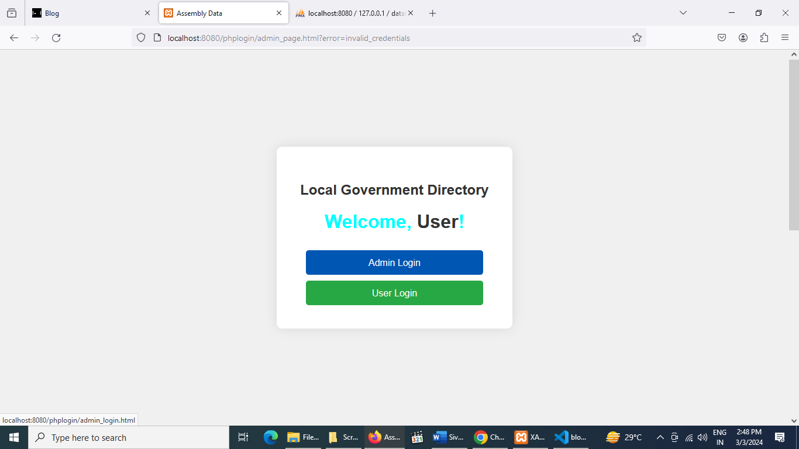

**ADMIN LOGIN**

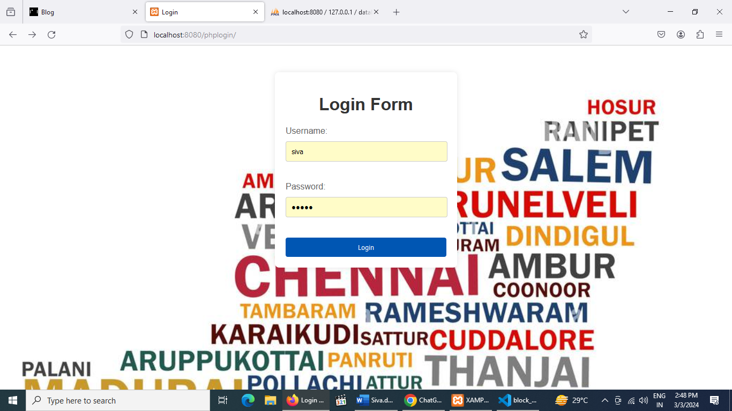

**Admin login page**

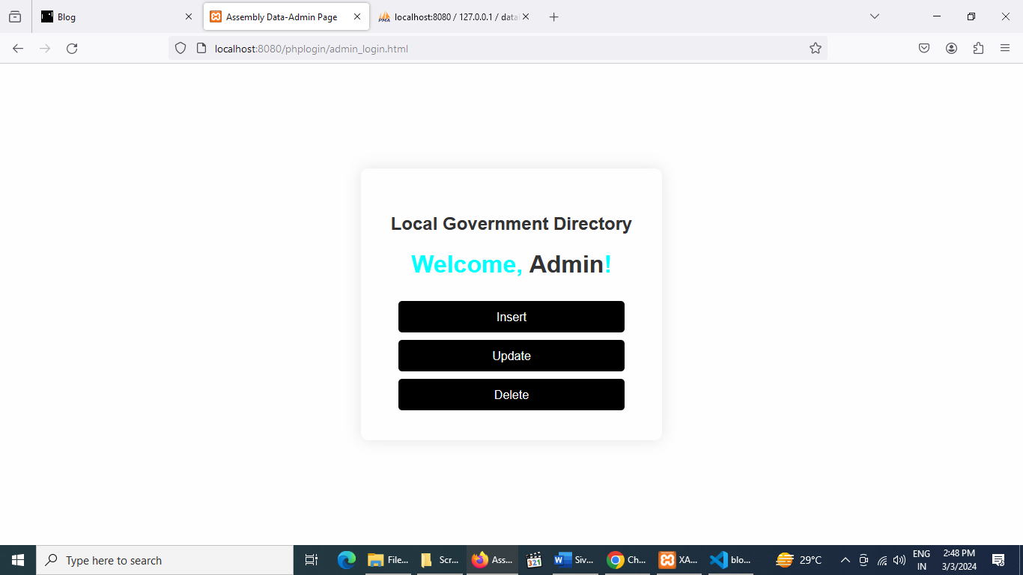

**Insert page**

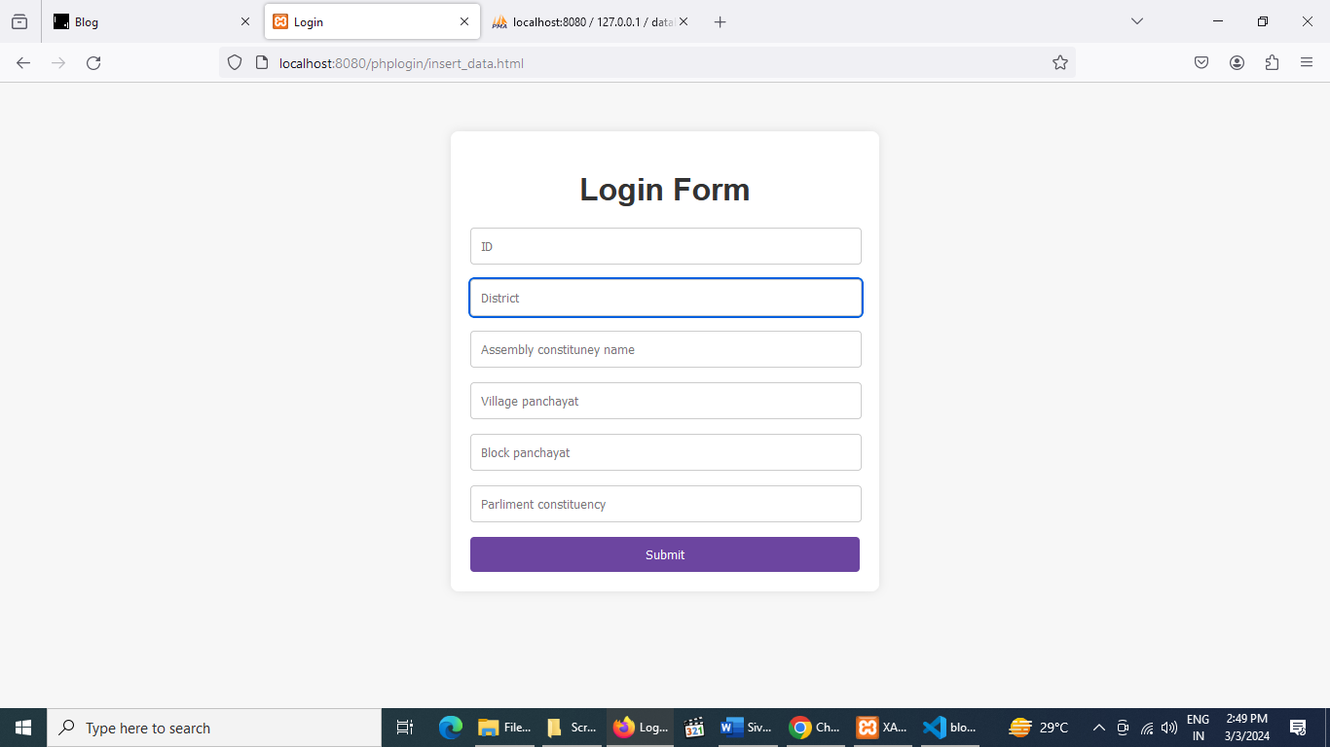

**Update page**

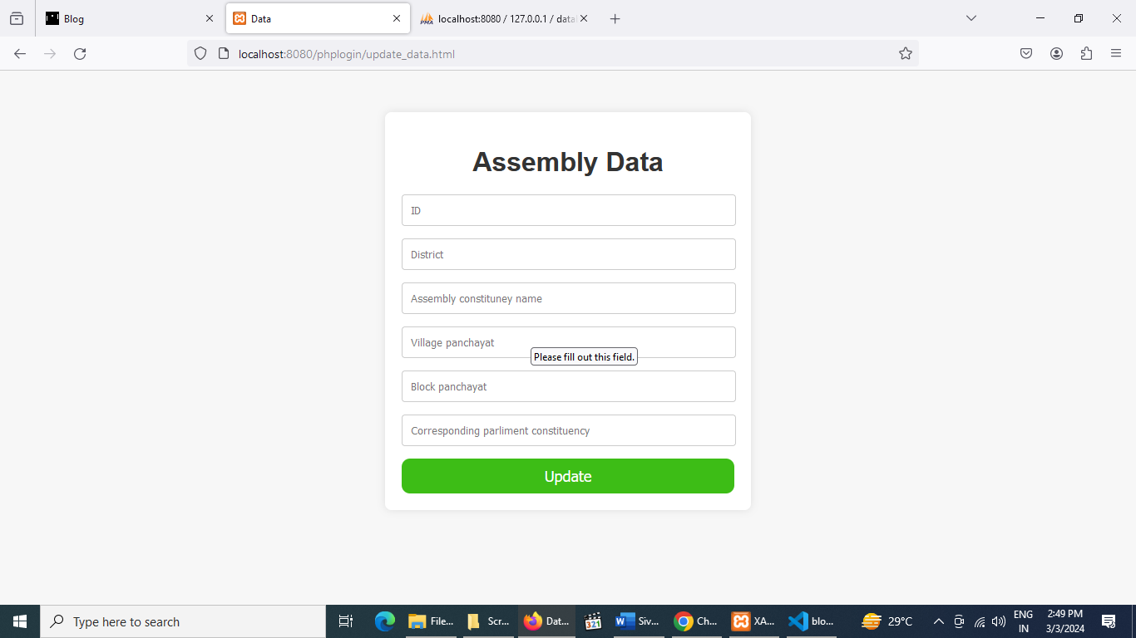

**Delete page**

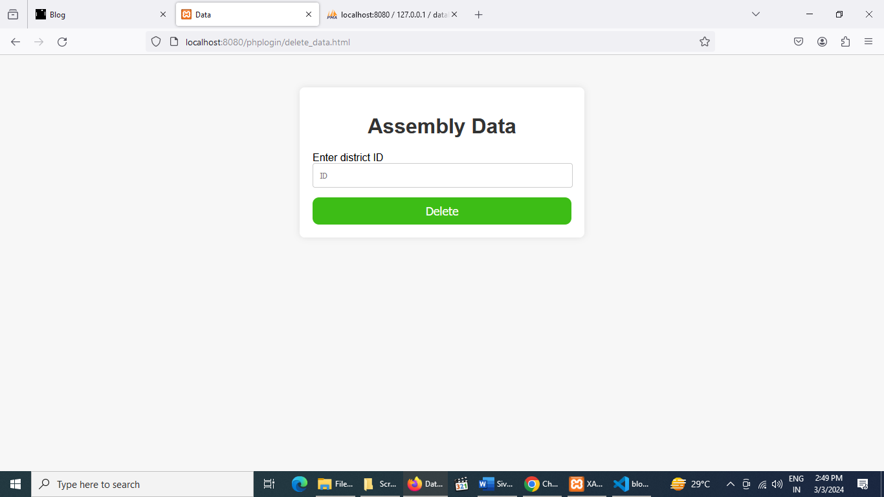

**User login page**

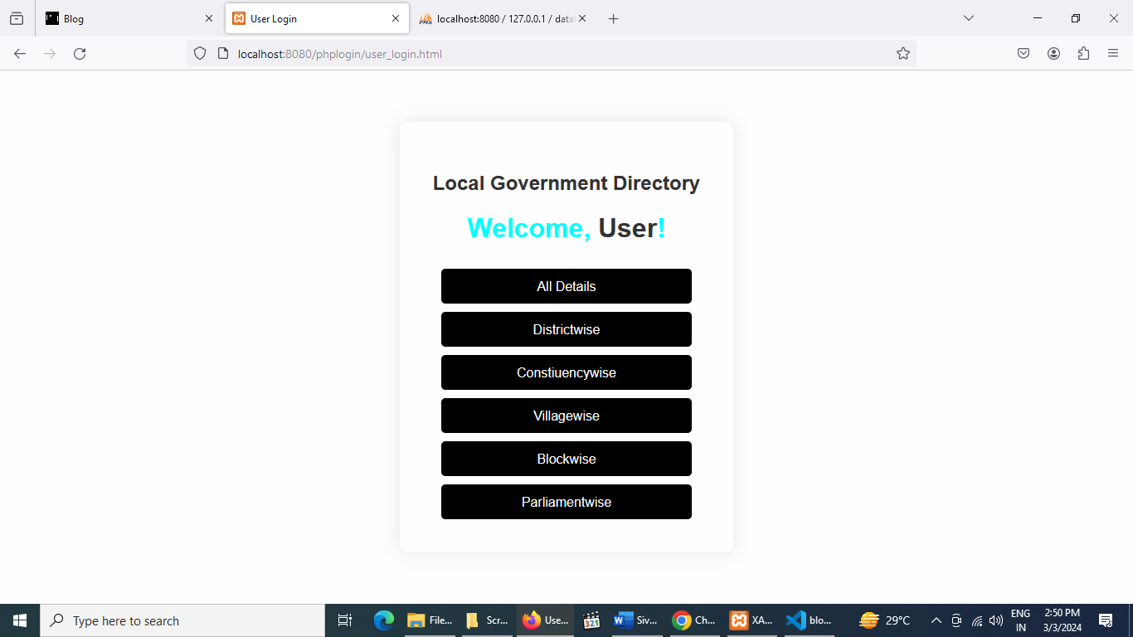

**All details**

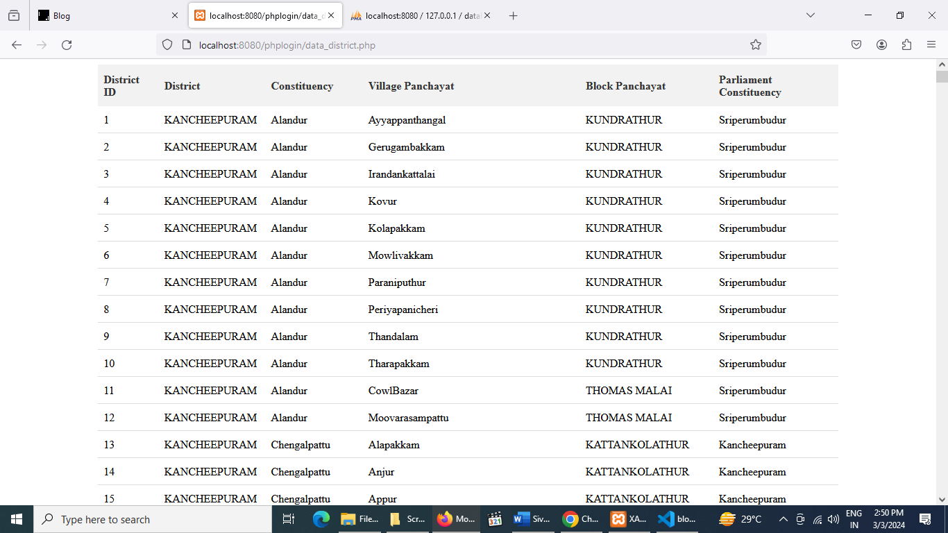

**District wise data**

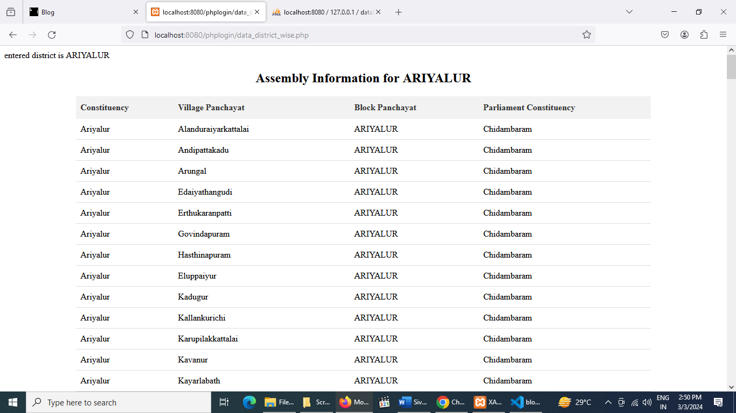

Constiuency wise data

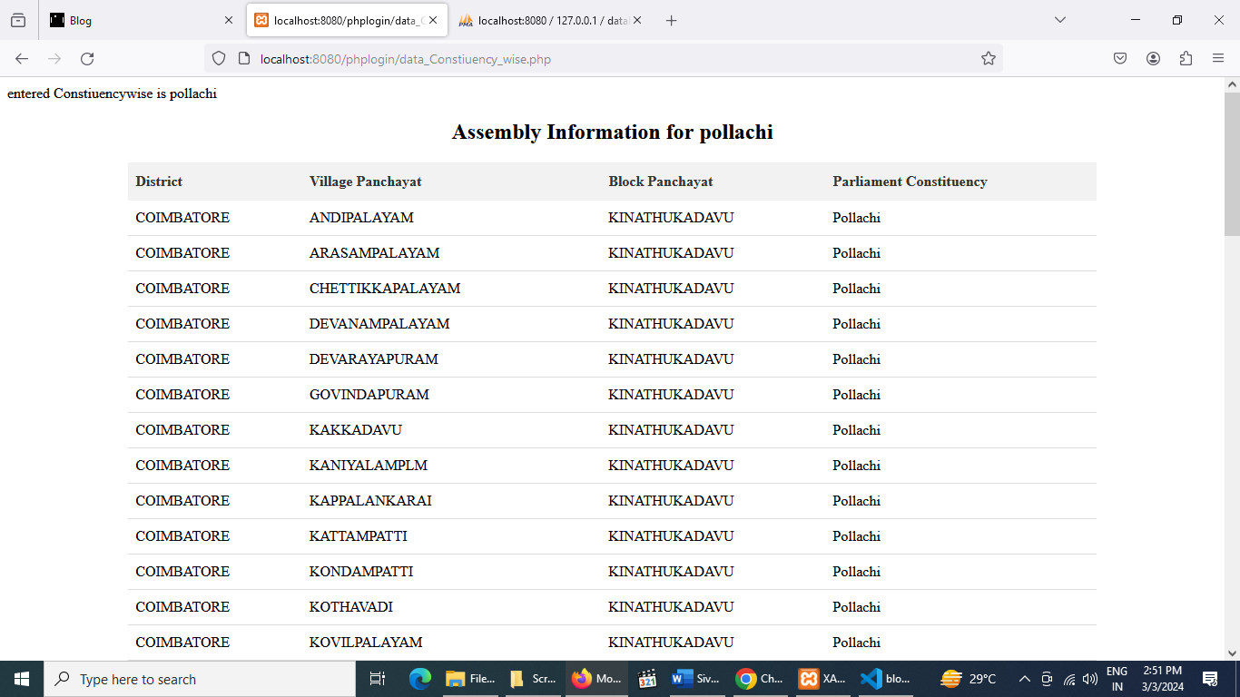

**Village wise data**

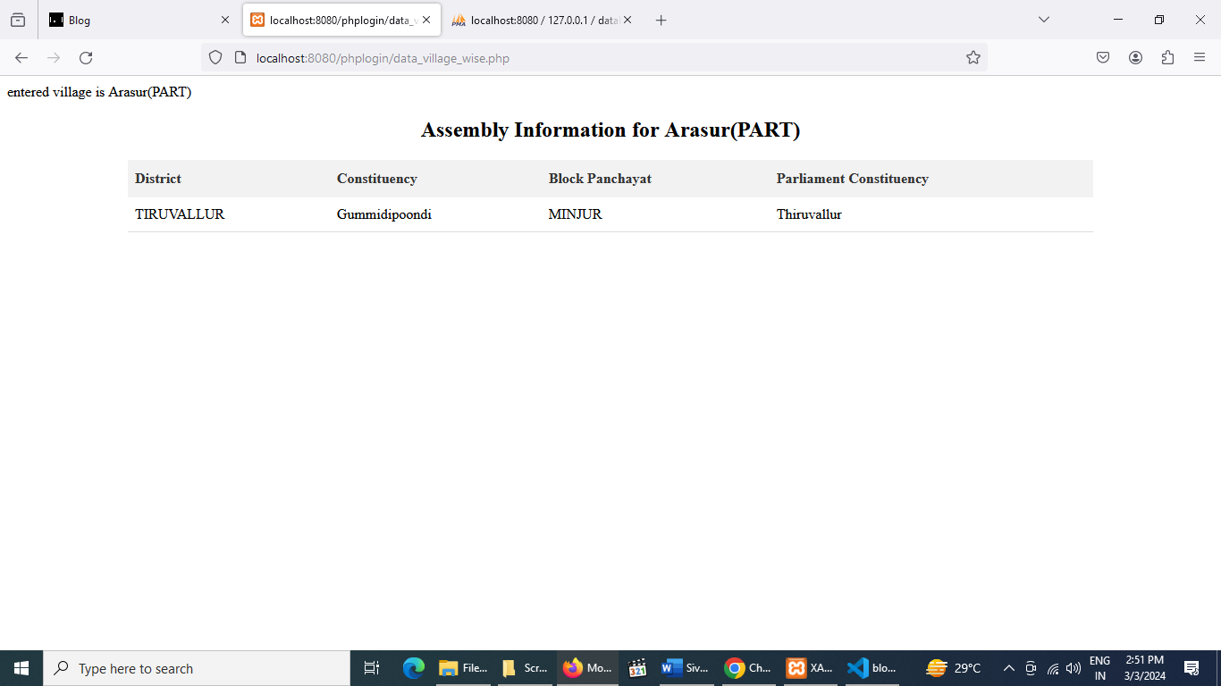

Block wise data

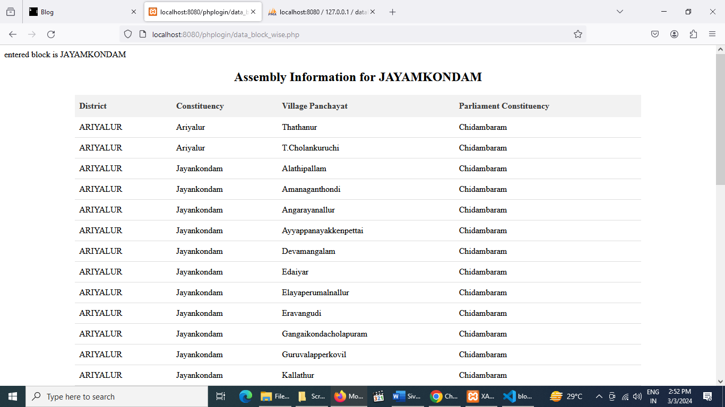

**Parliament wise data**

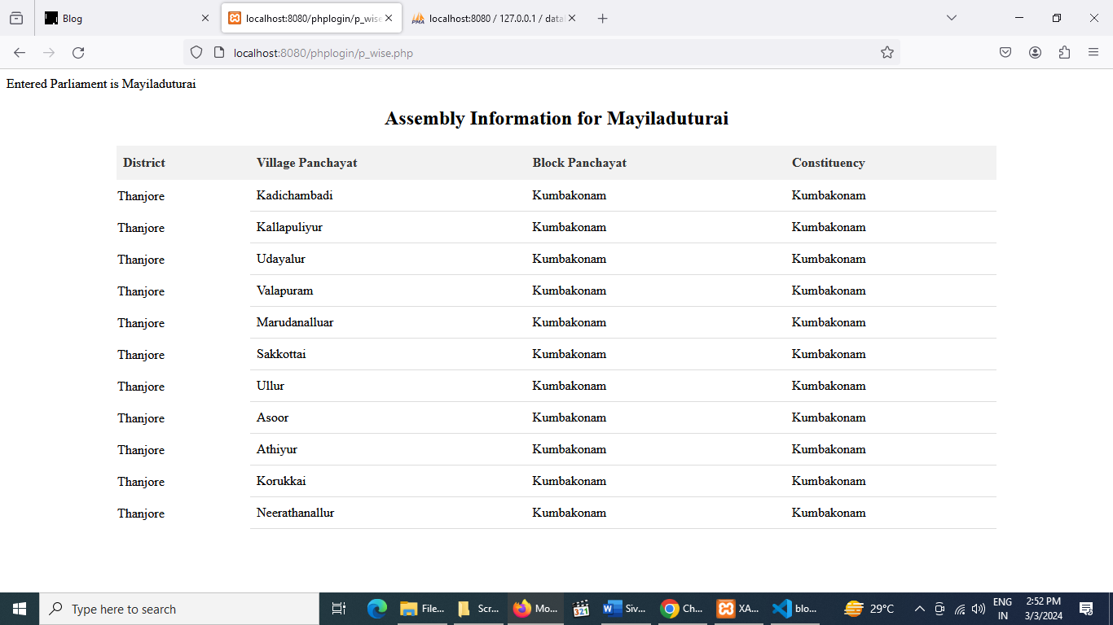

**PhpMyAdmin database**

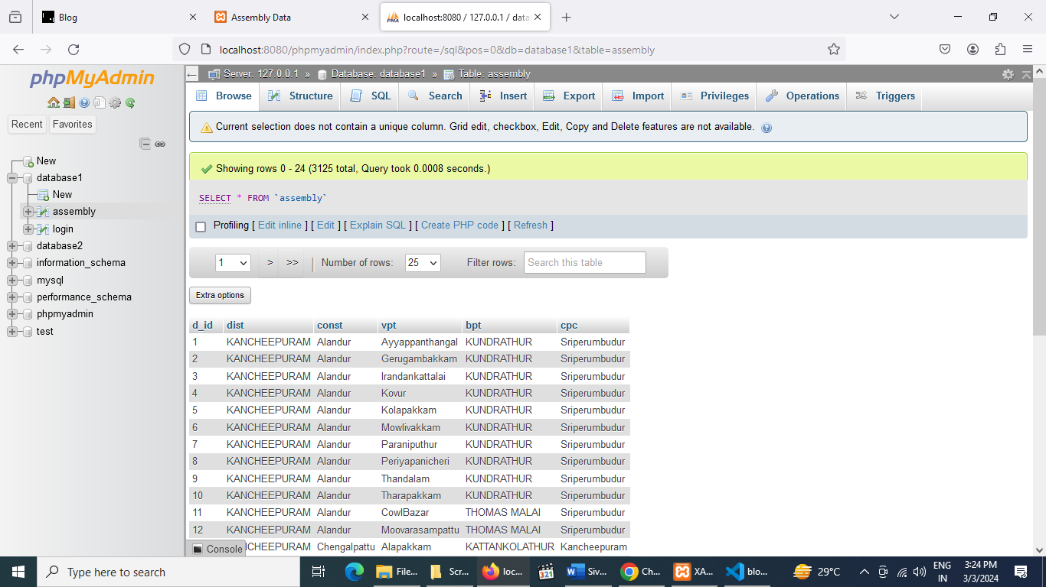

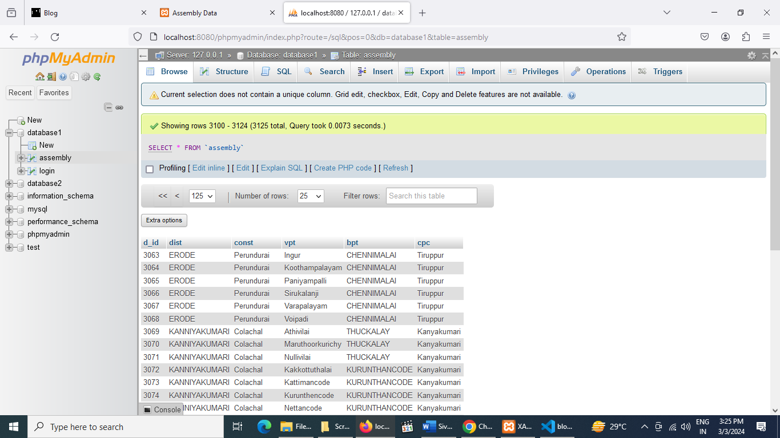

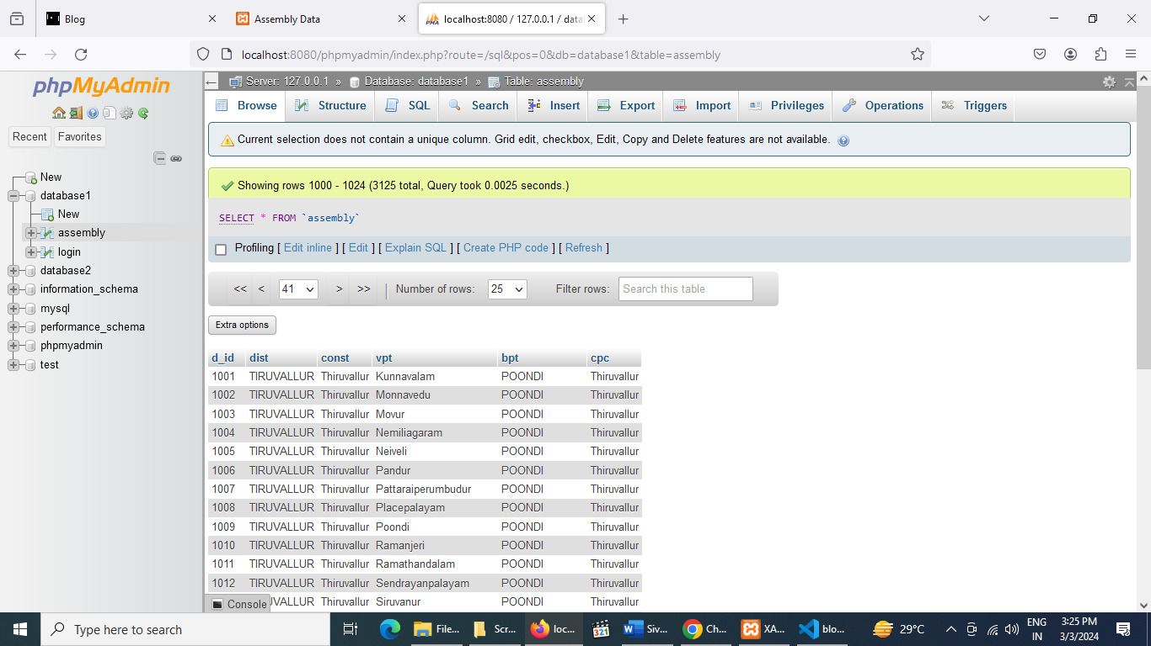

**CHAPTER-9**

**9. CONCLUSION**

This project is only a humble venture to satisfy the needs to manage the required

project work. Several user-friendly coding also adopted. This package shall prove to be a powerful package in satisfying all the requirements of the curriculum The objective of software planning is to provide a framework that enables the manager to make reasonable estimates made within a limited time frame at the beginning of the software project and should be updated regularly as the project progresses. The purpose of directory management system is to automate the existing manual system by the help of computerized and full-fledged computer software, fulfilling their requirements, so that their valuable data/information can be stored for a longer period with easy accessing and manipulation of the same. The required software and hardware are easily available and easy to work with. The beneficiaries can maintain computerized records without redundant entries. That means that one need not be distracted by information that is not relevant, while being able to reach the

information.

**CHAPTER-10**

10. **FUTURE ENHANCEMENTS**

The project has a very vast scope in future. The project can be implemented on

intranet in future. Project can be updated in near future as and when requirement for the same arises, as it is very flexible in terms of expansion. With the proposed software of database Space Manager ready and fully functional the client is now able to manage and hence run the entire work in a much better, accurate and error free manner.

The following are the future scope for the project.

* Can be added multilingual to this site.
* The admin can add more details about the movies
* And many features can be added this project to make it more robust.
* his whole project can be developed to all theatres
* The alert system can be included.
* We can add printer in future

**CHAPTER-11**

**11.BIBILOGRAPHY**