RAILWAY INFIRMARY INFORMATION SYSTEM(RIIS)

Project report Submitted to

Thanthai Periyar Government Arts and Science College (Autonomous),

Tiruchirappalli–620023

(Affiliated to Bharathidasan University, Tiruchirappalli–24)

In partial fulfillment of the requirements for the award of the degree of

**MASTER OF SCIENCE IN**

**COMPUTER SCIENCE**

by

# P. SABARESH (Reg.No:21PCS10)

Under the guidance of

# Dr. R. PARIMALA, M.Sc., M.Phil., DCPA., Ph.D.,

Assistant Professor of Computer Science



**P.G. AND RESEARCH DEPARTMENT OF COMPUTER SCIENCE THANTHAI PERIYAR GOVERNMENT ARTS&SCIENCE COLLEGE**

**(AUTONOMOUS) TIRUCHIRAPPALLI–620023**

**MAY–2023**

# P.G. AND RESEARCH DEPARTMENT OF COMPUTER SCIENCE

## THANTHAI PERIYAR GOVERNMENT ARTS & SCIENCE COLLEGE

**(AUTONOMOUS) TIRUCHIRAPALLI–620023**



**CERTIFICATE**

This is to certify that the project work entitled “**RAILWAY INFIRMARY INFORMATION SYSTEM(RIIS)”**, submitted in partial fulfillment of the requirements for the award of the Degree of Master of Science in Computer Science is a bonafide record of the project work done by **P.SABARESH (Reg.No:21PCS10)** during the even semester of the academic year 2022-2023 at Thanthai Periyar Government Arts and Science College(Autonomous), Tiruchirappalli-23.

Head of the Department Signature of the Guide.

Viva-Voce Examination held on .

Internal Examiner External Examiner

## ACKNOWLEDGEMENT

I am grateful to my Principal ,Dr.P.S.VIJAYALAKSHMI, M.com.,M.B.A.,M.phil., Ph.D.,for giving me the opportunity to take up this project.

I immensely happy to express my hearty thanks to Prof.T.KANNADASAN,MCA., Head of the Department, Computer Science for his endless encouragement in carrying out this project successfully.

I express my profound gratitude to **Dr.R.PARIMALA, MSc.,M.Phil.,DCPA.,Ph.D.,**Assistant Professor in Computer Science for her excellent guidance throughout the development of the project.

I express my invaluable thanks to all the staff members of the department of computer science of Periyar E.V.R College, Trichy, for their cooperation and encouragement that helped me a lot to bring this project in a successful way.

Finally, I record my sincere thanks to my parents for their encouragement and moral support they have been providing to me, without which would have been impossible for me to reach this stage.

## DECLARATION

I, **P.SABARESH (Reg.No:21PCS10**), declared that the project entitled

**“RAILWAY INFIRMARY INFORMATION SYSTEM(RIIS)”** submitted to

the pg& Research Department of Computer Science, Thanthai Periyar Government Arts & Science College (Autonomous), Tiruchirappalli -24 affiliated to Bharathidasan University, Tiruchirappalli-24 in partial fulfillment of the requirements for the award of the degree of Master of Science in Computer Science is the original project work done by me.

Place : Tiruchirappalli -24 Signature

Date : (P.SABARESH)

|  |  |  |
| --- | --- | --- |
| **Chapter** | **CONTENT** | **Page. No** |
| 1 | **ABSTRACT** | 1  2  4  10  41  44  46  51  52  53 |
| 2 | **SYSTEM ANALYSIS** |
|  | 2.1ExistingSystem |
|  | 2.2Disadvantages |
|  | 2.3ProposedSystem |
|  | 2.4Advantages |
| 3 | **SYSTEM CONFIGURATION** |
| 3.1HardwareRequirement |
|  | 3.2SoftwareRequirement |
|  | 3.3SoftwareDescription |
| 4 | **SYSTEM DESIGN** |
| 4.1 Input Design |
|  | 4.2DataflowDiagram |
|  | 4.3DatabaseDesign |
|  | 4.4Screenshot |
| 5 | **IMPLEMENTATION** |
| 6 | **TESTING MAINTENANCE** |
| 7 | SOURCE CODE  7.1 Output design |
| 8 | CONCLUSION |
| 9 | FUTURE ENHANCEMENT |
| 10 | BIBILOGRAPHY |

#### ABSTRACT

A “RAILWAY INFIRMARY INFORMATION SYSTEM(RIIS) is a

computerized management system. This management system has been developed to form whole management system including Employees, Doctors (consultants), Nurses, Patients, and Bills etc. This system also keeps the records of hardware assets besides software of this organization. The customizable alert system sends the text, IM and email reminders and improves the quality of patient care. The proposed system will keep a track of Employees, Doctors, Patients, Accounts and generation of report regarding the present status. Input screens are simple and easy to understand. Pulling up server or cloud information is now easily done with new technological computer systems, yielding an optimal performance. Patients can find doctors and book online appointment based on the specialty, rating, fees, and availability. Organizing doctor schedules, collating patient notes, and handling payment are effortless. Different reports catering to related department can be generated in neat and clear formats.

This project is developed using VB.NET with SQL. The project has been divided into various modules, which performs different functions and there are inter-related with each other.

# SYSTEM ANALYSIS

System analysis is an activity that encompasses most of the tasks that we collectively called system engineering. In the system analysis phase, the system analyst or the system development team determines what the new system should be accomplished. This phase includes two steps. They are,

* To analyze the existing system.
* To determine the needs of the new system.

This system analysis deals with the feasibility study, existing system and proposed system. The functioning of the existing is to get the clear idea about what is going on the present system. Using these, the idea for proposed system can be gained

## EXISTING SYSTEM

The existing system involves a lot of paper work. The typing of information and reports about the admin is done in computer, but it is not atomized. This is a tedious and repetitious task prone to errors. The software used earlier does not contain all the provisions, which are now satisfied by the current advancements. Also the earlier software had less flexibility. The student details in separate records are tedious task. Referring to all these records and updating is needed. There is a chance for more manual errors.

## DISADVANTAGE

* + - Less efficiency and accuracy due to lot of manual entries.
    - The handling of data is difficult.
    - It spends lot of time to perform any work.
    - There is no security of information.
    - There is a delay in information search and retrieval.
    - It is hard to prepare any report.
    - Quick replies are not possible.
    - It is tedious to keep track of the transactions efficiency.

## PROPOSED SYSTEM

The system is being developed using VB.NET as front end and SQL server as back end. The mission of the system is to replace the manual works into a fully computerized one. Computerization means speed, efficiency, reduction of paper work and smooth operations. The advancements in the software have improved the flexibility. The grids available here are more flexible and advanced compared to other older software.

## ADVANTAGE

The proposed system is designed to provide a solution for the drawbacks of present system. It

aims to:

* + - Replace manual processing system with an automated one.
    - It is user friendly.
    - Speedup Transactions.
    - Security of data is provided.
    - Retrieval of necessary information is very easy and fast. Reports can be easily generated takes minimum tim**e**

# SYSTEM CONFIGURATION

## REQUIREMENTS SPECIFICATION

Hardware and software specification gives the complete details about the hardware and software that were used to develop the **“**RIIS” system. Selection of hardware and software is very important factor for efficiency. Hardware specification specifies the requirements of the hardware to run the system. Software specification specifies the software requirements to develop the system in an efficient manner

## HARDWARE REQUIREMENTS

Processor - Core 2 Duo

RAM - 512 MB

Hard Disk - 160 GB

## SOFTWARE REQUIREMENT

Operating System - Windows 7/8 Front End - VB.Net

Back End - SQL Server 2005

## SOFTWARE DESCRIPTION VB.NET

VB.Net is developed by Microsoft. It is Visual Basic for .Net Platform. The .NET Framework is language neural. Currently it supports C++, C#, VB, Jscript. It provides a rich application execution environment.

Visual Basic A name everybody knows for a rich, easy and GUI based programming language, making each & every task easier and improves programmer's productivity. VB has won the best RAD(Rapid Application Development) Tool award for three times and still keeping itself at top.

Microsoft first started Visual Basic in early 1990s and the project name was "Thunder". After the launch of VB 5.0, it crosses all the boundaries and won the best RAD Tool award by beating PowerBuilder in 1998. VB 5.0 came out with some great enhancements but definitely this time VB.NET has come with revolutionary changes to make it suitable for next generation of application development.

Many developers today talk about new generation programming languages and don't count VB as a powerful tool for developing good programs, but i would like to present the surprising data about VB developers given by Bill Gates (The founder and chief software architect of MicrosoftCorp).

"Since Visual Basic's inception, its community has grown to more than 3 million professional developers worldwide. In fact, about half the world's developers now use Visual Basic. The increasing power and richness of the PC provided the backbone for this amazing growth."

Certainly this seems to be an amazing thing to talk about these details in the world of Internet Programming and when we know that Java has already taken place of most popular Internet programming language, but this is hard truth. The only feature lacking in VB was its Internet capabilities and when we are moving towards the third generation of the Internet, it becomes important to have strong Internet Programming capabilities for any programming

language. The industry is focusing on critical distributed computing with web services capabilities. At this moment VB.NET is definitely a powerful tool to provide all these solutions in integrated environment of .NET technology. Let us discuss the major problems with VB 6.0, which has been creating troubles for VB developers for a long time.

### Features of VB.NET

* After the development of .Net, VB was added with more set of controls and components and thus evolved a new language VB.Net.
* VB.NET is Microsoft Technology.
* We can drag controls from the tool bar and drop them on the form and write code for the controls
* Runs on the CLR (Common Language Runtime).
* Release of unused objects taken care by the CLR
* Object Orientation of language enhances modularity, readability and maintainability

**Problems with VB 6.0**

* + 1. No capabilities for multithreading.
    2. Lack of implementation inheritance and other object oriented features.
    3. Poor error handling capabilities.
    4. Poor integration with other languages such as C++.
    5. No effective user interface for Internet based applications.

In VB.NET all these shortcomings have been eliminated. we will discuss how VB.NET implements all these features in our subsequent articles one by one. In fact VB gets the most extensive changes of any existing language in the Visual Studio suite. Let us talk about the major features VB.NET has developed.

**Some new features of VB.NET**

1. Full support for object oriented programming.
2. Structured error handling capabilities.
3. Access to .NET Framework.
4. Powerful unified Integrated Development Environment (IDE).
5. Inherent support for XML & Web Services.
6. Better windows applications with Windows Forms.
7. New Console capabilities of VB.NET.
8. New Web capabilities with Web Forms.
9. Immense power of tools & controls (including Server Controls).
10. Inter operability with other .NET compiled languages.
11. Better database programming approach with ADO.NET.

### SQL Server

Microsoft SQL Server is a [Relational Database Management System](http://www.quackit.com/database/tutorial/database_management_systems.cfm) (RDBMS) designed to run on platforms ranging from laptops to large multiprocessor servers. SQL Server is commonly used as the backend system for websites and corporate CRMs and can support thousands of concurrent users.

SQL Server comes with a number of tools to help you with your database administration and programming tasks.

SQL Server is much more robust and scalable than a desktop database management system such as Microsoft Access. Anyone who has ever tried using Access as a backend to a website will probably be familiar with the errors that were generated when too many users tried to access the database!

Although SQL Server can also be run as a desktop database system, it is most commonly used as a server database system.

### SQL Server 2005

Microsoft SQL Server 2005 includes many graphical and command prompt utilities that allows users, programmers and administrators to:

* Administer and configure SQL Server
* Determine the Catalogue information in a copy of SQL Server.
* Design and test queries for retrieving data.
* Copy, import, export and transform data.
* Provide diagnostic information
* Start and stop SQL Server.

### Feasibility Study

The feasibility study concerns with the consideration made to verify whether the system is fit to developed in all items. It involves the most vital role to develop the new system. It is important to evaluate the feasibility of a project at the earliest possible time. Once an idea to develop the software is put forward the question that arises first will pertain to the feasibility aspects. Feasibility study is a test of a system proposal according to its work ability impact on the organization, ability to meet the user need and effective use of resources.

In “RIIS” the following feasibility analysis has been made.

* + Economic feasibility
  + Operational feasibility
  + Technical feasibility

### Economic Feasibility

The existing resources available in the company are sufficient for implementing the proposed system and hence no extra cost has to be incurred to run the system. Thus, the system is economically feasible. Social aspects are not going to cause any problems or anxiety, as the operation associated with the system is user-friendly.

### Operational Feasibility

There is no difficulty in implementing the system, if the user has the knowledge in internal working of the system. Therefore, it is assumed that he will not face any problems in running the system. The system does not affect the response rate of the computer. Thus, the system is found to be operational feasible.

### Technical Feasibility

Technical feasibility deals with the study of function, performance and constraints like resources availability, technology that may affect the ability to achieve an acceptance system. Thus, the system is found to be technical feasible.

After the feasibility study, the analyst has to formulate the problem. When ever there is a problem defined in terms, then only the analyst can solve it using the necessary steps. This will help to modularize the problem. Hence the stage of system and problem formulation places an important role in the system development life cycle.

# SYSTEM DESIGN

## ARCHITECTURAL DESIGN

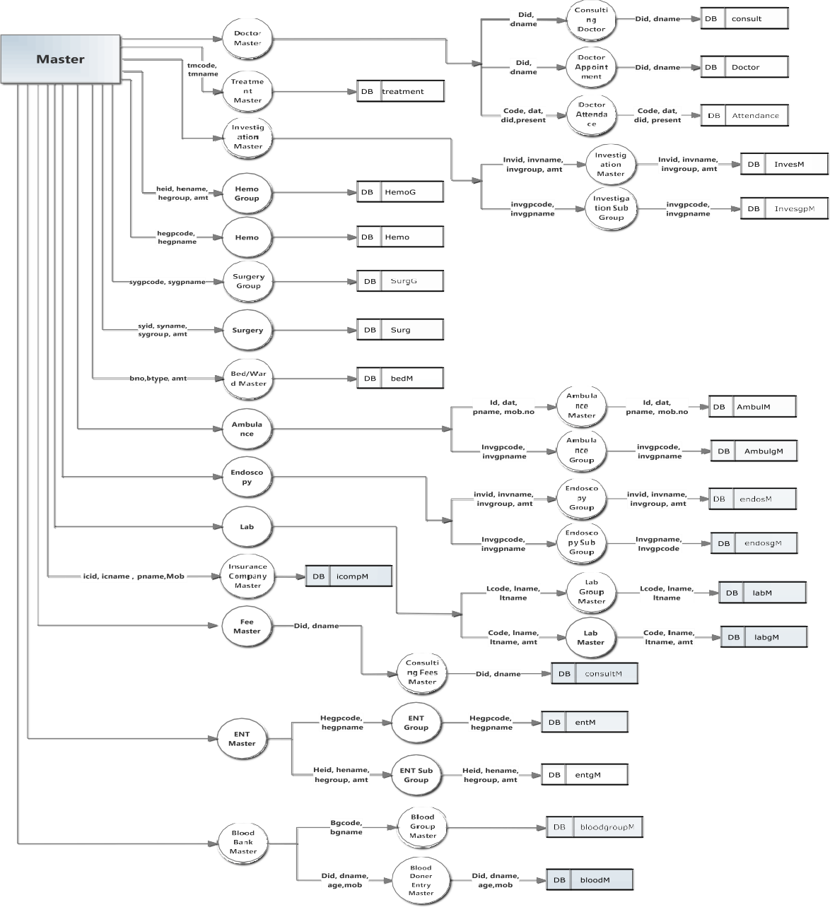

* 1. **INPUT DESIGN**

Input design is the process of converting user-oriented inputs to a computer based format .input design is one of the most expensive phases of the operation of computerized system and is often the major problem of a system.

### Data Flow Diagram

DFD is a graphical tool for the structure analysis. A DFD describes what data flow rather than how they are processed, and it does not depend on hardware, software, and data structure or file organization. The DFD methodology is quite effective, especially when the required design unclear and the analyst need a notational language for communication.

DFD is one of the most important tools used by system analysts. Most data flow modeling methods use four kinds of symbols. These symbols are used to represent four kinds of system components. Processes, a data stores, data flows and external entities. Circles in DFD represent a process

.

## LOGIN PAGE

LOGIN

MASTER

ADMIN

**NAVIGATION**

BLOOD BANK MASTER

ENT MASTER

LAB MASTER

SELECT COMPANY

ULILITIES

CREATE COMPANY

NAVIGATION

DATABASE

COMPANY

**MASTER PAGE**

MASTER PAGE

TREATMENT

MASTER

BED/WARD

MASTER

INVESTIGATION

MASTER

AMBULANCE

MASTER

HEMO MASTER

ENDOSCOPY MASTER

DOCTOR MASTER

SURGERY MASTER

**IP\OP**

IP\OP

PATIENT REGISTRATION

OP BOOKING

IP BOOKING

OP DIAGNOSIS ENTRY

IP DIAGNOSIS

ENTRY

IP BILL PRINT

**PAYROLL**

STAFF MASTER

STAFF RECORD MASTER

STAFF SALARY MASTER

STAFF ATTENDENCE

PAYROLL

**BILL**

LAB CASH

RECEIPT

ENDOSCOPY CASH REPORT

COLLECTION OF BILL

BILL

INVESTIGATION CASH REPORT

OP CASH RECEIPT

**REPORT**

REPORT

SALARY MASTER

REPORT

OP CASH RECEIPT

REPORT

IP CASH RECEIPT

REPORT

ENDOSCOPY CASH

RECEIPT REPORT

ENT CASH RECEIPT

REPORT

INVESTICATION CASH RECEIPT REPORT

DOCTOR MASTER REPORT

## DATABASE DESIGN

A database is to handle information as an integrated whole. A database is a collection of interrelated data stored with minimum redundancy to serve many users quickly and effectively. After designing input and output, the analyst must concentrate on database design or how data should be organized around user requirements. The general objective is to make easy quick, information access, inexpensive and flexible forother users.

The following objectives are concerned:

* Controlled Redundancy
* Accurate and integrating
* Recovery from failure
* Privacy and security
* Ease of learning and use

# TABLE DESIGN

#### Table Name: Company Primary Key: Compid

**Description:** This table stores the new company name, id etc. this specific table stores the username and password for all the company.

|  |  |  |  |
| --- | --- | --- | --- |
| **FIELDS** | **DATA TYPE** | **LENGTH** | **Allow Null** |
| Compid | Int | 4 | Not Null |
| Compname | varchar | 50 | Not Null |
| add1 | varchar | 50 | Not Null |
| add2 | varchar | 50 | Null |
| add3 | varchar | 50 | Null |
| City | varchar | 50 | Not Null |

|  |  |  |  |
| --- | --- | --- | --- |
| Pincode | Bigint | 8 | Not Null |
| Tinno | Int | 4 | Not Null |
| Fyear | Datetime | 8 | Not Null |
| Styear | datetime | 8 | Not Null |
| Endyear | datetime | 8 | Not Null |
| Compcode | Varchar | 50 | Not Null |
| Usname | varchar | 20 | Not Null |
| Pword | varchar | 10 | Not Null |

#### Table Name: Doctor

* **Primary Key: Did**
* **Description:** This table stores the details of the doctor like Did, Doctor Name, Qualification, Mob no, Mail id etc.

|  |  |  |  |
| --- | --- | --- | --- |
| **FIELDS** | **DATA TYPE** | **LENGTH** | **ALLOW NULL** |
| Did | Int | 4 | Not Null |
| Dname | Varchar | 50 | Not Null |
| add1 | Varchar | 50 | Not Null |
| add2 | Varchar | 50 | Null |
| City | Varchar | 50 | Not Null |
| Pin | Bigint | 8 | Not Null |
| Rphno | Varchar | 10 | Null |
| Ophno | Varchar | 10 | Not Null |
| Mobil | Varchar | 10 | Not Null |
| Email | Varchar | 50 | Not Null |
| Qua | Varchar | 50 | Not Null |

#### Table Name: Drattendance

* **Primary Key: Did**
* **Description:** This table stores the attendance details for the doctors.

|  |  |  |  |
| --- | --- | --- | --- |
| **FIELDS** | **DATA TYPE** | **LENGTH** | **ALLOW NULL** |
| Dat | Datetime | 8 | Not Null |
| Sid | Int | 4 | Not Null |
| Did | Int | 4 | Not Null |
| Dname | Varchar | 50 | Not Null |
| Present | Int | 4 | Not Null |

#### Table Name: Invgroup

* **Primary Key: Invgpcode**
* **Description:** This table is used to store the investigation group code and name that are available in the hospital.

|  |  |  |  |
| --- | --- | --- | --- |
| **FIELDS** | **DATA TYPE** | **LENGTH** | **ALLOW NULL** |
| Invgpcode | Int | 4 | Not Null |
| Invgpname | Varchar | 50 | Not Null |

#### Table Name: Investigation

* **Primary Key: Invid**
* **Description:** This table is used to store the investigation id,name,to which group it belong and its amount.

|  |  |  |  |
| --- | --- | --- | --- |
| **FIELDS** | **DATA TYPE** | **LENGTH** | **ALLOW NULL** |
| Invid | Int | 4 | Not Null |
| Invname | Varchar | 50 | Not Null |

|  |  |  |  |
| --- | --- | --- | --- |
| Invgroup | Varchar | 50 | Not Null |
| Amt | Decimal | 9 | Not Null |

#### Table Name: Endoscopy

* **Primary Key: Endosid**
* **Description:** This table is used to store the endoscopy id,name,to which group it belong and its amount .

|  |  |  |  |
| --- | --- | --- | --- |
| **FIELDS** | **DATA TYPE** | **LENGTH** | **ALLOW NULL** |
| Endosid | Int | 4 | Not Null |
| Endosname | Varchar | 50 | Not Null |
| Endosgroup | Varchar | 50 | Not Null |
| Amt | Decimal | 9 | Not Null |

#### Table Name: Lab

* **Primary Key: Lcode**
* **Description:** This table is used to store the labtestid,name,to which group it belong and its amount .

|  |  |  |  |
| --- | --- | --- | --- |
| **FIELDS** | **DATA TYPE** | **LENGTH** | **ALLOW NULL** |
| Lcode | Int | 4 | Not Null |
| Lname | Varchar | 50 | Not Null |
| Ltname | Varchar | 50 | Not Null |
| Amt | Decimal | 9 | Not Null |

#### Table Name: InsuranceComp

* **Primary Key: Icid**
* **Description:** This table is used to store the insurance company details like its id, company name, its contact person and address etc.

|  |  |  |  |
| --- | --- | --- | --- |
| **FIELDS** | **DATA TYPE** | **LENGTH** | **ALLOW NULL** |
| Icid | Int | 4 | Not Null |
| Icname | Varchar | 50 | Not Null |
| add1 | Varchar | 50 | Not Null |
| add2 | Varchar | 50 | Null |
| add3 | Varchar | 50 | Null |
| City | Varchar | 50 | Not Null |
| Pin | Varchar | 50 | Not Null |
| ph1 | Varchar | 15 | Null |
| Mobil | Varchar | 20 | Not Null |
| Email | Varchar | 20 | Null |
| Pname | Varchar | 50 | Not Null |

#### Table Name: BloodGroup

* **Primary Key: Bgcode**
* **Description:** This table stores the blood group code and name.

#### Table Name: BloodDonation

* **Primary Key: Pid**
* **Description:** This table is used to store the details of the blood donor his name,age,bloodgroup,area, mob.no.

|  |  |  |  |
| --- | --- | --- | --- |
| **FIELDS** | **DATA TYPE** | **LENGTH** | **ALLOW NULL** |
| Pid | Int | 4 | Not Null |
| Pname | Varchar | 50 | Not Null |
| Gender | Varchar | 50 | Not Null |
| Dob | Varchar | 50 | Not Null |
| Age | Int | 4 | Not Null |
| add1 | Varchar | 50 | Not Null |
| add2 | Varchar | 50 | Null |
| Pin | Bigint | 8 | Not Null |

|  |  |  |  |
| --- | --- | --- | --- |
| Phno | Bigint | 8 | Null |
| Mob | Bigint | 8 | Not Null |
| Hname | Varchar | 50 | Not Null |
| Ref | Varchar | 50 | Not Null |
| Typ | Varchar | 50 | Not Null |
| Wgt | Int | 4 | Not Null |
| Bgrp | Varchar | 50 | Not Null |
| Hbmgm | Varchar | 50 | Not Null |
| ref1n | Varchar | 50 | Not Null |
| ref1p | Bigint | 8 | Not Null |

#### Table Name: IpBooking

* **Primary Key: Ipbid**
* **Description:** This table is used to store the details of the In Patient booking.

|  |  |  |  |
| --- | --- | --- | --- |
| **FIELDS** | **DATA TYPE** | **LENGTH** | **ALLOW NULL** |
| Code | Int | 4 | Not Null |
| Hr.no | Datetime | 8 | Not Null |
| Dat | Varchar | 20 | Not Null |
| Pname | Varchar | 50 | Not Null |
| Age | Int | 4 | Not Null |
| Gender | Decimal | 9 | Not Null |
| Typttre | Tinyint | 1 | Not Null |
| Bedno | Int | 4 | Not Null |
| Adamt | Int | 4 | Not Null |
| Ipno | Int | 4 | Not Null |

#### Table Name: IpInsuranceBillPrint1

* **Primary Key: cod**
* **Description:** This table is used to store the details of the In Patient insurance bill print that contains billno,date, insurance no, company name, ip hr.no etc.

|  |  |  |  |
| --- | --- | --- | --- |
| **FIELDS** | **DATA TYPE** | **LENGTH** | **ALLOW NULL** |
| Cod | Int | 4 | Not Null |
| Insno | Varchar | 8 | Not Null |
| Ipno | Varchar | 20 | Not Null |
| Hrno | Varchar | 50 | Not Null |
| Pname | Varchar | 4 | Not Null |
| Ttype | Varchar | 9 | Not Null |
| insname | Varchar | 9 | Not Null |
| Billdate | Varchar | 20 | Not Null |
| Billno | Int | 4 | Not Null |
| Gender | Varchar | 10 | Not Null |
| Age | Int | 4 | Not Null |

* **Table Name: IpInsuranceBillPrint2**
* **Primary Key: cod**

|  |  |  |  |
| --- | --- | --- | --- |
| **FIELDS** | **DATA TYPE** | **LENGTH** | **ALLOW NULL** |
| Cod | Int | 4 | Not Null |
| Billno | Int | 4 | Not Null |
| Dat | Datetime | 8 | Not Null |
| Hrno | Varchar | 15 | Not Null |
| Ipno | Varchar | 15 | Not Null |
| Slno | Int | 4 | Not Null |
| Part | Varchar | 50 | Not Null |
| Amt | Decimal | 9 | Not Null |

* **Table Name: Attendance**
* **Primary Key: Code**
* **Description:** This table stores the attendance details for the staffs.

|  |  |  |  |
| --- | --- | --- | --- |
| **FIELDS** | **DATA TYPE** | **LENGTH** | **ALLOW NULL** |
| Code | Int | 4 | Not Null |
| Dat | Datetime | 8 | Not Null |
| Sid | Int | 4 | Not Null |
| Stfid | Int | 4 | Not Null |
| Sname | Varchar | 50 | Not Null |
| Design | Varchar | 50 | Not Null |
| Present | Int | 4 | Not Null |
| Reason | Varchar | 100 | Not Null |

#### Table Name: AttendanceRecord

* **Primary Key: Code**
* **Description:** This table stores the attendance Record details for the all staff.

|  |  |  |  |
| --- | --- | --- | --- |
| **FIELDS** | **DATA TYPE** | **LENGTH** | **ALLOW NULL** |
| Code | Int | 4 | Not Null |
| Dat | Datetime | 8 | Not Null |
| Sid | Int | 4 | Not Null |
| Stfid | Int | 4 | Not Null |
| Sname | Varchar | 50 | Not Null |
| Design | Varchar | 50 | Not Null |
| Cou | Int | 4 | Not Null |

#### Table Name: Entcashrec1

* **Primary Key: BillNo**
* **Description:** This table stores the details for the ENT cash receipt like billno,date,particular and its amount.

|  |  |  |  |
| --- | --- | --- | --- |
| **FIELDS** | **DATA TYPE** | **LENGTH** | **ALLOW NULL** |
| Billno | Int | 4 | Not Null |
| Dat | Datetime | 8 | Not Null |
| Slno | Int | 4 | Not Null |
| Part | Varchar | 50 | Not Null |
| Amt | Decimal | 9 | Not Null |

#### Table Name: ENTcashrec2

* **Primary Key: BillNo**
* **Description:** This table stores the details for the ENT cash receipt like billno,date,Hr.no,name,gender,age.

|  |  |  |  |
| --- | --- | --- | --- |
| **FIELDS** | **DATA TYPE** | **LENGTH** | **ALLOW NULL** |
| Billno | Int | 4 | Not Null |
| Dat | Datetime | 8 | Not Null |
| Hrno | Varchar | 50 | Not Null |
| Name | Varchar | 50 | Not Null |
| Gender | Varchar | 50 | Not Null |
| Age | Int | 4 | Not Null |

## SCREENSHOT

**Login**

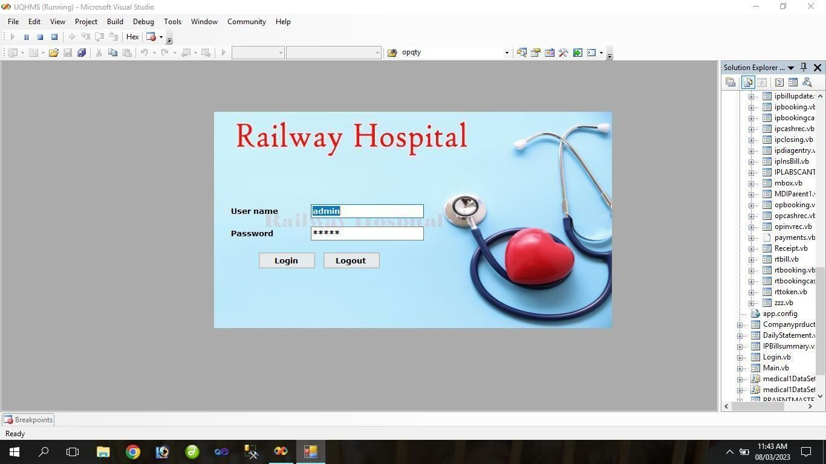

**Op patient**

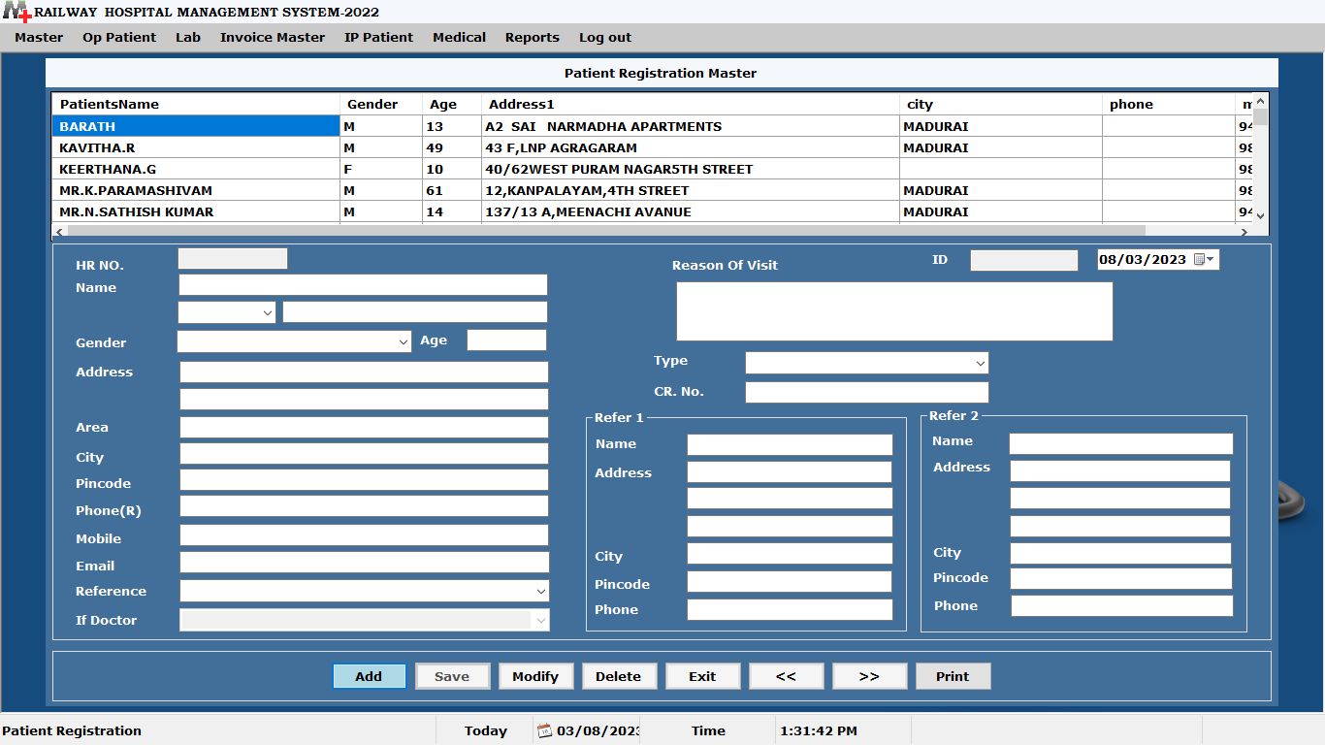

**Op Booking**

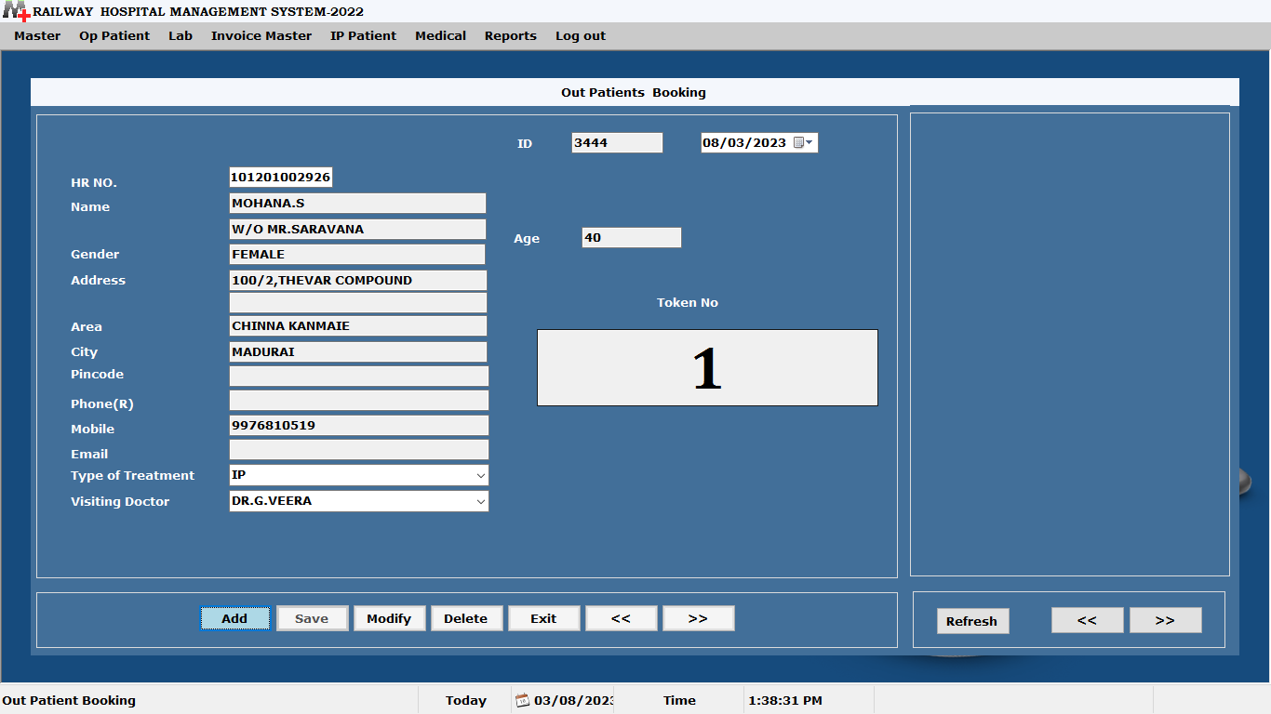

**Op Bill Master**

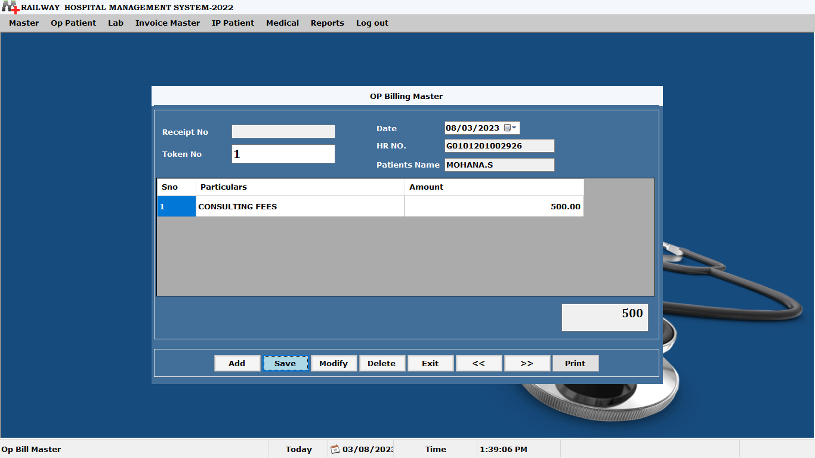

**Lab**

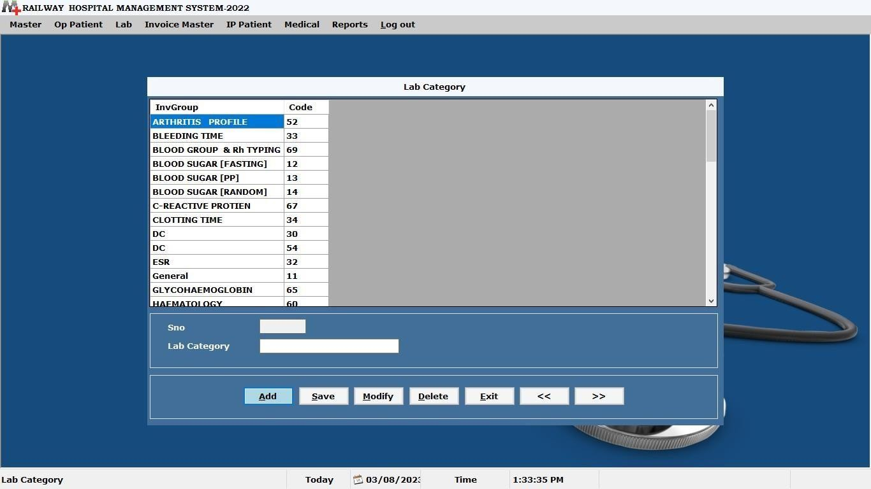

**Invoice Bill Master**

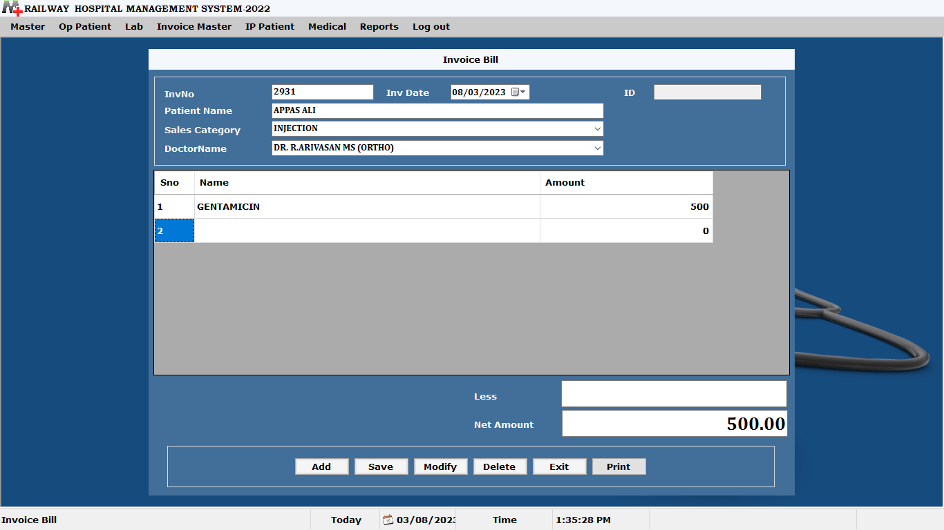

**Ip Booking**

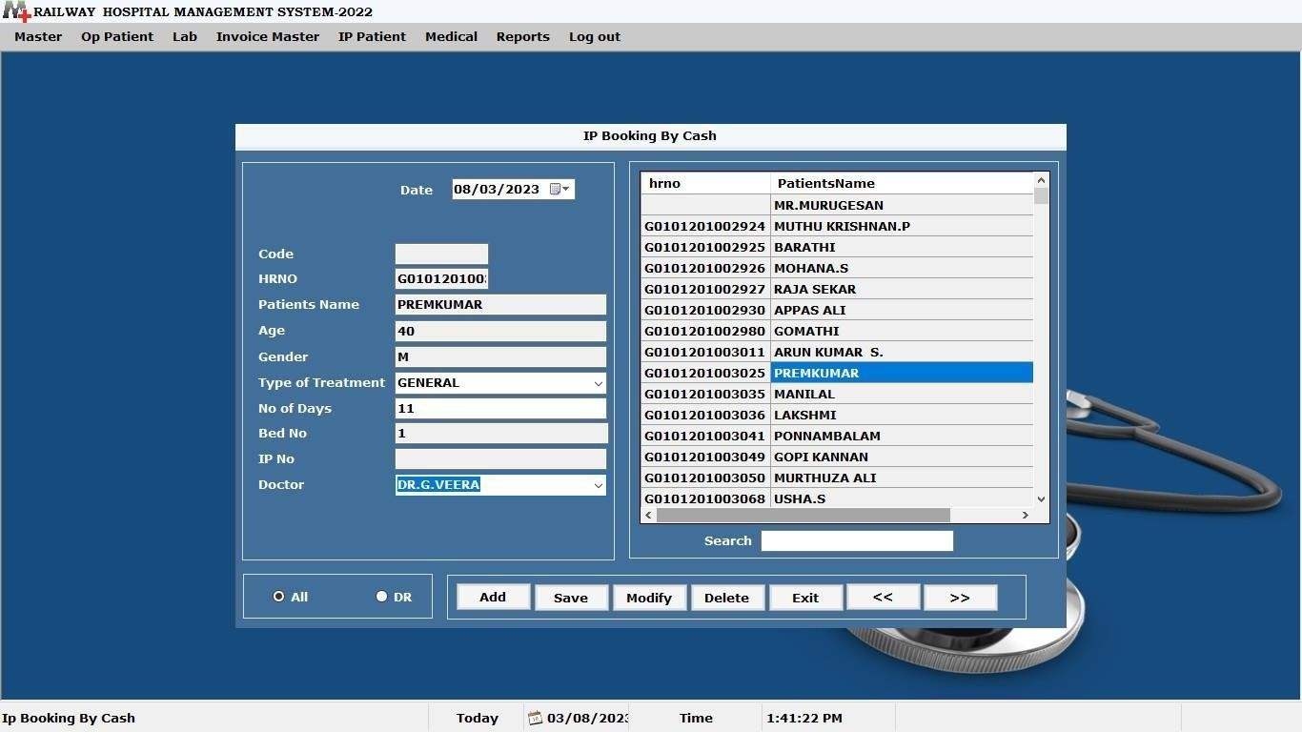

**IP Closing**

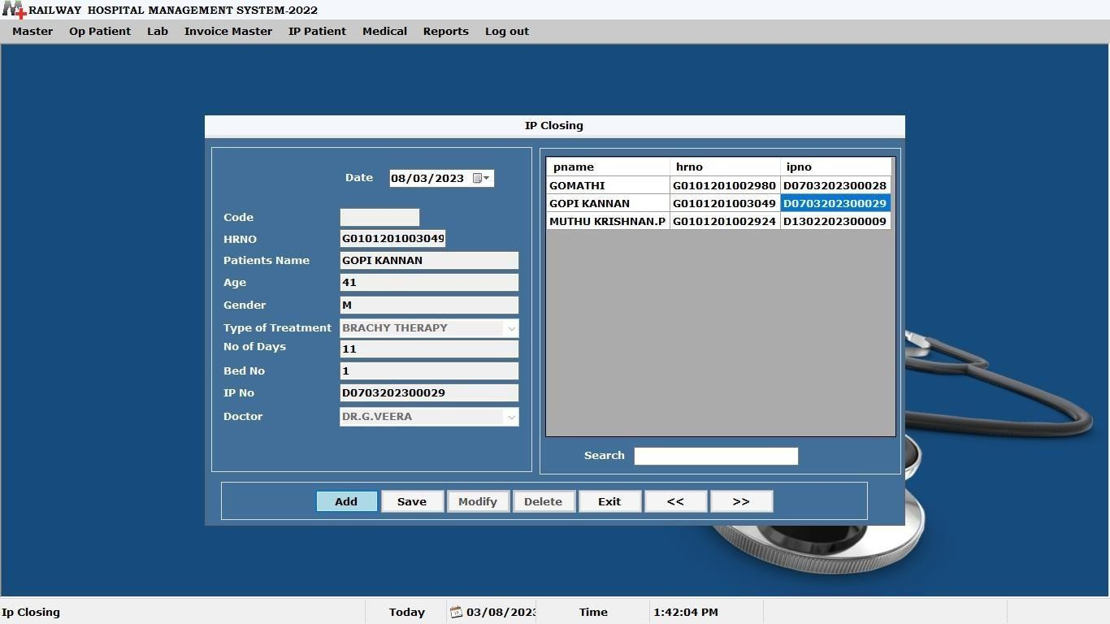

**Purchase Entry**

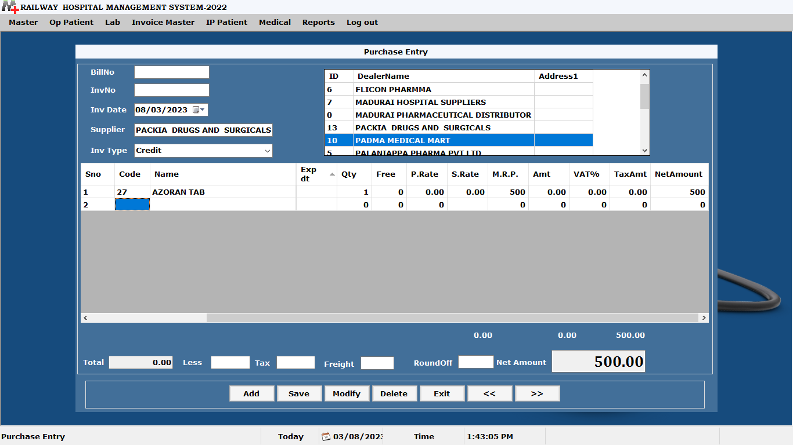

**Sales Entry**

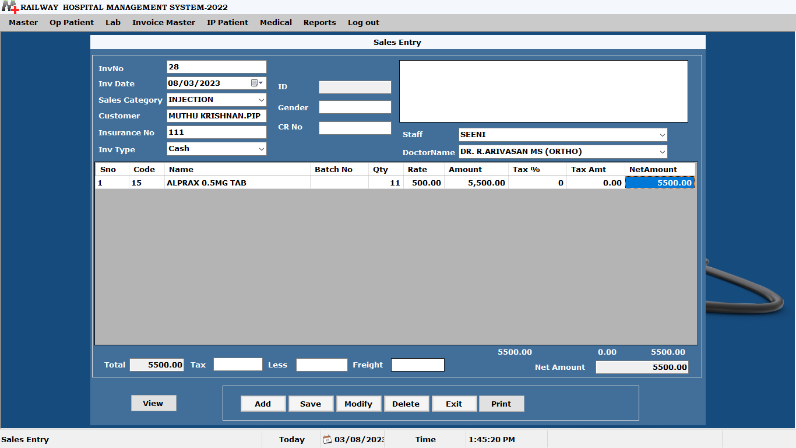

**Sales Report**

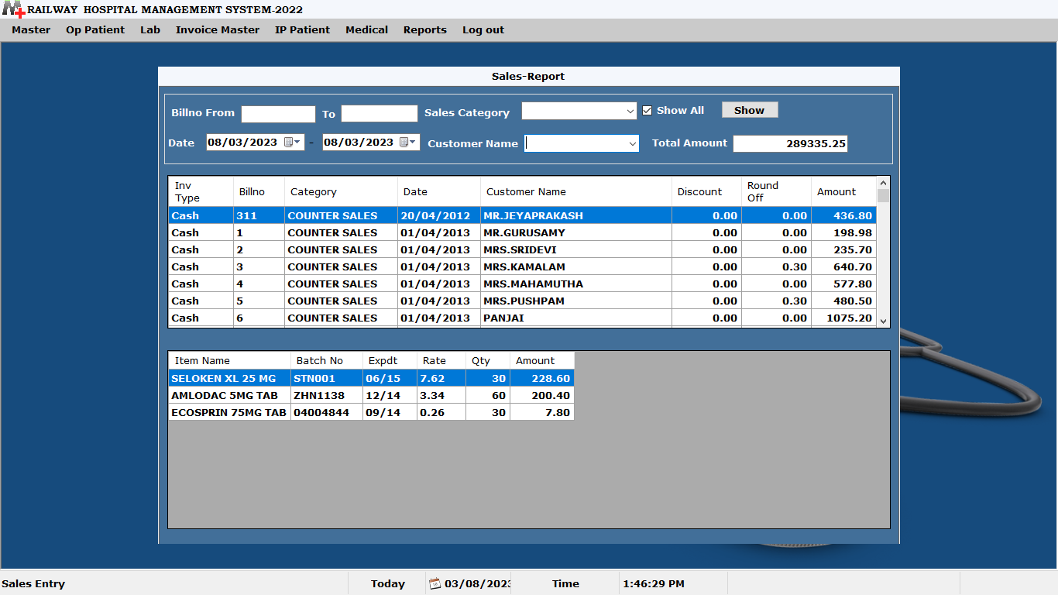

**Stock Product Wise**

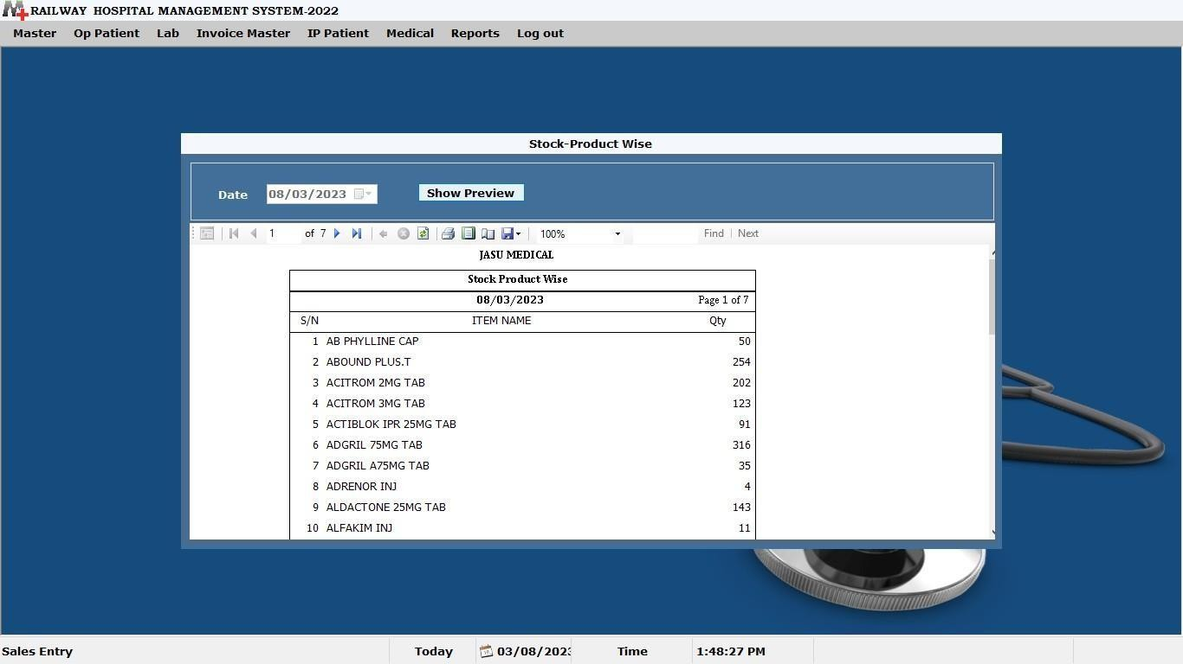

**Company Product Stock**

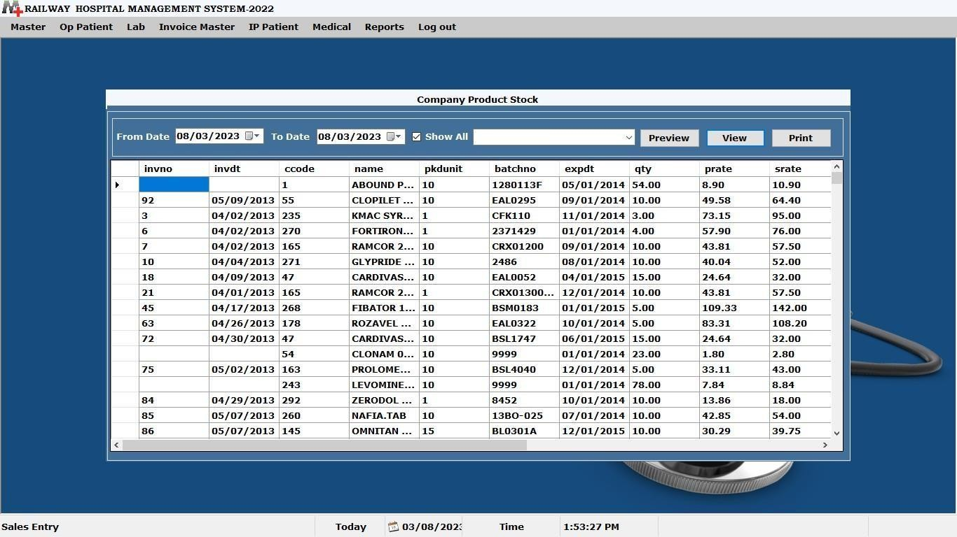

**Daily Statement**

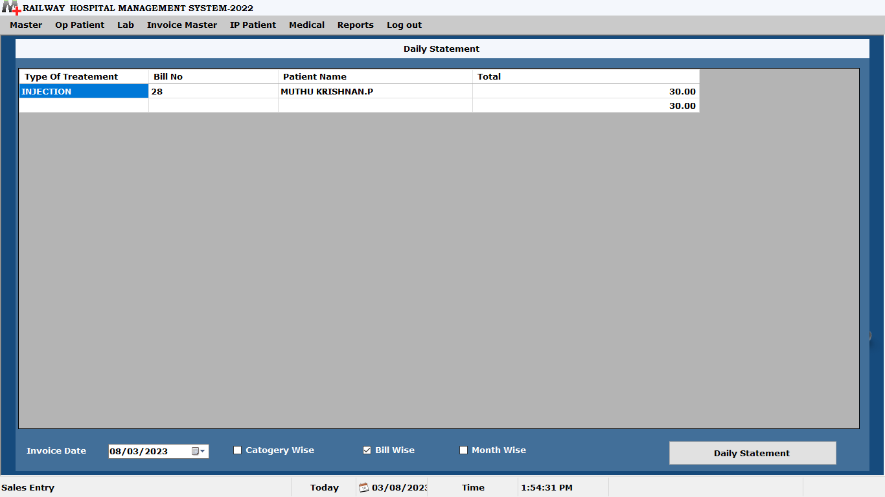

## MODULES

**Master Modules IP/OP Master Payroll Master Bill Masters**

**Port setting (GSM) Report**

**Settings Navigation**

# Modules Description

“RIIS” is a web based applications; it is a dynamic web pages. Each modules have the many sub modules:

#### Navigation

* Create Company
* Select Company

#### Master

* Doctor Master
* Treatment Master
* Investigation Master
* Hemo Master
* Surgery Master
* Bed/Ward Master
* Ambulance Master
* Endoscopy Master
* Lab Master
* ENT Master
* Blood Bank Master

#### IP\OP

* Patient Registration
* OP Booking
* IP Booking
* OP Diagnosis Entry
* IP Diagnosis Entry
* IP Bill Print

#### Payroll

* Staff Master
* Staff Record Master
* Staff Salary Master
* Staff Attendance Master

#### Bill

* + OP Cash Receipt
  + LAB Cash Receipt
  + Investigation Cash Receipt
  + Endoscopy Cash Receipt
  + Collection of Bill`

#### Port settings

* GSM
* Gateway

#### Report

* Doctor Master Report
* Salary Master Report
* OP Cash Receipt Report
* Investigation Cash Receipt Report
* IP Cash Receipt Report
* Endoscopy Cash Receipt Report
* ENT Cash Receipt Report

### Navigation Sub Modules

#### Create Company

In this, we create dynamic database for different companies. It includes details such as company code, name, financial year, etc.,

#### Select Company

In this, we select our database to use. It includes details such as company name, username, and password.

### Master

This module deals with the details of the different types of treatments, and it’s sub groups and also amount details etc. These details are bind with others modules. This module contains five sub modules.

### Sub Modules

#### Doctor Master

This describes about the Details of the Doctors in Hospital. Such, as Doctor ID, Name, Add, Phone No. etc.,

#### Treatment Master

This describes about the Type of the Treatment which are provide by Hospita

#### Investigation Master

This describes about the Treatment of investigation which are providing by hospital and it’s Amount.

#### Hemo Master

This describes about the Type of hemo which are provides by hospital and it’s Amount.

#### Surgery Master

This describes about the Details of the surgery in Hospital. Such as Surgery Name, Amount, etc.,

#### Bed/Ward Master

This describes about the Details of the Rooms in hospital. Like, Room no, Type, Amount, and Code.

#### Ambulance Master

Ambulance Group Master describes about the details of the Ambulance in Hospital Ambulance Master describes about the details of the person who have call. Such as, Date, Name, address, mobile no, etc.,

#### Endoscopy Master

This describes about the type of the Endoscopy which are in hospital and it’s

Amount.

#### Lab Master

This describes about the Details of Lab and Lab test. Such as code, name of the lab, Lab test and its amount.

#### ENT Master

ENT Group Master describes about the name of the ENT treatment which are in Hospital. ENT Master describes about the details of the ENT treatment. Such as, Code, Name of ENT group, Type of treatment and Amount.

#### Blood Bank Master

Blood Group master contains the names of Blood Group and it’s code. Blood Donor Master contains the Details of the Blood Donors who all donate blood Such as, Donor ID, Name, Age, address, etc., and their reference’s information Such as Name and Ph.no.

## IP/OP

### Sub Modules

#### Patient Registration

In this, we register every patient’s record. That, includes the details of patients such as, patient name, age, weight, blood group etc., here we generates HR No for each patients as unique.

#### OP Booking

Here we put entry only for outpatient. Those details are selected from patient registration. Here when we save the op booking entry that will automatically generates the ‘OP Token’.

#### IP Booking

Here we put entry only for outpatient. Those details are selected from patient registration. Here when we save the op booking entry that will automatically generates the ‘OP Token’.

#### OP Diagnosis Entry

Here we put entry only for outpatient. Those details are selected from patient registration. Here when we save the op booking entry that will automatically generates the ‘OP Token’.

#### IP Diagnosis Entry

Here we put entry only for outpatient. Those details are selected from patient registration. Here when we save the op booking entry that will automatically generates the ‘OP Token’.

#### IP Bill Print

Here we put entry only for outpatient. Those details are selected from patient registration. Here when we save the op booking entry that will automatically generates the ‘OP Token’.

### Payroll

This module maintains the details of the staff’s(Nurse, Clerk, Wardboy, etc.,) who are working in our hospital. This also contains the attendance details of the Staff who are working in our hospital Such as, Date, Staff ID, Name, Type, Pre/Abs and Reason.

### Sub Modules

#### Staff Master

Staff Group contains the Types of the staff and basic information about salary like, BP, HRA, PF, DA, ESI, and LIC.

Staff Master describes about the Entire details of the Staffs who are working in hospital.

Like.

#### Staff Salary Master

This describes about the salary details of the staffs that who are working in our hospital. Such as, Date, Staff ID, Name, Type, etc.,

#### Staff Attendance Master

This describes about the attendance details of the Staff who are working in our hospital Such as, Date, Staff ID, Name, Type, Pre/Abs and Reason.

#### Staff Record Master

This gives details about the Staffs in different formats. working in our hospital. Such as, Date, Staff ID, Name, Type, etc.,

### Bill

This module contains the details of putting bill for various departments. It also has the facility of seeing total collection of the bill for everyday, and send that amount details as sms, and mail to admin. etc., and also here we use ‘ONLINE PAYMENT GATEWAY’ option.

### Sub Modules

#### OP Cash Receipt

This maintains the details of putting bill for op patient’s consulting fees with their Token no. Here, we print the bill for op cash i.e., consulting fees. Details such as, receipt no, HR no, Token No, etc.,

#### LAB Cash Receipt

This maintains the details of putting bill for op patient’s lab cash with their HR no.

Here, we print the bill for Lab cash. Details such as, receipt no, HR no, Date, etc.

#### IP Cash Receipt

This maintains the details of putting bill for IP patients with their IP no. Here, we print the bill for IP cash. Here, we can Details such as, receipt no, HR no, Date, etc.,

#### Investigation Cash Receipt

This maintains the details of putting bill for op patient’s investigation cash with their HR no. Here, we print the bill for Lab cash. Details such as, receipt no, HR no, Date, etc.,

#### Endoscopy Cash Receipt

This maintains the details of putting bill for op patient’s Endoscopy cash with their HR no. Here, we print the bill for Lab cash. Details such as, receipt no, HR no, Date, etc.,

#### Collection of Bill

This maintains the details of Department wise, as well as Total collection amount for every day. These Details sends to admin as Sms and mail.

### Port Settings

In this module, we can set our sms port settings. We use two ways of sending sms.

### Sub Modules

* + - * **GSM**Global System for Mobile Communication. Here we can use Bluetooth device to send SMS

### Gateway

In this module we can send SMS via Internet .This is like way2sms.

### Report

It contains the details of the various reports. Such as, salary master report, Doctor master report, OP cash receipt repot, etc., Here, we can take date wise report, that will produce the report as dynamic. We can also convert the reports as PDF and Excel formats.

### Sub Modules

#### Doctor Master Report

In this, we can take report of doctors who are working in our hospital.

#### Salary Master Report

In this, we can get the report of salary details of the staffs that, who are working in our hospital. Details such as, Staff id, Name, Type, Date, salary, etc.

#### OP Cash Receipt Report

In this, we can see the report of the OP cash receipt that will be produce according to the bill date. Similarly, other reports also have produced the reports according to that department of treatments. Other Reports are,

#### Investigation Cash Receipt Report

In this, we can see the report of the investigation cash receipt that will be produce according to the bill date.

#### IP Cash Receipt Report

In this, we can see the report of the IP cash receipt that will be produce according to the bill date.

#### Endoscopy Cash Receipt Report

In this, we can see the report of the endoscopy cash receipt that will be produce according to the bill date.

#### ENT Cash Receipt Report

In this, we can see the report of the ENT cash receipt that will be produce according to the bill date

## IMPLEMENTATION

Software testing is a critical element of software quantity assurance and represents the ultimate review of specialization, design and coding.The objective of the system testing is to ensure that all the individual programs are working and the programs link together to meet the requirements specified and to ensure that the computer system and the associated clerical and other procedures work together.

Testing is vital to the success of the system. System testing marks a logical assumption that all the parts of the system are correct; the goal will be successfully achieved. Special test data is input for processing and the result are examined to locate unexpected results.

* Testing is the process of executing a program with the indent of finding an error.
* A good test case is one of that has a higher probability of finding a yet undiscovered error.
* A successful test is one that uncovers a yet undiscovered error.

System testing is the stage of implementation, which is aimed at ensuring that the system works accurately and efficiently before live operation commences.

Testing is vital to the success of the system. System testing makes a logical assumption that if all parts of the system are correct, the goal will be successfully achieved.

Testing is actually a series of different test whose primary purpose is to fully exercise the computer-based system. Testing begins at the module level and works toward the integration of the entire computer-based system.

#### Testing Methods

Four Testing Strategies that are often adopted by the software development team include:

* Unit Testing
* Integration Testing
* Validation Testing
* System Testing

This system was tested using Unit Testing and Integration Testing Strategies to test the project because there were the most relevant approaches for this project.

### Unit Testing

In the unit testing the analyst tests the program making up a system. The software units in a system are the modules and routines that are assembled and integrated to perform a specific function. In a large system, many modules on different levels are needed.

Unit testing can be performed from the bottom up starting with the smallest and lowest level modules and proceeding one at a time. For each module in a bottom-up testing, a short program executes the module and provides the needed data.

In “Railway Infirmary Information Maximerics“ the entire system is divided into several modules and is developed individually. Hence, unit testing is conducted to individual modules.

### Integration Testing

After the unit test, each module is gradually integrated to form one final system. Hence, the objective of integration testing is to take unit tested modules and build a final program structure. In this project, modules are combined to find the overall performance of the system.

Integration testing is a systematic technique for constructing the program structure while conducting test to uncover errors associate with interfacing. Objectives are used to take unit test modules and built program structure that has been directed by design.

### Black Box Testing

This method treats the coded module as a black box. The module runs with inputs that are likely to cause errors. Then the output is checked to see if any error occurred. This method cannot be used to test all errors, because some errors may depend on the code or algorithm used to implement the module.

### White Box Testing

White box testing, sometimes called glass-box testing is a test case design method that uses the control structure of the procedural design to derive test cases. Using white box testing methods, the software engineer can derive test cases that

* + Guarantee that all independent paths with in a module have been exercised at least once.
  + Exercise all logical decisions on their true and false sides.
  + Executive all loops at their boundaries and within their operational bounds and
  + Exercise internal data structure to assure their validity.

### Validation Testing

There are two types of testing Alpha testing and Beta Testing. Alpha testing it is conducted at the developer site by end user. Controlled by developer. Conducted controlled environment. It is conducted at user’s site. Conducted time application software environment.

### Acceptance Testing

The objective of the acceptance test is to tell the user about the validity and reliability of the system, it verifies whether the system operates as specified and the integrity of important data is maintained. User motivation is very important is very important for the successful performance of the system.

All the modules were tested individually using both test data and live data. After each module was ascertained that it was working correctly and it had been “integrated” with the system. Again the system was tested as a whole/ we hold the system tested with different types of users. The system design, data flow diagrams, procedures etc, were well documented so that the system can be easily maintained and upgraded by any computer professional at a later.

## TESTING MAINTENANCE

I have done my project with unit testing for to test the project “RIIS”. For each module in a bottom-up testing, a short program executes the module and provides the needed data.

### System Implementation

System implementation involves testing the installed system, converting from the old system to new system and training the users.

Conversion entails several steps :-

* Review the project plan, test documentation and implementation plan
* Convert the files
* Conduct parallel processing
* Log the computer run for reference
* Discontinue the old system.
* Plan for post-implementation review

**Testing** is program testing rather than debugging which is the central feature of the final stage in the creation of a program. The objective of testing is to verify that the program functions as it should, that it confirms with its specification and solves the right problem in the real world.

**Debugging** is the process of detecting and correcting the syntax and logical errors in a program. The compiler can detect the syntax errors. The diagnosis of logical errors is complicaated by the delay, which normally exists between us occurrence of the actual error and the apperance of the symptoms.

**Conversion** changing from one system to another. The objective is to put the tested system into operation while holding costs, risks and personnel irritation to a minimum

**Training** an analysis of user training focuses on two factors. User capabilities and the nature of the system being installed. Users usage from the native to the highly sophisticated. Developmental research provides interesting insights into how native users think about a new system.

Every operational system requires periodic evaluation after implementation. A post implementation review determines how well the system continues to meet performance specifications. It is after the fact-after design and conversion are complete. It also provides information to determine whether major design is necessary.

# SOURCE CODE

Imports System.Data.SqlClient Imports System.IO

Imports System.Threading PublicClass Login

PublicShared sharecocode AsString

PrivateSub Login_Disposed(ByVal sender AsObject, ByVal e As System.EventArgs) HandlesMe.Disposed

Microsoft.Win32.Registry.SetValue("HKEY_CURRENT_USER\Control Panel\International", "sShortDate", "dd/MM/yyyy")

EndSub

PrivateSub Login_KeyDown(ByVal sender AsObject, ByVal e As System.Windows.Forms.KeyEventArgs) HandlesMe.KeyDown

If (e.KeyCode = Keys.Escape) Then Me.Close()

EndIf EndSub

PrivateSub Login_Load(ByVal sender As System.Object, ByVal e As System.EventArgs) HandlesMyBase.Load

Microsoft.Win32.Registry.SetValue("HKEY_CURRENT_USER\Control Panel\International", "sShortDate", "MM/dd/yyyy")

Thread.Sleep(10)

Dim date1 AsDate = Now() '#1/1/2008 6:32:00 AM# Dim yr AsInteger = date1.Year

Dim mn AsInteger = date1.Month

Dim dt AsInteger = Date.DaysInMonth(yr, mn)

Dim todt AsString = CStr(mn) + "-" + CStr(dt) + "-" + CStr(yr) If (IsDate(todt)) Then

Else

MsgBox("Please Change Regional Setting's Date Formate to M/d/yyyy",

MsgBoxStyle.SystemModal) Me.Close()

ExitSub EndIf

Connectdb() UsernameTextBox.Focus()

EndSub

PrivateSub OK_Click(ByVal sender As System.Object, ByVal e As System.EventArgs) Handles OK.Click

Main.connect()

Dim con AsNew dbaction Dim rd As sqlDataReader

rd = con.getdata("select username,password from login where username='"& UsernameTextBox.Text &"'and password='"& PasswordTextBox.Text &"'")

If (rd.Read) Then

uname = UsernameTextBox.Text Main.Show()

Main.adminuser()

'Main.Label3.Text = "User Logged : " & UCase(uname) 'Main.Label4.Text = "Logged Since : " & Format(Now, "hh:mm tt") Me.Visible = False

Else

EndIf

MsgBox("UserName Or PassWord is Wrong Entry", MsgBoxStyle.Critical) clear()

UsernameTextBox.Focus()

rd.Close() EndSub

PrivateSub UsernameTextBox_KeyDown(ByVal sender AsObject, ByVal e As System.Windows.Forms.KeyEventArgs) Handles UsernameTextBox.KeyDown If (e.KeyCode = Keys.Enter) Then

PasswordTextBox.Focus()

EndIf EndSub

PrivateSub PasswordTextBox_KeyDown(ByVal sender AsObject, ByVal e As System.Windows.Forms.KeyEventArgs) Handles PasswordTextBox.KeyDown If (e.KeyCode = Keys.Enter) Then

OK.Focus()

EndIf EndSub

PrivateSub clear() UsernameTextBox.Text = "" PasswordTextBox.Text = ""

EndSub

PrivateSub Cancel_Click(ByVal sender As System.Object, ByVal e As System.EventArgs) Handles Cancel.Click

Me.Close() EndSub

PrivateSub Connectdb()

Dim LogReader As System.IO.StreamReader Dim path AsString

Path = Application.StartupPath

Try

LogReader = File.OpenText(path + "\Link\startup.ini")

Catch ex As Exception

'MsgBox("File Not Found", MsgBoxStyle.Exclamation) ' Settings.MdiParent = Me

Me.Visible = False

Settings.ShowDialog() ExitSub

EndTry Try

Dim cnt AsInteger Dim SubStr AsString

cnt = 1

While LogReader.Peek <> -1

SubStr = LogReader.ReadLine()

'SubStr = SubStr.Substring(SubStr.IndexOf(":") + 1, SubStr.Length) 'MsgBox(SubStr)

SubStr = Mid(SubStr, SubStr.IndexOf(":") + 2, SubStr.Length) If (cnt = 1) Then

SQLIPAddr = SubStr

EndIf

If (cnt = 2) Then

SQLUID = SubStr

EndIf

If (cnt = 3) Then

SQLPWD = SubStr

EndIf

If (cnt = 4) Then

SQLDB = SubStr

EndIf

EndWhile

cnt += 1

LogReader.Close()

' Main.connect()

' Catch ex As Exception

MsgBox(ex.ToString) EndTry

EndSub EndClas

# CONCLUSION

The project entitled “RIIS” has been developed successfully. This has been designed in the view of the requirements of the customers. Since it is web, mobile based product the functionality seems to be easier.

The project was successfully designed and developed as per the user requirements and specifications. This project is developed in such a way that the database is structured and quick retrieval of information from the database is accomplished.

All the disadvantages of the existing system have been overcome in the proposed system. This system reduces time, and it seems to be very easier for the higher officials. Hence the proposed system is user friendly and it works efficiently.

## FUTURE ENHANCEMENT

The project is developed considering management. It provides efficiency in many ways. All the features that is required for the a Hospital are can fulfill by the software **“RIIS”** Further requirements and improvements can easily be done since the coding is mainly structured or modular in nature.

In future, we may take the software as Web application like On-line doctor appointment can be made.

Changing the existing modules or adding new modules can develop and added

easily.

Regular Patients checkup date and appointment can be intimated to patients

through mail.

In future, Attendance for doctors and staffs can be taken using Thumb print machine

# BIBLIOGRAPHY

**BOOK REFERNCES:**

EBook: “**Visual Basic .Net Programming Black Book ”**by [Steven Holzner.](http://www.google.co.in/search?tbo=p&tbm=bks&q=inauthor%3A%22Steven%2BHolzner%22) Discusses

[Declaring Constants](http://books.google.co.in/books?id=s2J-9Ya6NaoC&pg=PA62&source=gbs_toc_r&cad=3), [Inheriting from a Base Class](http://books.google.co.in/books?id=s2J-9Ya6NaoC&pg=PA490&source=gbs_toc_r&cad=3), [Using the Graphics Class](http://books.google.co.in/books?id=s2J-9Ya6NaoC&pg=PA522&source=gbs_toc_r&cad=3), [Creating a](http://books.google.co.in/books?id=s2J-9Ya6NaoC&pg=PA571&source=gbs_toc_r&cad=3)

[Private Assembly,](http://books.google.co.in/books?id=s2J-9Ya6NaoC&pg=PA571&source=gbs_toc_r&cad=3) [Using the System Web UI Page Class](http://books.google.co.in/books?id=s2J-9Ya6NaoC&pg=PA571&source=gbs_toc_r&cad=3), [Using the DataBindings](http://books.google.co.in/books?id=s2J-9Ya6NaoC&pg=PA893&source=gbs_toc_r&cad=3)

[Property for Data Binding](http://books.google.co.in/books?id=s2J-9Ya6NaoC&pg=PA893&source=gbs_toc_r&cad=3), [Using Authorization Element in ASP NET Applications](http://books.google.co.in/books?id=s2J-9Ya6NaoC&pg=PA1181&source=gbs_toc_r&cad=3).

E Book: **“Mastering Visual Basic.NET Database Programming”** by[Evangelos.](http://www.google.co.in/search?tbo=p&tbm=bks&q=inauthor%3A%22Evangelos.%2BPetroutsos%22)

[Petroutsos](http://www.google.co.in/search?tbo=p&tbm=bks&q=inauthor%3A%22Evangelos.%2BPetroutsos%22), [Asli. Bilgin.](http://www.google.co.in/search?tbo=p&tbm=bks&q=inauthor%3A%22Asli.%2BBilgin%22) Discusses provides [Variables and Data Types](http://books.google.co.in/books?id=4qXd5cF8bKoC&pg=PA35&source=gbs_toc_r&cad=4),

[Programming Fundamentals,](http://books.google.co.in/books?id=4qXd5cF8bKoC&pg=PA85&source=gbs_toc_r&cad=4) [GUI Design and EventDriven Programming,Programming](http://books.google.co.in/books?id=4qXd5cF8bKoC&pg=PA123&source=gbs_toc_r&cad=4)

[with ADO NET,](http://books.google.co.in/books?id=4qXd5cF8bKoC&pg=PA805&source=gbs_toc_r&cad=4) [Structured Query Language](http://books.google.co.in/books?id=4qXd5cF8bKoC&pg=PA773&source=gbs_toc_r&cad=4), Storing Data in DataSets, [Working with](http://books.google.co.in/books?id=4qXd5cF8bKoC&pg=PA217&source=gbs_toc_r&cad=4)

[Forms.](http://books.google.co.in/books?id=4qXd5cF8bKoC&pg=PA217&source=gbs_toc_r&cad=4)

E Book: **“Mastering Visual Basic 6”** by [EvangelosPetroutsos](http://www.google.co.in/search?tbo=p&tbm=bks&q=inauthor%3A%22Evangelos%2BPetroutsos%22). Detailed coverage

includes: building custom stand-alone applications, working withforms,creating and deploying ActiveX controls, mastering Visual Basic drawing and graphics, methods, programming, databases, using recursive programming, optimizing your code, enhancing applications with multimedia, extending Visual Basic with the Windows API, OLE, and VBA, building Web-based applications with Visual Basic

EBook: **“Professional VB.Net** ” by Fred Barwell. Discusses [User Defined Types](http://books.google.co.in/books?id=N7ujE-E93NAC&pg=PA21&source=gbs_toc_r&cad=4), [The](http://books.google.co.in/books?id=N7ujE-E93NAC&pg=PA33&source=gbs_toc_r&cad=4)

[VB NET Programming Language,](http://books.google.co.in/books?id=N7ujE-E93NAC&pg=PA33&source=gbs_toc_r&cad=4) [Classes and Objects](http://books.google.co.in/books?id=N7ujE-E93NAC&pg=PA281&source=gbs_toc_r&cad=4), [Error Handling](http://books.google.co.in/books?id=N7ujE-E93NAC&pg=PA251&source=gbs_toc_r&cad=4), [Visual Basic](http://books.google.co.in/books?id=N7ujE-E93NAC&pg=PA351&source=gbs_toc_r&cad=4)

[NET IDE](http://books.google.co.in/books?id=N7ujE-E93NAC&pg=PA351&source=gbs_toc_r&cad=4), [Validation Controls](http://books.google.co.in/books?id=N7ujE-E93NAC&pg=PA867&source=gbs_toc_r&cad=4), [Dialog Controls](http://books.google.co.in/books?id=N7ujE-E93NAC&pg=PA641&source=gbs_toc_r&cad=4).

Ebook: “**Mastering Visual Basic.NET”**by [Evangelos. Petroutsos](http://www.google.co.in/search?tbo=p&tbm=bks&q=inauthor%3A%22Evangelos.%2BPetroutsos%22). coverage

includes Mastering the new Windows Forms Designer and controls, Building dynamic forms, Using powerful Framework classes such as ArrayLists and HashTables, Persisting objects to , disk files, Handling graphics and printing, Achieving robustness via structured exception handling and debugging, Developing your own classes and extending existing ones via inheritance