Resume Builder System

In this project we have designed all possible modules which can be designed to build resume automatically. User can upload photo and can define various education details, work experiences, skills, contact address and numbers. User can upload profile photo also.

Users are allow to sign up, login, update profile

Users can generate resume and can view all past created resumes

All resumes will get saved in encrypted format on server

User can download desired resume in decrypted format.

To run project install python 3.7 and then install all packages given in requirements.txt file and then install MYSQL database and then copy content from DB.txt file and paste in MYSQL console to create database

To run project double click on ‘run.bat’ file to start python server and get below page

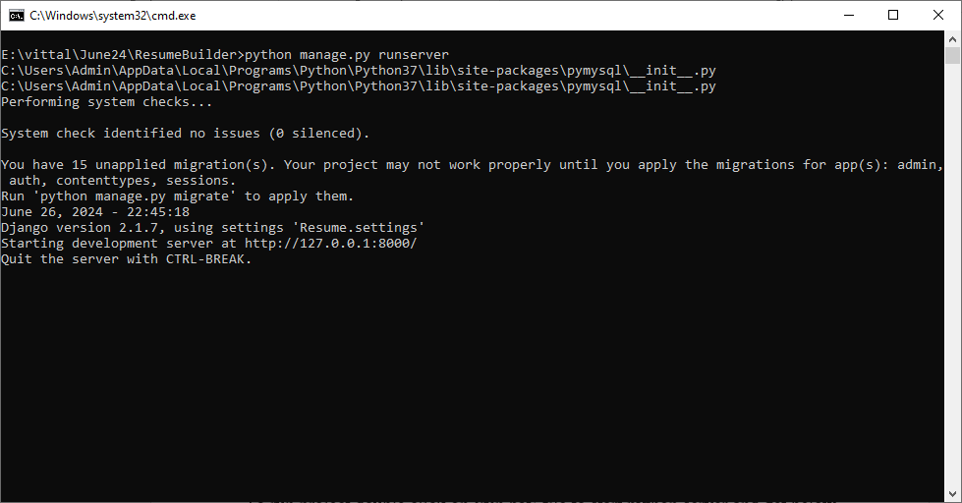

In above screen python server started and now open browser and enter URL as <http://127.0.0.1:8000/index.html> and press enter key to get below page

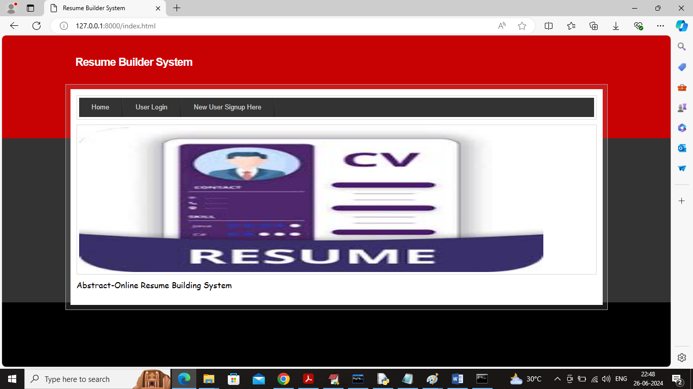

In above screen user can click on ‘New User Sign up’ link to get below page

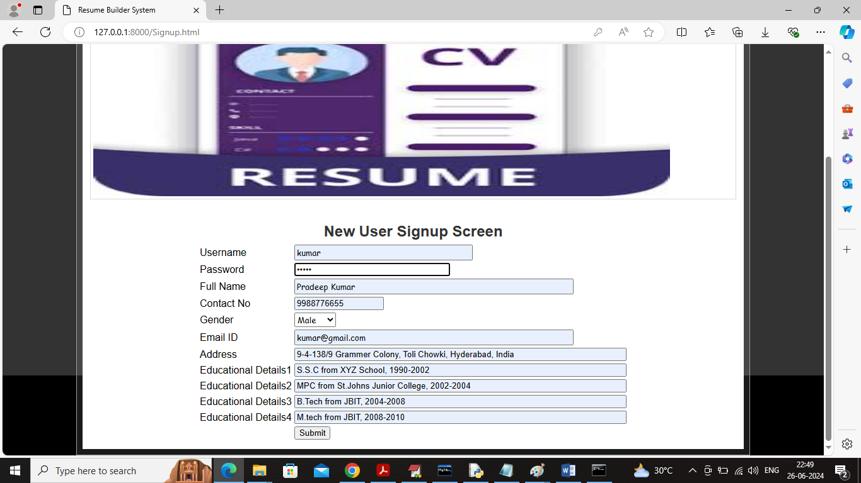

In above screen user is entering sign up profile details and then press button to save all user profile details to database and this details will be used to create user resume and user can update above details by login to system

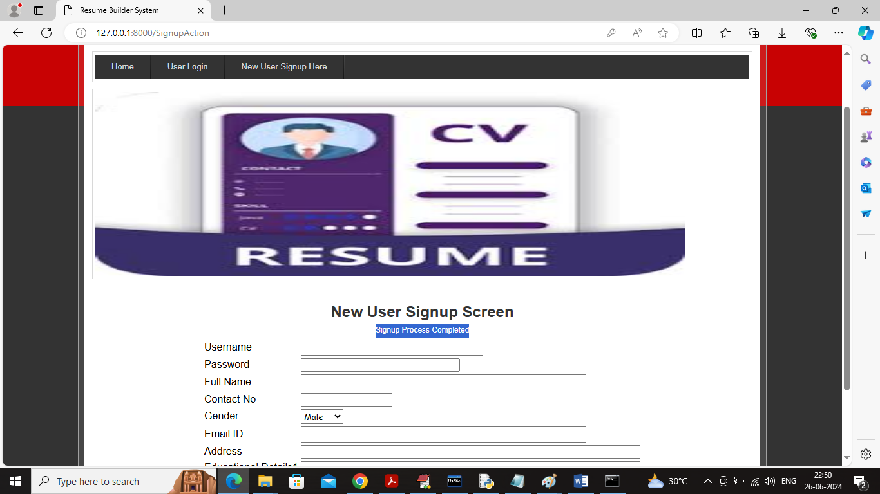

In above screen user sign up process completed and now click on ‘User Login’ link to get below login screen

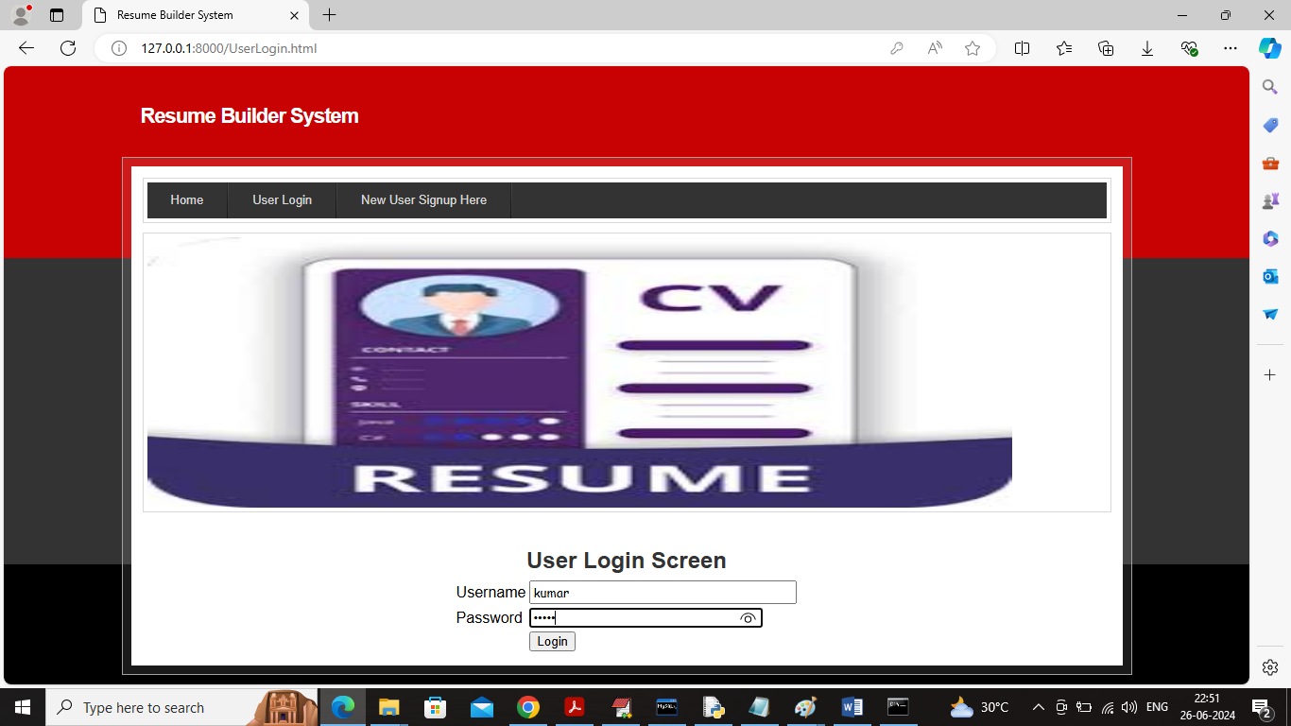

In above screen user is login and after login will get below page

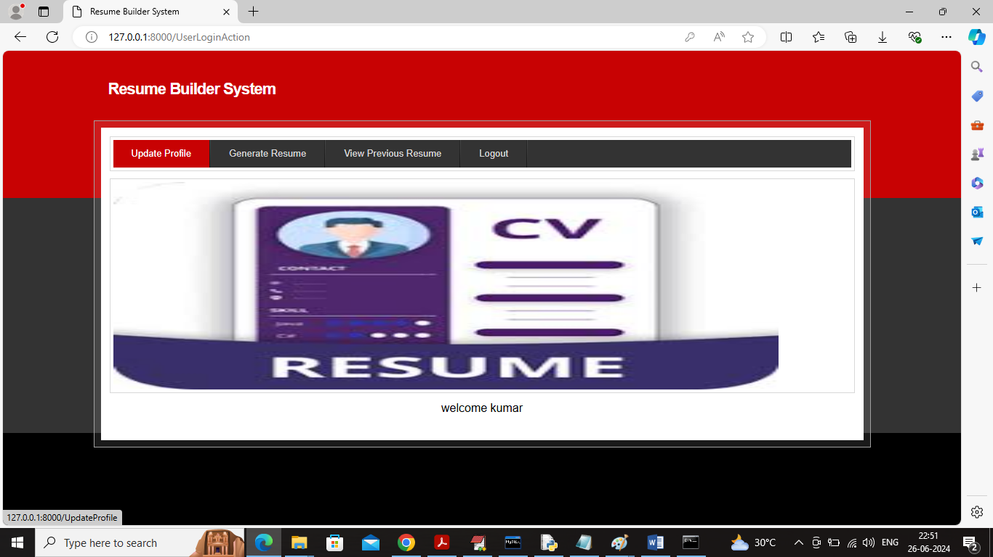

In above screen user can click on ‘Update Profile’ link to view user details and can update desired details

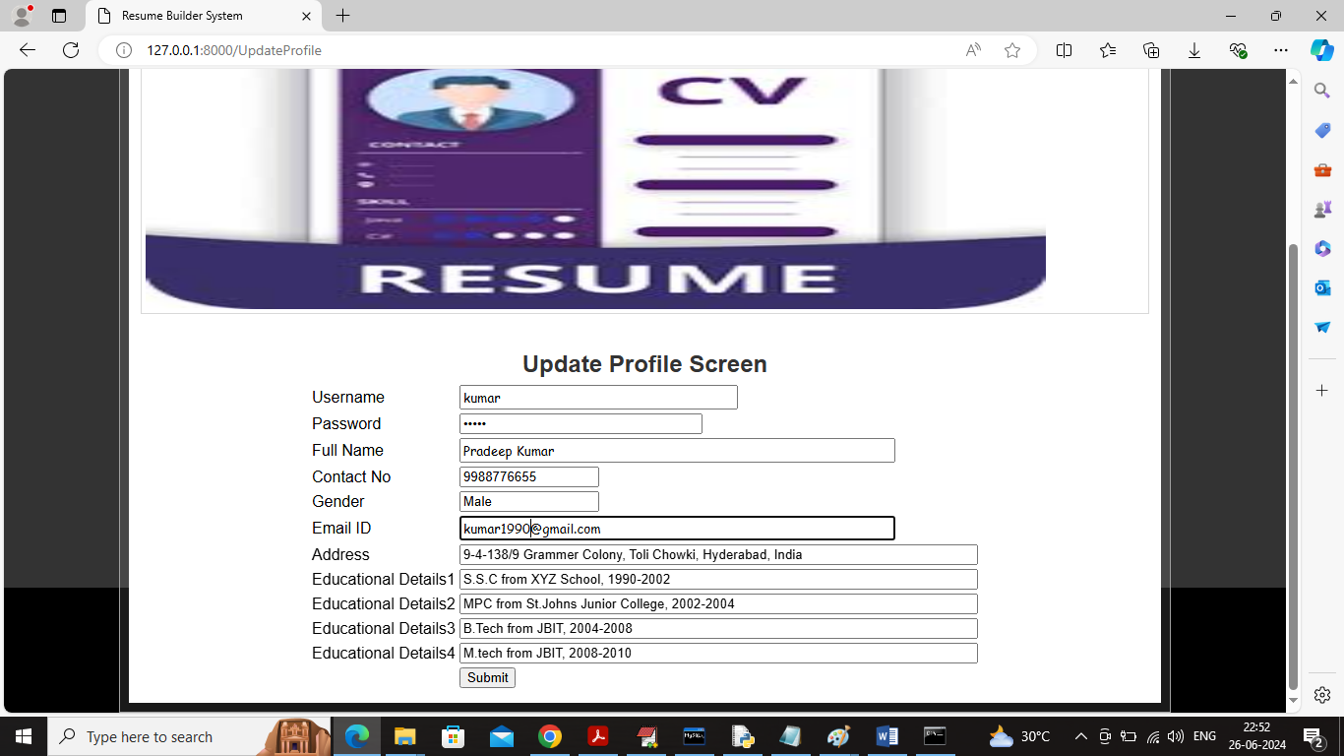

In above screen user can view existing profile details and can update desired details and then press button to get below page

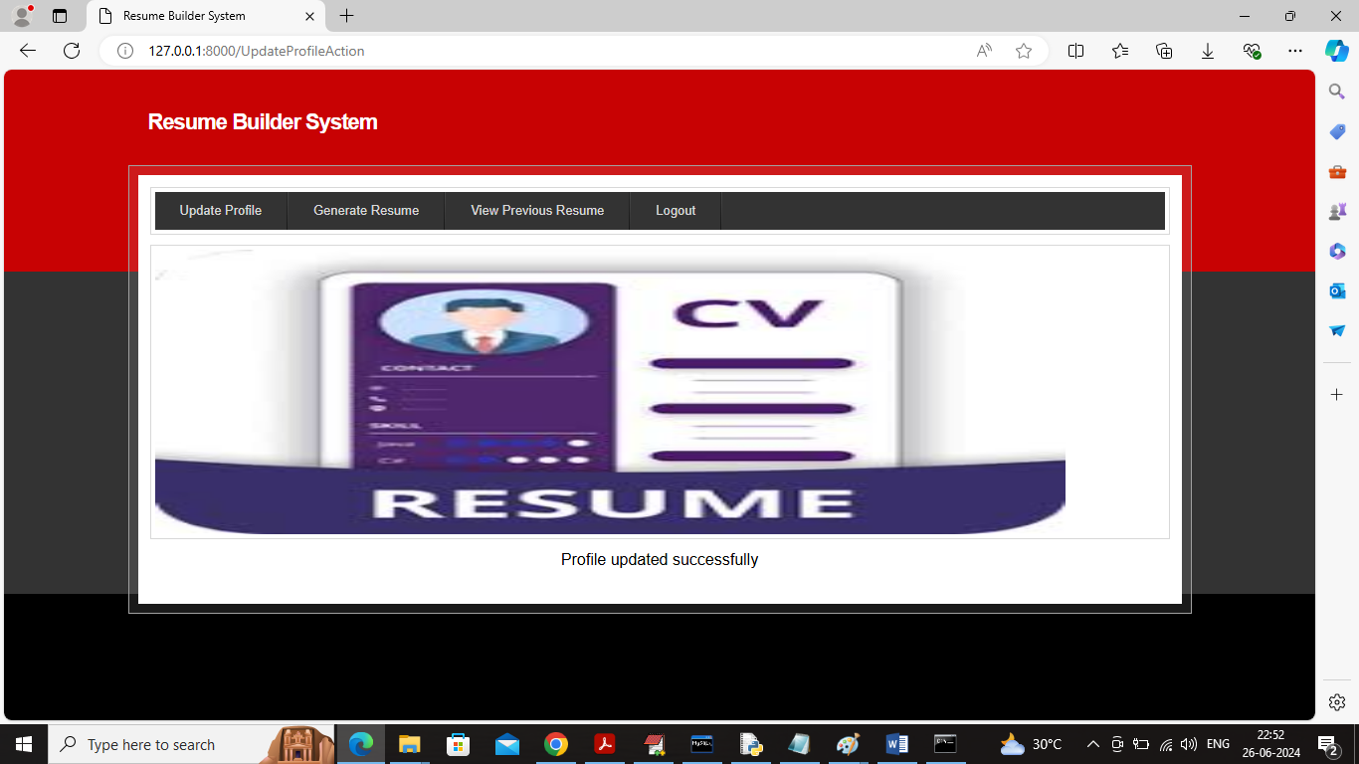

In above screen profile details updated and now click on ‘Generate Resume’ link to get below page to generate resume

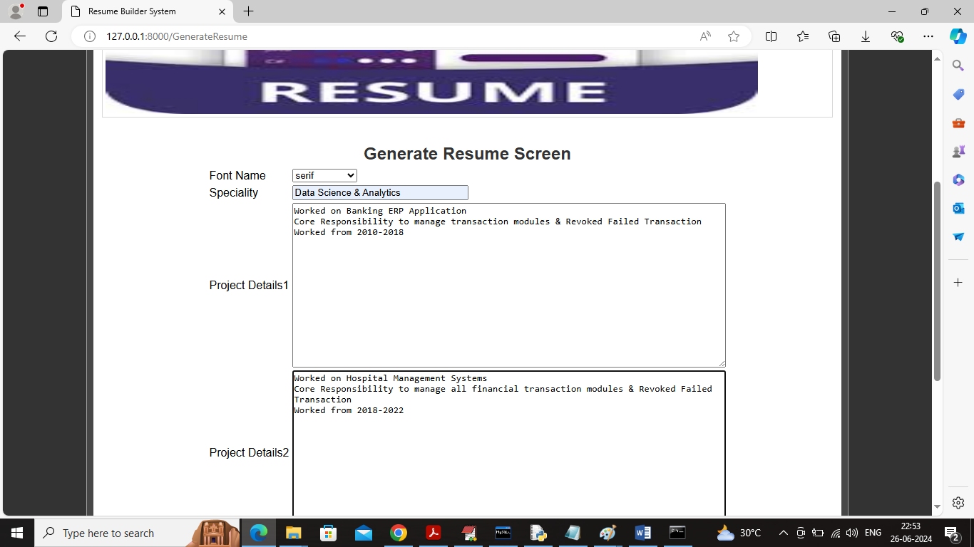

In above screen user will enter work experience details

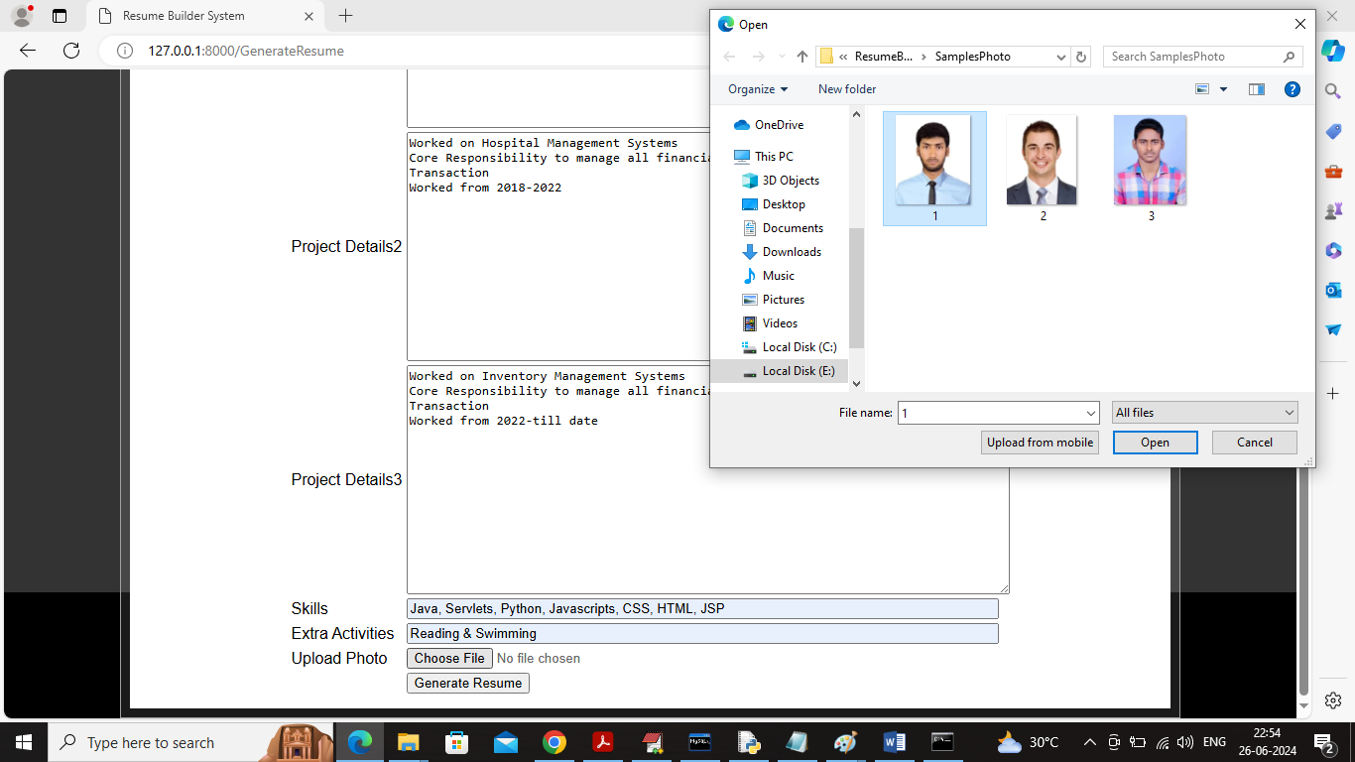

In above screen user will enter all resume details and then upload photo and then click on ‘Generate Resume’ button to generate resume and can view preview like below screen

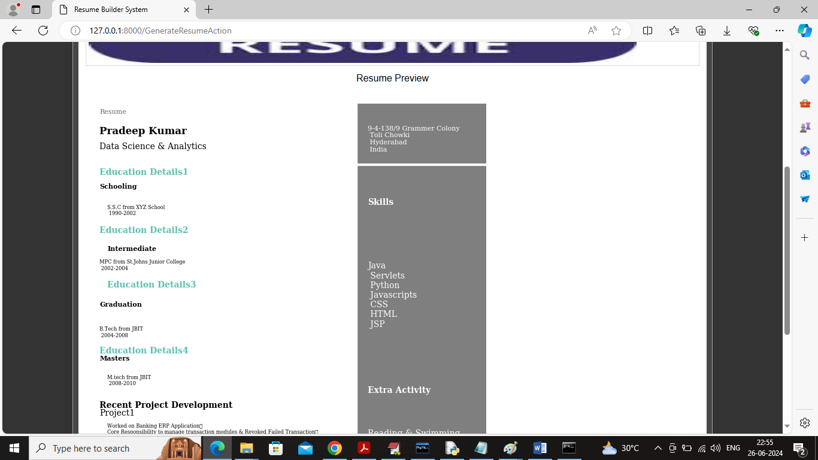

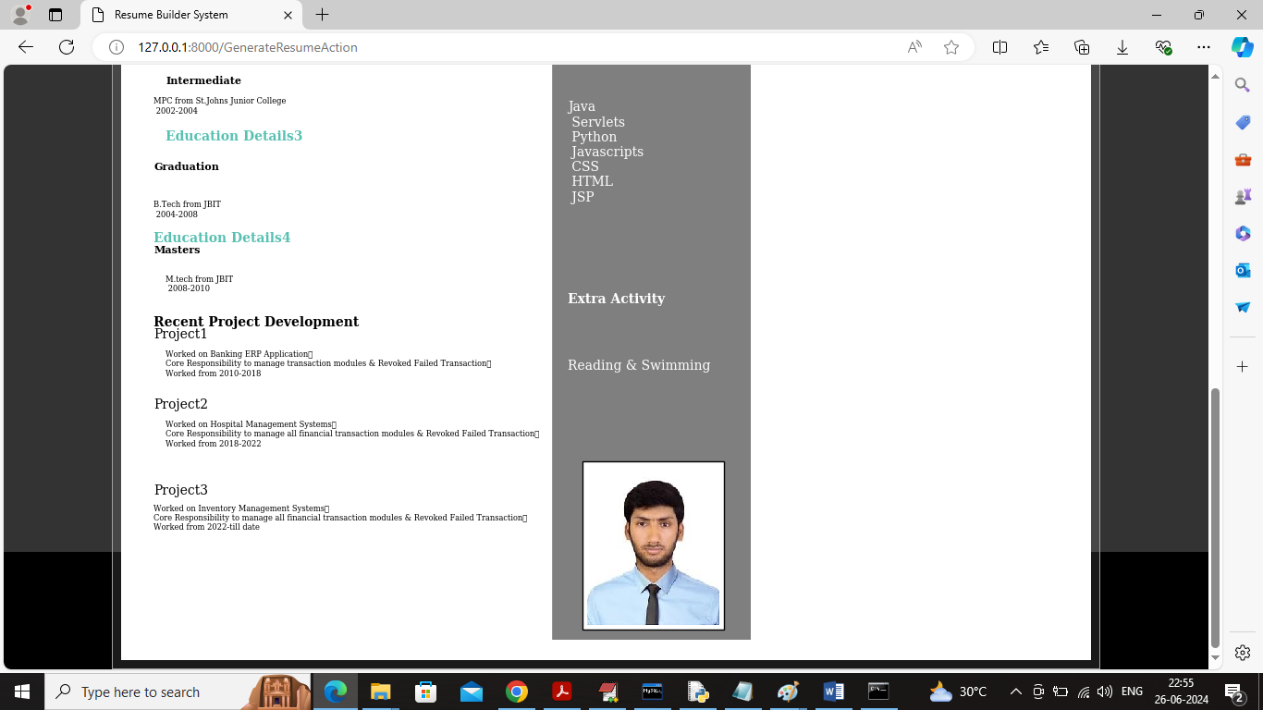

In above screen user resume created and can click on ‘View Past Resume’ link to view all generated resumes and get below page

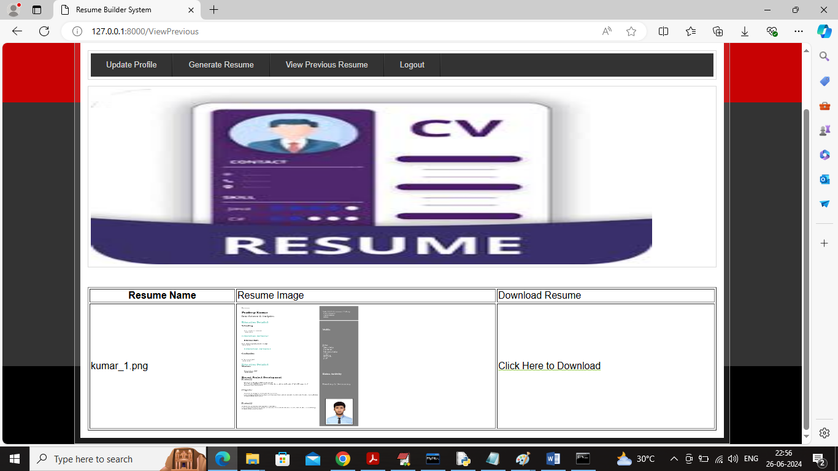

In above screen user can view all generated resume in tabular format and can click on ‘Click Here to Download’ link to download resume and get below page

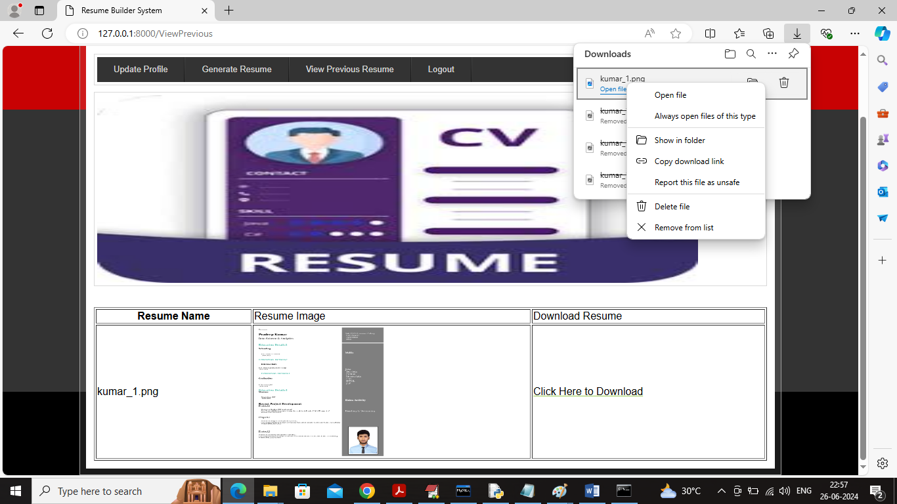

In above screen resume is downloaded and user can view in any photo viewer application like below screen

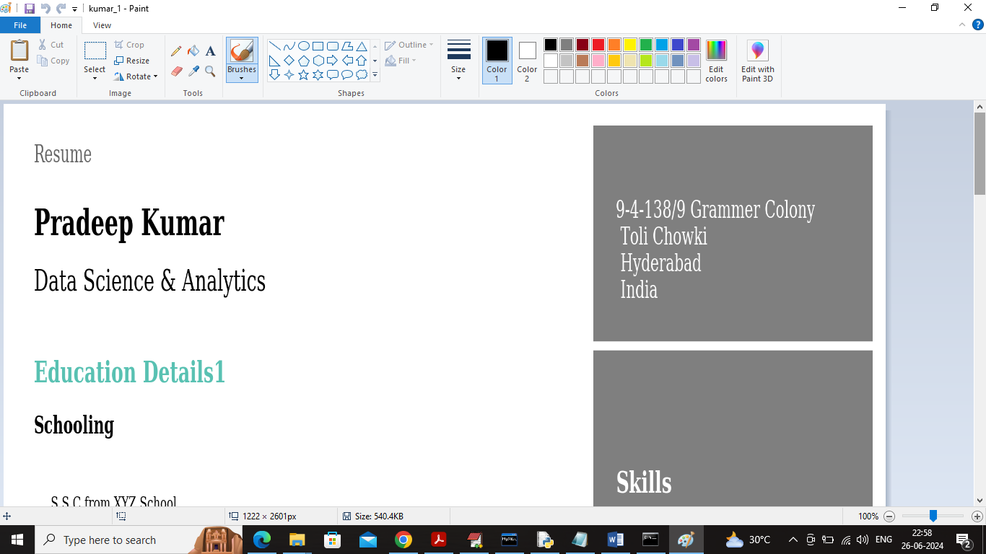

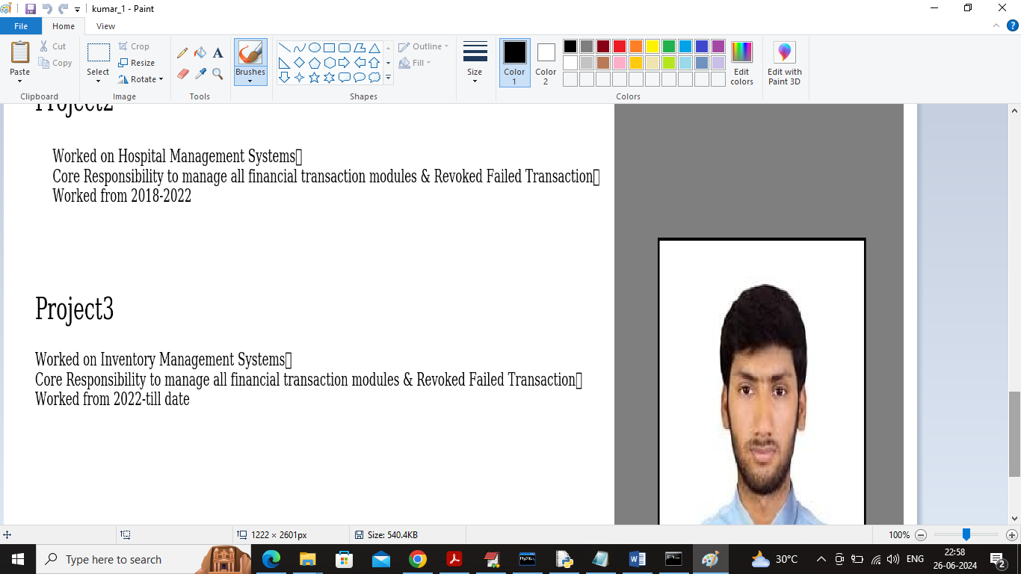

In above screen user can view resume in Paint tool and in below screen can see all resumes are saved at server in encrypted format

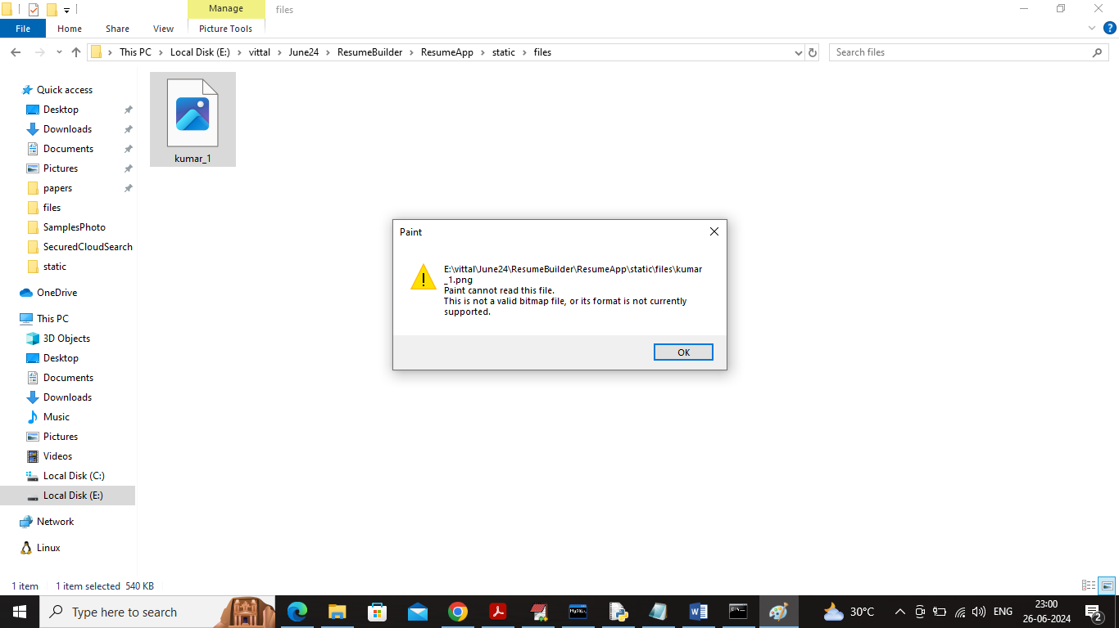

In above screen user resume is not opening as server saved in AES encrypted format.

Similarly by following above screens you can generate resumes