Detailed Project Report – AHOLD Store Order Classification

Problem Statement:
There are 996 various types of AHOLD physical stores existing in Netherlands who has got several suppliers for their regular store orders which can be processed through two main streams RDC (Reginal Distribution Centre) and Direct supply from vendors based on the items and its shelf life. The items listed in the store orders are often misplaced in the stream due to the systems misclassification of the suppliers which results a delay or failed in receiving ordered goods from the suppliers that causes a huge loss of business and customers.
Hence, the Tech-Stack team has decided to automate the store order classification through a Machine Learning techniques to achieve a maximum efficiency or potential.

Project Value:
B2B – Business to Business model.
There is a 0.5% error rate occurs among a direct supplier store orders which is significantly huge.

System Architecture:
Storage: Oracle 9i & Azure Blob (Binary Large Object) Storage
Cloud: Microsoft AZURE
API: 3rd party API
Tech Stack: ML-Classification: Naive Bayes, Random Forest, and XGBoost.
Hosting: CI / CD pipeline – Jenkins.
Dash boarding: Nil
ML Monitoring: It is a practice of tracking and analyzing production model performance to ensure acceptable quality as defined by the use case. It provides early warnings on performance issues and helps diagnose their root cause to debug and resolve. Tools are Neptune, Qualdo, Fiddler, Anodot, Evidently, Amazon SageMaker Model Monitor, Seldon Core, KFServing.
Hyper Case: Hypercare is the period of time immediately following a system Go Live where an elevated level of support is available to ensure the seamless adoption of a new system.

Q1. Tell me about your current project.
There are 996 various types of AHOLD physical stores existing in Netherlands who has got several suppliers for their regular store orders which can be processed through two main streams RDC (Reginal Distribution Centre) and Direct supply from vendors based on the items and its shelf life. The items listed in the store orders are often misplaced in the stream due to the systems misclassification of the suppliers which results a delay or failed in receiving ordered goods from the suppliers that causes a huge loss of business and customers.

Q2. What was the size of the data?
Around 3 million records been used that are retrieved from various RDC (Reginal Distribution Centre) legacy databases, Store order replenishment databases, and from DESO (Determination of Store Order) database. There are 47 related features used.

Q3. What was the data type?
The data types are both continuous and categorical that are preprocessed and performed appropriate EDA before executing feature engineering activates for ML model generation.

Q4. What was the team size and distribution?
The team consisted of:
- 1 Product Manager,
- 1 Solution Architect,
- 1 Lead,
- 1 Data Analyst,
- 2 Dev-Ops engineers,
- 2 QA engineers,
- 2 UI developers, and
- 3 Data Scientists.

Q5.What Hadoop distribution were you using?
Cloudera Hadoop distributions are used to provide scalable, distributed computing against on-premises, multi-function analytics, shared data experience with optimum security and governance, and cloud-based file store data.

Q6.What is the version of distribution?

CDH – 5.8.0

Q7.What was the size of the cluster?
The cluster (production setup) consisted of 26 servers with
- Intel i7 processors
- 56 GB of RAM
- 500 GB of Secondary storage each
- Mounted NAS locations

Q8. How many nodes were there in all the Dev, UAT, and Prod environments?
The necessary coding was done on one development server. But as a standalone machine won’t give enough speed to train the model in a short time, once we saw that the model’s loss is decreasing for a few numbers of epochs in the standalone machine, the same code was deployed to a cloud-based GPU machine for training. Once the model was trained there, we used the saved model file for prediction/classification. The same model file was deployed to the cloud UAT and Production environments.In total, we had:
- 5 nodes in the dev environment,
- 5 nodes in UAT, and
- 15 nodes in production.
Q9. How do you creating and maintaining the logs?
The log messages are maintained in MongoDB. The logs are started registering the messages of all activities (control flow) in the applications, starting from start of application, entering into the function, exiting from the function, capturing exceptions from the exception block.
The below picture depicts the flow of control and its message logging.

Q10.What techniques were you using for data pre-processing for various data science use cases and visualization?
Data pre-processing (Cleaning, Formatting, Scaling, and Normalization) and data visualization through different plots are two very important steps that help in building machine learning models more accurately.
Missing Values: In order to deal with missing data, multiple approaches can be used. Let’s look at each of them.
- Removing the training example: You can ignore the training example if the output label is missing (if it is a classification problem). This is usually discouraged as it leads to loss of data, as you are removing the attribute values that can add value to data set as well.
- Filling in missing value manually: This approach is time consuming, and not recommended for huge data sets.
- Using a standard value to replace the missing value: The missing value can be replaced by a global constant such as ‘N/A’ or ‘Unknown’. This is a simple approach, but not foolproof.
- Using central tendency (mean, median, mode) for attribute to replace the missing value: Based on data distribution, mean (in case of normal distribution) or median (for non-normal distribution) can be used to fill in for the missing value.
- Using central tendency (mean, median, mode) for attribute belonging to same class to replace the missing value: This is the same as method 4, except that the measures of central tendency are specific to each class.
- Using the most probable value to fill in the missing value: Using algorithms like regression and decision tree, the missing values can be predicted and replaced.
Eg., df.isnull().sum() , df.fillna(), using sklearn Imputer()
Handling Outliers: Outliers are extreme values that deviate from other observations on data, they may indicate a variability in a measurement, experimental errors or a novelty. In other words, an outlier is an observation that diverges from an overall pattern on a sample.
- Z-SCORE
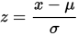
Z-score is a simple, yet powerful method to get rid of outliers in data if you are dealing with parametric distributions in a low dimensional feature space. For nonparametric problems Dbscan and Isolation Forests can be good solutions.
- IQR (Inter Quartile Range)
IQR method of identifying outliers to set up a “fence” outside of Q1 and Q3. Any values that fall outside of this fence are considered outliers. To build this fence we take 1.5 times the IQR and then subtract this value from Q1 and add this value to Q3. This gives us the minimum and maximum fence posts that we compare each observation to. Any observations that are more than 1.5 IQR below Q1 or more than 1.5 IQR above Q3 are considered outliers.
Equations:
IQR = Q3- Q1
Lower_limit_range = Q1 – (1.5 * IQR)
Upper_limit_range = Q3 + (1.5 * IQR)

- MEAN & STANDARD DEVIATION:
The mean and standard deviation of the residuals are calculated and compared. If a value is a certain number of standard deviations away from the mean, that data point is identified as an outlier. The specified number of standard deviations is called the threshold. The default value is 3.
- 1 Standard Deviation from the Mean: 68%
- 2 Standard Deviations from the Mean: 95%
- 3 Standard Deviations from the Mean: 99.7%
Formula | Explanation
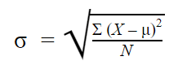 | - σ = population standard deviation  - ∑ = sum of…  - X = each value  - μ = population mean  - N = number of values in the population
The above three methods of handling outliers are called statistical methods.

Boxplot and Scatter plot methods are called Visualization methods.

Data Scaling: It’s a step of data preprocessing can be applied to independent features which helps to normalize the data within a particular range. Standardization is one of the method used to perform the feature scaling to manage the magnitude of the data points.
from sklearn.preprocessing import StandardScaler
sc = StandardScaler()
X_train = sc.fit_transform(X_train)

Feature Transformation: It’s a step of transforming the categorical feature into continuous feature which helps to increase the statistical value of the feature and for a better model training.
For example, gender data (Male or Female) is a categorical one. It can be converted to numeric values, as shown below:
df['Gender']=df['Gender'].map({'F':0, 'M':1})
Replacing or combining two or more attributes to generate a new attribute which serves the same purpose.
For example, if we use one-hot encoding in the example above, it will generate two separate columns for males and females. But if we observe, a person who is not a male is automatically a female(if we consider only two genders). So, the two columns essentially convey the same information in that case. This is called the dummy variable trap. So, one column can be conveniently dropped.

Dimensionality Reduction: It is a process of reducing number of random features under consideration by opting a set of principal components. It can be divided into feature selection and feature extraction. Feature extraction is also called as feature projection.
PCA(Principal Component Analysis) is one of the method, which tries to represent the same information but in a space with reduced dimensions.

Q11. How were you maintaining the failure cases?
Once you observe degraded model performance, you will need to redesign your model (pipeline).
One solution is referred to as manual learning. Here, we provide the newly gathered data to our model and re-train and re-deploy it just like the first time we build the model. If you think this sounds time-consuming, you are right. Moreover, the tricky part is not refreshing and retraining a model, but rather thinking of new features that might deal with the concept drift.
A second solution could be to weight your data. Some algorithms allow for this very easily. For others you will need to custom build it in yourself. One recommended weighting schema is to use the inversely proportional age of the data. This way, more attention will be paid to the most recent data (higher weight) and less attention to the oldest of data (smaller weight) in your training set. In this sense, if there is drift, your model will pick it up and correct accordingly.
The third and best solution is to build your productionized system in such a way that you continuously evaluate and retrain your models. The benefit of such a continuous learning system is that it can be automated to a large extent, thus reducing (the human labor) maintenance costs.
Eg,..
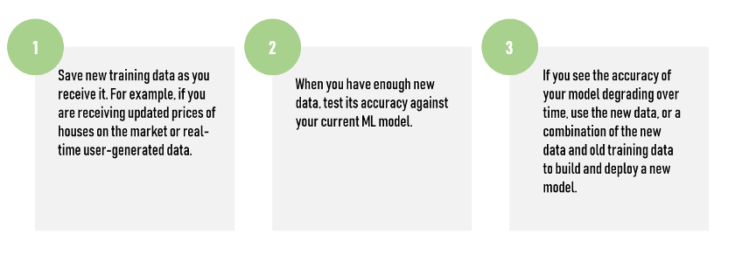

Q12.What kind of automation have you done for data processing?

We had a full-fledged ETL pipeline in place for data extraction.
There are three common elements to data automation: Extract, Transform, and Load, or ETL.

- Extract: the process of extracting your data from one or many sources systems

- Transform: the process of transforming your data into the necessary structure, such as a flat file format like a CSV. This could also include things like changing all state abbreviations to the full state name.

- Load: the process of loading the data into the final system, in this case the open data portal.

Q13.Have you used any scheduler?

Yes, a scheduler was used for retraining the model after a fixed time(20 days).

Q14.How are you monitoring your job?

There are logging set-ups done. We regularly monitor the logs to see for any error scenarios. For fatal errors, we had email notifications in place. Whenever a specific error code, which has been classified as a fatal error occurs, email gets triggered to the concerned parties.

Q15. What were your roles and responsibilities in the project?

My responsibilities consisted of gathering the dataset, perform data preprocessing, and feature engineering for the model training, training the model on the prepared dataset, deploying the trained model to the cloud, monitoring the deployed model for any issues, providing QA support before deployment and then providing the warranty support post-deployment.

Q16.What was your day to day task?

My day to day tasks involved completing the JIRA tasks assigned to me, attending the scrum meetings, participating in design discussions and requirement gathering, doing the requirement analysis, data validation, data preprocessing, feature engineering, Unit test for the models, providing UAT support, etc.

Q17.In which area you have contributed the most?

I contributed the most to image labeling and model training areas. Also, we did a lot of brainstorming for finding and selecting the best algorithms for our use cases. After that, we identified and finalized the best practices for implementation, scalable deployment of the model, and best practices for seamless deployments as well.

Q18.In which technology you are most comfortable?

I have worked in Machine Learning, Deep Learning, and proficiency with Natural Language Processing, and I have nearly equivalent knowledge in these fields. But if you talk about personal preference, I loved working in Machine Learning and Deep Learning the most.

Q19.How you rate yourself in big data technology?

I have no significant contribution towards big data as I do with data scientist.

Q20. In how many projects you have already worked?

I have worked in small and large scale projects in machine learning regression, and classification problems, and Deep Learning machine learning regression, and classification problems as well.

Q21. How were you doing deployment?

The mechanism of deployment depends on the client's requirement. For example, some clients want their models to be deployed in the cloud, and the real-time calls they take place from one cloud application to another. On the other hand, some clients want an on-premise deployment, and then they do API calls to the model. Generally, we prepare a model file first and then try to expose it through an API for predictions/classifications. The mechanism in which he API gets called depends on the client requirement.

The below pictures depicts the SDLC of Machine Learning.

The Training pipeline includes data pre-processing, selecting the algorithm for creating the machine learning model, checking the accuracy of the created model and then saving the model file.

The Testing Pipeline:
Once the training is completed, make the trained model as an API for the user to consume it. For prediction, the saved model is loaded first and then the predictions are made using it. When the web app works as expected, the same app would be deployed to the cloud platform.

How to choose target: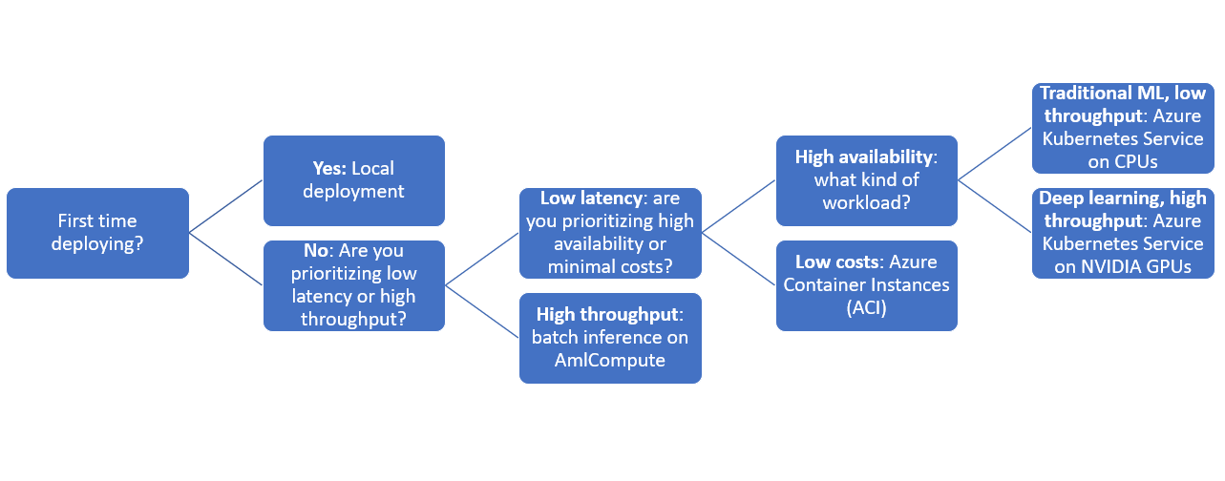
Deployment to Azure:
- Create a web app in Azure

- Provide the app name, resource group(create new if necessary), runtime stack(Python 3.7), region, select the 1 GB size, which is free to use. Click Review+create to create the web app.

- Open the app and go to the ‘Deployment Center’ option. Select ‘local git’ for source control and click continue.

- Select the kudo ‘App service build provider’ as the build provider and click continue.

- Click ‘Finish’ to complete the setup.
- Go to the overview section of the app, and the Git link now will be visible

- Go to ‘Deployment Credentials’ and copy the username and password. These will be required when doing the final push to the remote git repository.

- Open a command prompt and navigate to your project folder.
- Run git init to initialize an empty git repository
- Create a new remote git alias using the command: git remote add <alias> <git clone url>
- Use git add. to add all the files to the local git repository .
- Use commit –git m “First Commit” to commit the code to the git repo.
- Push the code to the remote repo using git push <alias> master –f
- This prompts for a username and password. Provide the same credentials as copied in the step above.
- After deployment, from the ‘overview’ section, copy the URL and paste into the browser to see the application running.

Q22.What kind of challenges have you faced during the project?

- Not Enough data: The biggest challenge that the team faced was gathering a relevant dataset from the huge legacy storage as it was the first automation project for the client.
- Poor Quality of data: Required an enormous time period for cleaning the data as it has lots of errors, outliers, and noises. The more you do EDA, the more you get model performance.
- Irrelevant Features: There were considerable amount of time spent against a Feature Engineering in order to select most statistically significant valued features which helped us to generate a consistent and well performed robust model.
- Overfitting: Few models were performed overfitting over the dataset during the validation due to the high variance. Ensemble algorithms been used to reduce the high variance by optimizing the hyper parameters.

Q23.What will be your expectations?

It’s said that the best learning is what we learn on the job with experience. I expect to work on new projects which require a broad set of skills so that I can hone my existing skills and learn new things simultaneously.

Q24. What is your future objective?

The field of data science is continuously changing. Almost daily, there is a research paper that changes the way we approach an AI problem. So, it really makes it exciting to work on things that are new to the entire world. My objective is to learn new things as fast as possible and try and implement that knowledge to the work that we do for better code, robust application and in turn, a better user/customer experience.

Q25. Why are you leaving your current organization?

I have 2 years of career gap, need your (Sudhanshu Sir) assistance to fill the gap.

Q27. How did you do Data enrichment?

Merging third-party data from an external authoritative source with an existing database of first-party customer data, but we didn’t require any third party datasets for the model training as we have a huge relevant records and that too it’s a client centric or specific data that are available only in premises dbs.

Q28. How would you rate yourself in machine learning?

Well, honestly, my 10 and your 10 will be a lot different as we have different kinds of experiences. On my scale of 1 to 10, I’ll rate myself as an 8

Q29. How would you rate yourself in distributed computation?

I’d rate myself a 7 out of 10.

Q30. What are the areas of machine learning algorithms that you already have explored?

I have explored various machine learning algorithms like Linear Regression, Logistic Regression, L1 and L2 Regression, Multi Linear Regression, Decision Trees, Random Forests, Extra Trees Classifier, PCA, XG Boost, ADA Boost, Gradient Boosting, K-Means, KNN, SVM, SVR, Naïve Bayes, DBScan, TFIDF, Word to Vec, Bag of words, Doc to Vec, and ANN are some of them.

Q31. In which part of machine learning have you already worked on?

I have worked on supervised and proficiency in unsupervised machine learning approaches and building different models as per the user requirement.

Q32.How did you optimize your solution?

Well, model optimization depends on a lot of factors.

- Train with better data (increase the quality), or do data pre-processing steps more efficiently.
- Increase the quantity of data used for training.
- Perform a feature engineering with high statistical value.
- Feature selection and scaling (likely to have a mean of zero and standard deviation of one) needs to be performed according to most significant values statistically.
- Various supervised algorithms to be used and pick an algorithm which has accurate classification and consistent performance.
- Hyper parameter to be used to find the optimal parameters leading to a lowest error on the validation set.

Q33.How much time did your model take to get trained?

It took around 5 hours to train the model using Nvidia Pascal Titan GPU.

Q34. At what frequency are you retraining and updating your model?

The model gets retrained every 20 days.

Q35. In which mode have you deployed your model?

I have deployed the model both in cloud environments as well in the on-premise ones based on the client and project requirements.

Q36. What is your area of specialization in machine learning?

I have worked on various algorithms. So, It’s difficult to point out one strong area. Let’s have a discussion on any specific requirement that you have, and then we can take it further from there.

