**FITFLEX**

**YOUR PERSONAL FITNESS**

**COMPANION(REACT APPLICATION)**

* **Team Details:**

|  |  |
| --- | --- |
| **Team Leader** | **EMAIL ID** |
| SIVA KUMAR M | sivakumaraju001@gmail.com |

|  |  |
| --- | --- |
| **Team Members** | **EMAIL ID** |
| LOKESH J | lokeshlokesh8546@gmail.com |
| MUKESH N | www.sandymukesh@gmail.com |
| GOKUL T | tangaraj2006@gmail.com |
| PRAVEEN RAJ S | Saravanansaravanan65850@gmail.com |

**Introduction**

FITFLEX is a dynamic, user-friendly React application designed to serve as a comprehensive fitness companion. It empowers users to track their fitness journey, set personal health goals, and provide guidance on exercise routines, diet plans, and progress monitoring.

This app aims to enhance users' overall well-being by offering tailored fitness plans, tracking tools, and motivational features to help them achieve their fitness goals, whether they are aiming for weight loss, strength training, or overall health improvement.

Core Features of FITFLEX:

1. User Profiles:
   * Users can create personalized accounts to store their fitness information, including weight, height, fitness goals, and progress.
2. Exercise Library:
   * A comprehensive library of exercises, categorized by type (strength, cardio, flexibility, etc.), skill level, and muscle group targeted.
3. Workout Routines:
   * Customizable workout plans based on users' fitness goals, such as weight loss, muscle gain, or improved endurance. Users can modify routines and track progress.
4. Diet and Nutrition:
   * A section for users to log their meals, calculate calorie intake, and provide nutrition recommendations based on their fitness goals.
5. Progress Tracking:
   * Tools to log weight, workout completion, calorie intake, and other fitness milestones. Visual progress charts are provided to show improvements over time.
6. Motivation and Reminders:
   * Push notifications to keep users on track with their workouts, diet, and other goals. Motivational quotes and tips to keep users engaged.
7. Social Features:
   * Option for users to connect with friends, share their achievements, and provide support within the app. Leaderboards and challenges can also keep the fitness community engaged.

Technologies Used:

* Frontend:
  + React.js for building dynamic and responsive UI.
  + React Router for navigation between different views.
  + Redux for state management to handle user data and workout progress.
  + Styled-components or Material-UI for consistent and attractive styling.
* Backend (Optional, if applicable):
  + Node.js and Express.js for the backend server (if needed for authentication or storing data).
  + MongoDB or Firebase for database management.
* APIs:
  + Integration with third-party APIs for exercise databases, nutrition tracking, and fitness-related metrics.

Purpose:

The purpose of FITFLEX is to create an all-in-one fitness solution that helps users stay committed to their fitness journey, providing them with the necessary tools and motivation to achieve a healthier lifestyle. Whether you're a beginner or a seasoned athlete, FITFLEX is designed to meet the needs of anyone looking to improve their physical fitness and overall health.

Would you like to dive deeper into any specific features or need help with development strategies for this React application?

**Description:**

FITFLEX is an innovative and interactive React application designed to be your personal fitness companion. With a focus on helping users achieve their health and fitness goals, FITFLEX offers a comprehensive range of features, including workout tracking, personalized fitness plans, diet recommendations, and progress monitoring. Whether you're just starting your fitness journey or you're a seasoned athlete, FITFLEX is tailored to provide the tools and motivation you need to stay on track and reach your fitness goals.

**Main Features of FITFLEX:**

1. Personalized User Profiles:
   * When users sign up or log in, they create a personal profile where they can input their fitness data, such as age, weight, height, fitness goals, and preferred workout types. This data helps to tailor the app's recommendations, workout plans, and nutrition tips.
2. Customizable Workout Plans:
   * FITFLEX provides a variety of workout routines, ranging from beginner to advanced levels. Users can select a workout plan based on their goals—such as fat loss, muscle gain, or improving endurance—and receive a structured schedule of exercises. These routines are customizable, allowing users to modify exercises or adjust intensity.
3. Exercise Database:
   * The app includes a comprehensive library of exercises, complete with detailed instructions and demonstration videos. Exercises are categorized by type (e.g., strength, cardio, flexibility), muscle group (e.g., chest, legs, arms), and difficulty level (beginner, intermediate, advanced).
4. Nutrition and Meal Tracking:
   * Users can log their meals, track calorie intake, and access personalized diet plans based on their fitness goals. The app can offer suggestions for meal prepping, recommend balanced meals, and calculate macronutrient distribution to help users stay on target with their dietary goals.
5. Progress Monitoring:
   * FITFLEX allows users to track their fitness progress over time. Users can log their weight, measurements, body fat percentage, and exercise performance (e.g., number of reps, time, or distance). The app provides visual progress charts to help users see how far they've come and identify areas for improvement.
6. Motivational Features:
   * Staying motivated is key to success in fitness, and FITFLEX offers built-in motivational features. These include personalized workout reminders, daily fitness tips, goal-based achievements, and inspiring quotes. Additionally, users can set reminders for workouts, meal prep, and hydration.
7. Social Community and Challenges:
   * Users can interact with other fitness enthusiasts within the app, join challenges, and share their progress. They can create or join fitness challenges (e.g., a 30-day push-up challenge) to stay engaged with their goals and feel a sense of community. Social features include progress sharing, leaderboards, and group activities.
8. Integration with Fitness Devices (Optional):
   * FITFLEX can be integrated with popular fitness tracking devices (such as Fitbit, Apple Watch, or Google Fit) to sync real-time data. This allows users to track their steps, calories burned, heart rate, and sleep patterns directly within the app.

User Interface:

* Sleek and Intuitive Design: FITFLEX is designed with a modern, clean, and intuitive interface. It features easy-to-navigate screens for logging workouts, tracking progress, viewing nutrition data, and more. The design is mobile-friendly, ensuring a seamless experience across all devices.
* Responsive Dashboard: The app's dashboard presents a snapshot of the user's progress, upcoming workouts, and fitness goals. It's designed to give users all the essential information at a glance, with quick links to detailed stats, settings, and preferences.

Technologies Used:

1. Frontend Development:
   * React.js: The core library for building dynamic, user-centric components.
   * React Router: For navigation across the app's pages.
   * Redux: To manage state across the application, particularly for user authentication, workout data, and progress tracking.
   * Material-UI: To speed up the design process with reusable components and styling.
2. Backend (Optional):
   * Node.js + Express: To handle user authentication, data storage, and app logic (e.g., user accounts, workout history).
   * MongoDB or Firebase: For database management to store user profiles, exercise data, and progress logs.
3. APIs:
   * Integration with fitness APIs for exercise libraries, nutrition tracking, and workout analytics.
   * Integration with third-party apps or devices (like Google Fit or Apple HealthKit) to sync activity and health data.
4. Data Visualization:
   * Chart.js or D3.js: To provide users with clear, interactive charts and graphs showcasing their progress, such as workout completion, weight loss, or muscle gain.

**Scenario-Based Introduction**

Imagine this:

**Meet Sarah, a busy professional who’s trying to balance her demanding career with her desire to stay fit and healthy.**

Sarah has always struggled to find the right routine that fits her busy lifestyle. She’s tried various apps in the past, but none of them provided the personalized support and flexibility she needed. After reading about FITFLEX, she decides to give it a try, hoping this will be the solution to her fitness challenges.

**Step 1: Creating a Personalized Profile**

When Sarah first opens FITFLEX, she’s greeted by an easy-to-navigate onboarding process. She quickly creates her account, filling in basic details about herself—her age, height, weight, fitness goals, and any specific preferences (e.g., strength training vs. cardio, or a focus on weight loss). FITFLEX asks her about her current fitness level (beginner, intermediate, or advanced), which helps tailor workout plans that are just right for her.

Now Sarah’s ready for her journey, and the app has already started learning what her fitness goals are: to lose weight, improve strength, and feel more energized throughout the day.

**Step 2: Discovering Custom Workouts**

After her profile is set up, Sarah is presented with a personalized fitness plan. Since she’s a beginner, FITFLEX suggests a balanced routine that includes both cardio and strength exercises, with easy-to-follow instructions and video demonstrations.

Sarah loves that she doesn’t have to worry about figuring out what to do every day—FITFLEX lays out her schedule for her. She can choose whether to work out in the morning or evening based on her availability, and the app adjusts the intensity accordingly.

She starts her first workout, following the step-by-step instructions. The app tracks her reps, time, and form, and even provides feedback on areas she can improve.

**Step 3: Tracking Progress and Staying Motivated**

After a few days, Sarah begins to see results, and she’s feeling more motivated than ever. The FITFLEX dashboard shows her daily progress: she’s lost a couple of pounds, increased her strength, and even managed to reduce her time on the treadmill by a few minutes.

Every time she reaches a milestone, such as completing her first 30-minute workout or hitting a weight target, FITFLEX congratulates her with a motivational message. The app also sends her daily reminders to stay on track and offers tips on staying consistent with her goals.

**Step 4: Adjusting the Plan Based on Feedback**

As Sarah continues using FITFLEX, she realizes she wants to focus more on strength training. The app lets her adjust her goals easily. She updates her preferences, and FITFLEX automatically adjusts her workout routine to include more weightlifting exercises, along with tracking her progress in terms of weights lifted and reps completed.

She also logs her meals within the app, which calculates her daily calorie intake and provides recommendations on how to balance her macronutrients based on her new goals.

**Step 5: Connecting with the Fitness Community**

Sarah starts feeling a sense of accountability, but she also wants to share her journey with others. She joins a fitness challenge within FITFLEX—a 30-day strength-building challenge. She connects with fellow participants, shares her progress, and even gets motivation from others when she’s feeling a bit tired.

The social aspect of FITFLEX makes Sarah feel like she’s part of a community. She can share her progress on the leaderboard, cheer on friends, and celebrate their achievements, too.

**Step 6: Integrating with Fitness Devices**

One day, Sarah buys a fitness tracker to monitor her steps and sleep patterns more closely. FITFLEX easily syncs with her device, allowing her to integrate data such as her daily steps, calories burned, and heart rate into the app. This integration provides her with a complete overview of her health, helping her track not only her workouts but also her overall activity levels throughout the day.

**Project Goals and Objectives:**

The overarching aim of FitFlex is to offer an accessible platform tailored for individuals passionate about fitness, exercise, and holistic well-being.

Our key objectives are as follows:

* **User-Friendly Experience:** Develop an intuitive interface that facilitates easy navigation, enabling users to effortlessly discover, save, and share their preferred workout routines.
* **Comprehensive Exercise Management:** Provide robust features for organizing and managing exercise routines, incorporating advanced search options for a personalized fitness experience.
* **Technology Stack:** Harness contemporary web development technologies, with a focus on React.js, to ensure an efficient and enjoyable user experience.

**Features of FitFlex:**

* **Exercises from Fitness API:** Access a diverse array of exercises from reputable fitness APIs, covering a broad spectrum of workout categories and catering to various fitness goals.
* **Visual Exercise Exploration:** Engage with workout routines through curated image galleries, allowing users to explore different exercise categories and discover new fitness challenges visually.
* **Intuitive and User-Friendly Design:** Navigate the app seamlessly with a clean, modern interface designed for optimal user experience and clear exercise selection.
* **Advanced Search Feature:** Easily find specific exercises or workout plans through a powerful search feature, enhancing the app's usability for users with varied fitness preferences.

**Technical Architecture:**

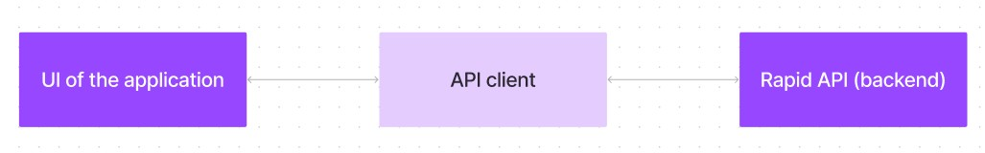

FitFlex prioritizes a user-centric approach from the ground up. The engaging user interface (UI), likely built with a framework like React Native, keeps interaction smooth and intuitive.

An API client specifically designed for FitFlex communicates with the backend, but with a twist: it leverages Rapid API. This platform grants access to various external APIs, allowing FitFlex to potentially integrate features like fitness trackers, nutrition data, or workout tracking functionalities without building everything from scratch. This approach ensures a feature-rich experience while focusing development efforts on the core FitFlex functionalities.

**PRE-REQUISITES**:

Here are the key prerequisites for developing a frontend application using React.js:

* **Node.js and npm**:

Node.js is a powerful JavaScript runtime environment that allows you to run JavaScript code on the local environment. It provides a scalable and efficient platform for building network applications.

Install Node.js and npm on your development machine, as they are required to run JavaScript on the server-side.

* + Download: <https://nodejs.org/en/download/>
  + Installation instructions: <https://nodejs.org/en/download/package-manager/>

* **React.js**:

React.js is a popular JavaScript library for building user interfaces. It enables developers to create interactive and reusable UI components, making it easier to build dynamic and responsive web applications.

Install React.js, a JavaScript library for building user interfaces.

* + Create a new React app:

npx create-react-app my-react-app

Replace my-react-app with your preferred project name.

* + Navigate to the project directory:

cd my-react-app

* + Running the React App:

With the React app created, you can now start the development server and see your React application in action.

* + Start the development server:

npm start

This command launches the development server, and you can access your React app at http://localhost:3000 in your web browser.

* **HTML, CSS, and JavaScript**: Basic knowledge of HTML for creating the structure of your app, CSS for styling, and JavaScript for client-side interactivity is essential.

* **Version Control**: Use Git for version control, enabling collaboration and tracking changes throughout the development process. Platforms like GitHub or Bitbucket can host your repository.

• Git: Download and installation instructions can be found at:

<https://git-scm.com/downloads>

* **Development Environment**: Choose a code editor or Integrated Development Environment (IDE) that suits your preferences, such as Visual Studio Code, Sublime Text, or WebStorm.

* + - Visual Studio Code: Download from <https://code.visualstudio.com/download>
    - Sublime Text: Download from <https://www.sublimetext.com/download>
    - WebStorm: Download from [https://www.jetbrains.com/webstorm/download](https://www.jetbrains.com/webstorm/download%20)

To get the Application project from drive:

Follow below steps:

* **Get the code:**
  + Download the code from the drive link given below: <https://drive.google.com/drive/folders/14f9eBQ5W7VrLdPhP2W6PzOU_HCy8UMex?usp=sharing> **Install Dependencies:**
  + Navigate into the cloned repository directory and install libraries:

cd fitness-app-react npm install

* **Start the Development Server**:
  + - To start the development server, execute the following command:

npm start

**Access the App:**

* + - Open your web browser and navigate to [http://localhost:3000](http://localhost:3000/).
    - You should see the application's homepage, indicating that the installation and setup were successful.

You have successfully installed and set up the application on your local machine. You can now proceed with further customization, development, and testing as needed.

**Project structure:**

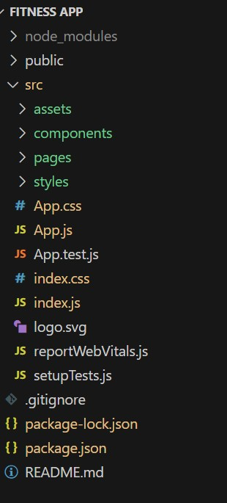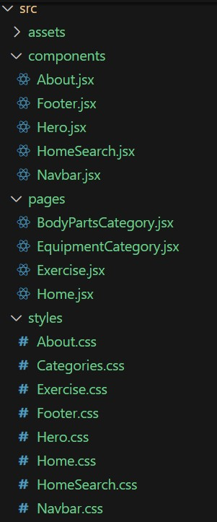

In this project, we’ve split the files into 3 major folders, *Components, Pages and Styles.* In the pages folder, we store the files that acts as pages at different URLs in the application. The components folder stores all the files, that returns the small components in the application. All the styling css files will be stored in the styles folder.

**Project Flow:**

**Project demo:**

Before starting to work on this project, let’s see the demo.

Demo

link:[https://drive.google.com/file/d/1mMqMb41RtroiFbUQ-1ZfeYfWJZ6okSNb/view?usp=sh aring](https://drive.google.com/file/d/1mMqMb41RtroiFbUQ-1ZfeYfWJZ6okSNb/view?usp=sharing)

Use the code in: <https://drive.google.com/drive/folders/14f9eBQ5W7VrLdPhP2W6PzOU_HCy8UMex?usp=sharing>

**Milestone 1: Project setup and configuration.**

* **Installation of required tools**:

To build the FitFlex app, we'll need a developer's toolkit. We'll leverage React.js for the interactive interface, React Router Dom for seamless navigation, and Axios to fetch fitness data. To style the app, we'll choose either Bootstrap or Tailwind CSS for pre-built components and a sleek look.

Open the project folder to install necessary tools. In this project, we use: o React Js o React Router Dom o React Icons o Bootstrap/tailwind css

o Axios

* For further reference, use the following resources o <https://react.dev/learn/installation> o <https://react-bootstrap-v4.netlify.app/getting-started/introduction/> o <https://axios-http.com/docs/intro> o <https://reactrouter.com/en/main/start/tutorial>

**Milestone 2: Project Development**

* Setup the Routing paths

Setup the clear routing paths to access various files in the application.

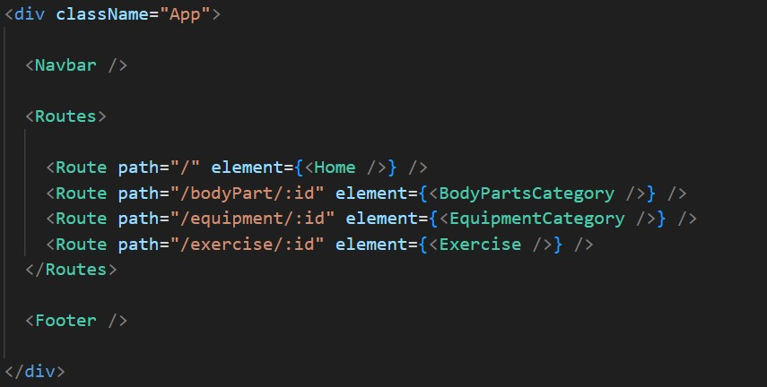

* Develop the Navbar and Hero components
* Code the popular search/categories components and fetch the categories from ***rapid Api***.
* Additionally, we can add the component to subscribe for the newsletter and the footer.
* Now, develop the category page to display various exercises under the category.
* Finally, code the exercise page, where the instructions, other details along with related videos from the YouTube will be displayed.

**Important Code snips:**

**Fetching available Equipment list & Body parts list**

From the Rapid API hub, we fetch available equipment and list of body parts with an API request.

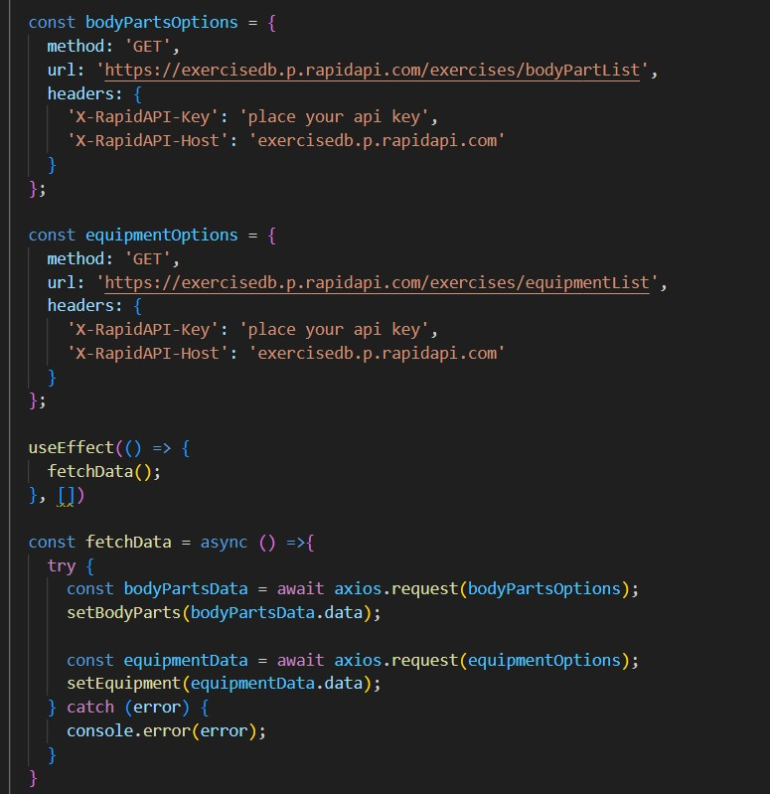

Here's a breakdown of the code:

*Dependencies:*

The code utilizes the following libraries:

Axios: A popular promise-based HTTP client for JavaScript. You can add a link to the official documentation for Axios <https://axios-http.com/>

*API Key:*

Replace 'place your api key' with a placeholder mentioning that the user needs to replace it with their own RapidAPI key. You can mention how to acquire an API key from RapidAPI.

*bodyPartsOptions and equipmentOptions:*

These variables hold configuration options for fetching data from the RapidAPI exercise database.

* *method:* The HTTP method used in the request. In this case, it's set to GET as the code is fetching data from the API.
* *url:* The URL of the API endpoint to fetch data from. Here, it's set to https://exercisedb.p.rapidapi.com/exercises/bodyPartList for fetching a list of body parts and https://exercisedb.p.rapidapi.com/exercises/equipmentList for fetching a list of equipment.
* *headers:* This section contains headers required for making the API request. Here it includes the X-RapidAPI-Key header to provide your API key and the X-RapidAPI-Host header specifying the host of the API.

*fetchData function:*

This function is responsible for fetching data from the API. It makes use of async/await syntax to handle asynchronous operations. First it fetches data for body parts using axios.request(bodyPartsOptions). Then it stores the fetched data in the bodyParts state variable using setBodyParts.

Similarly, it fetches data for equipment using axios.request(equipmentOptions). Then it stores the fetched data in the equipment state variable using setEquipment. In case of any errors during the API request, the catch block logs the error to the console using console.error.

*useEffect Hook:*

The useEffect hook is used to call the fetchData function whenever the component mounts. This ensures that the data is fetched as soon as the component loads.

Overall, the code snippet demonstrates how to fetch data from a RapidAPI exercise database using JavaScript's Axios library.

**Fetching exercises under particular category**

To fetch the exercises under a particular category, we use the below code.

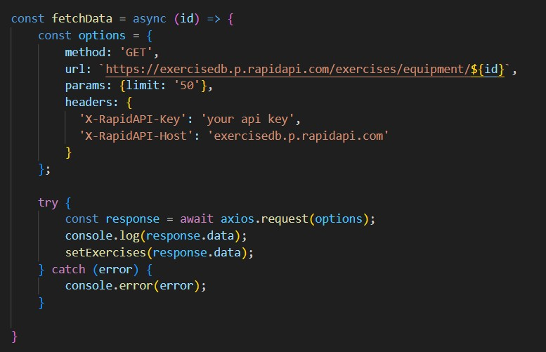

It defines a function called fetchData that fetches data from an exercise database API. Here's a breakdown of the code:

*const options = {...}:*

This line creates a constant variable named options and assigns it an object literal. The object literal contains properties that configure the API request, including:

* method: Set to 'GET', indicating that the API request is a GET request to retrieve data from the server.
* url: Set to https://exercisedb.p.rapidapi.com/exercises/equipment/${id}, which is the URL of the API endpoint for fetching exercise equipment data. The ${id} placeholder will likely be replaced with a specific equipment ID when the function is called.
* params: An object literal with a property limit: '50'. This specifies that you want to retrieve a maximum of 50 exercise equipment results.
* headers: An object literal containing two headers required for making the API request:
* 'X-RapidAPI-Key': Your RapidAPI key, which is used for authentication. You should replace 'your api key' with a placeholder instructing users to replace it with their own API key.
* 'X-RapidAPI-Host': The host of the API, which is 'exercisedb.p.rapidapi.com' in this case.

*const fetchData = async (id) => {...}:*

This line defines an asynchronous function named fetchData that takes an id parameter. This id parameter is likely used to specify the equipment ID for which data needs to be fetched from the API.

*try...catch block:*

* The try...catch block is used to handle the API request.
* The try block contains the code that attempts to fetch data from the API using axios.request(options).
* The await keyword is used before axios.request(options) because the function is asynchronous and waits for the API request to complete before proceeding.
* If the API request is successful, the response data is stored in the response constant variable.
* The console.log(response.data) line logs the fetched data to the console.
* The .then method (not shown in the image) is likely used to process the fetched data after a successful API request.
* The catch block handles any errors that might occur during the API request. If there's an error, it's logged to the console using console.error(error).

**Fetching Exercise details**

Now, with the help of the Exercise ID, we fetch the details of a particular exercise with API request.

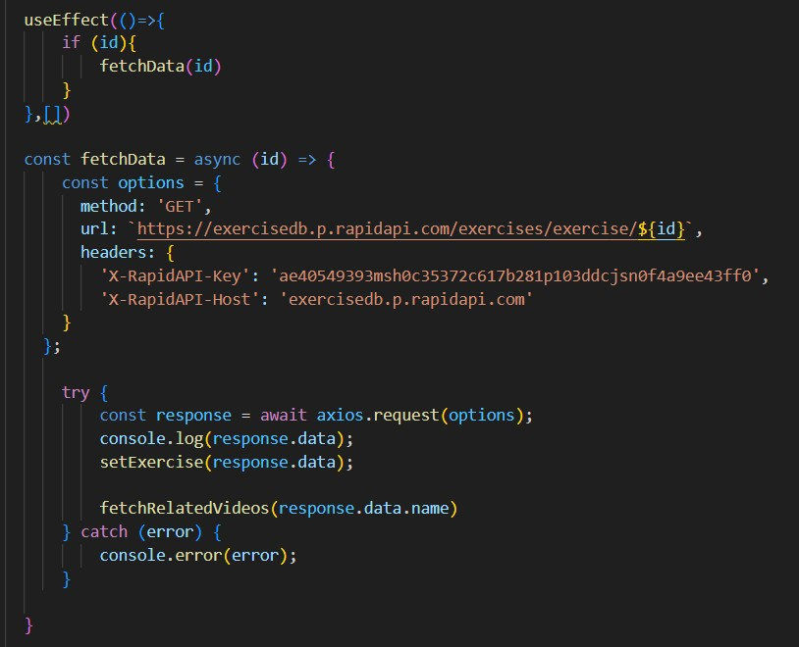

The code snippet demonstrates how to fetch exercise data from an exercise database API using JavaScript's fetch API. Here's a breakdown of the code:

*API Endpoint and Key:*

* Replace 'https://example.com/exercise' with the actual URL of the API endpoint you want to use.
* Replace 'YOUR_API_KEY' with a placeholder instructing users to replace it with their own API key obtained from the API provider.

*async function:*

The code defines an asynchronous function named fetchData that likely takes an id parameter as input. This id parameter might be used to specify the ID of a particular exercise or category of exercises to fetch.

*fetch request:*

Inside the fetchData function, the fetch API is used to make an HTTP GET request to the API endpoint. The function creates a fetch request with the following details:

* Method: GET (to retrieve data from the server)
* URL: The API endpoint URL where exercise data resides.

*Handling the Response:*

* The then method is used to handle the response from the API request. If the request is successful (i.e., status code is 200), the response is converted to JSON format using response.json().
* The .then method then likely processes the fetched exercise data, which might involve storing it in a state variable or using it to populate a user interface.

*Error Handling:*

The .catch method is used to handle any errors that might occur during the API request. If there's an error, it's logged to the console using console.error.

**Fetching related videos from YouTube**

Now, with the API, we also fetch the videos related to a particular exercise with code given below.

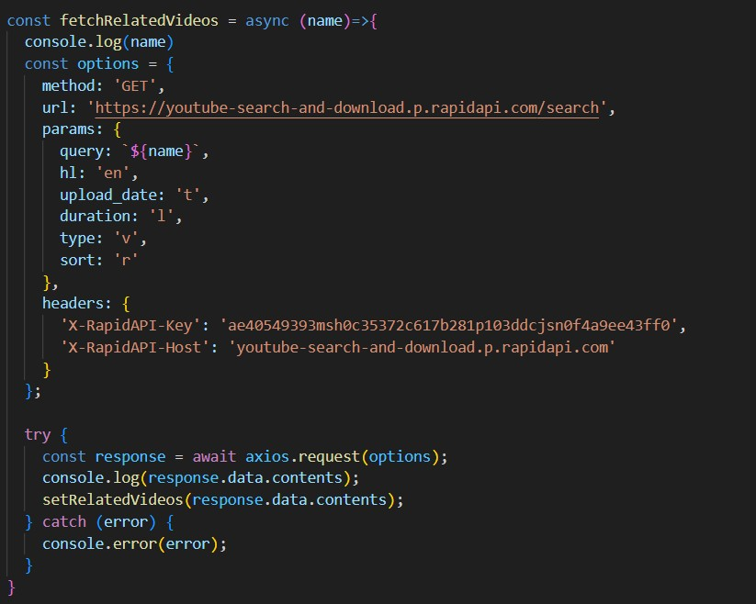

The code snippet shows a function called *fetchRelatedVideos* that fetches data from YouTube using the RapidAPI service. Here's a breakdown of the code:

*fetchRelatedVideos function:*

This function takes a name parameter as input, which is likely the name of a video or a search query.

*API configuration:*

The code creates a constant variable named options and assigns it an object literal containing configuration details for the API request:

* method: Set to 'GET', indicating a GET request to retrieve data from the server.
* url: Set to 'https://youtube-search-and-download.p.rapidapi.com/search', which is the base URL of the RapidAPI endpoint for YouTube search.
* params: An object literal containing parameters for the YouTube search query:
* query: Set to \${name}, a template literal that likely gets replaced with the actual name argument passed to the function at runtime. This specifies the search query for YouTube videos.
* Other parameters like hl (language), sort (sorting criteria), and type (video type) are included but their values are not shown in the snippet.
* headers: An object literal containing headers required for making the API request:
* 'X-RapidAPI-Key': Your RapidAPI key, which is used for authentication. You should replace 'YOUR_API_KEY' with a placeholder instructing users to replace it with their own API key.
* 'X-RapidAPI-Host': The host of the API, which is

'youtube-search-and-download.p.rapidapi.com' in this case.

*Fetching Data (try...catch block):*

* The try...catch block is used to handle the API request.
* The try block contains the code that attempts to fetch data from the API using axios.request(options).
* axios is an external JavaScript library for making HTTP requests. If you don't already use Axios in your project, you'll need to install it using a package manager like npm or yarn.
* The .then method (not shown in the code snippet) is likely used to process the fetched data after a successful API request.
* The catch block handles any errors that might occur during the API request. If there's an error, it's logged to the console using console.error(error).

**Project Execution:**

After completing the code, run the react application by using the command “npm start” or “npm run dev” if you are using vite.js

Here are some of the screenshots of the application.

**Hero component** this section would showcase trending workouts or fitness challenges to grab users' attention.

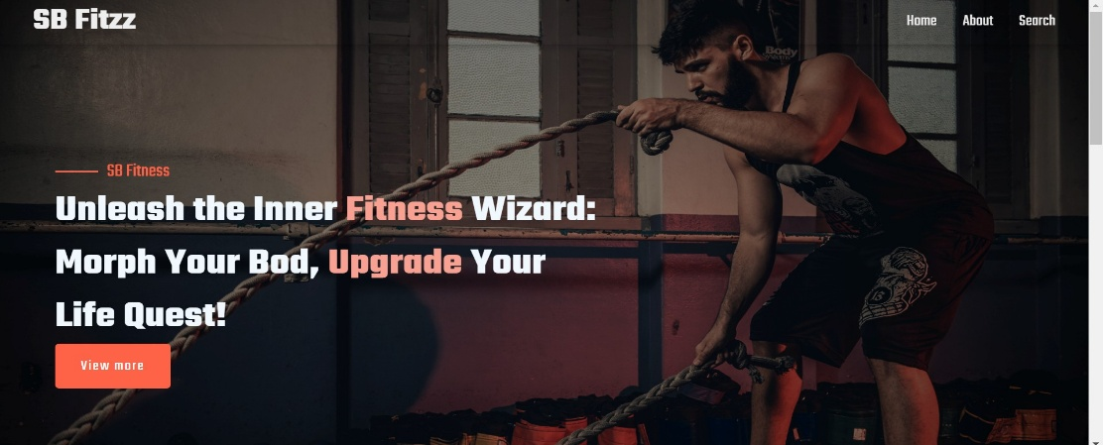

**About**

FitFlex isn't just another fitness app. We're meticulously designed to transform your workout experience, no matter your fitness background or goals.

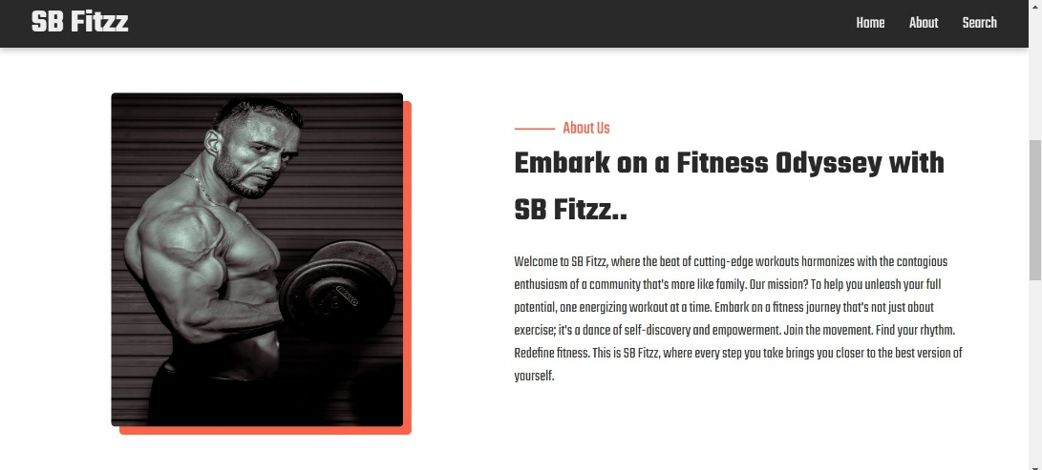

**Search**

B Fitzz makes finding your perfect workout effortless. Our prominent search bar empowers you to explore exercises by keyword, targeted muscle group, fitness level, equipment needs, or any other relevant criteria you have in mind. Simply type in your search term and let FitFlex guide you to the ideal workout for your goals.

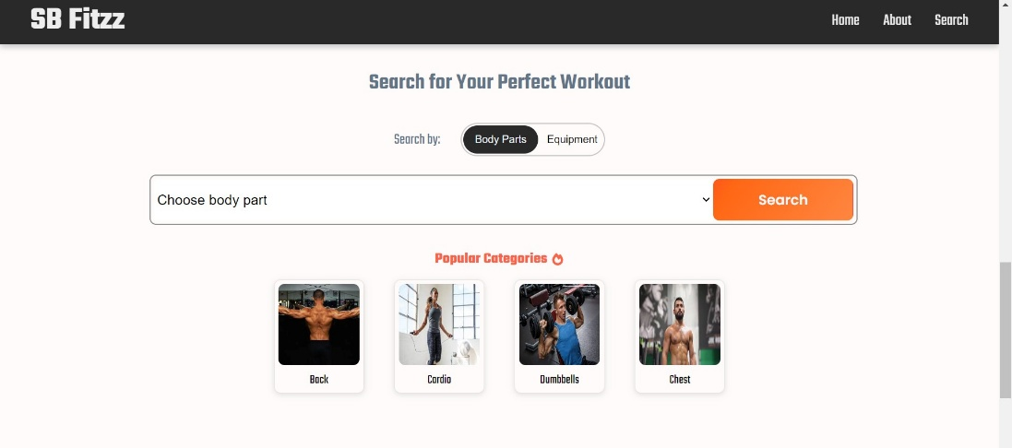

**Category page**

FitFlex would offer a dedicated section for browsing various workout categories. This could be a grid layout with tiles showcasing different exercise types (e.g., cardio, strength training, yoga) with icons or short descriptions for easy identification.

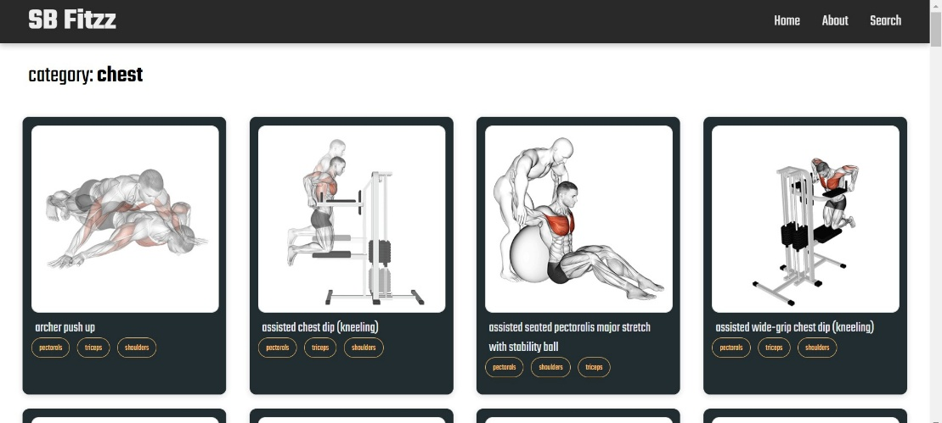

**Exercise page**

This is where the magic happens! Each exercise page on FitFlex provides a comprehensive overview of the chosen workout. Expect clear and concise instructions, accompanied by high-quality visuals like photos or videos demonstrating proper form. Additional details like targeted muscle groups, difficulty level, and equipment requirements (if any) will ensure you have all the information needed for a safe and effective workout.

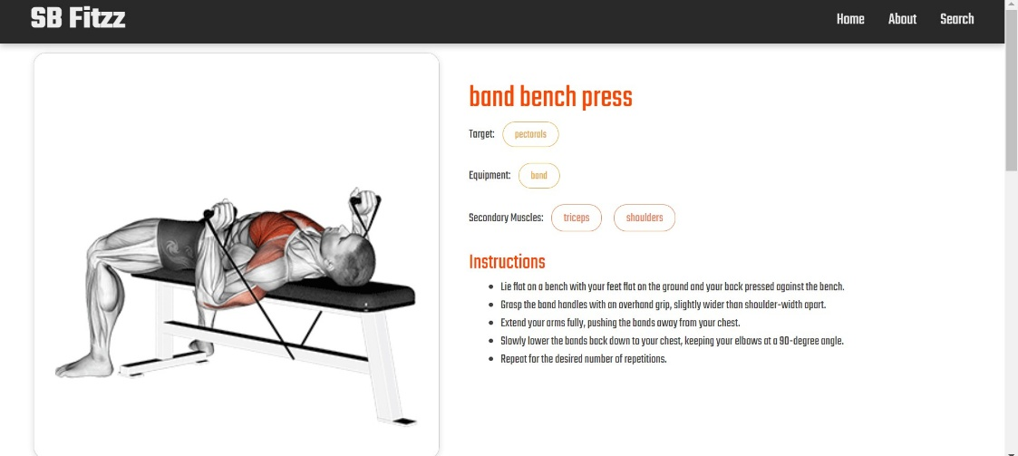

Demo link:<https://drive.google.com/file/d/1mMqMb41RtroiFbUQ-1ZfeYfWJZ6okSNb/view?usp=sharing>