COLLEGE MANAGEMENT SYSTEM
MINI PROJECT – REVIEW 2 & REVIEW 3
Review 2: System Analysis & Design
Review 3: Form Design and Reports
Department of Computer Applications (PG)
I MCA (2026–2028)

REVIEW 2: SYSTEM ANALYSIS & DESIGN
This review presents the analysis and design of the proposed College Management System. The system is a full-stack web application developed using Angular 17 on the frontend and Java Spring Boot 3 on the backend, with MySQL as the database. The application provides secure, role-based access for Admin, Teacher, and Student users. The purpose of this review is to define how the system processes information, how the modules communicate, and how the data is organized before implementation.

2.1 System Analysis
The existing college management process can involve separate files, registers, spreadsheets, and manual procedures for maintaining student, teacher, attendance, marks, and department information. This can make searching, updating, and reporting difficult. The proposed system centralizes these activities through a single web application.
- Admin manages departments, students, teachers, and overall system information.
- Teacher records attendance and manages student marks and class-related academic records.
- Student views personal profile, attendance, marks, and academic summary.
- All persistent information is stored in a centralized MySQL database.
- JWT authentication and role-based authorization protect the REST APIs and frontend routes.

2.2 Proposed System
The proposed system uses Angular 17 and TypeScript for the single-page application, Spring Boot 3 for RESTful APIs and business logic, Spring Security with JWT for authentication and authorization, JPA/Hibernate for database access, and MySQL for persistent storage. The backend follows Controller–Service–Repository separation and uses DTOs, validation, exception handling, and CORS configuration.

2.3 Functional Requirements
- Secure login using username and password with JWT-based authentication.
- Role-based access for Admin, Teacher, and Student.
- Admin CRUD operations for departments, students, and teachers.
- Search and filter records from the Admin module.
- Teacher attendance entry and update.
- Teacher marks entry and academic record management.
- Student access to only the student's own profile, attendance, and marks.
- Dashboard and report views for relevant users.
- Persistent storage and retrieval using MySQL.

2.4 Non-Functional Requirements
- Security: protected APIs, authentication, and role-aware authorization.
- Performance: efficient database queries and responsive screens.
- Accuracy: validation and consistent database relationships.
- Usability: clear forms, navigation, dashboards, and messages.
- Maintainability: modular backend and reusable Angular services/components.
- Scalability: architecture should allow future modules such as fees, timetable, notifications, or library management.

2.5 DFD – Data Flow Diagram
The DFD shows the logical movement of data through the College Management System. Admin, Teacher, and Student users interact with the Angular application. Requests are sent to Spring Boot REST APIs, where authentication, authorization, validation, and business processing are performed. The backend stores and retrieves records from MySQL and returns the required information to the frontend for dashboards and reports.
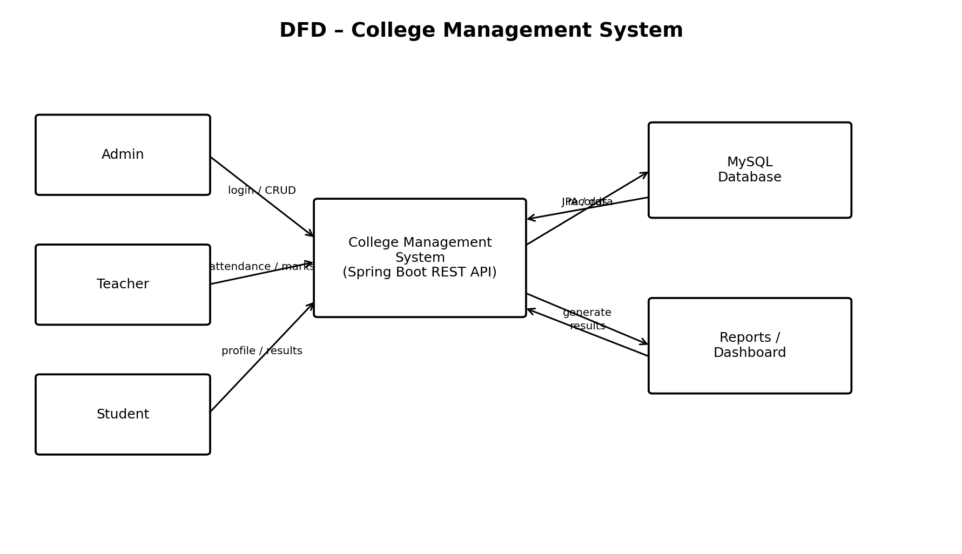
Figure 1: DFD showing data flow between Admin, Teacher, Student, backend services, database, and reports.

2.6 System Architecture / Block Diagram
The architecture separates the presentation, API, business, security, and data layers. Angular handles user interaction. Spring Boot controllers expose REST endpoints, services implement business rules, repositories communicate with MySQL through JPA/Hibernate, and Spring Security with JWT protects resources based on user roles.
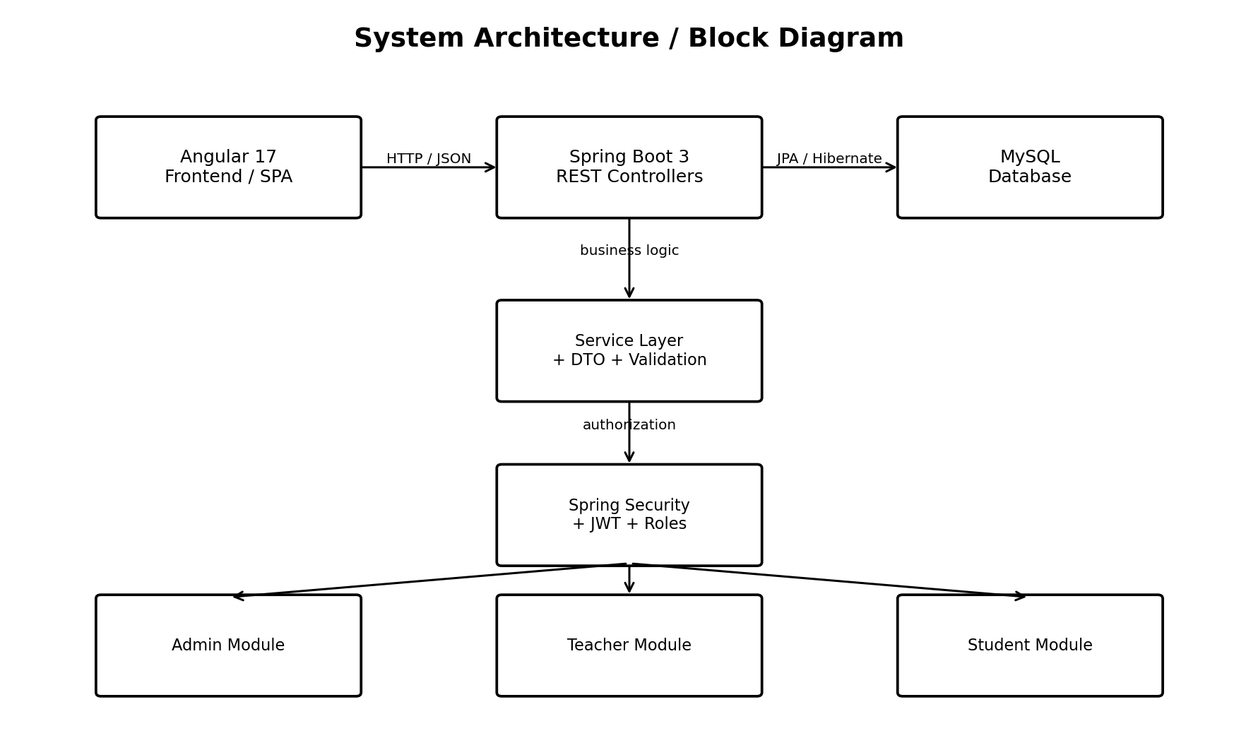
Figure 2: System architecture of the Angular–Spring Boot–MySQL College Management System.

2.7 ER Diagram
The ER diagram identifies the major database entities and their relationships. The users table stores login and role information. Students and Teachers are connected with Departments. Attendance records reference students and teachers, while Marks records maintain student, teacher, subject, marks, and examination information. Primary keys uniquely identify records and foreign keys maintain relationships.
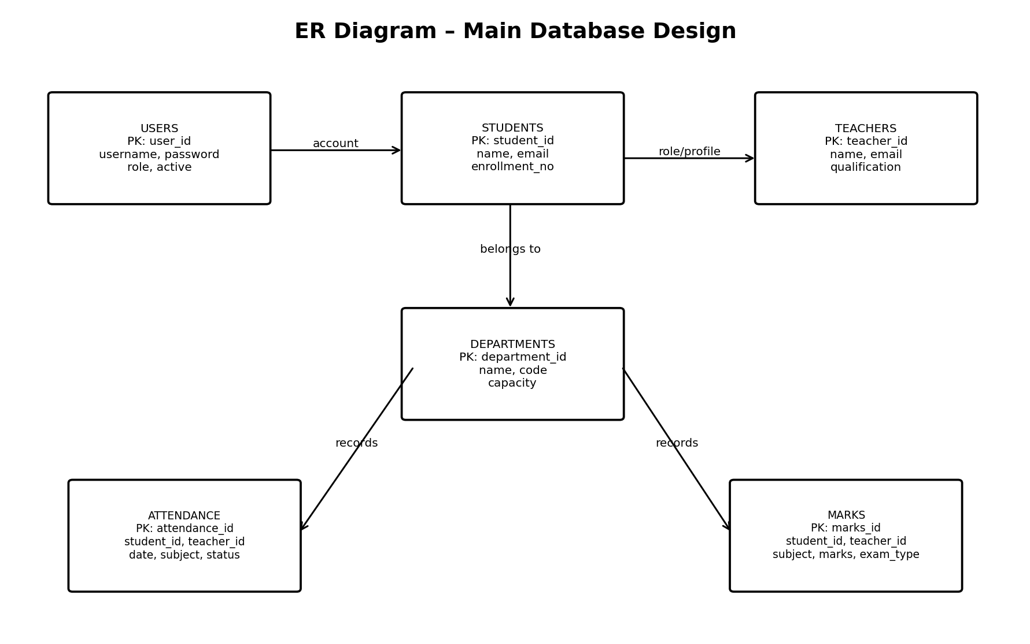
Figure 3: ER diagram representing the main database entities and relationships.

2.8 Database Design
Table | Primary Key | Important Fields | Purpose
users | user_id | username, password, role, active | Authentication and role management
departments | department_id | name, code, head, capacity | Department master information
students | student_id | name, email, enrollment_no, department_id | Student records
teachers | teacher_id | name, email, qualification, department_id | Teacher records
attendance | attendance_id | student_id, teacher_id, date, subject, status | Attendance tracking
marks | marks_id | student_id, teacher_id, subject, marks_obtained, total_marks, exam_type | Academic marks

2.9 Module-wise Design
- Admin Module – dashboard, department management, student management, teacher management, search and filtering.
- Teacher Module – teacher dashboard, attendance management, marks management, and class-related records.
- Student Module – student dashboard, personal profile, attendance view, marks view, and academic summary.
- Security Module – login, JWT generation/validation, role-based API authorization, and protected frontend routes.
- Common Services – API communication, validation, exception handling, database access, and reporting.

2.10 Review 2 Conclusion
Review 2 defines the complete system design required before coding. The DFD explains the movement of information, the ER diagram defines database relationships, the architecture explains the interaction between Angular, Spring Boot, security, and MySQL, and the database design provides a structured foundation for implementation. This design supports secure role-based access and future expansion of the College Management System.

REVIEW 3: FORM DESIGN AND REPORTS
Review 3 focuses on the user interface and output design of the College Management System. The Angular frontend provides responsive forms, dashboards, navigation, and reports. Each form is designed according to the user's role and contains validation rules to reduce incorrect data entry. Reports convert stored database information into useful academic and administrative information.

3.1 Form Design Principles
- Simple and consistent layout across all screens.
- Role-specific navigation and pages.
- Clear labels, input fields, dropdowns, date controls, and action buttons.
- Client-side and server-side validation.
- Clear success, warning, and error messages.
- Responsive layout suitable for desktop and smaller screens.
- Only authorized users can access data entry and editing operations.

3.2 Form and Data Flow
The form flow begins when a user enters data in an Angular form. The frontend performs basic validation and sends the request through an Angular service and HTTP interceptor. The JWT token is included for protected requests. Spring Boot receives the request, validates it, applies business rules, and stores or retrieves information through JPA/Hibernate. The result is returned to Angular and displayed as a confirmation, error message, dashboard, or report.
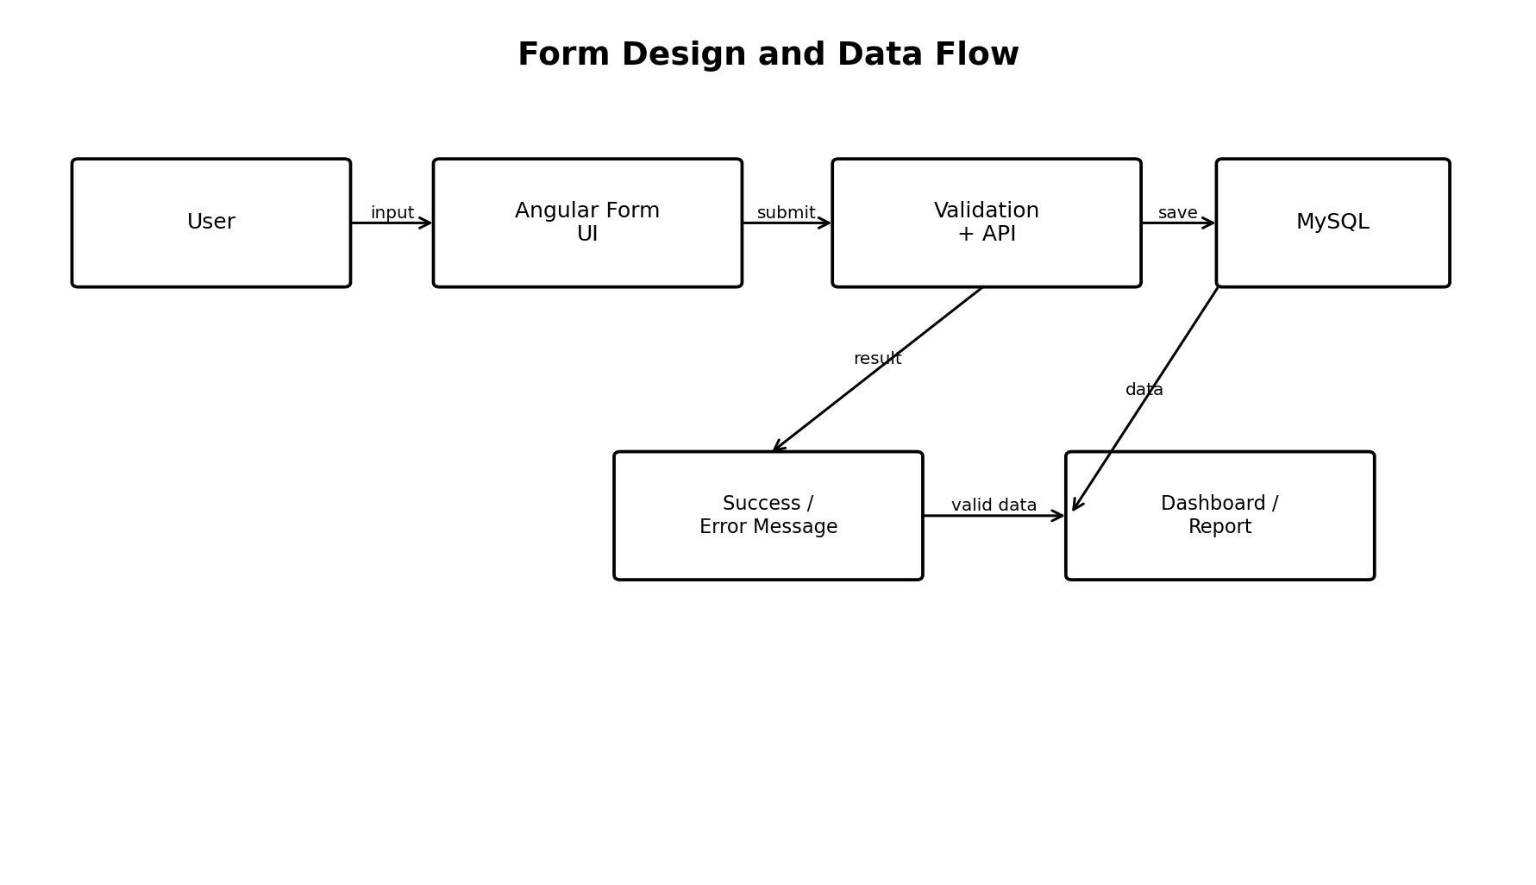
Figure 4: Form-to-database flow from Angular input through Spring Boot validation to MySQL and output.

3.3 Login Form
The login form is common to Admin, Teacher, and Student users. It contains username and password fields and a Login button. After successful authentication, the backend generates a JWT token and the user is redirected to the dashboard based on the assigned role. Invalid credentials display an appropriate error message.
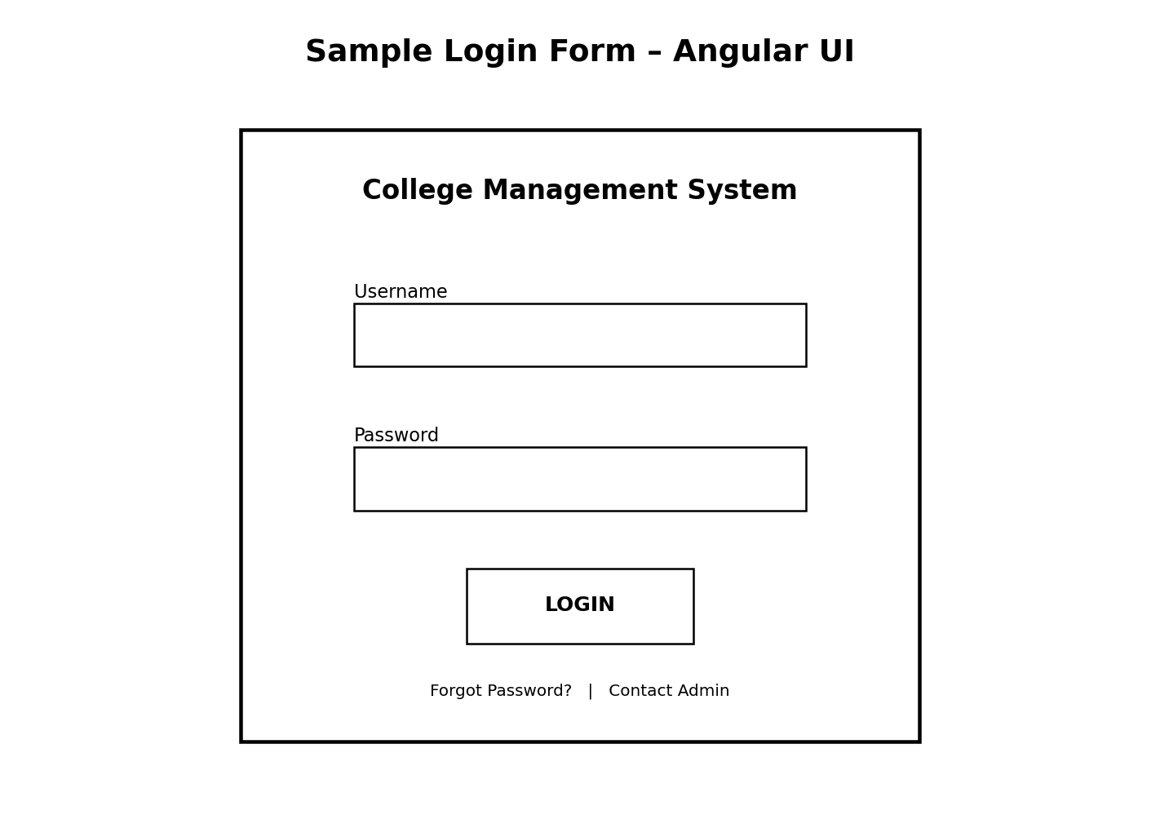
Figure 5: Sample Angular login form design.

3.4 Admin Forms
The Admin module contains forms for managing departments, students, and teachers. Admin users can add, edit, delete, view, search, and filter records. Required fields and unique identifiers are validated before saving.
- Department Form – department name, code, head, and capacity.
- Student Form – name, enrollment number, email, department, and other student details.
- Teacher Form – name, email, qualification, specialization, and department.
- Search/Filter controls – search by name, ID, department, or other relevant criteria.

3.5 Student Registration / Edit Form
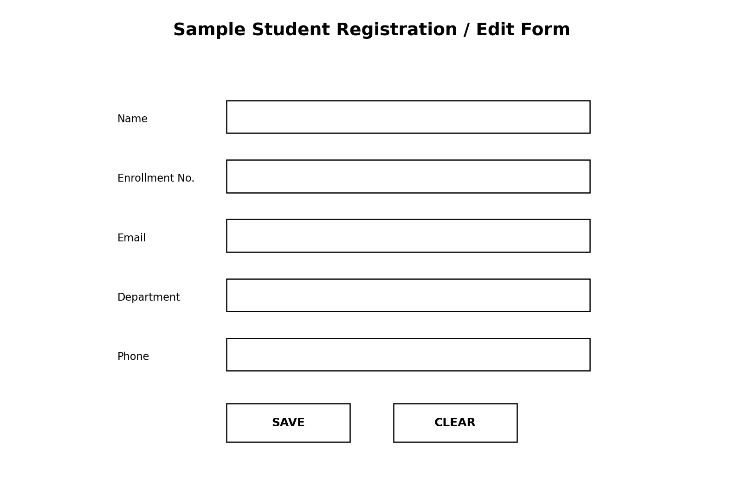
Figure 6: Sample Student Registration/Edit Form with validation-oriented fields.
The student form is used by authorized Admin users to create or update student information. The enrollment number should be unique, the email should follow a valid format, and required fields must be completed before the Save operation is accepted.

3.6 Teacher Attendance Form
The attendance form allows a Teacher to select the relevant student or class, subject, date, and attendance status. The system validates the request before storing it. Attendance information is later used to display attendance history and calculate attendance summaries for students.
- Student / class selection
- Subject selection
- Attendance date
- Present / Absent status
- Save and update actions
- Validation and confirmation message

3.7 Teacher Marks Form
The marks form allows authorized Teachers to enter or update academic marks. The form includes student, subject, marks obtained, total marks, teacher, and examination type. Marks obtained must not exceed total marks.
- Student selection
- Subject
- Exam type
- Marks obtained
- Total marks
- Save / Update / Clear actions

3.8 Student Dashboard
The Student Dashboard provides a quick summary of the student's academic information. It can display profile details, attendance percentage, recent marks, subject-wise results, and other information permitted by the student's role.

3.9 Report Design
Reports provide structured output from the database. The report layout should contain a clear title, student or department information where required, column headings, relevant totals or percentages, and the generated date. Reports can be viewed through the Angular application and can be extended later for printing or export.
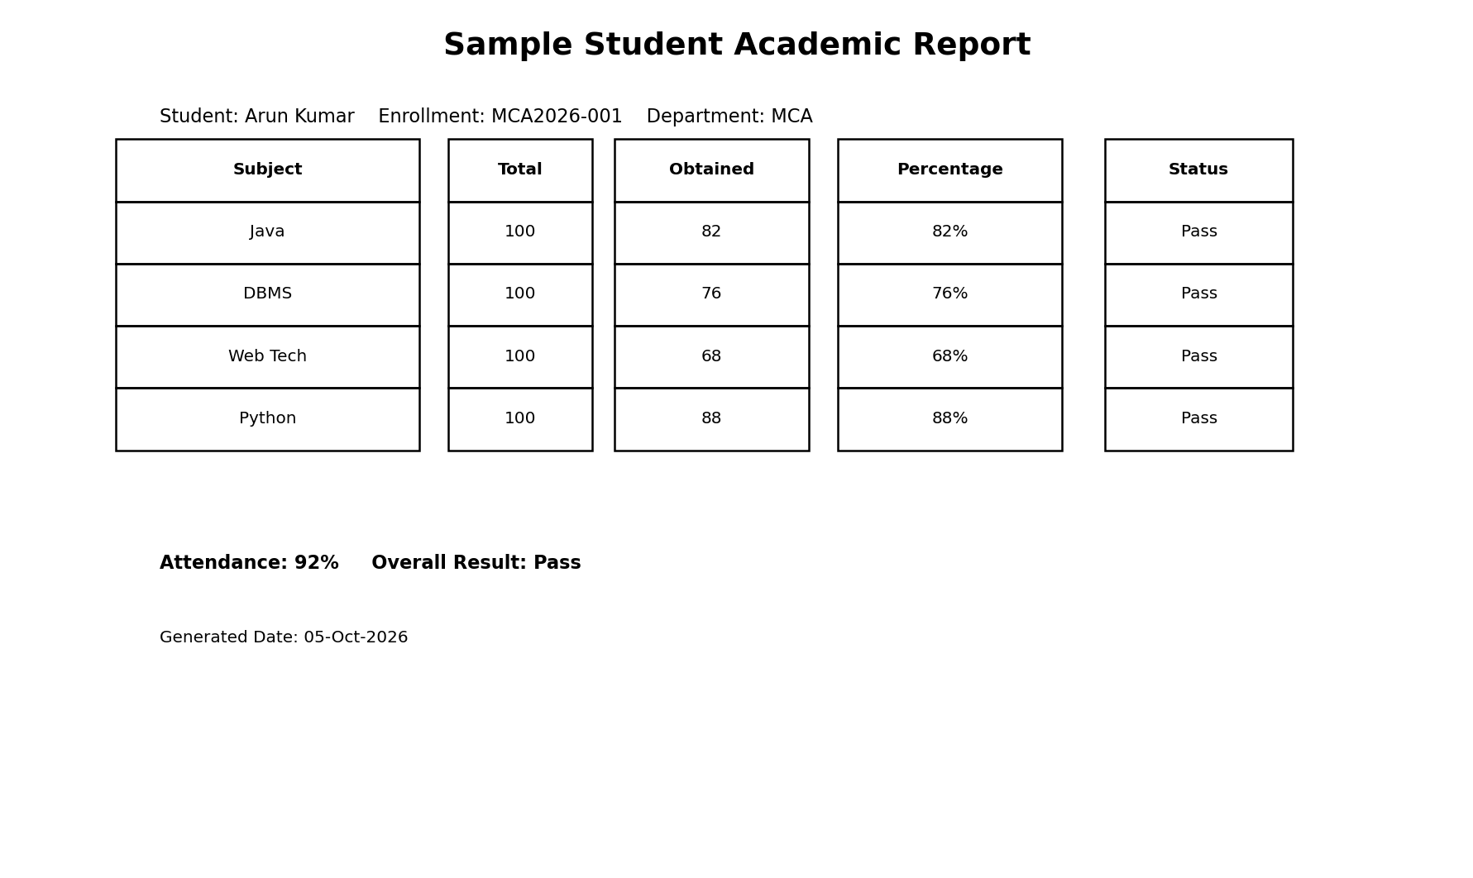
Figure 7: Sample Student Academic Report showing marks, percentages, attendance, and result status.

3.10 Types of Reports
Report | Contents | User
Student Profile Report | Name, enrollment number, department, email and profile information | Admin / Student
Attendance Report | Subject, date, status, attendance percentage | Teacher / Student / Admin
Marks / Result Report | Subject, total marks, obtained marks, percentage, result | Teacher / Student / Admin
Teacher Report | Teacher details, qualification, specialization, department | Admin
Department Report | Department details and related student/teacher information | Admin
Dashboard Summary | Counts, attendance summary, marks summary and key statistics | Role-based

3.11 Validation and Error Handling
- Required fields must not be empty.
- Enrollment number and other unique identifiers must not be duplicated.
- Email fields must follow a valid format.
- Marks obtained must be within the allowed range.
- Unauthorized operations must be rejected by the backend.
- Expired or invalid JWT tokens should require re-authentication.
- User-friendly messages should be displayed after successful or failed operations.

3.12 Review 3 Conclusion
Review 3 demonstrates how users interact with the College Management System and how information is presented. The Angular forms simplify data entry while validation improves accuracy. Role-specific dashboards and reports provide useful information to Admin, Teachers, and Students. The proposed form and report designs are therefore ready to be implemented as Angular components and connected to the Spring Boot REST APIs.

Final Summary – Review 2 & Review 3
Review 2 satisfies the System Analysis & Design requirements by covering the DFD, ERD, system/block architecture, database design, modules, and system requirements. Review 3 satisfies the Form Design and Reports requirements by covering login, Admin, Teacher, Student, attendance and marks forms, validation, dashboards, report layouts, and form-to-database flow. Together, these reviews provide a complete design blueprint for implementing the proposed College Management System using Angular 17, Spring Boot 3, Spring Security with JWT, JPA/Hibernate, and MySQL.

