**1. INTRODUCTION:**

New York, the city of exploring opportunities and opening new business. Various features in New York instigates globalization in greater trend. This universe thing makes the business highly competitive as well. But a proper insight with clear understanding can reduce the potential risk and influence profit in higher rates. The Organization is seeking for a Indian cuisine restraint in New York. Recommending, a better venue will the high priority and providing an existing sample for this will promote a proper idea.

**2. Data Acquisition**

Real time needs to be analysed over the entire process. So an Foursquare API will be used for end to end data processing. Wiki will be considered as other source of data in other factors which will be explored more in coming sections.

**3. Data Analysis**

The Exploratory analysis were drawn from various factors and please refer to the notebook and following graphs for better understanding

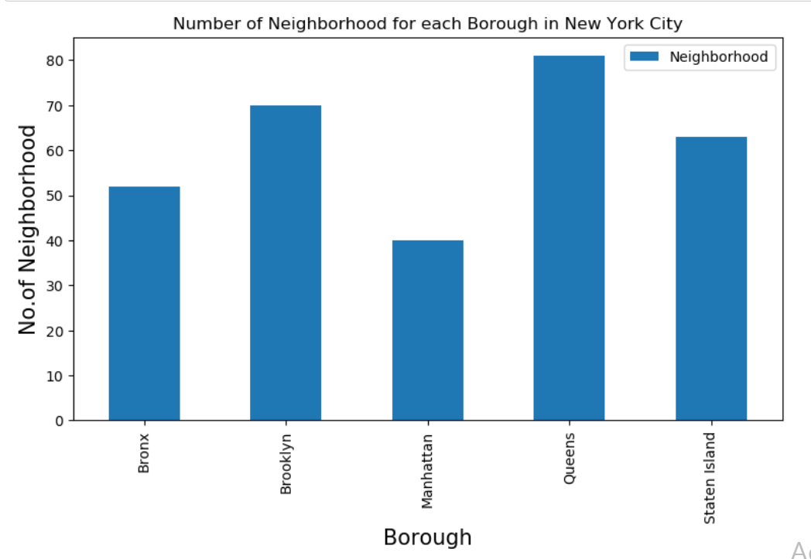

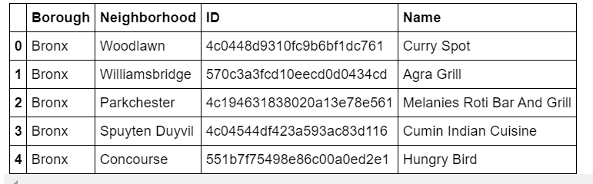

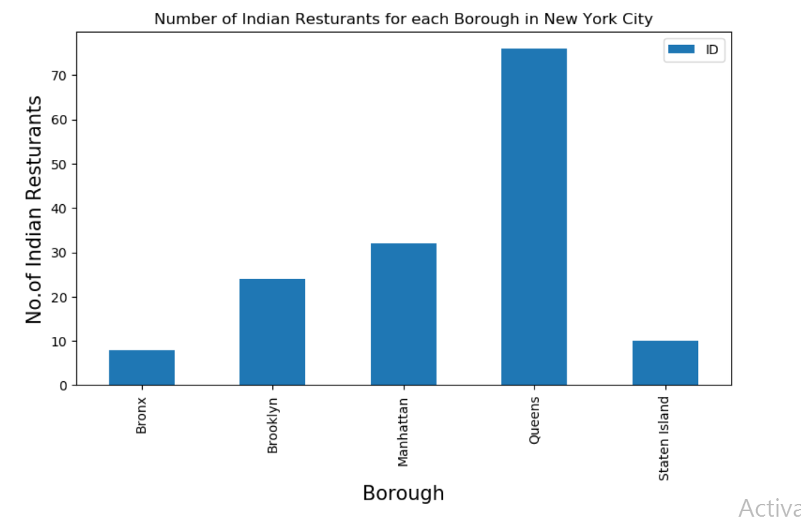

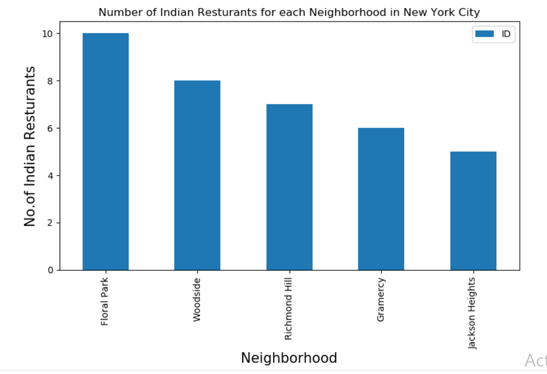

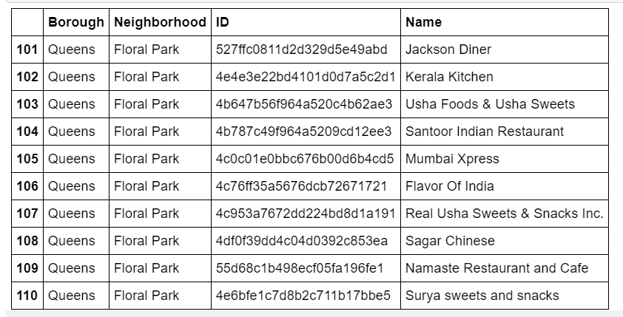

**CONCLUSION AND RECCOMENDATIONS**

With reference to the data analysis the following recommendations were made

1. Astoria(Queens), Blissville(Queens), Civic Center(Manhattan) are some of the best neighborhoods for indian cuisine.
2. Manhattan have potential Indian Resturant Market
3. Staten Island ranks last in average rating of Indian Resturants.