 

**Placement Empowerment Program**

***Cloud Computing and DevOps Centre***

Automate File Copying with a Script

Create a script to copy files from one folder to another automatically.

Name: SIVAKUMAR C Department: AML



**Introduction and Overview**

Copying file from one folder to another folder everyday takes a lot of time and becomes a repetitive task. So we can create a powershell script to automate this task. It will increase the overall efficiency and reduces time and complexity of this task.

**Objectives**

* Create a Script to Copy from one folder to another
* Automate the implementation of this task using task scheduler

**Importance**

* Reduce the workload by preventing the need to manually copy file from one folder to another
* Since the task is entirely automated , The chances of a mistake occurring is very low

**STEPS**

**STEP 1:** Create two folders as source folder and destination folder with the files to be copied in the source folder.



**STEP 2:** Open Notepad and write the script below and change the source and destination directories in the file and save it as .bat extension.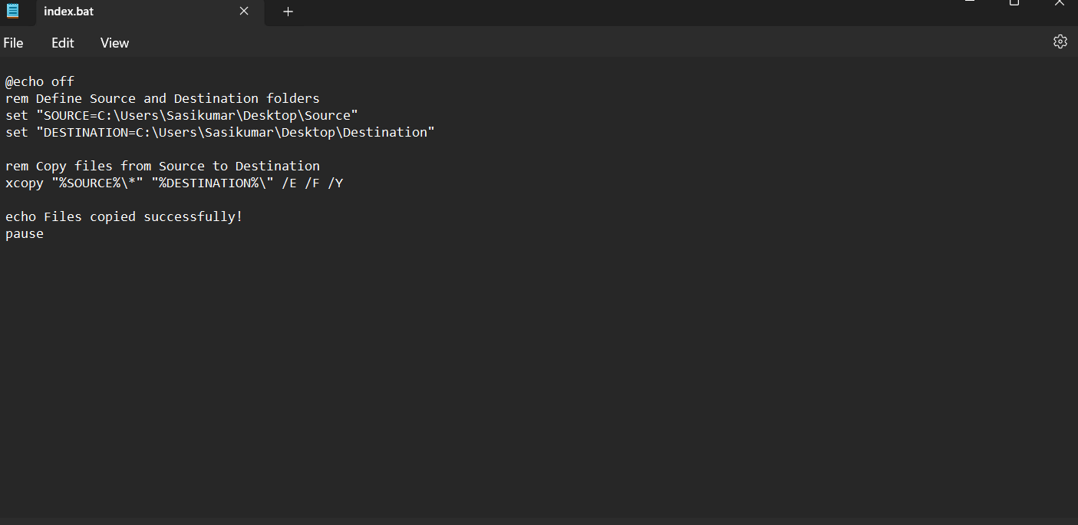

**STEP 3:** Press Win+R and type “taskshcd.msc” which will open thetask scheduler

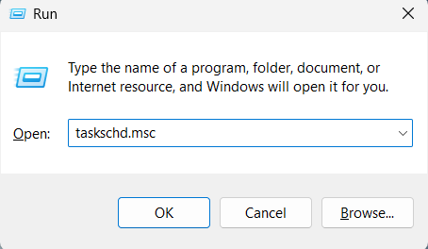

**STEP 5:** Right-Click the task scheduler and select create basic task.

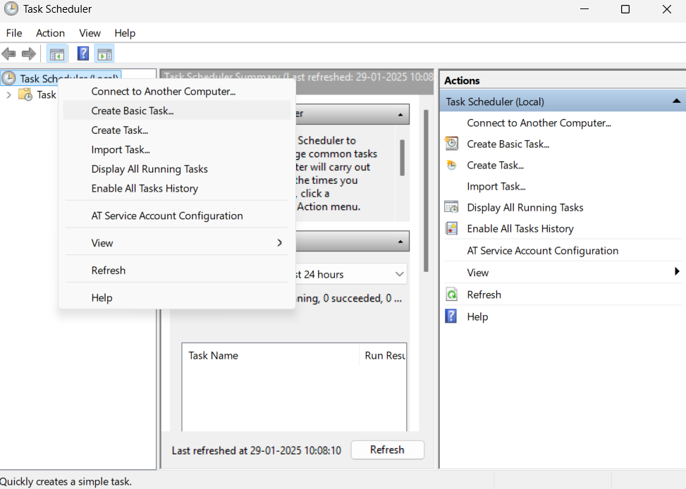

**STEP 6:** Provide a Name and Description for this automation task.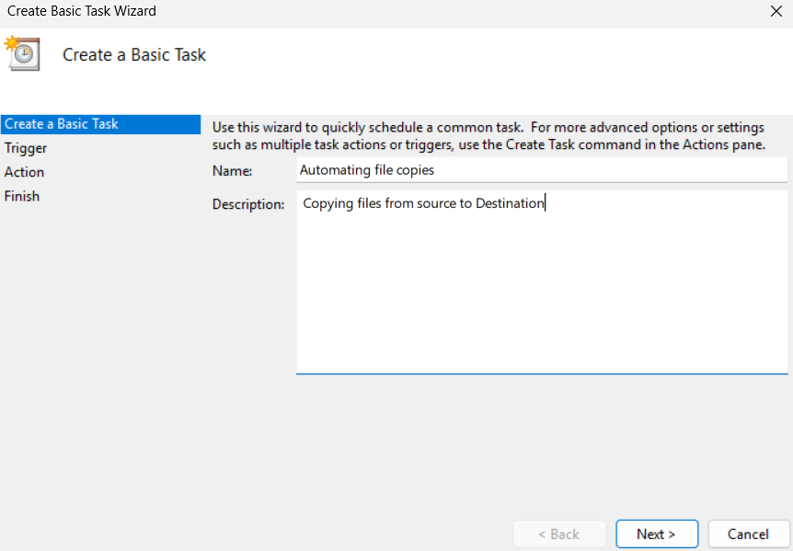

**STEP 7 :** Set a scheduled time and date to when the task should execute everyday within the trigger option.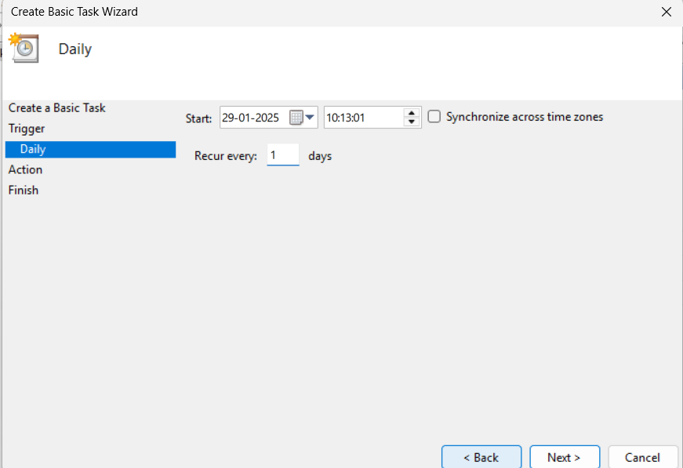

**STEP 8:** And Select Start a Program which confirms to the task scheduler that this task is supposed to start a program that is our script.

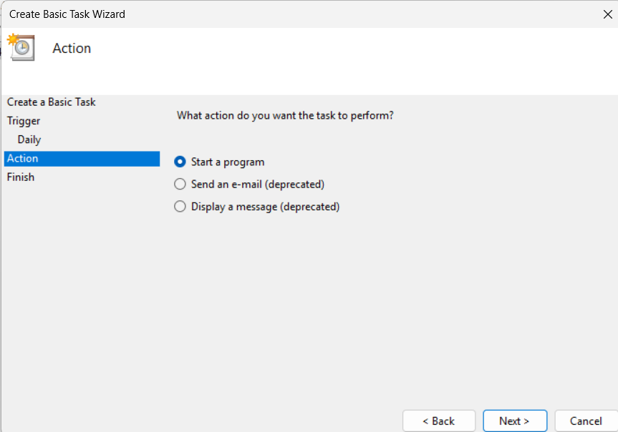

**STEP 9:** Now , select the file from the folder or paste the location path.

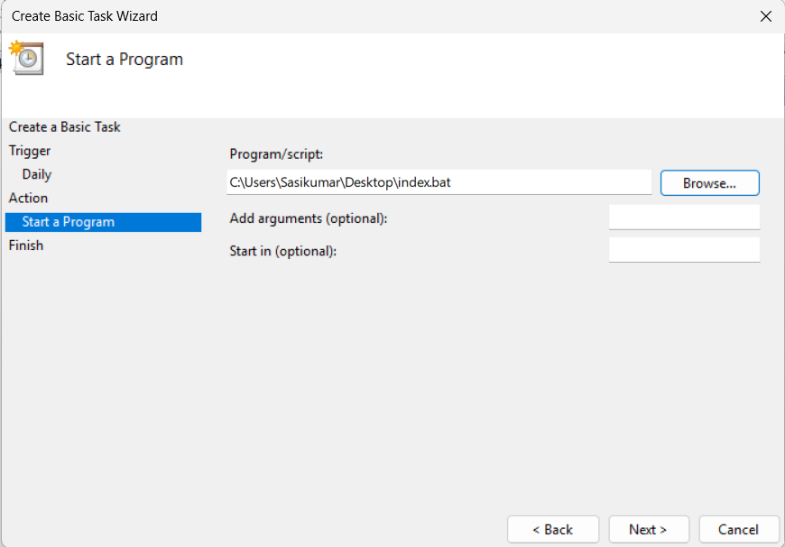

**STEP 10:** Select Finish and in the bottom right corner which will create the task .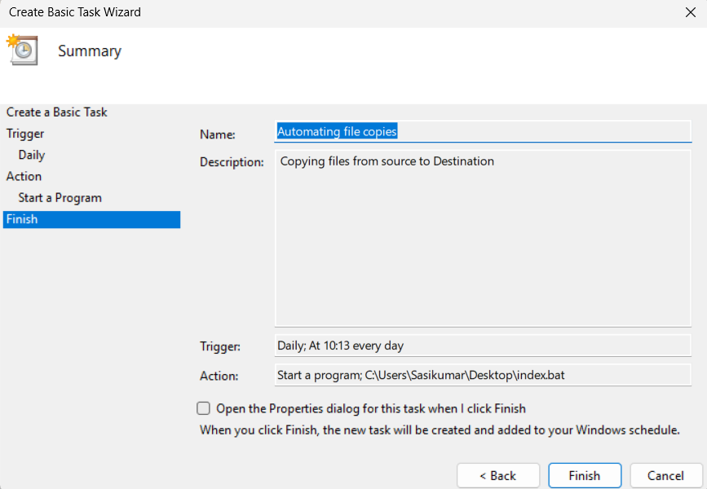

**STEP 11:** To check whether the script is working. Right Click the Script Name and select Run to execute the task.

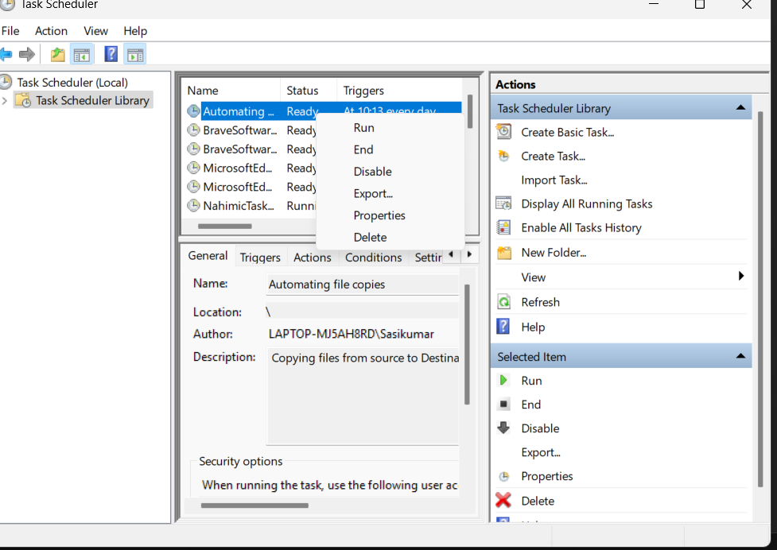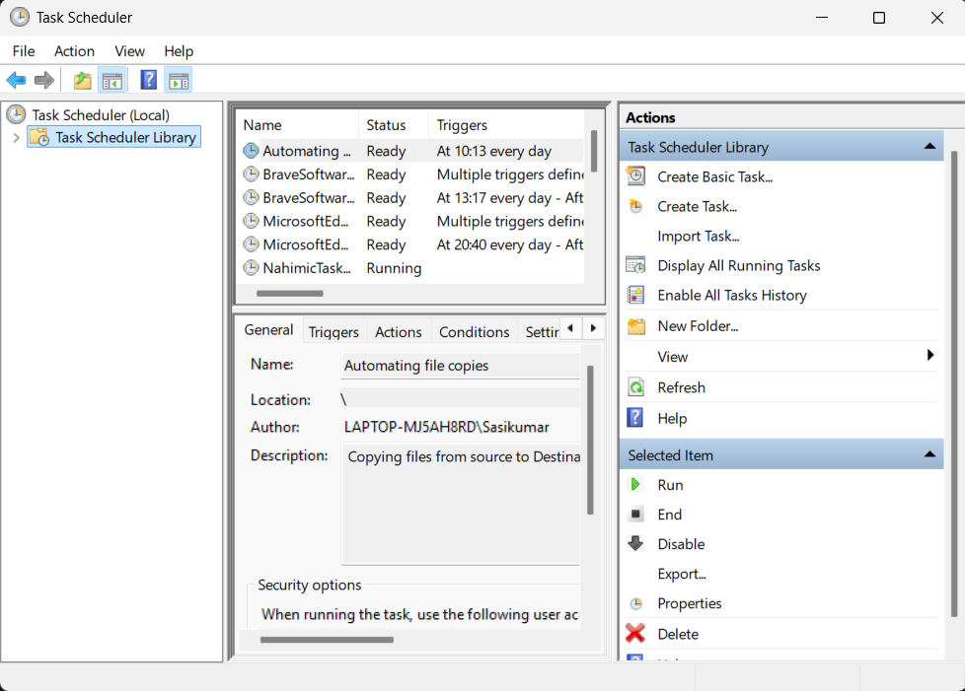

**STEP 12:** A Command Terminal will open ensuring that the files had been transferred successfully.