 

**Placement Empowerment Program**

***Cloud Computing and DevOps Centre***

**Deploy Your Static Website Using GitHub Pages**Host your local Git repository’s static website directly using GitHub Pages

Name: SIVAKUMAR C Department: AML



**Introduction and Overview**

GitHub Pages is a powerful tool that allows developers to host static websites directly from their GitHub repositories. This process leverages GitHub's infrastructure, making it easy to deploy personal projects, portfolios, and documentation without the need for external hosting services.

**Objectives**

* To learn how to initialize a Git repository locally.
* To understand the process of version controlling static website files.
* To deploy a static webpage using GitHub Pages.
* To manage and update website content through GitHub.

**Importance**

* **Cost-effective: Free hosting for personal and project websites.**
* **Version Control: Seamless integration with Git for tracking changes.**
* **Easy Deployment: Quick and straightforward process to publish web content.**
* **Reliability: Hosted on GitHub’s robust infrastructure ensuring high availability.**

**STEPS:**

**STEP 1: Initialize a Local Git Repository:**  
 Open your terminal and navigate to your project folder:

**cd path/to/your/project**

**git init**

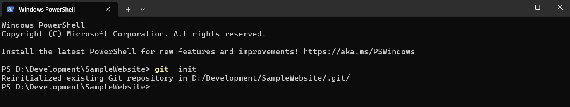

**STEP 2: Add Files to the Repository:**  
 Add all the files in your project to the Git staging area:

**git add index.html**

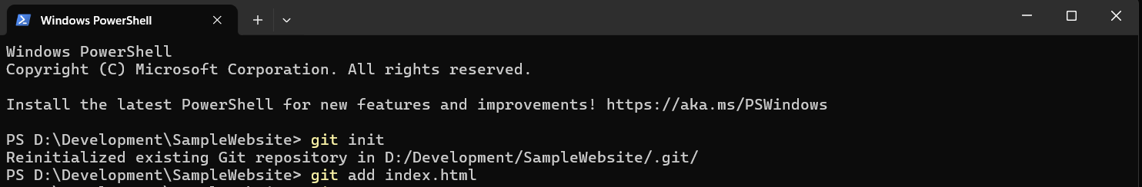

**STEP 3: Commit the Changes:**  
 Commit the staged files with a descriptive message:

**git commit -m "Initial commit"**

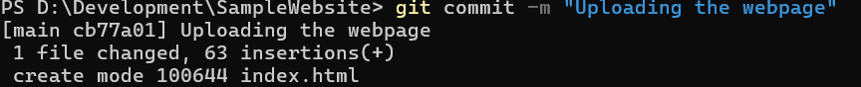

**STEP 4: Create a Repository on GitHub:**

* + Go to [GitHub](https://github.com/).
  + Click on **"New repository"**.
  + Name your repository (e.g., my-static-website).
  + Choose **Public** and click **Create repository**.

**STEP 5: Connect Local Repository to GitHub:**  
 Link your local repository to the GitHub repository:

**git remote add origin https://github.com/your-username/my-static-website.git**

**STEP 6: Push the Code to GitHub:**  
 Push your code to the main branch:

**git push -u origin main**

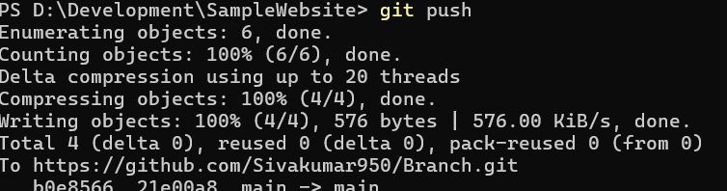

**STEP 7: Configure GitHub Pages:**

* + Go to your GitHub repository.
  + Click on **Settings → Pages**.
  + Under **"Source"**, select the main branch and / (root) folder.
  + Click **Save**.

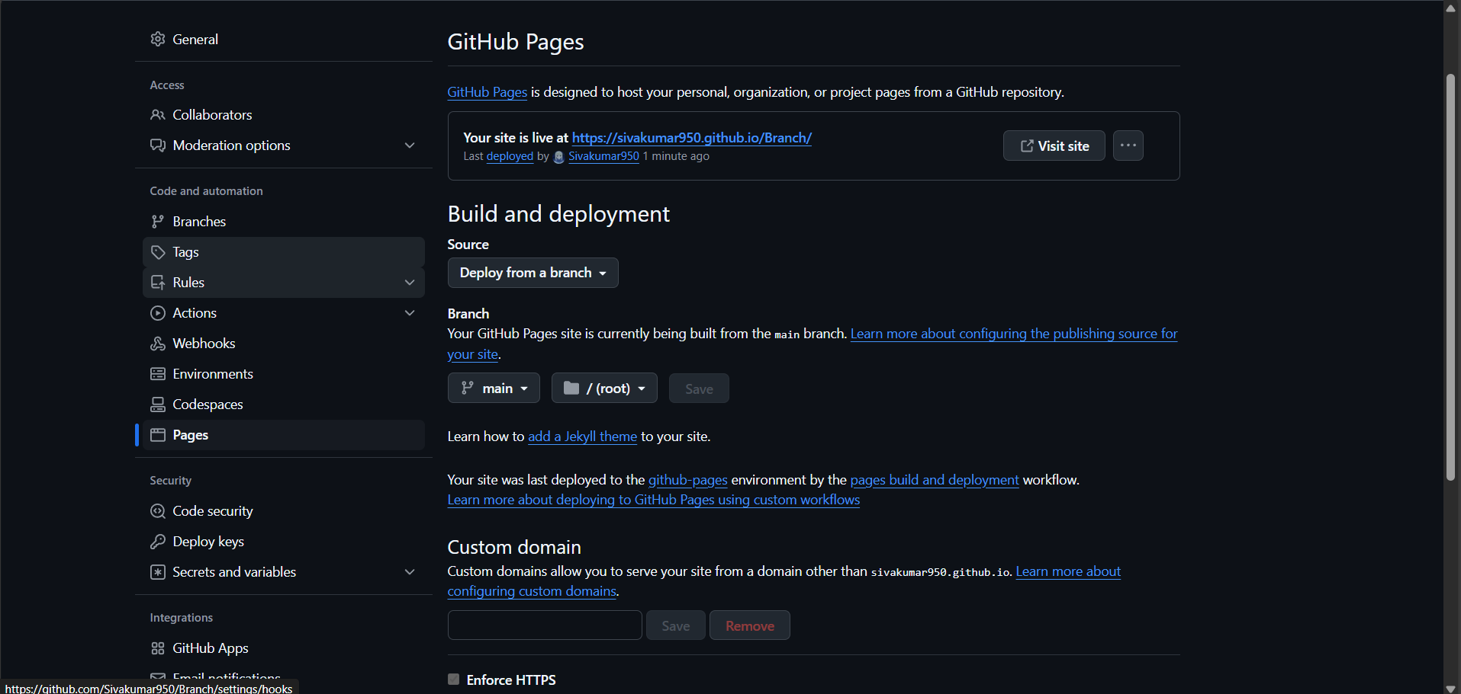

**STEP 8: Access Your Deployed Website:**  
After a few moments, GitHub Pages will provide a URL like:

https://your-username.github.io/my-static-website/

Open this URL to view your live static website.

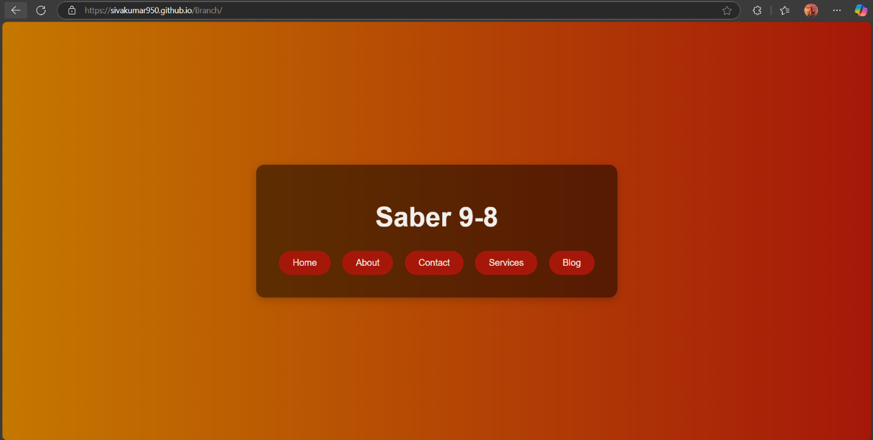

**Conclusion:**  
By following these steps, you can effectively deploy a static webpage using GitHub Pages. This approach is not only simple and efficient but also integrates well with version control, making it an ideal choice for personal projects and portfolios.