 

**Placement Empowerment Program**

***Cloud Computing and DevOps Centre***

Host a Static Website Locally: Set Up a Local Server Apache and Host a Simple HTML page with your name

Name: Sivakumar C Department : AML



**Introduction and Overview**

In this task, we use Apache lounge which is a web server to host your website. You will learn to install the Apache lounge and to host your static website using the Apache lounge .

**Objective**

The Final Objective of this project is to:

1. Set up a local web server using Apache.

2. Configure the server to host static files.

3. Create and host a simple HTML page displaying your name.

**Importance of Local Hosting**

Local hosting is an essential skill for developers, as it allows them to test and experiment with web applications in a controlled environment. It offers several advantages, such as:

**Hands-On Learning:** Gain practical experience with server setup and configuration.

**Testing Ground:** Safely test and debug websites before deploying them to a live server.

**Offline Development:** Work on web projects without requiring an active internet connection.

STEP 1:

Search Apache Lounge in your browser and download the .zip file according to your desktop recommendations.

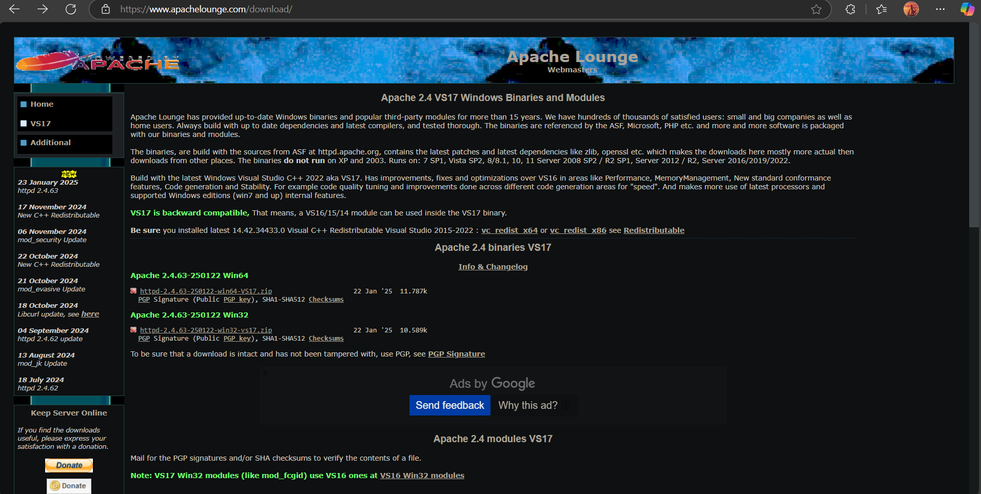

STEP 2:

Extract the .exe file in any locations you prefer.

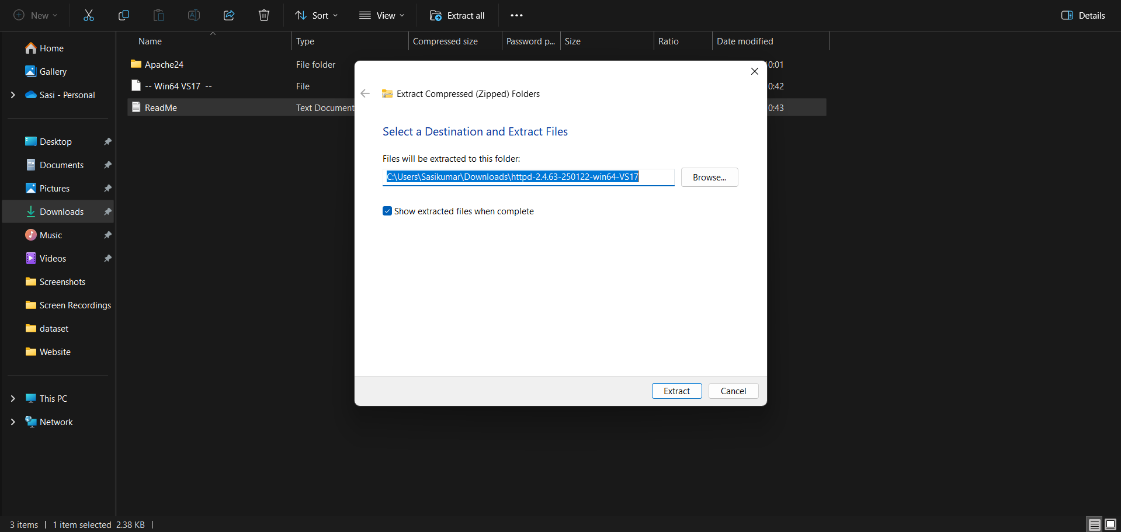

STEP3:

Go to the location where the httpd.conf is located. Within this , change the location to your directories where your apache lounge is located .

* Define SRVROOT "C:\Apache24\Apache24"
* DocumentRoot "C:\Apache24\Apache24\htdocs"
* <Directory "C:\Apache24\Apache24\htdocs">

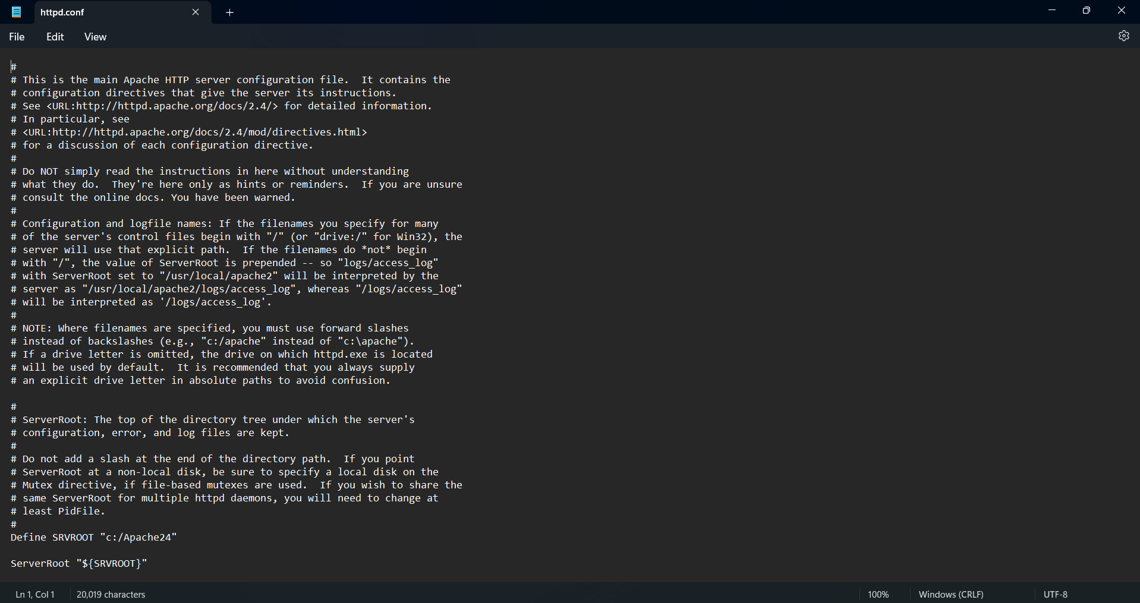

STEP 4:Open your CLI(Command Line Interface) and use the command -httpd install the Apache lounge web server.

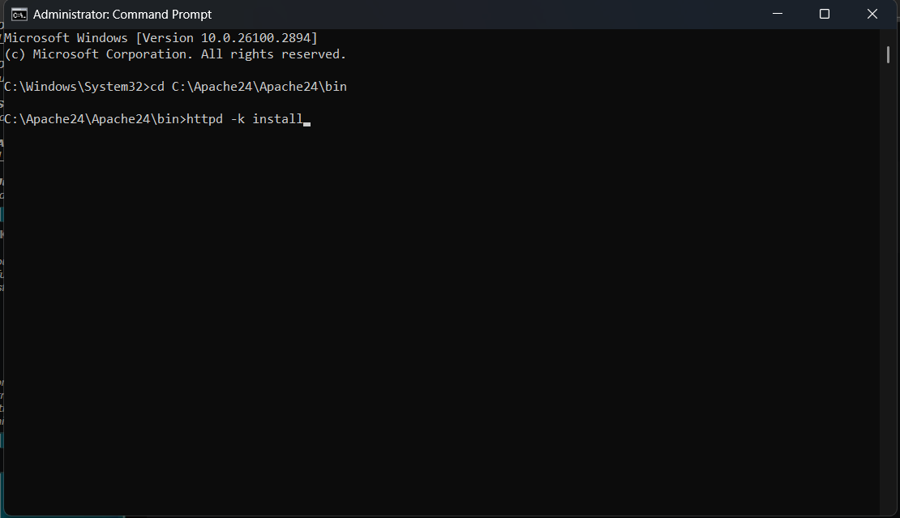

STEP 5:

In Windows, Press Window+R and search “services” and open it .Start the Apache services present in it and it will open the pre-existing website available within the server.

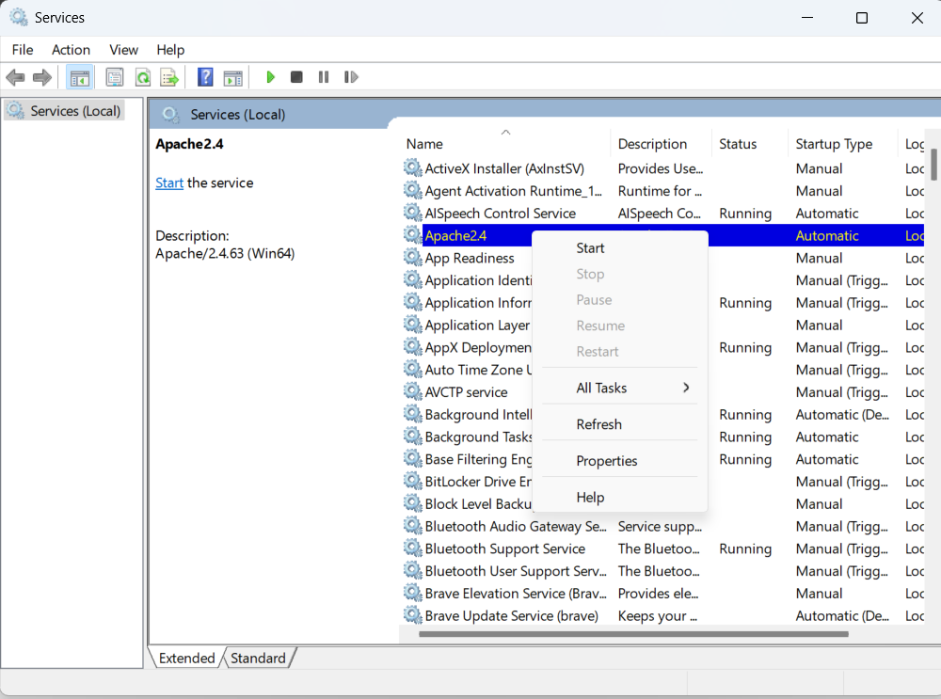

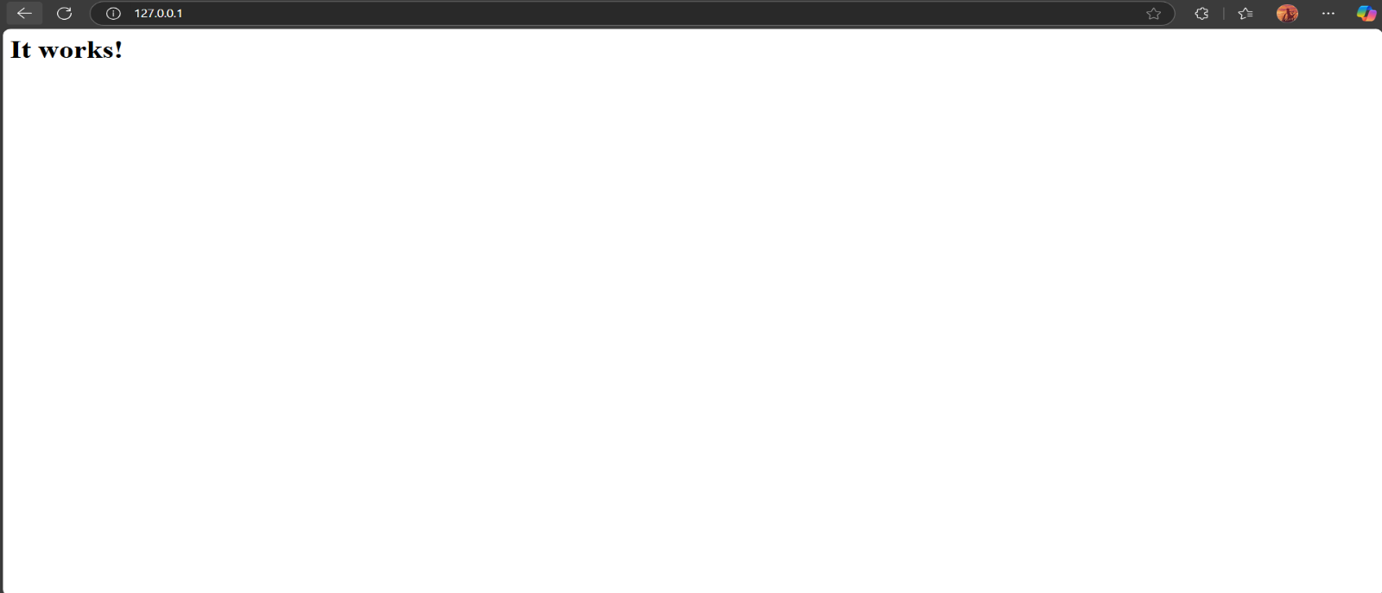

STEP 6:

Now Open the htdocs file located within the Apache24 folder.(eg: C:\Apache24\Apache24\htdocs). Replace the index.html file located inside the file with your html file.

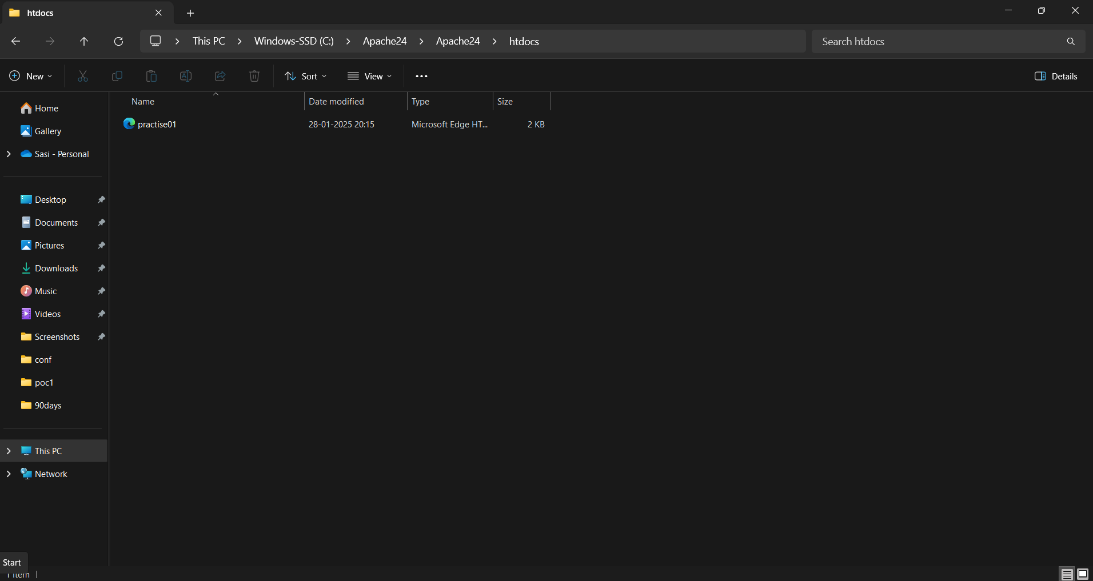

STEP 7:

Now repeat Step 5 and your website is hosted successfully within your local server.

