 

**Placement Empowerment Program**

***Cloud Computing and DevOps Centre***

**Host a Static Website on a Cloud VM**

Install Apache/Nginx on your cloud VM and host a simple HTML website.

Name: SIVAKUMAR C Department: AML



**Introduction and Overview**

Amazon EC2 (Elastic Compute Cloud) provides scalable computing capacity in the AWS cloud, allowing you to deploy and manage applications effortlessly. This document outlines the process to host a static website on an EC2 instance, making your content accessible over the internet.

**Objectives**

* Deploy a static website using an EC2 instance.
* Configure a web server (Apache or NGINX) to serve web content.
* Transfer website files securely to the EC2 instance.
* Make the website accessible via a public IP address.

**Importance**

* **Cost-Effective**: Utilize the AWS Free Tier with t2.micro instances for budget-friendly hosting.
* **Scalability:** Easily scale the infrastructure as traffic increases.
* **Flexibility:** Full control over the server environment for custom configurations.
* **Learning Opportunity:** Gain hands-on experience with cloud hosting and server management.

**STEPS:**

**STEP 1: Launch an EC2 Instance**

* Go to the AWS Management Console.
* Navigate to EC2 and click Launch Instance.
* Choose an Amazon Machine Image (AMI) like Amazon Linux 2.
* Select an instance type (e.g., t2.micro for free tier eligibility).
* Configure instance details as required.
* Add storage if needed.
* Add a security group:
  + Allow HTTP (port 80) for web traffic.
  + Allow SSH (port 22) for secure server access.
* Launch the instance and download the key pair (.pem file) for authentication.

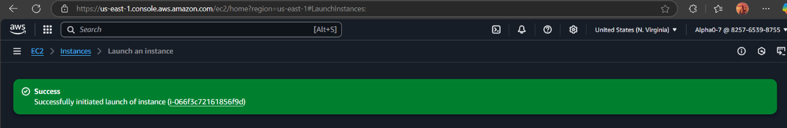

**STEP 2: Connect to Your EC2 Instance**

1. Open a terminal (or use PuTTY on Windows) in the location where the key pair is downloaded.
2. Run the following command to connect:

**ssh -i /path/to/your-key.pem ec2-user@<EC2-Public-IP>**

* + Replace /path/to/your-key.pem with the actual path to your key file.
  + Replace <EC2-Public-IP> with your EC2 instance’s public IP.

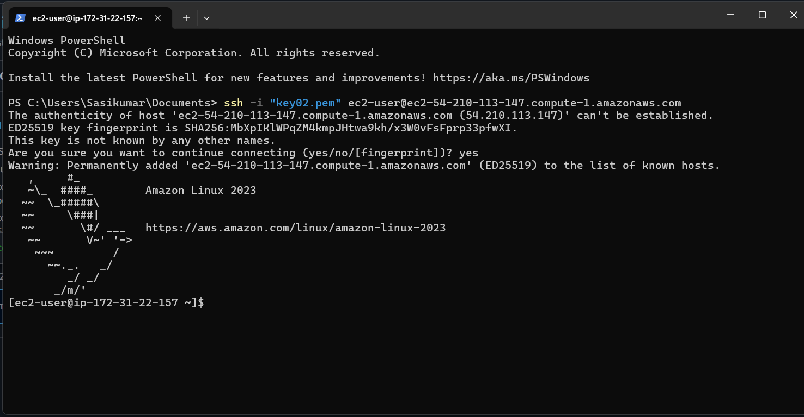

**STEP 3: Install a Web Server (Apache or NGINX)**

**For Apache:**

**sudo yum update -y**

**sudo yum install httpd -y**

**sudo systemctl start httpd**

**sudo systemctl enable httpd**

**For NGINX (optional):**

**sudo amazon-linux-extras enable nginx1**

**sudo yum install nginx -y**

**sudo systemctl start nginx**

**sudo systemctl enable nginx**





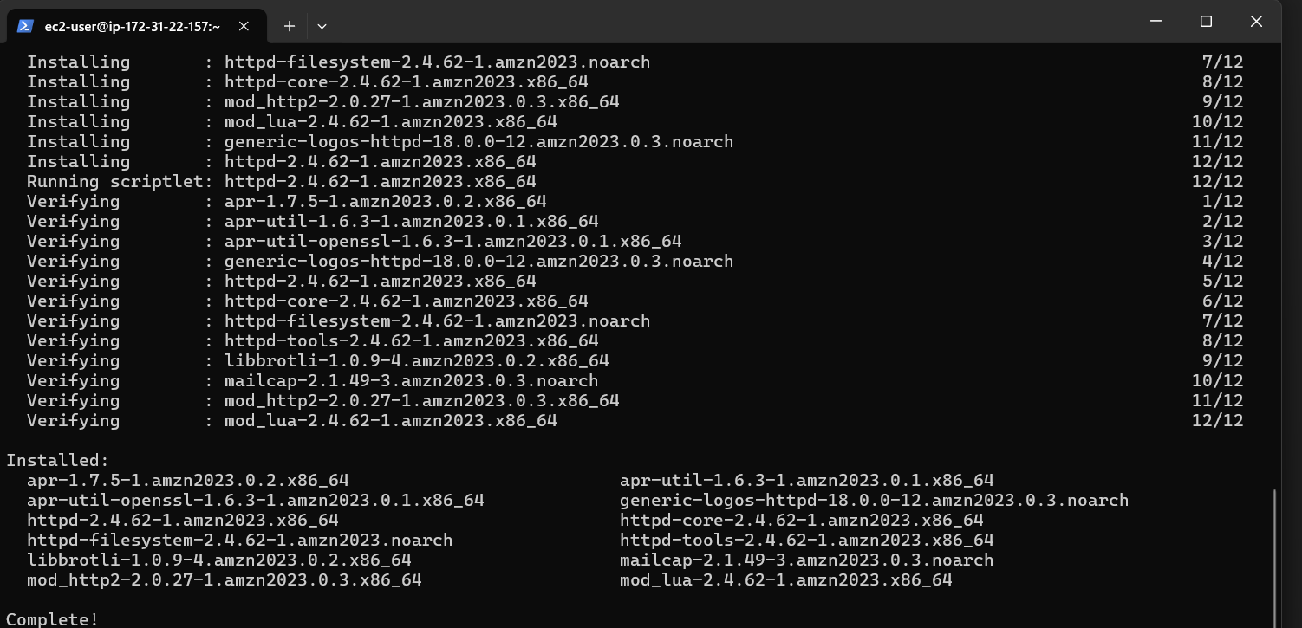



**STEP 4: Upload Your Website Files**

1. Exit the SSH session
2. Use SCP to upload your website files from your local machine:

**scp -i /path/to/your-key.pem -r /path/to/your-website ec2-user@<EC2-Public-IP>:/tmp**

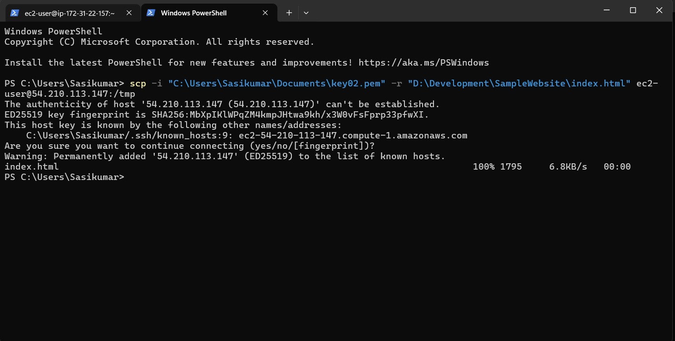

1. SSH back into the EC2 instance:

**ssh -i /path/to/your-key.pem ec2-user@<EC2-Public-IP>**

**STEP 5: Move the File to the Web Server Directory**

1. Move the website files to the web server directory:

**sudo mv /tmp/index.html /var/www/html/**



1. Restart the web server to apply changes:
2. **sudo systemctl restart httpd # For Apache**
3. **# OR**

**sudo systemctl restart nginx # For NGINX**



**STEP 6: Access Your Website**

Open a web browser and visit:

http://<EC2-Public-IP>

Replace <EC2-Public-IP> with your EC2 instance's public IP address to view your static website live.

