 

**Placement Empowerment Program**

***Cloud Computing and DevOps Centre***

**Set Up a Cloud-Based Monitoring** ServiceEnable basic cloud monitoring (e.g., CloudWatch on AWS). View metrics like CPU usage and disk I/O for your cloud VM.

Name: SIVAKUMAR C Department: AML



**Introduction and Overview**

Cloud-based monitoring is essential for keeping track of the performance and health of your cloud infrastructure. AWS CloudWatch provides a comprehensive monitoring solution that allows users to collect and track metrics, monitor log files, and set alarms for AWS resources like EC2 instances. By using CloudWatch, you can ensure the smooth operation of your systems and respond to performance anomalies proactively.

**Objectives**

* To enable CloudWatch monitoring for an EC2 instance.
* To view and analyze performance metrics such as CPU usage and disk I/O.
* To set up alarms to be notified of any performance issues or anomalies.

**Importance**

* **Performance Monitoring**: CloudWatch allows you to track various metrics like CPU utilization, disk I/O, network activity, etc., helping you understand the performance of your cloud VM.
* **Proactive Issue Resolution**: With CloudWatch alarms, you can be notified of issues in real time, allowing for quick resolution before they affect your systems.
* **Resource Optimization**: By analyzing the metrics, you can optimize your cloud resources, ensuring they are appropriately scaled to meet your needs while minimizing costs.
* **Operational Efficiency**: Automated monitoring and alerting increase the efficiency of your operations by allowing you to focus on critical issues without constantly checking the system manually.

**STEPS:**

**STEP 1: Enable CloudWatch Monitoring for Your EC2 Instance**

* Log in to the AWS Management Console and navigate to the EC2 Dashboard.
* Select the EC2 instance you want to monitor.
* In the Instance Details section, click Actions > Monitor and Troubleshoot > Manage Monitoring.

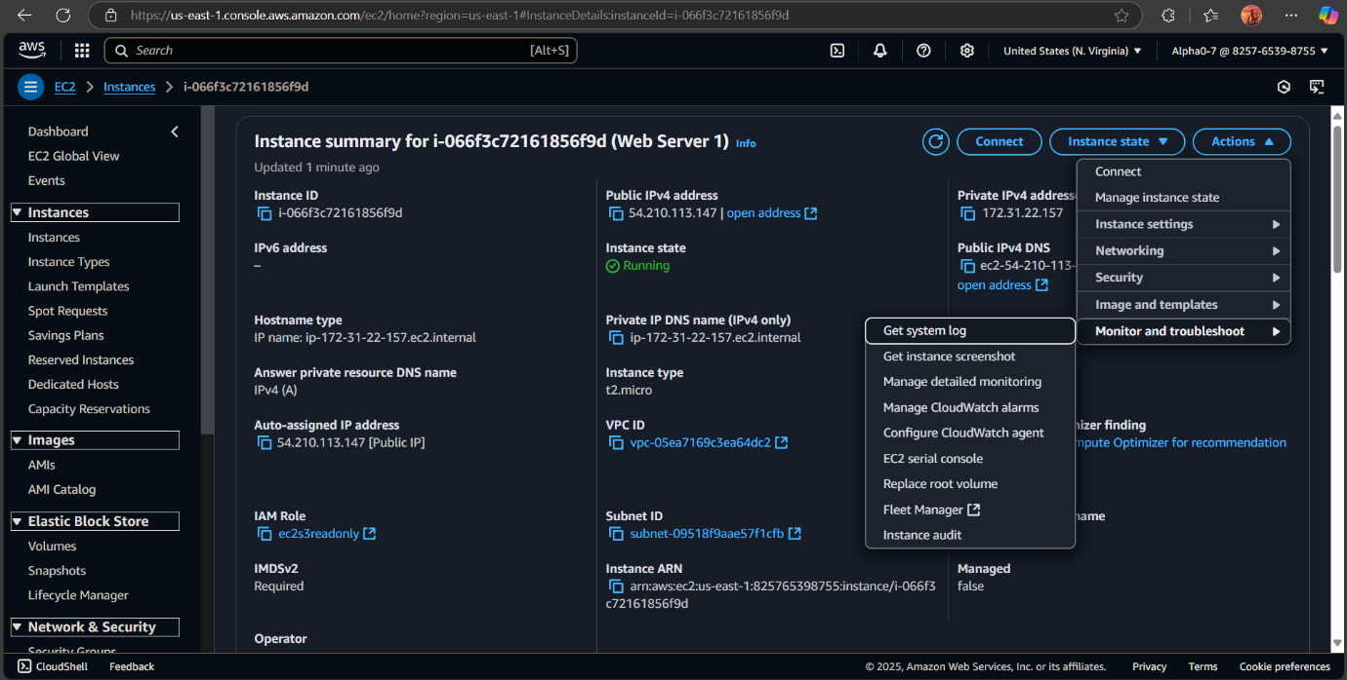

* Enable Detailed Monitoring by checking the box, which provides metrics at 1-minute intervals.

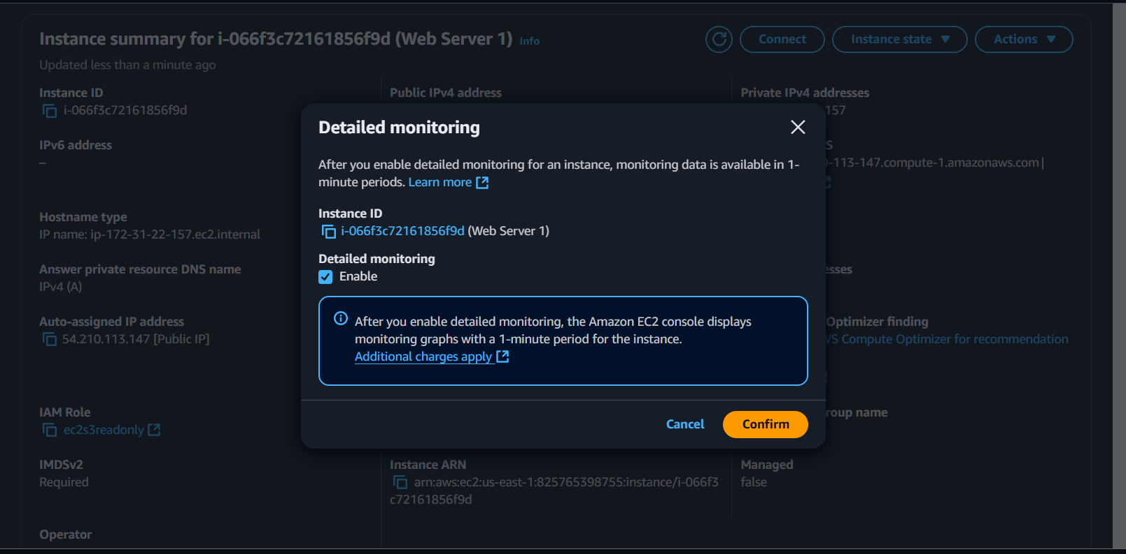

* Click Apply to enable detailed monitoring for the instance**.**

**Step 2: Access CloudWatch Metrics**

* Navigate to the CloudWatch Dashboard by searching for CloudWatch in the AWS Management Console.
* In the CloudWatch dashboard, click on Metrics in the left-hand sidebar.

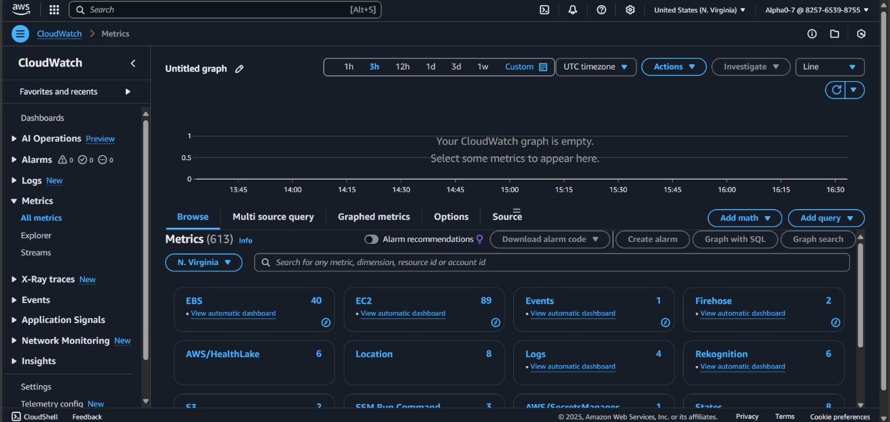

* Under the EC2 section, you’ll find various metrics categories such as Per-Instance Metrics, CPU Utilization, Disk I/O, etc.

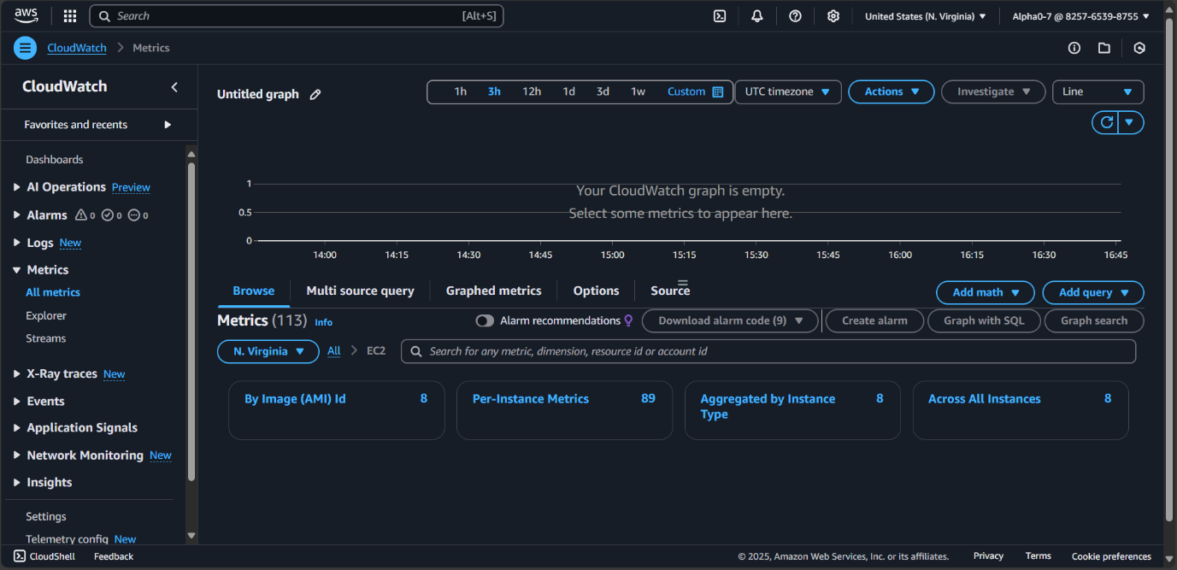

* Select the desired metric to view performance details (e.g., CPU Utilization, Disk I/O).

**Step 3: Analyze Metrics**

1. Once the metrics are selected, CloudWatch will display graphical representations of the metrics over time.
2. Review the metrics to identify trends and performance issues. Metrics such as CPU utilization and disk I/O are essential for assessing the health of your VM.

