 

**Placement Empowerment Program**

***Cloud Computing and DevOps Centre***

**Deploy a Web Application on the Cloud**

Write a Python Flask application and deploy it on your cloud VM. Configure the firewall to allow HTTP traffic.

Name: SIVAKUMAR C Department: AML



**Introduction and Overview**

This document outlines the process of deploying a simple Python Flask web application on an AWS EC2 instance. The guide covers creating a Flask app, transferring it to the EC2 instance, configuring security groups to allow HTTP traffic, and running the application successfully.

**Objectives**

* To develop a basic Python Flask web application.
* To deploy the Flask app on an AWS EC2 instance.
* To configure security settings to allow HTTP traffic on port 5000.
* To verify the app's accessibility over the internet.

**Importance**

* **Cloud Deployment Skills:** Demonstrates the ability to deploy applications in a real cloud environment.
* **Web Accessibility:** Ensures the app can be accessed from anywhere globally.
* **Security Configuration:** Provides hands-on experience with configuring security groups and firewall rules.
* **Practical AWS Knowledge:** Enhances practical understanding of AWS EC2, SSH, and server management.

**STEPS:**

**STEP 1: Write a Simple Flask Application:**Create a Python file named app.py with the following code:

**from flask import Flask**

**app = Flask(__name__)**

**@app.route('/')**

**def home():**

**return "Hello, Cloud World!"**

**if __name__ == '__main__':**

**app.run(host='0.0.0.0', port=5000)**

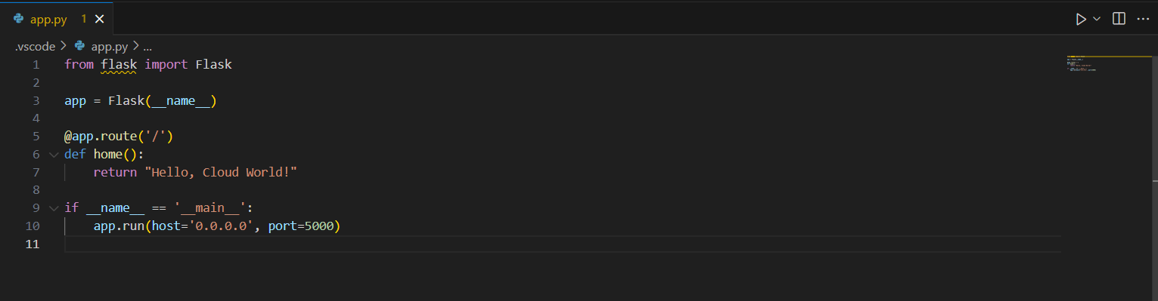

**STEP 2: Prepare Your EC2 Instance**:

* + Connect to your EC2 instance:

ssh ec2-user@your-ec2-public-ip

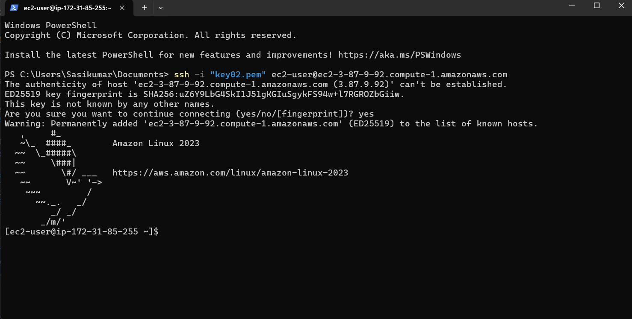

* + Update packages:

sudo yum update -y

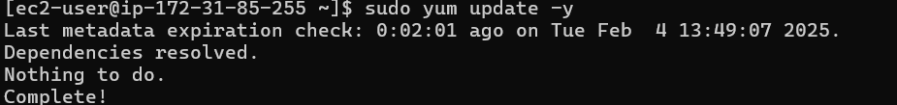

* + Install Python and pip:

sudo yum install python3 python3-pip -y

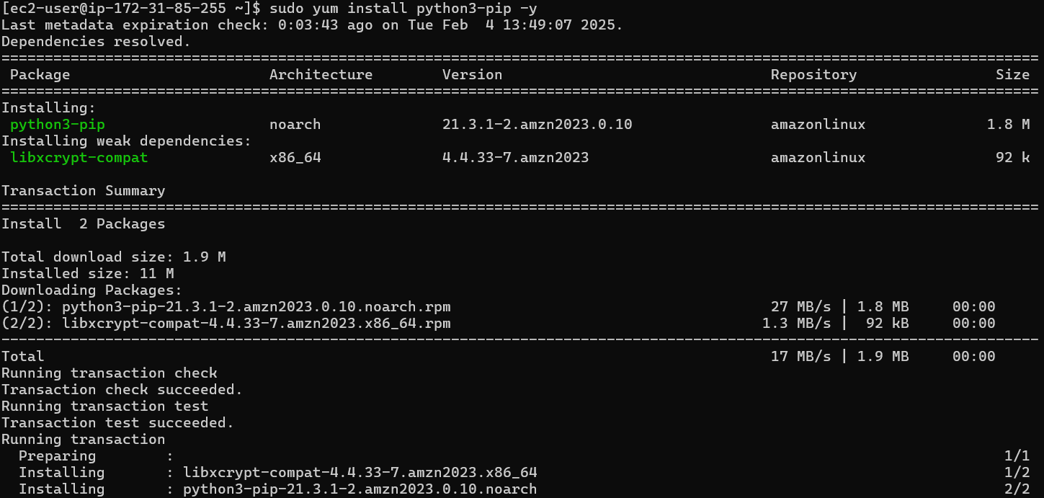

* + Install Flask:

pip3 install Flask

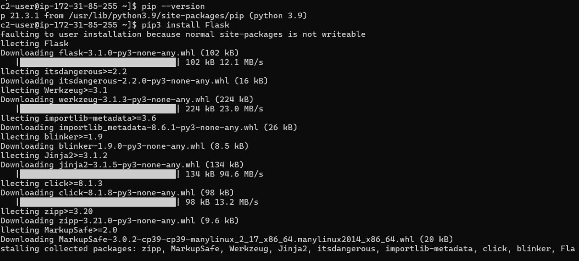

**STEP 3: Transfer the Flask App to the EC2 Instance:**

Open a terminal From your local machine and run the command:

**scp -i "path/to/key.pem" "D:/path/to/app.py" ec2- user@your-ec2-public-ip:/home/ec2-user/**

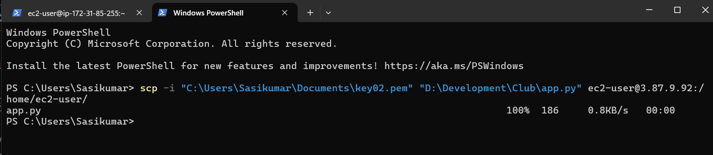

* Change the directories with your key pair and flask app location and your EC2 public IP

**STEP 4: Run the Flask App on the EC2 Instance:**

**python3 app.py**

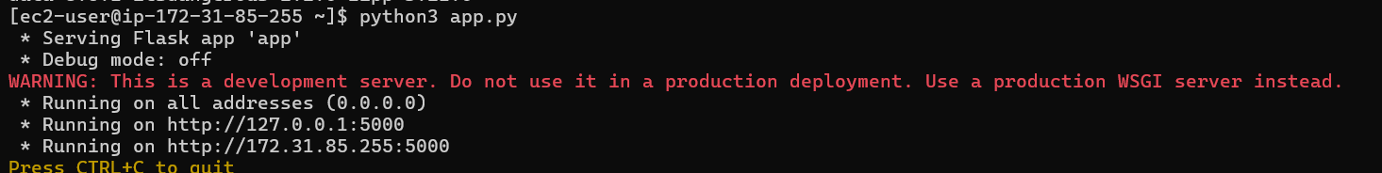

**STEP 5: Configure the Firewall (Security Group Settings):**

* + Go to AWS Console → EC2 Dashboard → Security Groups → Inbound Rules → Edit.
  + Add a rule:
    - Type: Custom TCP
    - Protocol: TCP
    - Port Range: 5000
    - Source: 0.0.0.0/0 (or specific IP for more security)



* + Save the rules.

**STEP 6: Access the Application:**  
 Open a browser and go to:

**http://your-ec2-public-ip:5000**

You should see "Hello, Cloud World!" displayed.

