 

**Placement Empowerment Program**

***Cloud Computing and DevOps Centre***

**Use Cloud CLI Tools**

Install the CLI for your cloud provider (e.g., AWS CLI). Use it to list resources, upload files to storage, and manage VMs.

Name: SIVAKUMAR C Department: AML



**Introduction and Overview**

This document outlines the process of installing and using the AWS Command Line Interface (CLI) to manage cloud resources efficiently. The AWS CLI allows users to interact with AWS services through terminal commands, providing a powerful way to automate tasks, list resources, upload files, and manage virtual machines (VMs).

**Objectives**

* To install the AWS CLI on a local machine.
* To configure the AWS CLI for secure access to AWS services.
* To list various AWS resources using CLI commands.
* To upload files to Amazon S3 buckets.
* To manage AWS EC2 instances through the CLI.

**Importance**

* **Automation Efficiency:** Streamlines cloud resource management through automation.
* **Faster Operations:** Reduces the time required for repetitive tasks compared to using the AWS Console.
* **Script Integration:** Enables easy integration into deployment scripts for CI/CD pipelines.
* **Enhanced Cloud Proficiency:** Strengthens skills in AWS services management from the command line.

**STEPS:**

**STEP 1: Install the AWS CLI:**

* + For Windows:
    - Download the installer from the [AWS CLI official page](https://aws.amazon.com/cli/).
    - Run the installer and follow the on-screen instructions.

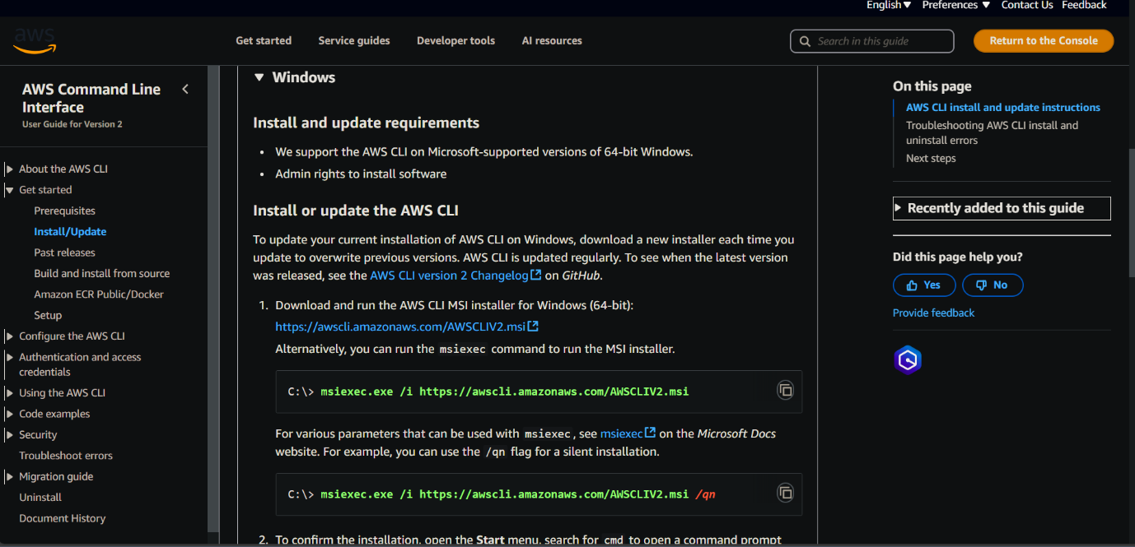

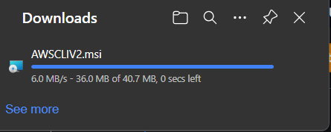

**STEP 2: Verify the Installation:**

**aws –version**

Output should display the AWS CLI version installed.

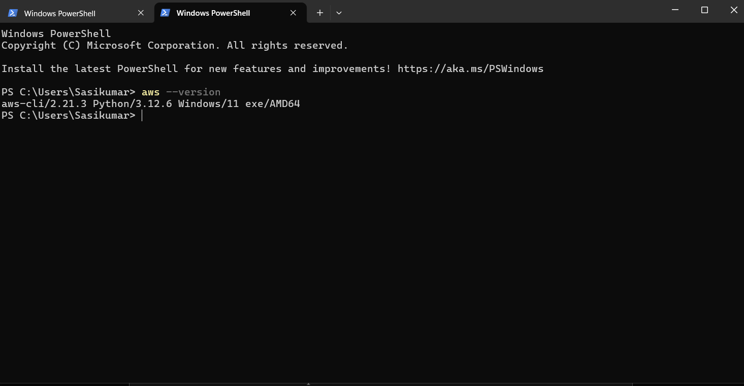

**STEP 3: Create an Access Key for AWS CLI:**

* Sign in to the [AWS Management Console](https://aws.amazon.com/console/).
* Go to the **Security credentials** tab.

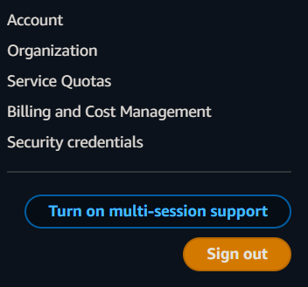

* Under **Access keys**, click **Create access key**.

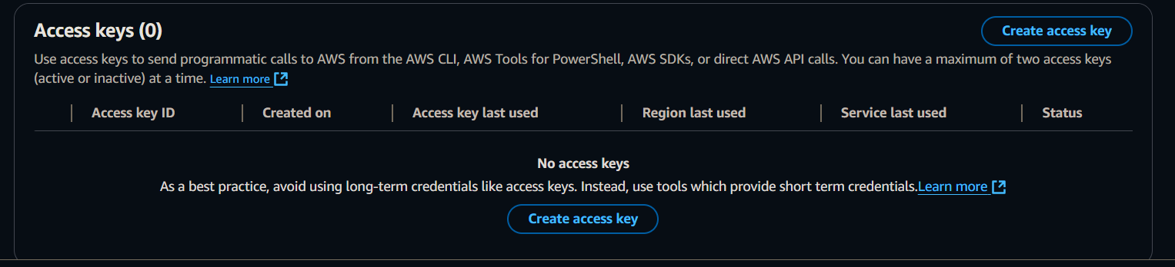

* Select Command Line Interface as Use case

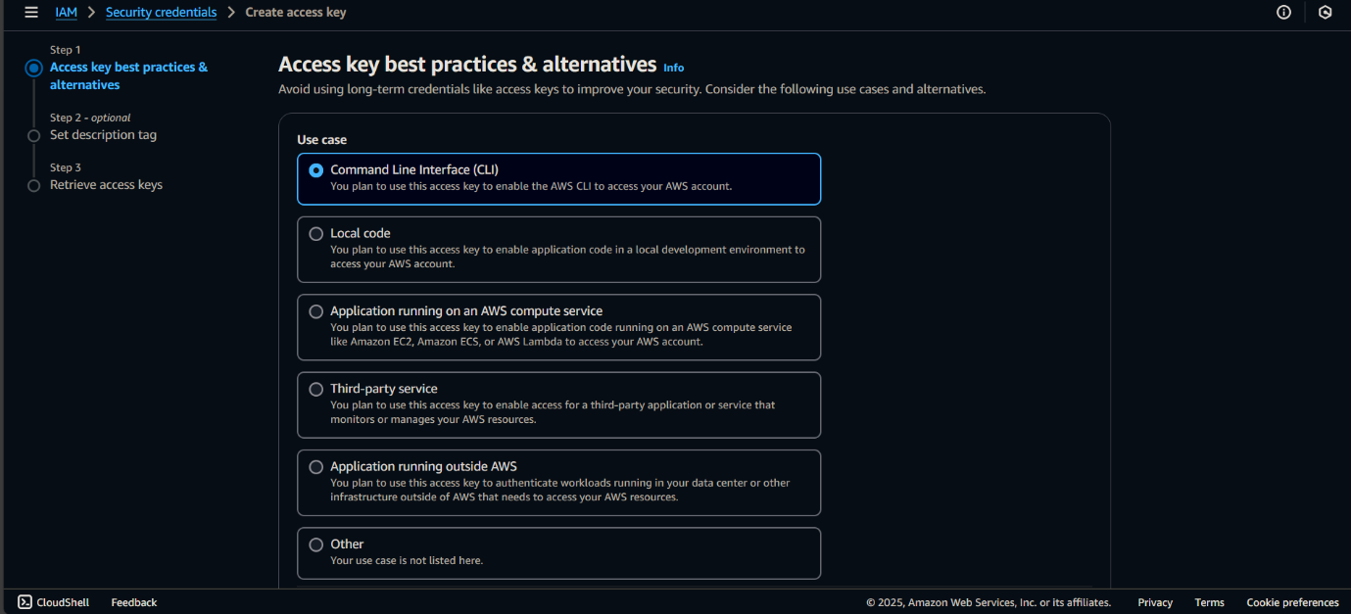

* Download the .csv file containing your **Access Key ID** and **Secret Access Key**

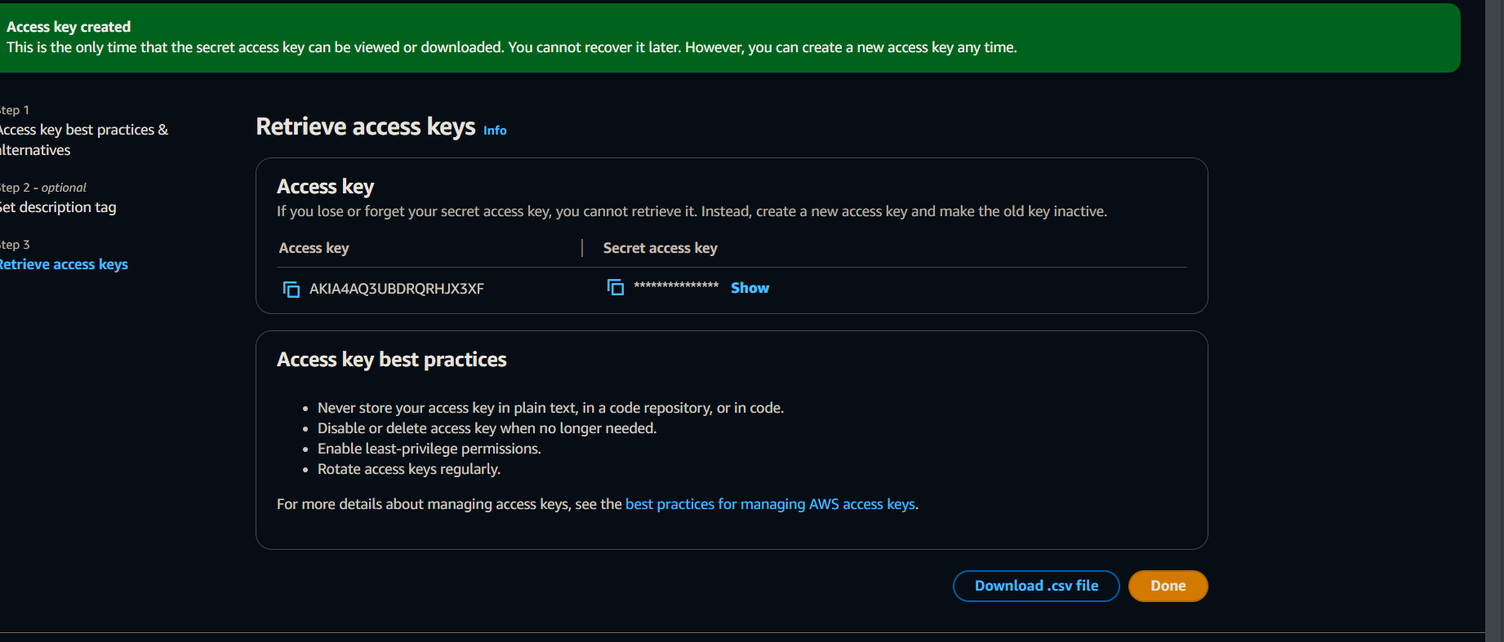

**STEP 4: Configure the AWS CLI:**

**aws configure**

Provide the following details when prompted:

* + AWS Access Key ID
  + AWS Secret Access Key
  + Default region name (e.g., us-east-1)
  + Default output format (e.g., json)

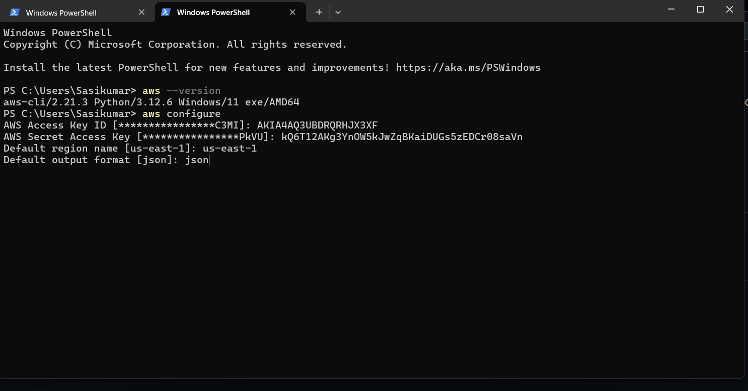

**STEP 5: List AWS Resources:**

* + List all S3 buckets:

**aws s3 ls**

