 

**Placement Empowerment Program**

***Cloud Computing and DevOps Centre***

**Back Up and Restore a Cloud Instance**

Take a snapshot of your cloud VM. Terminate the VM and restore it from the snapshot.

Name: SIVAKUMAR C Department: AML



**Introduction and Overview**

Backing up and restoring cloud instances in AWS is crucial for ensuring data integrity and business continuity. AWS provides flexible options to create snapshots of Elastic Block Store (EBS) volumes, allowing seamless restoration of EC2 instances in case of failures or unexpected issues.

**Objectives**

* To create a backup of an EC2 instance using EBS snapshots.
* To restore an EC2 instance from the snapshot.
* To ensure data and application continuity after restoration.
* To verify the restored instance functions identically to the original.

**Importance**

* **Data Protection:** Safeguards critical data against accidental deletion or corruption.
* **Disaster Recovery:** Enables quick recovery during system failures or outages.
* **Business Continuity:** Ensures uninterrupted access to applications and services.
* **Operational Efficiency:** Simplifies the recovery process with minimal manual intervention.

**STEPS:**

**STEP 1: Create an EC2 Instance with User Data**

* Go to the AWS Management Console → EC2 → Launch Instance.

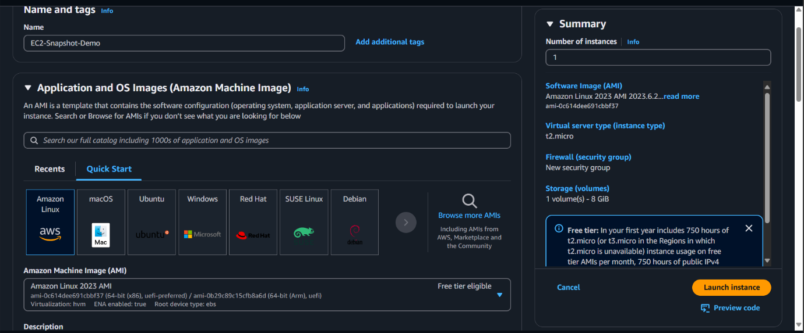

* Choose an Amazon Machine Image (AMI), e.g., Amazon Linux 2.
* Select an instance type like t2.micro.

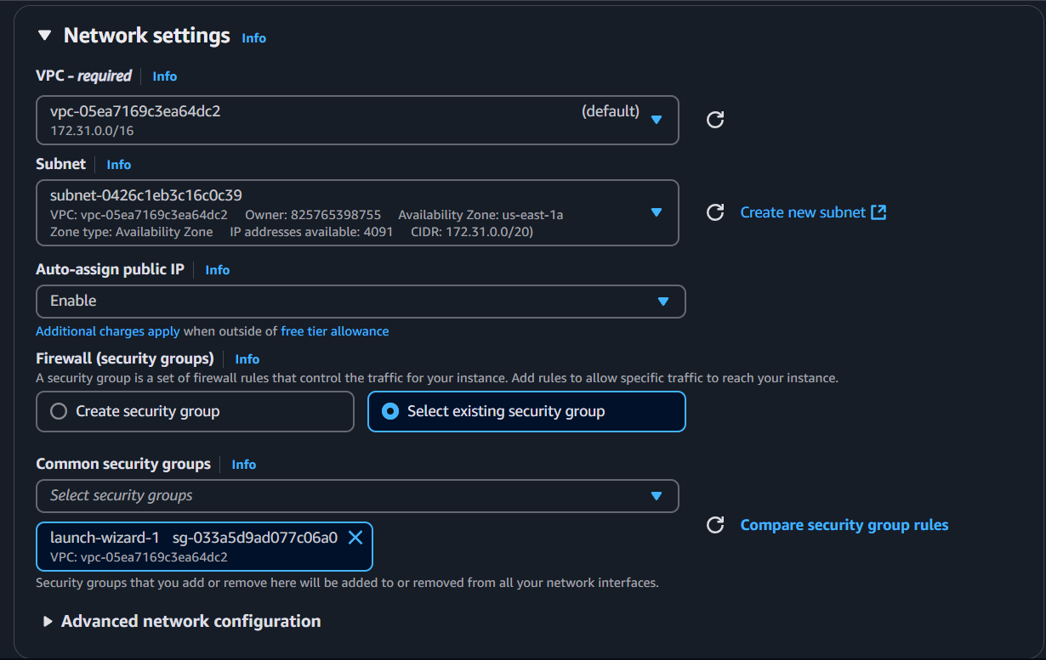

* In the Configure Instance section, add the following code in the User Data field to install Apache and display a custom message:

#!/bin/bash

yum update -y

yum install -y httpd

systemctl start httpd

systemctl enable httpd

echo "<h1>Hello World from $(hostname -f)</h1>" > /var/www/html/index.html

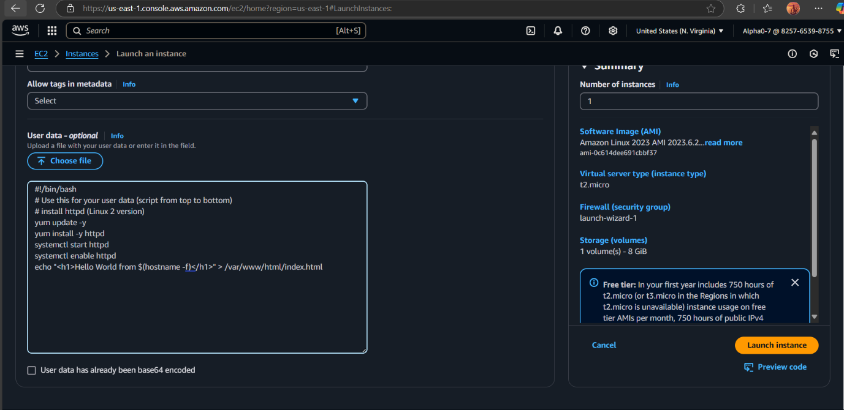

* Configure security groups to allow HTTP and SSH access.
* Launch the instance.

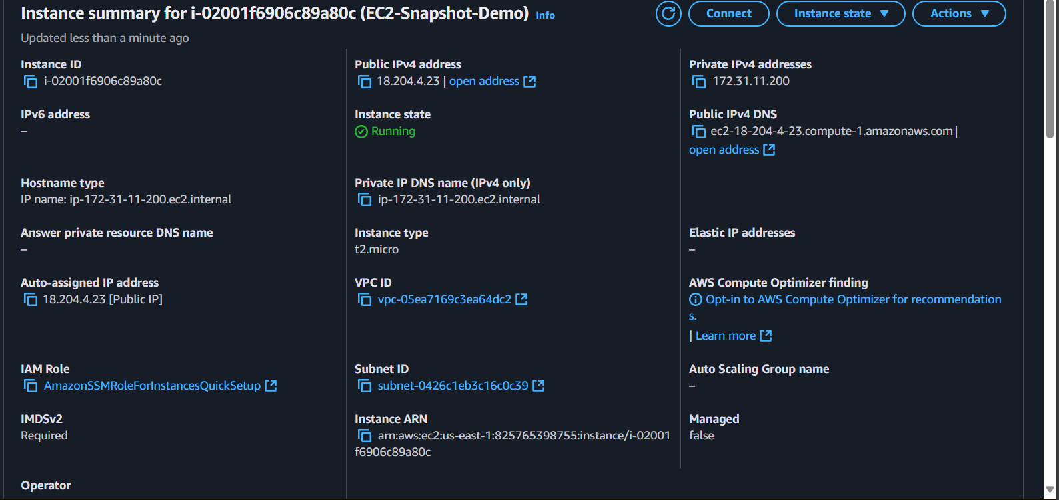

**STEP 2: Locate the EBS Volume and Create a Snapshot**

* Go to **EC2 Dashboard** → **Volumes** under **Elastic Block Store**.
* Identify the EBS volume attached to your EC2 instance.

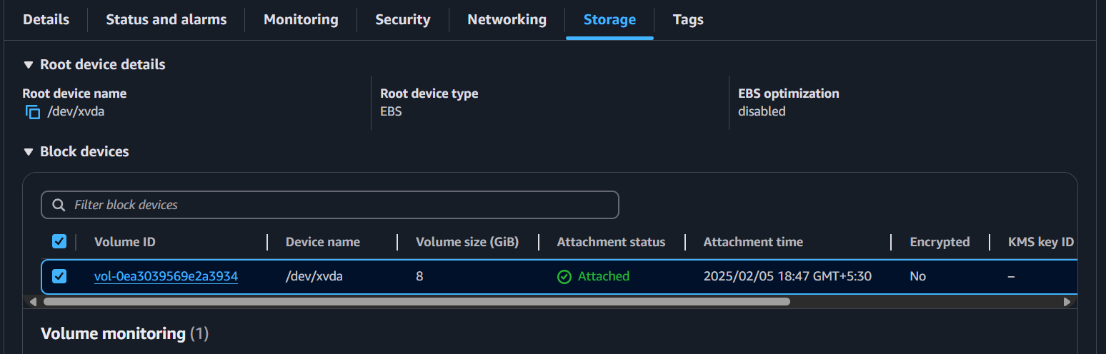

* Select the volume → **Actions** → **Create Snapshot**.

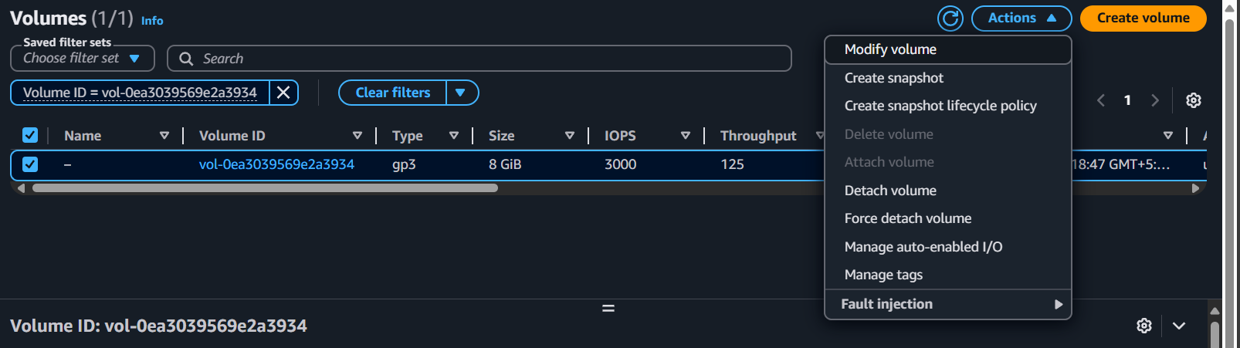

* Provide a name and description for easy identification.

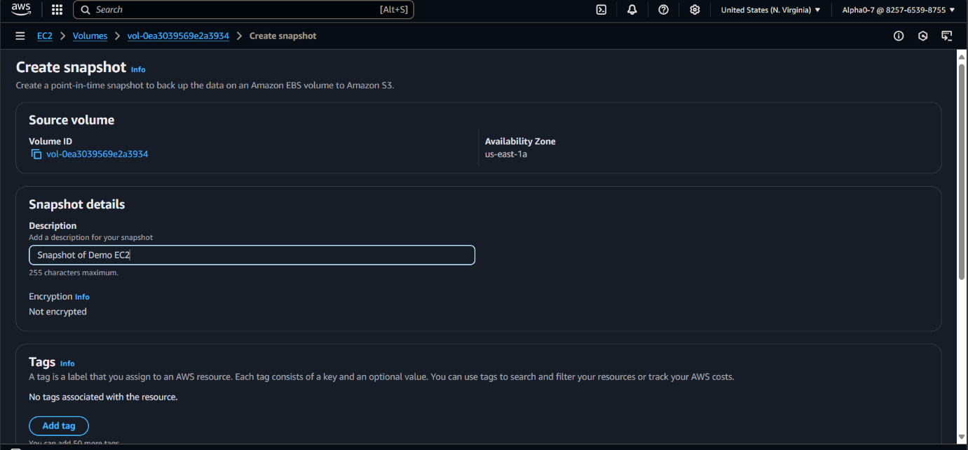

* Click **Create Snapshot**.

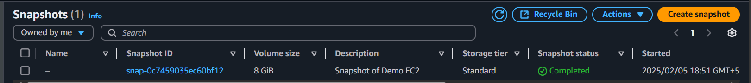

**STEP 3: Terminate the EC2 Instance**

1. Go to **EC2 Dashboard** → **Instances**.
2. Select the instance you created.

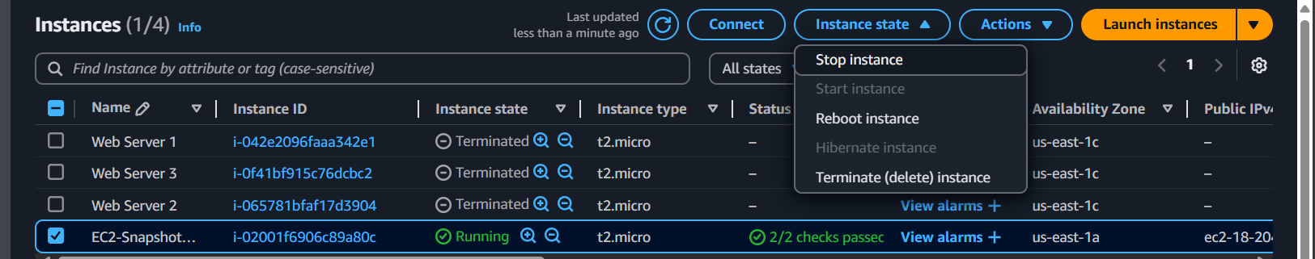

1. Click **Instance State** → **Terminate Instance**.
2. Confirm the termination.



**STEP 4: Create an AMI from the Snapshot**

1. Navigate to **Snapshots** under **Elastic Block Store**.
2. Select the snapshot you created.
3. Click **Actions** → **Create Image**.

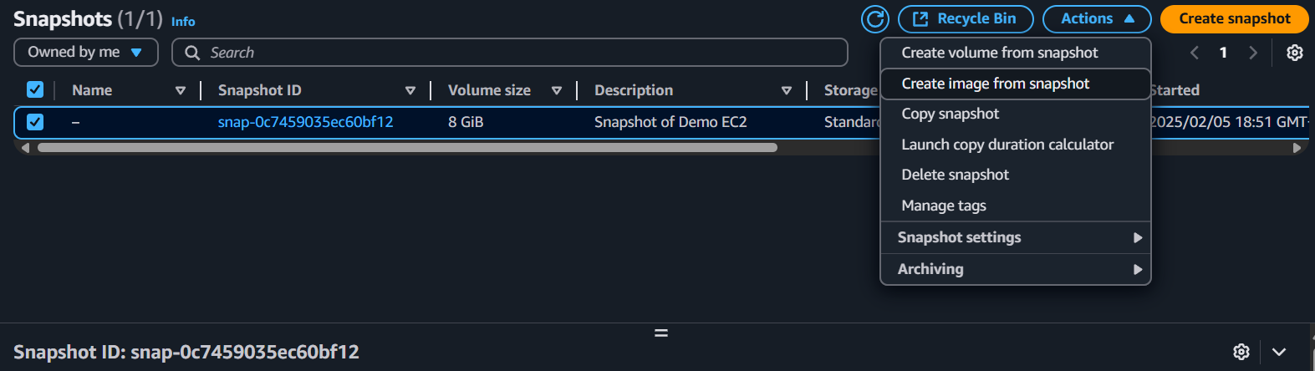

1. Provide an image name and change the root device name to **/dev/xvda**
2. Ensure the **Block Device Mapping** matches the original instance’s configuration.

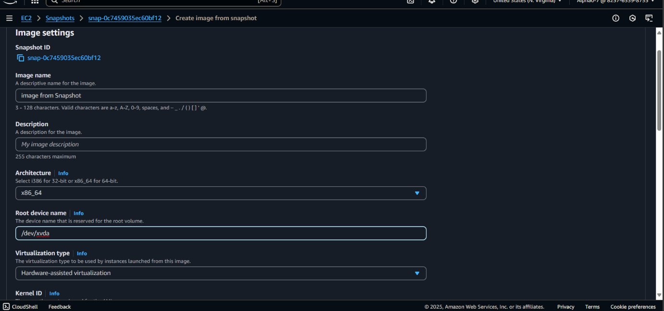

1. Click **Create Image**.

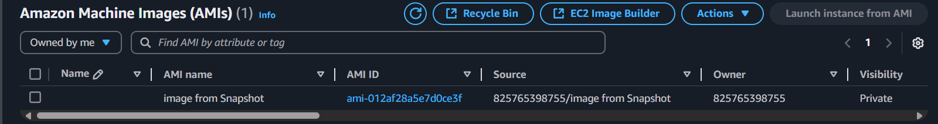

**STEP 5: Launch an EC2 Instance from the AMI**

1. Go to **EC2 Dashboard** → **AMIs**.
2. Select the AMI created from the snapshot.

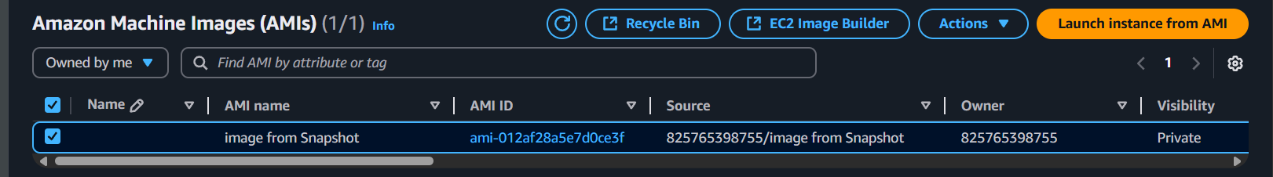

1. Click **Launch**.
2. Choose the instance type, configure security settings, and launch the instance (no need to add User Data).

**STEP 6: Verify the Restored Instance**

1. Copy the **IPv4 Public Address** of the new EC2 instance.
2. Paste it into your browser.

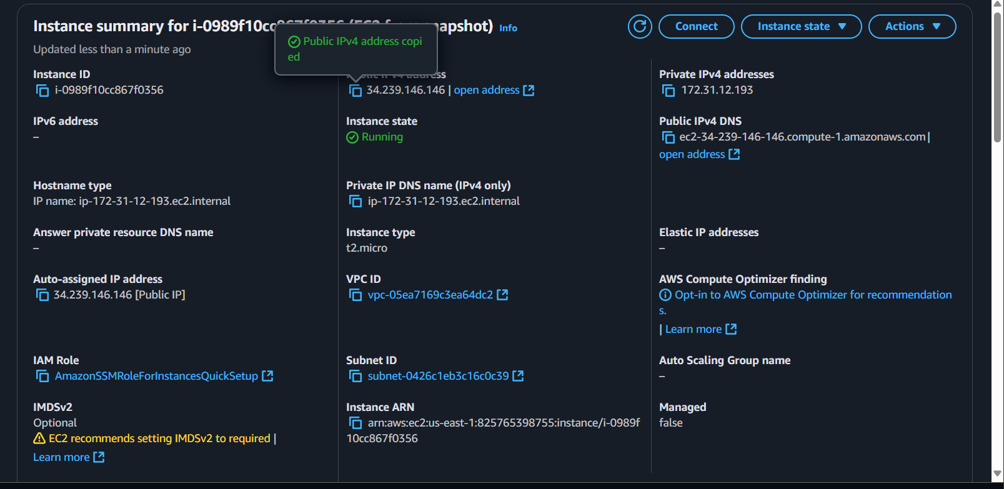

1. You should see the custom HTML message:

Hello World from [hostname]

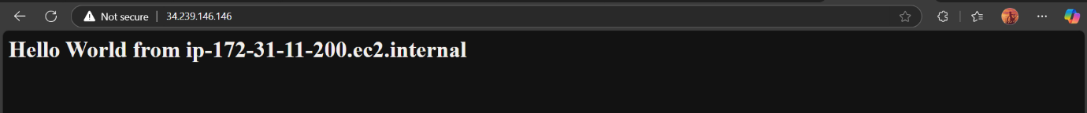

This confirms that the instance was successfully restored from the snapshot, retaining all original configurations and data.