 

**Placement Empowerment Program**

***Cloud Computing and DevOps Centre***

**Implement DNS for Your Application:**

Set up a DNS record to map your web application’s IP or load balancer to a domain name.

Name: Sivakumar C Department: AML



**Introduction**

Domain Name System (DNS) plays a crucial role in making applications accessible through human-readable domain names instead of numerical IP addresses. This document provides a step-by-step guide to setting up a DNS record for mapping a web application’s IP or load balancer to a domain name using a cloud provider’s DNS service (e.g., AWS Route 53). By following this guide, users can efficiently link their applications to a domain and access them seamlessly through a browser.

**Objectives**

* Configure DNS for a web application.
* Set up an A record pointing to the application’s public IP or load balancer.
* Verify DNS resolution and ensure the domain is accessible.
* Improve application accessibility and user experience.

**Importance**

* **Simplified Access:** Users can access applications using a domain name instead of an IP address.
* **Scalability:** Enables smooth transitions when changing server IPs without affecting user access.
* **Branding:** A domain name enhances the professionalism and credibility of an application.
* **Load Balancing Support:** Helps in distributing traffic efficiently when mapped to a load balancer.
* **Security:** Allows easier integration with SSL/TLS certificates for secure access.

**STEPS:**

**STEP 1:** **Purchase a Domain Name**

* Register a domain through a domain registrar (e.g., AWS Route 53, Namecheap, GoDaddy).

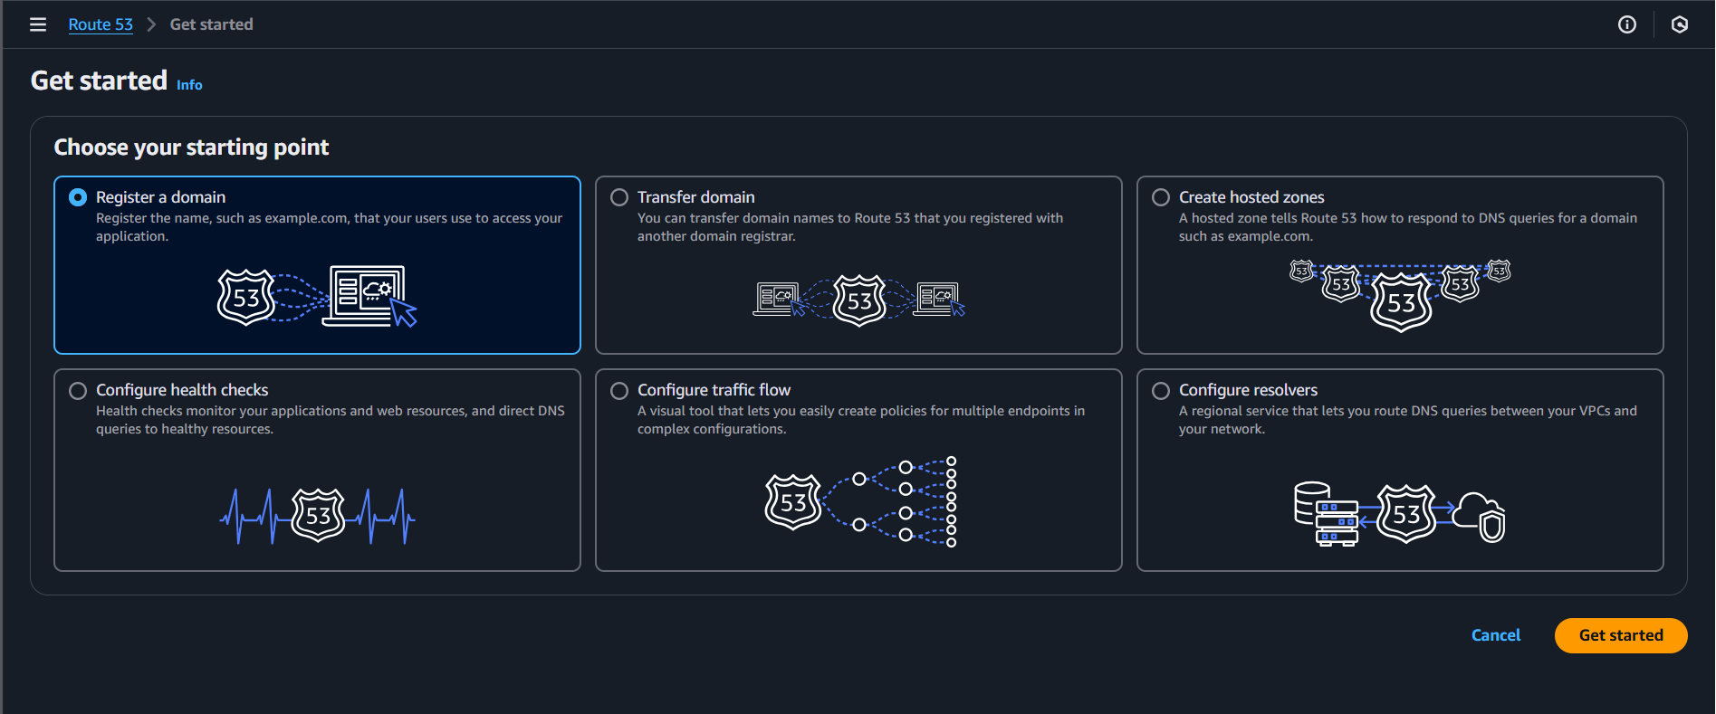

* Ensure the domain is active and ready for DNS configuration.

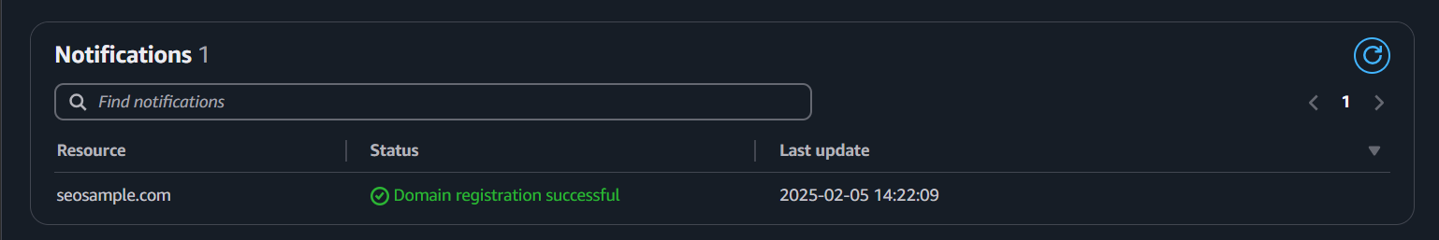

**STEP 2: Set Up a Hosted Zone in Route 53**

* Log in to the AWS Management Console.
* Navigate to AWS Route 53.
* Create a Hosted Zone for your registered domain.
* AWS will generate default NS (Name Server) and SOA (Start of Authority) records.

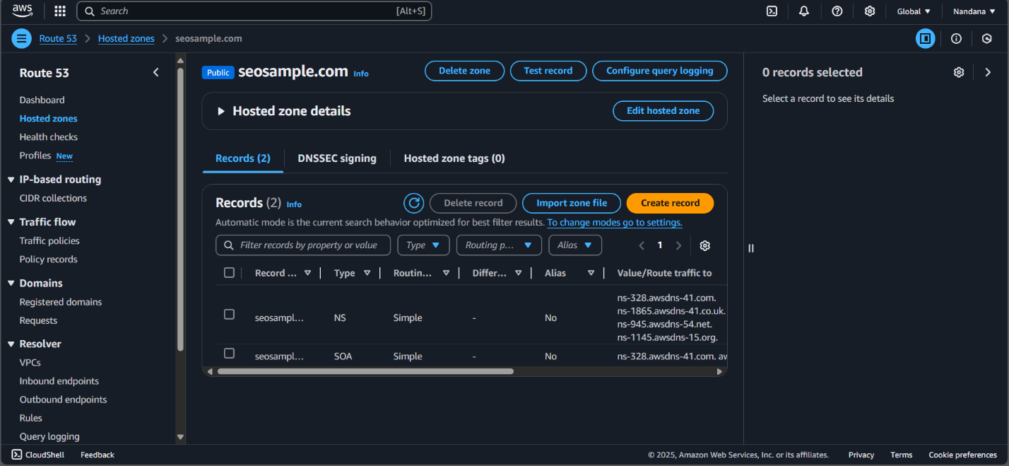

**STEP 3: Create an A Record to Map Your Domain to an IP or Load Balancer**

* In Route 53, go to the Hosted Zone of your domain.
* Click Create Record and select the A Record type.
* Enter the domain name (e.g., www.yourdomain.com).
* In the value field:
  + Enter the public IP of your web application (for a single server setup).
  + OR select Alias and choose the Load Balancer (for scalable applications).
* Save the record.

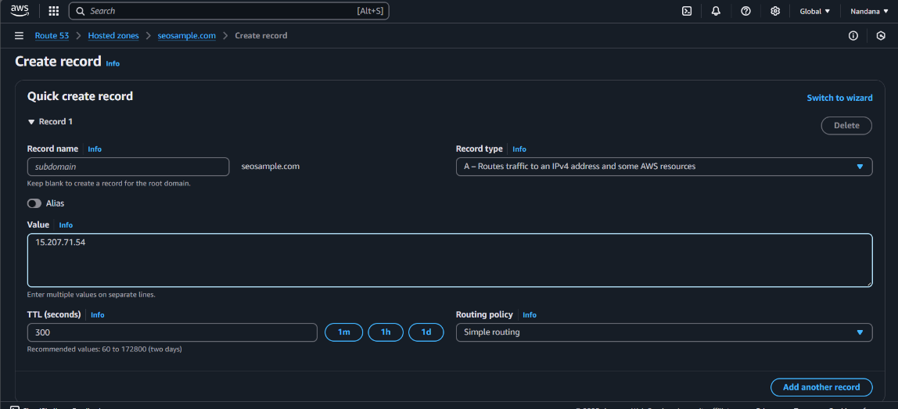

**STEP 5: Test DNS Resolution**

* Use the following commands to verify the DNS propagation:

**nslookup yourdomain.com**

**dig yourdomain.com**

* Open a browser and enter the domain name to check if it correctly directs to your application.
* It may take a few minutes to hours for DNS changes to propagate globally.

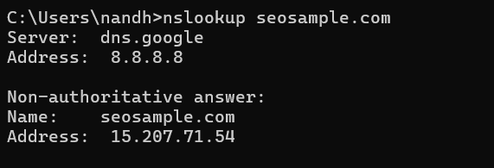

**Acknowledgment:** *Some of the images used in this document are sourced from available materials for demonstration purposes. Credit goes to the original creators for their work.*