 

**Placement Empowerment Program**

***Cloud Computing and DevOps Centre***

**Write a Shell Script to Manage Cloud Resources:**

Create a script to launch, stop, and terminate cloud VMs using the CLI.

Name: Sivakumar C Department: AML



**Introduction**

Managing cloud resources efficiently is essential for optimizing cloud infrastructure. This document provides a step-by-step guide to creating and executing a PowerShell script to manage AWS EC2 instances. The script allows users to list, start, stop, and terminate EC2 instances using the AWS CLI. By following the instructions, users can automate routine cloud management tasks and ensure better resource control.

**Objectives**

* Automate EC2 instance management using PowerShell.
* Execute AWS CLI commands within a PowerShell script.
* Provide a user-friendly interface to manage cloud resources.
* Enable users to interact with AWS EC2 instances seamlessly.
* Improve cloud administration efficiency and reduce manual effort.

**Importance**

* **Automation:** Reduces the need for manual intervention in EC2 instance management.
* **Efficiency:** Saves time by streamlining repetitive cloud operations.
* **Reliability:** Ensures consistent execution of EC2 management tasks.
* **User-Friendly:** Provides an interactive menu for easier navigation and execution.
* **Security:** Allows controlled access to start, stop, and terminate instances.

**STEPS:**

**STEP 1: Install CLI and Check It**

* Download and install the AWS CLI from [AWS CLI Official Website](https://aws.amazon.com/cli/).
* Verify installation by running:

**aws –version**

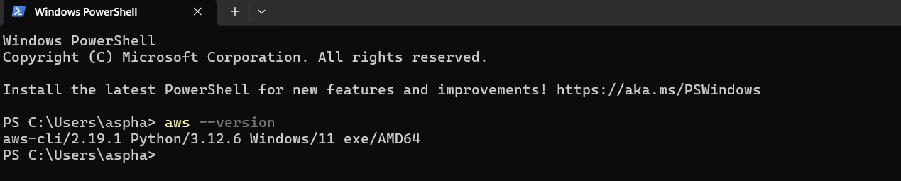

* Create an access key for CLI and log in using the access key:

**aws configure**

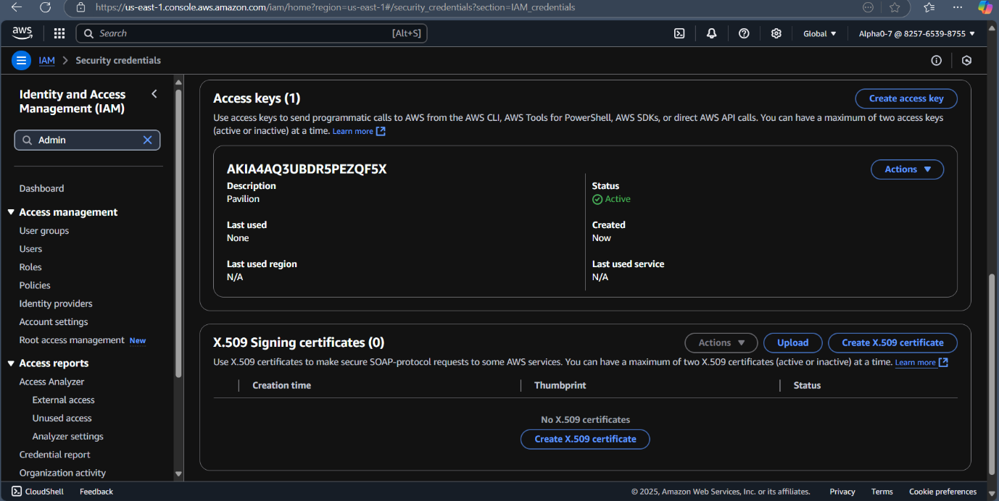

Enter your AWS Access Key, Secret Access Key, region, and output format.

**STEP 2: Create an EC2 Instance and Stop It**

* Launch an EC2 instance from the AWS Management Console or CLI.

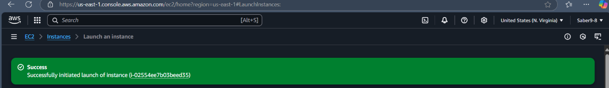

* Stop the instance using:

aws ec2 stop-instances --instance-ids <your-instance-id>

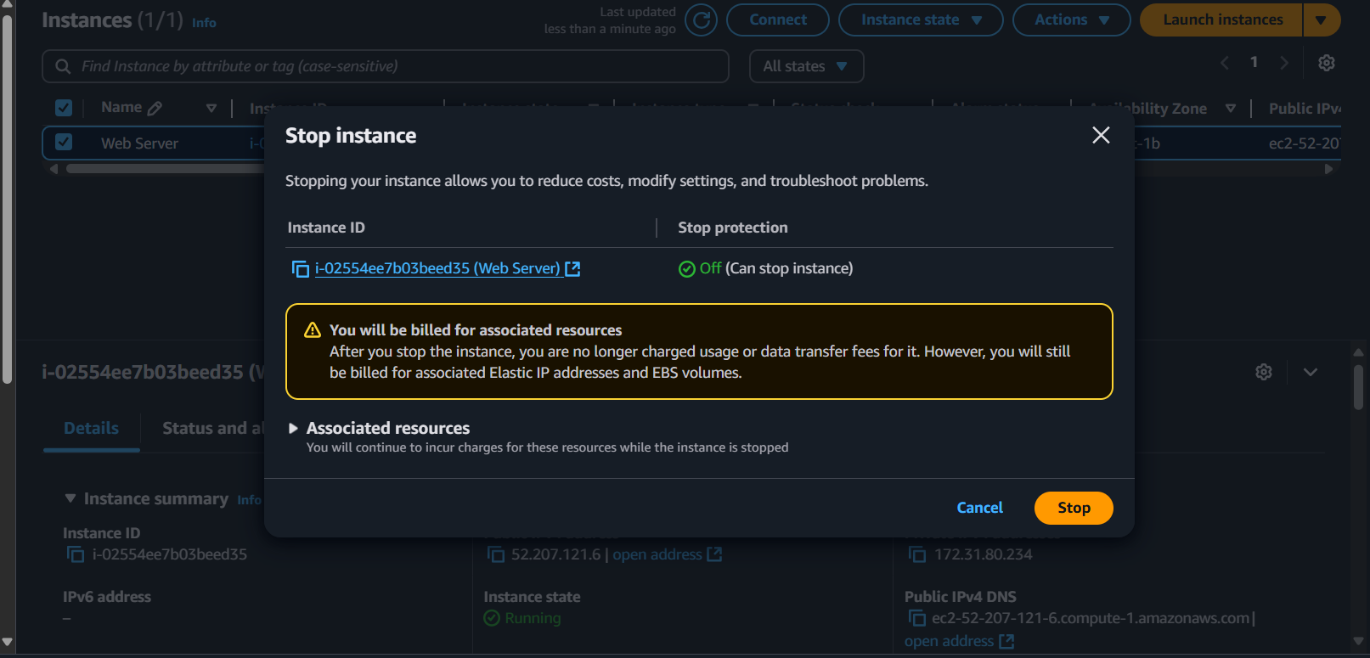

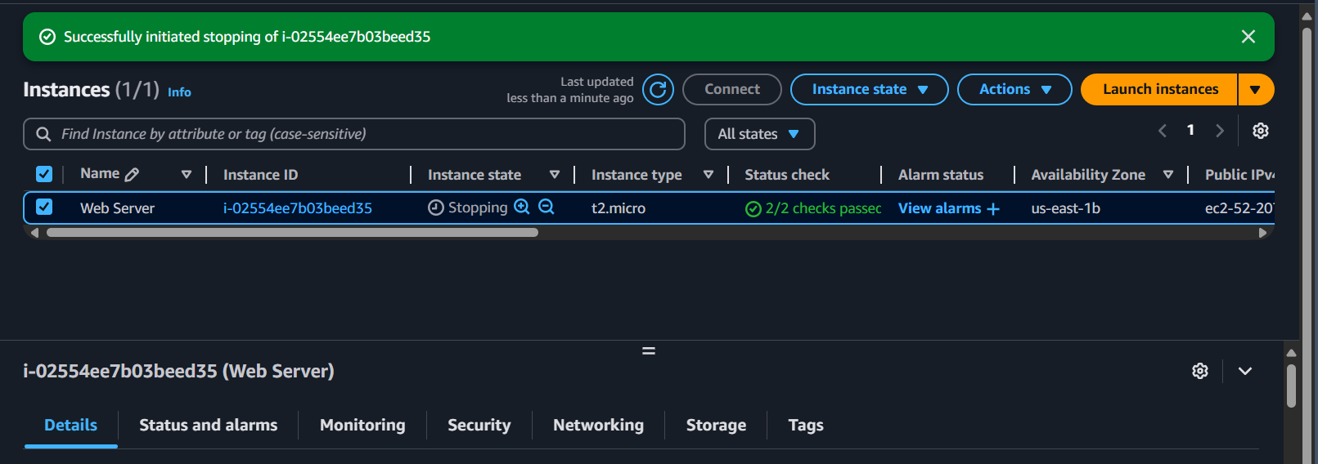

**STEP 3:Create the Script for Managing EC2 and Save It with .ps1 Extension**

* Open Notepad or any text editor and paste the following script:

**function List-Instances {**

**aws ec2 describe-instances --query "Reservations[].Instances[].[InstanceId, State.Name]" --output table**

**}**

**function Start-Instance {**

**$instanceId = Read-Host "Enter Instance ID to start"**

**aws ec2 start-instances --instance-ids $instanceId**

**Write-Host "Starting instance $instanceId..."**

**}**

**function Stop-Instance {**

**$instanceId = Read-Host "Enter Instance ID to stop"**

**aws ec2 stop-instances --instance-ids $instanceId**

**Write-Host "Stopping instance $instanceId..."**

**}**

**function Terminate-Instance {**

**$instanceId = Read-Host "Enter Instance ID to terminate"**

**aws ec2 terminate-instances --instance-ids $instanceId**

**Write-Host "Terminating instance $instanceId..."**

**}**

**Write-Host "Select an option:"**

**Write-Host "1) List Instances"**

**Write-Host "2) Start Instance"**

**Write-Host "3) Stop Instance"**

**Write-Host "4) Terminate Instance"**

**Write-Host "5) Exit"**

**$choice = Read-Host "Enter your choice"**

**switch ($choice) {**

**"1" { List-Instances }**

**"2" { Start-Instance }**

**"3" { Stop-Instance }**

**"4" { Terminate-Instance }**

**"5" { Write-Host "Exiting..."; exit }**

**default { Write-Host "Invalid choice! Please try again." }**

**}**

* Save the file as ec2_manager.ps1.

**STEP 4: Change Execution Policy and Execute the Script**

A. Open PowerShell

* Press Win + R, type powershell, and hit Enter.

B. Navigate to the Script Directory

* Use cd to change to the folder containing the script:

**cd "C:\Path\To\Your\Script"**

C. Change Execution Policy to Allow Script Execution

* If execution is blocked, enable script execution temporarily:

**Set-ExecutionPolicy RemoteSigned -Scope Process**

* To make it permanent:

**Set-ExecutionPolicy RemoteSigned -Scope CurrentUser**

D. Run the Script

* Execute the script using:

**.\ec2_manager.ps1**

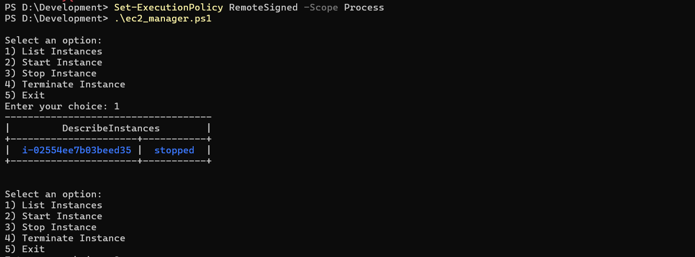

**STEP 5: List Instances and Start the Instance**

* Select the option to list instances.
* Copy the Instance ID displayed.
* Start the instance again using the script menu.

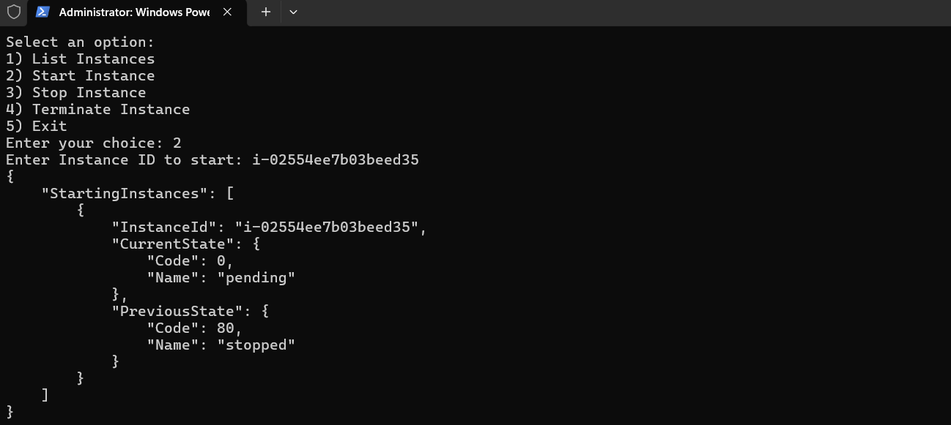

* Verify the instance state change in the AWS console.

**STEP 6: Terminate the Instance in CLI and Verify in Console**

* Use the script option to terminate the instance.

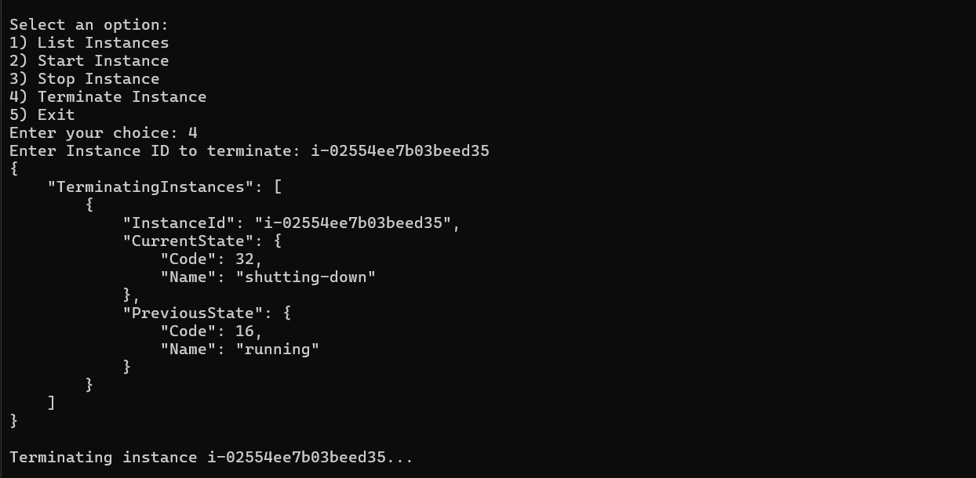

* Wait for the instance to be terminated in the AWS console.

