**Oracle Golden Gate**

1. Data can be transferred in realtime

* Continuous, real-time data movement with low latency
* Negligible impact and overhead on source and target systems
* No requirement for a middle-tier server
* Complete data recoverability in case of outages or failures
* Ability to apply transformations and mappings within the target database

2. General architecture for Bi-directional topology

Oracle GoldenGate enables multidirectional data replication to support a multi-master application configuration.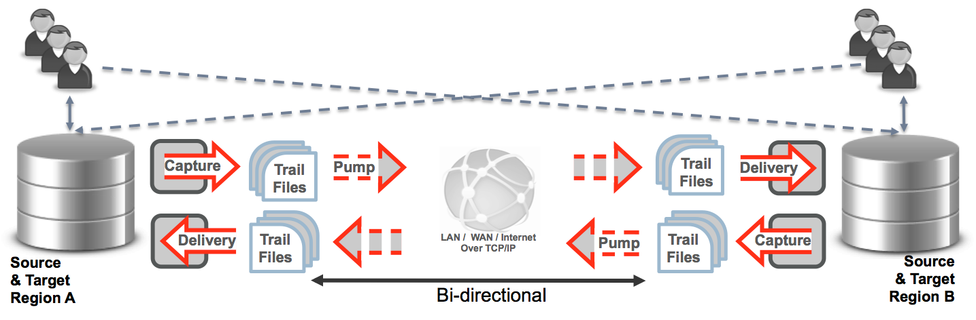

3. Streaming transactional data to Big Data systems through Adapters

* Available for all major databases and operating systems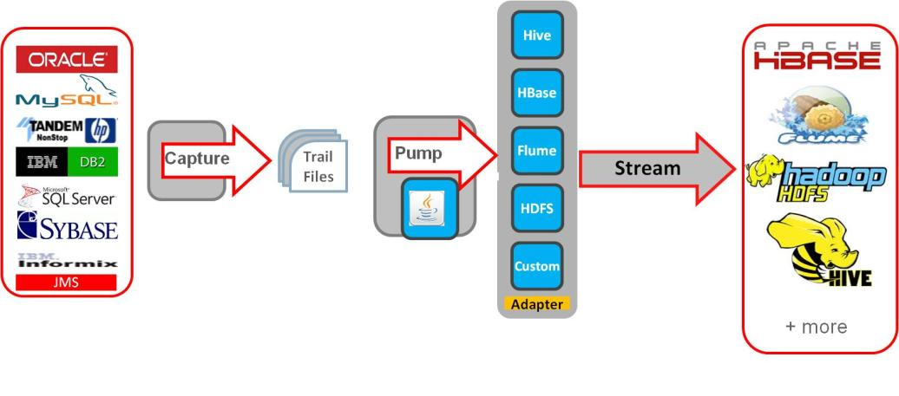
* Captures and delivers data between a variety of relational
* Data can be transferred to Big Data systems HDFS, Hive, Hbase, Spark etc for batch processing
* Data can be pushed to messaging systems Kafka, Storm and Flume for realtime processing

4. Flexible Topology Support (one-to-one, one-to-many, many-to-one, and many-to-many—for both unidirectional and bidirectional configurations)

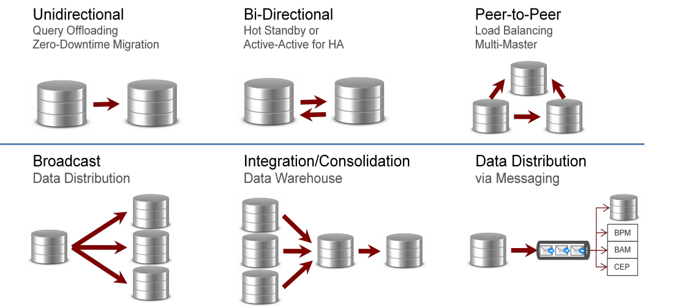

5. Performance and Scalability

* Performance of OGG is good and its able to transfer the data with low latency
* On Scalability, OGG doesn't store the data on its own and it just transfers the data as and when it arrives.