1. Creating Variables/Constants in Scala

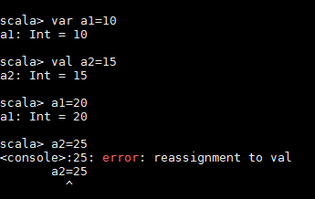

1. Different types of variables in Scala. This shows that Scala has the ability to infer the datatypes.

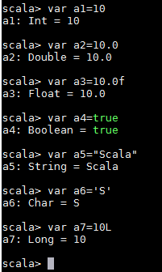

1. Create variables with explicit datatype.

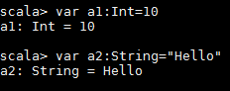

1. Create tuple/KeyValue and how to access the key or value.

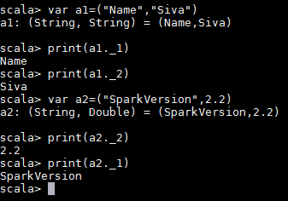

1. Creating the collections Array/List/Set and accessing the elements in Scala

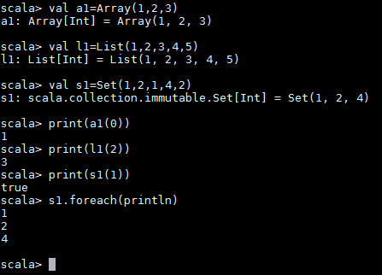

1. Applying map method on collections

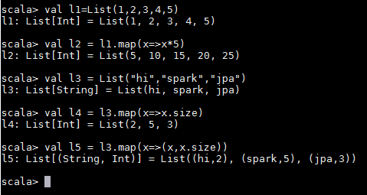

1. Wordcount Example on Spark

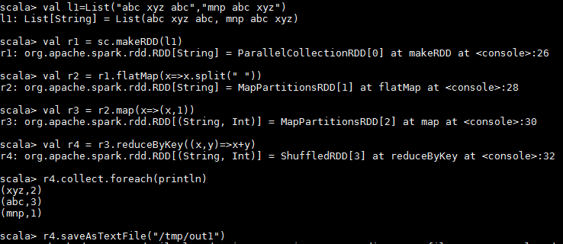

1. Wordcount example on spark in single line

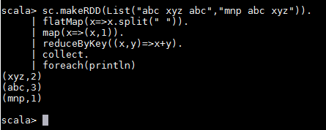

1. Get the sum by gender on the data.csv file

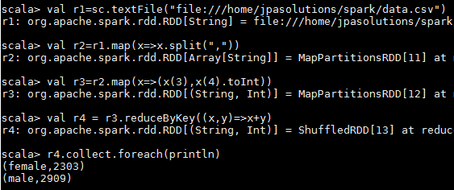

1. Using customer_data.json file on spark



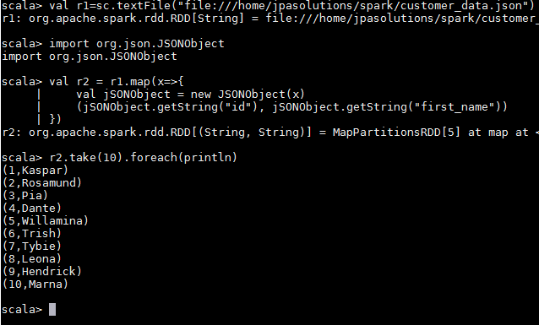

1. Another example of reading the json data

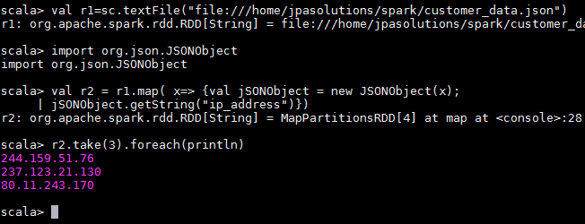

1. Writing the output as text file and sequence file

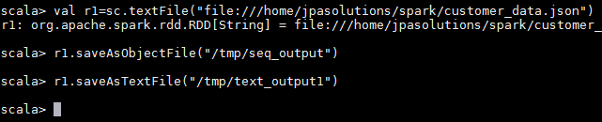

1. Reading the sequence file

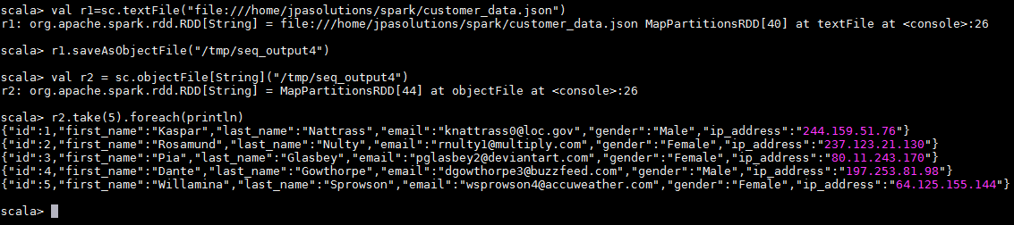

1. Reading the customer data on Spark SQL.

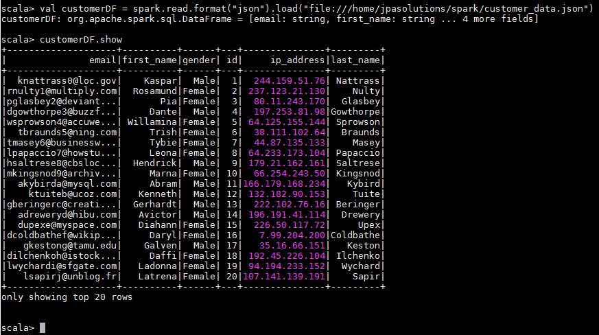

1. Writing the json data into csv/parquet/orc format

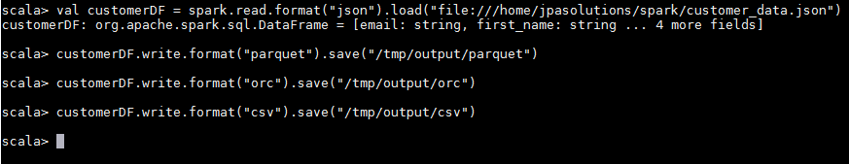

1. Reading the json/parquet/csv data

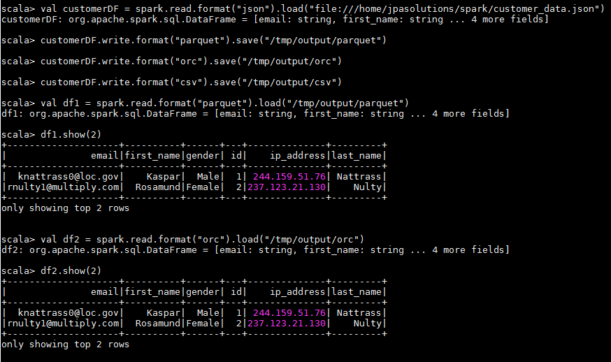

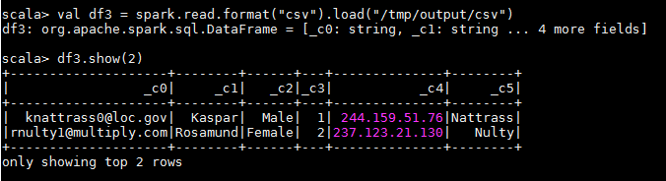

1. Write the data using the SaveMode

