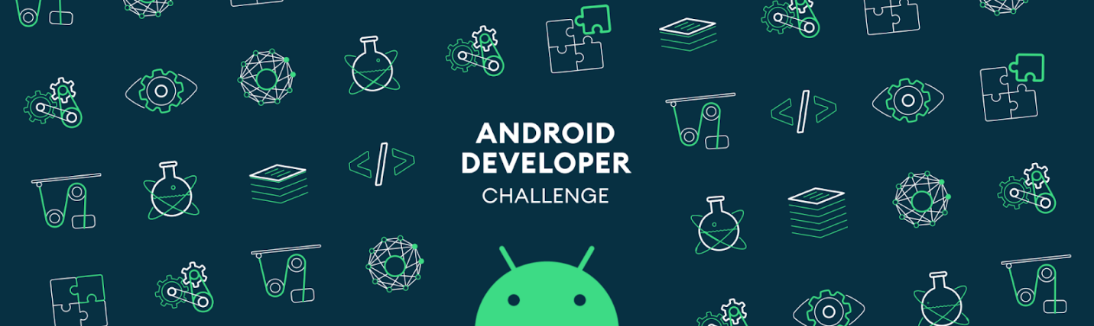

**\*Please make a copy of this document and include this in your GitHub repository for your submission, using the tag #AndroidDevChallenge\***

**Tell us what your idea is.**

*Describe in 250 words what the feature or service will do and how you’ll use Machine Learning to push the bar:*

My idea to save all genders and of all age groups in the time of emergency situation with the help of android wearable IOT device that transfers the encrypted and decrypted message to your nearest emergency contacts/police/hospital with or without the help of internet (peer to peer protocol) with advanced AI and Machine Learning Algorithms to get instant help. It works on Thermoelectric power and with solar power.

**Tell us how you plan on bringing it to life.**

*Describe where your project is, how you could use Google’s help in the endeavor, and how you plan on using On-Device ML technology to bring the concept to life. The best submissions have a great idea combined with a concrete path of where you plan on going, which should include:*

* *(1) any potential sample code you’ve already written,*

Since I started two days back I was focusing on my idea and started initial workflow.

* *(2) a list of the ways you could use Google’s help,*

Need google mentorship for creating a wearable IOT Device with the thermoelectric power and in solar power.

Need google assistance for creating the Mesh Network (Block Chain).

* *(3) as well as the timeline on how you plan on bringing it to life by May 1, 2020.*

December – creating wearable IOT device core Product design and Bluetooth 5.0 data transfer design with google assistance.

January – creating wearable Bluetooth 5.0 data transmission messages.

February - creating Mesh Network –block chain.

March – Encryption and decryption of messages with Guardian Protector Applications

April – working on the Guardian self-tracker, and integrating the device with the applications.

May – working on the testing and alpha release of the device with the applications.

**Tell us about you.**

I am android software developer with 3 years of expertise in creating android apps for e-commerce I am Interested to create a application that helps people in terms of emergency situations.

**Next steps.**

To enhance this idea for disability persons.