Matplotlib

**Introduction:**

Matplotlib is a comprehensive library for creating static, animated, and interactive visualizations in Python. Matplotlib makes easy things easy and hard things possible.

**Usage:**

* Create [publication quality plots](https://ieeexplore.ieee.org/document/4160265/citations?tabFilter=papers).
* Make [interactive figures](https://mybinder.org/v2/gh/matplotlib/mpl-brochure-binder/main?labpath=MatplotlibExample.ipynb) that can zoom, pan, update.
* Customize [visual style](https://matplotlib.org/stable/gallery/style_sheets/style_sheets_reference.html) and [layout](https://matplotlib.org/stable/tutorials/provisional/mosaic.html).
* Export to [many file formats](https://matplotlib.org/stable/api/figure_api.html#matplotlib.figure.Figure.savefig).
* Embed in [JupyterLab and Graphical User Interfaces](https://matplotlib.org/stable/gallery/" \l "embedding-matplotlib-in-graphical-user-interfaces).
* Use a rich array of [third-party packages](https://matplotlib.org/mpl-third-party/) built on Matplotlib.

**Example:**

from matplotlib import pyplot as plt

x_axis = [25,26,27,28,29,30,31,32,33,34,35]

y_axis = [38496, 42000, 46752, 49320, 53200, 56000, 62316, 64928, 67317, 68748, 73752]

plt.plot(x_axis, y_axis)

plt.show() 🡺 Figure to display

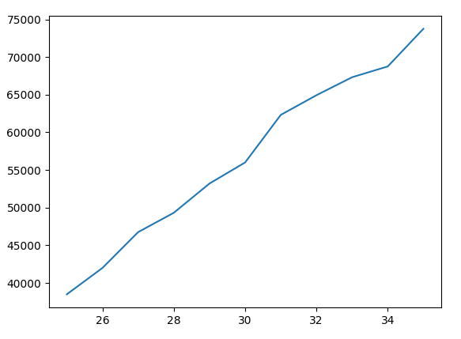

# **Parts of a Figure:**

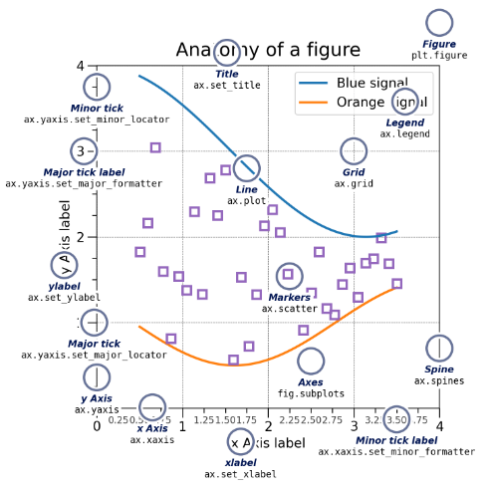

**Adding Labels:**

plt.title()

plt.xlabel()

plt.ylabel()

**Formatting the plot:**

plt.legend(['first_plt', 'second_plt'])

**Format Strings**

A format string consists of a part for color, marker and line:

fmt **=** '[marker][line][color]'

Each of them is optional. If not provided, the value from the style cycle is used. Exception: If line is given, but no marker, the data will be a line without markers.

Other combinations such as [color][marker][line] are also supported, but note that their parsing may be ambiguous.

Adding marker, color and linestyle:

plt.plot(x_axis, y_axis, color='blue', linestyle='--', marker = 'o',

label = 'line label')