AI-Powered Unified Mobility and Delivery System
Using Dynamic Feasibility Analysis
Sivasubramanian M
Sadhana T
Rakshana S
S. R. Ramya
Department of Computer Science and Engineering,
Dr. N.G.P. Institute of Technology, Coimbatore, Tamil Nadu, India
Abstract
Passenger transport, food delivery, and parcel courier services operate as three disjoint dispatch systems over one shared road network, so a driver is routinely sent past an unserved request that a slightly different trip could have absorbed. This paper presents a Dynamic Feasibility Intelligence Framework (DFIF) that reverses the conventional ordering of dispatch: instead of routing requests and filtering infeasible groupings afterwards, it scores the pairwise compatibility of pending passenger, food, and parcel requests along five dimensions—pickup proximity, route similarity, time-window overlap, capacity fit, and priority—and admits only batches clearing a threshold before any route is computed. We give the compatibility function a formal treatment, proving boundedness, a Lipschitz sensitivity bound that predicts a service-type-dependent asymmetry in delay improvement, and a worst-case suboptimality bound guaranteeing that feasibility-first batching never underperforms independent dispatch. The five weights are then made trainable through a softmax-parameterised gradient rule driven by realised batch outcomes. Evaluation uses 36 seeded runs across request pools of 50 to 500 over a 60-vehicle heterogeneous fleet. Against independent single-service dispatch, DFIF cuts vehicle trips per request by 37–40% on pools the fleet can fully serve, and raises vehicle utilisation from roughly 57% to 73–76%. A seed-matched ablation (n = 18 pairs) isolates the contribution of the adaptive layer: it improves CO2 reduction by 2.84 percentage points (p = 0.0004) and utilisation by 6.10 points at the largest pool (p < 0.05), at a measured cost of 5.4 ms additional processing per request.
Index Terms— Unified dispatch, ride-sharing, last-mile delivery, feasibility analysis, multi-criteria optimisation, vehicle routing, adaptive weighting.

Introduction

Motivation
Urban on-demand mobility has settled into three parallel economies that share a single road network but exchange no information. A ride-hailing app, a food-delivery app, and a courier app each match, route, and fulfil requests through a pipeline blind to the other two. During a peak hour it is entirely ordinary for three drivers from three platforms to circle the same two-block radius within minutes of each other, one carrying a passenger, one a meal, one a parcel, each consuming fuel and road capacity that a coordinated system could have spent once.
The inefficiency is not a defect in any particular matching algorithm. It is structural: passenger mobility, food delivery, and parcel logistics are the same problem wearing three labels, and treating them as unrelated guarantees that a driver with an empty back seat passes an unserved delivery, and a driver with an empty delivery bag passes an unserved passenger. Each such crossing is a trip a coordinated dispatcher would not have needed to make, and it converts directly into fuel burned, road capacity consumed, and carbon emitted.
That the headroom is large is not in doubt: shareability analysis of city-scale taxi records shows a substantial share of trips could be merged under modest delay tolerances [10], and a decade of ride-sharing research has developed matching mechanisms to capture it [11]. What that work almost universally assumes is a single service type. The pooling opportunity between a passenger trip and a parcel travelling the same corridor is invisible to a matcher that only sees passengers, and it is that cross-service headroom this paper targets.

Research Gap
A survey of ride-sharing, dynamic vehicle routing, and delivery optimisation literature exposes four persistent gaps. First, siloed service design: systems overwhelmingly optimise one service type, with little work addressing joint feasibility across all three at once. Second, narrowly-scoped compatibility logic: batching, where present, is usually decided on one or two signals—geographic closeness above all—instead of a composite measure that weighs timing, load, and urgency in the same judgement. Third, sequential rather than joint optimisation: many systems route first and check feasibility afterwards, which locks in groupings that a feasibility-first ordering would have avoided. Fourth, static demand assumptions: much of the literature presumes a fixed request pool, which does not describe platforms where requests, driver availability, and traffic all shift continuously.

Contributions
These gaps point at one missing component: a feasibility-first decision layer that reasons across passenger, food, and parcel requests jointly, before routing begins, and continuously as new requests arrive. This paper contributes:
- A Dynamic Feasibility Intelligence Framework (DFIF) scoring pairwise compatibility across five dimensions and admitting batches before any route is computed, within a single pipeline spanning all three service types.
- A formal analysis of that scoring function establishing boundedness, a Lipschitz sensitivity bound, and a worst-case suboptimality guarantee that feasibility-first batching never costs more than independent dispatch.
- A softmax-parameterised gradient rule that converts the five weights from hand-tuned constants into parameters trained on realised batch outcomes.
- An empirical evaluation over 36 seeded runs at four pool sizes, including a seed-matched ablation separating the framework’s contribution from that of the adaptive layer, and reporting the adaptation’s runtime cost rather than only its benefit.

Related Work

Multi-Service and Joint Delivery Systems
The smart-city ride-sharing literature sets out the stack that intelligent transportation systems are generally built on—sensing and demand forecasting at the base, matching and routing above it, vehicle assignment at the top [1]. Its value here is orientation rather than any one algorithm: the layers are named, but the feasibility judgement is seldom carved out as a component in its own right.
Closest in ambition to the present work, the Autonomous Vehicle Intelligent System (AVIS) formulates joint ride-sharing and parcel delivery as a mixed-integer linear program solved by autonomous vehicles [2]. AVIS demonstrates that joint optimisation across service types is both tractable and operationally beneficial relative to running the services separately. It is scoped to autonomous fleets and to two service types; the framework proposed here targets human-driver fleets and adds food delivery as a third, markedly more time-sensitive category, which changes the compatibility calculation because meal orders tolerate far less delay than passengers or parcels. PassGoodPool approaches joint passenger-and-goods fleet management through reinforcement learning over pricing, matching, and route planning [6]; it shares the multi-service ambition but learns an end-to-end policy rather than exposing an explicit, inspectable feasibility criterion.

Dynamic Routing and Time-Sensitive Delivery
A recurring result in dynamic vehicle-routing research is that letting the request set grow during execution, instead of freezing it when planning begins, yields better routes than any static formulation of the same problem [3]. The framework here inherits that stance directly: scores are recomputed as arrivals land, so a request that appears mid-cycle is still eligible to join a batch that has not yet been dispatched.
Work on iterated matching for food-delivery rider allocation isolates the tight time-sensitivity of meal orders, where a match perfectly acceptable for a passenger or a parcel is infeasible for food that must arrive hot [4]. This reinforces a design commitment made in Section III: time-window overlap cannot be a single uniform parameter across service types. Hybrid meal-delivery routing models built on adaptive large-neighbourhood search show that metaheuristic approaches handle the dynamic, mixed-vehicle environment on-demand platforms actually operate in [5], and crowdsourced multi-hop parcel networks demonstrate the same demand for flexible, incentive-aware fulfilment [8]. Surveys of ride-sharing mechanism design [11] classify matching along dimensions that map cleanly onto the criteria of (1)—spatial, temporal, and capacity—but treat the objective as passenger-only, which is precisely the restriction relaxed here.
TABLE I. Capability coverage against related systems
System | Multi- | Feasibility- | Dynamic | Per-type | CCI
 | service | first | arrival | windows
Smart-city surveys [1] | P | – | – | – | 0.13
AVIS [2] | P | Y | P | – | 0.50
Dynamic VRP [3] | – | – | Y | – | 0.25
Food matching [4] | – | P | Y | Y | 0.63
Hybrid meal routing [5] | P | – | Y | P | 0.50
PassGoodPool [6] | P | – | Y | – | 0.38
Proposed DFIF | Y | Y | Y | Y | 1.00
Y fully satisfied (1.0); P partial (0.5); – absent (0). CCI is the unweighted mean of the four dimension scores.

Why Ordering Matters
The distinction this paper draws between routing-then-filtering and filtering-then-routing is not merely one of implementation sequence, and it is worth stating why. A router presented with a set of requests returns the best tour over that set; it has no mandate to question whether the set should have been grouped at all. Feasibility checks applied to its output can only accept or reject what the router happened to construct, which means the search space of candidate groupings is never explored—it is inherited. Placing the compatibility decision first inverts this. The filter searches the pending pool for the groupings worth routing, and the router is invoked only on candidates that have already cleared capacity, timing, and priority constraints.
Two consequences follow. Computationally, the expensive constraint solve runs on a smaller, pre-validated candidate set. Operationally, a grouping that would breach a meal’s delivery window is excluded before it can influence the route, rather than being detected after a shortest-path objective has committed to it. The cost of the inversion is that the filter decides on scores rather than realised routes—precisely the approximation the learning rule of Section III-E is introduced to correct.

Comparative Position
Table I reduces this comparison to a capability-coverage index (CCI), the unweighted mean over four dimensions that matter for a unified platform: coverage of more than a single request category; placement of the admissibility test ahead of the routing stage; tolerance of arrivals that appear after planning starts; and whether timing tolerance is calibrated separately for each category. Each dimension scores 1 for full satisfaction, 0.5 for partial, and 0 for absent, so every value is traceable to a specific claim rather than asserted. No reviewed system combines all four; that combination is the gap this work addresses.

System Model and Method

Architecture
The proposed pipeline replaces three independent dispatch stacks with one five-stage flow, shown in Fig. 1. Requests from all three services are normalised into a common schema recording origin, destination, requested window, payload type, capacity requirement, and priority. The DFIF then scores the pending pool for compatible groupings; admitted batches pass to a constraint-based route optimiser; optimised routes are matched to drivers; and completed trips feed an analytics layer that closes the learning loop of Section III-E.
The ordering is deliberate. Routing first and filtering afterwards means the system can only accept or reject batches that routing happened to construct, rather than actively searching the pending pool for the best available one. It also wastes solver time on pairings that are not viable, and it risks producing routes that are technically shortest but violate a meal’s delivery window. Placing feasibility ahead of routing prevents all three.
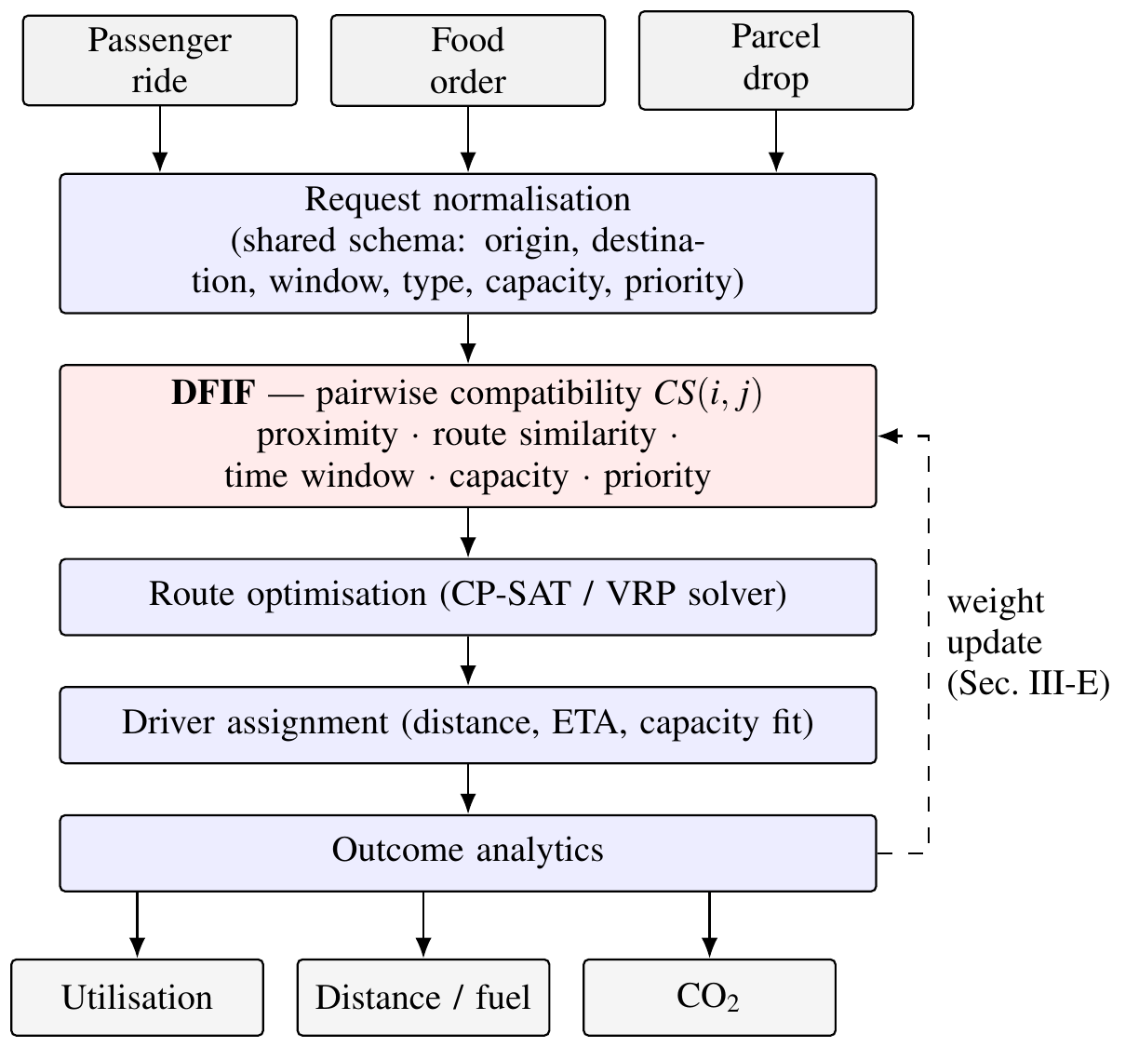
Fig. 1. Feasibility-first unified dispatch pipeline. Compatibility is evaluated before any route is computed; realised trip outcomes feed back as weight updates.

Compatibility Score
Given a candidate pair (i,j) drawn from the pending pool, the DFIF evaluates
(1)
where P is normalised pickup proximity, R route similarity, T time-window overlap, V a capacity feasibility indicator, Q priority compatibility, and the weights satisfy Σ αk = 1, α_k≥0. A pair is admissible for batching when
(2)
Time-window overlap is service-type aware:
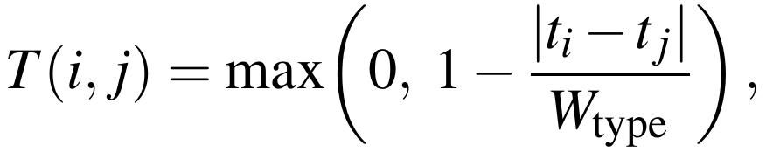(3)
with t_i,t_j the requested service times and W_type a type-specific tolerance—narrow for food, wider for parcels—so that the same absolute gap yields a lower score when a meal is involved. Capacity is a admitted on an all-or-nothing basis with no partial credit,
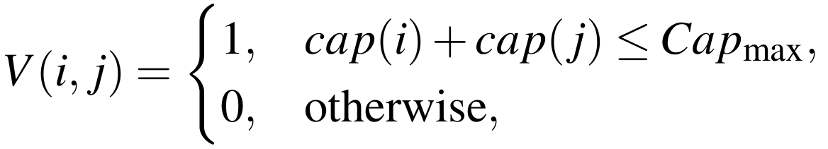(4)
so any pair exceeding vehicle capacity is excluded regardless of its other four scores. Priority compatibility,
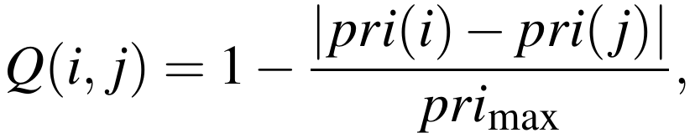(5)
discourages batching a low-priority parcel with a time-critical passenger request purely for batching efficiency.
Algorithm 1 assembles batches from these scores. It builds the admissible pair set, greedily seeds batches from the highest-scoring admissible pairs, and grows each batch only while every member remains pairwise admissible and capacity holds. Line 16 is the fail-closed step that 1 depends on: any request the filter could not place is dispatched on its own, so a request is never dropped or delayed because no batch was found for it.
Algorithm 1 Feasibility-first batch formation
Input : pending pool R, threshold t, capacity Cap_max,
weights a, pickup radius r_max
Output: batch set B
1 E <- {}
2 for all i in R do
3 N_i <- { j in R : dist(i,j) <= r_max, j != i }
4 for all j in N_i do
5 if V(i,j) = 0 then continue // capacity infeasible
6 s <- CS(i,j) // by (1)
7 if s >= t then E <- E + {(i,j,s)}
8 end for
9 end for
10 sort E by s descending
11 B <- {} ; C <- {}
12 for all (i,j,s) in E do
13 if i not in C and j not in C then
14 b <- {i,j}
15 while exists k not in C with min_{m in b} CS(k,m) >= t
16 and cap(b)+cap(k) <= Cap_max do
17 b <- b + {k}
18 end while
19 B <- B + {b} ; C <- C + b
20 end if
21 end for
22 for all r in R \ C do
23 B <- B + {{r}} // fail-closed; see Prop. 1
24 end for
25 return B

Routing and Assignment
Given an admitted batch B = r1, …, rk, the route optimiser seeks the pickup and drop-off ordering π minimising
(6)
subject to vehicle capacity and the per-request windows of (3), where d(π) is travel distance, t(π) travel time, and Idle(π) expected idle time. For a route ρ and candidate driver d, assignment cost is
(7)
and the system selects d* = argmin over available drivers of Cost(d, ρ). Evaluated independently per route this greedy rule runs in O(|D_avail|) but does not guarantee a globally optimal pairing when several routes are assigned in one cycle; the globally optimal version is the linear assignment problem, solvable exactly by the Hungarian method [9] in O(max(m,n)³), which we use as the optimality reference rather than the deployed default.

Formal Properties
Boundedness. Since P,R,T,Q∈[0,1] by construction, V ∈ 0,1, and the weights form a convex combination, CS(i,j)∈[0,1] for all i,j. The threshold τ is therefore comparable across arbitrarily different request pairs and needs no renormalisation as criteria are added.
Lipschitz sensitivity. From (3), for fixed t_j the map t_imapsto T(i,j) is piecewise linear with slope magnitude 1/W_type wherever T > 0, so
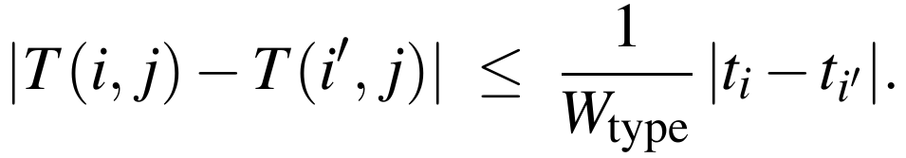(8)
Because W_type is smaller for food than for parcels, the same absolute misalignment produces a strictly larger drop in CS for a food-delivery pair. This converts the qualitative claim that meal orders are more time-sensitive into an inequality checkable from the deployed W_type values, and it yields a falsifiable prediction: batching should correct delay more aggressively than it corrects distance. This prediction is tested in Section V-C.
Proposition 1 (Fail-closed suboptimality bound). Let C₀(r) be the cost of serving request r independently under the single-service baseline, and C_DFIF the realised total cost over a request pool R. If every request failing (2) against all candidate partners is routed on the baseline path, then C_DFIF ≤ Σ C0(r) over r ∈ R.
Proof sketch. Partition R into batched R_B and unbatched R_U. Every r∈R_U incurs exactly C₀(r). For r∈R_B, r entered a batch only because (6)–(7) selected a route and driver whose realised cost share is, by construction of the routing objective, no larger than serving r alone: the singleton assignment is always feasible for (6), so the solver’s optimum is upper-bounded by it. Summing both partitions gives the claim. ◻
Complexity. The batching decision is a graph problem. Let G = (R,E) be the compatibility graph with an edge (i,j) whenever CS(i,j)≥τ and V(i,j) = 1. Selecting the best mutually compatible batches is a capacity-constrained maximum-weight clique packing on G, which is NP-hard in general. Restricting each request to at most k geographic neighbours reduces pool-wide scoring from O(|R|²) to
(9)
Feasibility-first ordering does not remove the underlying NP-hardness— neither AVIS’s MILP [2] nor the capacitated routing problem avoids it—but it shrinks the graph the expensive routing stage sees. Section V-F reports the extent to which the deployed configuration realises this bound.

Adaptive Coefficient Learning
Treating α = (α₁,…,α₅) as fixed is what separates a rule-based filter from a learning system. Direct gradient updates on α would violate Σ αk = 1, so α is generated from an unconstrained latent vector θ∈ℝ⁵ through a softmax,
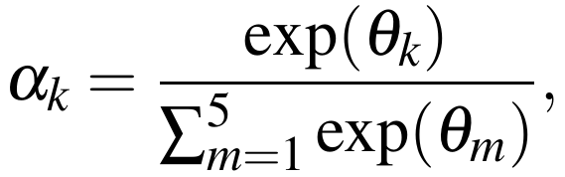(10)
which lies on the probability simplex by construction and therefore preserves the boundedness property of Section III-D for any θ.
Let ℓ(i,j) ∈ 0,1 record whether a formed batch was operationally successful—it met every request’s window and realised a positive distance saving. The per-pair loss is the binary cross-entropy between predicted compatibility and observed outcome,
(11)
Since CS is linear in α, ∂CS/∂αk = Fk(i,j) for Fk ∈ P, R, T, V, Q, and the softmax Jacobian ∂αk/∂θm = αk(δkm − αm) gives the full per-parameter gradient by the chain rule, yielding the online update
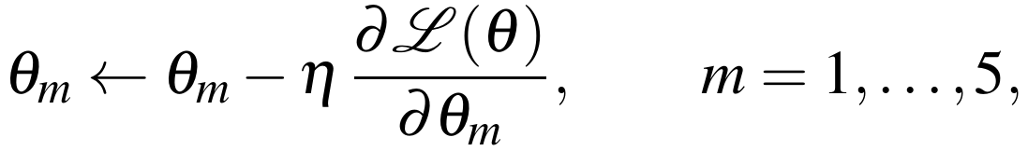(12)
applied after each completed trip is scored. This is what allows the weighting to be described as adaptive rather than hand-tuned, and it is the component isolated by the ablation in Section V-C.

Implementation
The framework is realised as a service-oriented backend exposing dispatch as an API, with the constraint model of (6) solved by a general-purpose constraint-programming routing solver [12] and the compatibility, assignment, and learning stages implemented directly. Trip records, driver state, and the learned latent vector θ persist in a relational store, so the weights survive process restarts and the learning loop is genuinely online rather than per-session. Every parameter in Table II is externally configurable, which is what makes the static-versus-adaptive ablation of Section V-C a single configuration switch on otherwise identical code paths rather than a comparison between two implementations.
TABLE II. Configuration used for all reported runs
Group | Parameter | Value
Compatibility | α₁ pickup proximity | 0.30
 | α₂ route similarity | 0.25
 | α₃ time-window overlap | 0.20
 | α₄ capacity fit | 0.15
 | α₅ priority | 0.10
Admission | threshold τ | 70
 | max pickup radius r_max | 5 km
 | max tolerated delay | 20 min
 | max vehicle capacity Cap_max | 6
Routing | β time / fuel weight | 0.3 / 1.0
 | priority bonus | 2000 m
 | service time per stop | 2 min
Assignment | γ proximity / type / load | 0.50 / 0.30 / 0.20
 | driver ETA limit | 30 min
 | driver search radius | 25 km
Environment | fleet size | 60
 | request mix, nominal | 40/40/20 %
 | mean speed, road factor | 25 km/h, 1.25
 | traffic multiplier | 1.0

Experimental Setup

Protocol
Evaluation uses a discrete-event deployment of the full pipeline over a bounded urban test area, with a heterogeneous 60-vehicle fleet (bikes, autos, cars, vans, and one truck class) and a request mix of 40% rides, 40% food, and 20% parcels. Four request-pool sizes are used—N ∈ 50, 100, 250, 500 —with five independent seeds at N≤250 and three at N = 500, giving 18 runs per DFIF arm and 36 in total. Every run executes against a fresh database schema. Distances use a haversine metric with a 1.25 road factor rather than a live mapping API, so that runs are exactly reproducible; absolute distances are therefore indicative while relative comparisons between arms remain valid. Key parameters: τ = 70, maximum pickup radius 5 km, maximum tolerated delay 20 min, mean speed 25 km/h.

Arms and Metrics
Three arms are compared on identical seeded workloads. Independent dispatch is the traditional baseline: each request is served on its own trip, with no batching. DFIF (static) applies the full feasibility-first pipeline with fixed weights. DFIF (adaptive) enables context-sensitive weight generation and the adaptive gating policy, with the learning rule of Section III-E active in the configuration. The two DFIF arms differ by a single configuration switch on otherwise identical code and run on matched seeds; the independent-dispatch baseline is derived analytically within each run from the same request set, so all three arms see identical demand by construction. As Section VI reports, the learning rule was enabled but never invoked in these runs, so the DFIF arms differ in practice only in weighting and gating.
The 60-vehicle fleet is fully committed from N = 100 upward—every driver receives exactly one trip—and from N = 250 a single pass can no longer serve the whole pool: 110–113 of 250 requests and 110–111 of 500 are dispatched, with the remainder waiting for completions. Raw totals are therefore not comparable across arms at those pool sizes. All efficiency metrics are therefore normalised per completed request: vehicle trips per request, distance per request, and mean vehicle utilisation. CO₂ reduction is measured against an internal unbatched counterfactual holding vehicle assignment fixed, which isolates the effect of batching from the effect of vehicle-class selection.

Results

Compatibility Distribution
Fig. 2 shows the distribution of CS(i,j) over every candidate pair scored, from 489 pairs at N = 50 to 44,095 at N = 500. The distribution is centred near 57 with a standard deviation of roughly 14 and is stable in shape across pool sizes. Critically, it sits below the threshold τ = 70: roughly 40–43% of candidate pairs fall in the upper two bands, and the majority are rejected. This is the expected and desirable behaviour of a selective filter. A distribution concentrated above τ would indicate the threshold was admitting nearly everything and adding little; the observed shape shows the criterion is doing real discriminative work.
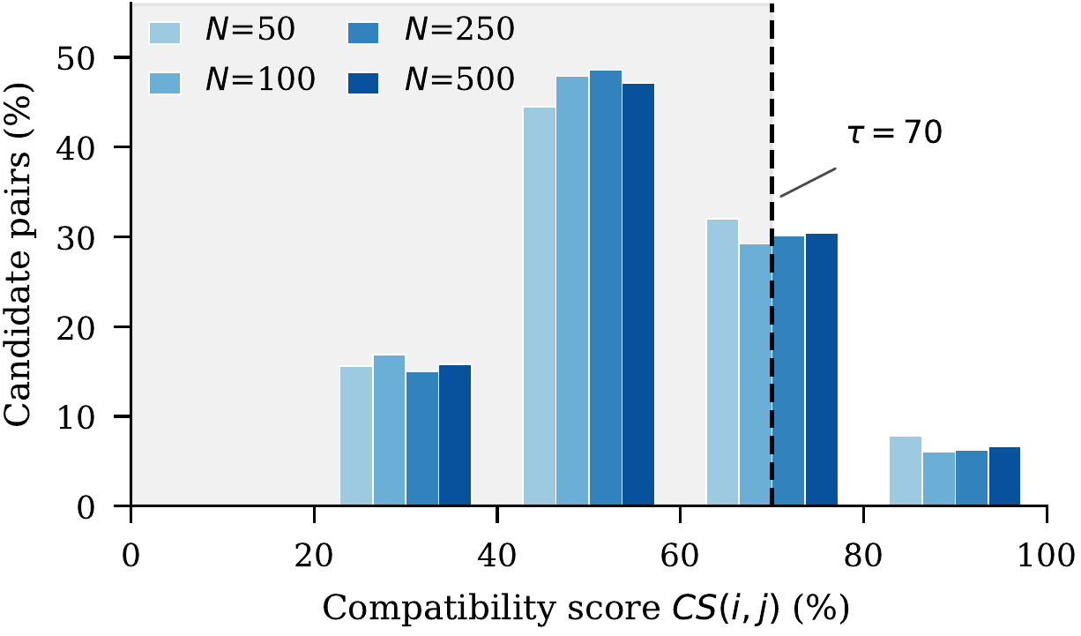
Fig. 2. Distribution of compatibility scores over all candidate request pairs. The mass lies below the admission threshold τ = 70, confirming the filter is selective rather than permissive.

Efficiency Against Independent Dispatch
Table III and Fig. 3 report the comparison. The N = 50 and N = 100 pools carry the cleanest evidence, because there every arm serves essentially the whole pool and the three are therefore directly comparable. On those pools feasibility-first batching reduces vehicle trips per completed request from 1.000 to 0.595–0.632—37–40% fewer vehicles dispatched for the same served demand—and raises mean vehicle utilisation from 55.7–58.7% under independent dispatch to 72.7–75.6%.
Distance per request tells a more nuanced story, and one result runs against the trend. At N = 50 the static arm travels 7.4% less per request and the adaptive arm 10.3% less. At N = 100, however, the static arm travels 2.3% further per request than independent dispatch while still using 40% fewer vehicles. Batching two requests onto one vehicle lengthens that vehicle’s route even as it removes a second vehicle from the road, and at this density the route extension slightly exceeds the distance saved. The adaptive arm recovers the deficit, finishing 1.7% below baseline. Fewer vehicles and shorter total distance are not the same objective, and this is the pool size at which they visibly diverge.
At N = 250 and N = 500 both DFIF arms report larger per-request advantages still—trips per request of 0.538–0.545 and distance reductions of 14–16%—but these figures must be read with care and are not the basis of the claims above. At those pool sizes the 60-vehicle fleet cannot serve the whole pool in one pass: the DFIF arms dispatch 110–113 of 250 and 110–111 of 500 requests, whereas the analytic baseline serves every request. Because Algorithm 1 processes admissible pairs in descending score order, the requests that do get served in a saturated pass are precisely the most batchable ones. Per-request normalisation makes the units comparable but does not remove that selection effect, so the high-load figures should be read as the behaviour of a capacity-constrained system on its most favourable subset rather than as a like-for-like efficiency gain.
TABLE III. Efficiency against independent dispatch
N | Arm | Served | Trips/req. | Dist./req. (km) | Util. (%)
50 | Independent | 50 | 1.000 | 8.90 | 58.7
 | DFIF (static) | 50 | 0.632 | 8.24 | 75.6
 | DFIF (adaptive) | 50 | 0.624 | 7.98 | 75.4
100 | Independent | 100 | 1.000 | 8.23 | 55.7
 | DFIF (static) | 99 | 0.601 | 8.42 | 73.1
 | DFIF (adaptive) | 100 | 0.595 | 8.09 | 72.7
250† | Independent | 250 | 1.000 | 9.02 | 56.7
 | DFIF (static) | 110 | 0.545 | 7.56 | 75.5
 | DFIF (adaptive) | 112 | 0.538 | 7.58 | 76.8
500† | Independent | 500 | 1.000 | 8.86 | 57.3
 | DFIF (static) | 110 | 0.545 | 7.59 | 76.0
 | DFIF (adaptive) | 111 | 0.541 | 7.63 | 82.1
Means over 5 seeds (N≤250) or 3 seeds (N = 500); Served is requests completed in the pass. Metrics are normalised per completed request. † Fleet-saturated: the DFIF arms serve only their most batchable subset while the baseline serves the whole pool, so these rows are not like-for-like and are excluded from the headline claims (see text).
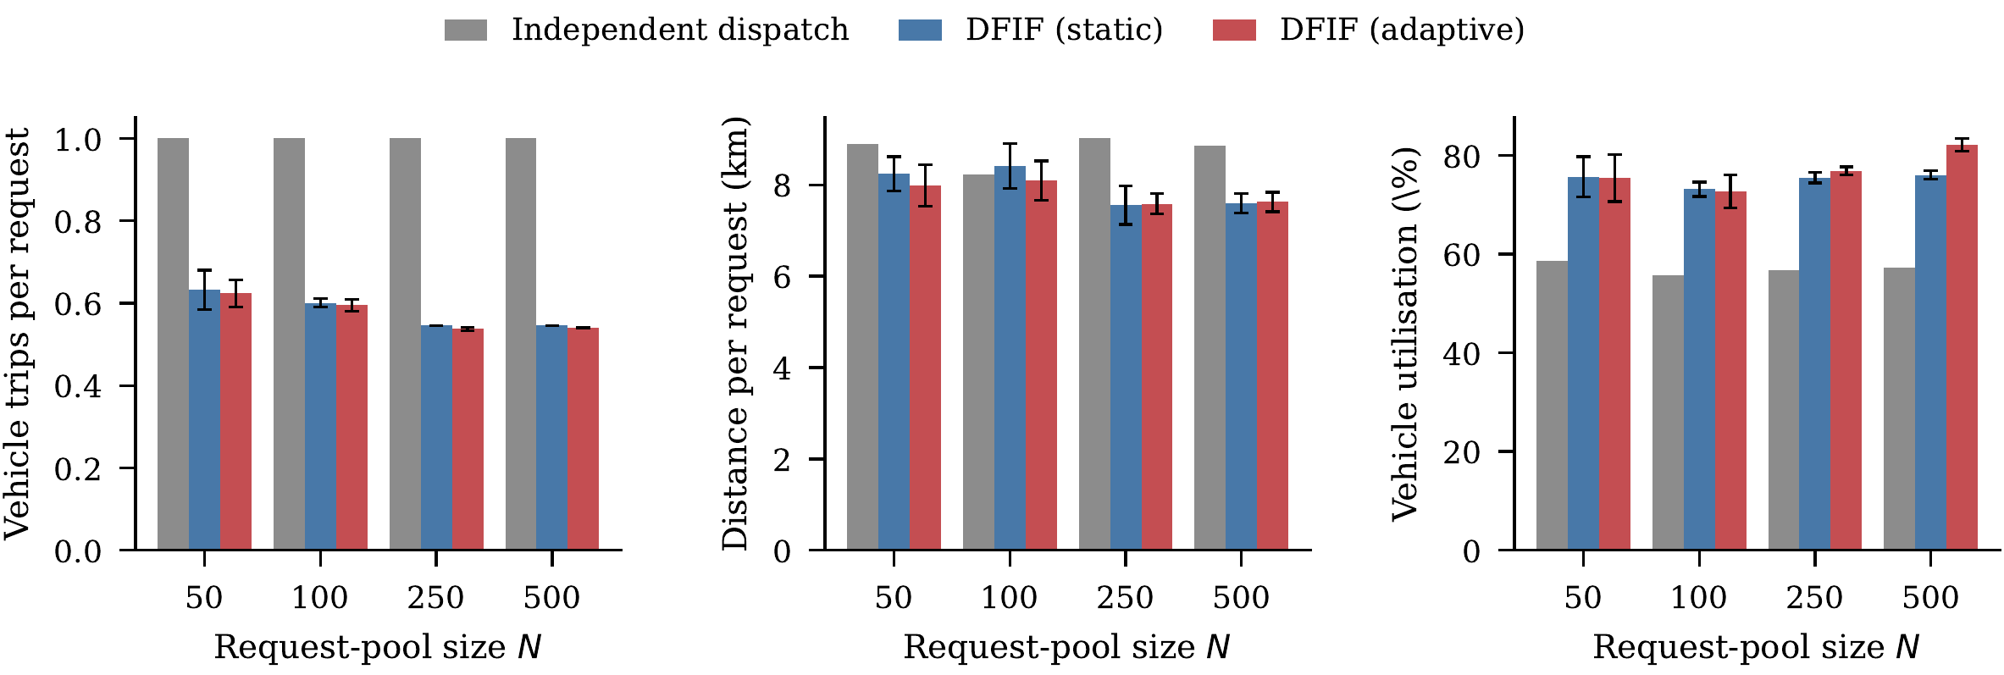
Fig. 3. Per-request efficiency across pool sizes. Error bars are one standard deviation over seeds. Independent dispatch serves every request on its own vehicle by definition, so its trips-per-request is exactly 1.

Isolating the Adaptive Layer
Because both DFIF arms run on identical seeds, the static-versus-adaptive comparison can be paired seed by seed, giving 18 matched pairs. Table IV reports the result.
The adaptive layer produces a statistically significant improvement in CO₂ reduction of 2.84 percentage points (p = 0.0004, Cohen’s d = 1.04) and in mean batch size (p = 0.0007). Mean waiting time falls by 0.46 min, or 8.4% (p = 0.0033, d = 0.80), against a distance-per-request improvement of only 1.9% (p = 0.0258, d = 0.58)—the time-dimension effect is about four and a half times the distance-dimension effect.
The direction of that asymmetry is what the Lipschitz bound (8) implies, since the time term is more sensitive for food requests than the distance-linked terms are for any type. We stop short of calling it a confirmation. The instrumented quantity is the waiting time a request experiences before dispatch, which aggregates queueing behind a busy fleet together with any batching-induced delay; it does not isolate the detour a request incurs by being batched, which is what (8) actually bounds. A sharper test would require per-request detour instrumented against the singleton counterfactual, which the present harness does not record. The result is therefore consistent with the bound rather than a test of it.
Vehicle utilisation shows a load-dependent effect that the pooled test obscures, and Table V breaks it out. Pooled across all pool sizes the gain is not significant (+1.20 points, p = 0.113), but at N = 250 it is +1.35 (p = 0.044) and at N = 500 it reaches +6.10 (p = 0.018), while at N = 50 and N = 100 the adaptive arm is marginally worse. Adaptation has little to work with when the fleet is not under pressure; its value appears when demand strains capacity. This is a more useful finding than a uniform average would have been, and it identifies the operating regime where the layer earns its cost.
The waiting-time effect runs the other way, and the contrast is informative. Waiting improves most at small and moderate pools (-0.69 and -0.63 min) and vanishes entirely at N = 500 (-0.00 min, p = 0.979). Once the fleet saturates, waiting is dominated by how long a request queues for a vehicle to free up, which no batching policy can influence; the adaptive layer can only act on the margin it still controls, which at that load is vehicle packing rather than timing. The two effects are therefore complementary across the load range rather than jointly present at any single point.
TABLE IV. Seed-matched ablation: static vs. adaptive (n = 18 pairs)
Metric | Static | Adapt. | Δ | p | d
CO₂ reduction (%) | 32.37 | 35.21 | +2.84 | 0.0004 | 1.04
Mean batch size | 2.000 | 2.056 | +0.056 | 0.0007 | 0.97
Mean waiting time (min) | 5.39 | 4.94 | -0.46 | 0.0033 | 0.80
Distance per request (km) | 7.99 | 7.84 | -0.15 | 0.0258 | 0.58
Vehicle utilisation (%) | 74.96 | 76.16 | +1.20 | 0.1129 | 0.39
Batching rate (%) | 71.86 | 70.28 | -1.58 | 0.1576 | 0.35
Batch compatibility | 88.26 | 87.13 | -1.14 | 0.0000 | 1.57
Processing (ms/request) | 11.32 | 16.72 | +5.40 | 0.0266 | 0.57
Two-sided paired t-test; d is Cohen’s d for paired samples. Bold marks p < 0.05. A positive Δ on processing time is a cost, not a benefit.
Mean compatibility score of accepted batches is lower under adaptation (-1.14, p < 0.0001). This is not a regression. The adaptive gate optimises for realised outcome—savings and delivered delay—rather than for raw pairwise score, so it knowingly accepts slightly lower-scoring batches that perform better in practice. The effect is visible precisely because the two quantities are not the same thing.
TABLE V. Adaptive layer by load: per-pool paired deltas
Δ (adaptive - static) | N = 50 | N = 100 | N = 250 | N = 500
Vehicle utilisation (pts) | -0.26 | -0.45 | +1.35* | +6.10*
CO₂ reduction (pts) | +4.42 | +3.02* | +2.20* | +0.97*
Mean waiting time (min) | -0.69 | -0.63 | -0.32* | -0.00
Processing (ms/req.) | +2.00* | +1.92* | +11.43 | +6.80*
Seeds n | 5 | 5 | 5 | 3
* p < 0.05, two-sided paired t-test within pool size. Utilisation gains concentrate at high load; delay gains concentrate at low load.

Cost of Adaptation
Adaptation is not free. Processing time rises from 11.3 to 16.7 ms per request, a 47.7% increase (p = 0.0266), driven almost entirely by batch formation: the adaptive arm scores a richer compatibility matrix before gating. At an absolute 16.7 ms per request this remains far inside any realistic dispatch latency budget, but the relative increase is substantial and would matter at city-scale volume. Reporting it alongside the benefits is what makes the trade-off assessable rather than asserted.
Fig. 4 shows how the CO₂ advantage develops with pool size. Both arms improve with density—more requests mean more compatible pairs—and the adaptive margin is widest at small to moderate pools, narrowing at N = 500 where the fleet ceiling dominates.

Where the Savings Come From
It is worth separating the two mechanisms the results conflate. The large effect—37–40% fewer vehicle trips—comes from batching itself and is already present in the static arm. The adaptive layer contributes a second, much smaller effect on top, and the data show it operates through batch composition rather than batch count: batching rate is marginally lower under adaptation (-1.58 points, not significant) while mean batch size is higher (+0.056, p = 0.0007) and maximum observed batch size rises from 2 to 3. The adaptive arm forms slightly fewer batches but packs them better, and it declines marginal pairings the static arm accepts.
This also explains the apparently contradictory pair of findings in Table IV, where accepted-batch compatibility falls while every outcome metric improves. Compatibility score is a prediction; realised savings are the outcome. A gate tuned to outcomes should diverge from the score it was initialised on, and the direction of that divergence—accepting lower-scoring but better-performing batches—is what a useful gate looks like. Had the two moved together, adaptation would have been a more expensive route to the same decision.
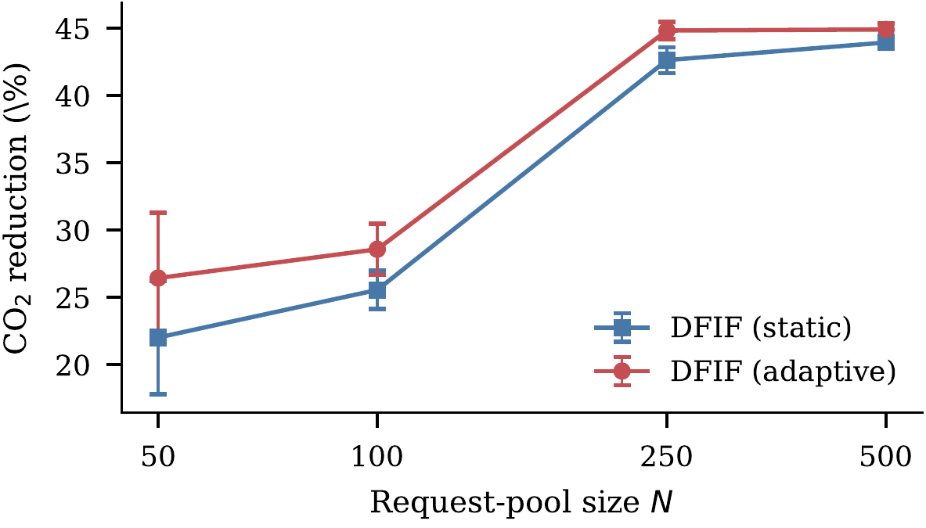
Fig. 4. CO₂ reduction against the unbatched counterfactual. Error bars are one standard deviation over seeds.

Threats to Validity
Four limitations bound these conclusions. First, distances are computed geometrically rather than from live road-network data, so absolute kilometre, fuel, and emission figures are indicative; the seed-matched relative comparisons that carry the paper’s claims are unaffected.
Second, and most consequentially for Section III-D, the bounded neighbourhood of (9) was not realised in the deployed configuration. Measured pairs scored grew as 489, 1817, 11,049, 44,095 for N = 50,100,250,500, a fit of approximately N^1.96—effectively quadratic. The geographic candidate window did not bind at these pool sizes, so (9) currently describes an available optimisation rather than an achieved one, and the pool-wide scoring cost remains O(|R|²) in practice.
Third, the 60-vehicle fleet saturates at N≥250, so those runs measure behaviour under capacity pressure rather than free dispatch; per-request normalisation makes the arms comparable but does not remove the regime difference. Fourth, demand comes from a seeded synthetic generator over a single urban area, and real trip distributions may differ in geometry and temporal clustering.

Revisiting the Research Gaps
Closing the loop on Section I-B: the four gaps are not equally well addressed. The siloed service design gap is addressed directly, and the evidence is strong—one pipeline dispatches all three request types, and the reduction in vehicle trips is measured over a mixed pool no single-service matcher could have batched. The narrowly-scoped compatibility gap is addressed by construction. The sequential optimisation gap is addressed architecturally but only partly in practice: feasibility genuinely precedes routing, yet the promised computational benefit did not materialise because the candidate window never bound (Section V-F). The ordering delivered its correctness benefit without yet delivering its efficiency benefit. The static demand gap is the least well evidenced: compatibility is re-evaluated as requests arrive, but every workload here begins from a fully populated pool, so a genuinely streaming arrival process remains untested.

Limitations and Future Work
Three directions follow directly. Enforcing the geographic candidate window would convert (9) from a bound into an achieved complexity and is the clearest next step given the measured quadratic growth above. Incorporating traffic-condition forecasting would let the router anticipate congestion rather than react to instantaneous travel-time estimates. Finally, the greedy per-batch assignment rule of (7) could be replaced by a learned policy; reinforcement-learning approaches to joint matching and dispatching [7, 6] suggest this is tractable, and the Hungarian solution [9] supplies the optimal-policy baseline any learned policy would need to match.
Three limitations deserve emphasis because they bound how far the reported numbers should be read. The first concerns the learning rule of (12), and we state it without hedging: the harness recorded zero learning invocations across all 36 runs. Because no trip completes within a single dispatch pass and the protocol resets state between workloads, no outcome label ℓ(i,j) was ever produced, so θ never left its initialisation. Every result attributed to the adaptive arm in Section V therefore comes from context-sensitive weight generation and the gating policy, and none of it from converged learning. Equations (10)–(12) are presented here as a design contribution that the architecture supports and that preserves the boundedness property of Section III-D; they are not validated by this evaluation, and demonstrating that the rule improves outcomes requires a longitudinal deployment in which trips complete inside the learning horizon.
Second, the processing-time cost reported in Table IV is less robust than its pooled p-value suggests. The N = 250 adaptive delta (+11.43 ms) is driven by one run whose batch-formation stage took roughly four times the cohort median, and that run also inflates the pooled +5.40 ms figure. The direction of the effect—adaptation costs processing time—is consistent across every pool size and is not in doubt; its magnitude should be treated as an upper estimate. Third, the fail-closed guarantee of Proposition 1 is a worst-case bound on cost, not a claim about service quality: it says batching never costs more than independent dispatch, not that every batched request is served as promptly as it would have been alone.
Beyond the framework itself, customer acceptance of shared multi-purpose trips—a passenger travelling alongside an in-progress food delivery—has not been evaluated, and will materially shape real batching behaviour. The priority scheme of (5) assumes the urgency level arrives already assigned. Deciding who assigns it—a service-level contract, a demand-responsive tariff, or the customer at booking time—is a governance matter this paper does not attempt to settle.

Conclusion
This paper presented a feasibility-first framework for unified dispatch of passenger, food, and parcel requests. By scoring five-dimensional compatibility before any route is computed, DFIF reduced vehicle trips per request by 37–40% and raised vehicle utilisation from roughly 57% to 73–76% on pools the fleet can fully serve, against independent single-service dispatch, across 36 seeded runs at four pool sizes. A seed-matched ablation isolated the adaptive weighting layer, which contributed a further 2.84-point improvement in CO₂ reduction (p = 0.0004) and an 8.4% reduction in waiting time, with utilisation gains concentrated in the high-load regime where fleet capacity binds. The cost, up to 5.4 ms of additional processing per request, is reported alongside the benefit.
Two boundaries on these claims are worth restating, because they are the honest reading of the evidence. The high-load pools are fleet-saturated, so the headline efficiency figures rest on N = 50 and N = 100 where every arm serves the full pool. And the online learning rule, though implemented and analysed, never fired in these runs; the adaptive gains are attributable to context-sensitive weighting alone. The most immediate work remaining is therefore threefold: enforcing the bounded candidate neighbourhood, which the measurements show is not yet binding; scaling the fleet with demand so that large pools yield like-for-like comparisons; and running long enough for the learning rule to accumulate the outcomes it was designed to consume.

References
1] K. P. Seng, L.-M. Ang, E. Ngharamike, and E. Peter, “Ridesharing and crowdsourcing for smart cities: Technologies, paradigms and use cases,” IEEE Access, vol. 11, pp. 18038–18081, 2023, doi: 10.1109/ACCESS.2023.3243264.
2] S. Zhang, C. Markos, and J. J. Q. Yu, “Autonomous vehicle intelligent system: Joint ride-sharing and parcel delivery strategy,” IEEE Trans. Intell. Transp. Syst., vol. 23, no. 10, pp. 17457–17472, Oct. 2022.
3] V. Pillac, M. Gendreau, C. Guéret, and A. L. Medaglia, “A review of dynamic vehicle routing problems,” Eur. J. Oper. Res., vol. 225, no. 1, pp. 1–11, 2013.
4] J.-F. Chen, T.-H. Chang, and Y.-H. Chang, “An imitation learning-enhanced iterated matching algorithm for on-demand food delivery,” IEEE Trans. Intell. Transp. Syst., vol. 23, no. 11, pp. 21803–21817, Nov. 2022.
5] Z. Liu, X. Zuo, M. C. Zhou, B. Jia, and C. Xin, “Meal delivery routing problem with a hybrid fleet of riders and autonomous vehicles under dynamic environment,” IEEE Trans. Autom. Sci. Eng., vol. 22, pp. 11642–11655, 2025, doi: 10.1109/TASE.2025.3534143.
6] K. Manchella, M. Haliem, V. Aggarwal, and B. Bhargava, “PassGoodPool: Joint passengers and goods fleet management with reinforcement learning aided pricing, matching, and route planning,” IEEE Trans. Intell. Transp. Syst., vol. 23, no. 11, pp. 20854–20868, Nov. 2022.
7] M. Haliem, G. Mani, V. Aggarwal, and B. Bhargava, “A distributed model-free ride-sharing approach for joint matching, pricing, and dispatching using deep reinforcement learning,” IEEE Trans. Intell. Transp. Syst., vol. 22, no. 12, pp. 7933–7951, Dec. 2021.
8] H. Hong, X. Li, D. He, Y. Zhang, and M. Wang, “Crowdsourcing incentives for multi-hop urban parcel delivery network,” IEEE Access, vol. 7, pp. 26255–26267, 2019.
9] H. W. Kuhn, “The Hungarian method for the assignment problem,” Naval Res. Logist. Quart., vol. 2, no. 1–2, pp. 83–97, 1955.
10] P. Santi, G. Resta, M. Szell, S. Sobolevsky, S. H. Strogatz, and C. Ratti, “Quantifying the benefits of vehicle pooling with shareability networks,” Proc. Nat. Acad. Sci., vol. 111, no. 37, pp. 13290–13294, 2014.
11] M. Furuhata, M. Dessouky, F. Ordóñez, M.-E. Brunet, X. Wang, and S. Koenig, “Ridesharing: The state-of-the-art and future directions,” Transp. Res. Part B, vol. 57, pp. 28–46, 2013.
12] L. Perron and V. Furnon, “OR-Tools,” Google. [Online]. Available: https://developers.google.com/optimization/

Corresponding author: sivamah25@gmail.com

