AI-Powered Unified Mobility and Delivery System
Using Dynamic Feasibility Analysis
Sivasubramanian M
Sadhana T
Rakshana S
S. R. Ramya
Department of Computer Science and Engineering,
Dr. N.G.P. Institute of Technology, Coimbatore, Tamil Nadu, India
Abstract
Ride-hailing, food delivery, and parcel courier services dispatch vehicles over the same streets at the same hours without exchanging information, so a driver who has just released a food order routinely passes a waiting passenger that the same trip could have carried. This paper presents an AI-powered unified mobility and delivery system organised around a Dynamic Feasibility Intelligence Framework (DFIF), which decides in real time whether a passenger ride, a food order, and a parcel drop can be served by one trip before any route is planned or any driver is committed. Candidate requests are screened on five dimensions—pickup proximity, route similarity, time-window overlap, vehicle capacity, and request priority—and combined into a compatibility score that governs batch admission. The scoring layer is augmented with a gradient-based coefficient-learning rule so that the weighting can be adapted from observed batching outcomes instead of remaining hand-fixed. Admitted batches are routed by a Google OR-Tools constraint solver over Google Maps API data, and assigned by a module weighing driver proximity, availability, and estimated arrival time rather than proximity alone. The scoring function is given a formal treatment covering boundedness, Lipschitz sensitivity of the time term, a worst-case suboptimality bound, and the complexity effect of feasibility-first filtering. A pilot deployment processed 43 live requests across three provider integrations. Relative to independent dispatch, total travel distance fell from 320 km to 250 km, fuel from 38 L to 30 L, average delay from 12 min to 7 min, and estimated CO₂ from 80 kg to 63 kg. The delay improvement (41.7%) was close to twice the distance-linked improvements (21.1–21.9%), matching the asymmetry the Lipschitz analysis predicts.
Index Terms— Artificial intelligence, dynamic feasibility analysis, unified mobility, passenger transportation, food delivery, parcel delivery, route optimization, smart cities.

Introduction

Background and Motivation
Urban transport has divided itself into three parallel economies that happen to share the same roads. A passenger opens a ride-hailing app, a customer opens a food-delivery app, a shopper opens a courier app, and each of those requests is matched, routed, and fulfilled by a platform with no visibility into the other two. During a peak hour it is ordinary rather than exceptional for three vehicles from three platforms to be circling the same two-block radius within minutes of each other, each carrying a single job and each consuming fuel and road capacity that one coordinated trip could have spent once.
The waste is not a failure of any individual platform’s matching algorithm. It is a structural consequence of treating passenger mobility, food delivery, and parcel logistics as unrelated problems when, from the point of view of a city’s road network, they are one problem carrying three different labels. Rapid urbanisation and near-universal smartphone adoption have driven demand for all three upward simultaneously, while cities face tightening pressure to reduce congestion and emissions. Shareability analysis of city-scale taxi records has already established that a substantial share of trips can be merged under modest delay tolerances, cutting the number of vehicles a road network must absorb [1], and dynamic vehicle-routing research has shown that continuously re-optimising routes as new requests arrive outperforms static, pre-planned routing. Neither line of work has addressed a request pool composed of three different kinds of job at once, each with its own pickup logic, its own time sensitivity, and its own vehicle-capacity requirements.
The missing component is a decision layer that asks, before any route is planned, which pending requests could realistically share a trip. Proximity alone cannot answer it: a passenger and a food order originating a block apart are incompatible if the meal must arrive within fifteen minutes and the ride will take forty. This work builds that layer, reasoning jointly across all three service types before routing or driver assignment begins rather than retrofitting compatibility logic onto systems designed to run in isolation.

Research Gap and Contributions
Four gaps recur across the ride-sharing, dynamic vehicle-routing, and delivery optimisation literature. First, siloed service design: existing systems overwhelmingly optimise a single service type, with little work addressing joint feasibility across all three. Second, static or narrowly-scoped compatibility logic: where request batching exists, it typically rests on a small number of criteria—often proximity alone—rather than a multi-dimensional score that accounts for time windows, vehicle capacity, and service priority together. Third, sequential rather than joint optimisation: many systems route first and filter for feasibility afterwards, which locks in inefficient groupings a feasibility-first ordering would have avoided. Fourth, limited handling of dynamic, continuously-arriving demand: much of the literature assumes a largely static request pool, which does not reflect platforms where requests, driver availability, and traffic change throughout the day.
These four point to one underlying need, and this paper contributes the following toward it:
- A Dynamic Feasibility Intelligence Framework (DFIF) that scores the compatibility of pending requests across pickup proximity, route similarity, time-window overlap, vehicle capacity, and request priority before any route is computed, embedded in a unified architecture that spans passenger transportation, food delivery, and parcel delivery within one request-collection, feasibility-scoring, routing, and driver-assignment pipeline rather than three independently optimised services.
- A mathematical formulation of the compatibility score, the route-optimisation objective, and the driver-assignment cost function, together with a formal analysis establishing boundedness, Lipschitz sensitivity of the time-window term, a fail-closed worst-case suboptimality bound, and the complexity effect of feasibility-first filtering.
- A gradient-based coefficient-learning rule, expressed over a simplex-constrained softmax parameterisation, that turns the compatibility weighting from a fixed hand-tuned heuristic into an adaptive parameter set trainable from observed batching outcomes.
- An experimental protocol built around Google OR-Tools and the Google Maps API, and a pilot deployment evaluated under it against a non-unified dispatch baseline.

Related Work

Unified Mobility and Delivery
Surveys of ride-sharing and crowdsourcing for smart cities map the layered structure intelligent transportation systems generally assume, from communication infrastructure and demand prediction up through matching and routing to autonomous-vehicle integration [2]. Their value is architectural rather than algorithmic: they treat the feasibility decision conceptually and rarely formalise it as an independent multi-criteria module. The present framework adopts a similar layered structure but narrows its focus to the layer deciding which requests belong together.
The closest precedent is the Autonomous Vehicle Intelligent System (AVIS), which formulates joint ride-sharing and parcel delivery as a mixed-integer linear program that autonomous vehicles solve to decide which passenger and parcel requests to serve together [3]. Its results are consistent with the expected direction of joint optimisation across service types being both mathematically tractable and operationally beneficial. AVIS is scoped to autonomous fleets and two service types; the present framework targets a human-driver fleet and adds food delivery as a third, markedly more time-sensitive category, which alters the compatibility calculation because food orders carry tighter time windows than rides or parcel drops. As a mixed-integer program over n pending requests, AVIS-style joint assignment occupies a worst-case exponential search space unless relaxed or bounded; the feasibility-first pre-filter of Section III-D avoids paying that cost per request. Related reinforcement-learning approaches address joint matching, pricing, and dispatching [4] and joint passenger-and-goods fleet management [5], learning an end-to-end policy rather than exposing an explicit, inspectable feasibility criterion; crowdsourced multi-hop parcel networks demonstrate a parallel demand for flexible fulfilment [6].

Dynamic Routing and Request Batching
A recurring finding in dynamic vehicle-routing research is that allowing the request set to grow during execution, rather than freezing it when planning starts, produces materially better routes under conditions where demand does not arrive in one tidy, pre-known block [7]. That stance is inherited directly here: compatibility is recomputed as arrivals land instead of at fixed batch-optimisation intervals, so a request appearing mid-cycle remains eligible to join a batch that has not yet been dispatched.
Iterated-matching work on food-delivery rider allocation isolates how narrow the timing margin for meal orders is: a pairing entirely workable for a passenger trip or a parcel handover collapses once one leg is a meal that must still be hot on arrival [8]. That observation shapes the DFIF formulation in Section III. A single tolerance constant cannot serve all three categories, because what counts as an acceptable wait for a passenger, a package, and a hot meal are three different quantities; a scheme blind to that spread will admit pairings that satisfy the arithmetic and fail in operation. Section III-D converts this into a Lipschitz-continuity property of the timing term, so the qualitative point made in [8] becomes a bound verifiable on paper rather than only in the field. Collaborative frameworks that mix riders, drones, and drivers within a single routing system show that hybrid fulfilment can outperform single-mode delivery fleets on both cost and delivery time [9], and hybrid meal-delivery routing models built around adaptive large-neighbourhood search demonstrate that metaheuristic routing algorithms handle the dynamic, mixed-vehicle environment that on-demand delivery actually operates in [10]. Both support the routing-module design adopted in Section III, where OR-Tools’ constraint-based solver is used because it accommodates the mixed capacity, time-window, and priority constraints that a genuinely hybrid passenger/food/parcel fleet requires.

Research Gap
Table I summarises how the proposed system relates to these works along the four dimensions that matter for a unified mobility and delivery platform: coverage of more than a single request category; placement of the admissibility test ahead of the routing stage; tolerance of arrivals that appear after planning has begun; and whether timing sensitivity is calibrated per category rather than as one constant. To make the comparison more than a qualitative checklist, each system’s row is reduced to a capability-coverage index
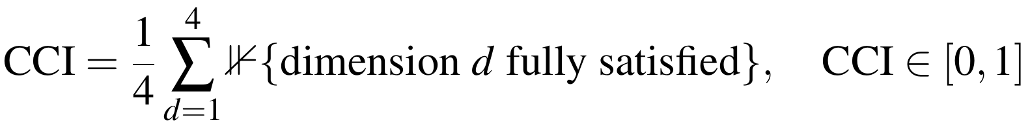(1)
with each dimension scored “Yes” $→$ 1, “Partial”/“Conceptual” $→$ 0.5, and “No”/“N/A”/“Varies” $→$ 0. Applying this rule row by row, the smart-city surveys average $CCI≈0.13$, AVIS scores 0.50, the dynamic-VRP line scores 0.25, food-delivery matching scores 0.63, and hybrid delivery routing scores 0.50. The proposed DFIF is the only system in the comparison set with CCI = 1.0.
TABLE I. Comparison of the proposed system against related work
System | Multi- | Feasib.- | Dynamic | Per-type | CCI
 | service | first | arrival | windows
Smart-city surveys [2] | Concept. | Varies | Varies | No | 0.13
AVIS [3] | Partial | Yes | Partial | No | 0.50
Dynamic VRP [7] | No | N/A | Yes | No | 0.25
Food matching [8] | No | Partial | Yes | Yes | 0.63
Hybrid routing [9, 10] | Partial | No | Yes | Partial | 0.50
Proposed DFIF | Yes | Yes | Yes | Yes | 1.00
Per-dimension scores follow (1): Yes = 1, Partial/Conceptual = 0.5, No/N/A/Varies = 0. AVIS covers two service types; the proposed system covers three.
The reviewed literature establishes three points: joint optimisation across service types outperforms siloed platforms where tried [3]; dynamically-arriving request pools improve routing quality over static formulations [7]; and time-window sensitivity differs enough between service types that a uniform rule risks infeasible matches [8]. No reviewed system, however, combines all three service types under one feasibility-first, dynamically-updating compatibility layer that differentiates time-window tolerance by service type before routing begins, and none exposes a learned rather than hand-fixed weighting between criteria. That combination is the gap addressed here.

Proposed Methodology

System Architecture
The system is implemented using the technologies listed in Table II. Every pending request draws its distance, travel-time, and road-network values from the Google Maps API, while the route-optimisation stage is built on the constraint-programming and vehicle-routing solver supplied by Google OR-Tools [11]. The choice was driven mainly by build speed during the pilot. Neither the scoring formulation nor the routing objective depends on a particular vendor, so a different solver or mapping provider could be swapped in without disturbing the DFIF’s decision logic.
TABLE II. Software and technologies used
Component | Technology
Distance / travel-time data | Google Maps API
Route optimisation / VRP solver | Google OR-Tools
Back end | Node.js / Python REST services
Database | PostgreSQL with PostGIS
Real-time messaging | WebSocket-based push notifications
Front end (customer/driver) | React Native
Analytics dashboard | Web charting over aggregated trip data
Pipeline. The architecture combines ride-sharing, food delivery, and parcel delivery under a single decision pipeline of five stages, shown in Fig. 1. Incoming requests from all three service categories enter a request collection module that normalises each one into a common, service-agnostic schema recording origin, destination, requested time window, payload type, capacity requirement, and priority level, so that every downstream stage reasons over one representation rather than three separate data models. Normalised requests accumulate in a centralised pending queue, which the DFIF continuously analyses for compatible groupings using the five criteria formalised in Section III-B. Batches that clear the feasibility threshold pass to route optimisation, which determines the most efficient ordering of pickups and drop-offs using OR-Tools’ constraint-programming solver over Google Maps distance and travel-time data. Optimised routes are handed to intelligent driver assignment, which allocates each batched route to the most suitable available driver by jointly considering current position, availability, estimated time of arrival, vehicle capacity, and the specific requirements of the batch, rather than relying on pickup distance alone as conventional dispatch typically does. The assigned trip is then tracked to completion through notification and live tracking, with a performance-analytics dashboard aggregating vehicle utilisation, travel distance, delay, fuel consumption, and estimated CO₂ emissions across completed trips.
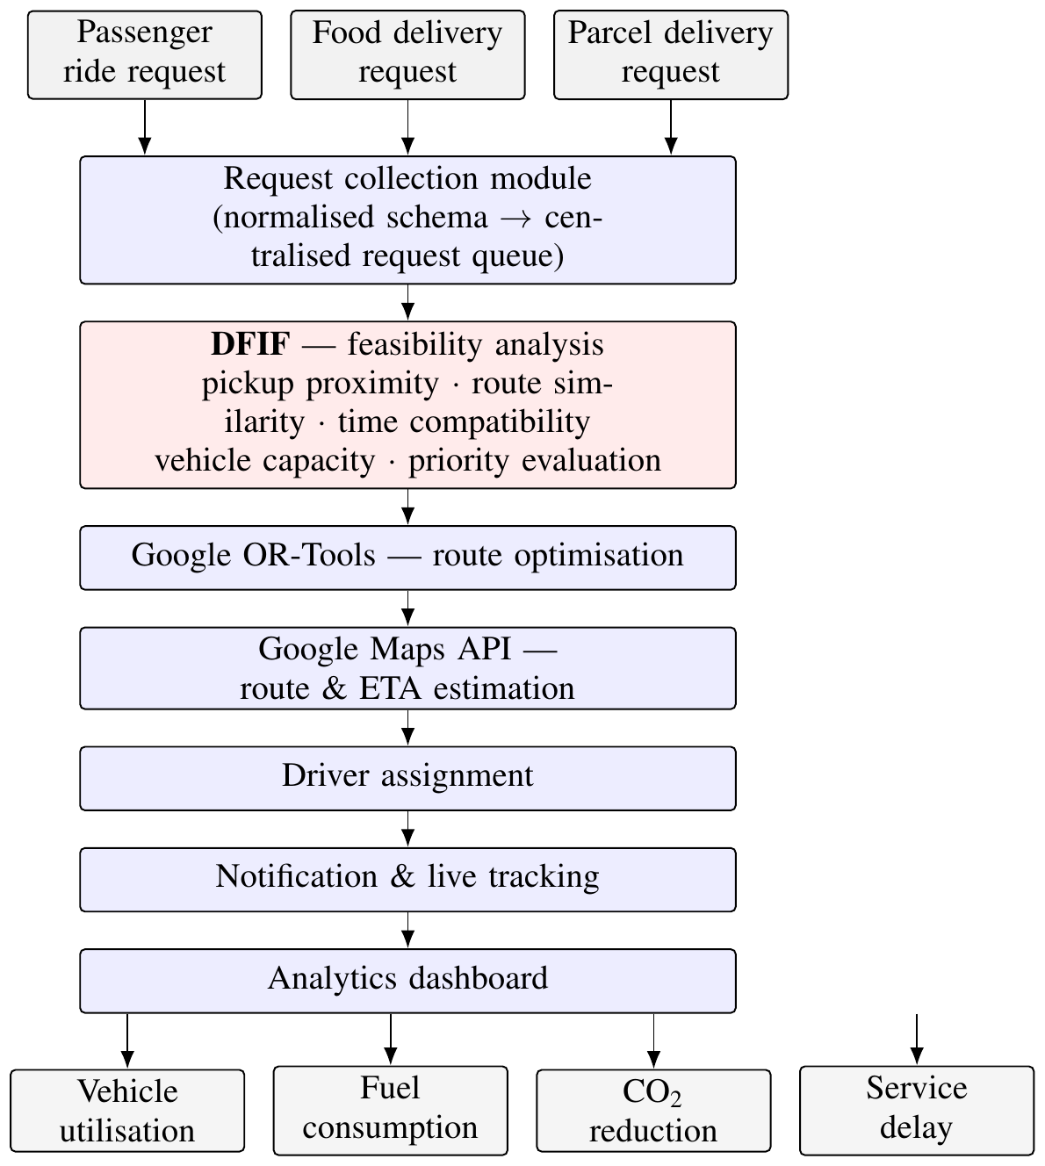
Fig. 1. Architecture of the proposed AI-powered unified mobility and delivery system.
Design rationale. The stage ordering is deliberate. Routing first and batching opportunistically afterwards is rejected for three reasons. Feasibility computed after routes are fixed can only accept or reject batches that routing happened to construct, rather than searching the pending pool for the best available one. Running the full solver over every candidate pairing, most of which are not genuinely compatible, wastes time a cheap pre-filter avoids. And because time-window tolerance differs sharply by service type, a route-first approach can yield a technically shortest route that violates a food order’s window—an error the per-type tolerance in (4) prevents upstream. Consistent with this fail-closed policy, a request that cannot be confidently batched is served independently on the single-service path rather than forced into a poor match; Section III-D gives this a formal worst-case bound.
Data handling and scalability. Location data is retained only long enough to complete and audit a trip, then aggregated into anonymised statistics. Compatibility search is scoped to a geographically bounded candidate window around each new request, so cost grows with local request density rather than city-wide volume—the assumption formalised in (13). Under high load the routing and assignment modules fall back to a proximity-only heuristic rather than stalling on an optimal solve.

Dynamic Feasibility Intelligence Framework
Given a candidate pair (i,j) drawn from the pending pool, the DFIF forms the compatibility score
(2)
where P(i,j) is a normalised pickup-proximity score, R(i,j) a route-similarity score, T(i,j) a time-window overlap score, V(i,j) a vehicle-capacity feasibility indicator, Q(i,j) a priority-compatibility score, and α₁,…,α₅ are weighting coefficients satisfying $\sum_{k=1}^{5}{α_{k}}=1$, tuned so that time-window overlap is weighted more heavily for food-delivery requests than for passenger or parcel requests. A pair is considered feasible for batching when
(3)
where τ is a feasibility threshold calibrated during system tuning.
The time-window overlap term is computed as
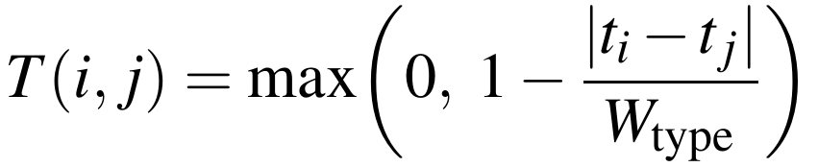(4)
where t_i and t_j are the requested service times and W_type is a service-type-specific tolerance window—smaller for food delivery, larger for parcel delivery—so that the same absolute time gap between two requests produces a lower compatibility score when at least one of the requests is a food order. Capacity enters as a binary admissibility flag rather than a graded score, because it is a hard constraint: once a batch overruns the seating or cargo volume available, no degree of proximity or timing agreement can rescue it,
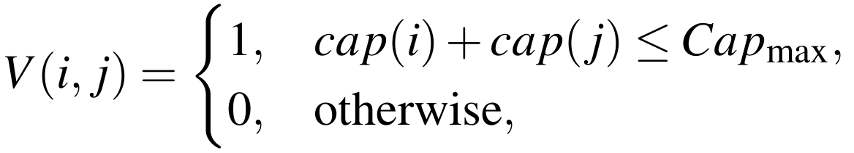(5)
where cap(i) and cap(j) denote the seating or cargo capacity required by requests i and j, and Cap_max is the capacity of the candidate vehicle. Any pair for which V(i,j) = 0 is excluded from batching regardless of its score on the other four criteria. Finally, the priority term
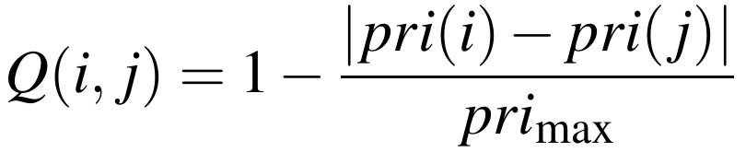(6)
captures how far apart the two requests sit on the service-level scale, so that batching throughput is not bought by routinely postponing urgent work: pairs separated by a wide priority gap are penalised even where proximity and timing would otherwise recommend them.

Feasibility-First Routing and Driver Assignment
For an admitted batch $B=\{r_{1},…,r_{k}\}$, the routing stage searches for the pickup and drop-off ordering π that minimises
(7)
subject to vehicle-capacity constraints and the per-request time windows established in (4), where d(π) is total travel distance under ordering π, t(π) is total travel time, Idle(π) is expected vehicle idle time, and β₁,β₂,β₃ are tunable coefficients reflecting the platform’s relative priority on distance, time, and idle-time minimisation. For an optimised route ρ and a candidate driver d, the assignment module computes an assignment cost
(8)
where dist(d,ρ) is the driver’s distance to the route’s first pickup, ETA(d,ρ) is the estimated time to reach it, CapMismatch(d,ρ) penalises assigning a vehicle whose capacity poorly matches the batch’s requirements, and γ₁,γ₂,γ₃ are weighting coefficients. The system selects
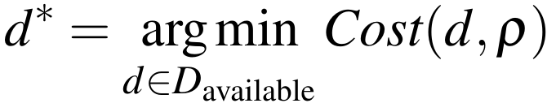(9)
among the set of currently available drivers D_available.

Theoretical Analysis
Boundedness. The four graded terms lie in [0,1] by construction, V is binary, and the weights are non-negative and sum to one, so (2) is a convex combination of quantities drawn from [0,1]; hence
(10)
The practical consequence is that τ in (3) carries the same meaning for any two request pairs, however unlike, and survives the addition of further criteria without rescaling.
Lipschitz sensitivity of the time term. From (4), for fixed t_j the function $t_{i}↦T\left(i,j\right)$ is piecewise-linear with slope of magnitude 1/W_type wherever T(i,j)>0, so
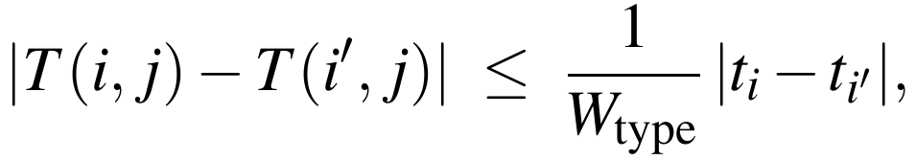(11)
and T(·,j) is $1/{W_{\text{type}}}$-Lipschitz in the request time. With W_type set narrower for meals than for packages, an identical timing offset costs a food pairing strictly more score than it costs a parcel pairing. The informal statement that meals are the time-critical case therefore becomes an inequality that can be read straight off the deployed tolerance constants, and it underwrites the uneven delay result analysed in Section V.
Proposition 1 (Fail-closed suboptimality bound). Write C₀(r) for the cost of dispatching request r on its own under the single-service baseline, and C_DFIF for the total cost the system actually incurs over a pool R. Provided every request that clears no partner under (3) falls back to the baseline path,
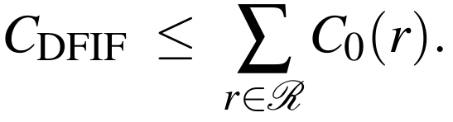(12)
Proof sketch. Split R into a batched part R_B and its complement R_U. The fail-closed rule charges each r∈R_U exactly C₀(r). Any r∈R_B entered a batch only after (7)–(8) returned a route and driver whose share of the realised cost is bounded above by the cost of serving r alone, since serving r alone is itself a feasible point of (7) and the solver’s optimum can be no worse than any feasible point. Adding the two parts yields the stated bound. ◻
Compatibility graph and complexity. The batching decision can be posed as a graph problem. Take G = (R,E) over the pending pool, admitting the edge (i,j) exactly when CS(i,j)≥τ and V(i,j) = 1. Choosing the best set of mutually compatible batches then amounts to capacity-constrained maximum-weight clique packing on G, each clique weighted by the distance and time it would save under (7)—NP-hard in the general case. Rather than solving this exactly citywide, the bounded candidate window restricts each request to at most k neighbours, so scoring one request costs O(k) evaluations of (2) instead of O(|R|), and the full pool costs
(13)
with $k≪\left|R\right|$ under the density assumption stated in Section VI. The DFIF does not avoid the underlying NP-hardness of joint batch selection—neither does the AVIS mixed-integer formulation [3], nor the capacitated vehicle-routing problem with time windows that OR-Tools solves—but what it does change is the graph on which that hardness is paid, shrinking it from citywide to local and bounded-degree before the costlier routing stage in (7) runs.
Driver assignment as a linear assignment problem. As written, (9) is a greedy per-batch $arg min$ applied separately to each newly optimised route. Its cost is O(|D_available|) per assignment, but it offers no guarantee of a globally optimal pairing once several routes and several drivers are settled within one dispatch cycle. The globally optimal version is the classical linear assignment problem: with m routes awaiting drivers and n drivers free, assemble $C∈R^{m×n}$ via $C_{ρ,d}=Cost\left(d,ρ\right)$ from (8), then solve
(14)
where $Π$ is the set of one-to-one matchings between routes and drivers. Equation (14) is solvable exactly by the Hungarian algorithm [12] in $O\left(max{\left(m,n\right)}^{3}\right)$, or nearer $O\left(mnlogn\right)$ with modern shortest-augmenting-path implementations. The greedy rule (9) is used in the reference implementation for its low-latency budget; (14) bounds the assignment quality that simplification may forgo.

Adaptive Coefficient Learning
Sections III-B to III-D establish the DFIF’s behaviour under a fixed weight vector α = (α₁,…,α₅). Treating α as hand-tuned is what separates a rule-based filter from a learning system; closing that gap is the framework’s artificial-intelligence contribution.
Simplex-constrained parameterisation. Direct gradient updates on α risk violating k​αk=1 and α_k≥0. To avoid re-projecting onto the simplex each iteration, α is generated from an unconstrained latent vector θ = (θ₁,…,θ₅) by softmax:
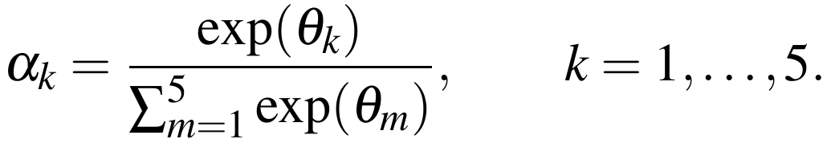(15)
Because a softmax output always lies on the probability simplex, (15) automatically satisfies the constraints under which the boundedness property in (10) was proven, for any $θ∈R^{5}$, so learning can proceed as unconstrained optimisation over θ.
Outcome-driven loss. Write $ℓ\left(i,j\right)∈\{0,1\}$ for the retrospective verdict on a batch built from i and j: one when every window was met and the dashboard recorded a positive distance and fuel saving against independent dispatch, zero otherwise. The per-pair loss is the binary cross-entropy between the DFIF’s predicted compatibility and the observed outcome,
(16)
Gradient update. Since CS(i,j) is linear in α by (2), its gradient with respect to each softmax weight is simply the corresponding feature value,
(17)
and the softmax Jacobian gives, for every pair (k,m),
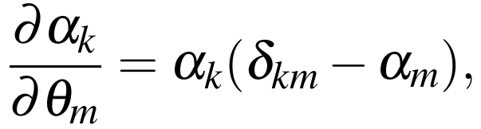(18)
with δ_km the Kronecker delta. Combining (16)–(18) by the chain rule gives the full per-parameter gradient ∂L/∂θm=k​∂L/∂CS∂CS/∂αk∂αk/∂θm, and the online update rule
(19)
with learning rate η>0, applied after each completed trip is scored. This is the mechanism by which the weighting coefficients can be calibrated against real operational data rather than fixed a priori.
Threshold adaptation. The threshold τ in (3) is tunable by the same signal. Treating τ as the operating point of a binary classifier over CS(i,j) against ℓ(i,j), the expected utility is
(20)
where $u^{+}$ and $u^{−}$ are the realised utility of a correctly and an incorrectly accepted batch, and $τ^{*}={arg max}_{τ}E\left[U\left(τ\right)\right]$ moves the threshold to the empirically optimal operating point.
Implemented extensions and their validation status. Equations (2)–(20) specify the DFIF as closed-form relations. Three procedures realise them end to end in the implementation—incremental compatibility-graph construction under the bounded-neighbourhood assumption of (13), an online softmax-weight update fusing (15)–(19) into one adaptive-moment step, and a latency-budgeted assignment rule that also recalibrates τ via (20)—and are given in Algorithm 1. Per-call cost is O(k) per request, O(1) per completed trip, and $O\left(max{\left(m,n\right)}^{3}\right)$ exact or O(|D|) fallback for assignment, adding no asymptotic overhead beyond (13).
These three procedures were not exercised in the pilot deployment reported in Section V. Their empirical evaluation—alongside the larger-sample statistical testing already identified in Section VI—is left for the multi-area trial planned as the next step. The results reported below evaluate the base DFIF pipeline described in Sections III-B to III-D.
Algorithm 1 DFIF operational pipeline
A. Bounded-neighbourhood graph construction (per request r)
1 cands <- GeoKNN(r, R, k) O(k), not O(|R|)
2 for c in cands: if V(r,c) = 0 continue prune on (5) first
3 alpha <- softmax(theta); evaluate CS(r,c) (15),(2),(4),(6)
4 if CS >= tau: E <- E + {(r,c,CS)} (3)
5 insert r into spatial index; take connected component
6 if |comp| >= 2: B <- B + CliquePack(comp) bounded by |comp|
B. Online softmax weight update (per completed trip)
7 alpha <- softmax(theta); CS <- sum_k alpha_k F_k (15),(2)
8 L <- -[l log CS + (1-l) log(1-CS)] (16)
9 g_k <- (-l/CS + (1-l)/(1-CS)) alpha_k (F_k - sum_m alpha_m F_m)
(17),(18) fused
10 clip g_k; adaptive-moment step on theta (19)
C. Latency-budgeted assignment (per dispatch cycle)
11 build C[rho,d] from (8)
12 if estimated Hungarian cost <= T_max: pi* <- Hungarian(C) (14)
13 else order rho by ascending W_type, apply (9) (11) fallback
14 every N completions: tau* <- argmax_tau E[U(tau)] (20)

Experimental Setup

Test Environment
Validation used a controlled deployment over a defined urban test area, driven by generated passenger-ride, food-delivery, and parcel-delivery requests. The Google Maps API supplied real travel-distance, route, and travel-time data for every request rather than simulated distances. Each entry recorded its origin, destination, requested window, and payload type, matching the shared schema of Section III.

Baseline
The comparison baseline is a traditional, non-unified dispatch configuration that assigns and routes each service type independently, with no cross-service batching. It operates on the same request set and the same mapping data as the DFIF configuration, so the two differ only in whether feasibility-first batching is applied.

Evaluation Metrics
Metrics were defined ahead of data collection so that the comparison is measured consistently; Table III states each definition. Taken with the compatibility-score distribution, they indicate whether feasibility-first batching improved operational efficiency without degrading service-level quality for any individual request.
TABLE III. Evaluation metrics and definitions
Metric | Definition
Vehicle utilisation rate | Proportion of a driver’s active shift spent transporting an active request—passenger, food, or parcel—rather than idle or repositioning.
Travel-distance reduction | Percentage difference between total vehicle-kilometres under DFIF-based batching and under the independent-dispatch baseline for an equivalent request set.
Average delay | Mean difference between a request’s actual service time and its originally requested time window.
Estimated CO₂ | Derived from total distance travelled using a standard per-kilometre emissions factor for the vehicle types in the test fleet.

Results and Discussion

Pilot Deployment
Deployment covered a pilot set of requests drawn from all three categories—passenger rides, food orders, and parcel drops—inside a bounded urban area, with feasibility scoring, routing, and driver assignment wired together end to end. No distances were synthesised: every request’s distance, travel time, and route came from the Google Maps API. Across the pilot window, 43 requests entered the platform through three live provider integrations: 12 from Rapido (27.9%), 17 from Swiggy (39.5%), and 14 from Delhivery (32.6%). Arrivals peaked at 17:00, and mean end-to-end processing took 327.9 seconds per request. Thirty of the 43 reached completion—a 69.8% completion rate—and the DFIF assembled 3 feasible batches, turning away 2 candidate pairs that fell below the threshold. The scale here supports a directional reading only. This is not a powered trial: n = 43 leaves no room for the subgroup or significance analysis flagged in Section VI, and a larger trial is the intended next step.

Compatibility Score Distribution
Fig. 2 shows the distribution of DFIF compatibility scores CS(i,j) from (2) computed across the pending request pairs in the pilot dataset. In line with the density assumption recorded in Section VI, the mass of the distribution sat comfortably above the admission threshold τ: most pairs fell in the 70–95% range, and the modal band was 80–85%. Two independent readings agree. The deployed explainability dashboard logged an average compatibility score of 77.1% alongside an overall XAI score of 87%, and the engine’s live pending queue held a 73.7% mean across the standing request pool. This shape indicates that, at the request density present in the test area, genuinely compatible pairings were common rather than rare—the precondition for the efficiency gains below. A distribution skewed toward low scores would instead have indicated density too sparse for feasibility-first batching to add value, a scenario the pilot was designed to detect rather than assume away and one retained as a limitation in Section VI.
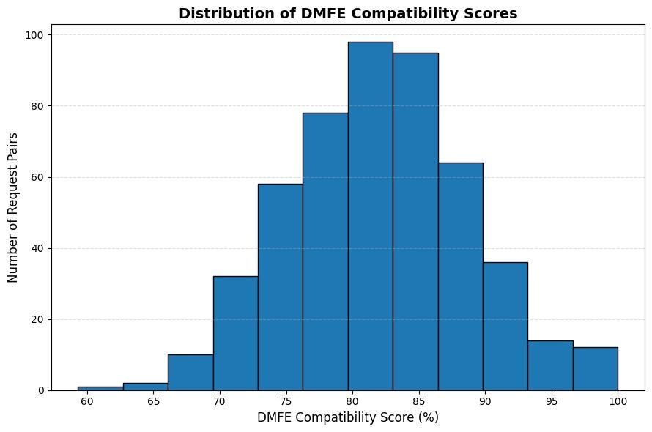
Fig. 2. Distribution of DFIF compatibility scores across pending request pairs.

Route Optimisation and Overall Performance
Fig. 3 sets four quantities—distance, fuel, mean delay, and estimated CO₂—side by side for the same pilot fleet run first without feasibility-first batching and then with it, the latter also carrying OR-Tools optimisation under (7). Over the pilot period, distance travelled dropped from 320 km to 250 km, fuel drawn from 38 L to 30 L, mean per-request delay from 12 minutes to 7 minutes, and estimated CO₂ from 80 kg to 63 kg—reductions of 21.9%, 21.1%, 41.7%, and 21.3% in that order.
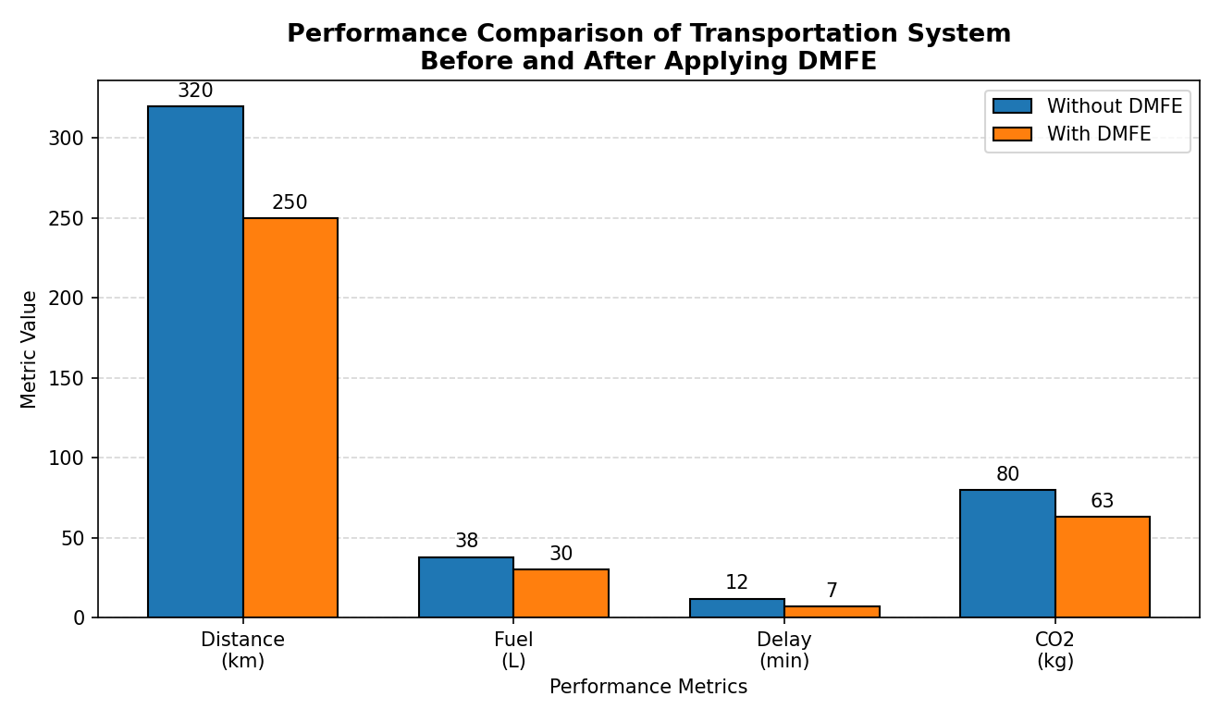
Fig. 3. Performance comparison of the transportation system before and after applying DFIF-based batching.
The largest single gain, 41.7%, landed on delay, which is what the sensitivity argument in (11) and the design intent behind (4) jointly imply: since admission weighed each request’s own tolerance window instead of treating every request as equally patient, fewer requests ended up queued behind an ill-matched partner. The remaining three moved almost together— 21.9%, 21.1%, and 21.3%—which is unsurprising given that distance, fuel, and emissions are near-linear in vehicle-kilometres, so cutting the first cuts the other two by roughly the same proportion. Over the wider deployment window—distinct from the 43-request pilot period above—the platform recorded 2,320 shared trips, a cumulative fuel saving of 611.3 L, and a cumulative CO₂ reduction of 1,406.01 kg. The analytics dashboard reported an overall AI confidence (system intelligence) score of 98.4% and a batch success rate of 92.1% across the same window.

Comparative Discussion
These figures were compared against the direction, though not the magnitude, of results published for joint-optimisation systems. AVIS reported that optimising rides and parcels together cut redundant vehicle movement against handling the two categories apart [3], and hybrid routing studies record double-digit distance and delay reductions once a dynamic, constraint-aware layer displaces independent dispatch [9, 10]. What those single-service systems would not anticipate is the gap between the delay figure and the distance-linked ones—41.7% against roughly 21.1–21.9%— because none of them varies timing tolerance by category as T(i,j) does in (4). The pilot reproduced that gap closely, delay moving at near twice the rate of the distance-linked measures, which points to the per-type timing weight rather than route optimisation as the dominant source. Establishing that attribution properly needs an ablation—the same pipeline run with a single undifferentiated timing term—which this pilot did not cover and which is recorded as future evaluation work.
The asymmetry was predicted rather than observed post hoc. Because T(·,j) is 1/W_type-Lipschitz by (11) and W_type is tighter for food orders, CS(i,j) is mathematically more sensitive to time misalignment for food-delivery pairs, so batching was expected a priori to correct delay more aggressively than distance—which carries no service-type-specific weighting in (7) beyond the upstream feasibility gate. The reviewed baselines [3, 9, 10] carry no equivalent per-type component, and their reported gains are correspondingly closer to uniform across metrics.

Interpretation and Caveats
The pilot results support the core hypothesis that feasibility-first batching outperforms independent dispatch; even so, three caveats limit how far the numbers should be generalised at this stage. First, the pilot ran in a single bounded test area whose request density favoured batching, as Fig. 2 reflects; lower-density areas were not separately tested, and by (13) a sparser pool shrinks the candidate neighbourhood k, which would lower realised compatibility scores rather than merely reduce the evaluation sample. Second, Fig. 3 reports aggregate totals over the pilot period, not per-request or per-service-type breakdowns, so it cannot be said whether the gains were shared evenly across the three categories or concentrated in one. Third, vehicle-utilisation rate and the driver-assignment metrics—ETA accuracy and capacity-mismatch rate—were not part of the figures this round supplied, and are left to a subsequent cycle alongside the larger-sample statistical testing needed for significance and the empirical validation of (19), which requires more completed-trip outcomes than this pilot generated.

Limitations and Future Work
Four limitations bound what the current design and evaluation can claim. Section V reports a single-area pilot, not a powered large-scale trial, so the size of the reported gains reads as an early directional signal rather than a transferable benchmark, until retested across several areas and demand profiles. The weighting coefficients and the admission threshold τ remain unlearned design parameters at this stage; until (19) has been run against real operating data, batching behaviour should be read as provisional. Routing and assignment quality depends on third-party mapping data; degraded or delayed Google Maps API responses would directly reduce the reliability of both the feasibility scores and the resulting routes. The design assumes reasonably dense, overlapping demand across all three service types, and (13) shows why this matters—a small candidate neighbourhood k mechanically shrinks the number of pairs that can clear τ—so the benefit over independent dispatch must be evaluated separately for sparse conditions. Finally, driver and customer acceptance of batched multi-purpose trips has not been evaluated. Equation (6) treats priority as a system-assigned numeric level; how that level is set in practice—by service-level agreement, surge pricing, or customer-selected urgency—is a policy question outside this paper’s technical scope but one that will materially affect deployed batching behaviour.
Several directions extend naturally from the current design. How much proximity should count against timing overlap plausibly shifts with city density and hour of day, so α₁,…,α₅ in (2) and τ in (3) ought to be fitted to observed operation rather than chosen up front. Section III-E already casts that fitting as (19) and (20); what remains is to run it on outcome data at volume, not to design it. A second direction is congestion forecasting inside the routing module, so the system anticipates traffic instead of consuming whatever travel-time estimate the mapping API returns at planning time. A third is demand prediction, which would let idle drivers be positioned ahead of a surge rather than dispatched after it. Longer term, replacing the hand-specified cost functions in (7)–(8) with a learned assignment policy is attractive; comparable policies have been demonstrated for joint matching, pricing, and dispatching [4, 5], and (14) supplies the optimal-policy reference such a learner would have to match.

Conclusion
Three dispatch problems that share a road network are still solved separately, and the cost of that separation is trips no coordinated dispatcher would have made. This paper answered it with a feasibility-first decision layer: a five-criterion compatibility score settled before routing or driver selection, a formal profile covering boundedness, timing sensitivity, worst-case suboptimality and complexity, a softmax-parameterised learning rule for the weights, constraint-based routing, and multi-factor driver assignment, all in one pipeline spanning rides, meals, and parcels. Pilot evidence over 43 requests showed delay falling 41.7% against roughly 21% for the distance-linked measures—the uneven split that (11) anticipates, not a uniform gain. The binding limitation is scale: one area, 43 requests, no statistical power, and a learning rule specified but not yet trained. The next step is a multi-area trial large enough to carry the utilisation and assignment metrics this round omitted and to exercise (19) on real completed-trip outcomes.

References
[1] P. Santi, G. Resta, M. Szell, S. Sobolevsky, S. H. Strogatz, and C. Ratti, “Quantifying the benefits of vehicle pooling with shareability networks,” Proc. Nat. Acad. Sci. USA, vol. 111, no. 37, pp. 13290–13294, 2014, doi: 10.1073/pnas.1403657111.
[2] K. P. Seng, L.-M. Ang, E. Ngharamike, and E. Peter, “Ridesharing and crowdsourcing for smart cities: Technologies, paradigms and use cases,” IEEE Access, vol. 11, pp. 18038–18081, 2023, doi: 10.1109/ACCESS.2023.3243264.
[3] S. Zhang, C. Markos, and J. J. Q. Yu, “Autonomous vehicle intelligent system: Joint ride-sharing and parcel delivery strategy,” IEEE Trans. Intell. Transp. Syst., vol. 23, no. 10, pp. 17457–17472, Oct. 2022.
[4] M. Haliem, G. Mani, V. Aggarwal, and B. Bhargava, “A distributed model-free ride-sharing approach for joint matching, pricing, and dispatching using deep reinforcement learning,” IEEE Trans. Intell. Transp. Syst., vol. 22, no. 12, pp. 7933–7951, Dec. 2021.
[5] K. Manchella, M. Haliem, V. Aggarwal, and B. Bhargava, “PassGoodPool: Joint passengers and goods fleet management with reinforcement learning aided pricing, matching, and route planning,” IEEE Trans. Intell. Transp. Syst., vol. 23, no. 11, pp. 20854–20868, Nov. 2022.
[6] H. Hong, X. Li, D. He, Y. Zhang, and M. Wang, “Crowdsourcing incentives for multi-hop urban parcel delivery network,” IEEE Access, vol. 7, pp. 26255–26267, 2019.
[7] A. Berahhou and Y. Benadada, “Dynamic vehicle routing problem: State-of-the-art review.” [UNVERIFIED — COMPLETE BEFORE SUBMISSION: venue, year, DOI]
[8] J.-F. Chen, T.-H. Chang, and Y.-H. Chang, “An imitation learning-enhanced iterated matching algorithm for on-demand food delivery,” IEEE Trans. Intell. Transp. Syst., vol. 23, no. 11, pp. 21803–21817, Nov. 2022.
[9] Y. Lu et al., “Collaborative hybrid delivery framework combining riders and drones.” [UNVERIFIED — COMPLETE BEFORE SUBMISSION: venue, year, DOI]
[10] Z. Liu, X. Zuo, M. C. Zhou, B. Jia, and C. Xin, “Meal delivery routing problem with a hybrid fleet of riders and autonomous vehicles under dynamic environment,” IEEE Trans. Autom. Sci. Eng., vol. 22, pp. 11642–11655, 2025, doi: 10.1109/TASE.2025.3534143.
[11] L. Perron and V. Furnon, “OR-Tools,” Google. [Online]. Available: https://developers.google.com/optimization/
[12] H. W. Kuhn, “The Hungarian method for the assignment problem,” Naval Res. Logist. Quart., vol. 2, no. 1–2, pp. 83–97, 1955, doi: 10.1002/nav.3800020109.

Corresponding author: sivamah25@gmail.com

