CODESPHERE ASSESSMENT
Sivan Tamam

SECTION ONE

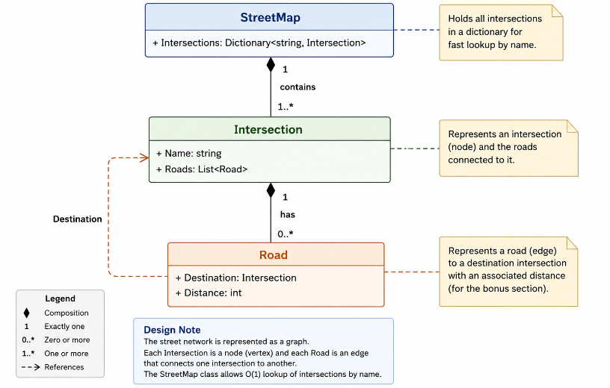
I chose a graph structure because road networks naturally form graphs where intersections represent nodes and roads represent edges. The common structure allows efficient traversal and route discovery between connected intersections.

Benefits:

Efficient Route Finding
  - Graphs are specifically designed for navigation problems.

Extendible. Can easily add:
  - Speed limits
  - One-way roads

Reusable
  - The graph structure can be reused for many routing scenarios.

Scalable
  - Adding new intersections requires minimal changes.

Drawbacks:

Memory Usage
  - Large graphs can consume significant memory.

Complexity
  - Traversal algorithms are more complex than simple collections.

Performance
  - Very large maps may require optimisation strategies.

Algorithm Design:

I would use a common algorithm called Breadth First Search (BFS) as it efficiently finds path, is easy to implement and is perfect for unweighted graph. This is an assumption made at this point. For bonus section the algorithm will be revisited.
BFS is good as it explores nearest roads first and guarantees the shortest path in terms of number of roads travelled when all roads have equal weight.

SECTION TWO
Refer to StreetMapApp for app solution.
BONUS SECTION
Once roads have distances:
A -> B = 100m
A -> C = 10m
C -> B = 10m
BFS is no longer sufficient. We now need Dijkstra's Algorithm because: A->B might be fewer roads but it is a longer distance so BFS would no longer be suitable. Dijkstra finds the shortest travel distance.
Refer to StreetMapApp for app solution.

