**#reading the log file**

raw_data_files = glob.glob(r'*C:\Users\User\Desktop\DataTesting\DataEngineerChallenge\data\2015_07_22_mktplace_shop_web_log_sample.log.gz'*)

log_df = spark.read.text(raw_data_files)

**#checking the schema**

log_df.printSchema()



**#checking sample data in dataframe**

log_df.show(10, truncate=False)

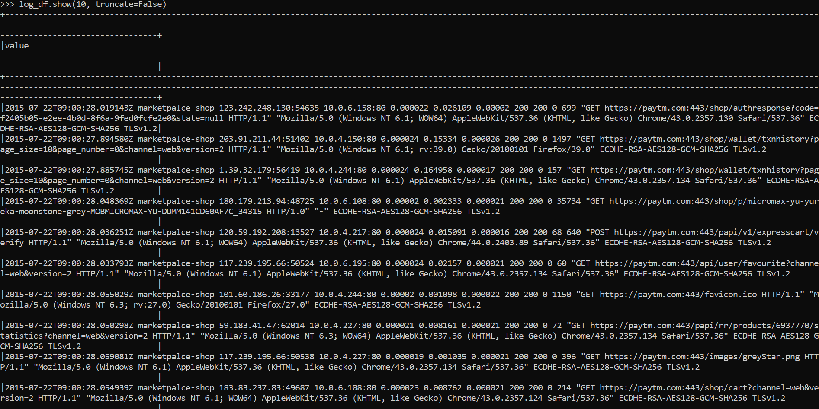

**#Checking row count to match after converting to multiple columns**

print((log_df.count(), len(log_df.columns)))



**#Checking null value**

print(log_df.filter(log_df['value'].isNull()).count())

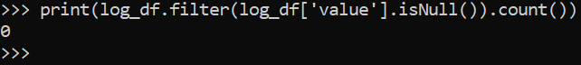

**#Converting single column in dataframe to multiple columns based on the schema**

split_col = split(log_df['value'], ' ')

split_ip = split(split_log_df['clientipport'], ':')

ip_pattern = r'(^\S+\.[\S+\.]+\S+)\s'

split_log_df = log_df.withColumn('logtimestamp', split_col.getItem(0).cast(TimestampType())) \

.withColumn('clientipport', (split_col.getItem(2))) \

.withColumn('useragent', split_col.getItem(12))

split_log_df = split_log_df.withColumn('clientip', split_ip.getItem(0))

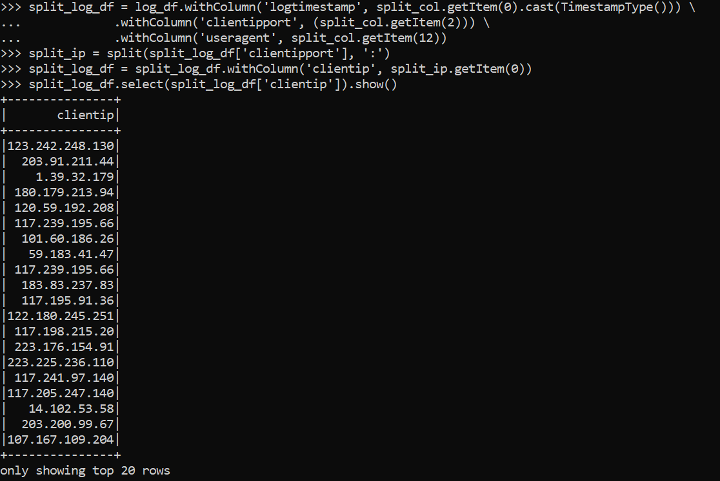

**# sessionizing data based on 15 min fixed window time and counting the hits**

**# assigning an uniqeId to each session grouped by ip and count of hits**

sessionized_df = split_log_df.select(window("logtimestamp", "15 minutes").alias('timewindow'),'logtimestamp','clientip')\

.groupBy('timewindow','clientip').count().withColumnRenamed('count', 'numofpagehits')\

.orderBy("numofpagehits")\

.withColumn("sessionid", monotonically_increasing_id())

sessionized_df.show(20,False)

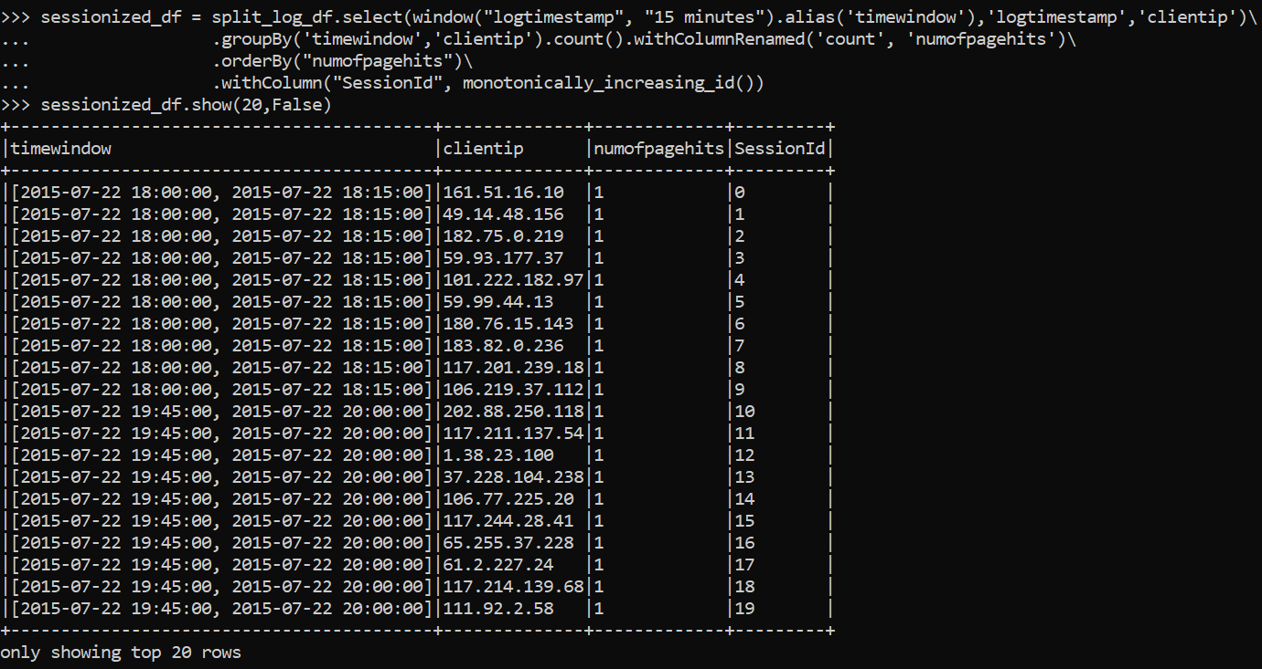

**# adding timestamp and url to the session dataframe for finding the first hit time**

timeurldf = split_log_df.select(window("logtimestamp", "15 minutes").alias('timewindow'),'logtimestamp',"clientip","useragent")

sessionized_df = timeurldf.join(sessionized_df,['timewindow','clientip'])

sessionized_df.show(10,False)

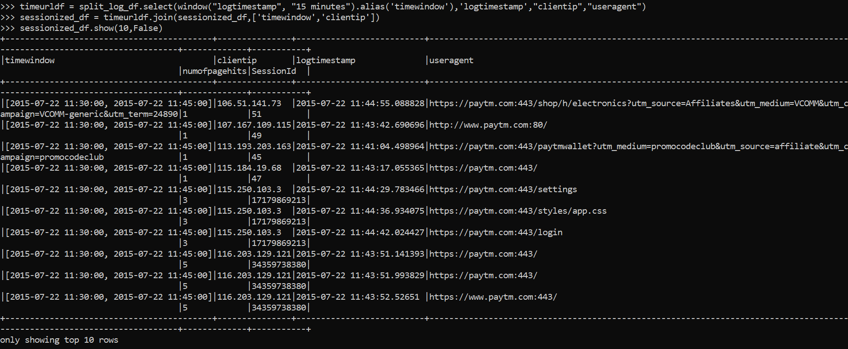

**# Finding the first hit timestamp for each ip for each session**

firsthittime = sessionized_df.groupBy("sessionid").agg(min("logtimestamp").alias('fristhittime'))

sessionized_df = firsthittime.join(sessionized_df,['sessionid'])

sessionized_df.select(col("sessionid"),col("clientip"),col("fristhittime")).show(20)

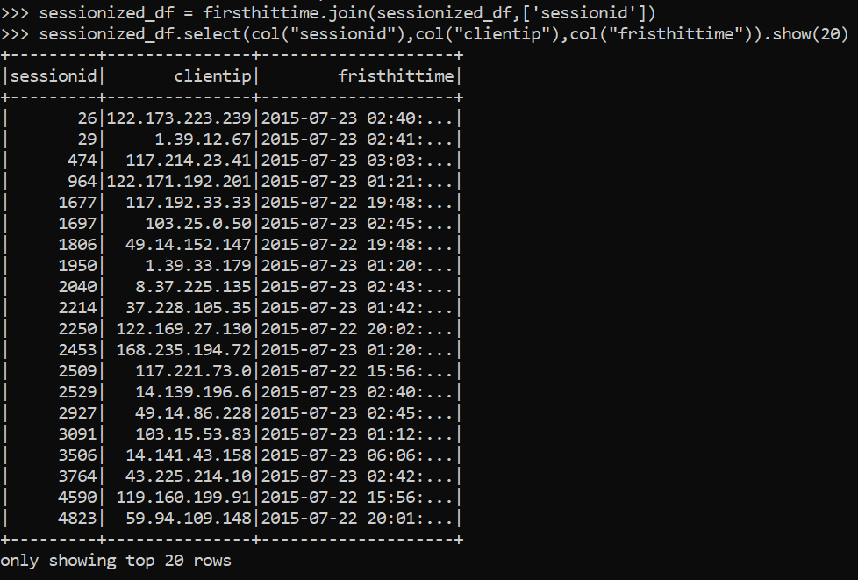

**# Average session time**

**# the time difference between first and last hit in a session is the duration of a session for each IP**

**# if there is only one hit in a session the duration is zero**

sessiontimediff = (unix_timestamp(sessionized_df.logtimestamp)-unix_timestamp(sessionized_df.fristhittime))

sessionized_df = sessionized_df.withColumn("timediff", sessiontimediff)

tmpdf = sessionized_df.groupBy("sessionid").agg(max("timediff").alias("sessioninterval"))

sessionized_df = sessionized_df.join(tmpdf,['sessionid'])

sessionized_df.select(col("sessionid"),col("clientip"),col("sessioninterval")).show(20)

averagedf = sessionized_df.groupBy().avg('sessioninterval')

averagedf.show()

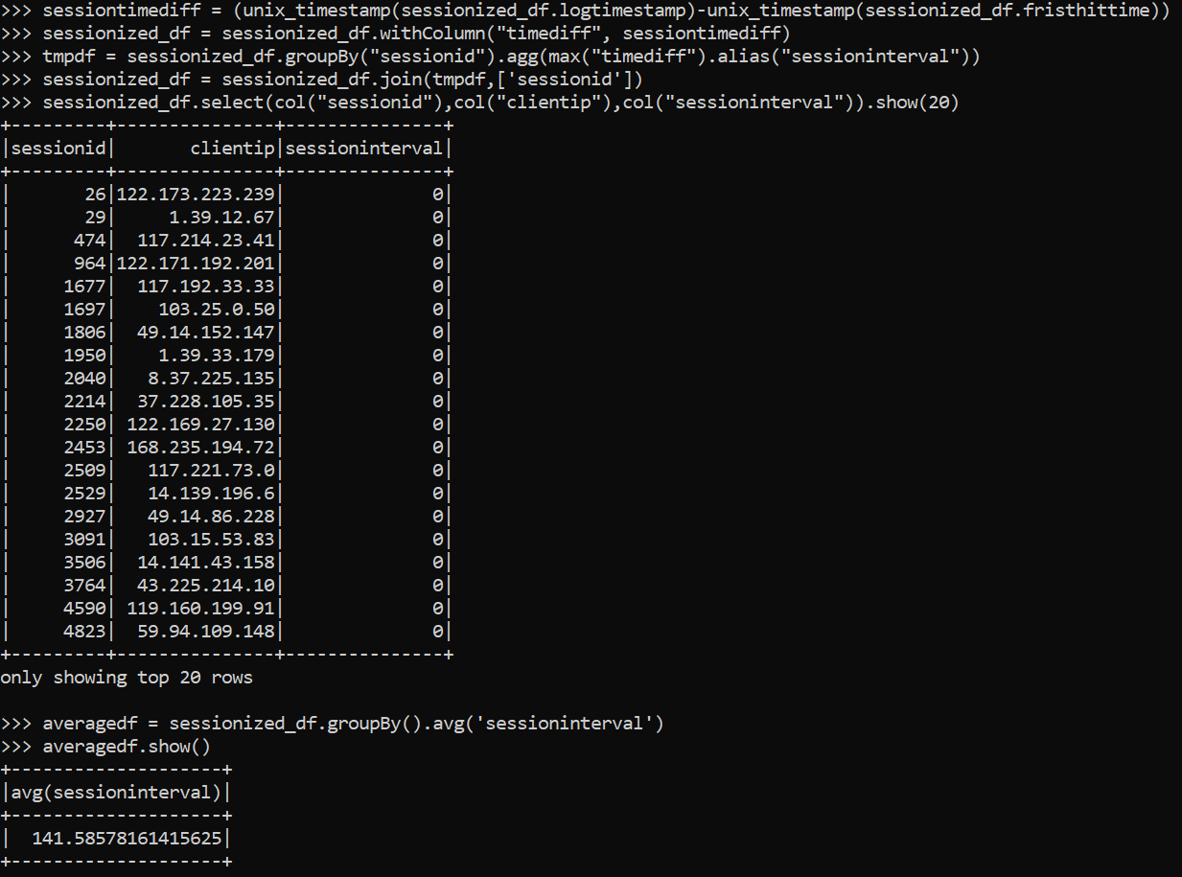

**#URL visits per session. unique URL count once per session**

sessiondfurl = sessionized_df.groupBy("sessionid","useragent").count().distinct().withColumnRenamed('count', 'urlhitcount')

sessiondfurl.show(20)

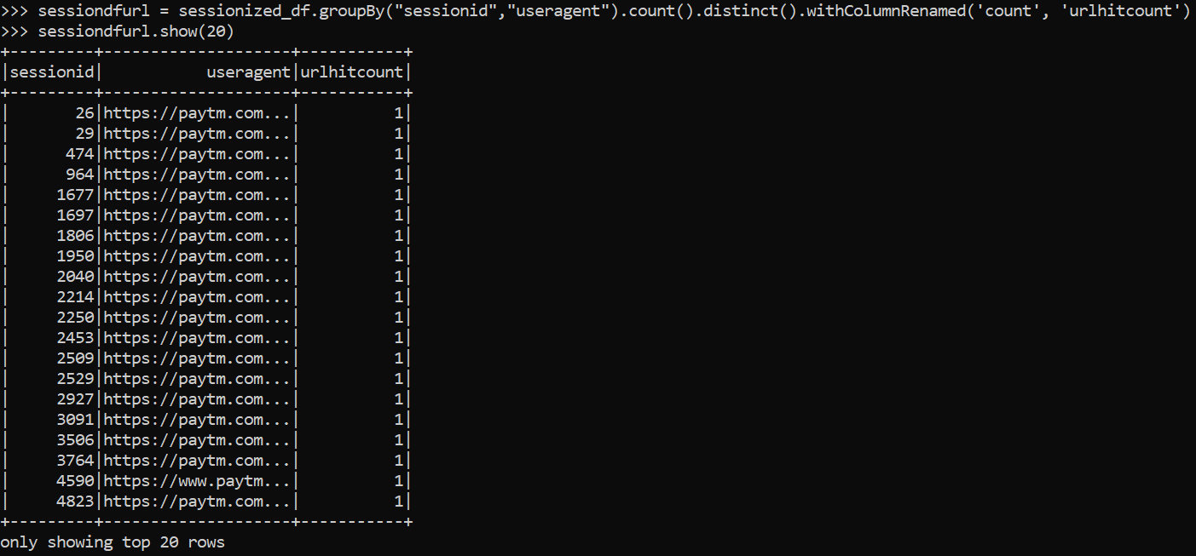

**#most engaged users, IPs with the longest session times**

mostengageduser = sessionized_df.select("clientip","sessionid","sessioninterval").sort(col("sessioninterval").desc()).distinct()

mostengageduser.show(20)

