Task-1: 3 tier setup in Azure

<https://medium.com/@sivaneni1992/in-start-of-learning-microsoft-azure-i-want-to-discuss-on-multi-tier-architecture-that-communicate-22c560cb8b6b>

Azure Compute Gallary

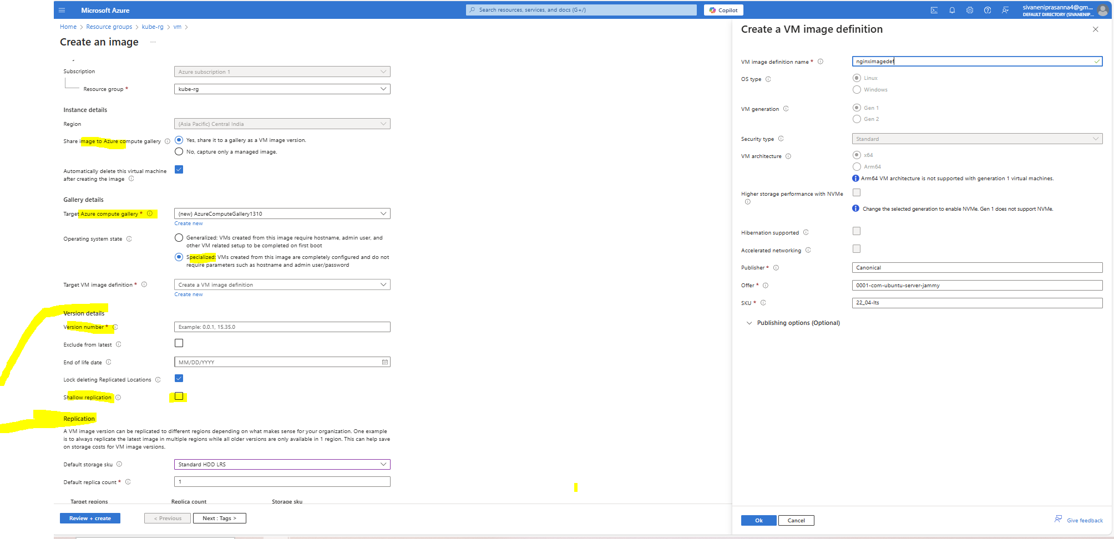

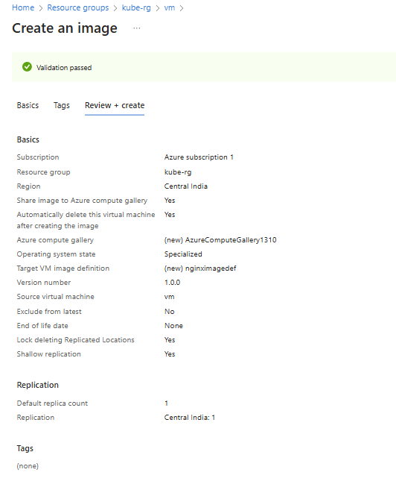

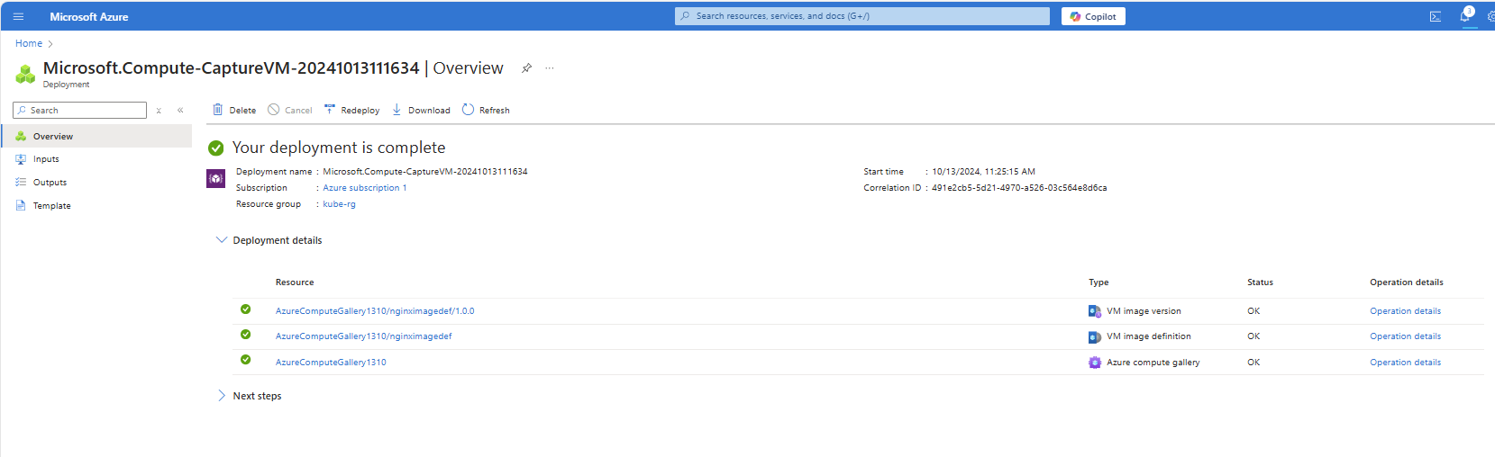

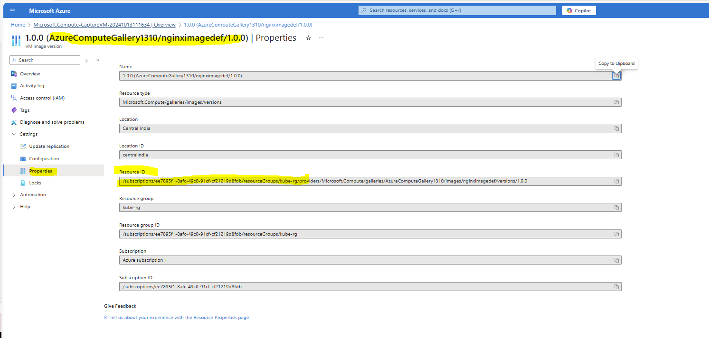

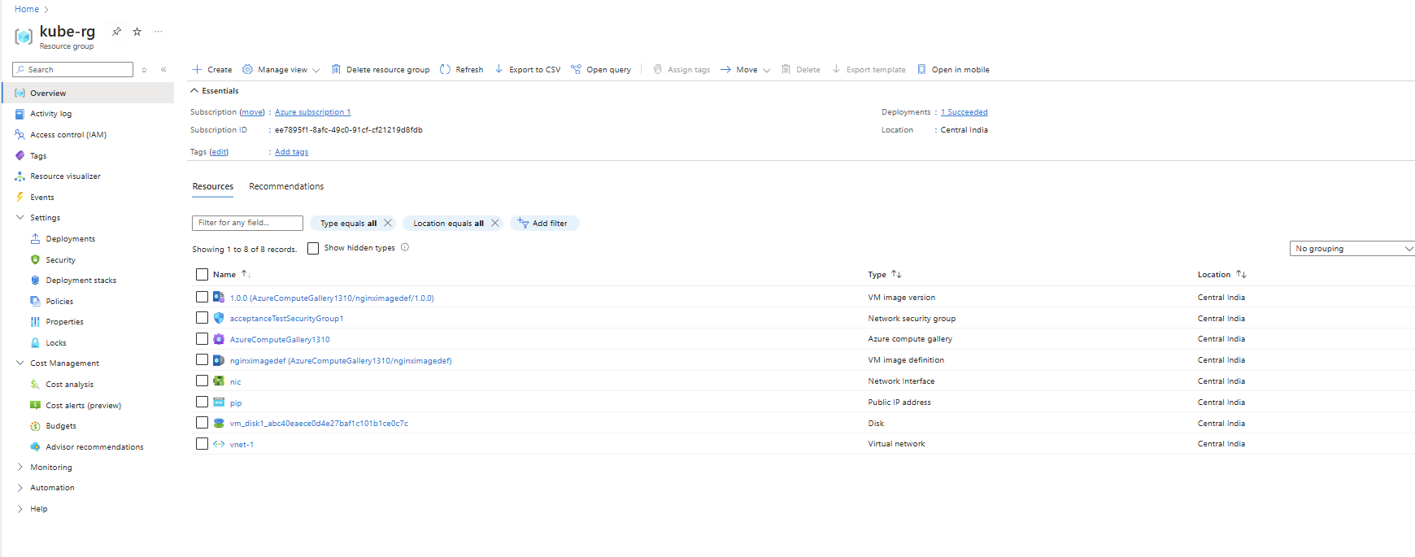

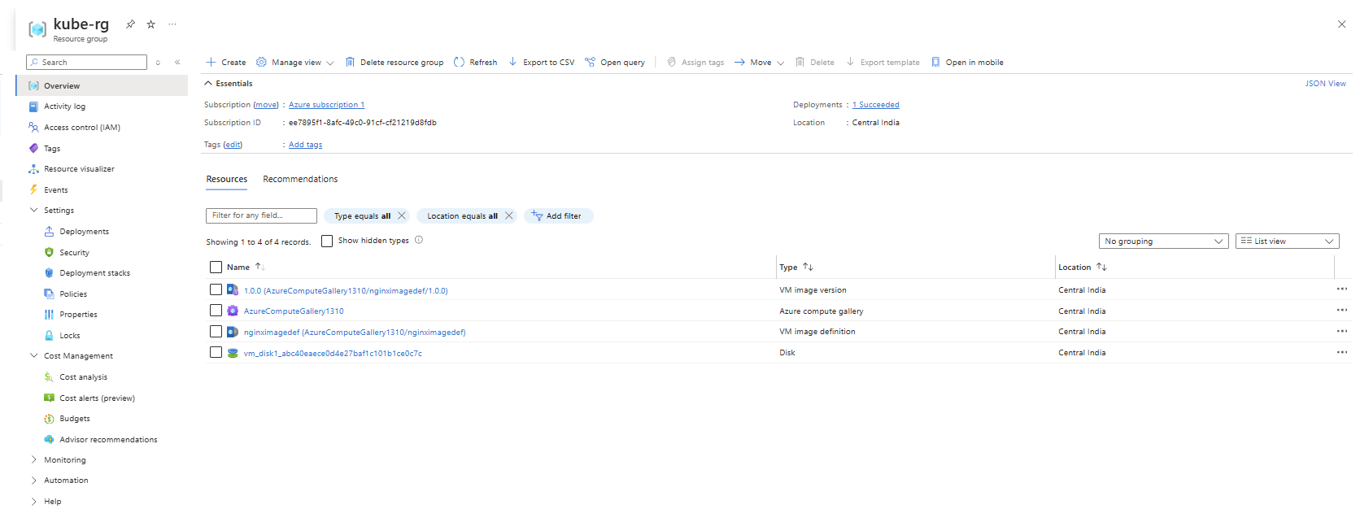

Execution Steps to configure Traffic Manager which is Global Load Balancer:

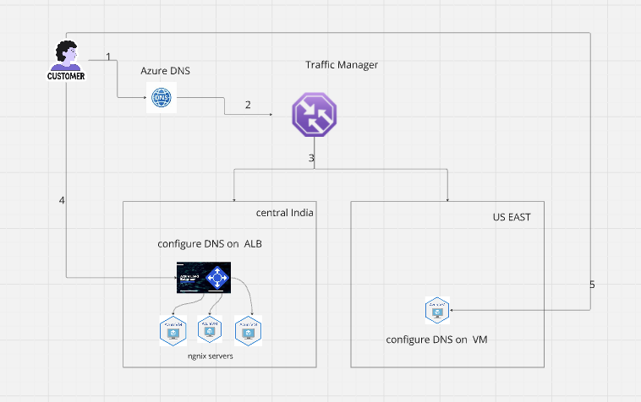 Machine generated alternative text:
Recursive 
DNS Service 
User 
DNS query 
Browser 
Client connects directly 
to selected endpoint. 
not through Traffic Manager 
Endpoint 1 
West US 
DNS response 
Traffic Manager 
Endpoint 2 
North Europe 
up closest available endpoint in latency 
table, usi DNS que source IP address 
West US East Asia 
Endpoint 3 
East Asia 
Microsoft 

1.Run the terraform script to create a single VM(Eg: Central India).This creates only nginx server

Git code: terraform folder

2.(Manual)Manually create a managed image at that time the vm created will be deleted only the disk and image will be present

Capture only Managed Image Steps:

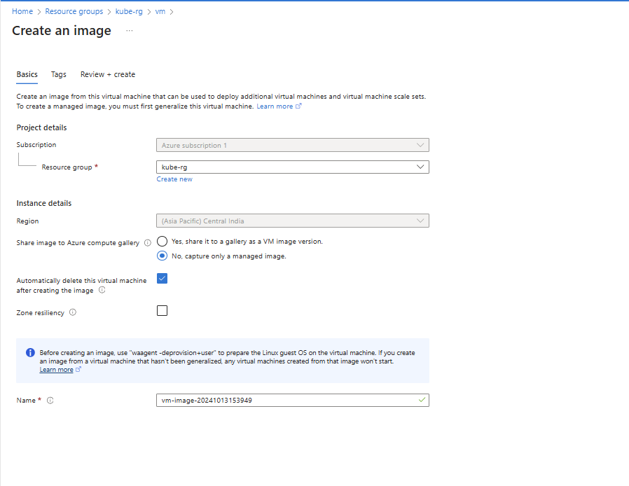

3.Run again terraform script to create ALB with 3 VM's from image generated from step-2(copy the id to source_image_id)

**Push the code to git:**

[**https://github.com/Sivaneni/terraform_multiplevm_creation_all-in-1-subnet.git**](https://github.com/Sivaneni/terraform_multiplevm_creation_all-in-1-subnet.git)

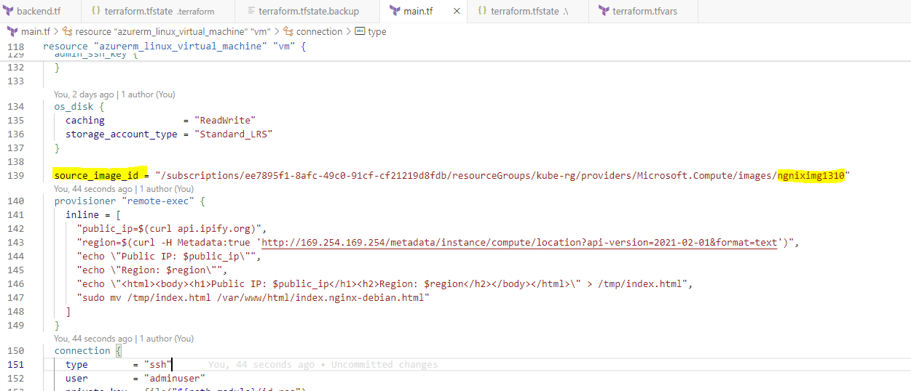

It will create an page with ip address of VM and region where server is hosted.it will be created in Central India.

Below ip address 98.70.123.173 is front-end ip of ALB and page display showing is of one of the nginx VM out of 3.

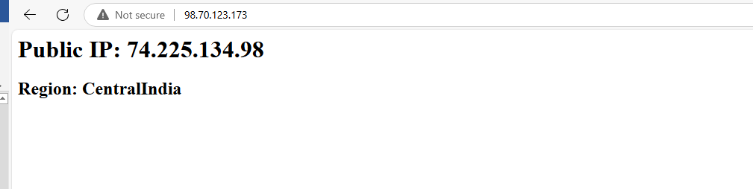

4.Run the terraform script to create a single VM in other region (eg:East US)

it will create an page with ip address of VM and region where server is hosted

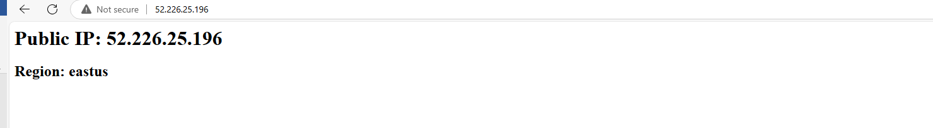

5.(Manual)configure DNS for ALB of Step-3 and DNS for Step-4 VM image

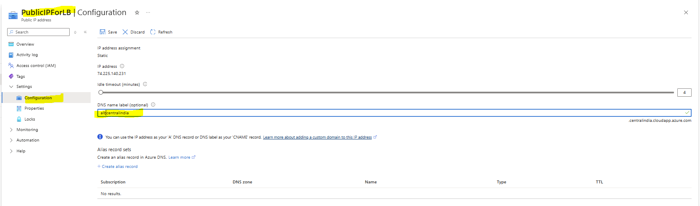

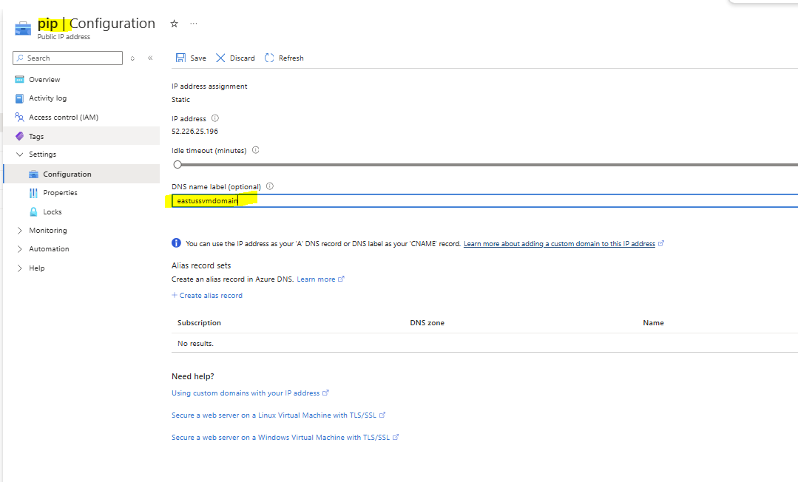

6.(Manual)Configure Traffic Manager in a different region (Not in Central India,East US) add the endpoints of step-5 and keep routing method as “priority”

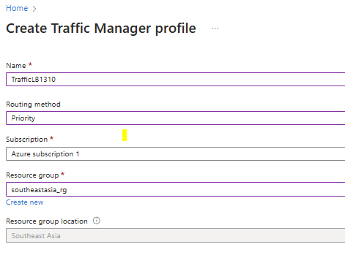

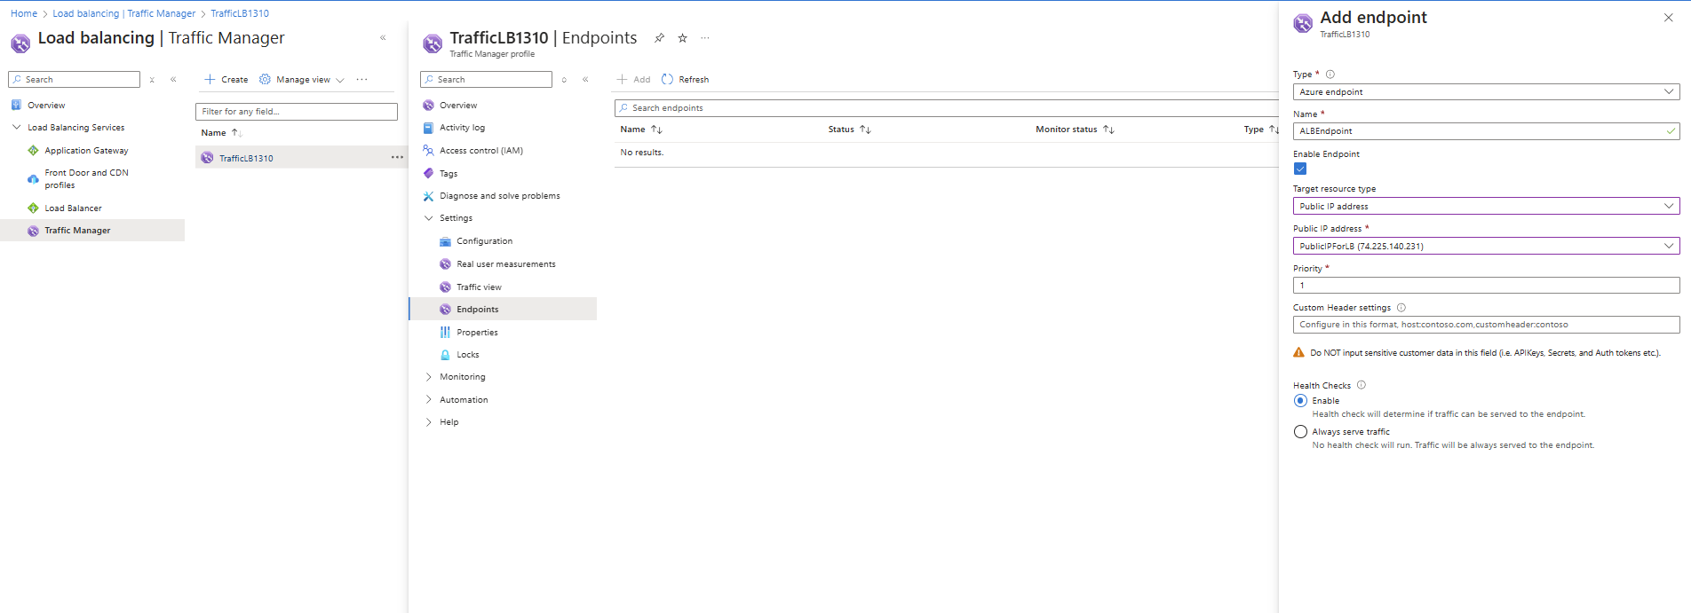

**supported Azure Locations:** "**australiacentral,australiacentral2,australiaeast,australiasoutheast,brazilsouth,brazilsoutheast,brazilus,canadacentral,canadaeast,centralindia,centralus,centraluseuap,eastasia,eastus,eastus2,eastus2euap,francecentral,francesouth,germanynorth,germanywestcentral,israelcentral,italynorth,japaneast,japanwest,jioindiacentral,jioindiawest,koreacentral,koreasouth,malaysiasouth,mexicocentral,newzealandnorth,northcentralus,northeurope,norwayeast,norwaywest,polandcentral,qatarcentral,southafricanorth,southafricawest,southcentralus,southeastasia,southindia,spaincentral,swedencentral,swedensouth,switzerlandnorth,switzerlandwest,uaecentral,uaenorth,uksouth,ukwest,westcentralus,westeurope,westindia,westus,westus2,westus3,australiaeastfoundational,austriaeast,chilecentral,eastusslv,indonesiacentral,israelnorthwest,malaysiawest,southcentralus2,southeastus,southwestus**"

7.Test the setup

As Priority is 1 it is going to central india nginx servers

s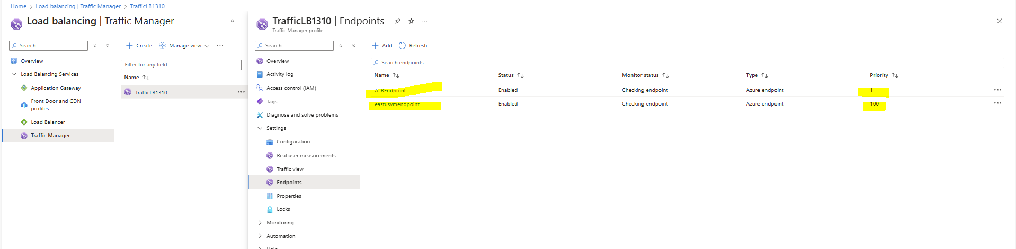

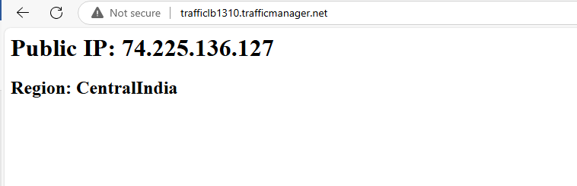

Now changing the priority to higher:

