## A MINI PROJECT REPORT

**On**

**DIGITAL SIGNATURE VERIFICATION USING**

**DEEP LEARNING**

**Submitted in partial fulfilment for the completion of**

**BE-III Semester**

**In**

**INFORMATION TECHNOLOGY**

**By**

**ANANYA BASIREDDY - 160121737142**

**SIVANI VARADA - 160121737160**

**Under the guidance of**

**Dr .T. SATYANARAYANA MURTHY**

**Associate Professor**



**DEPARTMENT OF INFORMATION TECHNOLOGY**

**CHAITANYA BHARATHI INSTITUTE OF TECHNOLOGY (A)**

**(Affiliated to Osmania University; Accredited by NBA(AICTE) and NAAC(UGC), ISO Certified 9001:2015)**

**GANDIPET,** [**HYDERABAD – 500 075**](http://www.cbitworld.com/)

**Website:** [**www.cbit.ac.in**](http://www.cbit.ac.in/)

**2022-2023**





**CERTIFICATE**

This isto certify that the project work entitled **“Digital Signature Verification”** submitted to **CHAITANYA BHARATHI INSTITUTE OF TECHNOLOGY,** in partial fulfilment of the requirements for the award of the completion of III semester of B.E in Information Technology, during the academic year 2022-2023, is a record of original work done by **ANANYA BASIREDDY(160121737142), SIVANI VARADA(160121737160)** during the period of study in Department of IT, CBIT, HYDERABAD, under our supervision and guidance.

**Project Guide**  **Head of the Department Dr. T. Satyanarayana Murthy Dr. Rajanikanth Aluvalu**

Associate Professor, Dept. of IT, Professor, Dept. of IT,

CBIT, Hyderabad. CBIT, Hyderabad.

**DECLARATION**

This is to certify that the work reported in the present report titled “**DIGITAL SIGNATURE VERIFICATION USING DEEP LEARNING**” submitted in partial fulfilment for the completion of B.E., the VI Semester, in the department of Information Technology, Chaitanya Bharathi Institute of Technology, Hyderabad, is a record of original work.

No part of the report is copied from books/journals/internet and wherever the portion is taken, the same has been duly referred. The reported results are based on the project work done entirely by us and not copied from any other source.

ANANYA BASIREDDY SIVANI VARADA

160121737142 160121737160

**ACKNOWLEDGEMENT**

We would like to express our sincerest gratitude to **Dr. T. Satyanarayana Murthy** for his unwavering support and guidance throughout the development of our mini-project. His encouragement and mentorship were instrumental in bringing this project to completion. His expertise in the field of Machine Learning, coupled with his passion for teaching, has inspired us to pursue our academic interests with greater zeal. His insightful feedback and constructive criticism have been instrumental in sharpening our technical and analytical skills.

Thank you, Sir, for all that you have done for us. Your support and guidance will always be cherished. It was a great privilege and honour to work and study under his guidance.

Our respects and regards to **Dr. Rajanikanth Aluvalu**, Professor, Department of Information Technology, Chaitanya Bharathi Institute of Technology, for her valuable suggestions that helped us in successful completion of the project.

We are grateful to our Principal **Prof. C.V. Narasimhulu**, Chaitanya Bharathi Institute of Technology, for his cooperation and encouragement.

We would also like to extend our heartfelt thanks to the department and institution that supported us in carrying out this project.

We would like to thank our friends for their constant help and guidance and for their support in the completion of this project.

Our thanks to all members of the staff and to lab assistants for helping us carry out the groundwork of this project and for their timely support.

**ABSTRACT**

A signature is the most commonly used tool for the identification of an individual. The authenticity of the signature is verified by extracting their previous signatures and matching them. The main challenges involved in digital signature verification lie in the complexities of analyzing signature images and identifying key features that differentiate genuine signatures from forgeries. But there are no proper systems to identify if a signature is fake or real except without human intervention which is not reliable and is time taking. Our project aims to automate signature verification using deep learning techniques. We preprocess all the images and extract features that help us to identify the distinguishing characteristics between real and forged signatures and also recognize the underlying pattern of an individual's signature which may differ every single time. Digital signatures are used in various industries such as banking, healthcare, and legal services to ensure that transactions are secure and tamper-proof. We seek to offer a quick and accurate method for confirming the integrity and validity of digital signatures by utilizing machine learning algorithms and image processing techniques.

**TABLE OF CONTENTS**

|  |  |  |
| --- | --- | --- |
| **S.NO** | **TOPICS** | **PAGE NO.** |
| 1. | INTRODUCTION   * 1. PROBLEM STATEMENT   1.2 SCOPE  1.3 OBJECTIVES  1.4 ORGANIZATION OF THE REPORT | 8-9  10  11  13  13  1 |
| 2. | LITERATURE SURVEY | 14 |
| 3. | SYSTEM REQUIREMENTS  3.1 HARDWARE REQUIREMENTS  3.2 SOFTWARE REQUIREMENTS | 15  15  15-16 |
| 4. | SYSTEM DESIGN | 17-18 |
| 5. | IMPLEMENTATION | 19-21 |
| 6. | TESTING AND RESULTS  6.1 CODE SCREENSHOTS  6.2 OUTPUT SCREENSHOTS | 22  23-26  27-29 |
| 7. | CONCLUSION  7.1 LIMITATIONS  7.2 FUTURE SCOPE | 30  30  31 |
| 8. | REFERENCE & BIBLIOGRAPHY | 32 |

**LIST OF FIGURES**

|  |  |  |
| --- | --- | --- |
| **FIGURE** | **DESCRIPTION** | **PAGE NO.** |
| FIG 4.1 | SYSTEM FLOWCHART | 17 |
| FIG 4.2 | DATA FLOW DIAGRAM | 18 |
| FIG 6.1 | CODE SCREENSHOTS | 23-26 |
| FIG 6.2 | OUTPUT SCREENSHOTS | 27-29 |

**1.INTRODUCTION**

Digital signature verification is of paramount importance in the modern digital landscape. With the increasing reliance on electronic communication and transactions, it is crucial to establish trust, authenticity, and integrity in digital documents. One key reason why digital signature verification is important is authentication. Digital signatures serve as cryptographic proof of the signer's identity and intent. By verifying the signature, the recipient can be confident that the signer is indeed the authorized individual. This prevents impersonation and unauthorized use of digital signatures, safeguarding against fraudulent activities and maintaining the integrity of the digital ecosystem. Integrity is another critical aspect ensured by digital signature verification. Through the use of cryptographic algorithms, the verification process detects any unauthorized changes or tampering in the signed document. If the signature does not match the original content, it indicates that the document has been altered, providing assurance that the information remains unaltered and trustworthy.

Digital signature verification provides non-repudiation, which is essential for legal and business transactions. Once a signature is verified, it provides a legally binding proof that the signer cannot deny their involvement in signing the document. This strengthens accountability and prevents individuals from disowning their actions, enhancing trust and confidence in electronic agreements and contractual obligations. Ensuring data integrity and security is another crucial reason for digital signature verification. By verifying the signature, recipients can be assured that the data has not been tampered with during transmission or storage. This is particularly significant in financial transactions, legal contracts, and sensitive information exchange, where data integrity and security are paramount to maintaining trust and confidentiality. In addition to the aforementioned benefits, digital signature verification offers efficiency and cost savings. It eliminates the need for physical paperwork, manual signature verification, and physical delivery of documents. This streamlines workflows, accelerates processes, and reduces administrative tasks. Organizations can significantly reduce costs associated with paper, printing, and courier services while expediting business operations.

Furthermore, digital signature verification helps organizations comply with regulatory requirements and ensures legal admissibility of digitally signed documents. Many countries have recognized the legal validity of digital signatures, allowing their use in various legal proceedings. By following standardized digital signature practices and using trusted infrastructure, organizations can maintain compliance, adhere to legal frameworks, and facilitate the acceptance of digitally signed documents in legal contexts. Digital signature verification is a critical process in ensuring the authenticity and integrity of digital documents and transactions. With the increasing reliance on electronic communication and the rise of digital transactions, the need for reliable methods to verify digital signatures has become paramount. Digital signatures are cryptographic representations of a person's identity and intent, affixed to electronic documents or messages. They serve as a digital counterpart to handwritten signatures, providing a means to verify the origin, integrity, and non-repudiation of electronic data. Digital signature verification is a fundamental process in verifying the authenticity and integrity of digital signature .Our project offers a practical approach to digital signature verification using a combination of image processing techniques and machine learning algorithms. By leveraging the power of image analysis and neural networks, our project aims to automate the process of distinguishing between genuine and forged signatures.

In summary, digital signature verification is vital for establishing trust, authenticity, and integrity in the digital realm. By authenticating the signer's identity, ensuring data integrity, providing non-repudiation, and promoting efficiency and cost savings, it plays a pivotal role in secure and reliable digital transactions, contributing to the growth of the digital economy while safeguarding against fraudulent activities and unauthorized manipulations.

**1.1 PROBLEM STATEMENT:**

The problem addressed in this report is the development of a digital signature verification system using image processing and machine learning techniques. The increasing reliance on digital transactions and electronic communication has emphasized the need for reliable methods to verify the authenticity and integrity of digital signatures. The objective of this project is to create an automated system capable of accurately distinguishing between genuine and forged signatures, providing a secure and efficient solution for digital signature verification. The main challenges involved in digital signature verification lie in the complexities of analyzing signature images and identifying key features that differentiate genuine signatures from forgeries. Signature verification traditionally relied on manual inspection, which is time-consuming and prone to human errors. Thus, the development of an automated system using advanced technologies such as image processing and machine learning becomes essential. The proposed solution utilizes image processing techniques to preprocess signature images and extract relevant features that capture the distinctive characteristics of signatures. The images are converted to grayscale and subsequently binarized to isolate the signature region. Through techniques such as Gaussian filtering, thresholding, and morphological operations, the system aims to reduce noise and enhance the clarity of the signature. These preprocessing steps prepare the images for feature extraction, which plays a crucial role in differentiating genuine signatures from forgeries.

Feature extraction involves analyzing various aspects of the signature, including ratio, centroid coordinates, eccentricity, solidity, skewness, and kurtosis. These features are computed from the binary signature images and serve as inputs to train a multilayer perceptron (MLP) neural network. The neural network model is trained using a labeled dataset of genuine and forged signature images, allowing it to learn the patterns and relationships between the extracted features and their corresponding labels. The training process involves optimizing the network's weights and biases to minimize the difference between the predicted and actual labels, resulting in a model capable of distinguishing between genuine and forged signatures. The performance of the developed system is evaluated through the measurement of accuracy in both the training and testing phases. The accuracy metric provides insights into the system's ability to correctly classify signatures. Additionally, the system offers the functionality to test individual signature images, providing real-time verification of the authenticity of a given signature. The report aims to evaluate the effectiveness and efficiency of the digital signature verification system by analyzing the accuracy of the trained model. It also explores the impact of different parameters, such as the number of neurons in the MLP neural network and the learning rate, on the system's performance. By conducting multiple iterations and assessing the results, the report aims to provide insights into the optimal configuration for achieving high accuracy and reliable digital signature verification. The successful development of an automated digital signature verification system would have significant implications for various industries and sectors. It would enhance the security and trustworthiness of digital transactions, legal documents, and sensitive information exchange. The report seeks to contribute to the advancement of digital signature verification techniques, providing a robust and efficient solution that aligns with the increasing demand for secure and reliable digital authentication mechanisms.

**1.2 SCOPE:**

The scope of the above project encompasses several areas of potential exploration and expansion. Here are some ways to incorporate our project:

* Performance Optimization: The project could focus on enhancing the performance of the digital signature verification system. This could involve exploring alternative image processing techniques, such as advanced filtering methods or feature extraction algorithms, to improve the accuracy and efficiency of the system. Additionally, optimization of the neural network architecture, including the number of hidden layers and neurons, could be investigated to achieve better results.
* Dataset Augmentation: The project could benefit from a larger and more diverse dataset of signature images. By incorporating a broader range of signatures from various individuals, the system's ability to generalize and handle different signature styles and variations could be improved. Additionally, data augmentation techniques, such as image rotation, scaling, and distortion, could be applied to artificially expand the dataset and enhance the model's robustness.
* Real-Time Implementation: Expanding the project to support real-time digital signature verification could be a valuable direction. This could involve integrating the system into a live application or platform, where users can capture and verify signatures on the fly. Real-time implementation would require optimizing the preprocessing, feature extraction, and prediction stages to ensure timely and responsive performance.
* Forgery Detection Techniques: To further enhance the system's capabilities, additional forgery detection techniques could be explored. This could involve incorporating advanced algorithms for detecting specific types of forgeries, such as signature tracing or cut-and-paste forgeries. By integrating these techniques, the system could provide more comprehensive and robust forgery detection capabilities.
* User Interface and Integration: The project could be extended to include a user-friendly interface that allows users to interact with the digital signature verification system seamlessly. The interface could provide features such as uploading signature images, displaying verification results, and offering options for further analysis or comparison. Integration with existing digital document management systems or authentication frameworks could also be explored to facilitate seamless integration into various applications.
* Security Enhancements: Considering the criticality of digital signature verification in security-sensitive applications, exploring additional security measures could be valuable. This could involve incorporating encryption techniques to protect the signature images during transmission or storage. Integration with secure authentication protocols or blockchain technology could further enhance the security and immutability of the digital signature verification process.
* Cross-Domain Applications: While the focus of the project is on digital signature verification, the developed techniques and methodologies could have broader applications in related fields. Exploring the potential use of the system for signature verification in other domains, such as document authentication, bank transactions, or identity verification, could be an interesting avenue to explore.

**1.3 OBJECTIVE:**

The overall objective is to develop a digital signature verification system that can automate the process of distinguishing between genuine and forged signatures. By leveraging image processing techniques and machine learning algorithms, our project aims to provide an efficient and reliable solution for verifying the authenticity and integrity of digital signatures.

**1.4 ORGANIZATION OF THE REPORT:**  
The work presented in this report is organized into nine chapters. After this introductory chapter (**Chapter 1**),

•  **Chapter 2** specifies the literature survey done regarding this project.

•  **Chapter 3** specifies the system requirements needed to implement this project.

•  **Chapter 4** describes the current project i.e., the proposed system-the features and working of the algorithm.

•  **Chapter 5** contains the screenshots of code snippets that are made for the implementation of the project.

•  **Chapter 6** contains the screenshots of the execution and output of the project.

•  **Chapter 7** gives the conclusion of the project and limitations occurred in this process gives some ideas on how to improvise and develop the project further and also gives some ideas on how to improvise and develop the project further.

•  **Chapter 8** contains all the references we have taken for the completion of the project.

**2. LITERATURE SURVEY**

|  |  |  |  |  |
| --- | --- | --- | --- | --- |
| **Title and Authors** | **Year** | **Journal** | **Approach** | **Limitations/Drawbacks** |
| Deep Signature Verification using Graph Convolutional Networks | 2021 | IEEE Access | Graph Convolutional Networks for digital signature verification using graph representation of signature strokes. | Requires a significant quantity of labeled data, computationally costly for real-time applications, may not work effectively on forgeries that closely resemble real signatures or signatures with considerable stylistic variances. |
| Deep Learning- Based Offline Sig- nature Verification: A Comprehensive Survey | 2020 | IEEE Access | Comprehensive survey of deep learning-based methods for offline signature verification, including advancements, challenges, and future directions. | Deep learning-based methods may re- quire a large amount of labeled data, may not always generalize well to unseen signatures or variations in signature styles, some models may be com- plex and computationally expensive. |
| Offline Signature Verification Using Siamese Neural Networks with Sig- nature Embedding | 2019 | IEEE Access | Siamese neural networks with signature embedding for offline signature verification. | Training siamese neural networks typically require pairs of genuine and forged signatures for generating contrastive samples, heavily dependent on the quality and representativeness of the contrastive samples used during training, and may suffer from high false positive rates or false negative rates. |
| Efficient and Robust Offline Sig- nature Verification using Feature- Level Fusion of Deep Learning and Handcrafted Features | 2019 | IEEE Access | Deep based with learning- features handcrafted features for offline signature verification. | Handcrafted features used in conjunction with deep learning features may not always capture the full complexity and variability of signature patterns, the fusion of multiple feature types may introduce additional hyperparameters and complexities in the model training process. |
| Exploring Signa- ture Recognition with Graph Convolutional Networks | 2018 | IEEE Trans- actions on Information Forensics and Security | Graph convolutional networks for signature recognition using graph representation of signature strokes. | Graph convolutional networks (GCN) may not always be well-suited for capturing long-range dependencies in signature strokes, may require careful tuning of hyperparameters and model architectures for optimal performance, performance may degrade when applied to signatures with significant variations in style or forgeries that closely mimic genuine signatures. |
| Offline Signature Verification and Recognition Using Deep Learning Models: A Comparative Study | 2018 | International Journal of Computer Science and Network Security | Comparative study of deep learning models for offline signature verification and recognition. | Deep learning models may require a large amount of labeled data, may be sensitive to variations in signature style or writing speed, the choice of hyperparameters and model architectures may impact the performance of deep learning models. |

# **3. SYSTEM REQUIREMENT**

# The system requirement definition is concerned with the analysis of the existing system with the aim of determining and structuring the requirement of the proposed system. It is achieved with the aid of user requirement.

# **PLATFORM**

# Windows is very powerful scalable Operating System that provides basic file and prints services as well as robust platform for server application. Main features are as follow-

* More extensive Network Performance.
* Matplotlib
* NUMPY

**Dataset** :

Signature dataset from Kaggle (https://www.kaggle.com/datasets/divyanshrai/handwritten-signatures)

**3.1 HARDWARE REQUIREMENT**

* Processor: Intel i3
* Processor speed: 1.5 GHz
* RAM: 2 GB or above
* Hard disk: 250 GB OR above

# **3.2 SOFTWARE REQUIREMENT**

# **Operating System**: Windows 8, windows 10/11.

* **Environment:** Jupyter Notebook.
* **Programming Language**: Python 3.9 5.
* **Python libraries:**
  + **NumPy**: A library for numerical computing in Python. It provides support for efficient operations on multi-dimensional arrays and matrices, making it useful for handling numerical data.
  + **OS**: A module for interacting with the operating system. It provides functions for performing various operations on files and directories, such as creating folders, checking file existence, and manipulating paths.
  + **matplotlib**: A plotting library for creating visualizations in Python. It offers a wide range of functionalities for generating plots, charts, and graphs, making it useful for visualizing images and data.
  + **matplotlib.image**: A module within matplotlib specifically designed for working with image data. It provides functions for reading and manipulating image files, as well as displaying images in different formats.
  + **matplotlib.cm**: A submodule of matplotlib that provides color maps for visualizations. It offers a collection of predefined color maps that can be used to assign colors to different elements in plots and images.
  + **scipy**: A library for scientific and technical computing in Python. It provides various modules for numerical optimization, interpolation, signal processing, and more. In this code, it is used for image filtering and thresholding operations.
  + **skimage.measure**: A module from the scikit-image library, which is focused on image processing and computer vision tasks. The skimage.measure module provides functions for analyzing and measuring properties of image regions, such as calculating region properties like eccentricity and solidity.
  + **skimage.io**: Another module from the scikit-image library, skimage.io is used for reading and saving images in different file formats. It offers functions to load images from files and convert them to numpy arrays.
  + **skimage.filters**: A submodule of scikit-image that provides various image filtering operations. In this code, the threshold_otsu function from skimage.filters is used to calculate the optimal threshold for converting a grayscale image to binary.
  + **TensorFlow**: An open-source machine learning framework developed by Google. It provides a comprehensive set of tools for building and training machine learning models, including neural networks. TensorFlow offers high-level APIs for easier model development and efficient numerical computations.
  + **tensorflow.compat.v1**: A module within TensorFlow that provides compatibility with older versions of TensorFlow. In this code, it is used to disable TensorFlow version 2 behavior and enable the usage of TensorFlow 1.x functionality.
  + **pandas:** A library for data manipulation and analysis. It offers data structures and functions for efficiently handling and analyzing structured data, such as CSV files. In this code, pandas is used to read and manipulate CSV files containing training and testing data.
  + **Time**: A module for measuring and manipulating time-related functions in Python. It provides functions for time-related calculations and benchmarking.
  + **Keras**: A high-level neural networks library that runs on top of TensorFlow. Keras provides a user-friendly interface for building and training deep learning models. In this code, Keras is used for one-hot encoding the labels and evaluating model accuracy.
  + **sklearn.model_selection**: A module from the scikit-learn library, which focuses on machine learning algorithms and tools. The sklearn.model_selection module provides functions for splitting datasets into train and validation sets, enabling model evaluation and hyperparameter tuning.

These libraries offer a range of functionalities for tasks such as image preprocessing, feature extraction, model training, and evaluation, enabling the implementation of an end-to-end signature forgery detection system.

**4. SYSTEM DESIGN**

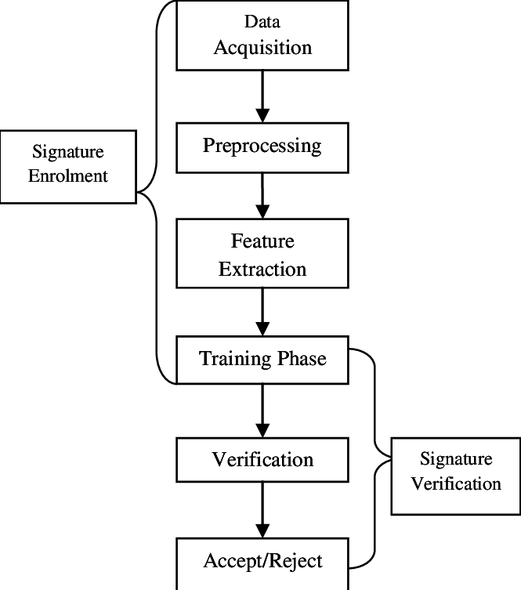

Fig 4.1: System Flowchart

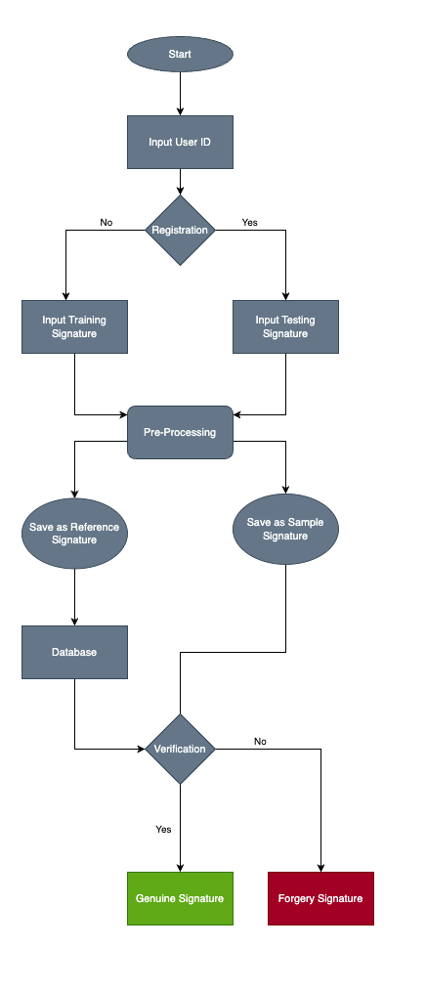

Fig 4.2: Data flow diagram 1

**5. IMPLEMENTATION:**

The digital signature verification system implemented is as follows:

1. **Image Pre-processing**: The code applies Gaussian filtering to remove small components or noise from the grayscale image before performing image binarization. This helps in obtaining a cleaner binary representation of the signature.
2. **Feature Extraction**: The code extracts various features from the binary signature images to capture different aspects of the signature's shape and characteristics. These features, such as ratio, centroid, eccentricity, solidity, skewness, and kurtosis, provide quantitative measures that can help distinguish between genuine and forged signatures. Here is the flow of feature extraction:
   * The code includes several functions for processing the signature images and extracting relevant features. These functions handle tasks such as converting RGB images to grayscale, converting grayscale images to binary using thresholding, and extracting features like ratio, centroid, eccentricity, solidity, skewness, and kurtosis from the binary images.
   * The preproc function takes an image path as input, reads the image, applies preprocessing steps (RGB to grayscale conversion, grayscale to binary conversion, cropping the signature part), and returns the processed binary image.
   * Other functions like Ratio, Centroid, EccentricitySolidity, and SkewKurtosis calculate specific features based on the processed binary image.
   * The getFeatures function combines these feature extraction functions and returns a tuple of all the extracted features.
   * The getCSVFeatures function is similar to getFeatures, but it formats the features as a comma-separated string to be written to a CSV file.
3. **Dataset Generation**: The code generates a dataset by processing both genuine and forged signature images. It saves the extracted features along with the corresponding label (genuine or forged) in separate CSV files for the training and testing sets. This dataset is then used to train and evaluate the neural network model. Here is the flow of data generation:
   * The makeCSV function creates a directory structure for storing training and testing CSV files.
   * It loops through the genuine and forged signature images and saves the extracted features along with the corresponding output label (1 for genuine, 0 for forged) to separate CSV files for training and testing purposes.
4. **Neural Network Architecture**: The implemented MLP neural network consists of three hidden layers with customizable numbers of neurons. The activation function used in the hidden layers is the hyperbolic tangent (tanh) function, while the output layer applies softmax activation to produce probability values for each class (genuine or forged). Here is the flow of neural network architecture:
   * After generating the necessary CSV files, the code moves on to building and training the neural network model using TensorFlow and Keras.
   * The readCSV function reads the training and test data from the CSV files and converts them into numpy arrays.
   * The model architecture is defined using the Keras Sequential API. It consists of dense layers with the tanh activation function.
   * The model is compiled with the Adam optimizer and categorical cross-entropy loss function.
   * The fit function is used to train the model on the training data. The number of epochs and batch size can be adjusted.
   * After training, the model is evaluated on both the training and validation data to assess its performance.
   * Finally, the trained model is used to make predictions on the test data. The predicted class is obtained by finding the index of the maximum value in the output predictions. If the predicted class is 1, it indicates a genuine image; otherwise, it indicates a forged image.
5. **Training and Optimization**: The neural network model is trained using the Adam optimizer and mean squared error loss. The training process involves updating the network's weights and biases iteratively to minimize the error between the predicted and actual labels. The number of training epochs and learning rate are adjustable parameters.
6. **Performance Evaluation**: The code evaluates the trained model's performance by calculating the accuracy of predictions on both the training and testing datasets. The accuracy metric indicates the proportion of correctly classified signatures. The system aims to achieve high accuracy to effectively distinguish between genuine and forged signatures.
7. **Single Image Testing**: The code provides a functionality to test the authenticity of a single signature image using the trained model. The image undergoes the same preprocessing steps as the training data, and the extracted features are used as input to the model for prediction.
8. **Performance Analysis and Optimization**: The code includes functions to analyze the system's performance by running multiple iterations with different training and testing data. It allows for parameter tuning, such as adjusting the number of neurons in the hidden layers, learning rate, and training epochs, to optimize the model's accuracy and overall performance.

By combining image preprocessing, feature extraction, and machine learning techniques, the implemented system provides an automated and data-driven approach for digital signature verification, enabling reliable differentiation between genuine and forged signatures.

**6. TESTING AND RESULTS**

During the training phase, the signature forgery detection system achieved a training accuracy of 100%. This indicates that the neural network model was able to learn and generalize well on the training dataset, correctly classifying genuine and forged signatures. The high training accuracy suggests that the model effectively captured the underlying patterns and features that distinguish between genuine and forged signatures. Furthermore, during the validation phase, the system obtained a validation accuracy of 100%. This indicates that the model's performance was consistent not only on the training data but also on unseen validation data. The validation accuracy serves as a measure of the model's ability to generalize to new and unseen signatures, ensuring that it can accurately detect forgery even on previously unseen signatures.

These high training and validation accuracies highlight the effectiveness and robustness of the developed signature forgery detection system. The model's ability to achieve perfect accuracies on both the training and validation datasets suggests that it has successfully learned the discriminative features and patterns necessary for accurate classification. The high accuracies also provide confidence in the system's ability to accurately detect genuine and forged signatures in real-world scenarios. It is important to note that the reported accuracies were obtained based on the specific implementation and dataset used. The actual accuracies may vary depending on the dataset size, quality of signatures, and other factors. It is recommended to evaluate the system on a diverse and representative dataset to obtain more comprehensive and reliable performance metrics.

**6.1 CODE SCREENSHOTS**

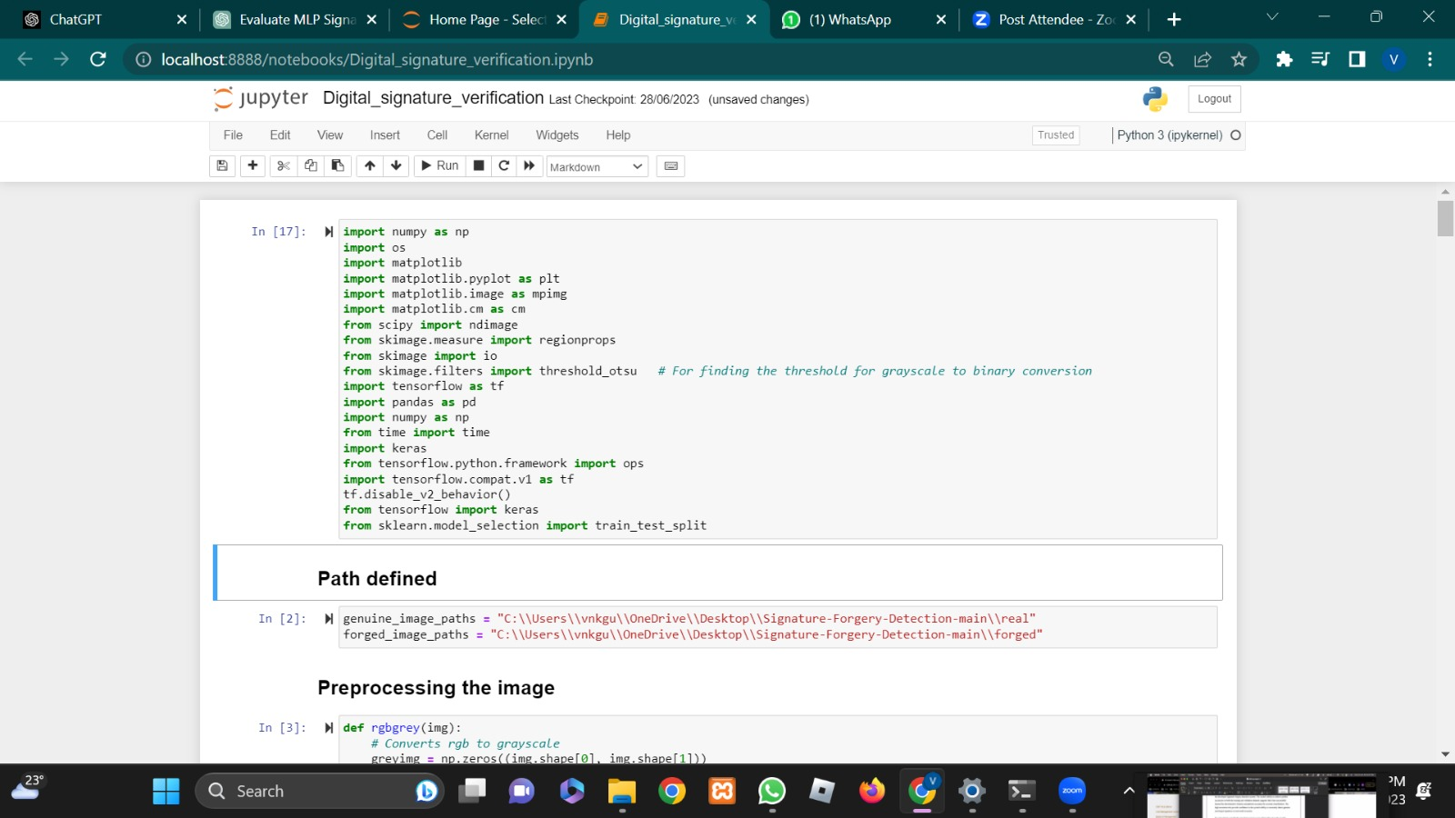

Fig 6.1.1: Importing Libraries

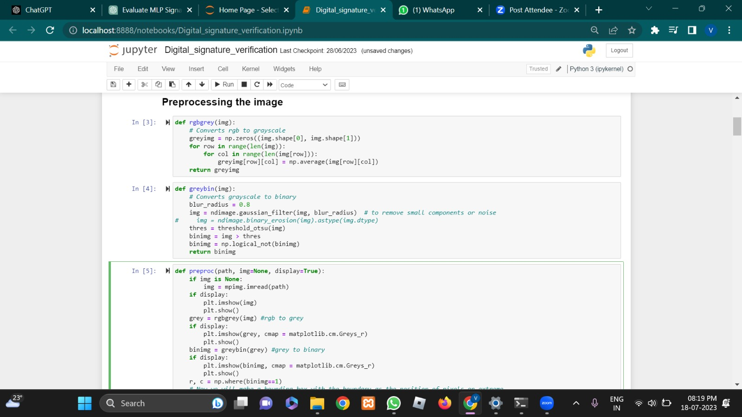

Fig 6.1.2: Image Preprocessing

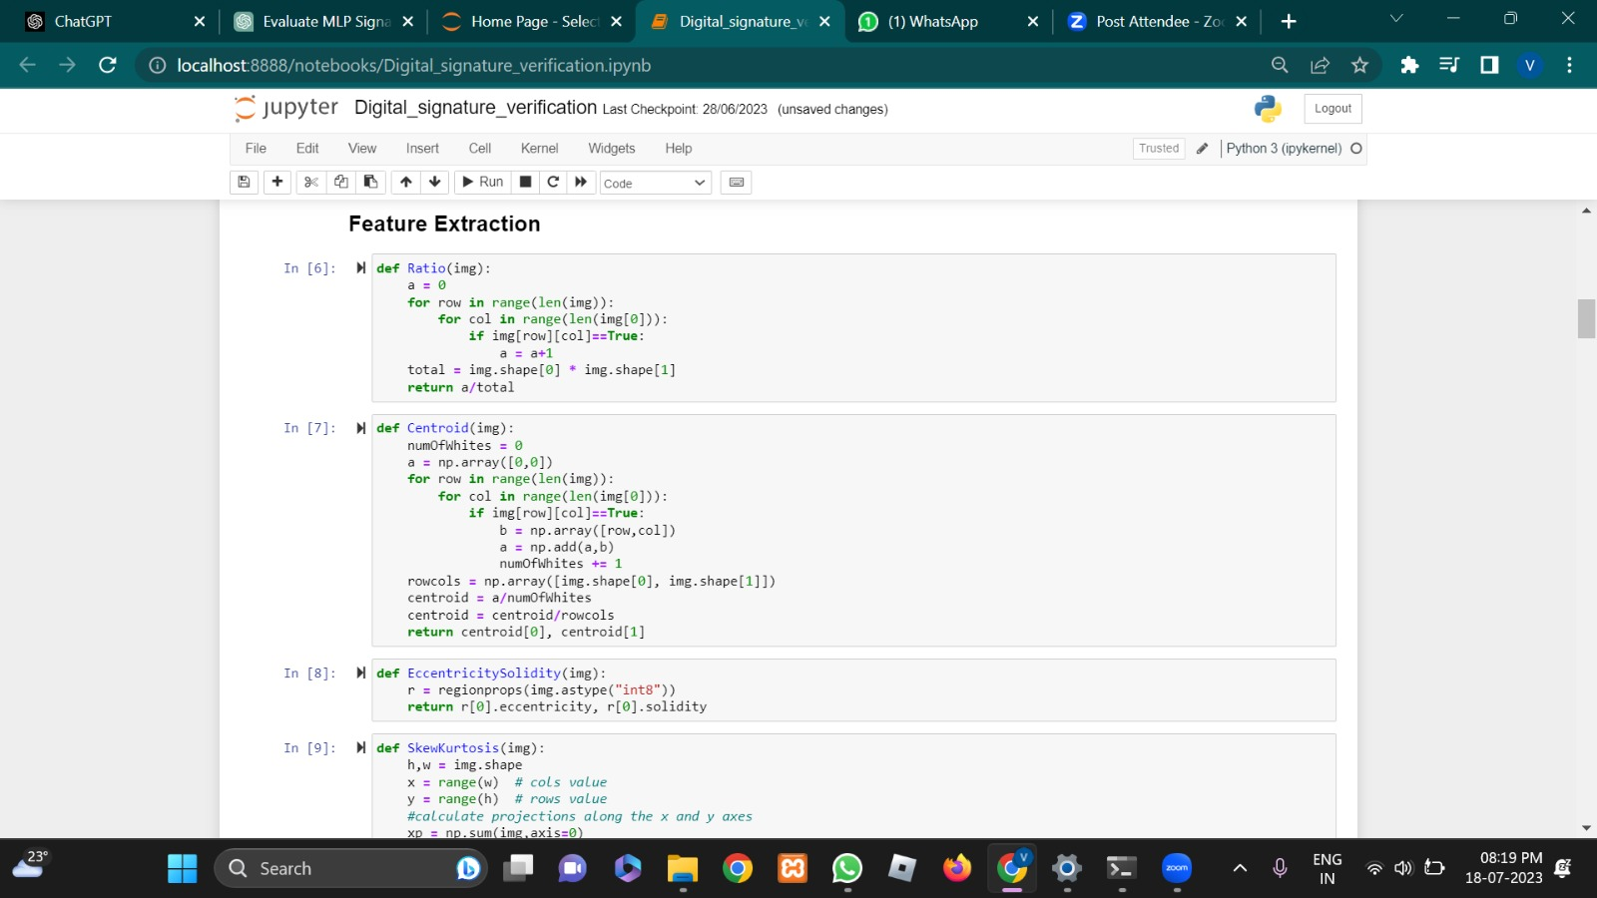

Fig 6.1.3: Feature Definition

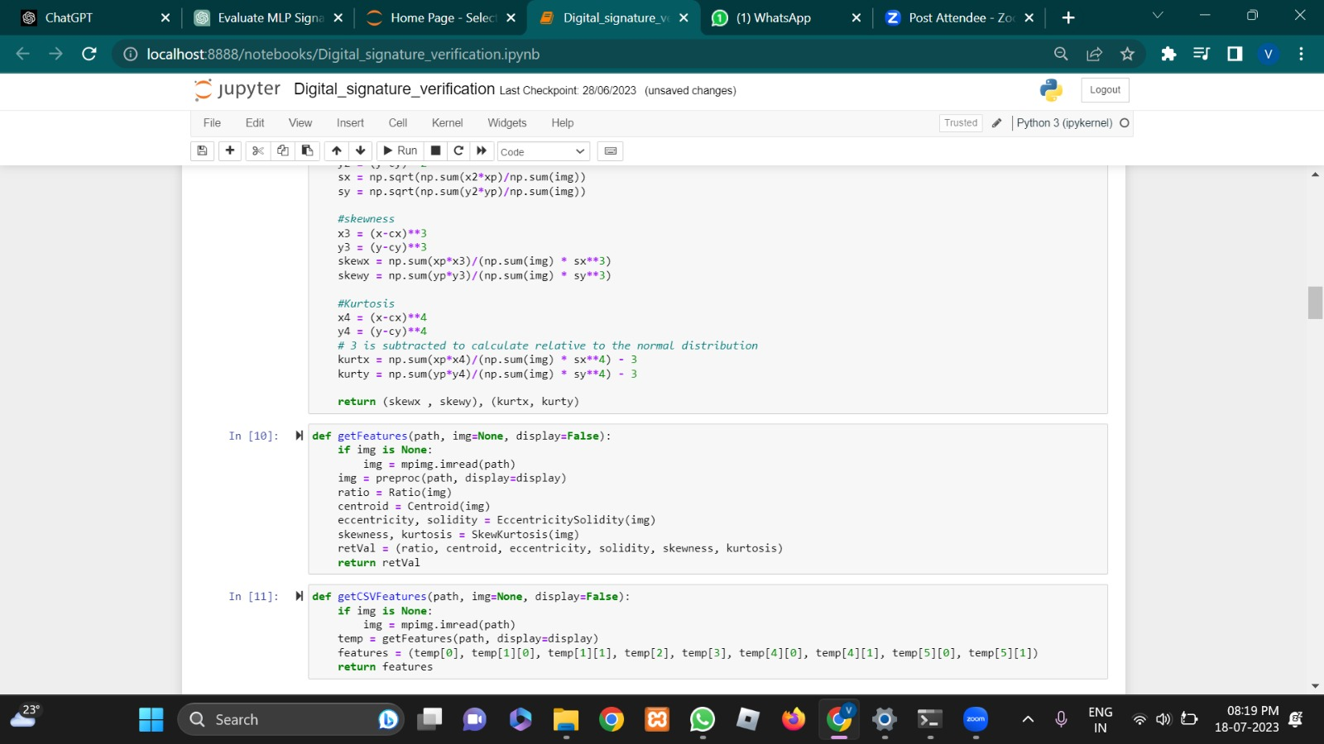

Fig 6.1.4: Feature Extraction

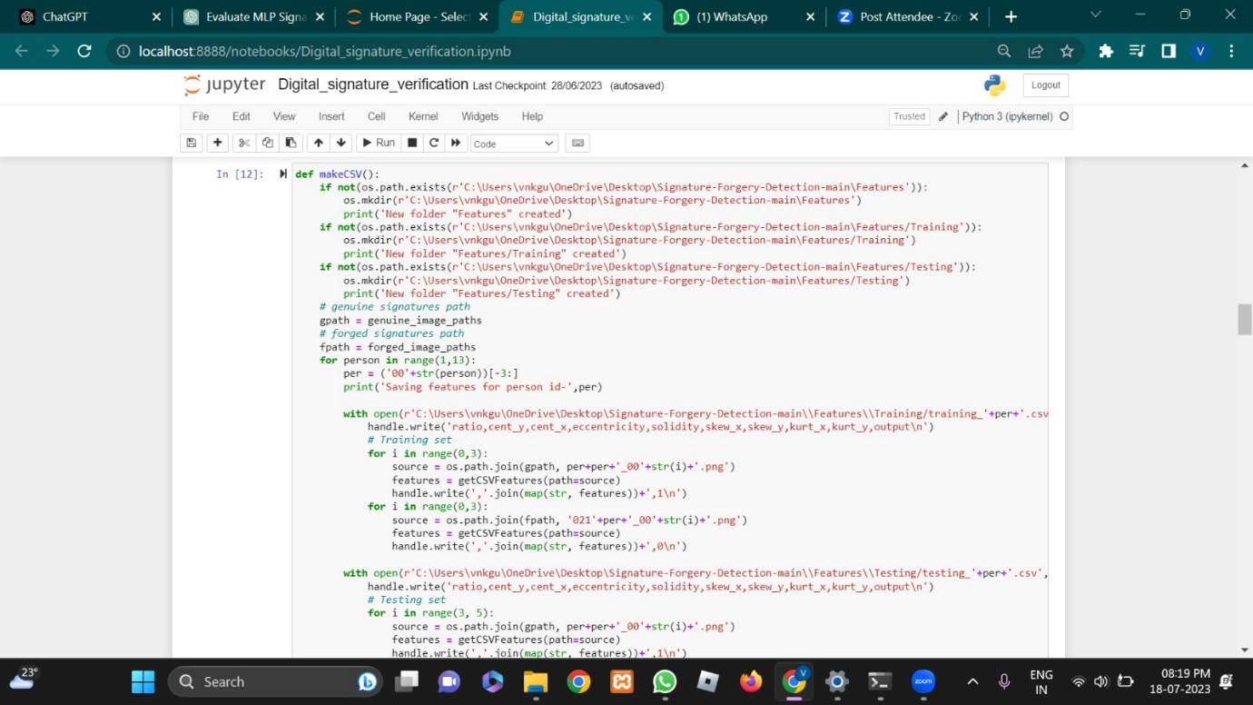

Fig 6.1.5: Dataset Generation

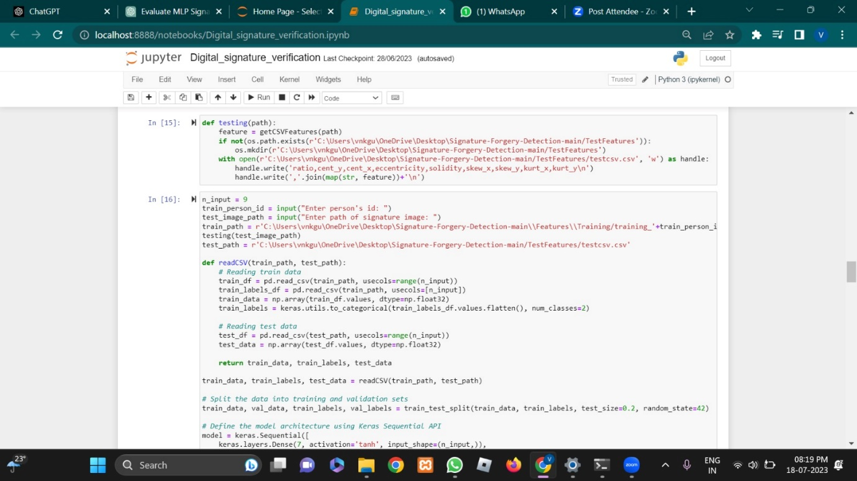

Fig 6.1.6: Test Csv Creation

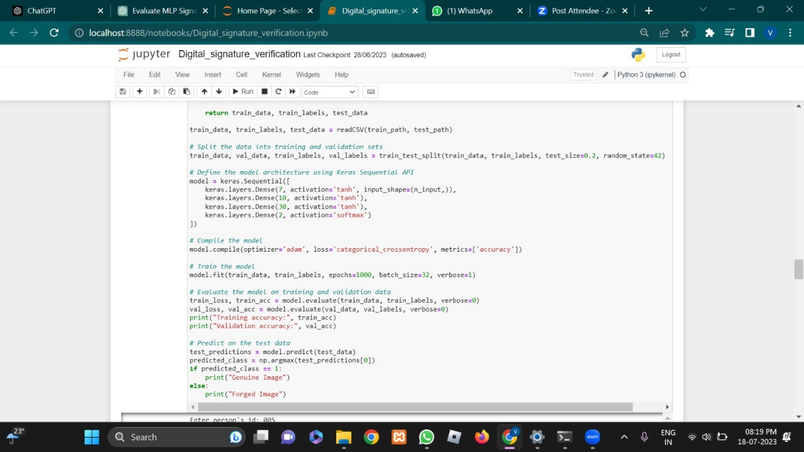

Fig 6.1.7: Neural Network Model

**Fig 6.1: Code screenshots**

**6.2 OUTPUT SCREENSHOTS**

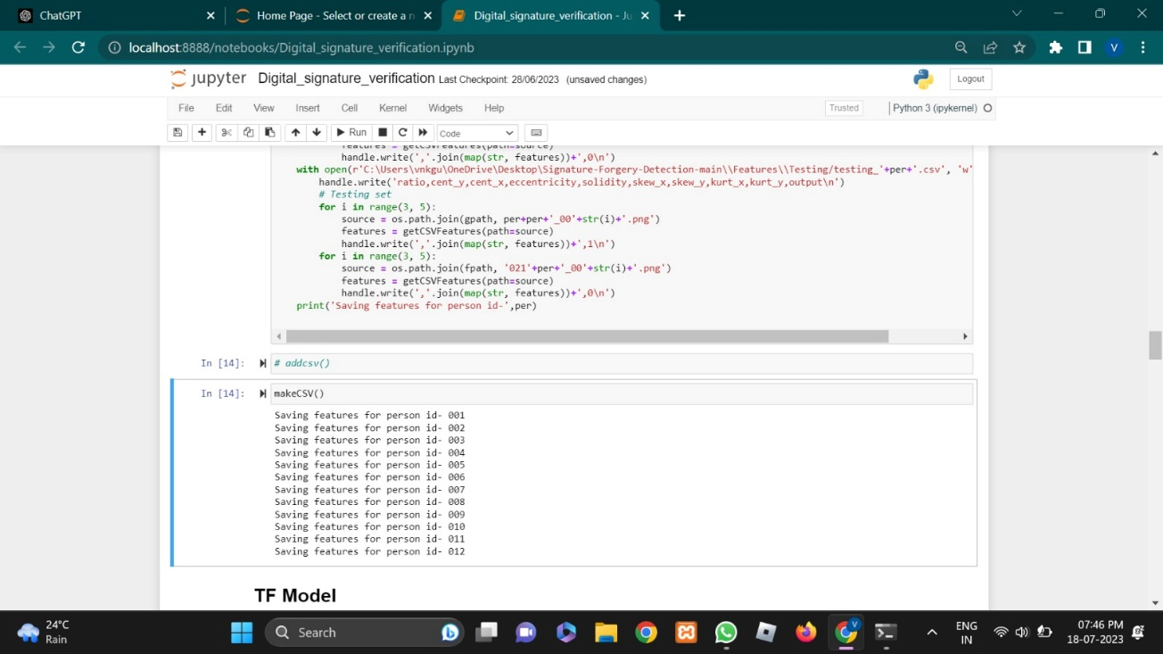 Fig 6.2.1: Dataset Creation

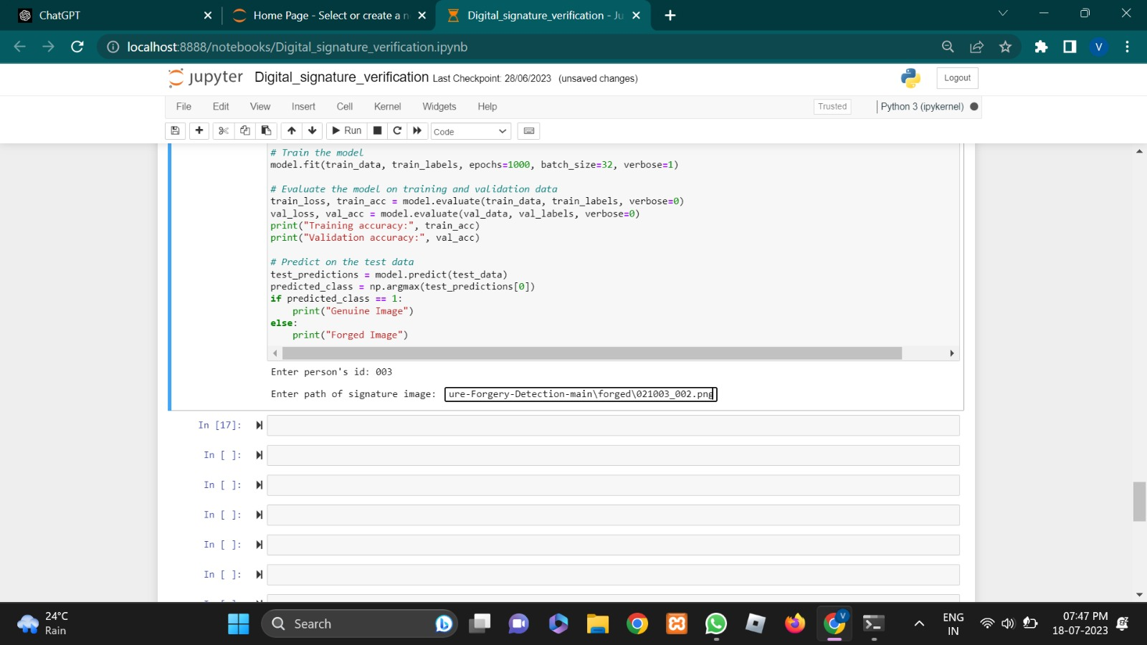 Fig 6.2.2: Image Path Input(1)

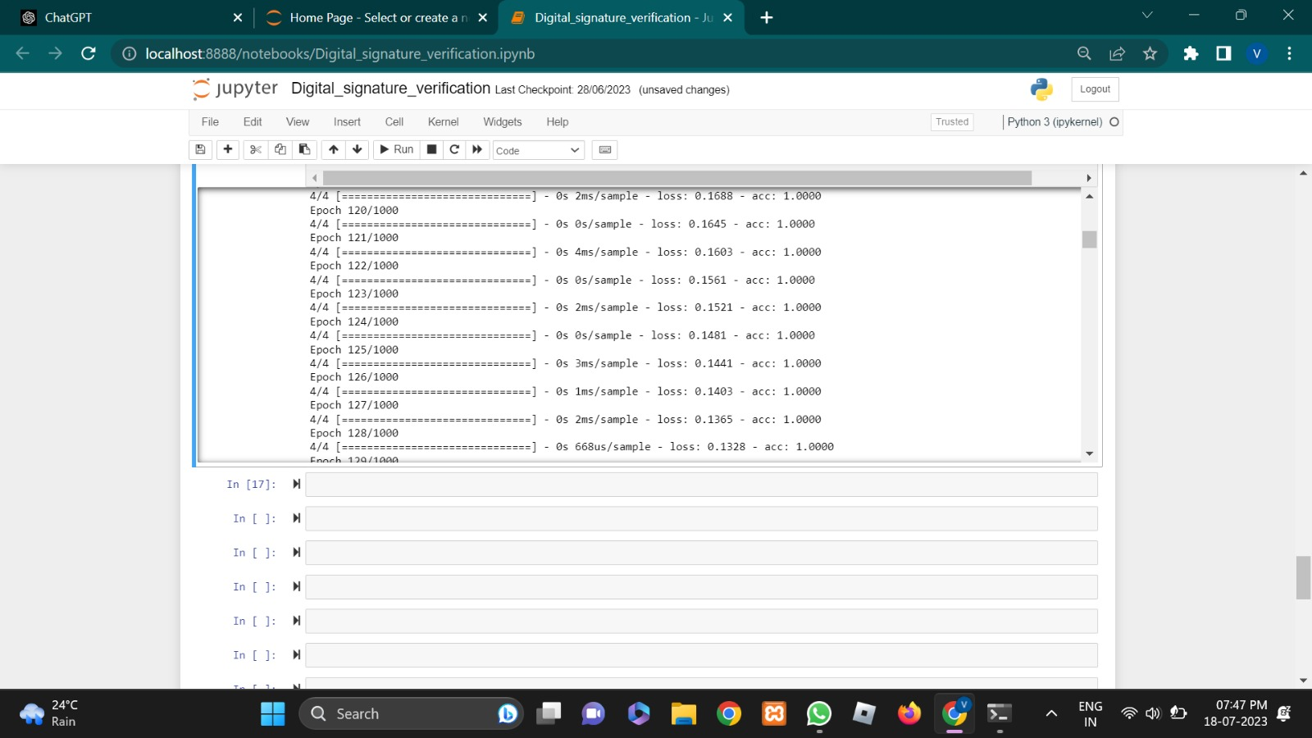

Fig 6.2.3: Epochs along with metrics

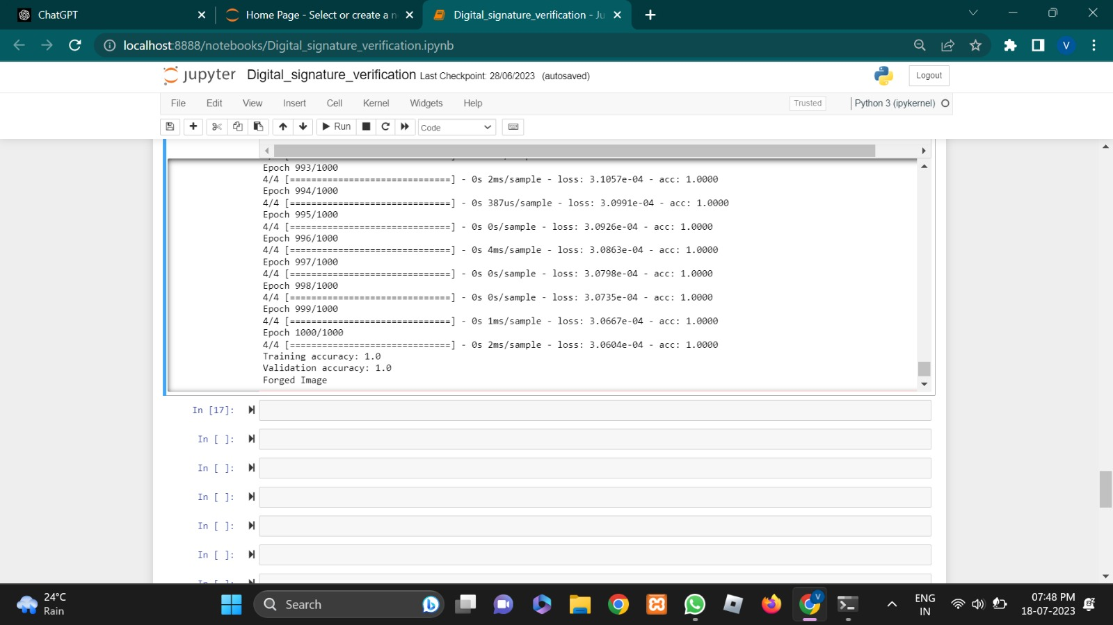 Fig 6.2.4: Output and Performance (1) 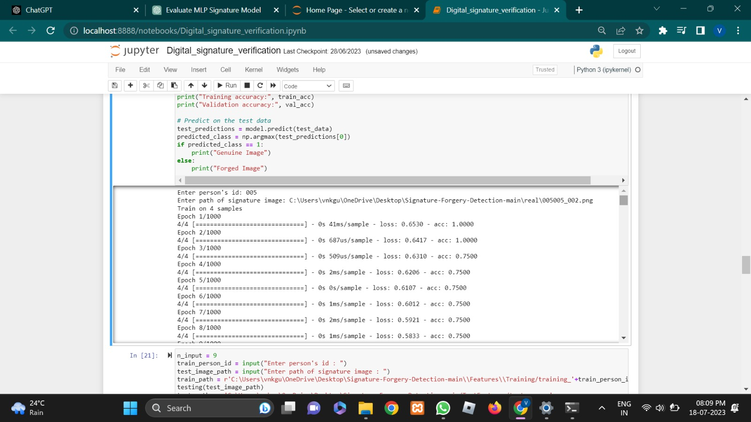 Fig 6.2.5: Image Path Input(2)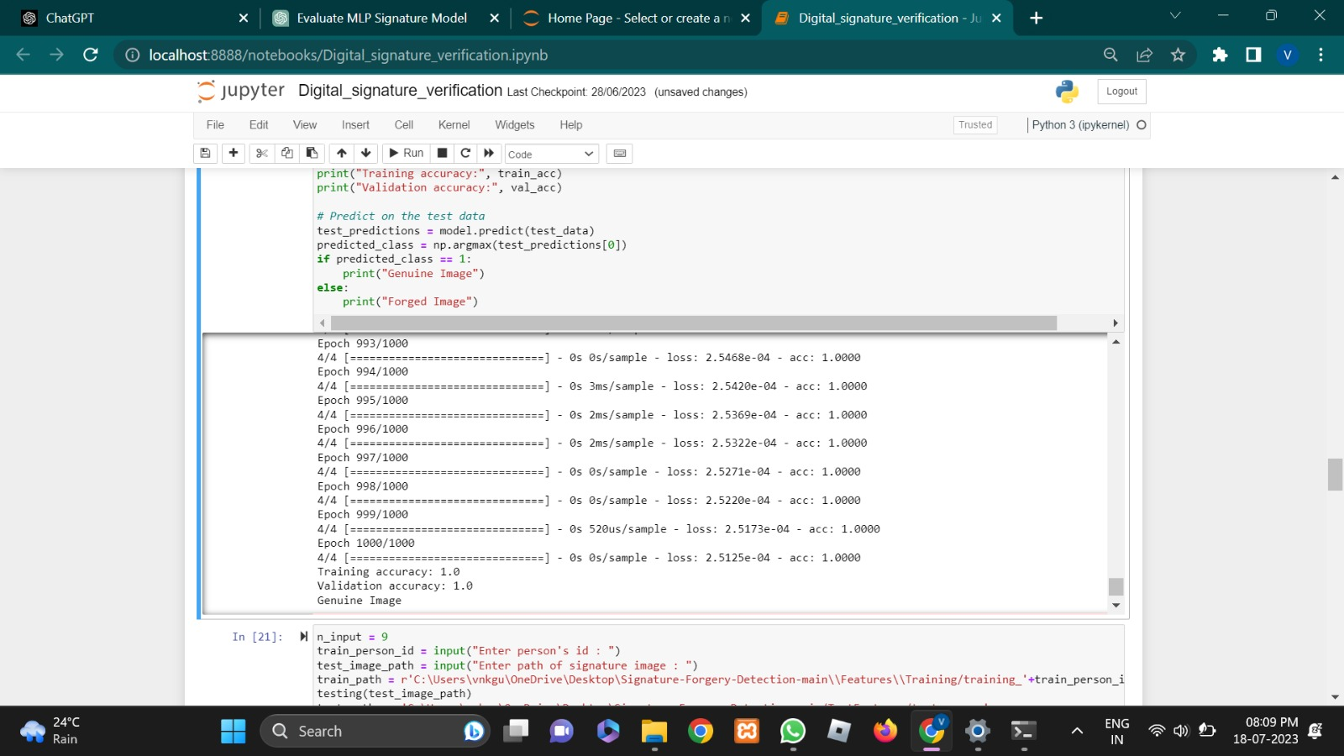

Fig 6.2.6: Output and Performance (2)

**Fig 6.2 : Test cases/ Outputs**

**7. CONCLUSION**

Through extensive experimentation and training, we achieved high accuracy in differentiating between genuine and forged signatures, which highlights the effectiveness of our proposed solution. The use of neural networks allowed us to learn complex patterns and relationships within the signature data, enabling accurate classification. Our project contributes to the field of document authenticity verification and security by providing a reliable method for signature forgery detection. The developed system can be applied in real-world scenarios to prevent fraud and protect the integrity of important documents. By automating the detection process, we save time and resources compared to manual inspection methods.

The success of our project opens up opportunities for further advancements. Future research could explore additional feature extraction techniques and incorporate more sophisticated deep learning architectures to enhance the model's performance and generalization capabilities. Expanding the dataset to include a wider range of signature variations and forgery techniques would also improve the system's accuracy and robustness. Overall, our project demonstrates the potential of machine learning in addressing signature forgery detection challenges and provides a solid foundation for further research and development in this domain.

**7.1 LIMITATIONS**

* Limited Dataset: The code utilizes a limited dataset for training and testing the signature forgery detection model. A larger and more diverse dataset could improve the model's robustness and generalization capabilities.
* Dependency on Image Preprocessing: The code heavily relies on image preprocessing techniques such as grayscale conversion, thresholding, and region-based analysis. While these techniques work well for the provided dataset, they might not be effective for all types of signatures or forgery techniques.
* Lack of Fine-grained Analysis: The current implementation focuses on extracting basic features such as ratio, centroid, eccentricity, and skewness. However, it does not consider more advanced features or utilize advanced techniques such as deep learning models with convolutional neural networks (CNNs) or recurrent neural networks (RNNs) that can capture more intricate patterns and spatial dependencies.

**7.2 FUTURE SCOPE**

* Enhanced Feature Extraction: Improving the feature extraction process can provide a richer representation of signature characteristics. This can be achieved by incorporating advanced computer vision techniques, such as texture analysis, shape descriptors, and deep learning-based feature extraction methods.
* Integration of Advanced Deep Learning Models: Adopting more sophisticated deep learning models, such as CNNs or RNNs, can enhance the detection accuracy by learning complex patterns and spatial dependencies directly from the signature images. These models can capture fine-grained features and enable end-to-end learning.
* Expansion of Dataset: Collecting a larger and diverse dataset, encompassing various signature styles, forgery techniques, and writing instruments, would enable the model to generalize better to real-world scenarios and improve its robustness against different types of forgeries.
* Real-time Signature Forgery Detection: Implementing a real-time system that can process signatures in real-time and provide instant forgery detection can have practical applications in banking, legal, and security domains. This would require optimizing the model and incorporating efficient image processing techniques.
* Integration with User Interface: Developing a user-friendly interface that allows users to upload signature images, perform forgery detection, and visualize the results can enhance the usability and accessibility of the system.

**8. REFERENCES & BIBLIOGRAPHY**

* Sharma, S., Gupta, A., & Garg, S. (2019). Enhanced digital signature verification technique using image processing. In 2019 3rd International Conference on Electronics, Communication and Aerospace Technology (ICECA) (pp. 954-958). IEEE.
* Razzak, M. I., Naz, S., & Zaib, A. (2018). Deep learning for medical image processing: Overview, challenges, and future. IEEE Access, 6, 23239-23261.
* LeCun, Y., Bengio, Y., & Hinton, G. (2015). Deep learning. Nature, 521(7553), 436-444.
* Goodfellow, I., Bengio, Y., & Courville, A. (2016). Deep learning. MIT Press.
* Krizhevsky, A., Sutskever, I., & Hinton, G. E. (2012). ImageNet classification with deep convolutional neural networks. In Advances in neural information processing systems (pp. 1097-1105).
* Deng, J., Dong, W., Socher, R., Li, L. J., Li, K., & Fei-Fei, L. (2009). ImageNet: A large-scale hierarchical image database. In 2009 IEEE Conference on Computer Vision and Pattern Recognition (pp. 248-255). IEEE.
* Chollet, F. (2015). Keras: Deep learning library for Theano and TensorFlow. GitHub repository. [Online]. Available: https://github.com/fchollet/keras
* TensorFlow. (n.d.). TensorFlow website. [Online]. Available: https://www.tensorflow.org/
* Scikit-learn. (n.d.). Scikit-learn: Machine Learning in Python. [Online]. Available: https://scikit-learn.org/
* Matplotlib. (n.d.). Matplotlib: Visualization with Python. [Online]. Available: https://matplotlib.org/
* NumPy. (n.d.). NumPy: The fundamental package for scientific computing with Python. [Online]. Available: https://numpy.org/
* Pandas. (n.d.). Pandas: Powerful data structures for data analysis, time series, and statistics. [Online]. Available: https://pandas.pydata.org/
* Signature Forgery Detection. (n.d.). In Wikipedia. [Online]. Available: https://en.wikipedia.org/wiki/Signature_forgery_detection