1Mb=1000Kb
1bit=0.000125Kb

Full Net

the model accuracy is 0.9658536585365853
+-----------+-------+-------+-------+-------+-------+
| | ACC | SEN | SPE | PPR | F1 |
+-----------+-------+-------+-------+-------+-------+
| NSR | 0.976 | 0.983 | 0.973 | 0.934 | 0.958 |
| APB | 0.985 | 0.867 | 0.995 | 0.929 | 0.897 |
| AFL | 1.0 | 1.0 | 1.0 | 1.0 | 1.0 |
| AFIB | 0.995 | 0.967 | 1.0 | 1.0 | 0.983 |
| SVTA | 1.0 | 1.0 | 1.0 | 1.0 | 1.0 |
| WPW | 1.0 | 1.0 | 1.0 | 1.0 | 1.0 |
| PVC | 0.985 | 0.926 | 0.994 | 0.962 | 0.943 |
| Bigeminy | 0.995 | 0.889 | 1.0 | 1.0 | 0.941 |
| Trigeminy | 1.0 | 1.0 | 1.0 | 1.0 | 1.0 |
| VT | 1.0 | 1.0 | 1.0 | 1.0 | 1.0 |
| IVR | 1.0 | 1.0 | 1.0 | 1.0 | 1.0 |
| VFL | 0.995 | 1.0 | 0.995 | 0.833 | 0.909 |
| Fusion | 1.0 | 1.0 | 1.0 | 1.0 | 1.0 |
| LBBBB | 1.0 | 1.0 | 1.0 | 1.0 | 1.0 |
| RBBBB | 1.0 | 1.0 | 1.0 | 1.0 | 1.0 |
| SDHB | 1.0 | 1.0 | 1.0 | 1.0 | 1.0 |
| PR | 1.0 | 1.0 | 1.0 | 1.0 | 1.0 |
| SUM | 0.996 | 0.966 | 0.998 | 0.966 | 0.966 |
+-----------+-------+-------+-------+-------+-------+
========================================================================================================================
Layer (type (var_name)) Input Shape Output Shape Param # Trainable
========================================================================================================================
FULL_ECG (FULL_ECG) [64, 1, 3600] [64, 17] -- True
├─Sequential (classifier) [64, 1, 3600] [64, 17, 24] -- True
│ └─FULL_conv_pool (0) [64, 1, 3600] [64, 8, 1803] -- True
│ │ └─ConstantPad1d (pad) [64, 1, 3600] [64, 1, 3610] -- --
│ │ └─Conv1d (conv) [64, 1, 3610] [64, 8, 3610] 96 True
│ │ └─MaxPool1d (pool) [64, 8, 3610] [64, 8, 1803] -- --
│ │ └─PReLU (prelu) [64, 8, 1803] [64, 8, 1803] 1 True
│ │ └─BatchNorm1d (bn) [64, 8, 1803] [64, 8, 1803] 16 True
│ └─FULL_conv_pool (1) [64, 8, 1803] [64, 16, 905] -- True
│ │ └─ConstantPad1d (pad) [64, 8, 1803] [64, 8, 1813] -- --
│ │ └─Conv1d (conv) [64, 8, 1813] [64, 16, 1813] 1,424 True
│ │ └─MaxPool1d (pool) [64, 16, 1813] [64, 16, 905] -- --
│ │ └─PReLU (prelu) [64, 16, 905] [64, 16, 905] 1 True
│ │ └─BatchNorm1d (bn) [64, 16, 905] [64, 16, 905] 32 True
│ └─FULL_conv_pool (2) [64, 16, 905] [64, 32, 456] -- True
│ │ └─ConstantPad1d (pad) [64, 16, 905] [64, 16, 915] -- --
│ │ └─Conv1d (conv) [64, 16, 915] [64, 32, 915] 5,664 True
│ │ └─MaxPool1d (pool) [64, 32, 915] [64, 32, 456] -- --
│ │ └─PReLU (prelu) [64, 32, 456] [64, 32, 456] 1 True
│ │ └─BatchNorm1d (bn) [64, 32, 456] [64, 32, 456] 64 True
│ └─FULL_conv_pool (3) [64, 32, 456] [64, 64, 231] -- True
│ │ └─ConstantPad1d (pad) [64, 32, 456] [64, 32, 466] -- --
│ │ └─Conv1d (conv) [64, 32, 466] [64, 64, 466] 22,592 True
│ │ └─MaxPool1d (pool) [64, 64, 466] [64, 64, 231] -- --
│ │ └─PReLU (prelu) [64, 64, 231] [64, 64, 231] 1 True
│ │ └─BatchNorm1d (bn) [64, 64, 231] [64, 64, 231] 128 True
│ └─FULL_conv_pool (4) [64, 64, 231] [64, 72, 120] -- True
│ │ └─ConstantPad1d (pad) [64, 64, 231] [64, 64, 241] -- --
│ │ └─Conv1d (conv) [64, 64, 241] [64, 72, 243] 41,544 True
│ │ └─MaxPool1d (pool) [64, 72, 243] [64, 72, 120] -- --
│ │ └─PReLU (prelu) [64, 72, 120] [64, 72, 120] 1 True
│ │ └─BatchNorm1d (bn) [64, 72, 120] [64, 72, 120] 144 True
│ └─FULL_conv_pool (5) [64, 72, 120] [64, 32, 64] -- True
│ │ └─ConstantPad1d (pad) [64, 72, 120] [64, 72, 130] -- --
│ │ └─Conv1d (conv) [64, 72, 130] [64, 32, 132] 20,768 True
│ │ └─MaxPool1d (pool) [64, 32, 132] [64, 32, 64] -- --
│ │ └─PReLU (prelu) [64, 32, 64] [64, 32, 64] 1 True
│ │ └─BatchNorm1d (bn) [64, 32, 64] [64, 32, 64] 64 True
│ └─FULL_conv_pool (6) [64, 32, 64] [64, 32, 36] -- True
│ │ └─ConstantPad1d (pad) [64, 32, 64] [64, 32, 74] -- --
│ │ └─Conv1d (conv) [64, 32, 74] [64, 32, 76] 9,248 True
│ │ └─MaxPool1d (pool) [64, 32, 76] [64, 32, 36] -- --
│ │ └─PReLU (prelu) [64, 32, 36] [64, 32, 36] 1 True
│ │ └─BatchNorm1d (bn) [64, 32, 36] [64, 32, 36] 64 True
│ └─FULL_conv_pool (7) [64, 32, 36] [64, 17, 24] -- True
│ │ └─ConstantPad1d (pad) [64, 32, 36] [64, 32, 46] -- --
│ │ └─Conv1d (conv) [64, 32, 46] [64, 17, 52] 2,737 True
│ │ └─MaxPool1d (pool) [64, 17, 52] [64, 17, 24] -- --
│ │ └─PReLU (prelu) [64, 17, 24] [64, 17, 24] 1 True
│ │ └─BatchNorm1d (bn) [64, 17, 24] [64, 17, 24] 34 True
├─Dropout (dropout) [64, 17, 24] [64, 17, 24] -- --
========================================================================================================================
Total params: 104,627
Trainable params: 104,627
Non-trainable params: 0
Total mult-adds (G): 2.07
========================================================================================================================
Input size (MB): 0.92
Forward/backward pass size (MB): 144.94
Params size (MB): 0.42=420KB
Estimated Total Size (MB): 146.28
========================================================================================================================
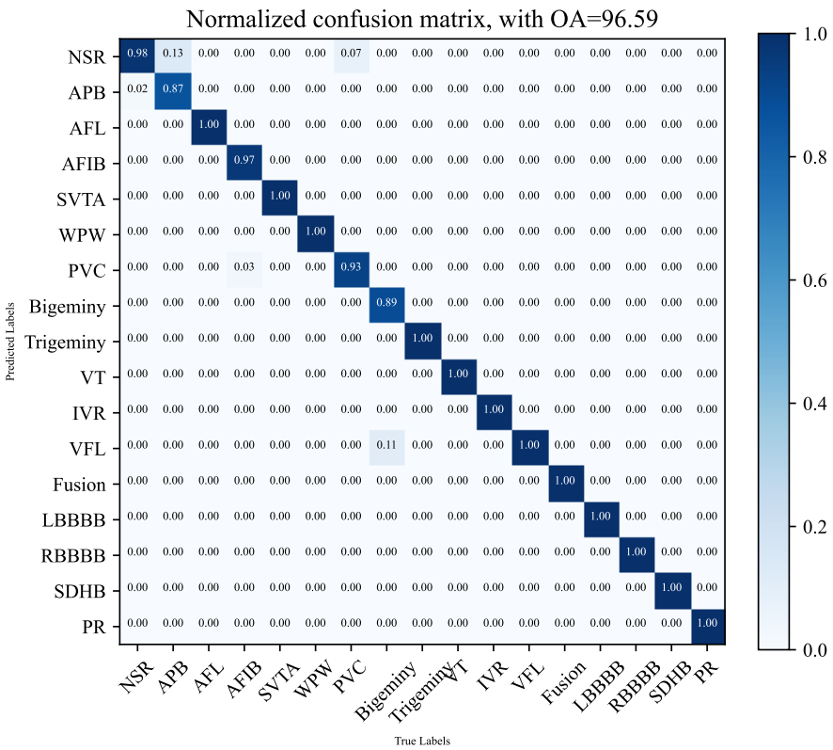
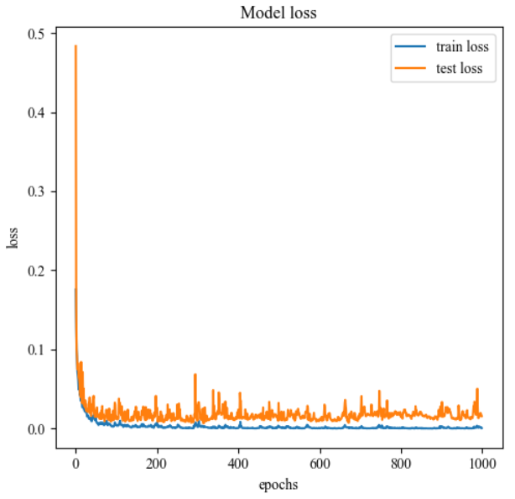
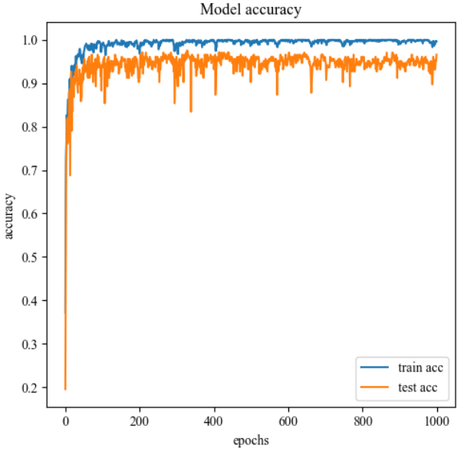

XNOR Net
the model accuracy is 0.9365853658536586
+-----------+-------+-------+-------+-------+-------+
| | ACC | SEN | SPE | PPR | F1 |
+-----------+-------+-------+-------+-------+-------+
| NSR | 0.951 | 0.983 | 0.939 | 0.864 | 0.919 |
| APB | 0.985 | 0.8 | 1.0 | 1.0 | 0.889 |
| AFL | 0.995 | 1.0 | 0.995 | 0.8 | 0.889 |
| AFIB | 0.985 | 0.9 | 1.0 | 1.0 | 0.947 |
| SVTA | 1.0 | 1.0 | 1.0 | 1.0 | 1.0 |
| WPW | 1.0 | 1.0 | 1.0 | 1.0 | 1.0 |
| PVC | 0.961 | 0.815 | 0.983 | 0.88 | 0.846 |
| Bigeminy | 1.0 | 1.0 | 1.0 | 1.0 | 1.0 |
| Trigeminy | 1.0 | 1.0 | 1.0 | 1.0 | 1.0 |
| VT | 1.0 | 1.0 | 1.0 | 1.0 | 1.0 |
| IVR | 1.0 | 1.0 | 1.0 | 1.0 | 1.0 |
| VFL | 1.0 | 1.0 | 1.0 | 1.0 | 1.0 |
| Fusion | 1.0 | 1.0 | 1.0 | 1.0 | 1.0 |
| LBBBB | 0.995 | 0.929 | 1.0 | 1.0 | 0.963 |
| RBBBB | 1.0 | 1.0 | 1.0 | 1.0 | 1.0 |
| SDHB | 1.0 | 1.0 | 1.0 | 1.0 | 1.0 |
| PR | 1.0 | 1.0 | 1.0 | 1.0 | 1.0 |
| SUM | 0.993 | 0.937 | 0.996 | 0.937 | 0.937 |
+-----------+-------+-------+-------+-------+-------+
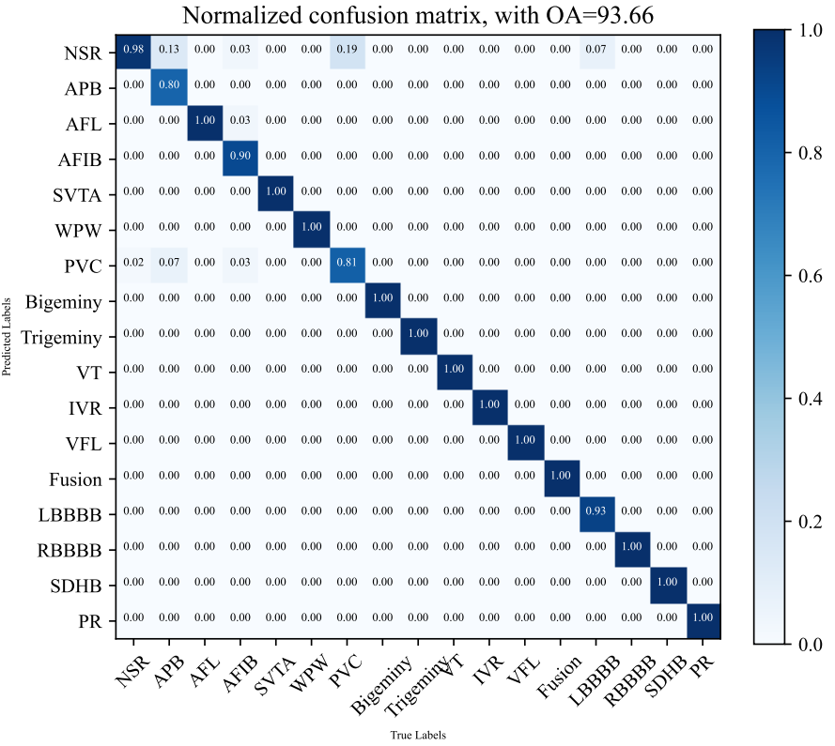
========================================================================================================================
Layer (type (var_name)) Input Shape Output Shape Param # Trainable
========================================================================================================================
ECG_Bin (ECG_Bin) [64, 1, 3600] [64, 17] -- True
├─Sequential (classifier) [64, 1, 3600] [64, 17, 14] -- True
│ └─Bn_bin_conv_pool (0) [64, 1, 3600] [64, 8, 1798] -- True
│ │ └─Conv1d (conv) [64, 1, 3600] [64, 8, 3600] 88 True
│ │ └─MaxPool1d (pool) [64, 8, 3600] [64, 8, 1798] -- --
│ │ └─PReLU (prelu) [64, 8, 1798] [64, 8, 1798] 1 True
│ │ └─BatchNorm1d (bn) [64, 8, 1798] [64, 8, 1798] 16 True
│ └─Bn_bin_conv_pool (1) [64, 8, 1798] [64, 16, 897] -- True
│ │ └─Conv1d (conv) [64, 8, 1798] [64, 16, 1798] 1,408 True
│ │ └─MaxPool1d (pool) [64, 16, 1798] [64, 16, 897] -- --
│ │ └─PReLU (prelu) [64, 16, 897] [64, 16, 897] 1 True
│ │ └─BatchNorm1d (bn) [64, 16, 897] [64, 16, 897] 32 True
│ └─Bn_bin_conv_pool (2) [64, 16, 897] [64, 32, 447] -- True
│ │ └─Conv1d (conv) [64, 16, 897] [64, 32, 897] 5,632 True
│ │ └─MaxPool1d (pool) [64, 32, 897] [64, 32, 447] -- --
│ │ └─PReLU (prelu) [64, 32, 447] [64, 32, 447] 1 True
│ │ └─BatchNorm1d (bn) [64, 32, 447] [64, 32, 447] 64 True
│ └─Bn_bin_conv_pool (3) [64, 32, 447] [64, 64, 222] -- True
│ │ └─Conv1d (conv) [64, 32, 447] [64, 64, 447] 22,528 True
│ │ └─MaxPool1d (pool) [64, 64, 447] [64, 64, 222] -- --
│ │ └─PReLU (prelu) [64, 64, 222] [64, 64, 222] 1 True
│ │ └─BatchNorm1d (bn) [64, 64, 222] [64, 64, 222] 128 True
│ └─Bn_bin_conv_pool (4) [64, 64, 222] [64, 72, 109] -- True
│ │ └─Conv1d (conv) [64, 64, 222] [64, 72, 222] 50,688 True
│ │ └─MaxPool1d (pool) [64, 72, 222] [64, 72, 109] -- --
│ │ └─PReLU (prelu) [64, 72, 109] [64, 72, 109] 1 True
│ │ └─BatchNorm1d (bn) [64, 72, 109] [64, 72, 109] 144 True
│ └─Bn_bin_conv_pool (5) [64, 72, 109] [64, 32, 54] -- True
│ │ └─Conv1d (conv) [64, 72, 109] [64, 32, 111] 20,736 True
│ │ └─MaxPool1d (pool) [64, 32, 111] [64, 32, 54] -- --
│ │ └─PReLU (prelu) [64, 32, 54] [64, 32, 54] 1 True
│ │ └─BatchNorm1d (bn) [64, 32, 54] [64, 32, 54] 64 True
│ └─Bn_bin_conv_pool (6) [64, 32, 54] [64, 32, 26] -- True
│ │ └─Conv1d (conv) [64, 32, 54] [64, 32, 56] 9,216 True
│ │ └─MaxPool1d (pool) [64, 32, 56] [64, 32, 26] -- --
│ │ └─PReLU (prelu) [64, 32, 26] [64, 32, 26] 1 True
│ │ └─BatchNorm1d (bn) [64, 32, 26] [64, 32, 26] 64 True
│ └─Bn_bin_conv_pool (7) [64, 32, 26] [64, 17, 14] -- True
│ │ └─Conv1d (conv) [64, 32, 26] [64, 17, 32] 2,720 True
│ │ └─MaxPool1d (pool) [64, 17, 32] [64, 17, 14] -- --
│ │ └─PReLU (prelu) [64, 17, 14] [64, 17, 14] 1 True
│ │ └─BatchNorm1d (bn) [64, 17, 14] [64, 17, 14] 34 True
├─Dropout (dropout) [64, 17, 14] [64, 17, 14] -- --
========================================================================================================================
Total params: 113,570
Trainable params: 113,570
Non-trainable params: 0
Total mult-adds (G): 2.06
========================================================================================================================
Input size (MB): 0.92
Forward/backward pass size (MB): 139.54
Params size (MB): 0.45
Estimated Total Size (MB): 140.92
========================================================================================================================

