Ctfs:
Bof:
We have a c file.
UAF:
Introduction: We possess a Human class that features two virtual functions, with one of them designed to initiate a shell session.
Objective: Our aim is to construct an instance, access the virtual table (the initial pointer within the instance), which contains two entries, one of which corresponds to the desired function. Upon deallocating the instance, the pointer to the virtual table is erased, but the virtual table itself persists.
Procedure: We will then proceed to allocate memory for the SAME chunk (achieved by requesting memory of identical size, resulting in the returned previously-deallocated chunk - Last In, First Out). Subsequently, we will insert a pointer to the virtual table's location, subtracted by 8. The rationale for this lies in positioning ourselves 8 bytes prior to the second function, which will then be invoked, including the shell.
Implementation:
Allocate memory for the object.
Deallocate the object.
Reallocate memory for the object (resulting in the previously deallocated chunk).
Insert the new virtual table (Vtable) pointer, reduced by 8.
Invoke the object's function again.
Context: Our objective revolves around identifying the pointer to the virtual table. We possess an object that implements an alternative virtual function, serving no purpose for our task.
Execution: During execution, an object of the "man" class is generated (inheriting from the Human class) with specific attributes such as age 19, facilitating easy identification of the relevant heap chunk.
Methodology: By setting a breakpoint after the creation of the "man" object, we can analyze the heap's contents by printing all allocated chunks.
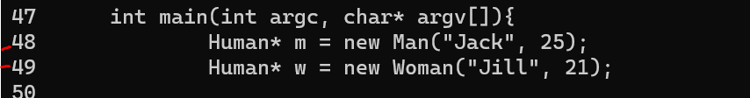
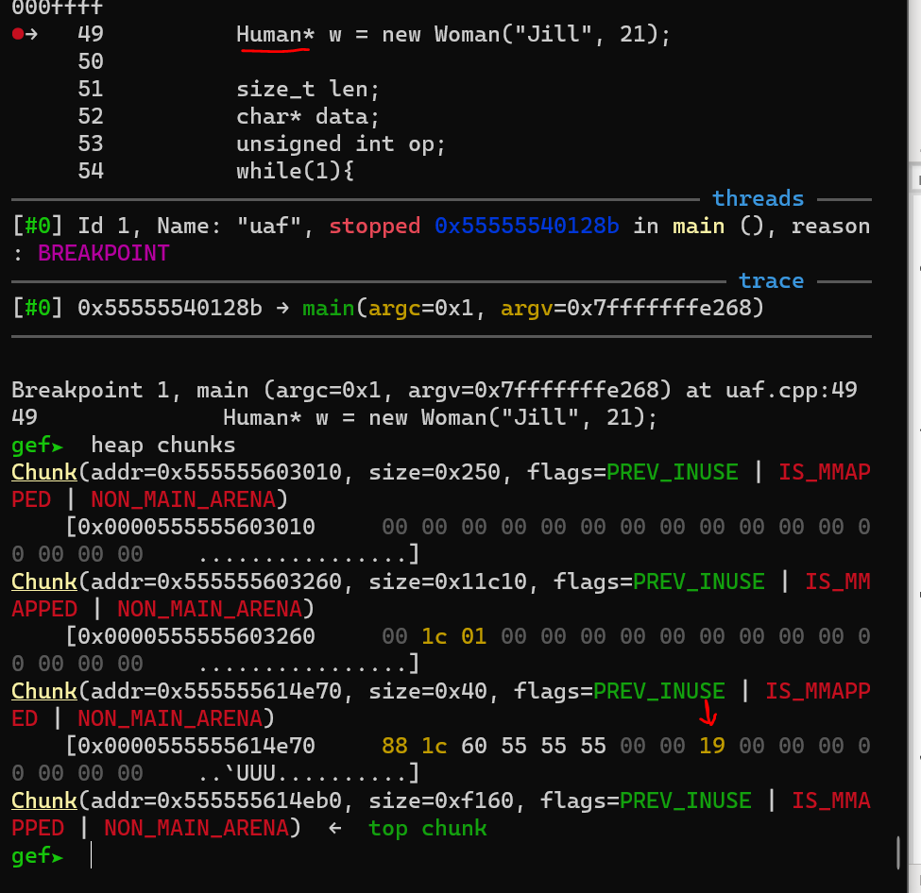
It's evident that the required chunk is the third one in the sequence. Observing the details, we can identify that its size is 40, which is crucial as we intend to replicate this allocation. Now, let's direct our attention to the address contained within this specific chunk.

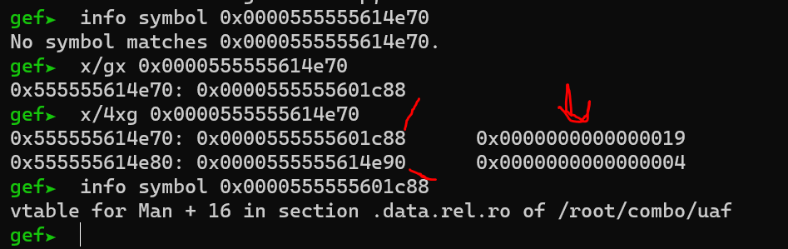

It becomes apparent that the chunk serves as a pointer to the "MAN" object. Upon inspecting the contents of this pointer, we observe both a pointer to the virtual table (Vtable) and the object's information (such as age and string name).

Subsequently, I executed the info symbol command on the initial address of the pointer, ensuring that it indeed corresponds to the required Vtable. The result confirms that it is the Vtable for "man+16".

Let's proceed to examine the functions present in the Vtable to ensure that they align with the functions we desire and require. We will achieve this by using the info symbol command.

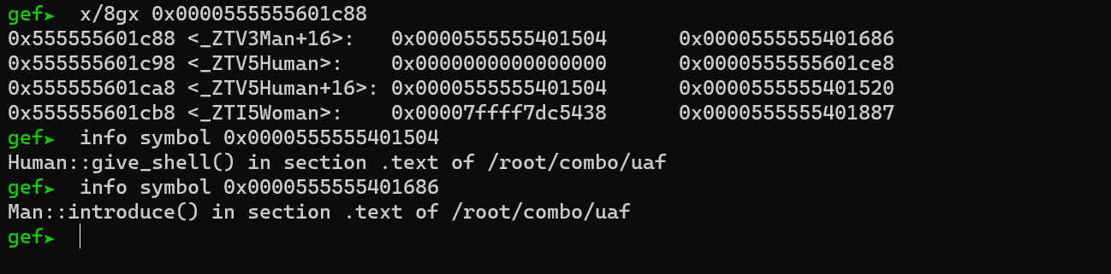
After printing the contents of the pointer, we observed the presence of two pointers within it. One corresponds to the give_shell function, and the other corresponds to the introduce() function. This discovery is exciting because it indicates that we have successfully identified the addresses we are targeting:
0x0000555555401504: Pointer to the give_shell() function.
0x555555614e70: Pointer to the "man" object.
0x0000555555601c88: Pointer to the virtual table (vtblae).
These addresses will serve as our guide for the subsequent steps in our task.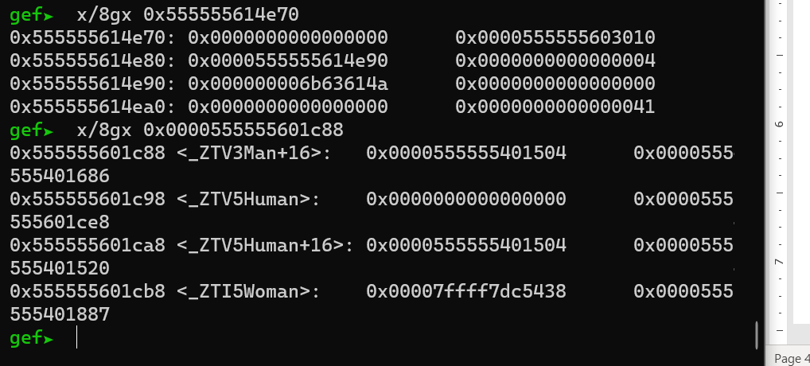
We've observed that within the chunk that previously contained the object, the pointers to the virtual table have been replaced with zeros. However, it's important to note that the virtual table itself persists.
To further investigate this, let's proceed to print the contents of the free bins after performing the deallocation. This step will provide us with valuable insights into the state of the memory allocation and deallocation process.
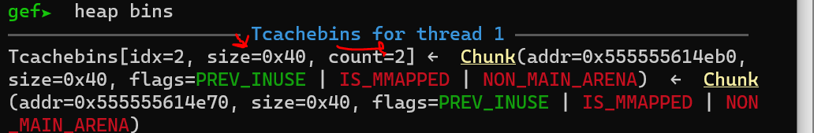

In summary, our approach involves substituting the address of the authentic virtual table with an address that is the virtual table's location minus 8. This manipulation ensures that when a request for access to the second function is made, the first function will be provided instead. This clever tactic leverages the memory layout to achieve the desired outcome.

