Dirty cow:
While trying to learn the specifics about dirty cow, I found it extremely annoying that I had trouble finding a good technical explanation as to what happens, and what is the exploit. Seems like the focus was on the usage of the bug and not understating how it happens.
So here is what happens (to my understating) in hopes the flow is clear, and how it works:
Main goal: we want to write to a read-only-file. To obtain that, we:
- we tell mister kernel that we want to write to a read-only-file, in OUR own process memory- legit. It means we want a copy of the original and change it for ourselves.
- So – we open a FD with read-only permissions.
- Then We mmap the file – we want to create a copy of it in OUR vm – copy the inside of the file to a private memory (it inherits the original page permissions). But due to copy-on-use, we’ll only obtain the actual copy that differs from the original when we actually start using and writing to the file (aka when a pagefault happens).
- At this point, we have two threads racing each other (AKA race condition)
  - Madvise – we won’t need access in the near future, free resources. Move to HD. not it RAM.
  - Write to proc/self/mem
- Lets look at process write:
- Open the file - /proc/self/mem – because we want to write to the memory of this process, that we mapped before (legit, legal)
- We now take a closer look at the __get_user_pages:
- Flow – start with Follow_page_mask -> if got null, continue to faultin_page, if got 0 retry.
- Follow_page_mask – scan the page tables to get the physical page for the given address (while taking into account the PTE permissions), or fail in case the request can’t be satisfied. During follow_page_mask’s operation the PTE’s spinlock is acquired— this guarantees the physical page won’t be released before we grab a reference. locate a remote process memory page at the address start with foll_flags access. If the page is null, it’s either not present or may need a page_fault to resolve the access. Why it can return null:
  - There is no memory mapping associated with it (first time?)
  - Because of demand-paging the content has not yet been loaded in (lazy lazy lazy)
  - The page has been paged out to the original or swap file (aka , HD)
  - The access of foll_floags violated the pages permissions- cow (like here!)
- we get a null page- since we want to write on a page that had read-only permissions. We copied it to our own memory, but thanks to COW we still didn’t necessarily obtain the page we wanted
- We enter faultin_page – remainder: we asked for a copy to write on in our memory. Now, we asked for the specific page (because we called “write”) to write on, we got NULL in the follow_page_mask and now we’re looking at the faultin_page. after a successful call to faultin_page the lock is released.
- We lock all present pages and dno’t fault in new pages. Then we create a new page that is private as well as dirty.
- Here’s the catch – before we return from the faultin_page, we remove (yes, lovely) the FOLL_WRITE flag. the pte_maybe_mkwrite_vm_maywrite flag won’t set the write bit. So the page went through cow cycle, and is ready to be written to.
- Why take off the flag? Each page we create, inherits the original (read only) access permissions as the original page. Same foll_flags, so we’ll go to the same loop as ret again.
- We drop the write flag
- we won’t go back to the return and get another page fault, we should obtain the page at follow_page_mask- with read permissions.
- 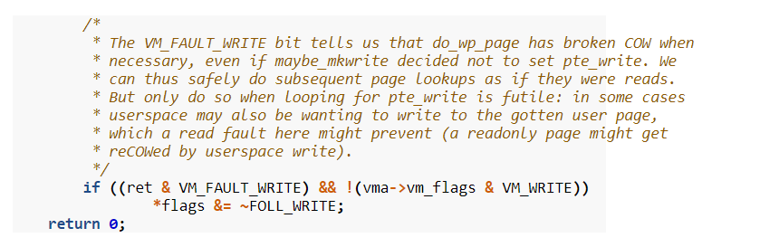

- Now to the evil exploit:

- The madvise process – got rid of the cow version that we had loaded (not in page tables anymore)
- We call faultin_page again.
- We don’t have foll_write anymore in foll_flags
- Instead of creating a dirty COW, handle_mm_fault (within the faultin_page) will return the page that is directly mapped to the original privileged file (from page cache).
- We don’t get a copy because of COW, since we didn’t ask for write flags and the kernel doesn’t lie. Hmf.
- Then, yet again – we’ll go again to “follow_page_mask” and we finally get a page- the original one.
- It’s all because the kernel is lying here. In its subsequent retry after being told a dirty COW page is ready, it goes on to tell follow_page_mask and handle_mm_fault that only read-only access is needed. The two functions happily comply and return a page that’s best optimised for the job. In this case, it returns a page that if we perform modification on it would get written back to original privileged file.

- After getting hold of the page, __get_user_pages can finally skip the faultin_page call and return the page all the way to the __access_remote_vm for further processing.



 