**1.**

## **Motherboard**

The motherboard is the main component of any branded or assembled PC, laptop, tablet or a mobile phone. The motherboard is a Printed Circuit Board which acts as the main platform for communication between all other components of a system. All the other computer parts are either directly installed or connected to various **motherboard components** and all the data is transferred between them through the motherboard.

Different types of motherboards:

AT Motherboards

The oldest of the main boards, these motherboards were used in earlier 286/386 or 486 computers. The AT means the board consists of advanced technology(AT) power connectors. There are two power connectors of 6 pin each mounted on the AT motherboards. The AT motherboards were available in the early 80’s.

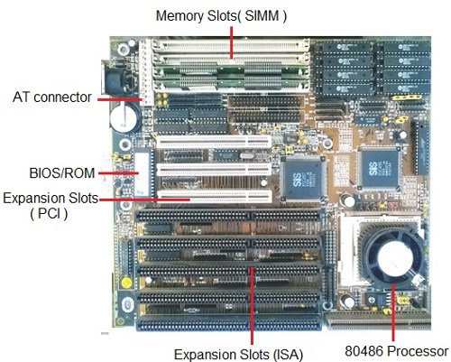

ATX Motherboards

The ATX motherboards started in 90’s and are still available. The ATX connector on the motherboard consists of a single connector. These boards are used for P2/P3 or P/4 processors.

**Motherboard for P1/P2 processors**:

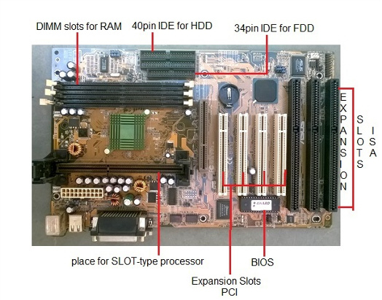

**Pentium 4 motherboard**

[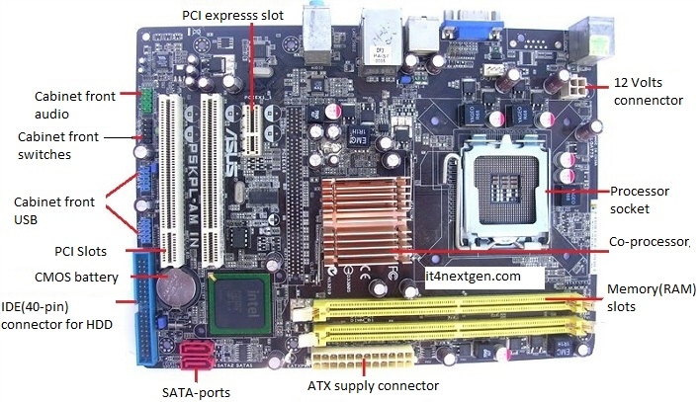](http://www.it4nextgen.com/wp-content/uploads/2016/08/main-board-p4.jpg)

**Where is the motherboard located?**

A computer motherboard is located inside the [computer case](https://www.computerhope.com/jargon/c/chassis.htm) and is where most of the parts and computer [peripherals](https://www.computerhope.com/jargon/p/peripher.htm) connect. With [tower computers](https://www.computerhope.com/jargon/t/tower.htm), the motherboard is on the left or right side of the tower and is the biggest [circuit board](https://www.computerhope.com/jargon/p/pcb.htm).

**Motherboard components**

Below are links to pages with more details for each of the motherboard components mentioned in the previous section. The links are listed in clockwise order starting from the top-left corner of the image. Components not labeled on the image above are found in sections later on this page.

* [Expansion slots](https://www.computerhope.com/jargon/e/expaslot.htm) ([PCI Express](https://www.computerhope.com/jargon/p/pciexpre.htm), [PCI](https://www.computerhope.com/jargon/p/pci.htm), and [AGP](https://www.computerhope.com/jargon/a/agp.htm))
* [3-pin case fan connectors](https://www.computerhope.com/jargon/c/casefan.htm)
* [Back pane connectors](https://www.computerhope.com/jargon/c/connect.htm)
* [Heat sink](https://www.computerhope.com/jargon/h/heatsink.htm)
* [4-pin (P4) power connector](https://www.computerhope.com/jargon/p/p4.htm)
* [Inductor](https://www.computerhope.com/jargon/c/coil.htm)
* [Capacitor](https://www.computerhope.com/jargon/c/capacito.htm)
* [CPU socket](https://www.computerhope.com/jargon/s/socket.htm)
* [Northbridge](https://www.computerhope.com/jargon/n/northbri.htm)
* [Screw hole](https://www.computerhope.com/jargon/s/standout.htm)
* [Memory slot](https://www.computerhope.com/jargon/m/memoslot.htm)
* [Super I/O](https://www.computerhope.com/jargon/s/sio.htm)
* [ATA / IDE disk drive primary connection](https://www.computerhope.com/jargon/i/ide.htm)
* [24-pin ATX power supply connector](https://www.computerhope.com/jargon/a/atxstyle.htm)
* [Serial ATA connections](https://www.computerhope.com/jargon/s/sata.htm)
* [Coin cell battery (CMOS backup battery)](https://www.computerhope.com/jargon/c/cmos.htm)
* [RAID](https://www.computerhope.com/jargon/r/raid.htm)
* [System panel connectors](https://www.computerhope.com/jargon/s/spc.htm)
* [FWH](https://www.computerhope.com/jargon/f/fwh.htm)
* [Southbridge](https://www.computerhope.com/jargon/s/soutbrid.htm)
* [Serial port connector](https://www.computerhope.com/jargon/s/seriport.htm)
* [USB headers](https://www.computerhope.com/jargon/u/usbhead.htm)
* [Jumpers](https://www.computerhope.com/jargon/j/jumper.htm)
* [Integrated circuit](https://www.computerhope.com/jargon/i/ic.htm)
* [1394 headers](https://www.computerhope.com/jargon/u/usbhead.htm)
* [SPDIF](https://www.computerhope.com/jargon/s/spdif.htm)
* [CD-IN](https://www.computerhope.com/jargon/c/cdin.htm)

**Older motherboard components**

The following list contains links to components that are not shown in the picture above or were part of older computer motherboards.

* [BIOS](https://www.computerhope.com/jargon/b/bios.htm)
* [Bus](https://www.computerhope.com/jargon/b/bus.htm)
* [Cache memory](https://www.computerhope.com/jargon/c/cache.htm)
* [Chipset](https://www.computerhope.com/jargon/c/chipset.htm)
* [Diode](https://www.computerhope.com/jargon/d/diode.htm)
* [Dip switches](https://www.computerhope.com/jargon/d/dipswitc.htm)
* [Electrolytic](https://www.computerhope.com/jargon/c/capacito.htm)
* [Floppy connection](https://www.computerhope.com/jargon/f/flopcabl.htm)
* [Fuse](https://www.computerhope.com/jargon/f/fuse.htm)
* [Game port and MIDI header](https://www.computerhope.com/jargon/u/usbhead.htm).
* [Internal speaker](https://www.computerhope.com/jargon/i/intespea.htm)
* [Keyboard controller](https://www.computerhope.com/jargon/k/keybcont.htm)
* [LCC](https://www.computerhope.com/jargon/l/lcc.htm)
* [Network header](https://www.computerhope.com/jargon/u/usbhead.htm)
* Obsolete expansion slots: [AMR](https://www.computerhope.com/jargon/a/amr.htm), [CNR](https://www.computerhope.com/jargon/c/cnr.htm), [EISA](https://www.computerhope.com/jargon/e/eisa.htm), [ISA](https://www.computerhope.com/jargon/i/isa.htm), and [VESA](https://www.computerhope.com/jargon/v/vesa.htm).
* Obsolete memory slots: [SIMM](https://www.computerhope.com/jargon/s/simm.htm).
* Onboard [LED](https://www.computerhope.com/jargon/l/led.htm)
* [Parallel port header](https://www.computerhope.com/jargon/u/usbhead.htm)
* [PS/2 header](https://www.computerhope.com/jargon/u/usbhead.htm)
* [Resistor](https://www.computerhope.com/jargon/r/resistor.htm)
* [RTC](https://www.computerhope.com/jargon/r/rtc.htm)
* [Serial port header](https://www.computerhope.com/jargon/u/usbhead.htm)
* [SCSI](https://www.computerhope.com/jargon/s/scsi.htm)
* [Solenoid](https://www.computerhope.com/jargon/s/solenoid.htm)
* [Voltage regulator](https://www.computerhope.com/jargon/v/voltregu.htm)
* [VRM (voltage regulator module)](https://www.computerhope.com/jargon/v/vrm.htm).

**2.**

**Memory Modules**

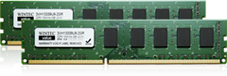

Memory modules are computer chips used to add memory to a computer.

There are two basic distinctions of memory. One is volatile memory where the data is lost as soon as power is removed, and one is non-volatile that can store the data without power. Random access memory (RAM) is used as read-write memory, which the processor can use as a scratch pad and modify rapidly. It utilizes silicon transistors and capacitors to store data but is done so in a grid-like configuration with a transistor-capacitor pair at each intersection of the grid. The advantage of the grid architecture is that it allows any specific bit of information to be read and written at any time. Any point on the grid can be accessed by interrogating the two lines, which will read or write the spot at which they intersect. This type of volatile memory is very fast but the downfall is that the capacitors lose their charge over time so the data must constantly be refreshed. This constant refreshing aspect of the memory is called dynamic RAM or DRAM.

By contrast, static random access memory (SRAM) does not need to be refreshed. Because of this, SRAM is faster because it doesn’t require the time necessary to refresh each bit. SRAM is also more expensive and not used as often. Different types of SRAM may lose the memory after power is removed but some do not.

Non-volatile RAM memory, or NVRAM, is a class of memory that also has a grid architecture, but the data is retained even after the power is removed. Flash memory is an example of a type of NVRAM that utilizes a special type of metal oxide semiconductor field effect transistor (MOSFET) to store data. Other types of NVRAM are ferroelectric RAM (FeRAM) and magnetoresistive ram (MRAM).

Read only memory (ROM) is memory that contains preset instructions and data, often for controlling physical devices like disk drives associated with the PC. ROM is non-volatile so it does not lose what is stored without power. While the name suggests that it is read-only and certain types are, more often it is read-only during normal operation but can be written under the special circumstances. ROM also covers a wide array of memory types.

Programmable read-only memory (PROM) is a type of ROM that is typically programmed once and can’t be changed after that. This type of memory is used in things like firmware and RFID chips. It is often used in hardware that has a dedicated purpose that will not change.EPROM memory is similar to PROM with one key difference. It can be erased and reprogrammed although this is not expected to happen often. The memory chips have an optical window on them, which must be exposed to UV light that will erase the memory and allow them to be reprogrammed. With this method, the memory must be completely erased before any new information is written.

Since the UV light method is somewhat inconvenient, electrically erasable programmable read-only memory (EEPROM) was developed. Erasing and programming are typically done with a voltage higher than normal operation.

**Types**

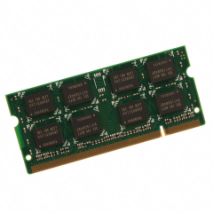

Choices for memory type include:

* RAM (random access memory)
* DRAM (direct random access memory)
* FPM RAM (fast page mode RAM)
* EDO RAM (extended data output RAM)
* BEDO RAM (burst extended data output RAM)
* SDRAM (synchronous DRAM)
* SRAM (static random access memory)
* L2 Cache (level 2 cache)
* Async RAM (asynchronous RAM)
* Sync RAM (synchronous RAM)
* PB SRAM (pipelined burst SRAM)
* VRAM (video RAM)
* WRAM (window RAM)
* SGRAM (synchronous graphics RAM)
* ROM (read only memory)
* PROM (programmable read only memory)
* EPROM (erasable programmable read only memory)
* EEPROM (electronically erasable programmable read only memory)
* Flash

**Specifications**

The form factor of any memory module describes its size and pin configuration. Most computer systems have memory sockets that can accept only one form factor. Choices for form factor include:

* SIMM — Single in-line memory module (SIMM) offers a data path of 32 bits. Because Pentium® memory modules are designed to handle a much wider data path than that, SIMMs must be used in pairs on Pentium motherboards (they can be used singly on boards based on 486 or slower processors).
* DIMM — Dual in line memory module (DIMM), which are of more recent origin, offer a 64-bit path, which makes them more suitable for use with the Pentium and other more recent processors. One DIMM will handle the work of two SIMMs and thus can be used singly on a Pentium motherboard. DIMMs are more economical in the long run, because they can be added one at a time to a system.

**Features**

* Capacity is the amount of data that can be transmitted over a specific period of time.
* Clock speed is the raw MHz that the CPU (Central Processor Unit) operates at. For example, an AMD Athlon 1 GHz has an operating clock speed of 1,000 MHz; this is the processor's clock speed.
* The cycle time is the length of time it takes to transmit data expressed in terms of the minimum amount of time required for a memory to complete a cycle such as read, write, read/write, or read/modify/write.
* Error checking and correction features of memory cards include parity, error checking parity, and nonparity. As data moves through a computer (e.g., from the CPU to the main memory), the possibility of errors can occur, particularly in older machines. Parity error detection was developed to notify the user of any data errors. By adding a single bit to each byte of data, this bit is responsible for checking the integrity of the other 8 bits while the byte is moved or stored. Once a single-bit error is detected, the user receives an error notification; however, parity checking only notifies, and does not correct a failed data bit. If your SIMM module has 3, 6, 9, 12, 18, or 36 chips then it is more than likely parity. Error Checking and Correction (ECC) modules have an extra chip that detects if the data was correctly read or written by the memory module. If the data wasn't properly written, the extra chip will correct it in many cases (depending on what type of error). Non-parity (also called non-ECC) modules do not have an error-detecting feature.

**Applications**

* Memory is used in lots of digital electronic devices from smart phones and watches to electronic toothbrushes and radios. Just about any electric device that needs to store information uses some form of memory. For a monitor or TV, this storage may be for the internal software that makes the device run, or as temporary storage for a processor. Many modern appliances such as refrigerators, thermostats, air conditioners, and automobiles use memory, as well as:
* Personal computing
* Motherboards and RAID cards
* Digital electronics
* Servers and networking
* Printers and imaging

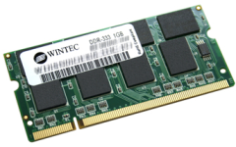

3.

What is Daughter Board

The daughter board is a computer hardware. It is also known as the piggyback board, riser card, daughter board, daughtercard or daughter card. A daughter board is a printed circuit board which is connected to the motherboard or expansion card. As compared to the motherboard, it is smaller in size. A daughter board does not act as an expansion card. An expansion card adds extra new functions to the computer. But a daughter board that is connected to the motherboard adds or supports the main functions of the motherboard.

Daughter boards are directly connected to the motherboards. You know that expansion cards are connected to the motherboard by using the bus and other serial interfaces.  But daughter board is directly connected to the board by soldering. As an update of the motherboard or expansion card, daughter boards are released to extend the features and services of the motherboard or expansion cards.

Functionalities of a Daughter Board

A daughter board is a circuit board that is directly connected to the motherboard or expansion card by soldering. Sometimes, people think that daughter board and expansion card are same. But this not true. They have their own functionalities. Daughter board’s functionalities are given below:

1. It is known as the piggyback board, riser card, daughtercard etcetera.
2. A daughter board is smaller than a motherboard and may have some slots like the motherboard.
3. A daughter board is a printed circuit board which is connected to the motherboard or expansion card.
4. Unlike expansion card, daughter boards are directly connected to the motherboard by soldering.
5. Daughter boards do not provide new functions to the circuit like an expansion But they extend the circuitry of the circuit in which they are plugged into.
6. Daughter boards are released by the vendors as an update of motherboard or expansion card.

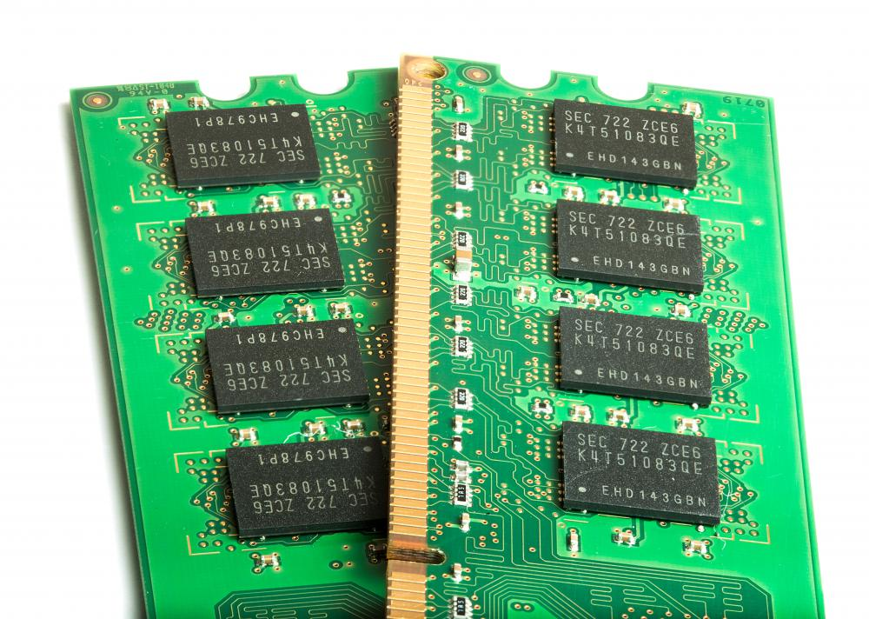

4.

**Expansion slot**

Alternatively known as a **bus slot** or **expansion port**, an **expansion slot** is a connection or port inside a [computer](https://www.computerhope.com/jargon/c/computer.htm) on the [motherboard](https://www.computerhope.com/jargon/m/mothboar.htm) or [riser card](https://www.computerhope.com/jargon/r/risecard.htm). It provides an installation point for a hardware expansion card to be connected. For example, if you wanted to install a new video card in the computer, you'd purchase a video expansion card and install that card into the compatible expansion slot.

What Are Expansion Slots Used For?

The expansion card is plugged directly into the expansion port so that the motherboard has direct access to the [hardware](https://www.lifewire.com/computer-hardware-2625895). However, since all computers have a limited number of expansion slots, it's important to [open your computer](https://www.lifewire.com/how-to-open-a-desktop-computer-case-2624589) and check what's available before you buy one.

Some older systems require the use of a riser board to add additional expansion cards; however, modern computers not only usually have enough expansion slot options, but they also have features integrated directly into the motherboard, eliminating the need for so many expansion cards.

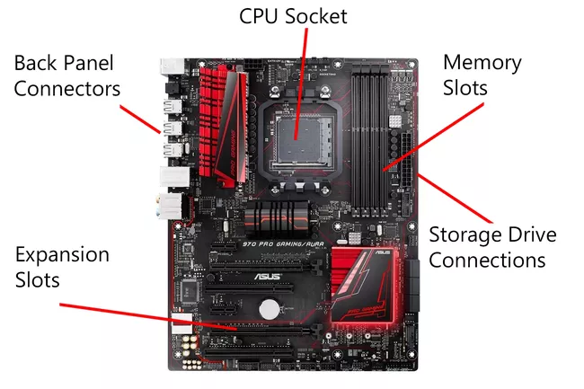

5.

What Does Switched-Mode Power Supply (SMPS)

A switched-mode power supply (SMPS) is an electronic circuit that converts power using switching devices that are turned on and off at high frequencies, and storage components such as inductors or capacitors to supply power when the switching device is in its non-conduction state.

Switching power supplies have high efficiency and are widely used in a variety of electronic equipment, including computers and other sensitive equipment requiring stable and efficient power supply.

A switched-mode power supply is also known as a switch-mode power supply or switching-mode power supply

Switched-Mode Power Supply (SMPS)

Switched-mode power supplies are classified according to the type of input and output voltages. The four major categories are:

* AC to DC
* DC to DC
* DC to AC
* AC to AC

A basic isolated AC to DC switched-mode power supply consists of:

* Input rectifier and filter
* Inverter consisting of switching devices such as MOSFETs
* Transformer
* Output rectifier and filter
* Feedback and control circuit

The input DC supply from a rectifier or battery is fed to the inverter where it is turned on and off at high frequencies of between 20 KHz and 200 KHz by the switching MOSFET or power transistors. The high-frequency voltage pulses from the inverter are fed to the transformer primary winding, and the secondary AC output is rectified and smoothed to produce the required DC voltages. A feedback circuit monitors the output voltage and instructs the control circuit to adjust the duty cycle to maintain the output at the desired level.

There are different circuit configurations known as topologies, each having unique characteristics, advantages and modes of operation, which determines how the input power is transferred to the output.

Most of the commonly used topologies such as flyback, push-pull, half bridge and full bridge, consist of a transformer to provide isolation, voltage scaling, and multiple output voltages. The non-isolated configurations do not have a transformer and the power conversion is provided by the inductive energy transfer.

Advantages of switched-mode power supplies:

* Higher efficiency of 68% to 90%
* Regulated and reliable outputs regardless of variations in input supply voltage
* Small size and lighter
* Flexible technology
* High power density

Disadvantages:

* Generates electromagnetic interference
* Complex circuit design
* Expensive compared to linear supplies

Switched-mode power supplies are used to power a wide variety of equipment such as computers, sensitive electronics, battery-operated devices and other equipment requiring high efficiency.

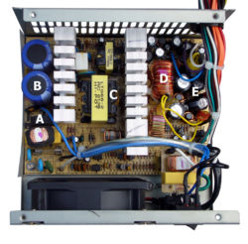

6.

**Internal Storage Devices**

Some storage devices are classed as 'internal' which means they are inside the computer case.

Most computers have some form of internal storage. The most common type of internal storage is the hard disk.

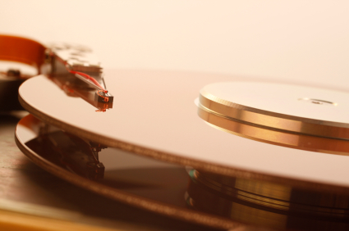

At the most basic level, internal storage is needed to hold the operating system so that the computer is able to access the input and output devices.

It will also be used to store the applications software that you use and more than likely, the original copies of your data files.

Internal storage allows the data and applications to be loaded very rapidly into memory, ready for use. The data can be accessed much faster than data which is stored on an external storage device. This is because internal storage devices are connected directly to the motherboard and its data bus whereas external devices are connected through a hardware interface such as USB, which means they are considerably slower to access.

Internal storage also means that if the computer is moved around, it will still retain its most commonly used data.

The main disadvantage of internal storage is that when the hard disk fails (and it will), all the data and applications may be lost.

This can be avoided to some extent by using more than one hard disk within the machine. Each hard disk has a copy of all the data, so if one fails the other can carry on. This is called a RAID array. An alternative is to use external drives for backup

7.

**Interfacing port**

A port is a physical docking point using which an external device can be connected to the computer. It can also be programmatic docking point through which information flows from a program to the computer or over the Internet.

Characteristics of Ports

A port has the following characteristics −

* External devices are connected to a computer using cables and ports.
* Ports are slots on the motherboard into which a cable of external device is plugged in.
* Examples of external devices attached via ports are the mouse, keyboard, monitor, microphone, speakers, etc.

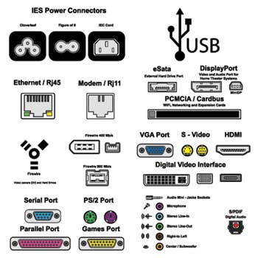

Let us now discuss a few important types of ports −

Serial Port

* Used for external modems and older computer mouse
* Two versions: 9 pin, 25 pin model
* Data travels at 115 kilobits per second

Parallel Port

* Used for scanners and printers
* Also called printer port
* 25 pin model
* IEEE 1284-compliant Centronics port

PS/2 Port

* Used for old computer keyboard and mouse
* Also called mouse port
* Most of the old computers provide two PS/2 port, each for the mouse and keyboard
* IEEE 1284-compliant Centronics port

Universal Serial Bus (or USB) Port

* It can connect all kinds of external USB devices such as external hard disk, printer, scanner, mouse, keyboard, etc.
* It was introduced in 1997.
* Most of the computers provide two USB ports as minimum.
* Data travels at 12 megabits per seconds.
* USB compliant devices can get power from a USB port.

VGA Port

* Connects monitor to a computer's video card.
* It has 15 holes.
* Similar to the serial port connector. However, serial port connector has pins, VGA port has holes.

Power Connector

* Three-pronged plug.
* Connects to the computer's power cable that plugs into a power bar or wall socket.

Firewire Port

* Transfers large amount of data at very fast speed.
* Connects camcorders and video equipment to the computer.
* Data travels at 400 to 800 megabits per seconds.
* Invented by Apple.
* It has three variants: 4-Pin FireWire 400 connector, 6-Pin FireWire 400 connector, and 9-Pin FireWire 800 connector.

Modem Port

* Connects a PC's modem to the telephone network.

Ethernet Port

* Connects to a network and high speed Internet.
* Connects the network cable to a computer.
* This port resides on an Ethernet Card.
* Data travels at 10 megabits to 1000 megabits per seconds depending upon the network bandwidth.

Game Port

* Connect a joystick to a PC
* Now replaced by USB

Digital Video Interface, DVI port

* Connects Flat panel LCD monitor to the computer's high-end video graphic cards.
* Very popular among video card manufacturers.

Sockets

* Sockets connect the microphone and speakers to the sound card of the computer.